Retail Sales Data Processing and Business Insights Generation

Fathima Sheen K S
NeoStats Data Engineering Internship Assessment
Date : 02/06/2026, Tuesday

- Project Overview

This project focuses on building a retail sales data engineering pipeline using Python and Power BI. The datasets contained issues such as missing values, inconsistent product names, inconsistent categories, and sensitive customer information.
The pipeline was developed to clean, transform, and prepare the data for business analysis. After processing the datasets, key business KPIs and insights were generated and visualized using an interactive Power BI dashboard.

- Data Flow Explanation

- The datasets were first loaded into Python using Pandas. Initial profiling was performed to identify missing values, inconsistent labels, and formatting issues.

- The data was then cleaned and standardized by handling missing prices, correcting category names, normalizing product names, and removing invalid records.

- Sensitive customer details such as emails and phone numbers were masked before generating KPIs and exporting the cleaned dataset to Power BI for reporting and visualization.

- Architecture Diagram

The following architecture diagram illustrates the overall workflow of the retail sales data engineering pipeline implemented in this project. The solution begins with raw retail transaction datasets stored in Excel format and progresses through multiple stages including data ingestion, profiling, cleaning, transformation, PII masking, KPI generation, and business intelligence reporting using Power BI.

Excel Datasets
(retail_data1, retail_data2, product_details)

Python Data Ingestion
(Pandas + OpenPyXL)
Power BI Dashboard
(Business Reporting & Visualization)

KPI Generation
(Revenue, City Analysis, Product Insights)
Cleaned CSV Dataset
(final_cleaned_retail_data.csv)
Data Cleaning & Transformation
(Standardization, Null Handling, Formatting)
Data Profiling
(Missing Values, Duplicates, Validation)
PII Masking
(Email & Phone Masking)

- Data Quality Issues Identified
The datasets contained several quality issues:
- Missing values in the price column
- Inconsistent product names such as PHONE, phone, and Phone
- Inconsistent category labels
- Formatting inconsistencies
- Sensitive customer information such as emails and phone numbers
- Invalid quantity values

- Data Cleaning Strategy

The following cleaning steps were performed:
- Missing prices were filled using the product reference table
- Product names were standardized
- Categories were normalized into consistent labels
- Invalid quantity records were removed
- Dates were converted into standard datetime format

- PII Masking

The datasets contained sensitive customer information such as email addresses and phone numbers. To improve privacy protection, masking techniques were applied during data processing.
Email addresses were partially hidden by masking characters in the username portion.
Example:
- SarahGuerrero@yahoo.com
- Sar***********@yahoo.com
Phone numbers were also partially masked.
Example:
- 7147248911
- 71******11
Implementing PII masking helps reduce sensitive data exposure and demonstrates basic data privacy and governance practices within the pipeline.

- KPI & Business Insights

Several business KPIs were generated from the cleaned dataset to support business analysis and reporting.
The following KPIs were calculated:
- Total Revenue
- Revenue by Category
- Revenue by City
- Top Selling Products
- Payment Method Distribution
Key Insights:
- Electronics contributed the highest revenue among all categories.
- Certain cities generated significantly higher sales compared to others.
- Products such as Laptop and Dining Table showed high sales quantity.
- Online payment methods were more frequently used than other payment options.
These KPIs helped in understanding sales performance, customer behavior, and regional business trends.
- Power BI Dashboard

The cleaned dataset was integrated into Power BI to create an interactive sales dashboard for business reporting and visualization.
The dashboard includes:
- KPI cards for Total Revenue, Total Transactions, and Quantity Sold
- Revenue analysis by category and city
- Top product performance charts
- Payment method distribution visualization
- Interactive slicers for filtering data by city
The dashboard provides a simple and user-friendly way to analyze retail sales performance and business trends.
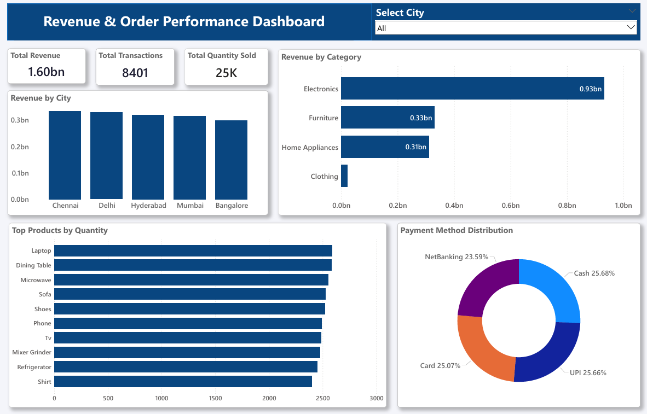
- Assumptions Made
The following assumptions were made during the implementation process:
- Missing prices were replaced using the product master reference table.
- Invalid quantity values such as zero or negative quantities were removed.
- Product names and categories were standardized based on business logic.
- Transaction records with valid product IDs were considered reliable for transformation.
- Masked customer data was sufficient for analytical purposes without exposing sensitive information

- Conclusion

- The retail sales data engineering pipeline was successfully implemented using Python, Pandas, and Power BI.
- The project included data ingestion, profiling, cleaning, transformation, PII masking, KPI generation, and dashboard creation.
- The final cleaned dataset was transformed into a business-ready analytics dataset and visualized through an interactive Power BI dashboard for reporting and business insights.

