### CUSTOMER CHURN PREDICTION USING MACHINE LEARNING

**TEAM MEMBER**

**412621243018 : FATHIMA S**

# Phase-4 Dashboard using IBM Cognos Analytics

**Project:** *Customer Churn Prediction*

* machine learning algorithms to build a predictive model that identifies potential churners based on historical data and relevant features.

**Program and output**

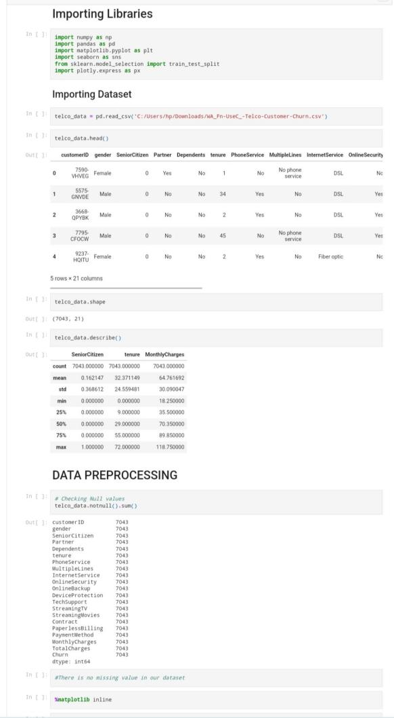

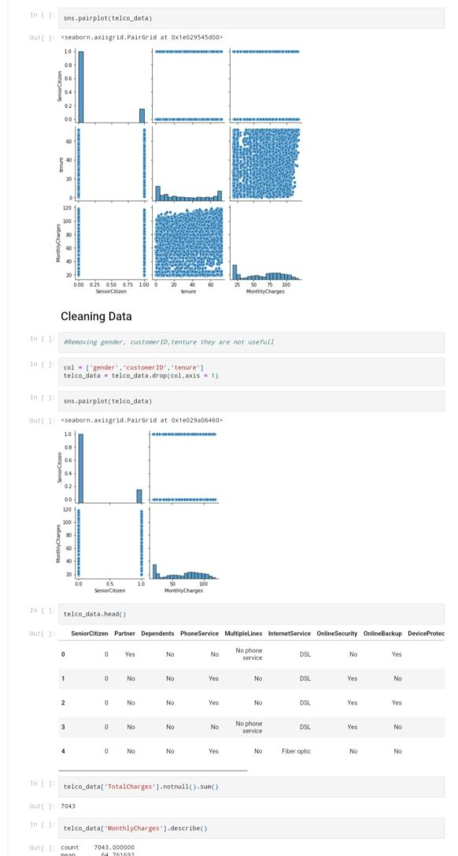

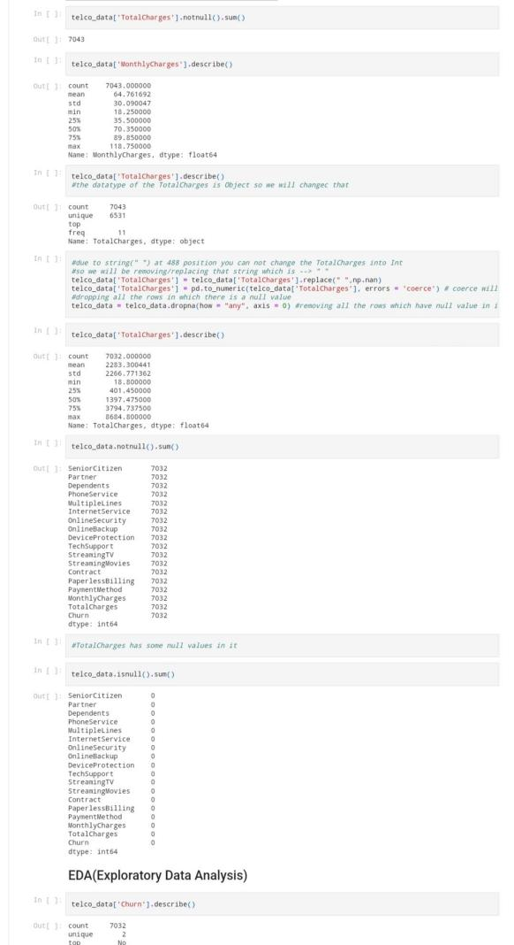

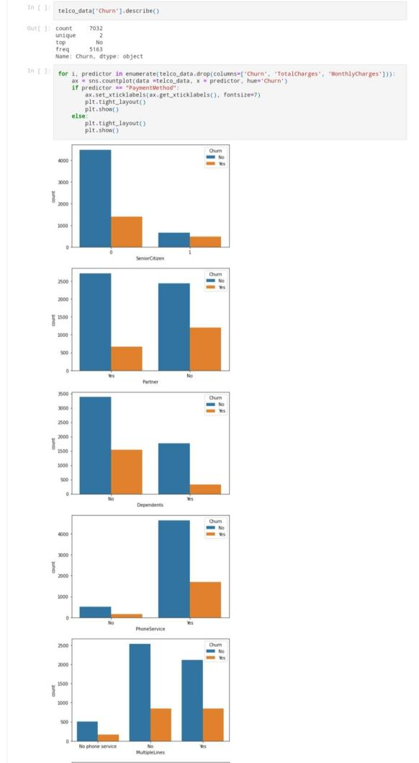

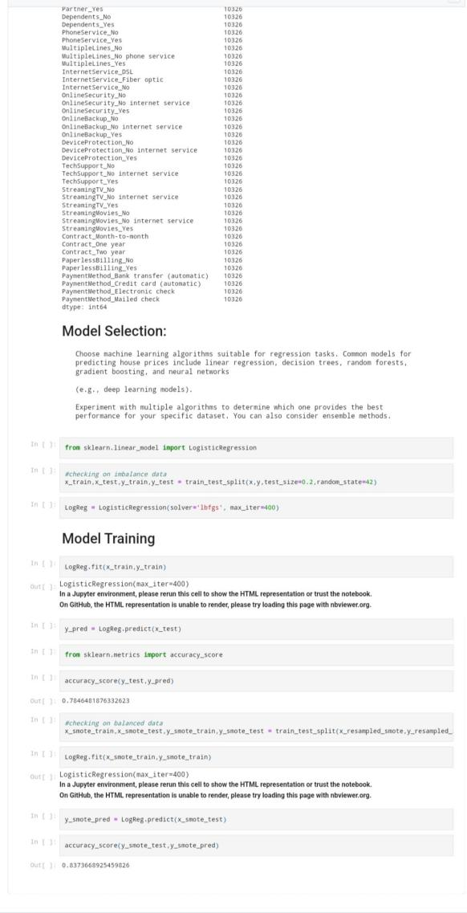

dashboard using ibm cognos analytics

