**Project Documentation**

**Project Name: Movie Metadata Overview**

### 1. Project Overview

This project is designed to explore and visualize a comprehensive movie metadata dataset using Microsoft Excel and Power BI. It aims to uncover hidden patterns and relationships in box office performance, viewer preferences, and production trends across different countries and genres. Through a well-structured dashboard, stakeholders can gain insights into profitability, audience engagement (via IMDb scores), social media influence (Facebook likes), and technical production factors such as duration and format. These visual analytics support data-driven decision-making for movie producers, marketers, and analysts.

### 2. Tools Used

* Microsoft Excel
* Power BI

### 3. Dataset

* **Source:** Sample dataset of movie metadata
* **Data contains:**  
  Movie Title, Gross, Duration, Title year, Budget, Director Name, Color, Language, Genres, Country, Director Facebook Likes, Actor 1 Name, Actor 1 Facebook Likes, Actor 2 Name, Actor 2 facebook likes, Actor 3 Name, Actor 3 Facebook Likes, Cast Total Facebook Likes, Num Critic For Reviews, Num Voted Users, Facenumber In Poster, Plot Keywords, Movie imdb link, Num user for reviews, Content rating, imdb score, Aspect ratio, Movie facebook likes

### 4. Steps Followed

* Cleaned data in Excel (e.g., handled encoding errors, filled missing values appropriately, corrected column formatting, changed data types, and removed duplicates)
* Imported cleaned data into Power BI
* Added conditional and custom columns using Power Query
* Added calculated measures, columns, and tables using DAX
* Created dashboard using charts, slicers, and KPIs:
  + Pie chart: Total number of movies by color (Color vs B&W)
  + Line & stacked column chart: Avg Profit & IMDb Score by Content Rating
  + Stacked bar chart: Total movies by Profit Status
  + Scatter chart: Average Duration and IMDb Score by Country
  + Line & clustered column chart: Total Gross by Top 10 Directors
  + Filled map: Average Gross by Country
  + Line chart: Gross & Budget by Decade and Color
  + Funnel chart: Profit by Movies
* Tooltips and Drillthrough Pages:
  + Tooltip 1: Avg. Users for Reviews, Critics, Duration by Profit Status and Decade Count
  + Tooltip 2: Country-wise Movie Count, Average Gross and Profit
* Slicers used: Movie Title, Country, Language, IMDb Score, Profit Status, Release Year
* Added Action Buttons: Full Movie Details and Facebook Likes Details
* Created multi-card visuals combining: Movie Count, Average Gross, and Average Profit by Country

### 5. Key Insights

* Most movies are produced in color, with black & white being rare.
* PG-13 and R-rated movies show higher profits and IMDb scores.
* A large portion of movies are profitable, but losses still occur frequently.
* The USA leads in both movie production and performance metrics.
* A few top directors account for the majority of total gross earnings.
* Countries with more movie production generally see higher gross and profit.

### 6. Screenshot

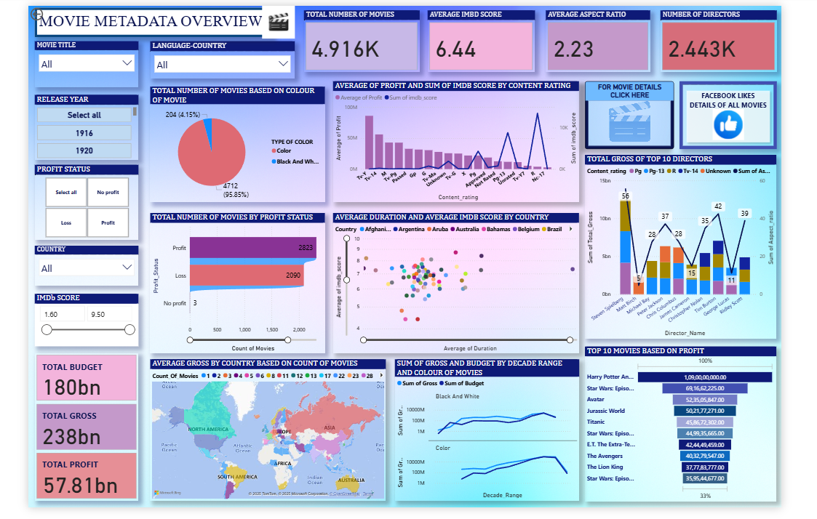

### 7. Files Included

* **Movie Metadata Preprocessed.xlsx** – Cleaned data and pre-analysis
* **Movie Metadata Dashboard** – Power BI dashboard
* README.md – Project description

### 8. How to Use

* Open Movie Metadata Preprocessed.xlsx in Excel to review cleaned data.
* Open movie_dashboard.pbix in Power BI Desktop to explore visuals and insights.