
COFFEE SHOP SALES ANALYSIS
Power BI Dashboard — Final Project Report
Data period: January – June 2023
Report prepared: September 2026

Table of Contents

1. Executive Summary
2. Project Brief
2.1 Overview
2.2 Business objectives
3. Data Overview
4. Data Cleaning and Preparation
5. Design System
6. Dashboard Architecture
7. Key DAX Measures
8. Final Dashboard
9. Interactivity: Drillthrough and Tooltip
9.1 Store Detail drillthrough
9.2 Heatmap tooltip
10. Insights and Recommendations

1. Executive Summary
This report documents the design, build, and analysis behind an interactive Power BI dashboard for a coffee shop chain operating three New York City locations — Lower Manhattan, Hell's Kitchen, and Astoria — covering January to June 2023. The final dashboard spans six pages: three primary analysis pages (Overview, Product Analysis, Store & Time Analysis), a Store Detail drillthrough page, a custom heatmap tooltip page, and a closing Insights & Recommendations page.
The project began from a supplied brief and reference design, was rebuilt with a custom coffee-themed colour system, refined through iterative formatting fixes, extended with drillthrough and tooltip interactivity, and concluded with five data-driven findings translated into concrete business recommendations.

2. Project Brief

2.1 Overview
The Coffee Shop Sales Analysis Dashboard is a Power BI project that visualises sales data for a local coffee shop chain, focused on total sales, orders, and quantity sold, with breakdowns by product category, product type, store location, and sales trends over time — built to help stakeholders identify sales patterns and support business and operational planning.

2.2 Business objectives
- Measure overall sales performance
- Track sales, orders, and quantity sold over time
- Identify high-performing product categories and product types
- Compare sales performance across store locations
- Identify peak sales periods
- Provide data-based insights and recommendations for business planning

3. Data Overview
Source file: Coffee_Shop_Sales.xlsx (“Transactions” sheet), transaction-level data — one row per item sold, with date, time, store, product category/type/detail, quantity, and unit price. 149,116 transactions in total.
Metric | Value
Total Sales | $698,812
Total Orders | 149,116
Total Quantity Sold | 214,470 items
Average Order Value | $4.69
Date Range | 1 Jan 2023 – 30 Jun 2023
Store Locations | Lower Manhattan, Hell's Kitchen, Astoria
Product Categories | 9

4. Data Cleaning and Preparation
Before modelling, the dataset was reviewed and prepared in Power Query:
Step | What was checked | Outcome / action
Missing values | Checked every column for nulls/blanks | None found — dataset already complete
Duplicate records | Checked for duplicate transaction rows | None found — each row unique
Data types | Reviewed Power Query's assigned type per column | Corrected: date→Date, time→Time, unit_price→Decimal, qty→Whole Number, IDs→Text
Text formatting | Inspected text columns for inconsistent casing/spacing | Applied Trim/Clean in Power Query; standardised capitalisation
Calculated columns | Added fields not present in source data | Hour, Total Price, Weekday, IsWeekend , Month, MonthName added via Power Query/DAX
The source data was found to be in good condition — no missing values and no duplicate records — so preparation focused on enforcing correct data types, tidying text formatting, and adding calculated fields to support time-based analysis.

5. Design System
A coffee-themed colour palette was built with each colour tied to a purpose: espresso browns for text/structure, caramel as the single primary accent, and a fixed, meaningful colour per product category (e.g. Coffee = dark roast brown, Tea = sage green, Bakery = golden wheat) so the same category reads identically across every chart on every page. A matching Power BI theme file was produced so background, card, and table colours apply automatically on import.

6. Dashboard Architecture
The final dashboard consists of six pages:
Page | Contents
1 — Overview | Total Sales, Orders, AOV, Quantity KPIs (with goal-tracking KPI visual); monthly sales trend; Top Performing Store; sales by category
2 — Product Analysis | Total orders by category; top products by sales; Quantity vs Sales bubble chart (Top 10 product types, sized by revenue)
3 — Store & Time Analysis | Store performance, orders by store, AOV by store; sales-by-hour-and-weekday heatmap; orders by hour
Store Detail (drillthrough) | Store-scoped KPIs; category share (store vs company average); store-specific sales trend; back button to Page 1
Hour Tooltip | Custom hover popup for the heatmap — total orders/sales for that cell, top product, and store split for that hour
Insights & Recommendations(2 pages) | Five data-driven findings, each with implication and recommendation, closing the analysis

7. Key DAX Measures
Measure | DAX logic | Purpose
Total Sales | SUMX(Transactions, transaction_qty * unit_price) | Core revenue measure used across all visuals
Total Orders | DISTINCTCOUNT(Transactions[transaction_id]) | Unique transaction count
Total Quantity | SUM(Transactions[transaction_qty]) | Total units sold
Avg Order Value | DIVIDE([Total Sales], [Total Orders]) | Basket-size indicator
Weekend Sales % | CALCULATE([Total Sales], DateTable[IsWeekend]=TRUE) / [Total Sales] | Share of revenue from Sat/Sun
Sales % Change Value | (Last month sales − first month sales) / first month sales | Numeric % change; store-scoped automatically on drillthrough page
Top Store Name | CONCATENATEX(TOPN(1, VALUES(store_location), [Total Sales], DESC), store_location) | Name of the best-performing store
Top Store Sales | MAXX(TOPN(1, VALUES(store_location), [Total Sales], DESC), [Total Sales]) | Sales value of the top store
Category Share (Store) | DIVIDE([Total Sales], CALCULATE([Total Sales], ALL(product_category))) | This store's category mix
Category Share (All Stores) | Company-wide equivalent, ALL(store_location) added | Baseline for comparison on drillthrough page
Sales Target | CALCULATE([Total Sales], PREVIOUSMONTH(DateTable[Date])) * 1.05 | Target used by the native KPI visual

These are some measures and there are more measures than these.
A dedicated DateTable was created and marked as the official date table, with IsWeekend, Weekday, Month, and MonthName as supporting calculated columns, enabling all time-intelligence functions above.

8. Final Dashboard

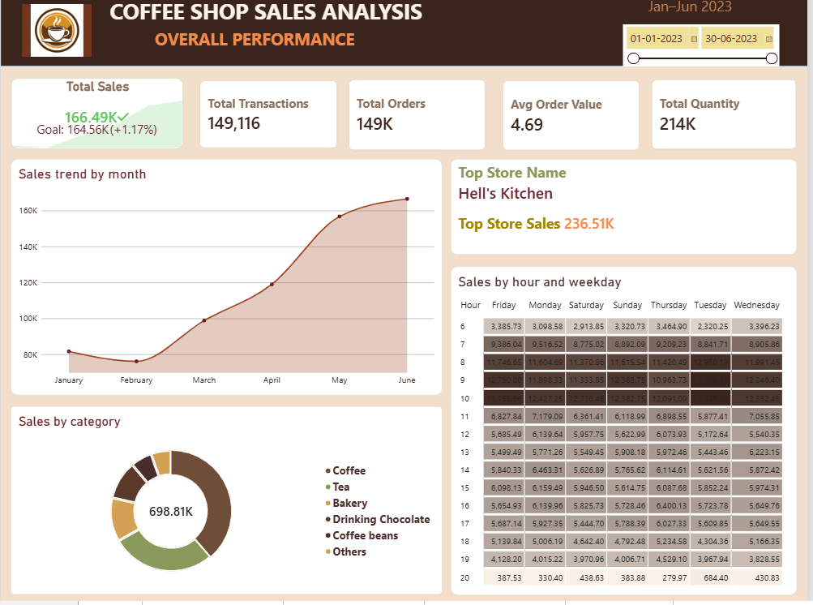

Dashboard -page 1

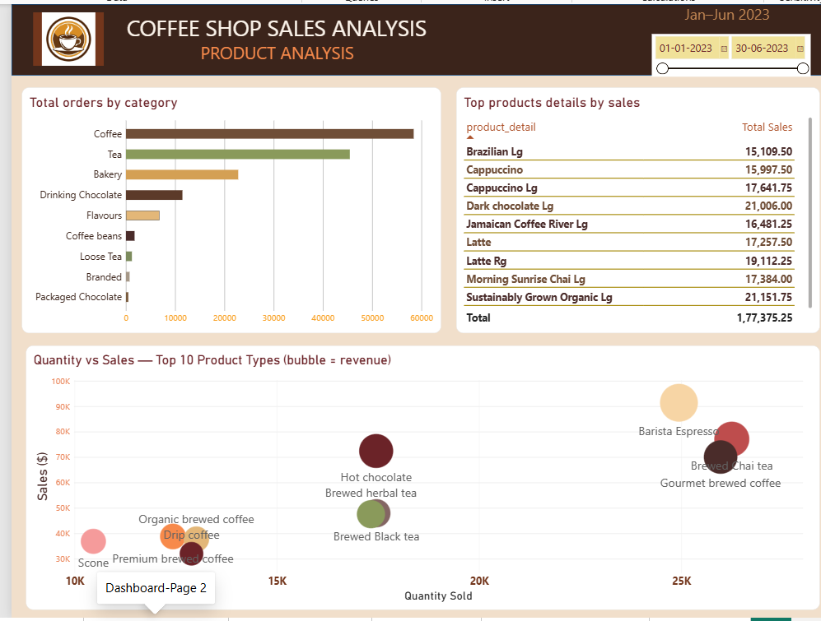
Dashboard -page 2

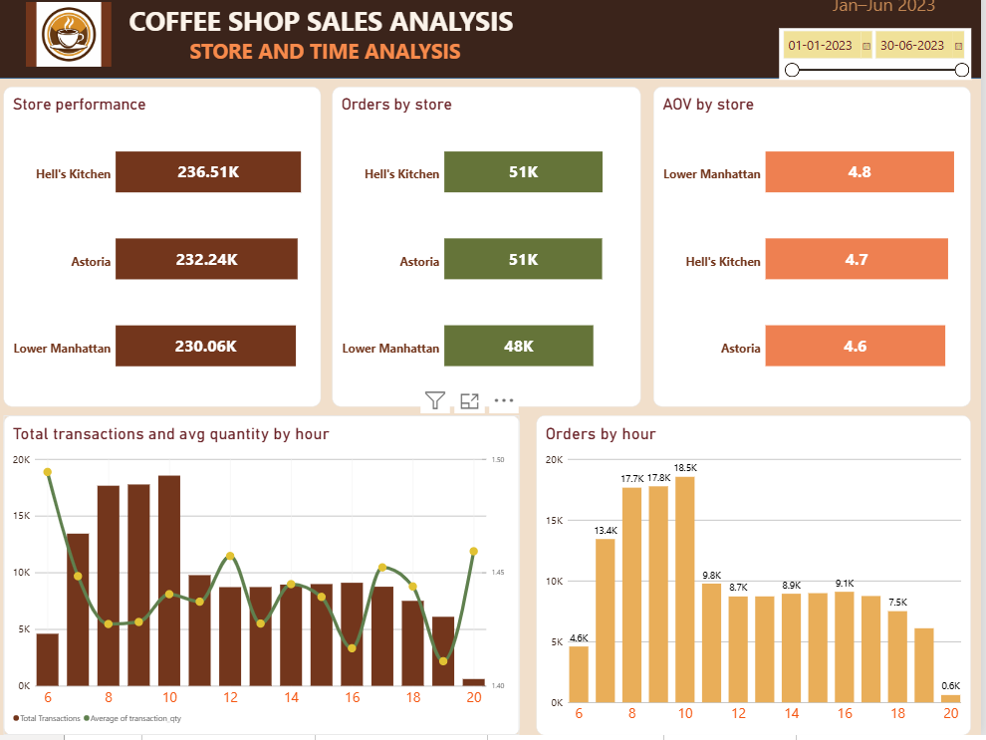
Dashboard -page 3

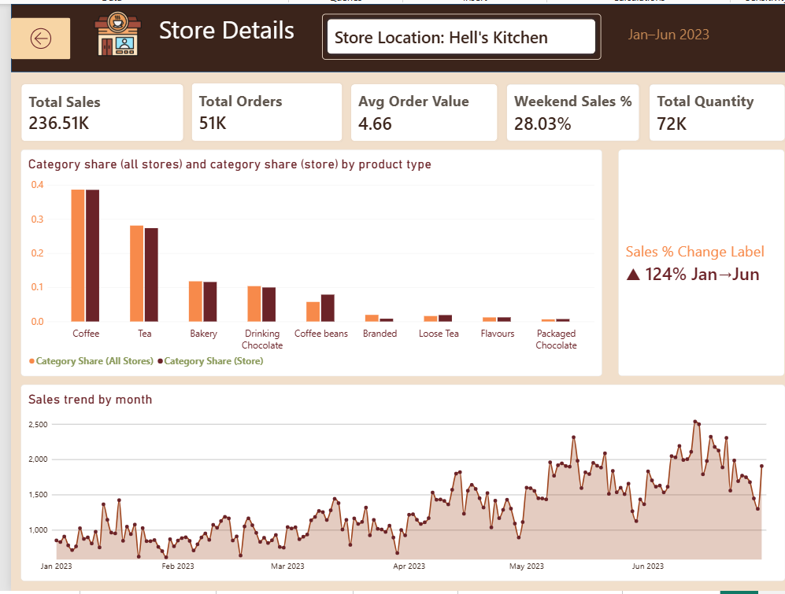
Drillthrough

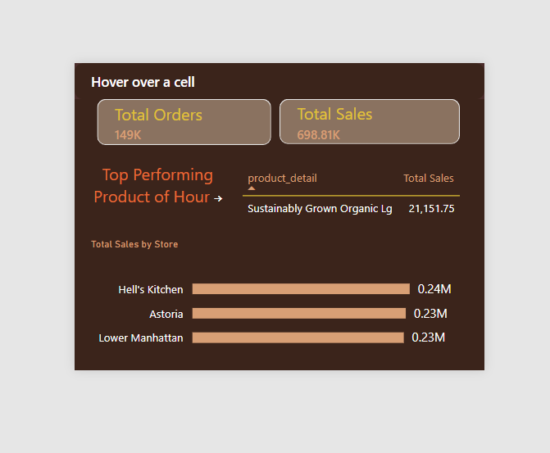
Tooltip

9. Interactivity: Drillthrough and Tooltip

9.1 Store Detail drillthrough
Right-clicking any store in the Store Performance visual on Page 1 or Page 3 drills through to a dedicated Store Detail page, pre-filtered to that store. It shows store-scoped KPIs, a category-mix comparison against the company average, and a store-specific sales trend — answering questions the aggregate pages cannot.

9.2 Heatmap tooltip
Hovering any cell in the Sales by Hour and Weekday heatmap on Page 3 opens a custom report-page tooltip showing total orders and sales for that specific hour/day combination, the top-selling product in that slot, and the sales split across the three stores — detail the heatmap's colour alone cannot convey.

10. Insights and Recommendations
Each finding below follows Data → Finding → Business Implication → Recommendation, derived directly from the dataset rather than assumed:
01 SALES TREND
Finding: Sales grew by about 68% from March to June across all three stores, with each store growing around 65–72%. Coffee alone added $26.5K to the increase, making it the biggest contributor.
Implication: Growth is happening across all categories, not because of one store. Coffee is the main
reason for the growth.
Recommendation: Increase coffee inventory and supply before the seasonal increase in demand.
Don't give credit to just one store for the growth.

02 PEAK HOURS
Finding: The 6–11 AM period makes up 48.9% of total sales and 48.3% of orders — almost half of the business
happens during these 4 hours.
Implication: Not having enough staff or running out of stock during this time could cause a big loss in sales.
Recommendation: Focus more staff and preparation on the
6–11 AM period. Consider having fewer staff after 6 PM, when sales drop a lot.

03 CATEGORY CONCENTRATION
Finding: Coffee makes up 38.6% of total revenue ($269,952), making it the biggest category. It is
about 1.4× larger than the next category, Tea (28.1%).
Implication: Total revenue depends heavily on coffee sales and having enough coffee available.
Recommendation: Give the highest priority to inventory and quality checks for the top coffee
products.

04 PRICE VS VOLUME
Finding: Barista Espresso and Gourmet brewed coffee sell almost the same number of units (~25K
each), but Espresso makes $91.4K compared with $70.0K for Gourmet brewed coffee. The average
price is $3.66 for Espresso and $2.70 for Gourmet brewed coffee.
Implication: The revenue difference comes mainly from the higher price, not from selling more units. Both products have similar customer demand.
Recommendation: Promote or upsell Barista Espresso, or consider increasing the price of Gourmet
brewed coffee since it has similar demand.

05 STORE PARITY
Finding: All three stores are within 2.8% of each other in total sales ($230K–$236.5K). No store is clearly performing much better or worse than the others.
Implication: The performance issue is not specific to one store. Operations seem to be fairly
consistent across all stores.
Recommendation: Focus on company-wide improvements like pricing and product mix instead of making changes to individual stores.

