1.What are the two values of the Boolean data type? How do you write them?

A) The two values of the Boolean data type are:

1) True

2) False

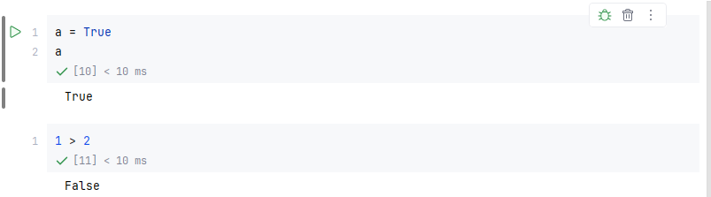

We can also use comparison operators to create Booleans. They must be written with a capital "T" and capital "F".

2. What are the three different types of Boolean operators?

A) The three different types of Boolean operators are: AND, OR, NOT. These operators are used to combine or modify Boolean expressions in logical conditions

1. AND (and): Returns True only if both conditions are true.  
   A close-up of a white rectangular object

   AI-generated content may be incorrect.
2. OR (or): Returns True if at least one condition is true.  
   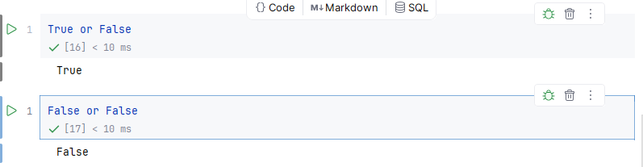
3. NOT (not): Reverses the Boolean value.  
   A close-up of a computer screen

   AI-generated content may be incorrect.

3. Make a list of each Boolean operator’s truth tables (i.e. every possible combination of Boolean values for the operator and what it evaluates).

A) truth tables for each Boolean operator: AND, OR, and NOT.

1. AND (and) - Returns True only if both values are True

|  |  |  |
| --- | --- | --- |
| A | B | A and B |
| True | True | True |
| True | False | False |
| False | True | False |
| False | False | False |

1. OR (or) - Returns True if at least one value is True

|  |  |  |
| --- | --- | --- |
| A | B | A or B |
| True | True | True |
| True | False | True |
| False | True | True |
| False | False | False |

1. NOT (not) - Reverses the Boolean value (only one input)

|  |  |
| --- | --- |
| A | not A |
| True | False |
| False | True |

4. What are the values of the following expressions?

(5 &gt; 4) and (3 == 5)

not (5 &gt; 4)

(5 &gt; 4) or (3 == 5)

not ((5 &gt; 4) or (3 == 5))

(True and True) and (True == False)

(not False) or (not True)

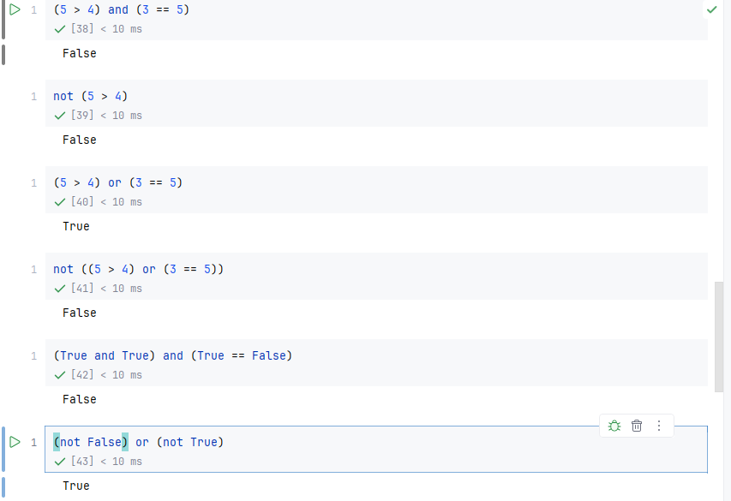

5. What are the six comparison operators?

A) We have six comparison operators: Equal to (==) Not Equal to (! =), Greater than (>), Less than (<), Greater than Equal to (>=), Less than Equal to (<=).

6. How do you tell the difference between the equal to and assignment operators? Describe a condition and when you would use one.

A) 1. Assignment Operator (=) - Assigns a value to a variable. It is Used when you want to store a value in a variable. 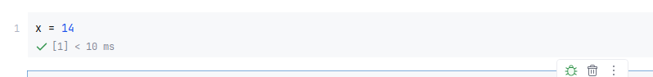

2. Equality Operator (==) - Compares two values to check if they are equal. It is used in conditions like if, while, etc.

7. Identify the three blocks in this code:

spam = 0

if spam == 10:

print('eggs')

if spam > 5:

print('bacon')

else:

print('ham')

print('spam')

print('spam')

1. A white rectangular object with blue lines

   AI-generated content may be incorrect.

8. Write code that prints Hello if 1 is stored in spam, prints Howdy if 2 is stored in spam, and prints Greetings! if anything else is stored in spam.

9.If your programme is stuck in an endless loop, what keys you’ll press?

Hold the Ctrl key and press C (Ctrl + C)

10. How can you tell the difference between break and continue?

1) Break Statement

It exits the entire loop immediately, even if the loop condition is still true. we can use this when we want to stop the loop early because a certain condition is met.A white rectangular sign with blue trim

2. Continue Statement

It skips the rest of the current iteration and moves to the next loop cycle. We can use it when we want to skip certain values but continue looping.

11. In a for loop, what is the difference between range(10), range(0, 10), and range(0, 10, 1)?

1) range(10)

2) range(0, 10)

3) range(0, 10, 1)

It will also has the same result as above two ranges but now you explicitly define all parameters that start with 0 and stop before 10 and increment by 1 each time. So it skips 0 number in between each iteration. 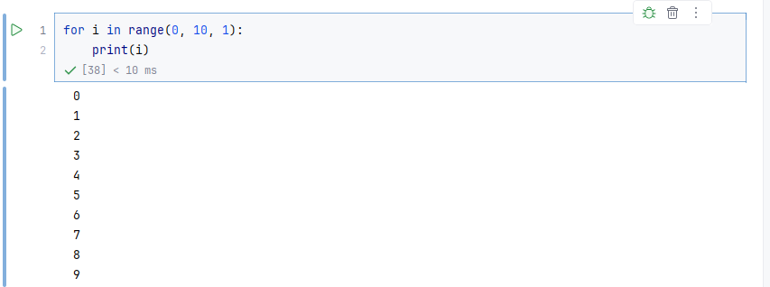

12. Write a short program that prints the numbers 1 to 10 using a for loop. Then write an equivalent program that prints the numbers 1 to 10 using a while loop.

1) for loop

A for loop is used when you know in advance how many times you want to repeat something. It goes through a sequence of numbers or items one by one.

In below example, range(1, 11) means it start from 1 and go up to 10 and i is like a counter it is incremented by 1 each time the loop runs and print(i) displays the number on screen. A screenshot of a computer

2) while loop

A while loop keeps running as long as a condition is true.

In below example, i = 1 starts the counter at 1 and while i <= 10 means keep looping as long as i is 10 or less than 10 and print(i) shows the number and i += 1 increases the value of i by 1 each time. 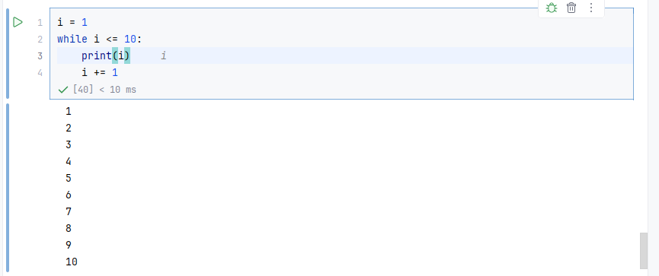

13. If you had a function named bacon() inside a module named spam, how would you call it after importing spam?

Module:

A module is just a file that contains some Python code.

Inside spam.py program we wrote the below code.

def bacon():

print("Hello from bacon!")

Function:

A function is a reusable block of code that performs a specific task.  
In another program (IMPORTING SPAM.PY) we are calling the bacon() funtion which we declared in spam.py program(**import the module**, and then **call the function** from it).

import spam

spam.bacon()

