SAP CAP Extension for S/4HANA
📋 Project Overview
Project Name: cap-s4-extension-demo
Purpose: Build a side-by-side extension for S/4HANA to receive and manage Business Partner data
Technology Stack: SAP CAP, Node.js, SQLite, OData V4
Business Scenario: Receive Business Partner master data from S/4HANA system and expose it via REST API

📂 Project Structure
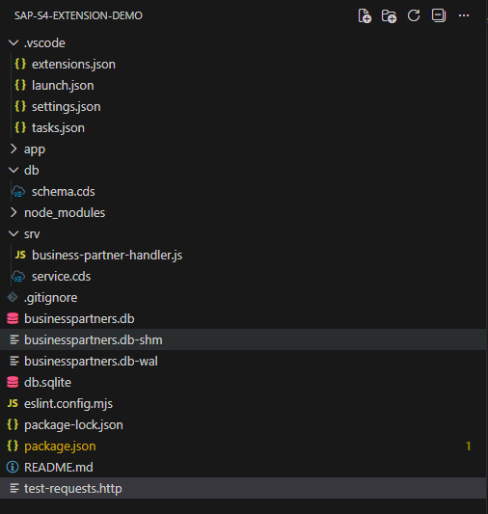

🛠️ Step-by-Step Development Process
STEP 1: Prerequisites Installation
1.1 Install Node.js
What: JavaScript runtime environment
Why: Required to run SAP CAP applications
Version: 20.x or higher
Installation:
- Download from: https://nodejs.org/
- Choose LTS (Long Term Support) version
- Run installer with default settings
- Restart computer after installation
Verification:
node --version
# Expected output: v20.x.x or higher
1.2 Install SAP CDS Development Kit
What: SAP Cloud Application Programming Model tools
Why: Provides cds command and development tools
Installation:
npm install -g @sap/cds-dk
Verification:
cds --version
# Expected output: Shows CDS version information
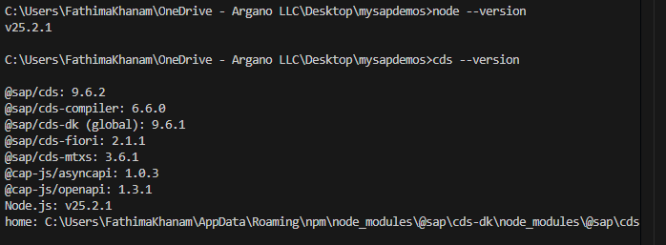

STEP 2: Create New CAP Project
2.1 Create Project
Open Terminal/Command Prompt:
# Navigate to your workspace (e.g., Desktop)
cd Desktop

# Create new CAP project
cds init cap-s4-extension-demo

# Navigate into project folder
cd cap-s4-extension-demo
What Happened:
- Created project folder structure
- Generated basic files (package.json, README.md)
- Created empty db/ and srv/ folders
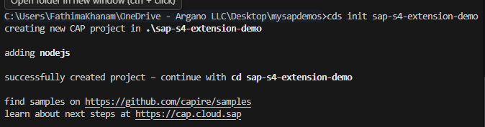
2.2 Open in VS Code
# Open project in VS Code
code .
What You See:
- File explorer with project structure
- Empty db/ and srv/ folders
- package.json file

STEP 3: Define Data Model
3.1 Create Schema File
File: db/schema.cds
Purpose: Define Business Partner entity structure
Create the file:
- Right-click on db folder
- Select "New File"
- Name it: schema.cds
Add this content:
namespace s4extension;

/**
* Business Partner Entity
* Stores master data received from S/4HANA
*/
entity BusinessPartners {
key ID : String(10); // Unique Business Partner ID
FirstName : String(100); // First name
LastName : String(100); // Last name
Email : String(150); // Email address
Phone : String(30); // Phone number
Country : String(3); // Country code (ISO 3166-1 alpha-3)
PartnerType : String(20); // Customer or Supplier
CreatedAt : Timestamp; // Record creation time
ModifiedAt : Timestamp; // Last modification time
}
Understanding the Code:
Element | Explanation
namespace | Logical grouping for entities (like a package)
entity | Defines a database table
key | Primary key field
String(100) | Text field with max 100 characters
Timestamp | Date and time field
Save the file: Ctrl+S
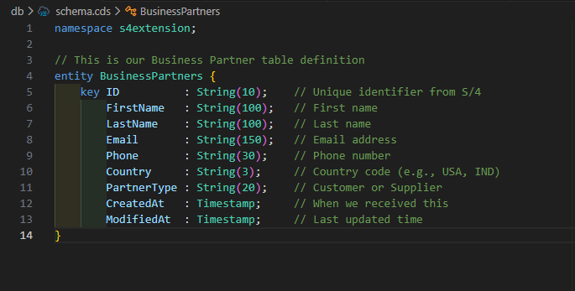
STEP 4: Define Service API
4.1 Create Service Definition
File: srv/service.cds
Purpose: Expose OData API and define custom actions
Create the file:
- Right-click on srv folder
- Select "New File"
- Name it: service.cds
Add this content:
using s4extension from '../db/schema';

/**
* Business Partner Service
* Provides OData API and inbound integration endpoint
*/
@impl: './business-partner-handler.js'
service BusinessPartnerService {

/**
* OData Entity: Read-only access to Business Partners
* External systems can query but not directly modify
*/
@readonly
entity BusinessPartners as projection on s4extension.BusinessPartners;

/**
* Custom Action: Inbound API for S/4HANA
* This is the endpoint S/4HANA calls to send Business Partner data
*
* Input: Business Partner details as parameters
* Output: Success message and ID
*/
action receiveBusinessPartner(
ID : String,
FirstName : String,
LastName : String,
Email : String,
Phone : String,
Country : String,
PartnerType : String
) returns {
message : String;
ID : String;
};
}
Understanding the Code:
Element | Explanation
using | Import entities from schema
@impl | Links service to handler JavaScript file
service | Creates an OData service
@readonly | Users can only read, not create/update/delete
projection | View of the entity
action | Custom operation (like a function call)
returns | Defines output structure
This Creates Endpoints:
- GET /odata/v4/business-partner/BusinessPartners - Read all
- GET /odata/v4/business-partner/BusinessPartners('BP001') - Read one
- POST /odata/v4/business-partner/receiveBusinessPartner - Inbound API
Save the file: Ctrl+S
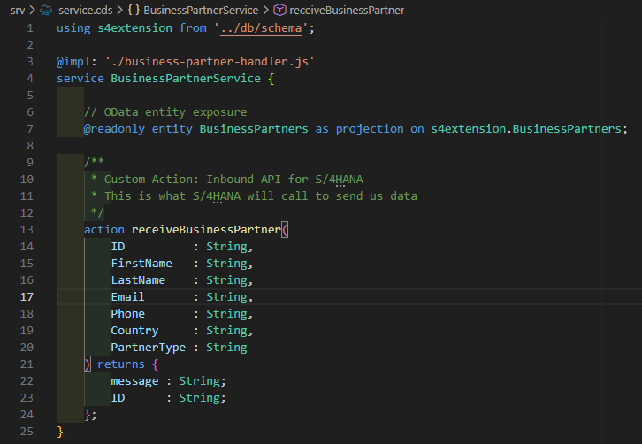
STEP 5: Implement Business Logic
5.1 Create Handler File
File: srv/business-partner-handler.js
Purpose: Implement custom action logic
Create the file:
- Right-click on srv folder
- Select "New File"
- Name it: business-partner-handler.js
Add this content:
const cds = require('@sap/cds');
const cds = require('@sap/cds');

module.exports = cds.service.impl(async function() {

// Get reference to our entity
const { BusinessPartners } = this.entities;

/**
* Custom Action: Receive Business Partner from S/4HANA
* This is our INBOUND API
*/
this.on('receiveBusinessPartner', async (req) => {
try {
// Extract data from the request
const incomingData = req.data;

console.log('📥 Received Business Partner from S/4HANA:', incomingData);

// Prepare the data for our database
const businessPartner = {
ID: incomingData.ID,
FirstName: incomingData.FirstName,
LastName: incomingData.LastName,
Email: incomingData.Email,
Phone: incomingData.Phone,
Country: incomingData.Country,
PartnerType: incomingData.PartnerType,
CreatedAt: new Date().toISOString(),
ModifiedAt: new Date().toISOString()
};

// Check if this Business Partner already exists
const existing = await SELECT.one.from(BusinessPartners).where({ ID: incomingData.ID });

if (existing) {
// UPDATE existing record
await UPDATE(BusinessPartners)
.set({
...businessPartner,
CreatedAt: existing.CreatedAt // Keep original creation time
})
.where({ ID: incomingData.ID });

console.log('✅ Updated existing Business Partner:', incomingData.ID);
return { message: 'Business Partner updated successfully', ID: incomingData.ID };

} else {
// INSERT new record
await INSERT.into(BusinessPartners).entries(businessPartner);

console.log('✅ Created new Business Partner:', incomingData.ID);
return { message: 'Business Partner created successfully', ID: incomingData.ID };
}

} catch (error) {
console.error('❌ Error processing Business Partner:', error);
req.error(500, `Failed to process Business Partner: ${error.message}`);
}
});

/**
* Custom READ handler: Add filtering capabilities
* Example: Get only Customers from India
*/
this.before('READ', BusinessPartners, async (req) => {
console.log('🔍 Reading Business Partners with filters:', req.query);
});

this.after('READ', BusinessPartners, (data) => {
console.log(`📤 Returning ${Array.isArray(data) ? data.length : 1} Business Partner(s)`);
});
});

Understanding the Code:
Key Concepts:
- Event Handlers:
  - this.on('receiveBusinessPartner') - Handles custom action
  - this.before('READ') - Runs before read operations
  - this.after('READ') - Runs after read operations
- CDS Query Language:
  - SELECT.one.from() - Query single record
  - UPDATE().set().where() - Update existing record
  - INSERT.into().entries() - Insert new record
- Upsert Pattern:
  - Check if record exists
  - If yes → Update
  - If no → Create
  - Common in integration scenarios
- Error Handling:
  - Try-catch block
  - Detailed error logging
  - Proper HTTP error responses
Save the file: Ctrl+S
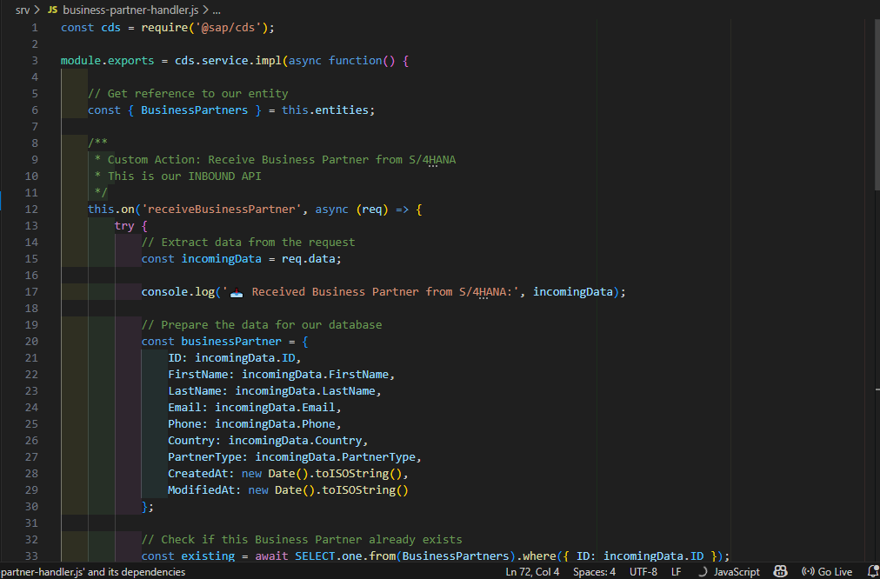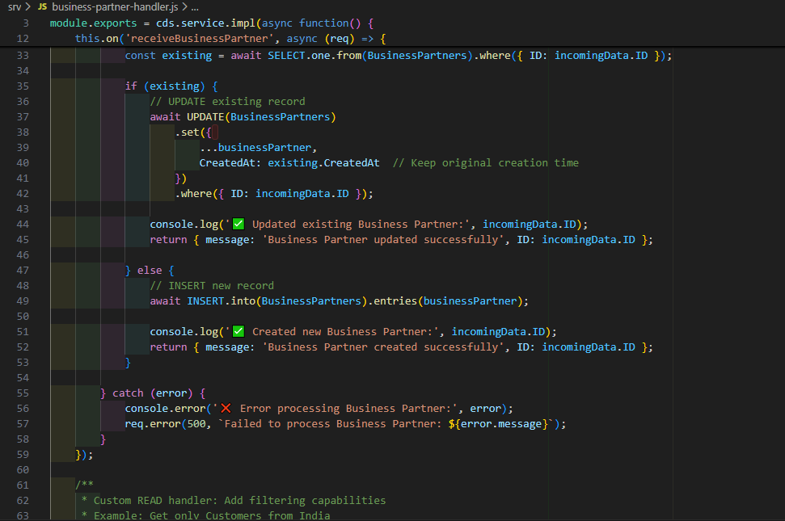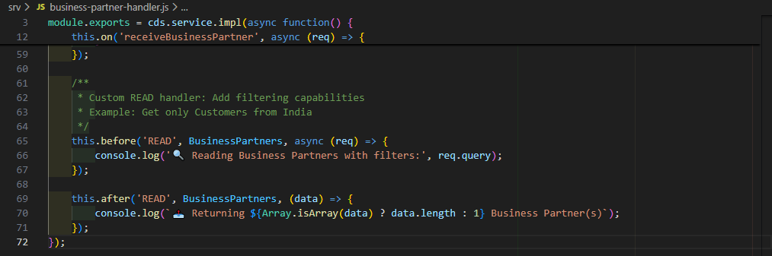
STEP 6: Configure Project Dependencies
6.1 Update package.json
File: package.json
Purpose: Define project dependencies and database configuration
Replace entire content with:
{
"name": "cap-s4-extension-demo",
"version": "1.0.0",
"description": "SAP CAP Extension for S/4HANA Business Partners",
"main": "server.js",
"engines": {
"node": ">=20"
},
"dependencies": {
"@sap/cds": "^9",
"express": "^4"
},
"devDependencies": {
"@cap-js/sqlite": "^2"
},
"scripts": {
"start": "cds-serve",
"watch": "cds watch"
},
"cds": {
"requires": {
"db": {
"kind": "sqlite",
"credentials": {
"database": "businesspartners.db"
}
}
}
},
"private": true
}
Understanding the Configuration:
Section | Explanation
engines | Minimum Node.js version required
dependencies | Runtime libraries (CAP, Express)
devDependencies | Development-only libraries (SQLite)
scripts | Command shortcuts
cds.requires.db | Database configuration
Key Configuration:
- "kind": "sqlite" - Use SQLite database
- "database": "businesspartners.db" - Database file name
- This makes data persistent across server restarts
Save the file: Ctrl+S
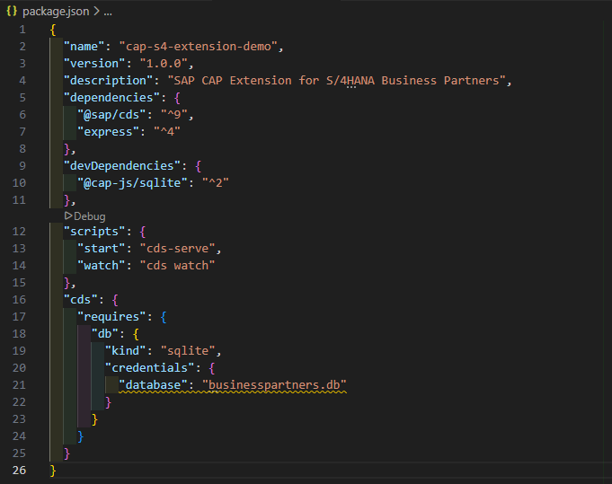
STEP 7: Install Dependencies
7.1 Install Node Modules
Open Terminal in VS Code:
- Press Ctrl+` (backtick key)
- Or: Menu → Terminal → New Terminal
Run installation command:
npm install
What Happens:
- npm reads package.json
- Downloads all dependencies
- Creates node_modules folder
- Creates package-lock.json
Duration: 30-60 seconds (depending on internet speed)
Expected Output:
added 150 packages, and audited 151 packages in 45s
found 0 vulnerabilities
[Screenshot: npm install output]
Verify Installation:
Check that node_modules folder exists with contents:
node_modules/
├── @sap/
│ └── cds/
├── express/
└── ... (many other folders)
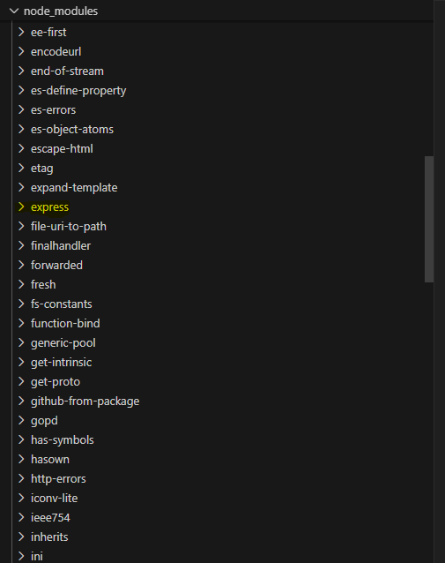
STEP 8: Deploy Database Schema
8.1 Create Database Tables
Purpose: Transform CDS entities into actual database tables
Run deployment command:
cds deploy --to sqlite:businesspartners.db
What This Does:
- Reads: db/schema.cds file
- Compiles: CDS entities to SQL CREATE TABLE statements
- Generates: SQL schema
- Creates: businesspartners.db file
- Executes: SQL to create tables
- Initializes: Empty tables ready for data
Expected Output:
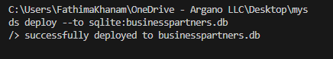Verify Database Creation:
Check that businesspartners.db file exists in project root:
cap-s4-extension-demo/
├── businesspartners.db ← New file created
├── db/
├── srv/
└── package.json
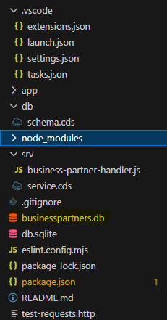
8.2 Verify Database Structure
Optional: Check created tables
Using VS Code Extension
- Ensure "SQLite Viewer" extension is installed
- Click on businesspartners.db file in VS Code
- Extension opens showing:
  - List of tables
  - Table structures
  - Empty data grids
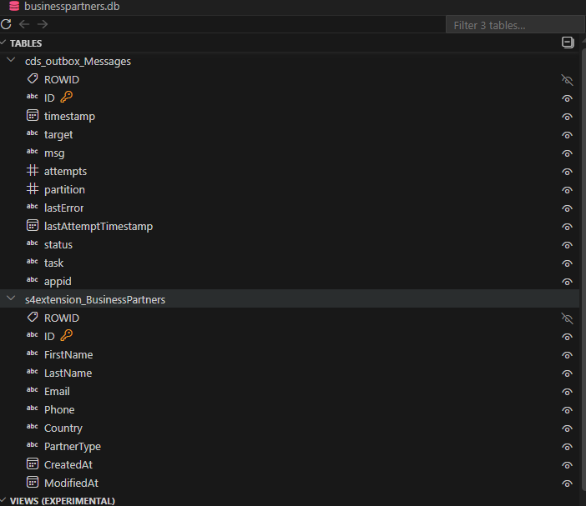
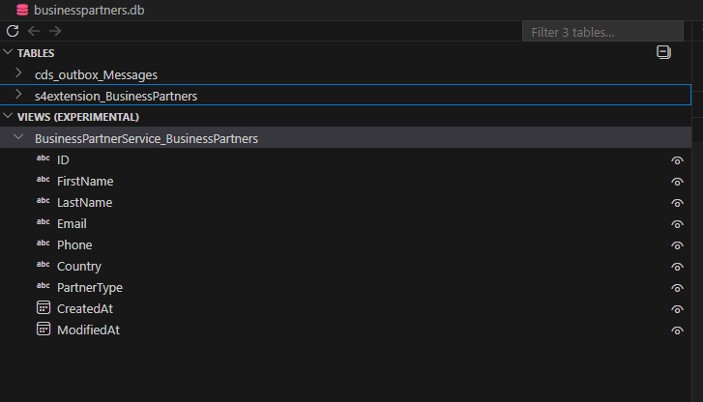
STEP 9: Start the Application
9.1 Start Development Server
Run server command:
cds watch
What This Does:
- Compiles CDS models
- Connects to database
- Loads handler implementations
- Generates OData services
- Starts Express web server on port 4004
- Watches for file changes (auto-reload)
Expected Output:
[cds] - loaded model from 3 file(s):

srv/service.cds
node_modules/@sap/cds/srv/outbox.cds
db/schema.cds

[cds] - connect to db > sqlite { database: 'businesspartners.db' }
[cds] - using auth strategy {
kind: 'mocked',
impl: 'node_modules\\@sap\\cds\\lib\\srv\\middlewares\\auth\\basic-auth.js'
}
[cds] - serving BusinessPartnerService {
at: '/odata/v4/business-partner',
impl: 'srv/business-partner-handler.js'
}

[cds] - server listening on { url: 'http://localhost:4004' }
[cds] - launched in 913 ms
[cds] - [ terminate with ^C ]
Key Lines to Verify:
connect to db > sqlite { database: 'businesspartners.db' } - Database connected
impl: 'srv/business-partner-handler.js' - Handler loaded
server listening on { url: 'http://localhost:4004' } - Server running
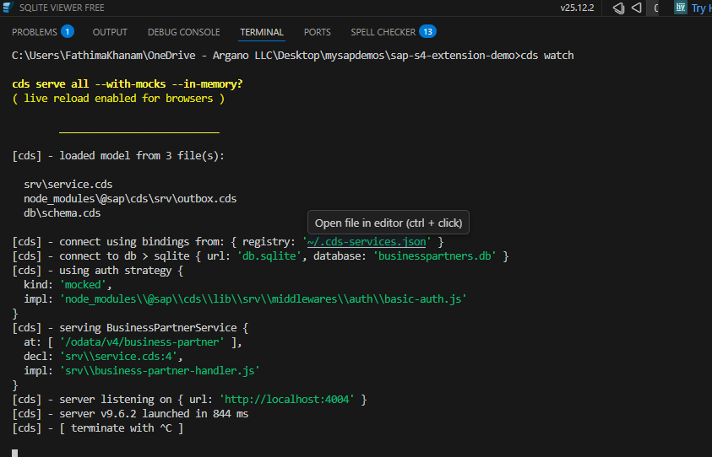
9.2 Verify Server is Running
Open browser and navigate to:
http://localhost:4004
Expected Result:
Welcome page showing:
Welcome to cds.services

BusinessPartnerService
/odata/v4/business-partner
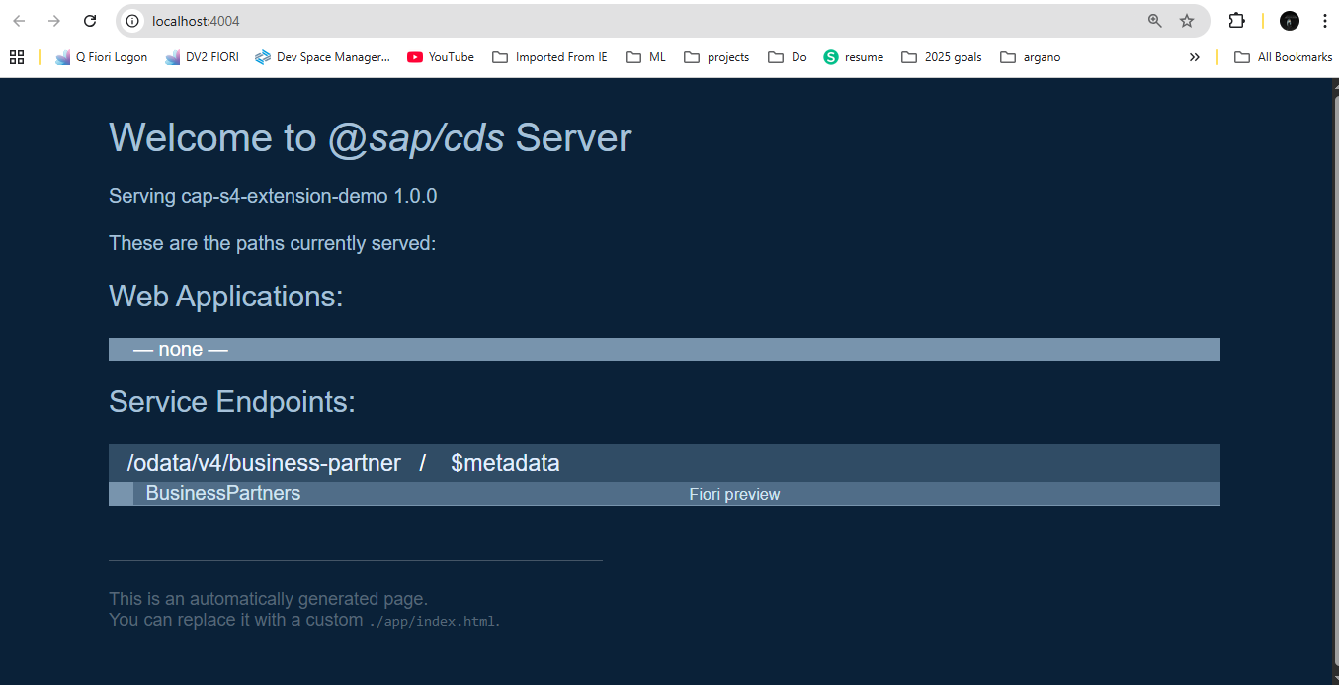
Test Service Metadata:
Navigate to:
http://localhost:4004/odata/v4/business-partner/$metadata
Expected Result:
XML document showing service structure:
This XML file does not appear to have any style information associated with it. The document tree is shown below.
<edmx:Edmx xmlns:edmx="http://docs.oasis-open.org/odata/ns/edmx" Version="4.0">
<edmx:Reference Uri="https://oasis-tcs.github.io/odata-vocabularies/vocabularies/Org.OData.Capabilities.V1.xml">
<edmx:Include Alias="Capabilities" Namespace="Org.OData.Capabilities.V1"/>
</edmx:Reference>
<edmx:Reference Uri="https://sap.github.io/odata-vocabularies/vocabularies/Common.xml">
<edmx:Include Alias="Common" Namespace="com.sap.vocabularies.Common.v1"/>
</edmx:Reference>
<edmx:Reference Uri="https://oasis-tcs.github.io/odata-vocabularies/vocabularies/Org.OData.Core.V1.xml">
<edmx:Include Alias="Core" Namespace="Org.OData.Core.V1"/>
</edmx:Reference>
<edmx:DataServices>
<Schema xmlns="http://docs.oasis-open.org/odata/ns/edm" Namespace="BusinessPartnerService">
<Annotation Term="Core.Links">
<Collection>
<Record>
<PropertyValue Property="rel" String="author"/>
<PropertyValue Property="href" String="https://cap.cloud.sap"/>
</Record>
</Collection>
</Annotation>
<EntityContainer Name="EntityContainer">
<EntitySet Name="BusinessPartners" EntityType="BusinessPartnerService.BusinessPartners"/>
<ActionImport Name="receiveBusinessPartner" Action="BusinessPartnerService.receiveBusinessPartner"/>
</EntityContainer>
<EntityType Name="BusinessPartners">
<Key>
<PropertyRef Name="ID"/>
</Key>
<Property Name="ID" Type="Edm.String" MaxLength="10" Nullable="false"/>
<Property Name="FirstName" Type="Edm.String" MaxLength="100"/>
<Property Name="LastName" Type="Edm.String" MaxLength="100"/>
<Property Name="Email" Type="Edm.String" MaxLength="150"/>
<Property Name="Phone" Type="Edm.String" MaxLength="30"/>
<Property Name="Country" Type="Edm.String" MaxLength="3"/>
<Property Name="PartnerType" Type="Edm.String" MaxLength="20"/>
<Property Name="CreatedAt" Type="Edm.DateTimeOffset" Precision="7"/>
<Property Name="ModifiedAt" Type="Edm.DateTimeOffset" Precision="7"/>
</EntityType>
<ComplexType Name="return_BusinessPartnerService_receiveBusinessPartner">
<Property Name="message" Type="Edm.String"/>
<Property Name="ID" Type="Edm.String"/>
</ComplexType>
<Action Name="receiveBusinessPartner" IsBound="false">
<Parameter Name="ID" Type="Edm.String"/>
<Parameter Name="FirstName" Type="Edm.String"/>
<Parameter Name="LastName" Type="Edm.String"/>
<Parameter Name="Email" Type="Edm.String"/>
<Parameter Name="Phone" Type="Edm.String"/>
<Parameter Name="Country" Type="Edm.String"/>
<Parameter Name="PartnerType" Type="Edm.String"/>
<ReturnType Type="BusinessPartnerService.return_BusinessPartnerService_receiveBusinessPartner"/>
</Action>
<Annotations Target="BusinessPartnerService.EntityContainer/BusinessPartners">
<Annotation Term="Capabilities.DeleteRestrictions">
<Record Type="Capabilities.DeleteRestrictionsType">
<PropertyValue Property="Deletable" Bool="false"/>
</Record>
</Annotation>
<Annotation Term="Capabilities.InsertRestrictions">
<Record Type="Capabilities.InsertRestrictionsType">
<PropertyValue Property="Insertable" Bool="false"/>
</Record>
</Annotation>
<Annotation Term="Capabilities.UpdateRestrictions">
<Record Type="Capabilities.UpdateRestrictionsType">
<PropertyValue Property="Updatable" Bool="false"/>
</Record>
</Annotation>
</Annotations>
</Schema>
</edmx:DataServices>
</edmx:Edmx>

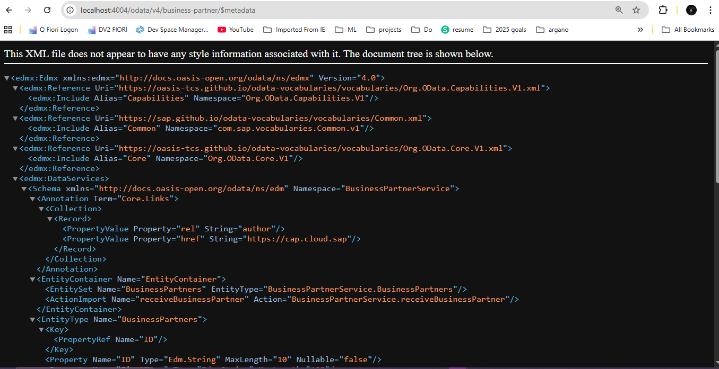
STEP 10: Create Test File
10.1 Create HTTP Test Requests
File: test-requests.http
Purpose: Test API endpoints using REST Client extension
Create file in project root:
- Right-click in Explorer (root level)
- New File
- Name: test-requests.http
Add this content: &
Testing the Application
1. Test: Send Business Partner from S/4HANA (Create New)
POST http://localhost:4004/odata/v4/business-partner/receiveBusinessPartner
Content-Type: application/json

{
"ID": "BP001",
"FirstName": "Rajesh",
"LastName": "Kumar",
"Email": "rajesh.kumar@example.com",
"Phone": "+91-9876543210",
"Country": "IND",
"PartnerType": "Customer"
}
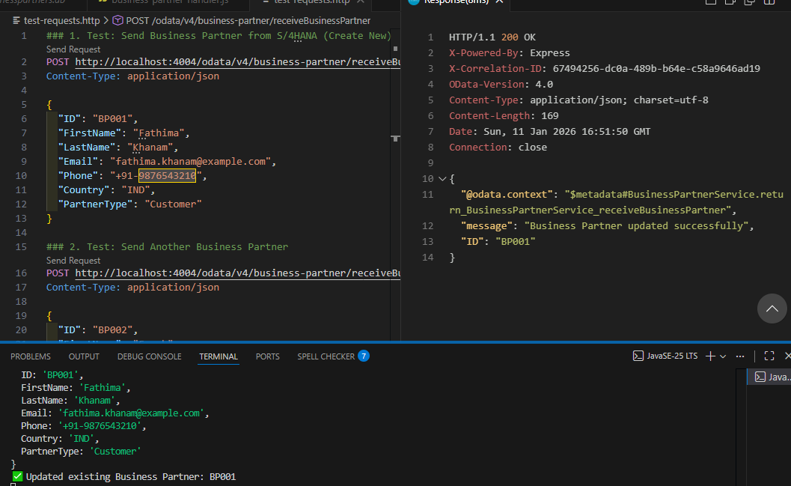
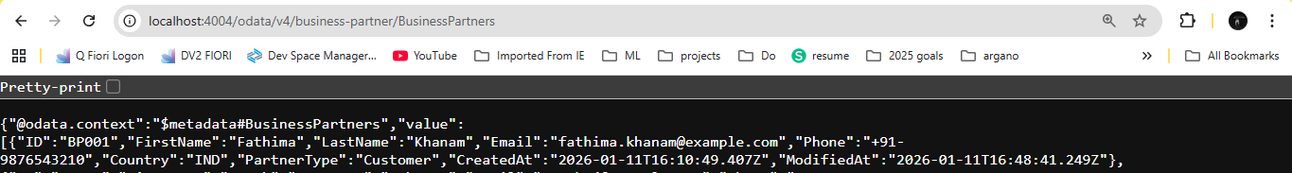
2. Test: Send Another Business Partner
POST http://localhost:4004/odata/v4/business-partner/receiveBusinessPartner
Content-Type: application/json
{
"ID": "BP002",
"FirstName": "Sarah",
"LastName": "Johnson",
"Email": "sarah.j@example.com",
"Phone": "+1-555-0123",
"Country": "USA",
"PartnerType": "Supplier"
}
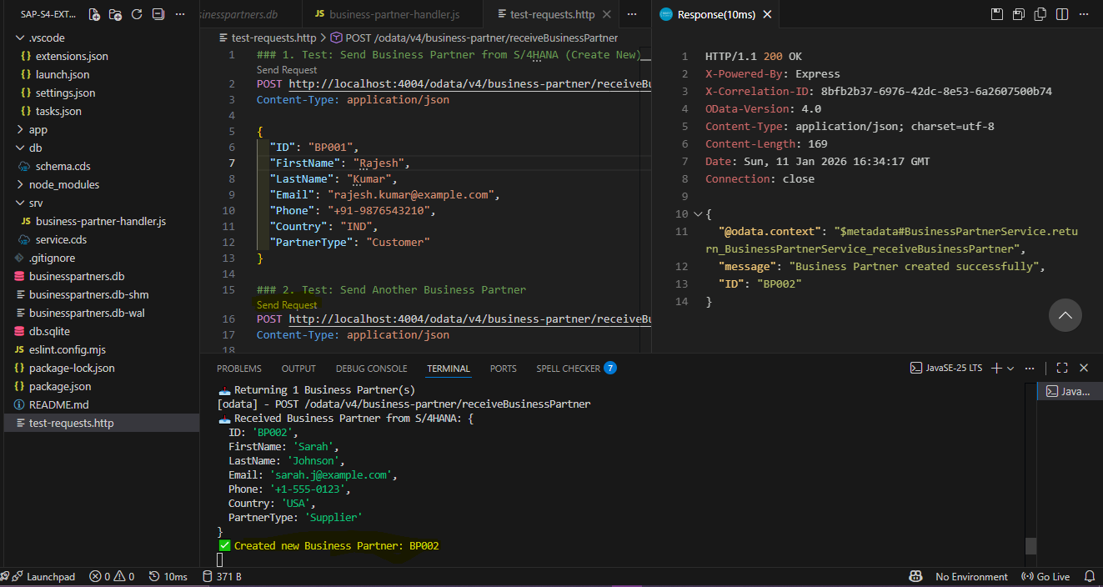
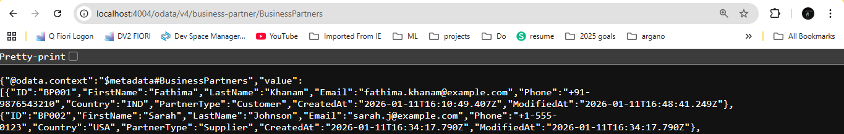

3. Test: Send Indian Supplier
POST http://localhost:4004/odata/v4/business-partner/receiveBusinessPartner
Content-Type: application/json

{
"ID": "BP003",
"FirstName": "Priya",
"LastName": "Sharma",
"Email": "priya.sharma@example.com",
"Phone": "+91-9988776655",
"Country": "IND",
"PartnerType": "Supplier"
}
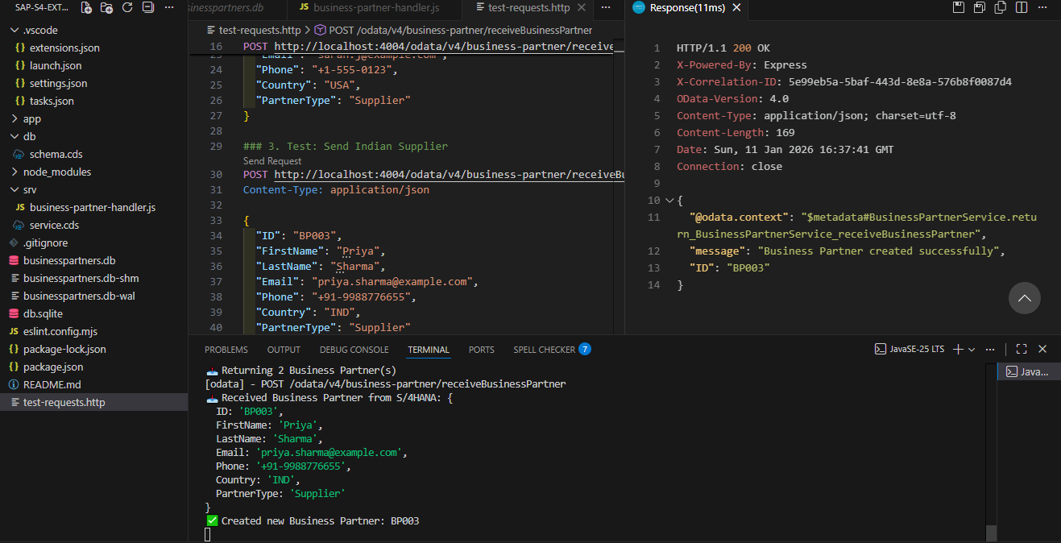
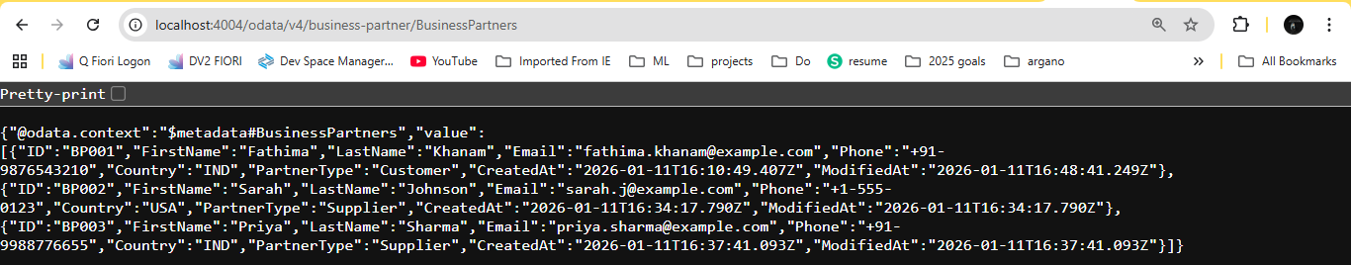
4. Test: Update Existing Business Partner (send BP001 again with changes)
POST http://localhost:4004/odata/v4/business-partner/receiveBusinessPartner
Content-Type: application/json

{
"ID": "BP001",
"FirstName": "Rajesh",
"LastName": "Kumar Updated",
"Email": "rajesh.new@example.com",
"Phone": "+91-9876543210",
"Country": "IND",
"PartnerType": "Customer"
}
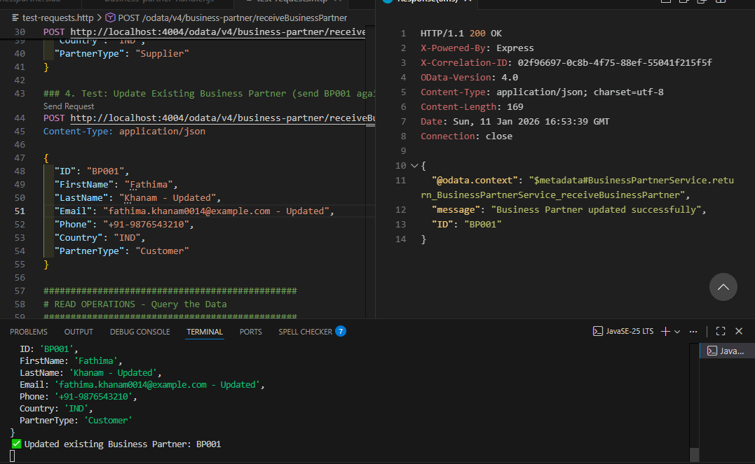
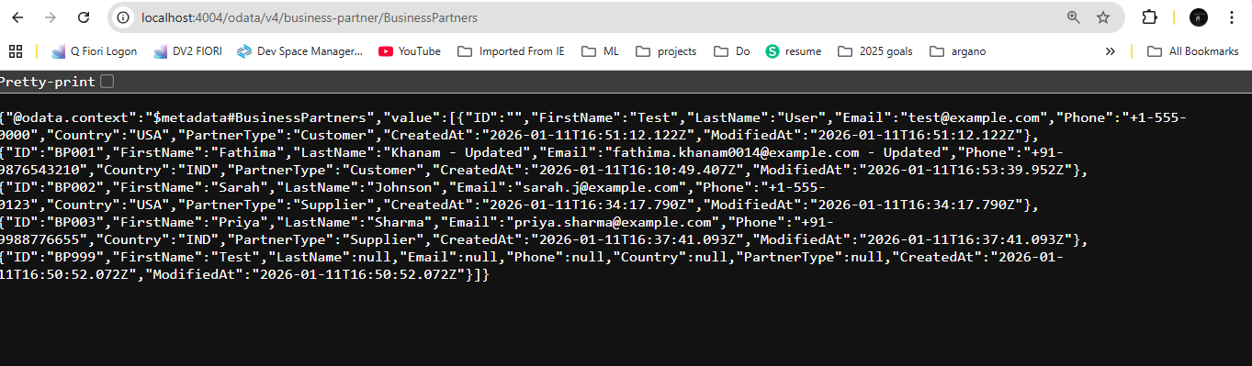
READ OPERATIONS - Query the Data
5. Get All Business Partners
GET http://localhost:4004/odata/v4/business-partner/BusinessPartners
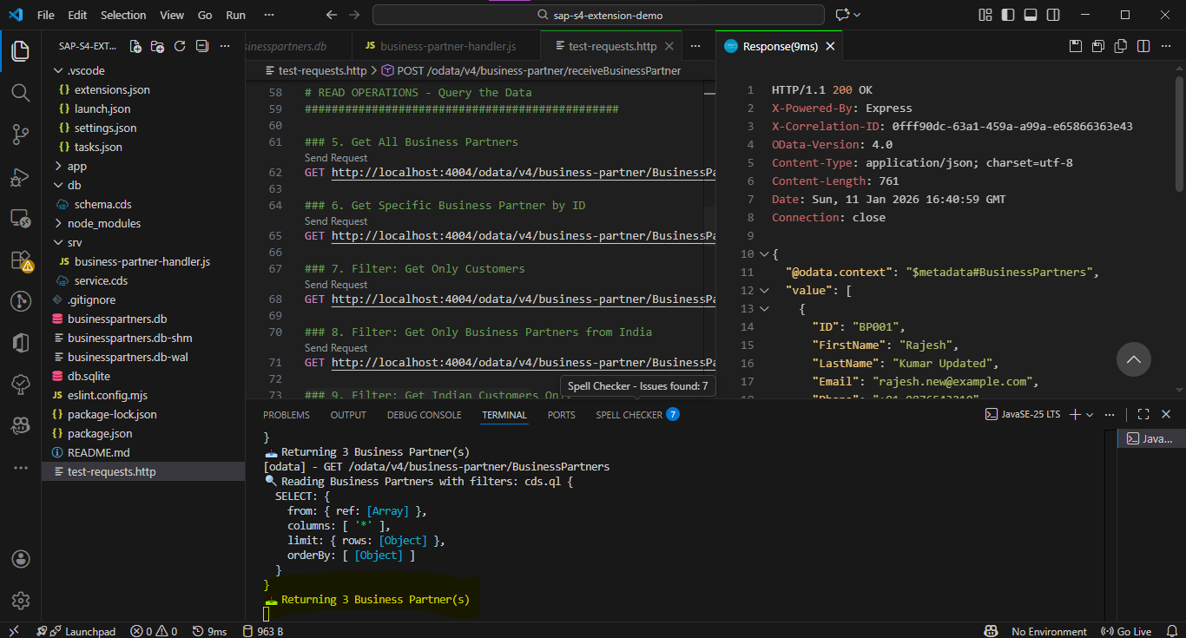

6. Get Specific Business Partner by ID
GET http://localhost:4004/odata/v4/business-partner/BusinessPartners('BP001')
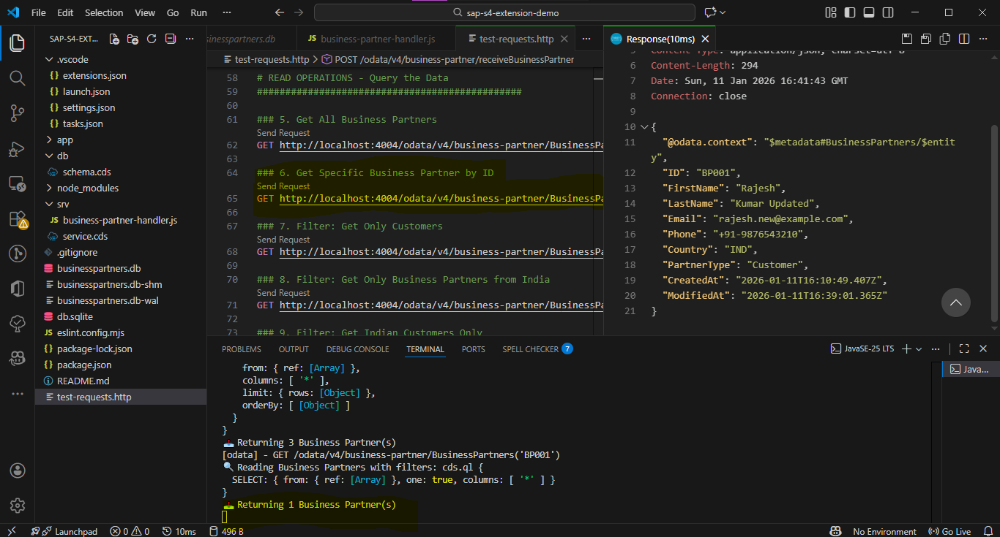
7. Filter: Get Only Customers
GET http://localhost:4004/odata/v4/business-partner/BusinessPartners?$filter=PartnerType eq 'Customer'
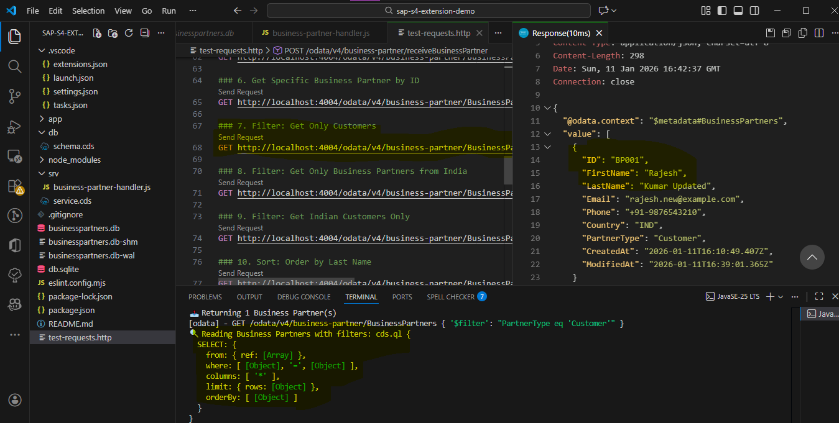
8. Filter: Get Only Business Partners from India
GET http://localhost:4004/odata/v4/business-partner/BusinessPartners?$filter=Country eq 'IND'
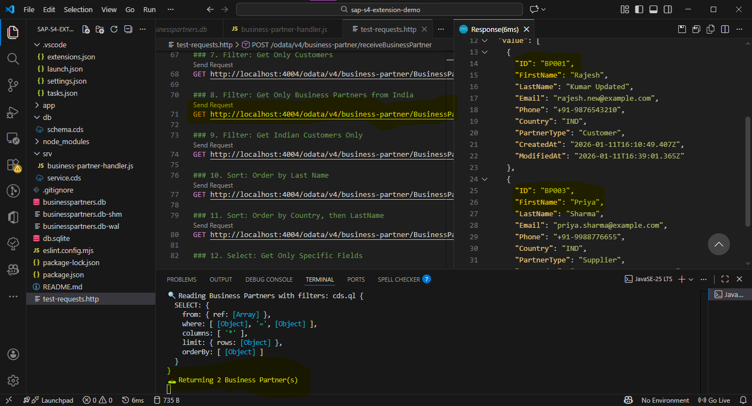
9. Filter: Get Indian Customers Only
GET http://localhost:4004/odata/v4/business-partner/BusinessPartners?$filter=Country eq 'IND' and PartnerType eq 'Customer'
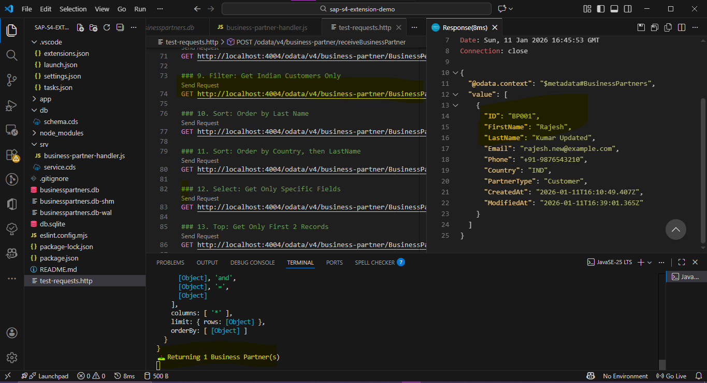
10. Sort: Order by Last Name
GET http://localhost:4004/odata/v4/business-partner/BusinessPartners?$orderby=LastName
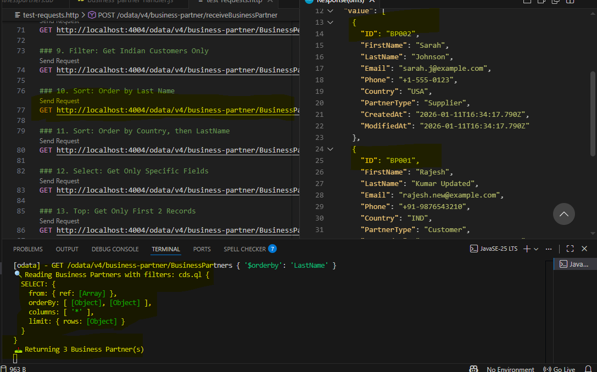
11. Sort: Order by Country, then LastName
GET http://localhost:4004/odata/v4/business-partner/BusinessPartners?$orderby=Country,LastName
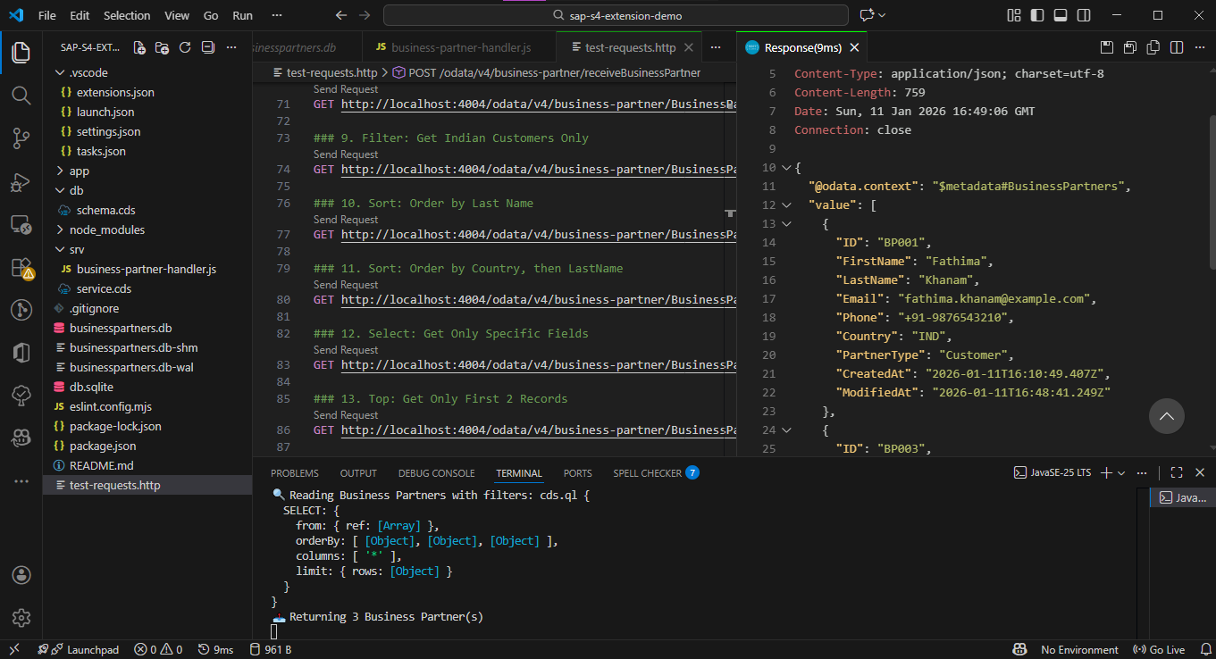
12. Select: Get Only Specific Fields
GET http://localhost:4004/odata/v4/business-partner/BusinessPartners?$select=ID,FirstName,LastName,Country
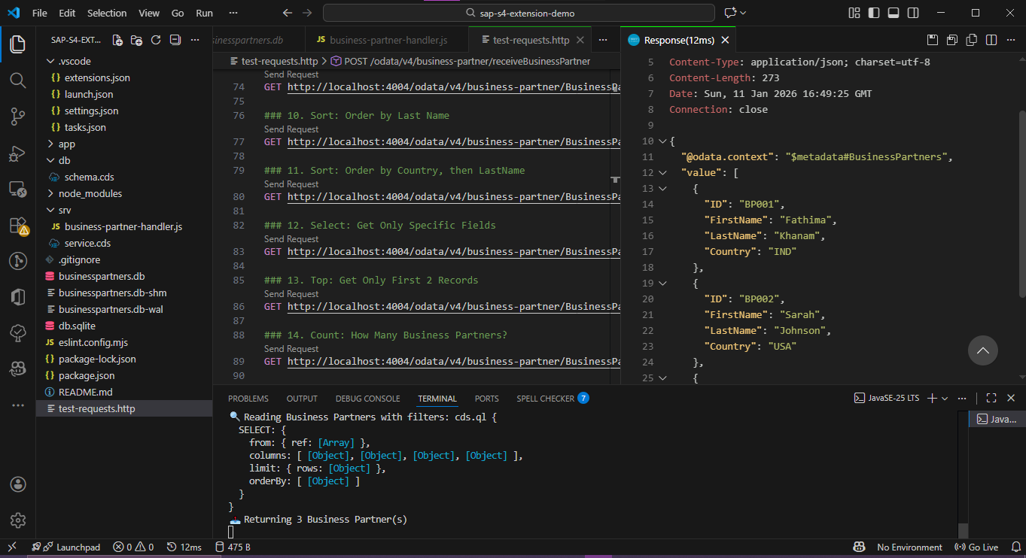
13. Top: Get Only First 2 Records
GET http://localhost:4004/odata/v4/business-partner/BusinessPartners?$top=2
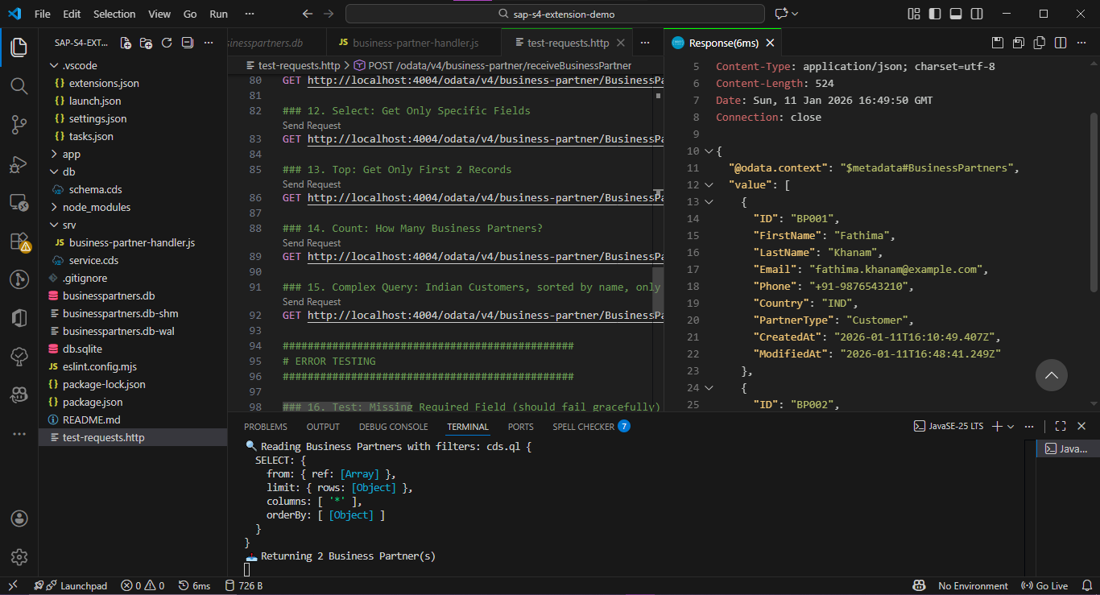
14. Count: How Many Business Partners?
GET http://localhost:4004/odata/v4/business-partner/BusinessPartners/$count
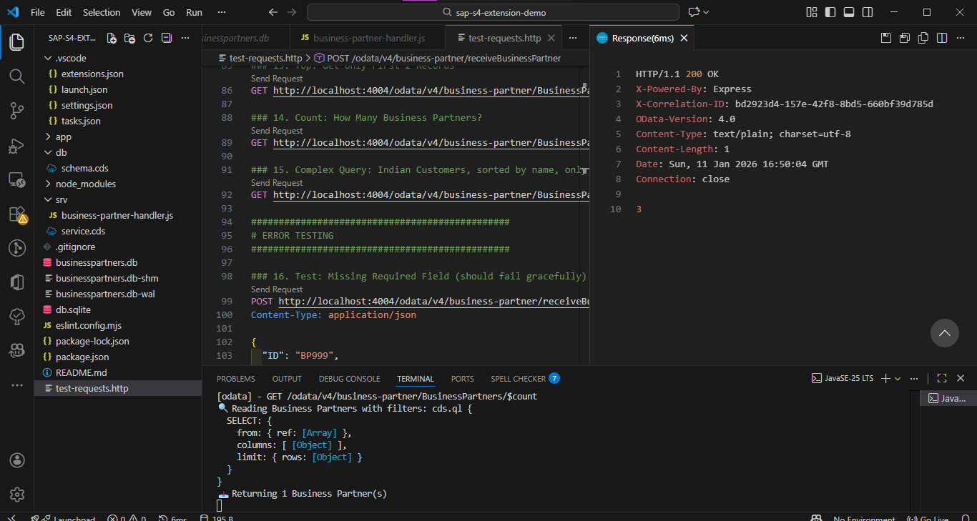
15. Complex Query: Indian Customers, sorted by name, only ID and Name
GET http://localhost:4004/odata/v4/business-partner/BusinessPartners?$filter=Country eq 'IND' and PartnerType eq 'Customer'&$orderby=LastName&$select=ID,FirstName,LastName
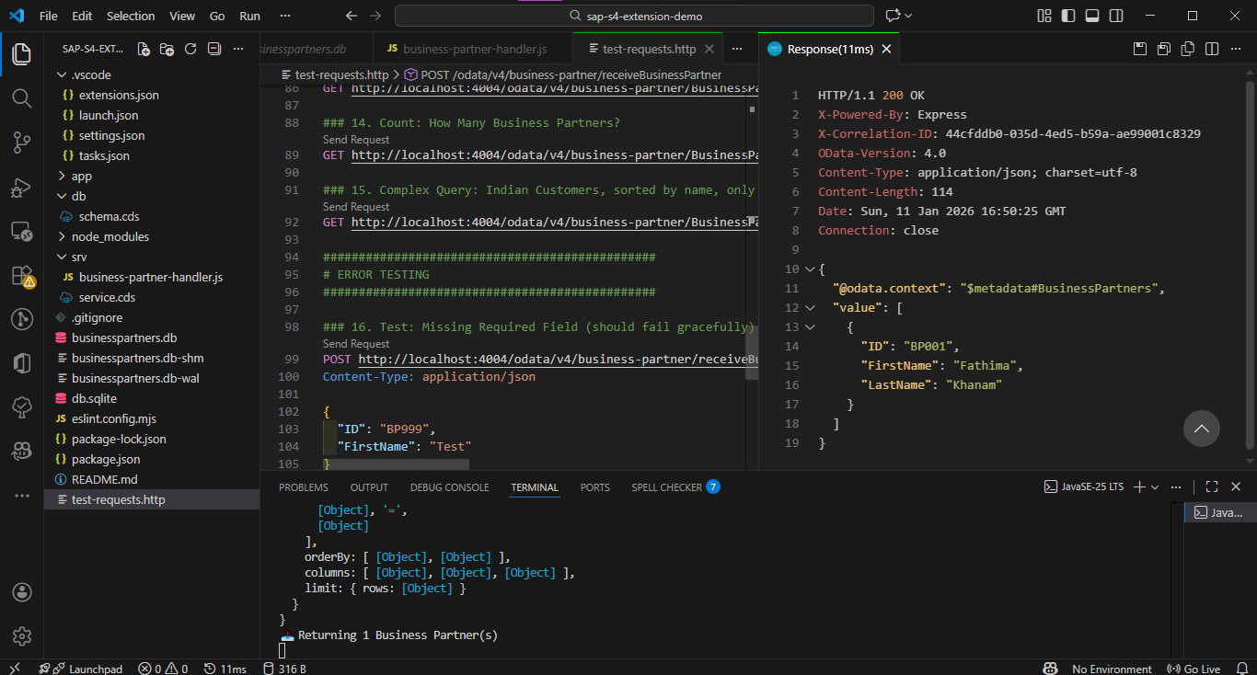

ERROR TESTING
16. Test: Missing Required Field (should fail gracefully)
POST http://localhost:4004/odata/v4/business-partner/receiveBusinessPartner
Content-Type: application/json
{
"ID": "BP999",
"FirstName": "Test"
}
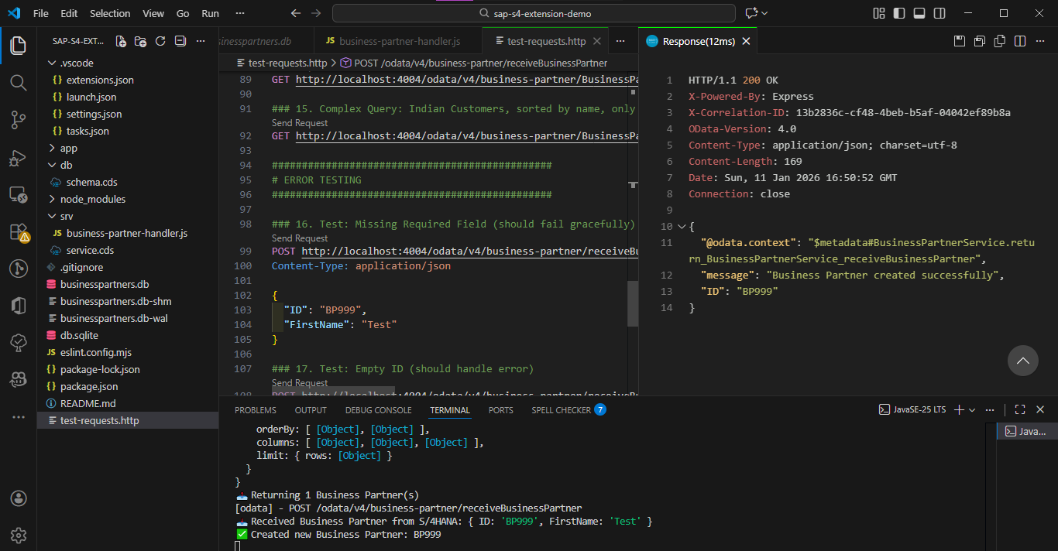
17. Test: Empty ID (should handle error)
POST http://localhost:4004/odata/v4/business-partner/receiveBusinessPartner
Content-Type: application/json
{
"ID": "",
"FirstName": "Test",
"LastName": "User",
"Email": "test@example.com",
"Phone": "+1-555-0000",
"Country": "USA",
"PartnerType": "Customer"
}
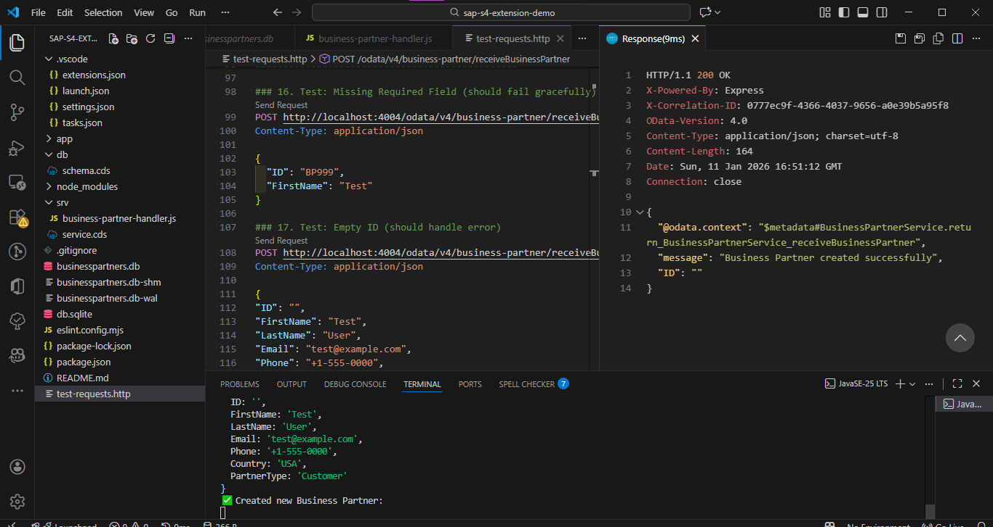

STEP 12: Verify in Database
12.1 Check Database Directly
Method 1: Using SQLite Viewer Extension
- Click on businesspartners.db file in VS Code
- Extension opens showing database structure
- Click on table: s4extension_BusinessPartners
- View all records in grid format
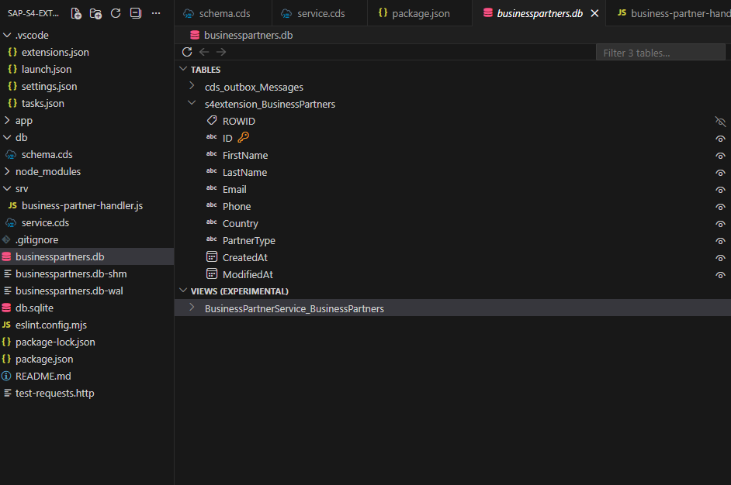

STEP 13: Understanding OData Query Capabilities
13.1 Filter Operations ($filter)
Equals:
$filter=Country eq 'IND'
SQL equivalent: WHERE Country = 'IND'

Not Equals:
$filter=Country ne 'USA'
SQL equivalent: WHERE Country != 'USA'

Greater Than (for strings, alphabetically):
$filter=ID gt 'BP002'
SQL equivalent: WHERE ID > 'BP002'

Multiple Conditions (AND):
$filter=Country eq 'IND' and PartnerType eq 'Customer'
SQL equivalent: WHERE Country = 'IND' AND PartnerType = 'Customer'

Multiple Conditions (OR):
$filter=Country eq 'IND' or Country eq 'USA'
SQL equivalent: WHERE Country = 'IND' OR Country = 'USA'

Contains (Substring Search):
$filter=contains(LastName,'Kumar')
SQL equivalent: WHERE LastName LIKE '%Kumar%'

Starts With:
$filter=startswith(Email,'rajesh')
SQL equivalent: WHERE Email LIKE 'rajesh%'

Ends With:
$filter=endswith(Email,'example.com')
SQL equivalent: WHERE Email LIKE '%example.com'

13.2 Sorting ($orderby)
Sort Ascending:
$orderby=LastName
SQL equivalent: ORDER BY LastName ASC

Sort Descending:
$orderby=LastName desc
SQL equivalent: ORDER BY LastName DESC
Sort by Multiple Fields:
$orderby=Country,LastName
SQL equivalent: ORDER BY Country ASC, LastName ASC
13.3 Field Selection ($select)
Select Specific Fields:
$select=ID,FirstName,LastName
SQL equivalent: SELECT ID, FirstName, LastName
Benefits:
- Reduces response size
- Faster data transfer
- Better performance

13.4 Pagination
Limit Results ($top):
$top=5
SQL equivalent: LIMIT 5
Returns first 5 records.

Skip Records ($skip):
$skip=10
SQL equivalent: OFFSET 10
Skips first 10 records.

Combine for Pagination:
$skip=10&$top=5
SQL equivalent: LIMIT 5 OFFSET 10
Skips 10, returns next 5 (records 11-15).
Use Case: Building paginated tables
- Page 1: $skip=0&$top=10
- Page 2: $skip=10&$top=10
- Page 3: $skip=20&$top=10

13.5 Count Records ($count)
Get Total Count:
/BusinessPartners/$count
Response:
3
Just a number, not JSON.

13.6 Combining Multiple Operations
Complex Query Example:
GET /BusinessPartners
?$filter=Country eq 'IND' and PartnerType eq 'Customer'
&$orderby=LastName desc
&$select=ID,FirstName,LastName,Email,Phone
&$top=10
&$skip=0
This Query:
- Filters: Indian Customers only
- Sorts: By LastName descending
- Selects: Only 5 fields
- Limits: First 10 results
- Pagination: Starting from record 0
Use Case: Building a filtered, sorted, paginated table in UI

STEP 14: How the Application Works
14.1 Request Flow - CREATE Operation
Step-by-Step Flow:
1. HTTP POST Request Arrives
↓
URL: /odata/v4/business-partner/receiveBusinessPartner
Body: { "ID": "BP001", "FirstName": "Rajesh", ... }

2. CAP Framework Routes Request
↓
Identifies: receiveBusinessPartner action
Finds: @impl annotation pointing to handler file

3. Handler Function Executes
↓
this.on('receiveBusinessPartner', async (req) => { ... })
Extracts: req.data

4. Data Preparation
↓
Creates businessPartner object with timestamps

5. Database Check
↓
SELECT.one.from(BusinessPartners).where({ ID: 'BP001' })
Result: null (doesn't exist)

6. Insert Operation
↓
INSERT.into(BusinessPartners).entries(businessPartner)
SQLite executes: INSERT INTO s4extension_BusinessPartners VALUES (...)

7. Return Success
↓
Returns: { message: "Business Partner created successfully", ID: "BP001" }

8. HTTP Response Sent
↓
Status: 200 OK
Body: { "message": "...", "ID": "BP001" }

14.2 Request Flow - UPDATE Operation (Upsert)
Step-by-Step Flow:
1. HTTP POST Request Arrives
↓
Same endpoint, but ID already exists: BP001

2-4. Same as Create Flow
↓

5. Database Check
↓
SELECT.one.from(BusinessPartners).where({ ID: 'BP001' })
Result: { ID: 'BP001', ... } (exists!)

6. Update Operation
↓
UPDATE(BusinessPartners)
.set({ ...businessPartner, CreatedAt: existing.CreatedAt })
.where({ ID: 'BP001' })
SQLite executes: UPDATE s4extension_BusinessPartners SET ... WHERE ID = 'BP001'

7. Return Success
↓
Returns: { message: "Business Partner updated successfully", ID: "BP001" }

8. HTTP Response Sent
↓
Status: 200 OK
Body: { "message": "updated successfully", "ID": "BP001" }

14.3 Request Flow - READ Operation
Step-by-Step Flow:
1. HTTP GET Request Arrives
↓
URL: /odata/v4/business-partner/BusinessPartners?$filter=Country eq 'IND'

2. CAP Framework Parses OData Query
↓
Identifies: BusinessPartners entity
Filter: Country eq 'IND'

3. Before Handler Executes (Optional)
↓
this.before('READ', BusinessPartners, ...)
Logs query details

4. CAP Generates SQL
↓
Converts OData to SQL:
SELECT * FROM s4extension_BusinessPartners WHERE Country = 'IND'

5. Database Executes Query
↓
SQLite returns matching records

6. After Handler Executes (Optional)
↓
this.after('READ', BusinessPartners, ...)
Logs result count

7. CAP Formats Response
↓
Converts to OData JSON format
Adds @odata.context metadata

8. HTTP Response Sent
↓
Status: 200 OK
Body: { "@odata.context": "...", "value": [...] }

STEP 15: Common Scenarios & Solutions
15.1 Server Not Starting
Problem: cds watch fails
Solution Checklist:
bash
# Check Node.js installed
node --version

# Check CDS installed
cds --version

# Install dependencies
npm install

# Check for syntax errors in .cds files
# Look at error message in terminal

# Try clean install
rm -rf node_modules package-lock.json
npm install

15.2 Database Table Not Found
Problem: "no such table: BusinessPartnerService_BusinessPartners"
Solution:
bash
# Stop server (Ctrl+C)

# Deploy database schema
cds deploy --to sqlite:businesspartners.db

# Restart server
cds watch
15.3 Handler Not Loading
Problem: "Service has no handler for receiveBusinessPartner"
Solution:
- Check srv/service.cds has @impl annotation:
cds
@impl: './business-partner-handler.js'
service BusinessPartnerService {
- Check handler file exports function:
javascript
module.exports = async function() {
- Restart server:
bash
# Ctrl+C
cds watch
- Verify terminal shows:
impl: 'srv/business-partner-handler.js'

15.4 Data Not Persisting
Problem: Data disappears after server restart
Solution:
Check package.json has database configuration:
json
"cds": {
"requires": {
"db": {
"kind": "sqlite",
"credentials": {
"database": "businesspartners.db"
}
}
}
}
Verify terminal shows:
connect to db > sqlite { database: 'businesspartners.db' }
Not: { url: ':memory:' }

STEP 18: Next Steps & Enhancements
18.1 Immediate Enhancements
1. Add Validation:
javascript
// In handler
if (!incomingData.Email.includes('@')) {
return req.error(400, 'Invalid email format');
}

if (incomingData.Phone && !/^\+[\d-]+$/.test(incomingData.Phone)) {
return req.error(400, 'Invalid phone format');
}

2. Add More Entities:
cds
// In schema.cds
entity SalesOrders {
key OrderID : String(10);
Customer : Association to BusinessPartners;
OrderDate : Date;
TotalAmount : Decimal(10,2);
Status : String(20);
}

3. Add Associations:
cds
entity BusinessPartners {
key ID : String(10);
// ... other fields
Orders : Association to many SalesOrders on Orders.Customer = $self;
}
Then query with expand:
GET /BusinessPartners?$expand=Orders

4. Add Custom Queries:
javascript
// In handler
this.on('getTopCustomers', async (req) => {
const { limit = 10 } = req.data;

return await SELECT.from(BusinessPartners)
.where({ PartnerType: 'Customer' })
.orderBy('ModifiedAt desc')
.limit(limit);
});

18.2 Advanced Features
1. Add Authentication:
javascript
// In handler
this.before('*', (req) => {
if (!req.user.is('Admin')) {
req.reject(403, 'Forbidden');
}
});

2. Add Caching:
javascript
const cache = new Map();

this.on('READ', BusinessPartners, async (req, next) => {
const cacheKey = JSON.stringify(req.query);

if (cache.has(cacheKey)) {
return cache.get(cacheKey);
}

const result = await next();
cache.set(cacheKey, result);

return result;
});

3. Add Batch Processing:
javascript
this.on('bulkReceiveBusinessPartners', async (req) => {
const { partners } = req.data;
const results = [];

for (const partner of partners) {
// Process each partner
results.push(await processPartner(partner));
}

return { processed: results.length, results };
});

18.3 Learning Resources
Official Documentation:
- SAP CAP: https://cap.cloud.sap/docs/
- OData V4: https://www.odata.org/documentation/
- SQLite: https://www.sqlite.org/docs.html
Tutorials:
- CAP Getting Started: https://cap.cloud.sap/docs/get-started/
- OData Query Examples: https://www.odata.org/getting-started/basic-tutorial/
Community:
- SAP Community: https://community.sap.com/

STEP 19: Troubleshooting Reference
Quick Fix Commands
# Server won't start
npm install
cds deploy --to sqlite:businesspartners.db
cds watch

# Database issues
rm businesspartners.db
cds deploy --to sqlite:businesspartners.db

# Clean install
rm -rf node_modules package-lock.json
npm install

# Check versions
node --version
cds --version
npm --version

# View logs with SQL
DEBUG=sql cds watch

# View all debug logs
DEBUG=* cds watch

Conclusion
This project successfully demonstrates the design and implementation of a side-by-side extension for SAP S/4HANA using the SAP Cloud Application Programming Model (CAP). The application provides a robust and scalable solution to receive, store, and expose Business Partner master data from S/4HANA using OData V4 services.
Throughout the implementation, core enterprise-grade concepts such as layered architecture, service-based design, data modeling using CDS, and event-driven business logic handling were applied. The solution supports both create and update scenarios using an upsert pattern, ensuring data consistency and reliability in real-world integration use cases.
The project also showcases how CAP simplifies complex backend development by automatically handling OData exposure, database persistence, and request lifecycle management. Advanced querying capabilities such as filtering, sorting, pagination, and field selection were demonstrated using standard OData features, making the service highly flexible and consumer-friendly.
From a business perspective, this application represents a realistic side-by-side extension pattern commonly used in SAP BTP landscapes, where core S/4HANA systems are kept clean while extensions are built externally in a scalable and maintainable way.
Overall, this project serves as a strong foundation for enterprise integration scenarios and can be further enhanced by adding authentication, validations, additional business entities, associations, and deployment to SAP BTP Cloud Foundry.

