**MYSQL**

Create a Table Empl to store employee details as shown below and write statement for following queries based on table.

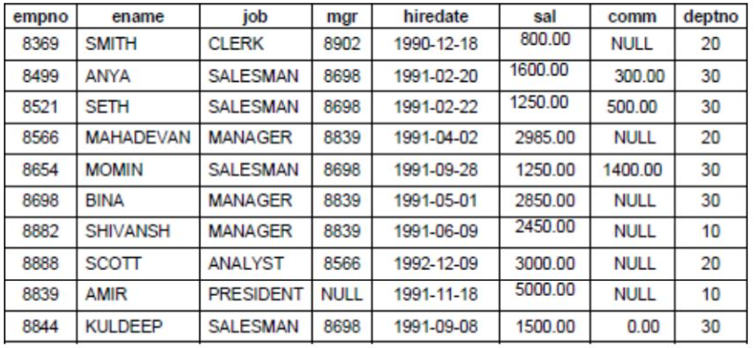

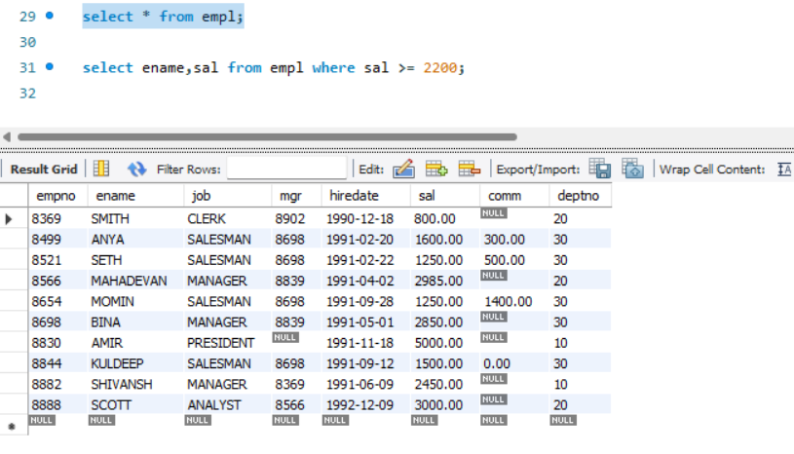

1. **Consider the Employee table and write SQL command to get the following.**
2. Write a query to display EName and Sal of employees whose salary are greater are greater than or equal to 22000?

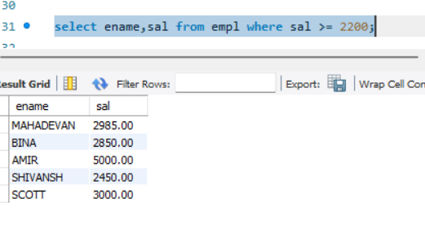

1. Write a query to display details of employees who are not getting commission?

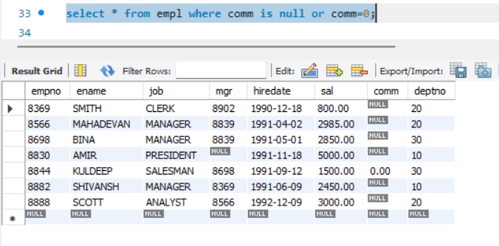

1. Write a query to display employee name and salary of those employees who don’t have their salary in the range of 2500 to 4000?

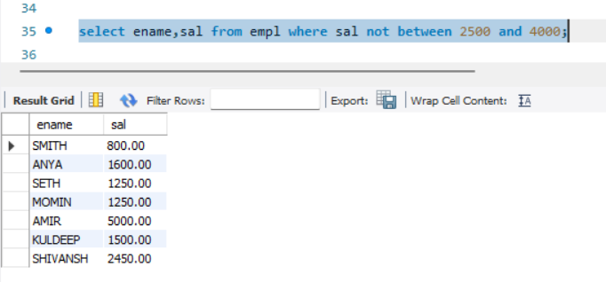

1. Write a query to display the name, job title and salary of employee who don’t have a manager?

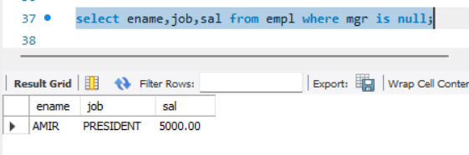

1. Write a query to display the name of an employee whose name contains “A” as third alphabet?

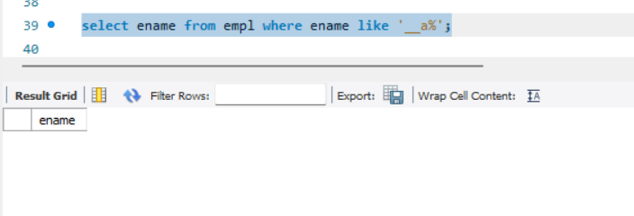

1. Write a query to display the name of an employee whose name contains “T” as the last alphabet?

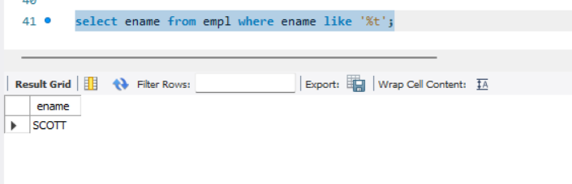

1. Write a program for JDBC to connectivity and insert the below data.

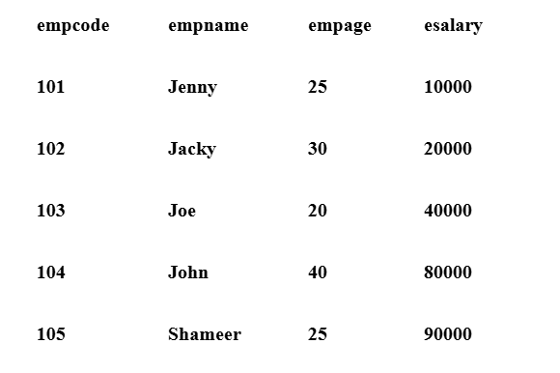

Output in Java:

