WORKFORCE DEMAND AND
EMPLOYMENT GROWTH ANALYSIS
Using the U.S. National Employment Matrix
2025–2035

PROJECT REPORT

Submitted by: Fathimath Thasniya V.
Batch: D55
Dataset source: U.S. Bureau of Labor Statistics

Contents
No. | Contents | Page No.
1 | Title Page | 1
2 | Contents | 2
3 | Abstract | 3
4 | Introduction | 3
5 | Problem Statement | 3
6 | Project Objectives | 3
7 | Dataset Description | 4
8 | Tools and Technologies Used | 4
9 | Data Cleaning and Preprocessing | 4
10 | Exploratory Data Analysis (EDA) | 5
11 | Data Visualization | 6
12 | Key Findings and Insights | 9
13 | Recommendations | 10
14 | Conclusion | 10
15 | References | 11

Abstract
This project analyses projected employment patterns across occupations and industries in the United States between 2025 and 2035 using the U.S. Bureau of Labor Statistics (BLS) National Employment Matrix. The original dataset contains 113,898 records and 14 columns. Data preparation included standardising column names, trimming text values, checking missing values, duplicates, data types, invalid numerical values and potential outliers. Two derived columns were added to compare source-reported employment change with independently calculated change.
A detailed subset of 34,474 occupation–industry records, classified as Line item for both occupation and industry, was used for the main exploratory analysis. Python, Pandas, NumPy, Matplotlib, Seaborn and Plotly were used to examine employment increases and declines, percentage growth, industry-level changes, distributions and correlations. The largest selected occupation–industry increase was 533.3 thousand jobs for home health and personal care aides in services for the elderly and persons with disabilities. Data scientists in solar electric power generation had the highest reported percentage growth in the selected detailed records, at 218.4%. The findings are projections rather than guaranteed outcomes.

Introduction
Employment projections help describe how workforce demand may change over time. Changes in population needs, technology, business activity and industry structure can affect the number and types of workers required. Examining employment at both occupation and industry level provides a more detailed view than considering either dimension alone.
This project uses the BLS National Employment Matrix to compare estimated employment in 2025 with projected employment in 2035. It examines both absolute employment changes, measured in thousands of jobs, and source-reported percentage changes. The analysis also distinguishes detailed occupation–industry records from summary records so that aggregated totals are not confused with individual combinations.

5. Problem Statement
The project addresses the need to understand which occupation–industry combinations and industries are projected to experience the greatest employment growth or decline in the United States from 2025 to 2035. It also examines how employment size relates to projected change and why percentage growth and absolute job gains can lead to different rankings.

6. Project Objectives
- Prepare and validate the BLS National Employment Matrix for analysis.
- Examine the structure and quality of the original dataset.
- Identify potential statistical outliers and assess them without automatically removing genuine extreme observations.
- Compare projected employment levels for 2025 and 2035.
- Identify occupation–industry combinations with the largest absolute increases and declines.
- Examine records with the highest reported percentage growth.
- Summarise employment changes across industries using detailed records.
- Explore distributions and relationships among employment indicators through visualisations.

7. Dataset Description
The dataset was obtained from the U.S. Bureau of Labor Statistics (BLS), Employment Projections programme. The project notebook records the source as:
https://www.bls.gov/emp/data/occupational-data.htm
The workbook used in the analysis is named matrix.xlsx and includes a Field Descriptions worksheet. Employment estimates are expressed in thousands and are published to one decimal place.
Dataset characteristic | Details
Original records | 113,898 rows
Original columns | 14
Final cleaned dataset | 113,898 rows × 16 columns
Detailed analysis subset | 34,474 rows × 16 columns
Projection period | 2025–2035
Main record types | Summary and Line item
Employment unit | Thousands of jobs

Important columns
Column | Description
occupation_code / occupation_title | Occupation identifier and name.
industry_code / industry_title | Industry identifier and name.
occupation_type / industry_type | Indicates whether a record is a Summary or Line item.
2025_employment | Employment estimate for 2025, in thousands.
2035_employment | Projected employment for 2035, in thousands.
numeric_change_202535 | Source-reported numerical employment change.
percent_change_202535 | Source-reported percentage employment change.
calculated_employment_change | Derived value: 2035 employment minus 2025 employment.
change_difference | Difference between source-reported and independently calculated change.

8. Tools and Technologies Used
Tool / library | Purpose in the project
Python | Main programming language used for data processing and analysis.
Google Colab | Notebook environment used to run and document the analysis.
Pandas | Reading, cleaning, filtering, grouping and summarising tabular data.
NumPy | Numerical checks and calculations.
Matplotlib | Static plotting and chart formatting.
Seaborn | Correlation heatmap visualisation.
Plotly Express / Graph Objects | Interactive charts created during the visualisation stage.
Microsoft Excel | Source workbook and final cleaned dataset export.

9. Data Cleaning and Preprocessing
The original dataset was preserved in df_raw, while df_clean was created as the working copy. The following checks and transformations were documented in the notebook:
- Column names were converted to lowercase snake_case, with spaces and special characters standardised.
- Leading and trailing whitespace was removed from text columns.
- Missing values were checked across all columns. No missing values were detected.
- Complete duplicate rows were checked. No complete duplicate rows were identified.
- Occupation and industry classification categories (Summary and Line item) were retained because they represent different levels of detail.
- Employment estimates were checked for negative values; none were identified for 2025 or 2035.
- Percentage distribution columns were checked for values outside the 0–100 range.
- Infinite numerical values were checked; none were identified.
- Two derived columns were created: calculated_employment_change and change_difference.
- Occupation and industry codes were checked for missing, blank and whitespace-affected values. The notebook reports 1,112 unique occupation codes and 423 unique industry codes.

Outlier assessment using IQR
The Interquartile Range (IQR) method was applied to the full cleaned dataset. The notebook reported 17,912 potential outliers for 2025 employment, 17,913 for 2035 employment, 30,649 for numerical employment change and 7,886 for percentage employment change. These are statistical flags, not proof of incorrect records.
The extreme values were retained. The dataset contains both aggregate summary records and detailed records, so very large employment totals and changes can be expected for broad categories. Some large percentage changes may also occur where the starting employment level is relatively small. Outlier status was therefore interpreted in context rather than used as an automatic deletion rule.

Validation of source-reported changes
Source-reported numerical changes were compared with the difference between 2035 and 2025 employment. The maximum absolute difference was approximately 0.1 thousand, and 22,982 records differed by more than 0.01 thousand. The notebook also compared reported percentage changes with calculations based on displayed values. Because published employment estimates are rounded to one decimal place, calculations from the displayed figures may not reproduce the underlying BLS calculations. The original source-reported values were retained.

10. Exploratory Data Analysis (EDA)

10.1 Record classification
The original dataset contains Summary and Line item records for both occupations and industries. A separate detailed subset was created by retaining records where occupation_type and industry_type were both Line item. This produced 34,474 rows. The original 113,898-row dataset was retained for broader analysis.

10.2 Employment change range
Across the cleaned dataset, source-reported numerical employment change ranged from −772.4 to 5,917.6 thousand, while reported percentage change ranged from −68.3% to 218.4%. Negative values were retained because they represent projected declines rather than necessarily invalid data.

10.3 Detailed occupation–industry analysis
The detailed subset was checked for repeated occupation-code and industry-code combinations. No repeated combinations were identified. The main occupation–industry rankings and visualisations were then prepared from this subset.

10.4 Correlation analysis
The correlation matrix examined 2025 employment, 2035 employment, source-reported numerical change and source-reported percentage change. The relationship between the two employment-level variables was very strong (1.00 when rounded to two decimal places). Numerical change had moderate positive correlations with 2025 employment (0.57) and 2035 employment (0.64). Reported percentage change had very weak correlations with the other indicators (0.01, 0.02 and 0.08). Correlation describes association and does not establish causation.

11. Data Visualization
Eight visualisations were prepared to present the main patterns in the detailed occupation–industry records. The charts below are included with concise interpretations.
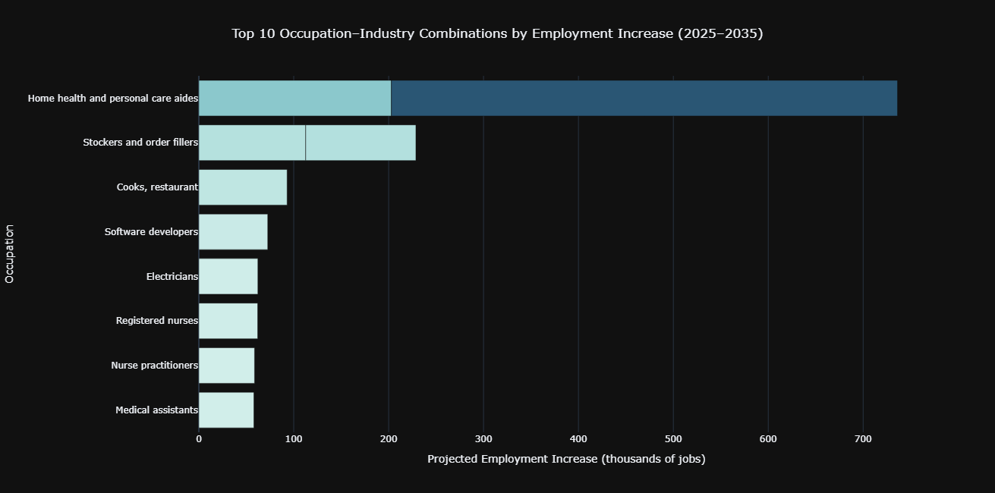
Figure 1. Top 10 occupation–industry combinations by projected employment increase. Home health and personal care aides in services for the elderly and persons with disabilities recorded the largest increase, at 533.3 thousand jobs. The chart also shows increases in home healthcare, retail, food services, software development, electrical contracting and healthcare occupations.
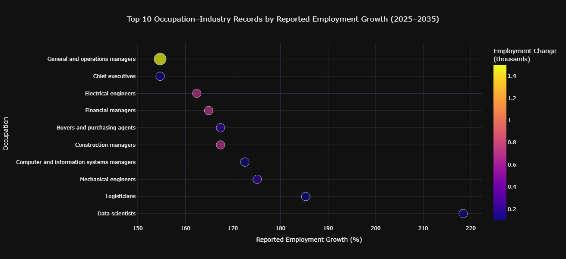
Figure 2. Top 10 detailed occupation–industry records by reported percentage growth. Data scientists in solar electric power generation recorded the highest reported growth at 218.4%, followed by logisticians at 185.3% and mechanical engineers at 175.1%. High percentage growth should be considered alongside the number of jobs added.
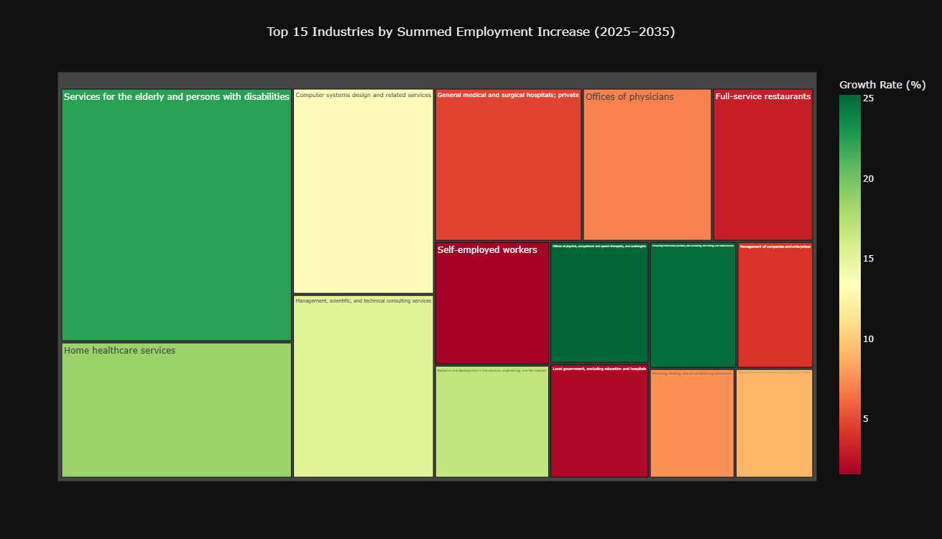
Figure 3. Treemap of the 15 industries with the largest summed employment increases across detailed records. Services for the elderly and persons with disabilities recorded a summed increase of 623.8 thousand, followed by home healthcare services (335.4 thousand) and computer systems design and related services (310.6 thousand). These are sums of detailed records, not verified official industry totals.
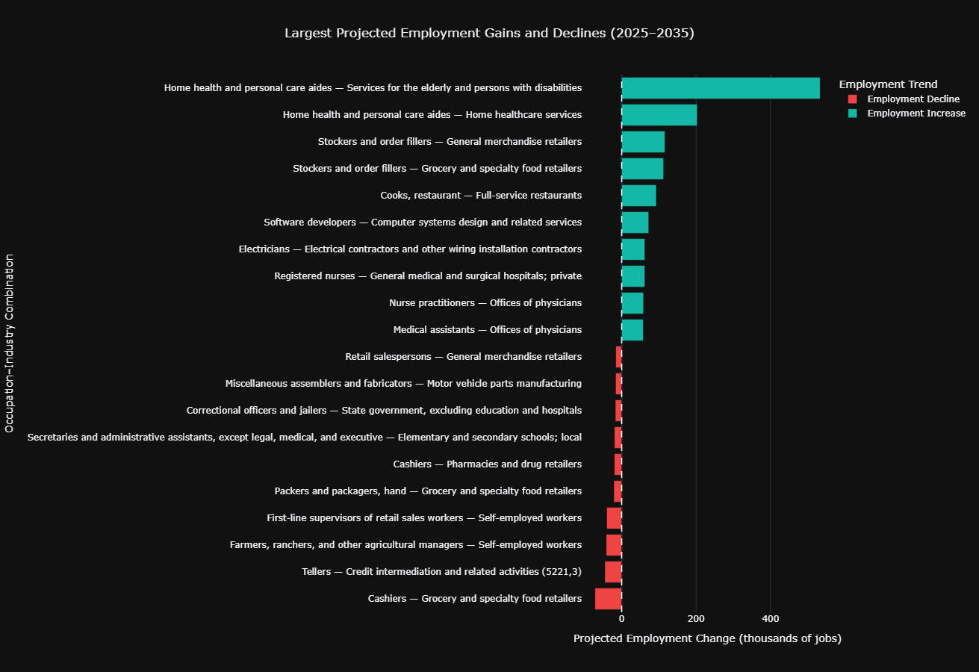
Figure 4. Largest projected employment gains and declines among detailed occupation–industry records. The chart compares the ten largest increases with the ten largest declines. Cashiers in grocery and specialty food retailers recorded the largest decline among the selected records.
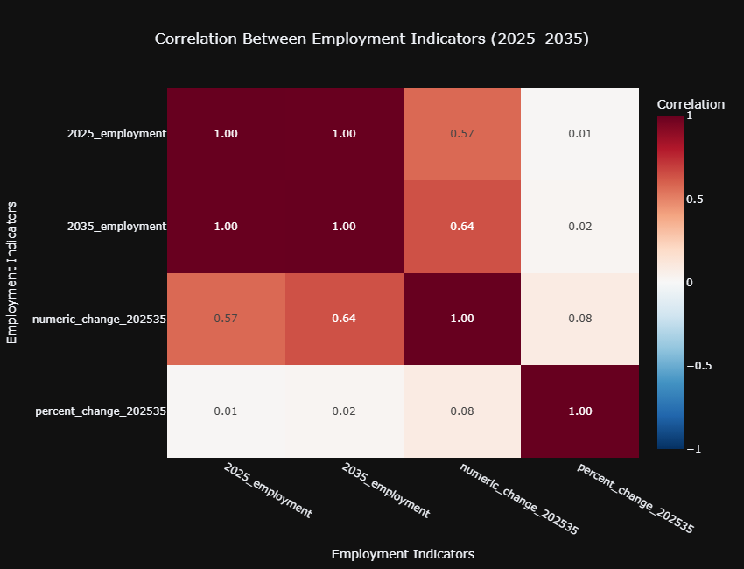
Figure 5. Correlation heatmap for the four employment indicators. Employment levels in 2025 and 2035 are very strongly correlated, while absolute employment change has moderate positive relationships with employment levels. Reported percentage growth has very weak correlations with the other indicators.
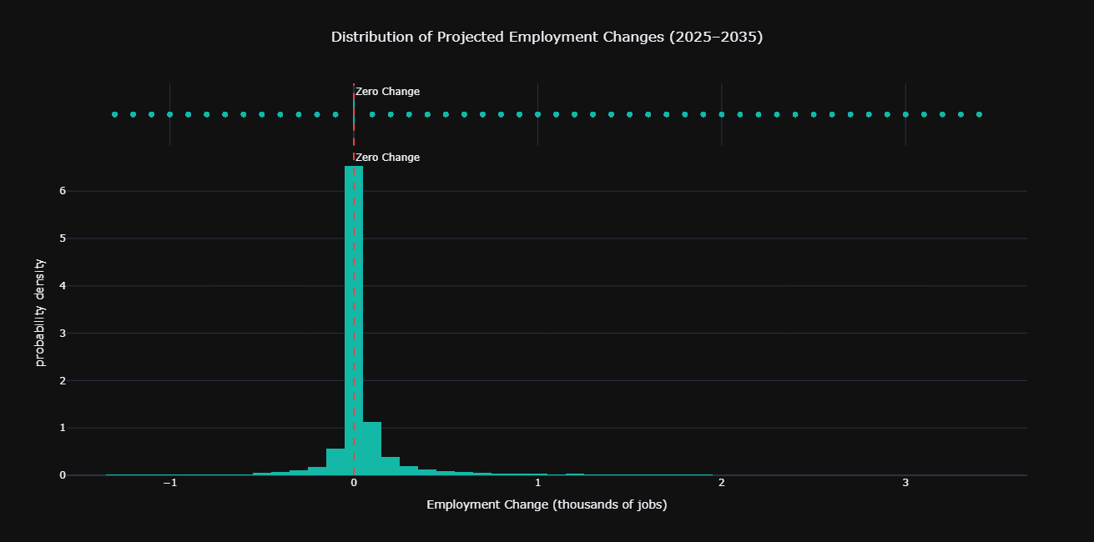
Figure 6. Distribution of projected employment changes, focusing on the central 98% of detailed records for readability. Most observations cluster close to zero, with a positively skewed distribution and a longer tail toward larger increases. Some records show projected declines.
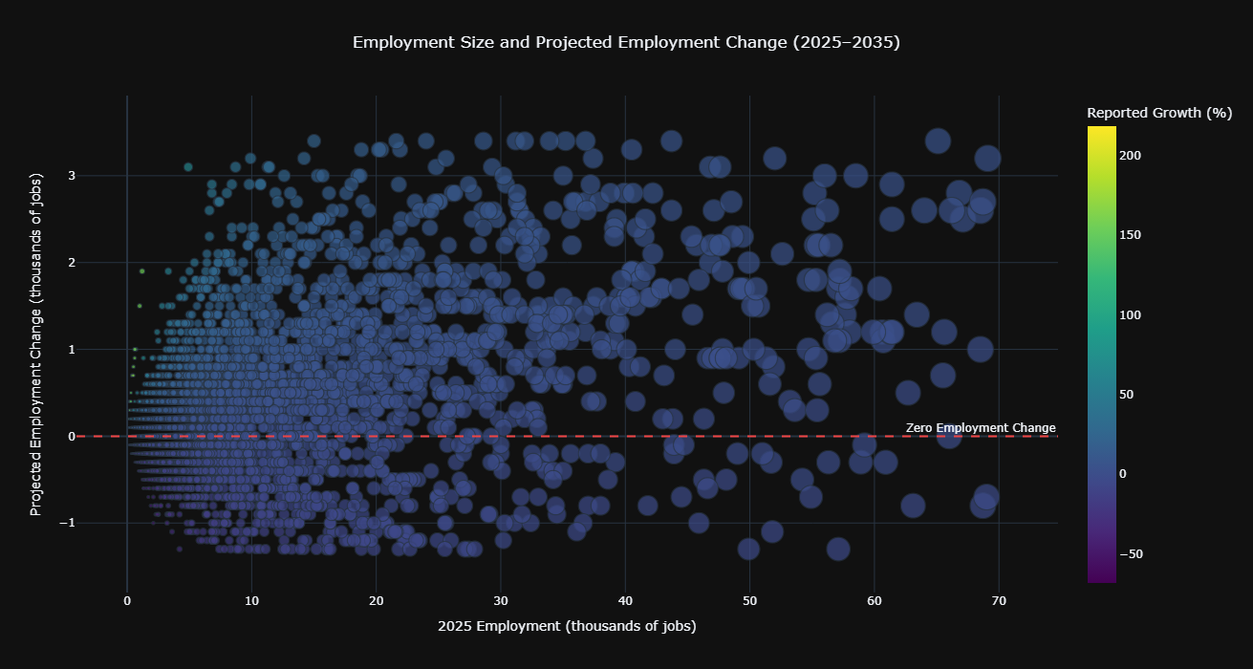
Figure 7. Bubble chart comparing 2025 employment size with projected numerical change. Bubble size represents 2035 employment and colour represents reported percentage growth. The central 98% filter displays 33,711 records; 763 extreme records are excluded from this chart only, not from the cleaned dataset.
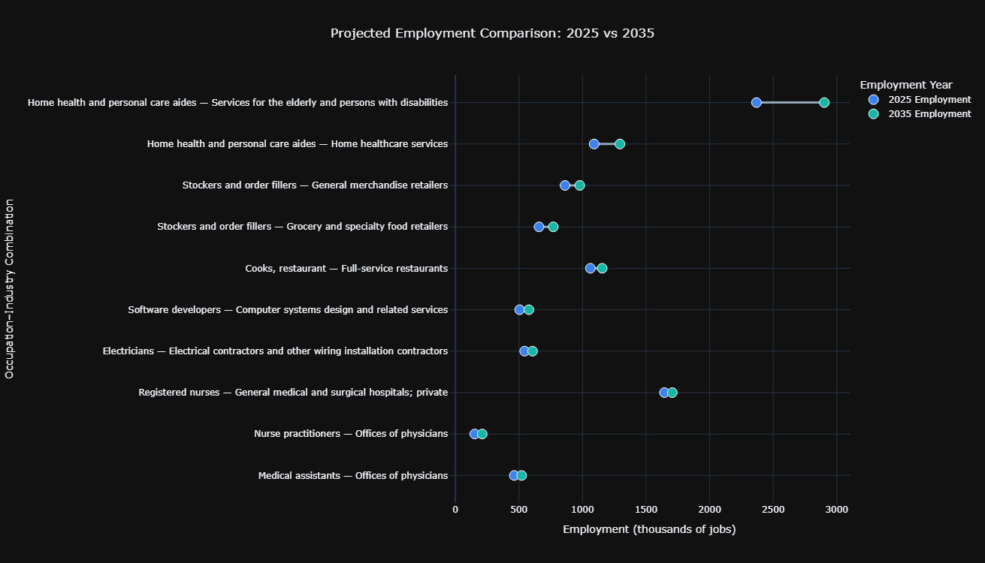
Figure 8. Dumbbell comparison of 2025 and 2035 employment for the ten occupation–industry combinations with the largest projected increases. Each selected combination shows higher projected employment in 2035 than in 2025.

12. Key Findings and Insights
- Care-related employment: Home health and personal care aides in services for the elderly and persons with disabilities recorded the largest selected occupation–industry increase, at 533.3 thousand jobs. Home healthcare services also showed a substantial increase.
- Industry-level sums: Services for the elderly and persons with disabilities (+623.8 thousand), home healthcare services (+335.4 thousand) and computer systems design and related services (+310.6 thousand) were the three largest summed increases in the detailed-record industry analysis.
- Percentage growth: Data scientists in solar electric power generation recorded the highest reported percentage growth among the selected detailed records, at 218.4%. This is a percentage measure and does not necessarily represent the largest absolute job gain.
- Employment declines: Some occupation–industry combinations are projected to decline. Cashiers in grocery and specialty food retailers had the largest decline among the ten selected losses.
- Distribution: Most detailed occupation–industry employment changes are concentrated close to zero, while a smaller number of records show much larger increases or decreases.
- Relationships: 2025 and 2035 employment levels are very strongly correlated. Absolute employment change is moderately correlated with employment size, whereas reported percentage growth has very weak correlations with the other indicators.

13. Recommendations
- Interpret employment growth using both absolute job change and percentage change; neither measure alone provides a complete picture.
- Give attention to care-related occupations and services when examining projected workforce demand, while recognising that projections are not guarantees.
- Consider technology, engineering, logistics and professional occupations when exploring areas of percentage growth.
- Use detailed occupation–industry records for specific comparisons and clearly label aggregate or summed results.
- Retain extreme observations unless there is evidence that they are data errors; document the context and limitations of statistical outlier methods.
- For further analysis, compare projections with future realised employment data as those observations become available.

14. Conclusion
The project examined projected U.S. employment patterns from 2025 to 2035 using the BLS National Employment Matrix. The analysis identified substantial projected increases in care-related services and notable growth in selected technology, retail, healthcare and professional occupation–industry combinations. It also identified records with projected employment declines, showing that workforce demand is not expected to change uniformly across all occupations and industries.
The results demonstrate the importance of examining employment levels, absolute changes and percentage growth together. The largest percentage increase does not necessarily correspond to the largest number of additional jobs. Overall, the project achieved its objectives by preparing the dataset, assessing its quality, analysing detailed occupation–industry records and presenting the results through visualisations.

14.1 Limitations
- The analysis is based on BLS projections for 2025–2035; projected values are estimates and may differ from future actual employment.
- Employment estimates are rounded to one decimal place in thousands, which can produce small differences when recalculating changes from displayed values.
- Industry-level totals calculated by summing detailed records may differ from official summary totals because of rounding and suppression in detailed data.
- IQR identifies statistical extremes, but it does not determine whether a record is erroneous. Aggregate and detailed records have different scales.
- The central 98% filters used in selected charts improve readability but omit extreme records from those particular visualisations only.
- Correlation results describe relationships among variables and do not establish causal relationships.

14.2 Future Scope
- Compare projected employment with subsequent actual employment data to assess projection accuracy.
- Extend the analysis to additional projection years when updated BLS matrices become available.
- Investigate selected occupations and industries in greater detail, including regional or state-level patterns if suitable data are available.
- Explore additional factors that may be associated with workforce demand, while clearly distinguishing association from causation.

15. References
U.S. Bureau of Labor Statistics. Employment Projections: Occupational Employment Projections Data. https://www.bls.gov/emp/data/occupational-data.htm
U.S. Bureau of Labor Statistics. National Employment Matrix, 2025 and projected 2035. Source workbook used in this project: matrix.xlsx, including the Field Descriptions worksheet.

