A Systems-Level Trade Study of CubeSat Deorbit Strategies Under Mass and Power Constraints
Fathimathu Nathiya
Pre-University Research Project
2026

Introduction

The rapid growth of small satellite missions has significantly increased congestion in low Earth orbit (LEO), raising concerns about long-term orbital sustainability and space debris accumulation. CubeSats, due to their low development cost and short mission timelines, are widely used for scientific, educational, and commercial applications. However, many CubeSat missions lack reliable end-of-life disposal mechanisms, leading to an increasing population of inactive spacecraft in LEO. International debris mitigation guidelines therefore emphasize the importance of ensuring timely deorbit of satellites after mission completion.

Active deorbiting using onboard propulsion systems provides a controlled and predictable method for orbital decay compared to passive techniques such as atmospheric drag augmentation. Traditional chemical propulsion systems can deliver high thrust but require relatively large amounts of propellant mass, which is a critical limitation for mass- and volume-constrained CubeSat platforms. In contrast, electric propulsion systems offer much higher specific impulse and consequently lower propellant mass requirements, although they operate with lower thrust levels and require longer maneuver durations. In recent years, green propulsion technologies have also emerged as safer and environmentally friendly alternatives to conventional chemical propellants for small spacecraft missions.

The selection of an appropriate propulsion system for CubeSat deorbiting involves multiple interacting factors, including spacecraft dry mass, propellant mass fraction, available onboard power, and acceptable deorbit time. While many studies compare propulsion technologies based on isolated performance metrics, fewer investigations adopt a systems-level perspective that simultaneously considers mass scaling behavior and mission constraints. A quantitative trade study framework is therefore necessary to support early-stage mission design decisions for sustainable CubeSat operations.

This study presents a systems-level trade analysis of CubeSat deorbit strategies by comparing green propulsion and electric propulsion technologies using an analytical orbital mechanics model. The required deorbit delta-V is first computed for a representative low Earth orbit mission scenario, and the corresponding propellant mass is determined using the rocket equation. A sensitivity analysis is then performed to evaluate how variations in CubeSat dry mass influence propellant requirements for both propulsion systems. In addition, the study extends to include mission constraints such as deorbit time and power availability in order to assess the practical feasibility of each propulsion option.

The objective of this work is to develop a reproducible and quantitative framework for evaluating CubeSat deorbit propulsion strategies based on propellant mass, spacecraft mass scaling, and mission-level constraints. The results aim to provide engineering insight into propulsion system selection and contribute toward the design of sustainable and responsible small satellite missions.

- Mission Description and Assumptions

This study considers a representative CubeSat mission operating in low Earth orbit (LEO) with the objective of performing a controlled deorbit at the end of its operational lifetime. The mission scenario is selected to be simple and general in order to allow comparison between different propulsion technologies under consistent conditions. The CubeSat is assumed to be initially deployed into a circular orbit and subsequently commanded to perform a deorbit maneuver to reduce its orbital altitude until atmospheric drag leads to natural reentry.

The baseline orbital parameters assumed in this study consist of an initial circular orbit altitude of 500 km and a target final altitude of 120 km. These values represent a typical operational LEO regime for CubeSat missions and a commonly adopted threshold for initiating rapid orbital decay. The Earth is modeled as a spherical body with standard gravitational parameters, and perturbative effects such as atmospheric drag during the maneuver, Earth oblateness, and third-body influences are neglected in order to focus on first-order propulsion performance trends.

The CubeSat dry mass is treated as a variable parameter in the sensitivity analysis, ranging from 5 kg to 25 kg to represent different CubeSat class configurations and payload capacities. This range allows the investigation of how spacecraft mass scaling affects propellant requirements and propulsion system selection. The spacecraft is assumed to carry a single propulsion system dedicated to the deorbit maneuver, and all propellant is used exclusively for end-of-life disposal.

Two propulsion technologies are considered in this study: green chemical propulsion and electric propulsion. The green propulsion system is characterized by a moderate specific impulse and relatively high thrust, while the electric propulsion system is characterized by a high specific impulse and low thrust. Representative specific impulse values are selected from typical literature ranges for small satellite propulsion systems. These parameters are used consistently across all analyses to ensure a fair comparison between propulsion options.

Several simplifying assumptions are made in order to maintain analytical tractability. The orbit is assumed to remain circular during the deorbit maneuver, and the required delta-V is computed using an idealized orbital velocity model. The propulsion systems are assumed to operate at constant performance throughout the maneuver, and losses due to inefficiencies, attitude control, and power system limitations are initially neglected. These assumptions enable a clear comparison of mass and performance trends while providing a baseline framework that can be extended in future work to include more detailed dynamics and system-level constraints.

This mission definition and set of assumptions provide a controlled environment for evaluating the impact of propulsion system selection on CubeSat deorbit performance. The framework established in this section supports subsequent analyses, including propellant mass comparison, sensitivity analysis with respect to CubeSat mass, and the incorporation of mission constraints such as deorbit time and available onboard power.

- Methodology

The methodology adopted in this study combines analytical orbital mechanics with a computational simulation framework developed in Python. The objective is to quantify the propellant mass required for CubeSat deorbit maneuvers using different propulsion technologies and to evaluate the sensitivity of these requirements to variations in spacecraft mass and mission parameters.

The required delta-V for deorbit is calculated based on the change in orbital velocity between the initial and final circular orbits using a Hohmann transfer approximation. Assuming a circular orbit at altitude h1 and a target orbit at altitude h2, the orbital velocity is computed using the standard gravitational parameter of Earth and the orbital radius. The delta-V is obtained from the difference between the two orbital velocities. This approach provides a first-order estimate of the velocity change required to initiate orbital decay.

The propellant mass required for the maneuver is calculated using the Tsiolkovsky rocket equation:

Delta V = Isp g0 ln (m0 / mf)

where Isp is the specific impulse of the propulsion system, g0 is the standard gravitational acceleration, m0 is the initial spacecraft mass before the maneuver, and mf is the final mass after propellant expenditure. Rearranging this equation yields the propellant mass required for a given delta-V and spacecraft mass.

Representative propulsion parameters are selected for two propulsion technologies: green chemical propulsion and electric propulsion. Each system is assigned a constant specific impulse value based on typical performance ranges reported in small satellite propulsion literature. These parameters are used consistently across all simulation cases to ensure comparability between propulsion options.

A modular Python code structure is employed to implement the analytical model. Core functions are developed to compute orbital velocity, delta-V, and propellant mass. These functions are reused across multiple analysis scripts, including baseline propulsion comparison and sensitivity analysis. Input parameters such as CubeSat mass, propulsion system type, and orbital altitudes are defined at the top of each script to allow rapid modification and parametric studies.

For the sensitivity analysis, the CubeSat dry mass is varied over a defined range while holding orbital parameters and propulsion characteristics constant. For each mass value, the delta-V and corresponding propellant mass are computed for both propulsion systems. The results are stored in structured data containers and visualized using bar plots and line plots generated with the Matplotlib library.

All simulations are executed in a Visual Studio Code (VS Code) environment to enable interactive testing, verification, and visualization. The generated plots are saved as image files and incorporated into the technical report for interpretation and discussion. This computational methodology enables reproducible analysis and provides a foundation for extending the study to include additional constraints such as power availability and deorbit time.

- Results and Discussion

This section presents the outputs obtained from the developed Python-based simulation framework. The results include a comparison of propulsion strategies for CubeSat deorbiting and a series of parametric trade studies. These trade studies investigate the influence of spacecraft mass, power and propulsion system characteristics, and deorbit time constraints on the required propellant mass and overall system performance.

  - : Propellant Mass Comparison for CubeSat Deorbit

This subsection presents the results of the analytical deorbit model and compares the propellant mass requirements for different propulsion systems. The analysis considers a CubeSat deorbit maneuver from an initial circular orbit at an altitude of 500 km to a target altitude of 120 km. The spacecraft dry mass is assumed to be 12 kg, and Earth is taken as the central body. These mission parameters are summarized in Table 1.

Parameter | Value
Initial orbit altitude | 500 km
Target orbit altitude | 120 km
Spacecraft dry mass | 12 kg
Central body | Earth
Table 1: Mission parameters used for the deorbit analysis.

The required velocity change (delta-V) for the deorbit maneuver was calculated using the analytical orbital mechanics model described in Section 3. The resulting delta-V requirement is presented in Table 2.

Quantity | Value
Required deorbit delta-V | 109.08 m/s
Table 2: Required delta-V for the deorbit maneuver.

Using the computed delta-V value, the propellant mass required for two different propulsion systems—green chemical propulsion and electric propulsion—was determined using the Tsiolkovsky rocket equation. The specific impulse values assumed for the propulsion systems were 220 s for green propulsion and 1200 s for electric propulsion. The resulting propellant mass requirements are summarized in Table 3.

Propulsion system | Specific impulse (s) | Required propellant mass (kg)
Green propulsion | 220 | 0.6223
Electric propulsion | 1200 | 0.1118
Table 3: Comparison of propellant mass requirements for different propulsion systems.

The comparison of propellant mass requirements for the two propulsion systems is illustrated in Figure 1.

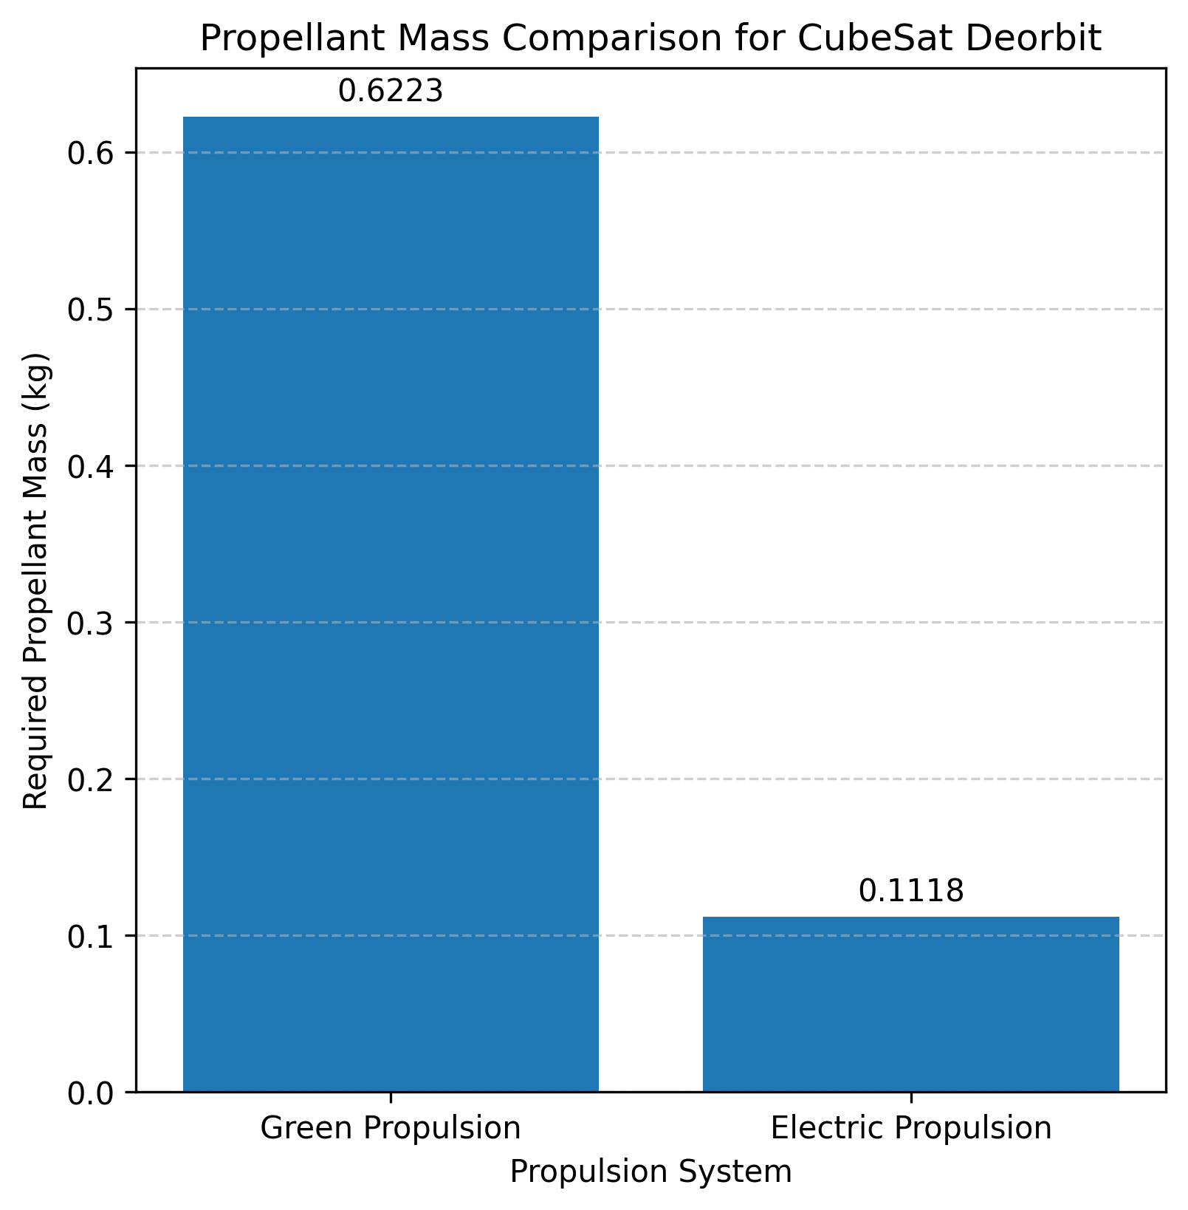
Figure 1: Comparison of required propellant mass for green and electric propulsion systems for CubeSat deorbit.

For a deorbit maneuver from an initial altitude of 500 km to a target altitude of 120 km, a total delta-V of 109.08 m/s is required. Based on this delta-V, green propulsion requires approximately 0.62 kg of propellant, whereas electric propulsion requires only about 0.11 kg. This significant reduction in propellant mass highlights the advantage of high specific impulse propulsion systems for CubeSat deorbit missions.

Electric propulsion systems enable substantial mass savings, which can be utilized for additional payload capacity, enhanced subsystem margins, or extended mission duration. These results demonstrate that propulsion system selection plays a critical role in the overall mass budget of CubeSat deorbit strategies and motivates further investigation into system-level trade-offs involving mass, power, and deorbit time.

  - : Sensitivity Analysis of Propellant Mass with Respect to CubeSat Dry Mass

This subsection investigates the sensitivity of the required propellant mass to variations in CubeSat dry mass. While the previous analysis considered a fixed spacecraft dry mass of 12 kg, practical CubeSat missions span a wide range of masses depending on payload, subsystem configuration, and form factor. Therefore, a parametric study was performed by varying the CubeSat dry mass and evaluating its effect on the required propellant mass for different propulsion systems.

In this analysis, the CubeSat dry mass was varied over a representative range while keeping all other mission parameters constant, including the initial orbit altitude of 500 km, the target orbit altitude of 120 km, and the required deorbit delta-V of 109.08 m/s. The same propulsion system characteristics used in Section 4.1 were retained, with specific impulse values of 220 s for green propulsion and 1200 s for electric propulsion.

For each selected CubeSat dry mass value, the corresponding propellant mass was computed using the Tsiolkovsky rocket equation. This approach allows direct quantification of how spacecraft mass scaling impacts the propellant budget for deorbit maneuvers.

The results of the sensitivity analysis are presented in Figure 2, which shows the variation of required propellant mass as a function of CubeSat dry mass for both propulsion systems.
The corresponding numerical values of propellant mass for each CubeSat dry mass are summarized in Table 4.

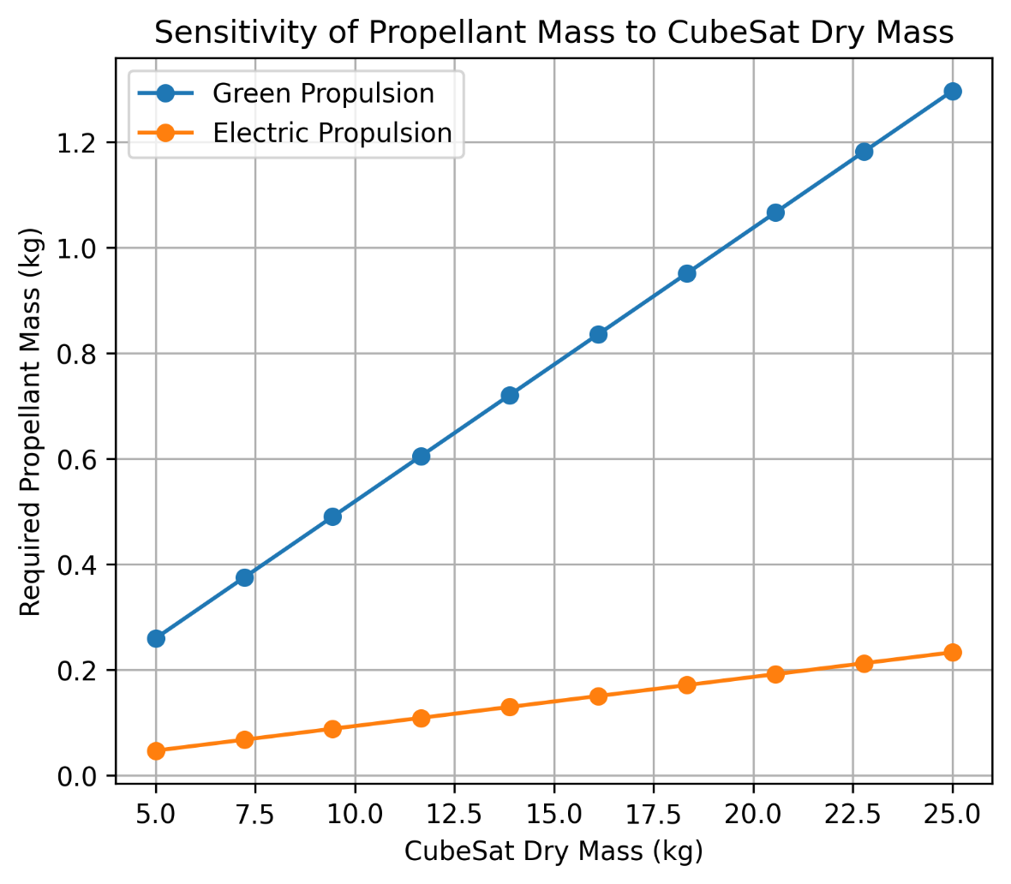
Figure 2: Sensitivity of required propellant mass to CubeSat dry mass for green and electric propulsion systems.

CubeSat Dry Mass (kg) | Propellant Mass – Green Propulsion (kg) | Propellant Mass – Electric Propulsion (kg)
5.0 | 0.2593 | 0.0466
7.2 | 0.3746 | 0.0673
9.4 | 0.4898 | 0.0880
11.7 | 0.6050 | 0.1086
13.9 | 0.7203 | 0.1293
16.1 | 0.8355 | 0.1500
18.3 | 0.9508 | 0.1707
20.6 | 1.0660 | 0.1914
22.8 | 1.1813 | 0.2121
25.0 | 1.2965 | 0.2328
Table 4: Required propellant mass as a function of CubeSat dry mass for green and electric propulsion systems.

The results indicate that the required propellant mass increases monotonically with increasing CubeSat dry mass for both propulsion systems. However, the rate of increase differs significantly between the two cases. Green propulsion exhibits a steeper growth in propellant mass as spacecraft mass increases, whereas electric propulsion shows a comparatively gradual increase due to its much higher specific impulse.

For lower-mass CubeSats, the propellant mass required by green propulsion remains relatively small; however, as spacecraft mass increases, the propellant fraction becomes a more substantial portion of the total system mass. In contrast, electric propulsion maintains low propellant mass requirements even for higher spacecraft dry masses, making it more scalable for larger CubeSat platforms.

This sensitivity analysis highlights the strong dependence of deorbit propellant requirements on spacecraft mass and demonstrates the importance of considering mass scaling effects during early mission design. The results further emphasize the benefits of high specific impulse propulsion systems in minimizing propellant mass penalties, particularly for CubeSat missions with increasing payload or subsystem mass.

Overall, the sensitivity study provides quantitative insight into the trade-offs between spacecraft mass and propulsion system selection and forms a basis for system-level optimization when designing CubeSat deorbit strategies.

  - : Power Constraint and Propulsive Burn Time Trade Study

This section presents a combined power constraint analysis and propulsive burn time trade study for the CubeSat deorbit mission using electric propulsion. The power constraint analysis evaluates the thrust capability of the propulsion system under different available onboard power levels, while the propulsive burn time trade study examines the duration of thrusting required to achieve the computed deorbit delta-V. Together, these analyses assess the feasibility of electric propulsion under realistic CubeSat power limitations.

For a fixed mission delta-V and spacecraft mass, the thrust generated by an electric propulsion system is fundamentally limited by the available electrical power. Lower power levels result in reduced thrust and mass flow rate, thereby increasing the total propulsive burn time required to complete the deorbit maneuver. Conversely, higher power availability enables greater thrust and shorter burn durations. This trade-off is critical for CubeSat missions, where onboard power generation capability is constrained by spacecraft size and solar array area.

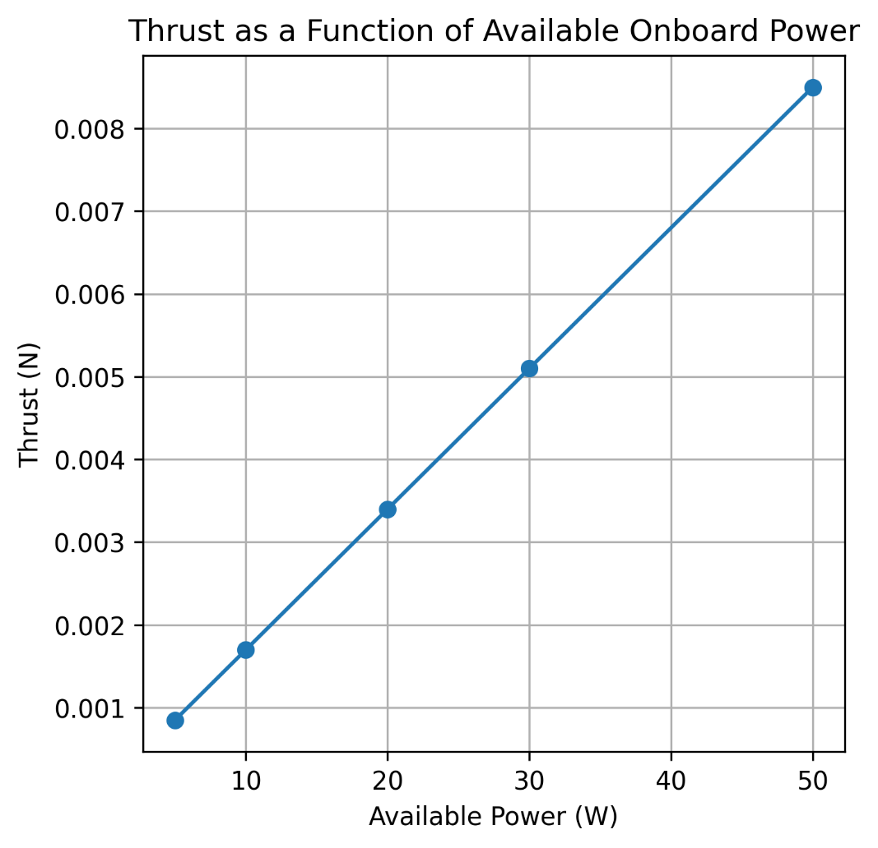
Figure 3: Thrust as a function of available onboard power for electric propulsion.

Figure 3 illustrates the dependence of propulsion thrust on available electrical power. The results indicate a direct relationship between power and thrust, confirming that electric propulsion performance is strongly constrained by the CubeSat power subsystem. At low power levels, the generated thrust is minimal, which limits maneuver aggressiveness and extends mission timelines. As available power increases, thrust capability improves, enhancing maneuver feasibility but requiring larger power generation and storage systems.

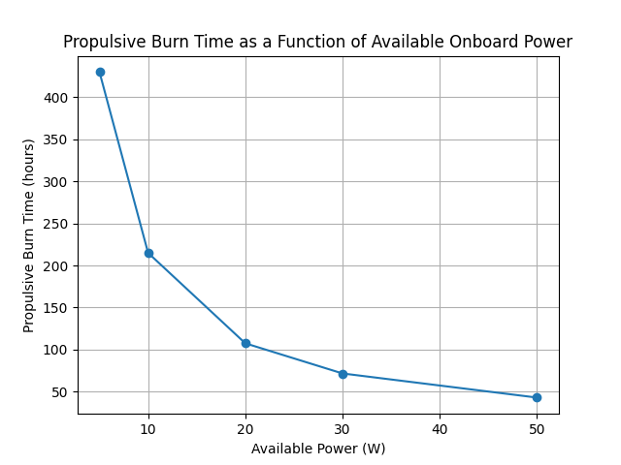
Figure 4: Propulsive burn time as a function of available onboard power for electric propulsion.

Figure 4 presents the variation of propulsive burn time with available onboard power. The results show that burn time decreases significantly as power increases, reflecting the higher thrust and mass flow rate achievable at higher power levels. At low power levels, the required burn duration becomes excessively long, which may be impractical due to operational constraints, attitude control limitations, and mission lifetime considerations. These findings highlight the importance of balancing propulsion capability with realistic power budgets in CubeSat design.

Available Power (W) | Thrust (N) | Propulsive Burn Time (hours)
5 | 0.000850 | 429.89
10 | 0.001700 | 214.94
20 | 0.003399 | 107.47
30 | 0.005099 | 71.65
50 | 0.008498 | 42.99
Table 5: Power constraint and propulsive burn time trade study results.
Table 5 summarizes the numerical results of the power constraint and burn time analyses. The table provides quantitative insight into how increasing power levels improve thrust capability while reducing the required propulsive burn duration. These results reinforce the trends observed in Figures 3 and 4 and enable direct comparison across discrete power scenarios. Such tabulated data is useful for preliminary spacecraft design decisions, allowing designers to evaluate feasible combinations of propulsion performance and power system capacity.

The combined power constraint and propulsive burn time trade study demonstrates that electric propulsion feasibility for CubeSat deorbit missions is governed primarily by available onboard power. While electric propulsion offers propellant mass advantages, its low-thrust nature results in extended burn durations under limited power conditions. These findings emphasize the need for integrated design of propulsion and power subsystems and provide a quantitative framework for assessing trade-offs in small satellite deorbit mission planning.

- Conclusion

This study presented a systems-level trade analysis of CubeSat deorbit strategies by examining propellant mass requirements, spacecraft mass sensitivity, and power-limited electric propulsion performance. Analytical models were developed and implemented in Python to evaluate deorbit delta-V requirements and compare chemical and electric propulsion approaches under realistic CubeSat constraints.

The results demonstrate that electric propulsion offers significant propellant mass savings compared to chemical propulsion; however, this benefit is accompanied by substantially lower thrust levels and extended propulsive burn durations. Sensitivity analysis revealed that increases in spacecraft mass lead to corresponding increases in propellant demand, highlighting the importance of mass optimization in small satellite design. Furthermore, the power constraint and burn time trade study showed that available onboard power is a primary limiting factor for electric propulsion feasibility, with low power levels resulting in impractically long maneuver durations.

Overall, this work underscores the necessity of integrated subsystem design when selecting deorbit strategies for CubeSat missions. While electric propulsion presents a mass-efficient solution, its successful implementation depends on careful consideration of power availability and mission timeline constraints. The analytical framework developed in this study provides a quantitative basis for preliminary mission planning and supports informed decision-making in the design of future CubeSat deorbit systems.

- References

O’Reilly, D., Herdrich, G., & Kavanagh, D. F. (2021). Electric Propulsion Methods for Small Satellites: A Review. Aerospace, 8(1), 22.
Alnaqbi, S., Darfilal, D., & Swei, S. M. (2024). Propulsion Technologies for CubeSats: Review. Aerospace, 11(7), 502.
NASA. (2020). Emerging Low-Toxicity “Green” Chemical Propulsion
Technologies for SmallSats.

