Fatih Suljovic Module 5.2   
Fsuljovic 2/4/24

UPPER()  
  
Can be used when signing up a new user with their email for your service. Makes no difference for the user to enter either upper or lowercase so that they dont make a mistake in the future for signing in.

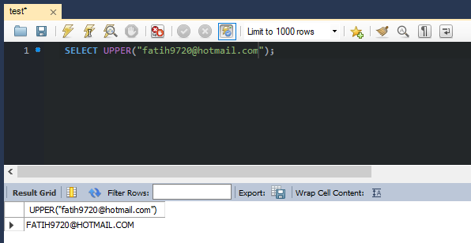

LENGTH()

Checks to see the length of the string input. To check if the user has offered a long enough password on signup. Or input for their search to allow for a query to be let through.

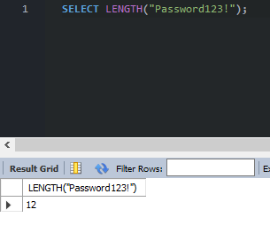

LTRIM()

Removes the spaces from the start of the string. Cleans up any mistyped spaces at the beginning of the string so that the user does not make the mistake of having that misinput affect a search or other application.

