No. | Task | Category | Reason
1 | Solving calculus/maths problem sets by hand | Just me | I actually need to build the intuition myself here if AI solves it, I lose the muscle memory that exams test and AI doesn’t always gives accurate answers for maths problem.
2 | Debugging a tricky logic error where the code runs but gives wrong output | Just me | Understanding why something's wrong is the whole point of learning to debug; letting AI fix it skips the skill I'm trying to build.
3 | Writing boilerplate/starter code for programming assignments (e.g. class structures, imports, setup) | Delegate to AI with review | This part is repetitive and doesn't teach me anything new, but I still check it compiles and matches what's actually asked.
4 | Writing lab reports/write-ups after finishing lab work | Delegate to AI with review | AI drafts it fast from my rough notes, but I always reread since grading cares about accuracy, not just polish.
5 | Turning instructor slides into study notes | Delegate to AI with review | AI is great at condensing, but I skim the output against the slides so I don't accidentally study a wrong summary.
6 | Writing comments/docstrings for my own code | Delegate to AI with review | Saves time on something low-stakes, though I edit anything that misdescribes what the function actually does.
7 | Fixing syntax/compile errors | Delegate to AI with review | Usually a quick fix, and I can verify instantly by just running the code again.
8 | Working on my semester project (design decisions, architecture, iterating on features)(e.g., V-Flute) | Collaborate with AI | This needs real back-and-forth. I explain what I want, AI suggests approaches, we go a few rounds before I lock in a direction.
9 | FlyRank ML internship tasks (notebooks, task framing, research questions) | Collaborate with AI | I bring the domain context and decisions, AI helps me think through structure and catches gaps I miss.
10 | Brainstorming ideas/architecture for personal side projects (like recently doing ResuMatch) | Collaborate with AI | I use AI as a sounding board to stress-test my own ideas rather than to generate them from scratch.
11 | Formatting citations/references for reports | Fully automate | Purely mechanical, there's one correct format and no judgment call involved, so review adds no value.
12 | Converting lecture recordings into text transcripts | Fully automate | I just need searchable text later; accuracy issues here are low-stakes since I'm not quoting it anywhere formal.
13 | Generating flashcards from finished notes for revision | Fully automate | Even if a card or two is slightly off, I catch it while reviewing. The automation just saves the manual card-making step.
AI Fluency Assignment (Week-1)
Task 1

Task 2
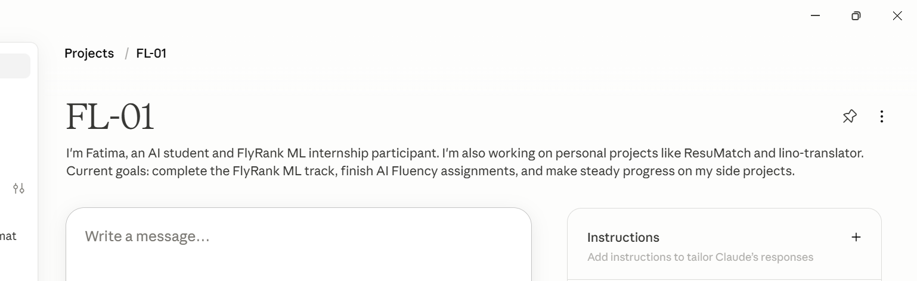

Task 4
Task | Category | What "done well" means
Turning instructor slides into study notes | Delegate to AI with review | Notes capture every key term and definition the instructor actually covered, contain zero factual errors, and I can fully verify accuracy in under 5 minutes by skimming against the original slides.
Working on my semester project (V-Flute) design decisions, architecture, iterating on features | Collaborate with AI | A design/architecture question gets resolved in 2 rounds of back-and-forth or fewer, and I can clearly explain why I accepted or rejected each AI suggestion.
Converting lecture recordings into text transcripts | Fully automate | Transcript is at least 95% accurate with no manual correction needed, fully searchable, and usable as-is for finding a specific point in a lecture later.

