**3.8 Performing Subqueries**

Step 1

Step 2

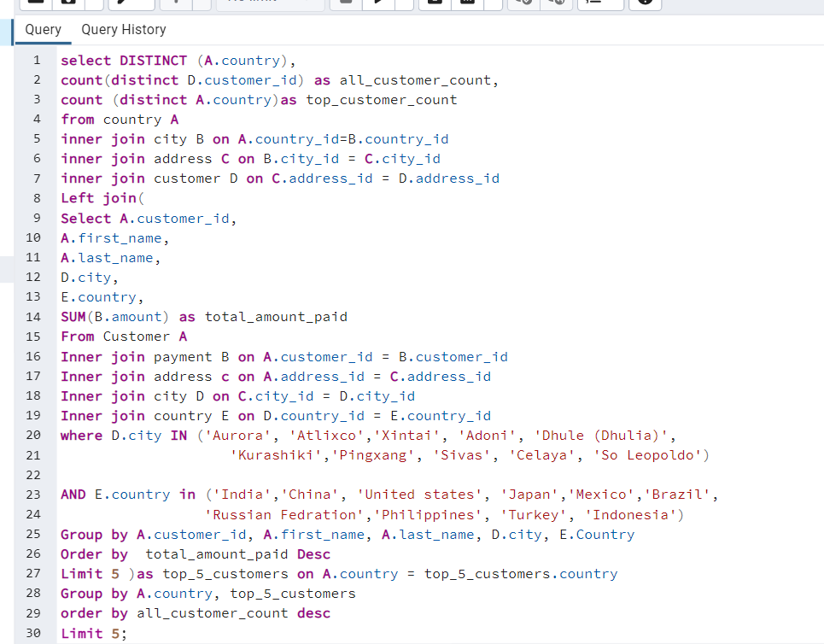

Step 3

1.Query one can be done without subquery and summary function can be used. In query 2 need to be aggregated.

4. Sub-queries are useful in combining multiple data source, using a left join you extract what you need from the data