|  |  |  |
| --- | --- | --- |
| **Sr.** | **Frame**  **Work** | **Functionalities** |

|  |  |  |  |  |  |  |  |  |  |  |  |  |  |  |
| --- | --- | --- | --- | --- | --- | --- | --- | --- | --- | --- | --- | --- | --- | --- |
|  |  | **License(open source)** | **Cost** | **Codeable** | **Support Urdu** | **Platform**  **Website** | **Can be trained** | **Conversion from speech to text and vice versa** | **No. of users** | **Own Server or not?** | **No. of messages** | **Programming Languages/Apps/Integration** | **Examples** | **Link of framework** |
| **1.** | **RASA** | ✓ | ✕ | ✓ | ✕  Can add new languages | ✓ | ✓ | - |  |  |  | SDK in Python  HTTP API | [Tia](https://www.asktia.com/app/)  [Yellobot](https://medium.com/rasa-blog/building-with-rasa-yellow-pages-canada-chatbot-7a5d75d052c7) | [Link1](https://rasa.com/)  [Link2](https://medium.com/@itsromiljain/build-a-conversational-chatbot-with-rasa-stack-and-python-rasa-nlu-b79dfbe59491)  [To support website](https://forum.rasa.com/t/connect-rasa-to-a-web-site-with-the-recommeded-plataform/4019) |
| **2.** | **Wit.ai** | ✓ | ✕ | ✓ | ✓ | ✓ | ✓ | ✓ |  |  |  | Flexible to use SDKs like  Android  iOS   * Cordova * HTML * JavaScript * Node.js * .NET * Unity * Xamarin * C++ * Python * Ruby * PHP * Epson * Moverio * Botkin * Java. | [Car Dost](https://www.facebook.com/RideWidth)  [Wedding Planner](https://medium.com/@MissAmaraKay/first-chatbot-experience-with-wit-ai-47c2ebddf050) | [Wit.AI Code](https://github.com/wit-ai)  [Link2](https://wit.ai/docs/quickstart)  [Link3](https://www.programmableweb.com/api/witai/sample-source-code)  [Link4](https://medium.com/@Giuul/wit-ai-and-how-to-use-it-72372b07d98b)  [Link5](https://www.codementor.io/srijansaxena/how-to-make-a-basic-chatbot-wit-ai-part-1-7g82j81wu)  [Link6](https://github.com/wit-ai/pywit)  [Link7](https://github.com/wit-ai?language=java)  [Link8](https://github.com/wit-ai/wit-ruby)  [Link9](https://github.com/sebsylvester/botbuilder-wit)  [Link10](https://www.programmableweb.com/sample-source-code/witai-python-sample-code)  [Link11](https://pusher.com/tutorials/chatbot-preact-witai) |
| **3.** | **Microsoft Bot Framework** | ✓ | ✕  Paid plans also available. | ✓ | ✓ | ✓ | ✓ | ✓ |  |  |  | * Bot builder SDK(Node.js SDK,.NET SDK) * Bot Connector * Develop Portal * Bot Directory   SDKs in   * C# * Java * Python * JavaScript | [NAVITIME](https://microsoft.github.io/techcasestudies/cognitive%20services/2017/06/28/Navitime.html)  [Super Brand Mall](https://microsoft.github.io/techcasestudies/bot%20framework/2017/06/21/CaaP-SuperBrandMall.html) | [*Bot Builder SDK*](https://dev.botframework.com/)  [BotBuilder-Version3](https://github.com/microsoft/BotBuilder-V3)  [SDK v4 - .NET](https://github.com/Microsoft/botbuilder-dotnet)  [SDK v4 - JavaScript](https://github.com/Microsoft/botbuilder-js)  [SDK v4 - Python](https://github.com/Microsoft/botbuilder-python)  [SDK v4 - Java](https://github.com/Microsoft/botbuilder-java)  [Bot Builder tools](https://github.com/Microsoft/botbuilder-tools)  [Bot Builder Emulator](https://github.com/Microsoft/BotFramework-Emulator)  [SDK v3 Documentation](https://docs.microsoft.com/en-us/azure/bot-service/?view=azure-bot-service-3.0)  [SDK v4 Documentation](https://docs.microsoft.com/en-us/azure/bot-service/?view=azure-bot-service-4.0)  [Solution1](https://github.com/microsoft/botframework-solutions)  [Documentation](https://docs.microsoft.com/en-us/azure/bot-service/?view=azure-bot-service-4.0)  [Microsoft Docs](https://github.com/MicrosoftDocs/bot-docs)  [Documentation2](https://microsoftbotframework.readthedocs.io/en/latest/) |
|  |  |  |  |  |  |  |  |  |  |  |  |  |  |  |
|  |  | **License/open source** | **Cost** | **Codeable** | **Support Urdu** | **Platform**  **Website** | **Can be trained** | **Conversion from speech to text and vice versa** |  |  |  | **Programming Languages/Apps/Integration** | **Examples** | **Link of framework** |
| **4.** | **Semantic Machines** | ✓ | ✕ | ✓ | ✓ | ✓ | ✕ | ✓ |  |  |  | Language independent. |  |  |
|  |  |  |  |  |  |  |  |  |  |  |  |  |  |  |
| **5.** | **ChatScript** | ✓  MIT License |  |  | ✓ | ✓ |  |  |  |  |  | Rules are created in program scripts through a process called dialog flow scripting. These use a scripting metalanguage (‘script’) as their source code. |  |  |
| **6.** | **API.ai** | ✓ | ✕ | ✕ | ✕ |  |  | ✓ |  |  |  | SDK in   * Node.js * Java * Python * ioS * unity |  |  |
| **7.** | **Botsify** | ✕  Free version with 20 templates for 100 users | ✕  Paid plans also available. | ✕ |  | ✓ | ✓ | ✓ |  |  |  |  | * Apple * Shazam * Grin | [Link1](https://github.com/usamanoman/botsify.docs.github.io) |
| **8.** | **BotKit** | ✓ | ✕ | ✓ | ✓ | ✓ | ✓ | ✓ |  |  |  | SDK in Node.js |  | [Documentation1](https://www.npmjs.com/package/botkit)  [Documentation](https://botkit.ai/docs/v4/) |
|  |  | **License(open source)** | **Cost** | **Codeable** | **Support Urdu** | **Platform**  **Website** | **Can be trained** | **Conversion from speech to text and vice versa** |  |  |  | **Programming Languages/Apps/Integration** | **Examples** | **Link of framework** |
| **9.** | **IBM Watson** | ✓ | ✕  Paid plans also available. | ✓ |  | ✓ | ✓ | ✓ |  |  |  | SDKs:   * Java * Node * Salesforce * Python * ioS * unity | Staples  H&R Block  Autodesk |  |
| **10.** | **Reply.ai** | ✕ | ✓ | ✕ | ✓ | ✓ | ✕ |  |  |  |  | Visual bot builder | Samsung Coca-Cola  KIA  Hilton  Ad Council | [Documentation](https://apidocs.reply.io/?version=latest)  [Documentation2](https://chatbotslife.com/how-we-wrote-a-wirecutter-like-bot-with-reply-ai-in-just-a-few-hours-59e7ddfa242c) |
| **11.** | **Chatfuel** | Х | X  Pro plan also available | X | Х | X | X |  |  |  |  | No language required. Only plugins:   * Google search * Bing search * JSON API * RSS Import | Adidas  MTV  British Airways  Volkswagen |  |
| **12.** | **Kitt.ai** | Х | X | X | ✓ | ✓ |  |  |  |  |  | No language required. |  |  |
| **13.** | **MobileMonkey** |  | Х  Pro plans also available. |  |  | ✓ |  |  |  |  |  |  |  |  |
| **14.** | **Rebot.me** |  |  |  | Х | ✓ |  |  |  |  |  |  |  |  |
| **15.** | **ManyChat** | X | X  Paid plans also available. | ✓ |  | ✓ | X |  |  |  |  |  |  |  |
| **16.** | **FlowXo** | Х | X  Paid plans also available. | X | ✓ | ✓ |  |  |  |  |  | Multi-language support |  |  |
|  |  | **License(open source)** | **Cost** | **Codeable** | **Support Urdu** | **Platform**  **Website** | **Can be trained** | **Conversion from speech to text and vice versa** |  |  |  | **Programming Languages/Apps/Integration** | **Examples** | **Link of framework** |
| **17.** | **DialogFlow** | X | ✓ | X | X | ✓ |  | ✓ |  |  |  | * PHP * Go * Java (Maven) * Ruby (Gem) * Python * C# * Node.js |  | [Documentation](https://dialogflow.com/docs)  [Botkit library](https://github.com/dialogflow/dialogflow-botkit-client) |
| **18.** | **BotPress** | ✓  dual-license | ✕ | ✓ |  | ✓ | ✓ | ✓ |  |  |  | TypeScript |  | [Documentation](https://botpress.io/docs/) |
| **19.** | **BotMan** |  |  |  |  | ✓ |  |  |  |  |  | SDKs:   * PHP * Node.js * Java * C# |  | [Documentation](https://botman.io/2.0/welcome) |
| **20.** | **ChatterBot** | X | ✓  Free for only 10 days |  | ✓ |  | X |  |  |  |  | Language independent.  Integration with Django. |  |  |
| **21.** | **PandoraBots** | X | Х  Paid plan  also available | ✓ | ✓ | ✓ | X | ✓ |  |  |  | SDKs:   * Java * Node.js * Python * Ruby * PHP * Go |  | [Documentation](https://pandorabots.com/docs/) |
|  |  | **License(open source)** | **Cost** | **Codeable** | **Support Urdu** | **Platform**  **Website** | **Can be trained** | **Conversion from speech to text and vice versa** |  |  |  | **Programming Languages/Apps/Integration** | **Examples** | **Link of framework** |
| **22.** | **Microsoft Language Understanding Intelligent Service(LUIS)** |  | Х |  | Х  But can be extended. |  |  |  |  |  |  | SDKs:   * C# * Python * Node Js * Android |  |  |
| **23.** | **Digital** **Genius** | X | ✓ |  | X |  | ✓ |  |  |  |  | Language independent. |  |  |
| **24.** | **Amazon Lex** |  |  | ✓ |  | Х |  | ✓ |  |  |  | SDKs:   * Java * Node.js * Python * Ruby * PHP * Android |  |  |
| **25.** | **Live Agent** |  | ✓  14 days free trial |  | X  But can be extended. |  |  |  |  |  |  |  |  |  |
| **26.** | **Pypestream** | X |  |  | X |  | ✓ |  |  |  |  | * Smart Messaging Framework * Pypeconnect SDK * Pypemanager * Pypestream mobile app * API plugins and integration |  |  |
|  |  | **License(open source)** | **Cost** | **Codeable** | **Support Urdu** | **Platform**  **Website** | **Can be trained** | **Conversion from speech to text and vice versa** |  |  |  | **Programming Languages/Apps/Integration** | **Examples** | **Link of framework** |
| **27.** | **Twyla** | X | X |  | X | ✓ | X |  |  |  |  | Analyses data either via the API of your helpdesk or chat solution or a secure file upload. |  |  |
| **28.** | **AgentBot** | X | X  Paid plans also available. |  | ✓ |  | ✓ |  |  |  |  |  |  |  |
| **29.** | **Octane.AI** | X | ✓ |  |  | X | X |  |  |  |  |  |  |  |
| **30.** | **Gupshup** |  | X  Customized plans also available. |  | X |  |  |  |  |  |  | * Messaging APIs * Bot Platform |  |  |
| **31.** | **It’s Alive** | X | X | X | X | X | X |  |  |  |  | No language required. |  |  |
| **32.** | **Msg.ai** | X | ✓ |  | X |  | X |  |  |  |  |  |  |  |
| **33.** | **LiveWorld** | X | ✓ |  |  |  | X |  |  |  |  |  |  |  |
| **34.** | **AceBot** | X | ✓ |  |  |  | X |  |  |  |  |  |  |  |
| **35.** | **NGChat** | X | ✓ |  |  |  | X |  |  |  |  |  |  |  |

### **Microsoft Bot Framework**

The Microsoft Bot Framework is a comprehensive platform for building enterprise-grade conversational AI experiences. It includes a set of **open source SDKs, tools, and services** which enable developers to build, test, and connect bots that interact naturally with users, wherever they are.

With the Microsoft Bot Framework, it is easy to create a bot with the ability to **speak, listen, understand, and learn** from your users with Azure Cognitive Services.

If you use LUIS, other **Cognitive Services, or Azure Bot Service** for hosting you will have **to pay for exceeding the free tier or when using the paid plans.**

**Using the SDK itself will not incur any charges.**

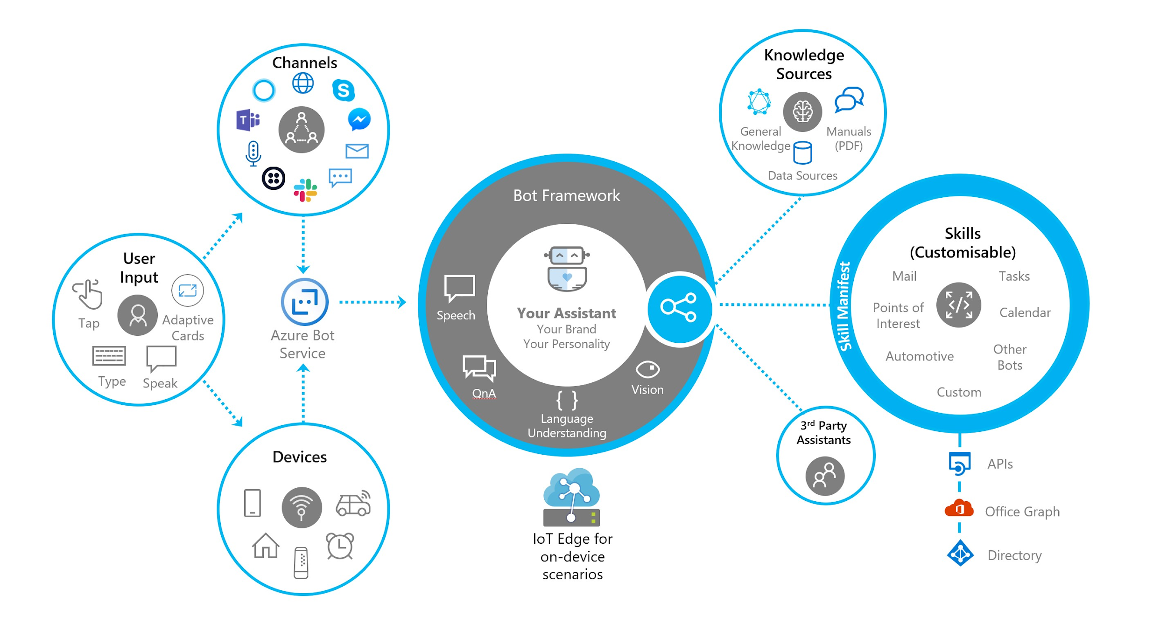

**Related Links:**

* [What is Microsoft Bot Framework Overview](https://blogs.msdn.microsoft.com/uk_faculty_connection/2016/04/05/what-is-microsoft-bot-framework-overview/)
* [Documentation](https://github.com/microsoft/botframework)

This link lists the SDK, tools, and services needed to build a great conversational AI experience. Its role is to serve as a landing page and one place to find all the information required to get started.

* [BakeBot - A Bot for our Bakery Built with the Microsoft Bot Framework](http://jameschambers.com/2018/03/bakebot/bots-day-0-Building-Bots-With-Microsofts-Bot-Framework/)
* [Microsoft Bot Builder V3 SDK in C# for Microsoft Bot Framework](https://github.com/microsoft/BotBuilder-V3)
* [Bot Framework SDK V4 for .NET](https://github.com/Microsoft/botbuilder-dotnet)

This repository contains code for the .NET version of the [Microsoft Bot Framework SDK](https://github.com/Microsoft/botbuilder). The Bot Framework SDK v4 enable developers to model conversation and build sophisticated bot applications using .NET.

* [Bot Framework SDK V4 for JavaScript](https://github.com/Microsoft/botbuilder-js)

This repository contains code for the JavaScript version of the Microsoft Bot Framework SDK. The Bot Framework SDK v4 enable developers to model conversation and build sophisticated bot applications.

* [Bot Framework SDK V4 for Python](https://github.com/Microsoft/botbuilder-python)

This repository contains code for the Python version of the [Microsoft Bot Framework SDK](https://github.com/Microsoft/botbuilder). The Bot Framework SDK v4 enables developers to model conversation and build sophisticated bot applications using Python.

* [Bot Framework SDK for Java](https://github.com/Microsoft/botbuilder-java)

This repository contains code for the Java version of the Microsoft Bot Framework SDK. The Bot Framework SDK v4 enable developers to model conversation and build sophisticated bot applications.

* [Bot Framework Tools](https://github.com/Microsoft/botbuilder-tools)

The Bot Framework tools are a collection of cross-platform command line tools designed to cover end-to-end bot development workflow.

* [Bot Framework Emulator](https://github.com/Microsoft/BotFramework-Emulator)

The Bot Framework Emulator is a desktop application that allows bot developers to test and debug bots built using the [Bot Framework SDK](https://github.com/microsoft/botbuilder). You can use the Bot Framework Emulator to test bots running either locally on your machine or connect to bots running remotely through a tunnel.

* [Azure Bot Service Documentation](https://docs.microsoft.com/en-us/azure/bot-service/?view=azure-bot-service-3.0)

#### **Microsoft Framework chatbot examples**

#### The Englander Institute for Precision Medicine at Weill Cornell Medicine is just one institution that’s [putting Microsoft Bot Framework, Azure, and LUIS to work](https://microsoft.github.io/techcasestudies/bot%20framework/2017/06/15/WeillCornell.html). Developers there built a chatbot that responds to text and voice requests from clinicians. Users can converse with the chatbot to access data that assists in medical decisions—and, ultimately, in medical outcomes.

Other use cases include customer service and transactions, but enterprise productivity is where you can really take advantage of everything this framework has to offer. Consider [André](https://microsoft.github.io/techcasestudies/bot%20framework/2017/06/19/Powel.html), a chatbot developed on Microsoft Bot Framework that helps field engineers perform inspections of electrical grids. Relaying their questions to André means that inspectors don’t have to free up their hands to reference information. As a result, they finish the job faster.

#### **Framework pricing**

#### In terms of cost to build a bot on Microsoft Bot Framework, there are two tiers—Free and S1. The Free tier gives you unlimited messages on standard channels (think Microsoft services, like Skype, or services with publicly available APIs, such as Slack) and 10,000 messages per month on premium channels (e.g., your own mobile app or website). The S1 tier still gives you unlimited messages on standard channels, but, on premium channels, you pay $0.50 per 1,000 messages.

Additional charges may apply when you utilize different aspects of the Azure Bot Service. For example, a bot that runs as an [Azure Web App is subject to its own pricing model](https://azure.microsoft.com/en-us/pricing/details/app-service/windows/).

### **Wit.ai**

Wit.ai is the Facebook acquired company. Wit is **free**, including for **commercial use**. So both **private and public Wit apps are free** and governed by [our terms](https://wit.ai/terms).

It is an NLP platform which allows developers to configure the entities and intents. Developers can use the **HTTP API** to connect the wit.ai to your chatbot or any other applications.

Chatbots with Wit.ai support **50+ languages** and developers have the flexibility to use any of the available SDKs like **Android, iOS, Cordova, HTML, JavaScript, Node.js, .NET, Unity, Xamarin, C++, Python, Ruby, PHP, Epson Moverio, Botkin, and Java.**

Forty-five percent of the respondents in a study by Mindbowser said they trust Wit.ai more than any other bot-building platform. By April 2017, it was used by over **100,000 developers.**

Wit.ai isn’t only for Facebook Messenger bots. You can integrate it with any platform that has a public API or use it to build a chatbot for your **website or mobile application.**

Thanks to the built-in NLP features, you can create a **text or voice-controlled bot** and launch it on any domain, mobile or IoT device.

Another plus is that there are **official clients for Python, Ruby, and Node.js**, so you don’t have to be a C# or .NET aficionado to build a sophisticated bot and to integrate it with your mobile app. Wit’s “recipes” also show you how to use these clients to integrate with your website, app, or Facebook Messenger.

When it comes to human languages, Wit.ai has you covered. Build a bot that communicates in everything from **English or Icelandic to Southern Ndebele or Telugu. In fact, Wit.ai supports over 75 different languages including URDU.**

#### **Wit.ai chatbot examples**

One developer, Amara Graham, [built a wedding planner bot in just two days using Wit](https://medium.com/@MissAmaraKay/first-chatbot-experience-with-wit-ai-47c2ebddf050). And, in another example, though they lament how “painstakingly long” it took to train Wit.ai to handle all of the languages they needed it to process, these [developers used the Wit.ai framework to create Meno BOT](https://devpost.com/software/meno-bot), a voice-activated assistant that helps clinicians update medical records and access information.

#### **Framework pricing**

Wit.ai is free for both personal and commercial use.

**Related Links:**

* [FAQ - Wit.ai](https://wit.ai/faq)
* [All About Wit.ai](https://wit.ai/)
* [Wit.ai -Github](https://github.com/wit-ai)
* [Wit.AI API - Sample Source Code](https://www.programmableweb.com/api/witai/sample-source-code)
* [HOW TO BUILD A CHATBOT WITH PREACT AND WIT.AI](https://pusher.com/tutorials/chatbot-preact-witai)
* [Wit.ai and how to use it](https://medium.com/@Giuul/wit-ai-and-how-to-use-it-72372b07d98b)
* [First Chatbot Experience with Wit.ai](https://medium.com/@MissAmaraKay/first-chatbot-experience-with-wit-ai-47c2ebddf050)
* [Creating a conversational chatbot using Wit.ai](https://labs.bawi.io/creating-a-conversational-chatbot-using-wit-ai-6eba3c625f4f)
* [How to make a basic ChatBot (Wit.ai) Part-1](https://www.codementor.io/srijansaxena/how-to-make-a-basic-chatbot-wit-ai-part-1-7g82j81wu)
* [Issues · wit-ai/wit · GitHub](https://github.com/wit-ai/wit/issues)
* [Quickstart - Wit.ai](https://wit.ai/docs/quickstart)
* [wit-ai/wit-api-only-tutorial - GitHub](https://github.com/wit-ai/wit-api-only-tutorial)

### **RASA**

### Itis an **open source** framework and is based on machine learning.

It works on two main integrants – **Rasa NLU** and **Rasa Core.**

The first one is natural language processing of the bot while the later one works on the inputs based on intent and entities.Rasa core allows more sophisticated dialogue, trained using interactive and supervised machine learning.

### The major advantage of using Rasa Stack is chatbot can be deployed on your own server by keeping all the components in-house.

### It is possible to use Rasa Core or Rasa NLU separately. Rasa is production ready and used in large companies everywhere.

### Rasa Platform extends the **open source Rasa NLU and Rasa Core libraries with APIs, a graphical user interface, and customer success program** which includes enterprise-grade support. **Rasa core is written in Python.**

Rasa is an **open source** machine learning framework to **automate text-and voice-based**

**conversations.**

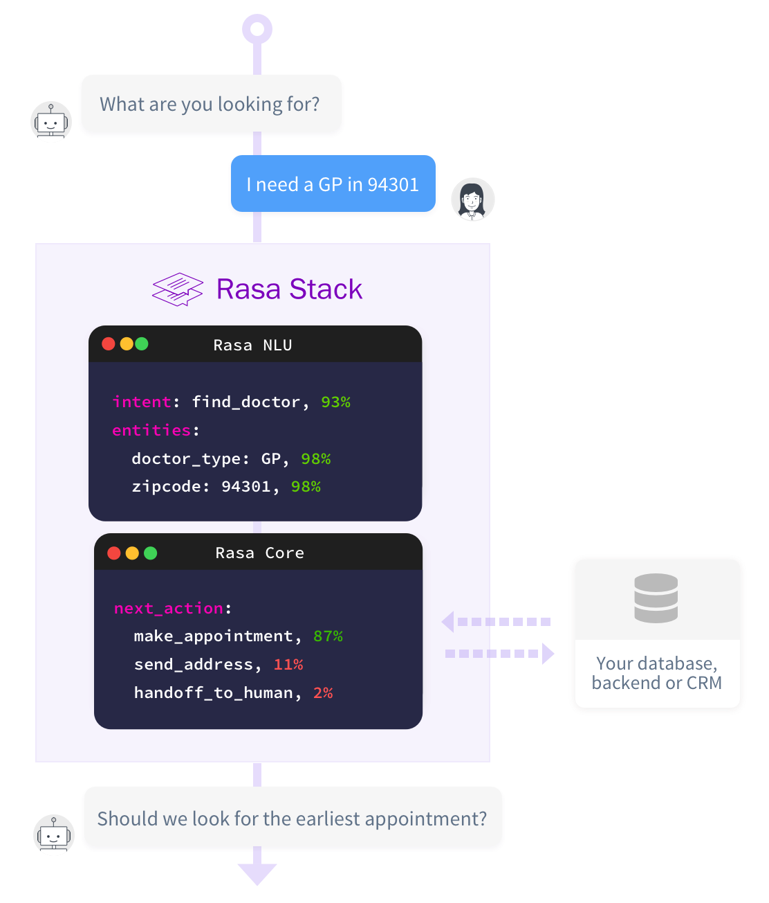

Some of the features are:

* Manage Contextual Dialogues
* Recognize Intents
* Exact Entities
* Full Data Control
* Connect Your APIs
* Custom Models

It has **HTTP API** and **Python support, intent classification, and entity** extraction.it is an open source tool that runs locally.

#### **Rasa chatbot examples**

#### If you know somebody who’s never heard of a contextual chatbot assistant, just point them to Tia. Built with Rasa, Tia makes it easy for women to ask questions about their health and to receive clinician-sanctioned responses from real-world user interactions.

#### **Framework pricing**

Rasa is free to use in any project. Rasa Platform is [a paid tier](https://rasa.com/products/pricing/) that includes Rasa plus training, QA, and a customer success program.

**Related Links:**

* [Documentation](https://rasa.com/docs/getting-started/)
* [Rasa-Open Source Code](https://github.com/RasaHQ)

Open source machine learning tools for developers to build, improve, and deploy text-and voice-based chatbots and assistants

* [Building a Conversational Chatbot for Slack using Rasa and Python](https://towardsdatascience.com/building-a-conversational-chatbot-for-slack-using-rasa-and-python-part-1-bca5cc75d32f)
* [How to Build a Chatbot with RASA : Complete Guide](https://www.datasciencelearner.com/how-to-build-a-chatbot-rasa-complete-guide/)
* [Learn how to Build and Deploy a Chatbot in Minutes using Rasa](https://www.analyticsvidhya.com/blog/2019/04/learn-build-chatbot-rasa-nlp-ipl/)
* [Building a chatbot with Rasa](https://itnext.io/building-a-chatbot-with-rasa-9c3f3c6ad64d)

### **Semantic Machines**

### Semantic Machines created a proprietary conversational AI. The features of the system include a **conversation engine, speech synthesis, deep learning, reinforcement learning, speech recognition, semantic intent extraction, and language generation (NLG)** technology. Semantic Machines goes beyond understanding commands to understanding conversations. The platform is language independent.

### Semantic Machines is an AI development company. It offers a **language-independent technology platform** that goes beyond understanding commands and actually understands conversations.

### Its conversational engine can deal with **text and speech** and can absorb knowledge from users to enhance its capabilities. Semantic Machines supports a wide range of use cases ranging from business productivity, customer acquisition and customer service for travel, e-commerce, concierge, search, automotive, and beyond.

**Related Links:**

* [Documentation 1](http://www.semanticmachines.com/)
* [Documentation2](http://www.semanticmachines.com/technology)
* [Neural Code Comprehension: A Learnable Representation of Code Semantics](https://github.com/spcl/ncc)
* [Selected Machine Learning algorithms for natural language processing and semantic analysis in Golang](https://github.com/james-bowman/nlp)
* [semantic-analysis](https://github.com/topics/semantic-analysis)

### **IBM Watson**

IBM Watson is the preferred chatbot development platform when it comes to building an AI chatbot that can handle a complex conversation with ease.

According to *Chatbots Journal*, IBM Watson is the **bot-building platform for 61% of businesses**. It can process around four terabytes of data and is hosted on a cluster of ninety IBM Power 750 servers, each of which uses a 3.5 GHz POWER7 eight-core processor.

An [IBM Watson chatbot](https://www.rootinfosol.com/why-chatbot-development-ibm-watson) can serve different verticals including customer engagement, education, financial services, health, IoT, media, HR, and workplaces.

The framework might be easier for non-developers to use. In fact, IBM mentions in the product literature that you don’t need to know how to code to build a bot. A visual dialog editor simplifies the process. Watson Assistant comes with SDKs for **Python, Ruby, and other languages** popular among web application developers.

Although many frameworks attempt their seamless integration with various platforms, Watson Assistant doesn’t. You can still use it where you want to—in fact, you can actually deploy your Watson Assistant chatbot anywhere. Even though IBM isn’t using “seamless integrations” or “one-click deployment” as selling points, deploying your bot on a given channel, like Slack, is still pretty straightforward.

**IBM Watson Assistant chatbot examples**

1. Creval Sistemi e Servizi, an Italian bank, understands just how useful Watson can be. After using Watson to build Alfredo, a chatbot that processes requests to the bank’s service desk, customer-facing employees placed 80 percent fewer calls to back-of-office staff. Alfredo helped them retrieve the information they needed, faster.
2. Other companies have had similar success with Watson. Woodside, an oil and gas company, trained a Watson-based cognitive system to understand 600,000+ pages of documentation. In the past, employees spent 80 percent of their time researching problems and 20 percent of their time applying fixes. Since Watson, they’ve reversed those percentages.

Enterprise productivity bots make up a hefty chunk of Watson Assistant use cases, but many developers use it to build simpler bots for customer service or appointment booking.

#### **Framework pricing**

#### Lite and Standard packages come at different price points. The first is free, and

#### the second is $0.0025 per message. Both packages come with industry-specific, prebuilt content to help you get started, and both have analytics dashboards (7-day analytics with Lite, 30-day analytics with Standard).

There are other packages available, but pricing depends on how you use the bot.

**Related Links:**

* [Documentation](https://dataplatform.cloud.ibm.com/docs/content/wsj/analyze-data/pm_service_supported_frameworks.html)
* [How to build a chatbot for your business](https://www.ibm.com/watson/how-to-build-a-chatbot)
* [IBM Watson Talent Frameworks](https://www.ibm.com/products/watson-talent-frameworks)

### **BotKit**

### Botkit is an **open source** developer tool for building chat bots, apps and custom integrations for major messaging platforms.It is one of the leading bot developer tools. Botkit.ai helps you build your bot with the help of **visual conversation builder** and **allows you to add plugins as per your needs.** It works on **natural language processing** engine from **LUIS.ai** plus includes open source libraries.

### There are more than 10,000 bots developed and in use with the help of Botkit. It works and integrates with the following platform.

* Slack
* Cisco Spark
* Microsoft
* Twilio
* IBM Watson
* Facebook
* Api.ai
* Glitch
* Heroku

Although you can technically integrate any available natural language processing (NLP) service into bots built with Botkit, Microsoft LUIS might be of particular interest. Botkit is part of the [Microsoft Bot Framework](https://dev.botframework.com/) and is released under the [MIT Open Source license](https://github.com/howdyai/botkit/blob/master/LICENSE.md)

**Related Links:**

* [Botkit](https://github.com/howdyai/botkit)

This repository contains the core Botkit library, as well as a series of plugins and extensions for connecting Botkit to messaging and chat platforms and other tools in the bot building ecosystem.

* [Documentation](https://botkit.ai/docs/v4/)