National University of Computer and Emerging Sciences (FAST), Islamabad
AI4015 Agentic Artificial Intelligence — Fall 2026
Semester Project — Phase 1
Literature Review, Research Gaps, Proposal & Baseline
Project code: G3-09
Seed: EMI-RAPL — Trustworthy Mechatronics and Robotics Intelligence through Reasoning Agentic LLMs and Physics-Informed Learning
Mind the Twin Gap: Physics-Calibrated, Uncertainty-Aware LLM Agents for Fault-Tolerant Multi-Zone Thermal Control
Name | Roll number | Role
Fatima Khursheed | 23I-0746 | Group head
Saleha Muhammad | 23I-0727 | Member
Supervisor: Naeem Tareen | Instructor: Muhammad Owais Idrees
GitHub (Deliverable C): https://github.com/Fatima-Khursheed20/emi-rapl-thermal
October 2026

Deliverable A — Literature Review and Research Gaps

A.1 Paper selection
We searched OpenAlex, Crossref, IEEE Xplore, ScienceDirect and arXiv for 2025–2026 work that combines large language model (LLM) agents with feedback control, process supervision or physics-based verification, using queries such as "LLM agent fault-tolerant control", "LLM PID tuning", "LLM model predictive control" and "LLM process control safety". Of roughly sixty candidates we kept twelve peer-reviewed articles that (i) describe a concrete method or agent architecture, (ii) evaluate it on a named plant, benchmark or hardware platform, and (iii) report quantitative results. Preprints and surveys were excluded from the count; well-known preprints such as ControlAgent [14] are cited only as background. Every bibliographic record was checked against Crossref.
The twelve papers fall into four groups: LLM agents that supervise or tune controllers online [1]–[5]; LLM agents that design controllers offline [6], [8], [9], [12]; LLM agents with causal or structural safety layers [7], [10]; and verification of LLM fault reasoning [11]. Ten appear in Elsevier, IEEE, Springer Nature or MDPI journals, one in IFAC-PapersOnLine and one in the IEEE CCTA proceedings.

A.2 Base paper
Reference. J. Vyas, M. S. Gill, A. Markaj, F. Gehlhoff, and M. Mercangöz, "From detection to action: Using LLM agents for fault-tolerant control," Journal of Process Control, vol. 167, Art. no. 103855, Nov. 2026, doi: 10.1016/j.jprocont.2026.103855.
Proof of ranking. Journal of Process Control (Elsevier, ISSN 0959-1524) has a 2025 SCImago Journal Rank (based on Scopus) of 0.874, Q1, with an h-index of 138 [19]. In 2025 it is Q1 in Control and Systems Engineering, in Industrial and Manufacturing Engineering and in Modeling and Simulation, and Q2 in Computer Science Applications. The guideline accepts a Q1 ranking in Scopus or JCR, so the base paper is eligible. Figure 1 shows the SCImago record.
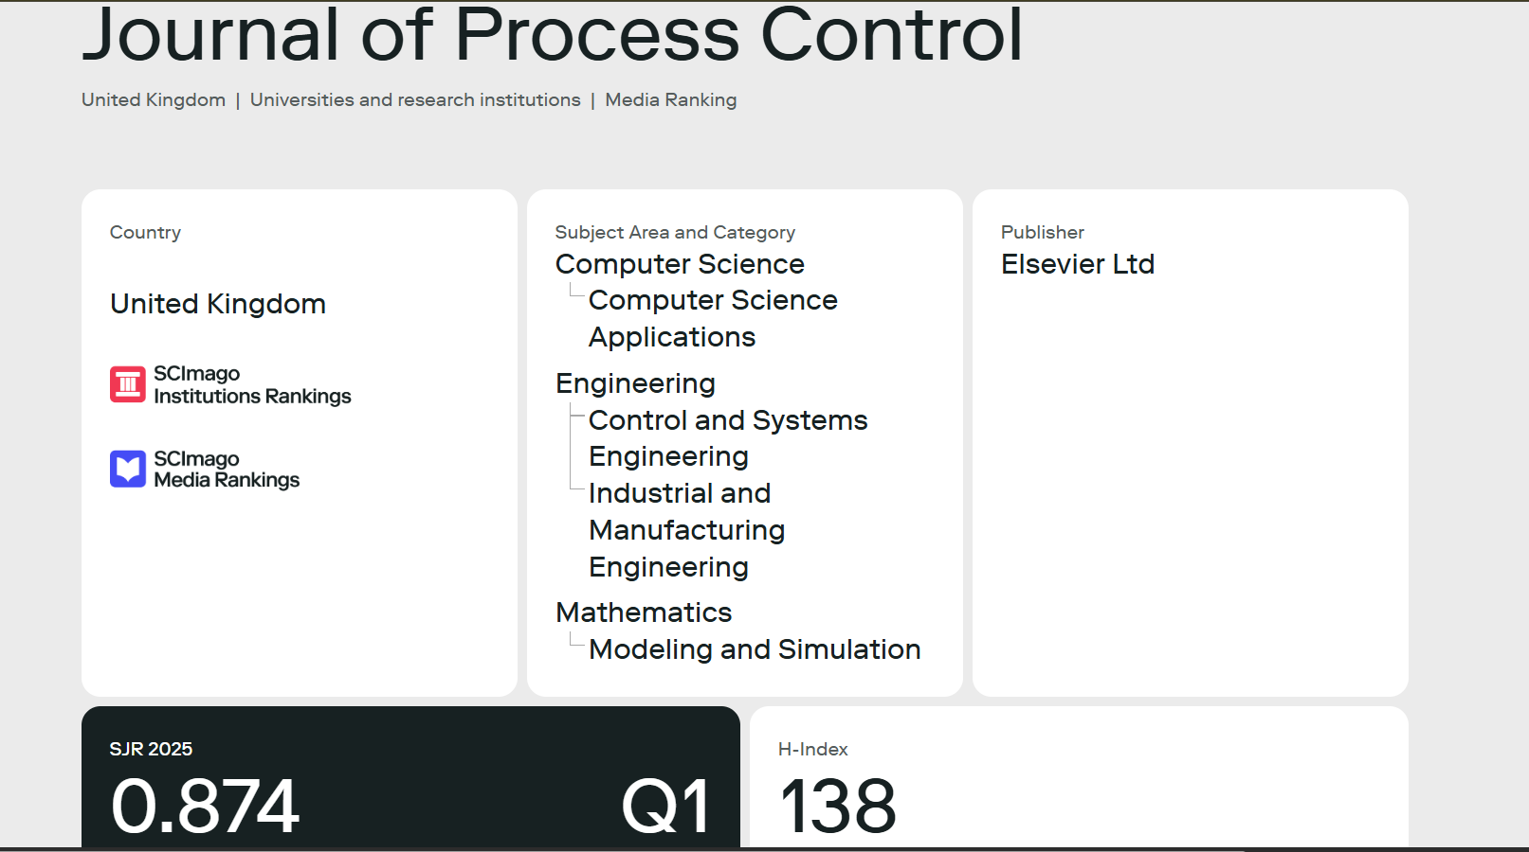
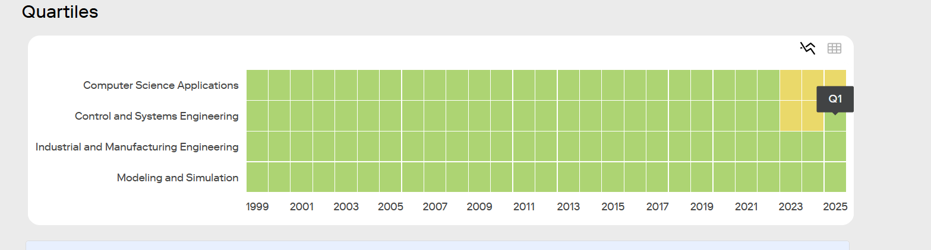
Figure 1. SCImago Journal Rank record of Journal of Process Control [19]: (top) subject categories and 2025 SJR of 0.874 in quartile Q1; (bottom) quartile history by category, with 2025 in Q1 for Control and Systems Engineering, Industrial and Manufacturing Engineering and Modeling and Simulation (green = Q1, yellow = Q2).

Why this paper was selected
- It addresses the same problem as our project: turning a detected fault into a safe, validated control action using LLM agents grounded in plant knowledge and a digital twin. This is the EMI-RAPL idea of agents that reason while physics models enforce feasibility.
- It is directly usable as a comparison point. The agent roles, validation-and-reprompt loop, reprompt budget, deterministic fallback and metrics (success rate, recovery rate, latency, token cost) are clearly specified, and the code is released under an MIT licence [18].
- The same group earlier evaluated LLM control agents on the TCLab thermal board [2], [3], [15], the testbed our environment is built on, so re-implementing the workflow on a thermal plant follows the authors' own line of work.
- Its limitations section names the problems we target: the matched-model assumption, oracle fault localisation, and systematic errors that reprompting cannot fix. Our gaps are therefore grounded in the base paper itself.

Problem, method, data and results
Problem. When a fault is detected in a process plant, operators must choose a recovery path and concrete control actions quickly, often during an alarm flood. The paper asks whether LLM agents, grounded in structured plant knowledge and checked by simulation, can take this "detection-to-action" step reliably and within the time the process allows.
Method and agent architecture. The framework decomposes operator work into a multi-agent workflow. A Monitoring Agent raises an intervention once a fault is reported. A Planning Agent retrieves a fault-relevant subgraph from a CPSMod-based ontology through Graph RAG (stored in GraphDB and queried with SPARQL) and selects a minimal-risk recovery path through the plant's state machine. An Action Agent turns that path into discrete actuator commands or continuous setpoint changes. A Simulation Agent executes the candidate on a Digital Process Plant Twin, and a deterministic validator checks interlocks, operating envelopes and dynamic feasibility. If the check fails, structured feedback is sent back through a reprompting loop (limit of five); if no acceptable plan appears in time, a deterministic fallback policy takes control. GPT-4o-mini and GPT-4.1-mini are used.
Dataset / benchmark. Two simulated benchmarks: a discrete batch mixing module with six fault scenarios (for example pump failure, pump degradation, clogging, sensor fault and leak), and a continuous stirred-tank reactor under PID regulation with three faults (fouling, pump degradation and a cooling valve stuck near closed). Each scenario is run ten times per model.
Key results. On the mixing module GPT-4.1-mini succeeded in all 60 runs without needing a reprompt, while GPT-4o-mini succeeded in 51 (85%); its failures concentrated in pump degradation (50% success, 44% recovery rate) and sensor faults (60% success, 33% recovery), with action precision falling to 61.4% because of unnecessary actuations. On the CSTR, GPT-4.1-mini reached 93.3% (28/30) and GPT-4o-mini 76.7% (23/30); under the stuck cooling valve GPT-4o-mini succeeded in only 4 of 10 runs and none of its reprompted runs recovered. Agent calls took about 2–3 s and complete runs 33–52 s, with roughly 13–15 thousand input tokens per CSTR action call.

Limitations stated by the authors
- Matched-model assumption: the twin used for validation is identical to the model that generates the plant behaviour and contains the same injected fault, so robustness to plant–model mismatch, sensor noise and actuator degradation is not evaluated. The authors suggest uncertainty-aware validation, online calibration or interval bounds as future work.
- Fault localisation is out of scope and assumed to come from the monitoring layer; without it the agents may keep proposing plausible but inapplicable actions.
- Reprompting corrects transient mistakes but not systematic reasoning errors, as the low recovery rates show.
- Novel faults cannot be validated because the twin only contains faults modelled in advance; knowledge-graph construction is laborious; latencies rule out hard real-time loops.

Limitations identified by our group
- Because the validator twin is the plant, a "validated" action is counted as a success. The metric cannot reveal actions that pass validation but would fail on a real plant, which is exactly the risk that matters for deployment.
- Only two closely related models from one vendor are tested; there are no open-weight or smaller models and no non-LLM baselines such as a rule table or an optimiser, so the value added by LLM reasoning is not isolated.
- Ten runs per scenario with fixed fault magnitudes and no confidence intervals give limited statistical evidence.
- Validator feedback says which constraint failed but not by how much or what would be feasible, which may explain why weaker models repeat the same mistake until the budget runs out.

How our project builds on, compares against and goes beyond it
We re-implement the workflow (same agent roles, reprompt budget of five, deterministic fallback and metrics) on a multi-zone thermal plant built from the TCLab energy balance [16]. We evaluate it in two settings: the paper's own matched twin, and a realistic nominal twin that knows only the reported fault type. The difference between the two quantifies Gap 1. We then go beyond the paper with three components, one per gap: an online physics-calibrated, uncertainty-aware twin (G1), quantitative counterexample feedback with LLM-seeded numeric repair (G2), and a tool-grounded diagnosis agent that replaces the oracle localisation (G3). Unlike the paper, all success metrics are computed on the hidden true plant and include non-LLM baselines.

A.3 Critical summaries of the reviewed papers
Each summary covers the problem, method, data, results, limitations (author-stated and our own) and relevance to our project.

[1] Vyas et al., "From detection to action" (base paper)
Problem. Moving from a raised alarm to a safe corrective action quickly, when operators are overloaded and LLM suggestions are rarely checked against plant physics before they are applied.
Method. Monitoring, planning, action-synthesis, simulation, validation and reprompting agents, grounded in a CPSMod ontology through Graph RAG; every proposal is simulated on a digital twin and checked against interlocks, envelopes and dynamic feasibility, with a fixed fallback after five failed revisions.
Data. Simulated mixing module (six faults) and PID-regulated CSTR (three faults), ten runs each with GPT-4o-mini and GPT-4.1-mini.
Results. GPT-4.1-mini: 60/60 and 28/30 successes; GPT-4o-mini: 85% and 76.7%, with recovery rates of 0–44% in its hardest scenarios; 2–3 s per call and 33–52 s per run.
Limitations. The validation twin is the data-generating model itself, including the injected fault, so mismatch and noise are never tested; localisation is supplied by an oracle; only two related models and no non-LLM baselines are compared. Counting a validated action as success hides validated actions that would fail on a real plant.
Relevance. This is our base paper. We re-implement its workflow on a thermal plant and address the three weaknesses above (Section A.2).

[2] Vyas and Mercangöz, IFAC-PapersOnLine 2025
Problem. Whether LLM agents can run a physical control loop on their own and correct their own mistakes without a human.
Method. Three CrewAI agents: an operator proposes heater actions, a validator checks whether the action keeps the temperature in band, and a reprompter asks for a revision when the check fails; a safety override acts after a fixed number of attempts.
Data. A real TCLab Arduino board controlled for 40 minutes with on/off heating between 25 and 27 °C, using GPT-3.5, GPT-4o-mini, GPT-4o and GPT-4.
Results. Reprompting raised GPT-3.5 from 60.0% to 85.3% valid actions and GPT-4o-mini from 72.5% to 90.0%; GPT-4o was almost always right first time (99.6%). Accuracy did not equal control quality: GPT-4o-mini stayed closest to the band centre, while GPT-4, the slowest model, spent the longest outside the band because its decisions arrived late.
Limitations. The authors point out that inference latency restricts the method to slow processes and that the task is simple. We add that the validator is a threshold rule rather than a physical model, each model was run only once, and on/off switching says little about continuous decisions such as gain or setpoint changes.
Relevance. It uses the same TCLab hardware as our environment and shows both the benefit and the ceiling of plain reprompting (Gap 2) and the absence of a physics-based check (Gap 1).

[3] Wang et al., IEEE CCTA 2026
Problem. Large cloud LLMs are slow, opaque or data-sensitive for edge control; can a compact model produce valid actions when paired with a validator?
Method. A Qwen2.5-1.5B model aligned to control rules with Group Relative Policy Optimisation, placed in an action, validator and reprompter loop with a symbolic, twin-style validator.
Data. Randomised thermal-control simulations: 30 experiments of 500 steps each.
Results. Mean action-alignment accuracy of 91.5% (86.3–100% across cases) at 3.84 s mean latency, and a 95% in-range rate when the symbol mapping was altered.
Limitations. Simulation only, with a symbolic rather than calibrated dynamic validator. The main metric is agreement with a reference action rather than plant safety or tracking, and the small model works only after task-specific reinforcement-learning fine-tuning, which limits transfer to other plants or off-the-shelf models.
Relevance. It shows small models need more than reprompting to be reliable. Our Gap 2 targets the same weakness without fine-tuning, through quantitative physical feedback and numeric repair.

[4] Arif and Rahim, Actuators 2025
Problem. Whether an LLM can tune the PID gains of a physical servo while it runs.
Method. Two agents in an n8n workflow: a control agent (o3-mini) watches steady-state error, overshoot, rise time and settling time and decides when to tune; an optimiser agent (GPT-4.1-mini) proposes new gains from a guided prompt or freely within a fixed safe range, sent to the hardware through a Python/Flask link.
Data. A Quanser QUBE-Servo 2 motor.
Results. Both modes reduced IAE, ISE, MAE and RMSE after the initial transient, but not ITAE or ITSE because of high-frequency oscillation and noise; without the guiding prompt the agent failed to settle on final gains in about one run in ten.
Limitations. Only three runs are tabulated and the detailed analysis uses one, without statistics. Safety rests on a static gain box, so a destabilising gain set inside the box would still be applied. There is no comparison with classical tuning on an equal budget and no fault scenario.
Relevance. A hardware example of agentic tuning without pre-execution verification, which motivates the twin-based validator our work keeps and strengthens.

[5] Amin et al., IEEE Access 2025
Problem. PID tuning for warehouse AGVs is laborious and usually needs system identification or repeated experiments.
Method. Prompt-only gain inference through in-context learning: MultiSpeed prompting interpolates gains from the target speed, and Few-Shot + MultiSpeed adds worked examples.
Data. A two-wheeled AGV at five speeds between 5 and 25 m/min.
Results. Gains stayed close to simulation-optimised values, kept physically sensible trends (Kp rising and Ki falling with speed), held tracking RMSE within 5–10% of optimal and cut calibration effort by over 80%.
Limitations. A single LLM call with no feedback loop or safety check; accuracy relies on exemplars from an existing optimiser, so it is unlikely to cope with dynamics unlike those examples, for instance after a fault. Only one vehicle under nominal conditions is tested.
Relevance. It represents the single-call, non-agentic design used as our baseline B2, which we argue is insufficient once the plant changes in ways the prompt has not seen.

[6] Ren et al., Advanced Engineering Informatics 2026
Problem. Developing MPC controllers for buildings needs substantial expertise and time, which blocks wide deployment.
Method. AgentiControl-MPC: six LLM agents share data processing, predictive-model design, MPC formulation, code generation and error correction, coordinated by inter-layer, intra-layer and state-aware communication.
Data. The BESTEST Hydronic Heat Pump case from the BOPTEST simulation framework.
Results. Across repeated runs the multi-agent system produced working controllers 93.3% of the time against 66.7% for a single-agent baseline; the best generated MPC cut energy cost by 52% and thermal discomfort by 69% relative to the baseline PI controller.
Limitations. One simulated building is studied, so generalisation is untested. "Success" means a controller was produced and ran, not that it stays safe under faults or model error, and the task is offline design rather than a time-limited online decision.
Relevance. A clean multi-agent versus single-agent comparison in a thermal domain that supports our agentic justification; like the base paper it trusts its simulator completely (Gap 1).

[7] Xin et al., Applied Energy 2026
Problem. Adaptive multi-zone HVAC control normally needs a building-specific model or a trained RL policy, both costly to transfer between buildings.
Method. Hierarchical LLM agents propose hourly updates to rule-based controllers, which issue 15-minute setpoints. Each update must pass structural checks, checks against a human-confirmed causal graph built during onboarding, and zone cooling allowances.
Data. BOPTEST cases with one, two and five zones, compared with basic and enhanced rule-based control, hierarchical MPC, PPO and multi-agent PPO.
Results. Highest mean reward and lowest energy in all three cases, 2.2–43.2% less energy than the baselines, small comfort deviations (0.019–0.454 PMV·h), and fewer safety interventions with the causal layer active; ablations cover memory, cross-zone coordination and LLM "thinking".
Limitations. The causal graph is built and confirmed by hand. The checks are causal and structural rather than quantitative rollouts, so a correctly directed but wrongly sized update can pass, and no equipment faults are injected.
Relevance. The most thorough evaluation design in our set and a template for our baselines and ablations; its causal checks inspire the counter-hypothesis test in our diagnosis agent (Gap 3).

[8] Zhou et al., IEEE T-ASE 2026
Problem. LLM-designed feedback controllers have mostly been shown on simplified systems, with little comparison to expert designs or real robots.
Method. The LLM designs a compensator that makes an unknown plant respond like a chosen reference model, following the idea of model-reference adaptive control, instead of writing a controller from scratch; a Lyapunov analysis supports stability.
Data. A two-degree-of-freedom soft robot and a one-degree-of-freedom humanoid shoulder, in simulation and on hardware.
Results. Performance comparable to four conventional adaptive controllers, with a simpler reasoning process than an LLM-designed adaptive controller.
Limitations. The authors note that the compensator is only effective within a bounded region of tracking-error conditions, becomes ineffective when its structural assumptions are violated, and that the Lyapunov analysis is carried out on a single system. We add that design happens offline and stability is argued afterwards rather than checked before each deployment; only two low-DoF platforms are studied and faults are not considered.
Relevance. It confirms that dealing with an unknown or mismatched plant is the central difficulty for LLM-designed control, the issue our Gap 1 tackles for supervisory recovery, and represents the robotics strand of EMI-RAPL.

[9] Carr et al., IEEE TII 2026
Problem. LLM-guided program synthesis works on benchmarks but has rarely produced controllers deployed on real robots.
Method. The LLM writes the structure of the control law and particle swarm optimisation tunes its coefficients with a reward from a Markov decision process; candidates move from a custom simulator to PX4 software-in-the-loop and then to a physical UAV.
Data. Lemniscate and Lissajous trajectory tracking, against PID with a disturbance observer and LQR.
Results. The synthesised law tracked better than both baselines, with at least about 38% lower mean squared error in real flights.
Limitations. An offline, optimisation-heavy process suited to design rather than time-limited recovery; one platform and two trajectories are tested and fault robustness is not studied.
Relevance. Its central lesson, that the LLM should decide structure and an optimiser should decide numbers, is the basis of our Gap 2 approach, which applies the same split inside an online recovery loop.

[10] Schall, Autonomous Intelligent Systems 2026
Problem. Hallucination and the lack of physical understanding make direct LLM control in safety-critical processes unacceptable.
Method. The Autonomous Action Execution framework confines the LLM to an observation-only monitor, while deterministic verification and execution agents make every safety-relevant decision. SCADA data, P&IDs and procedures are converted to text, and proposals are checked by traversing the P&ID graph for tag existence, actuatability, fail-state consistency and downstream effects; baselines B0–B3 add components one by one.
Data. Three Tennessee Eastman Process scenarios plus synthetic polymer-reactor and dryer cases.
Results. The validator caught all 43 crafted invalid proposals, and over 50 LLM runs, in which models proposed unsafe actions 10–70% of the time, it caught every invalid proposal in the covered categories.
Limitations. The checks are structural, so a physically wrong setpoint on a valid tag would pass; the scenarios are synthetic, and keeping the LLM out of the action path limits autonomy.
Relevance. It quantifies how often LLMs propose unsafe actions, which supports a validator, while showing that structural checks alone are not enough (Gap 1).

[11] Galitsky and Rybalov, Processes 2026
Problem. LLMs produce fault explanations that sound plausible but contradict physics, sensor evidence or plant dynamics.
Method. The LLM (GPT-5.1) only generates explanations and a symbolic layer judges them: abductive logic programming tests coherence, counter-abduction builds rival hypotheses from mass and energy balances, and a discourse-weighted variant favours the central clauses of operator notes and alarm logs.
Data. A 500-scenario process-control hallucination dataset covering faults such as pump restriction, valve stiction, fouling and runaway, plus a 36-person user study.
Results. Logical accuracy improved by up to 18%; the full discourse-weighted variant raised consistency by 15 and 12 points in the ablation; inference time fell by more than 20%; user trust rose by 23%.
Limitations. The authors acknowledge synthetic or semi-synthetic scenarios and a dependence on a complete process ontology. The work stops at explanation and never closes the loop to a control action.
Relevance. Direct evidence that LLM fault diagnosis must be verified, motivating the tool-grounded diagnosis agent with a counter-hypothesis check in our Gap 3.

[12] Li et al., Journal of Manufacturing Systems 2026
Problem. Setting up and adapting tension and speed controllers on roll-to-roll lines consumes scarce expert time.
Method. A five-phase LLM-assisted multi-agent framework: system identification from operating data, automatic controller selection and tuning, simulation-to-real adaptation with safety checks, continuous monitoring with diagnostics, and periodic model refinement.
Data. A simulated multi-span roll-to-roll web-handling system: the "real" plant is itself a simulation, and the controller is tuned on a deliberately mismatched model (8.3–50% parameter deviations); hardware testing is left to future work.
Results. RMSE fell by 55.7% for tension control and 82.4% for velocity tracking, outperforming an MPC baseline.
Limitations. The authors list hardware validation on a physical roll-to-roll testbed and extension to other manufacturing processes as future work, and note that tension–velocity coupling grows stronger at production speeds than at the low speed they tested. We add that each configuration appears to be evaluated in a single run without repeats or statistics, and that the Monitoring Agent is described but never evaluated: no faults or degradation are injected in the validation study.
Relevance. It shows that refreshing the model online matters in practice, the step our base paper leaves out, and gives a manufacturing example of the EMI-RAPL idea.

A.4 Cross-paper comparison
Table 1 summarises all reviewed papers; the base paper is marked with ★ and highlighted.
Table 1. Cross-paper comparison of the twelve reviewed papers (★ = base paper).
# | Title (short) | Year & venue | Dataset / benchmark | Method / agent architecture | Evaluation metrics | Key results | Limitations / research gap
1 ★ | LLM agents for fault-tolerant control (BASE) | 2026, J. Process Control (Q1) | Sim. mixing module + CSTR, 9 faults | Monitor–plan–act–simulate–validate–reprompt; Graph RAG; digital twin; fallback | Success, recovery rate, plan/action correctness, latency, tokens | GPT-4.1-mini 100% / 93%; GPT-4o-mini 85% / 77%; recovery 0–44% on hard faults | Matched twin; oracle localisation; reprompting cannot fix systematic errors
2 | Agentic framework for industrial control | 2025, IFAC-PapersOnLine | Real TCLab board, 40 min | Operator, validator and reprompter agents (CrewAI) | Valid-action rate, time outside band | 60→85% (GPT-3.5); 99.6% (GPT-4o) | Rule-based validator; single run; latency
3 | SLM control with self-correction | 2026, IEEE CCTA | Randomised thermal sims, 30×500 steps | GRPO-tuned Qwen2.5-1.5B + validator + reprompter | Action alignment, in-range rate, latency | 91.5% alignment, 3.84 s | Needs RL fine-tuning; symbolic validator
4 | Agentic real-time PID of a servo | 2025, Actuators | Quanser QUBE-Servo 2 | o3-mini monitor + GPT-4.1-mini optimiser; safe gain box | IAE, ISE, MAE, RMSE, ITAE, ITSE | IAE/ISE/RMSE reduced; ITAE/ITSE not; ~1/10 unguided runs fail | Three runs; no pre-execution check; no classical baseline
5 | Prompt-based PID for AGVs | 2025, IEEE Access | Two-wheeled AGV, 5 speeds | Single-call few-shot / MultiSpeed prompting | RMSE vs optimum, calibration effort | Within 5–10% of optimum; >80% less effort | Non-agentic; no feedback, faults or safety
6 | AgentiControl-MPC | 2026, Adv. Eng. Informatics | BOPTEST heat-pump building | Six-agent MPC development pipeline | Generation success, energy cost, discomfort | 93.3% vs 66.7% single agent; −52% cost | One building; offline; success ≠ safe operation
7 | Causality-constrained HVAC agents | 2026, Applied Energy | BOPTEST 1-, 2-, 5-zone | Hierarchical LLM agents gated by causal graph | Reward, energy, PMV·h, interventions | 2.2–43.2% less energy than baselines | Manual causal graph; no quantitative rollout; no faults
8 | LLM-guided adaptive compensator | 2026, IEEE T-ASE | Soft robot, humanoid shoulder (sim + real) | LLM-designed MRAC-style compensator; Lyapunov analysis | Tracking error vs adaptive controllers | Comparable to four adaptive controllers | Offline design; no online checks or faults
9 | LLM + PSO UAV controller synthesis | 2026, IEEE TII | UAV sim → PX4 SITL → real UAV | LLM writes control law; PSO tunes coefficients | Trajectory MSE | ≥38% lower MSE in real flights | Offline and compute-heavy
10 | P&ID-grounded validation | 2026, Auton. Intell. Systems | Tennessee Eastman + 2 synthetic plants | Observation-only LLM; deterministic graph verifier | Recall of invalid proposals, unsafe-proposal rate | 100% recall; LLMs unsafe in 10–70% of runs | Structural checks only; no dynamics
11 | Neuro-symbolic hallucination checks | 2026, Processes | 500-scenario dataset + 36-user study | GPT-5.1 generator; abductive and counter-abductive verifier | Logical accuracy, consistency, trust | +18% accuracy; +15/+12 consistency; +23% trust | Explanations only; synthetic data
12 | LLM multi-agent roll-to-roll control | 2026, J. Manuf. Systems | Simulated R2R web-handling system | Sys-ID, tuning, sim-to-real safety checks, monitoring, refinement | Tension and velocity RMSE | −55.7% / −82.4% RMSE; beats MPC | Simulation only; single runs; monitoring not evaluated

A.5 Research gap synthesis
Reading the twelve papers side by side shows a common pattern: almost all of them place a verification step between the LLM and the plant, but that step is either a perfect copy of the simulator [1], [6], a rule or symbolic check [2], [3], [7], [10], or absent [4], [5]. In parallel, the papers that measure repeated revisions [1]–[3] show that the LLM often cannot repair its own proposal from pass/fail feedback, and the papers on diagnosis [10], [11] show that LLM fault explanations cannot be trusted without verification. From these observations we derived six candidate gaps and selected the three that are specific, supported by named papers, tied to the base paper and measurable on our plant within the semester.
Table 2. Candidate research gaps identified from the review.
Gap | Description | Evidence
G1 (selected) | Validation assumes a twin identical to the plant; mismatch, noise and unknown fault size are untested. | [1], [2], [3], [6], [10], [12]
G2 (selected) | Pass/fail reprompting cannot repair systematic numeric or mode errors, especially for small models. | [1], [2], [3], [9]
G3 (selected) | Fault localisation is assumed to be given, and LLM fault diagnosis is unverified. | [1], [7], [10], [11]
G4 | LLM latency (seconds to a minute) versus process dynamics; fast loops are excluded. | [1], [2], [3]
G5 | Weak statistics: few runs, no confidence intervals, few or no non-LLM baselines. | [1], [2], [4], [6]
G6 | High manual effort to build plant knowledge graphs and causal graphs. | [1], [7]

The three selected gaps are specific (each names one mechanism), evidence-based (each is supported by named papers above), relevant (each is a limitation of the base workflow) and testable (each has a metric we can compute on our plant this semester). G4–G6 are real but either outside the semester's scope (G6) or handled as part of our methodology rather than as a contribution (G4 is measured as latency; G5 is addressed by repeats, confidence intervals and non-LLM baselines).
Table 3. Selected research gaps.
Gap | Supporting evidence (papers) | Proposed approach | How it will be measured
G1: Validation trusts a perfect twin. Mismatch, noise and unknown fault magnitude are never tested, so a "validated" action can still fail on the real plant. | Base paper states the matched-model assumption and leaves mismatch and noise untested [1]; validators in [2], [3] are rule or symbolic checks; [10] checks structure only; [6] trusts one simulator; [12] needs online model refinement in practice. | Adaptive extended Kalman filter that jointly estimates zone temperatures, heater gains, heat-loss coefficients and sensor bias with EWMA noise adaptation; the twin uses these estimates, and candidate actions are validated over an ensemble sampled from the EKF covariance (accepted only if the 95th-percentile peak temperature and tracking error meet the limits). | Validated-but-failed rate, plant success and safety-violation rate on the hidden true plant, at 0/10/20/30% parameter mismatch and two noise levels; EKF parameter error; added decision time. Compared with the base workflow using matched and nominal twins.
G2: Pass/fail reprompting cannot fix systematic errors. The model keeps repeating a wrong mode or wrong numbers until the budget runs out, especially with small models. | Recovery rates of 0–44% and budget exhaustion for GPT-4o-mini [1]; 15% of actions still wrong after reprompting with GPT-3.5 [2]; a small model needs RL fine-tuning [3]; separating LLM structure from optimiser numbers works [9]. | The validator returns quantitative counterexamples and physics-derived feasible bounds (for example the highest reachable temperature of a degraded zone from the calibrated energy balance), routes mode errors back to the planner, and runs a bounded differential-evolution repair seeded with the LLM proposal inside the chosen mode. | Recovery rate, mean reprompts, fallback rate and plant success for gpt-oss-20b and gpt-oss-120b; tokens and wall time; ablation of each feedback element.
G3: Fault localisation is assumed and LLM diagnosis is unverified, so the base workflow cannot run when the monitor reports only symptoms. | Localisation declared out of scope, with failures when it is missing [1]; LLM fault explanations hallucinate [11]; LLM confined to observation because of hallucination [10]; causal constraints stabilise LLM decisions [7]. | A diagnosis agent that calls physics-residual tools (EKF parameter deviations, innovation tests, replay of recent data under each candidate fault on the twin) and must pass a counter-hypothesis check before committing to a ranked fault report. | Top-1 localisation accuracy (fault kind and zone); end-to-end plant success without the oracle, compared with the base workflow with and without the oracle; unsafe actions caused by misdiagnosis.

Deliverable B — Project Proposal

B.1 Project title and selected seed
Title: Mind the Twin Gap: Physics-Calibrated, Uncertainty-Aware LLM Agents for Fault-Tolerant Multi-Zone Thermal Control.
Selected project: G3-09, "EMI-RAPL: Trustworthy Mechatronics and Robotics Intelligence through Reasoning Agentic LLMs and Physics-Informed Learning" (supervisor: Naeem Tareen). The seed describes a broad programme spanning WAAM process identification, adaptive PID control of multi-zone furnaces, adaptive extended Kalman filtering, RLHF for robotic tasks and inverse kinematics, and it asks each group to select one robot or mechatronics task, combine physics constraints with agent reasoning, and validate on hardware or a high-fidelity digital twin.
We selected the seed's first thrust, physics-grounded process control of multi-zone thermal systems, and refined it into one concrete problem: supervisory fault-tolerant control of a multi-zone electric heating process, in which LLM agents choose and parameterise recovery actions and a physics-based digital twin, calibrated online by an adaptive EKF, decides whether those actions are safe. The adaptive-PID, differential-evolution and adaptive-EKF elements of the seed reappear as the low-level control loops, an optimisation tool and the calibration module respectively.

B.2 Problem statement and motivation
Multi-zone thermal equipment such as heat-treatment furnaces, reflow ovens and curing ovens is regulated by one temperature loop per zone. Faults are common and varied: heating elements age and deliver less power, insulation degrades or a door seal fails and heat loss rises, thermocouples drift and read low, and a failed relay can leave a heater stuck on. Each fault calls for a different response. A degraded zone needs a lower, reachable setpoint; a biased sensor needs correcting before the loop overheats the product; a stuck heater may need the neighbouring zones switched off or, if the zone would exceed its limit regardless, a full shutdown. Choosing correctly requires reasoning about the specific fault and its size, while a wrong choice either damages product and equipment or stops production unnecessarily.
Target users are process and control engineers and operators of small and medium thermal equipment, including SMEs and teaching laboratories, the audience the EMI-RAPL seed aims to serve. These users rarely have a dedicated fault-tolerant control system and depend on fixed alarm responses or manual intervention.
Recent work shows that LLM agents can propose recovery actions that are then checked on a digital twin before execution [1]. However, that evaluation assumes the twin is an exact copy of the plant, including the injected fault, and that the fault has already been located. In practice the twin is only a nominal model, the fault size is unknown, and the monitor reports symptoms rather than causes. Under these conditions a twin can approve an action that fails on the real plant or reject one that would have worked. This false assurance is the core problem our project addresses: making the verification step trustworthy when the model is wrong, and making the agent able to recover when verification fails.

B.3 Base paper and research gaps
The base paper, Vyas et al. [1] (Journal of Process Control, 2026, Scopus Q1), proposes a monitoring, planning, action, simulation, validation and reprompting workflow for fault-tolerant control, grounded in an ontology through Graph RAG and protected by a deterministic validator and fallback. It reports 85–100% success with lightweight GPT models on two simulated process benchmarks. Section A.2 analyses it in detail.
Our project builds on it in three steps. First, we re-implement the workflow on a multi-zone thermal plant and evaluate it in its own matched-twin setting and in a realistic nominal-twin setting, which turns its main unstated risk into a measured quantity. Second, we address the three gaps selected in Section A.5, one component each: an EKF-calibrated, uncertainty-aware twin (G1); quantitative counterexample feedback with LLM-seeded numeric repair (G2); and a diagnosis agent that removes the oracle localisation (G3). Third, we judge every method on the hidden true plant and compare against non-LLM baselines, which the base paper does not do.

B.4 Target product or system
By the end of the semester the project will deliver EMI-RAPL Thermal, a working supervisory agent for multi-zone thermal processes, consisting of:
- A Python package and command-line tool that connects to the simulated plant (two-zone TCLab board or four-zone furnace chain) or, through the same interface, to a real TCLab board via the tclab package.
- The full agent: diagnosis, knowledge retrieval, planning, action synthesis, numeric repair, calibrated-twin validation, reprompting and fallback, with every decision stored as an auditable trace.
- A small dashboard showing live zone temperatures, alarms and each decision (plan, proposed action, twin prediction, verdict), with buttons for the operator to approve a shutdown or large derate, or to override.
- A reproducible benchmark: scenario suites, all baselines, evaluation scripts and the scripts that regenerate every table and figure in the final paper.

B.5 Agentic justification
The problem needs agentic behaviour rather than a deterministic workflow, a single LLM call or a simple RAG pipeline, for five reasons:
- The fault is unknown in advance. Kind, zone and magnitude vary, and the right response depends on all three; a stuck heater on a hot zone needs a shutdown, the same fault on a cooler zone does not. A fixed fault-to-action table (our rule-table baseline) uses assumed magnitudes and fails when reality differs.
- The decision requires a feedback loop with the environment. The agent must diagnose with residual tools, consult admissible modes, propose, simulate the proposal on the twin, read the violations, and revise. A single LLM call cannot see the consequence of its own proposal; our single-call baseline applies whatever it proposes. This interleaving of reasoning and acting is the core idea of ReAct-style agents [13].
- Retrieval alone cannot check physics. A RAG pipeline can recall what a fault means, but only a rollout on a calibrated model can show whether a particular setpoint is reachable or safe.
- A plain optimiser lacks the reasoning layer. A differential-evolution search (our DE baseline) needs a predefined decision space and objective for each fault and cannot decide that a sensor should be corrected rather than a gain retuned. In our design the agent chooses the mode and the decision space, and the optimiser becomes one of its tools.
- Human oversight is part of the loop. Shutdowns and large derates are high-impact decisions that need operator approval, and the agent must explain them through its trace.

B.6 Goals and success criteria

Development objectives
- Multi-zone thermal digital twin with fault injection, parameter mismatch and sensor noise (completed in Phase 1).
- Re-implementation of the base-paper workflow and four comparison baselines (completed in Phase 1).
- Adaptive EKF calibration and ensemble, chance-constrained validation (G1).
- Counterexample feedback, feasible-bound tool and LLM-seeded numeric repair (G2).
- Diagnosis agent with residual and hypothesis-replay tools (G3).
- Operator dashboard with approval and override, and an optional run on a physical TCLab board.

Research objectives and success criteria
Table 4. Success criteria, one or more per gap.
Gap | Success criterion
G1 | At 30% plant–model mismatch, the validated-but-failed rate is at most 5%, and plant success is at least 15 percentage points higher than the base workflow with a nominal twin, with no more than twice its decision time.
G2 | With gpt-oss-20b, the recovery rate (successful episodes among those needing a reprompt) is at least 80%, and the mean number of reprompts falls by at least 40% relative to the base workflow.
G3 | Top-1 localisation accuracy of at least 85%, and end-to-end plant success without the oracle within 10 percentage points of the base workflow with the oracle.

B.7 Data, environment and source
The environment is confirmed and already implemented. It is a lumped-parameter model of the TCLab temperature control laboratory [16], a widely used benchmark built around an Arduino board with two transistor heaters and thermistors. Each zone is a small thermal mass heated electrically and cooled by convection and radiation, with heat exchanged between neighbouring zones and a first-order sensor lag; equations are integrated with a fourth-order Runge–Kutta step at 1 Hz. With the published parameters, the model reproduces the real board's behaviour (zones settle near 71 °C and 62 °C at full power). We use two plants: the two-zone TCLab board and a four-zone chain representing a multi-zone furnace.
Realism is introduced in three ways. The true plant differs from the nominal model by a random multiplicative mismatch of 0, 10, 20 or 30% on heat-transfer coefficients, heater gains, sensor lags and thermal mass. Measurements carry Gaussian noise (σ = 0.15 °C) and 0.01 °C quantisation. Five fault types are injected at a random time between 25 and 30 minutes into each 70-minute episode:
Table 5. Fault library of the evaluation environment.
Fault | Class | Injected effect (range) | Consequence without recovery
Heater degradation | Actuator | Heater gain × 0.30–0.50 on one zone | Setpoint becomes unreachable
Enclosure heat loss | Process | Heat-transfer coefficient × 2.5–3.5 on all zones | Setpoints unreachable on all zones
Local insulation loss | Process | Heat-transfer coefficient × 3–5 on one zone | One setpoint unreachable
Sensor bias | Sensor | Reading offset −7 to −14 °C on one zone | Loop overheats the true temperature
Stuck-high heater | Actuator | Heater output frozen at 85–100% | Zone may exceed the 60 °C limit

The Phase-1 evaluation suite contains 120 scenarios: five faults × two plant sizes × four mismatch levels × three seeds. Because free-tier LLM quotas are limited (8,000 tokens per minute and 200,000 tokens per day per model), LLM methods are run on a fixed two-zone subset; Phase 1 reports its 10-scenario core set, which covers all five faults at 0% and 20% mismatch. In Phase 2 the suite grows to five seeds, two noise levels and a held-out set with unseen magnitudes and compound faults. LLMs are accessed through Groq's OpenAI-compatible API: openai/gpt-oss-20b as the small model and openai/gpt-oss-120b as the large one, both with low reasoning effort. Every number in this report can be regenerated from the repository.

B.8 System architecture
Table 6. System architecture components.
Component | Design
Models | Three LLM agents (diagnosis, planning, action) served through an OpenAI-compatible client with a token-budget pacer, retries and token accounting; the deterministic monitor, validator, fallback and PI loops are ordinary code.
Tools | snapshot (current measurements, setpoints, outputs, residuals, short trend); retrieve (knowledge subgraph); twin.rollout and validate (simulate a candidate action and check it); in Phase 2 also ekf.estimate, feasible_bounds, test_hypothesis and repair.
State and contracts | All agent inputs and outputs are typed Pydantic contracts: Snapshot, FaultReport, PlanDecision, RecoveryAction, ValidationResult, LLMCallRecord and DecisionTrace. LLM output that does not parse into a contract counts as a failed proposal and is never executed.
Knowledge | A typed plant knowledge graph holding structure (zones, heaters, sensors, neighbours), dynamics, the operating-mode state machine (NORMAL, RETUNE, DERATE, SENSOR_CORRECTION, COMPENSATE, SAFE_SHUTDOWN), admissible modes per fault class and constraints. Retrieval returns the subgraph for the implicated zone and its neighbours, a lightweight equivalent of the base paper's ontology and Graph RAG.
Memory | Per-decision conversation and validation history in the trace; no long-term memory is needed for this task.
Orchestration | An explicit state machine: diagnose, retrieve, plan, act, (repair), validate, then apply, reprompt the responsible agent, or fall back once the budget of five reprompts is exhausted.
Human controls | Operator approval for shutdowns and large derates, manual override, and the full decision trace for audit.
External environment | The simulated plant (true parameters hidden from all agents), or a real TCLab board through the same interface.

B.9 Methodology and architecture diagram
Figure 2 shows the complete system. Blue components form the base-paper workflow that serves as our main baseline; orange components are the three gap-specific additions, marked G1–G3; grey boxes are deterministic modules. The baseline path runs from the monitor through oracle localisation, knowledge retrieval, the planning and action agents and a matched or nominal twin to the validator, with reprompting and fallback. The proposed path replaces the oracle with the diagnosis agent (G3), adds numeric repair after the action agent (G2), and validates on an EKF-calibrated twin ensemble fed by plant measurements (G1).
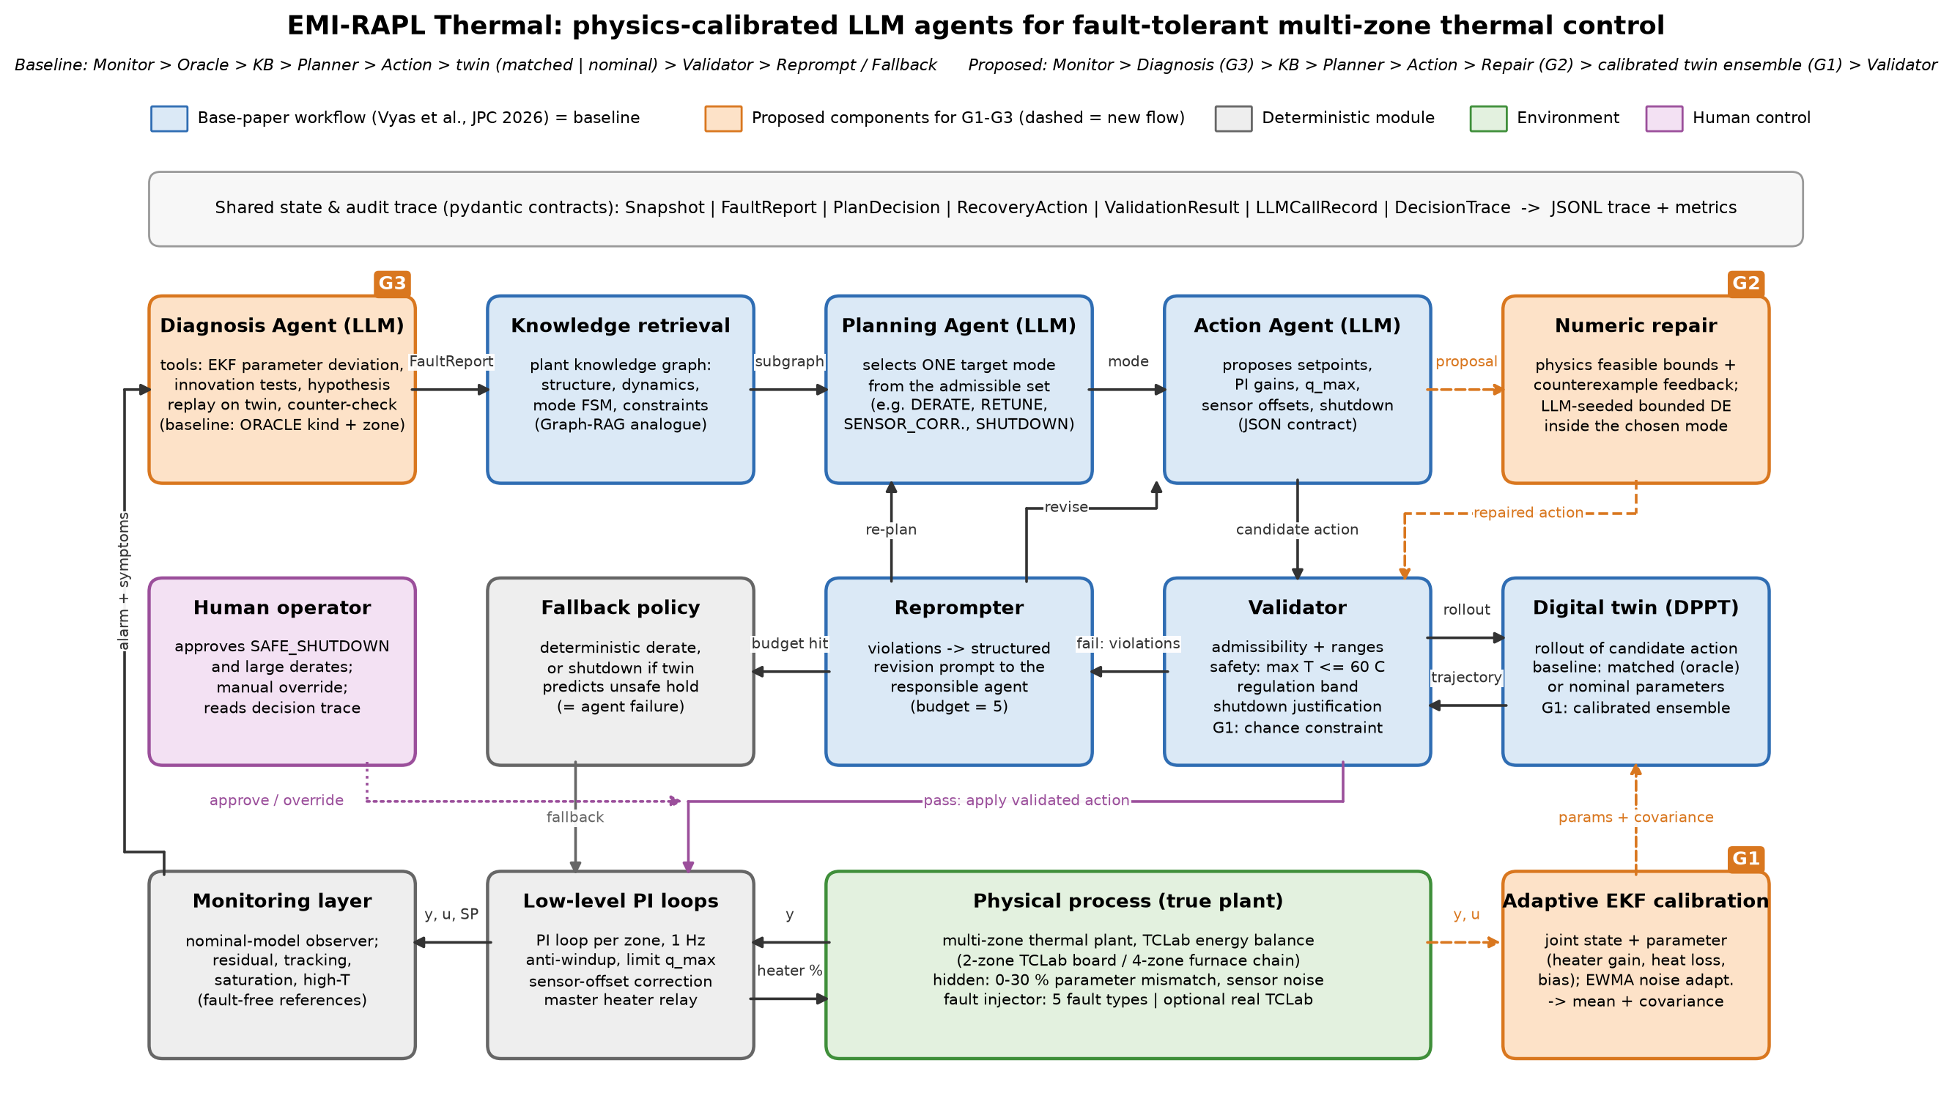
Figure 2. System architecture. Blue: base-paper workflow (baseline); orange: proposed components for gaps G1–G3 (dashed lines are new data flows); grey: deterministic modules; purple: human control.

B.10 Baselines
Table 7. Baselines.
Baseline | Description
B0 No recovery | The PI loops continue unchanged after the fault (fault-agnostic control).
B1 Rule table | A fixed fault-type-to-action table with nominal fault magnitudes, applied without simulation (deterministic workflow).
B2 Single LLM call | One LLM call proposes the mode and parameters; the action is applied without simulation or validation.
B3 DE retune | Differential evolution [17] searches setpoint derate, PI gains and sensor offset on the nominal twin (non-LLM optimiser, the seed's DE line).
B4 Base workflow | Re-implementation of [1] with a matched twin (its own evaluation assumption, an upper bound) and with a nominal twin (realistic deployment).

B.11 Research questions and hypotheses
Table 8. Research question and testable prediction per gap.
Gap | Research question | Hypothesis
G1 | Under 10–30% plant–model mismatch, does validating on an EKF-calibrated twin ensemble reduce the rate of actions that pass validation but fail on the true plant, compared with the base workflow's nominal twin? | At 30% mismatch the validated-but-failed rate drops to 5% or less and plant success rises by at least 15 points, with at most twice the decision time.
G2 | Does returning quantitative counterexamples and feasible bounds, together with LLM-seeded numeric repair, raise the recovery rate of a small free-tier LLM? | For gpt-oss-20b the recovery rate reaches at least 80% and the mean number of reprompts falls by at least 40%.
G3 | Can a tool-grounded diagnosis agent replace oracle localisation without losing end-to-end safety? | Top-1 localisation accuracy is at least 85%, and plant success without the oracle is within 10 points of the base workflow with the oracle.

B.12 Evaluation plan
Table 9. Evaluation plan.
Item | Plan
Evaluation sets | Phase-1 suite (120 scenarios) and the 10-scenario LLM core set (20-scenario subset in Phase 2); Phase-2 extended suite (about 200 scenarios plus a held-out set of unseen magnitudes and compound faults). Each LLM configuration is repeated three times at temperature 0.2.
Primary metrics | Plant success (no safety violation after the action and healthy zones regulated within ±1.5 °C, with shutdown only when unavoidable); agent success (the base paper's definition: a validated LLM action applied without fallback); validated-but-failed rate; safety-violation rate (more than 0.5 °C or 60 s above the 60 °C limit after the action).
Secondary metrics | Peak temperature, time above the limit, setpoint retention, integrated absolute error, recovery rate, reprompts, fallback rate, localisation accuracy (G3) and EKF parameter error (G1).
System measures | LLM calls, input and output tokens, LLM latency and total decision time per episode.
Comparisons | All baselines and the proposed system on identical scenarios, broken down by fault type, plant size and mismatch level; paired tests (McNemar for success rates, Wilcoxon for continuous metrics) with 95% confidence intervals.
Ablations | G1: nominal twin vs EKF point estimate vs EKF ensemble. G2: pass/fail text vs quantitative violations vs feasible bounds vs numeric repair. G3: oracle vs symptoms only vs residual tools vs counter-hypothesis check. Model size: gpt-oss-20b vs gpt-oss-120b.

B.13 Milestones and feasibility
Table 10. Milestones.
Stage | Work
Phase 1 (done) | Environment, fault library, PI loops, contracts, knowledge graph, twin and validator, LLM client, base workflow, four baselines, evaluation suite, initial results.
Phase 2, days 1–3 | Adaptive EKF, calibrated twin and ensemble validation (G1); first G1 experiment.
Phase 2, days 4–6 | Counterexample feedback, feasible-bound tool, numeric repair (G2); G2 experiment.
Phase 2, days 7–9 | Diagnosis agent and its tools (G3); G3 experiment.
Phase 2, days 10–12 | Full runs, repeats, ablations, statistics, failure analysis.
Phase 2, days 13–15 | Dashboard, optional TCLab hardware run, conference paper and Turnitin reports.
Phase 3 (1 week) | Slides, live demonstration, viva preparation.

Table 11. Technical risks and fallback strategies.
Risk | Mitigation / fallback
Free-tier LLM limits (8k tokens/min and 200k tokens/day per model) | Token-budget pacer and clean stop/resume at the daily cap (implemented); run the two models in parallel on separate quotas; spread long runs over several days; LLM experiments on the two-zone subset; local open model through Ollama as a last resort.
LLM non-determinism | Three repeats per configuration, fixed temperature, logged prompts and replies, confidence intervals.
EKF divergence under large mismatch | Recursive least squares or a batch grey-box fit over a sliding window as a fallback estimator.
Compute cost of DE (30–130 s per decision) | Smaller population and horizon, vectorised rollouts, parallel scenario shards (already used).
No physical testbed | Model built on the published TCLab parameters; an optional real board (about USD 35) for a final demonstration.
Gemini access blocked for our project | Not required; Groq models cover the small/large comparison.
Compute is modest: the simulator runs at about 4,000 steps per second on a laptop CPU, so an episode takes roughly one second without LLM calls. The binding constraint is the LLM quota, which the pacer and subset design keep within free-tier limits.

B.14 Work division
Table 12. Responsibilities.
Member | Responsibilities
Fatima Khursheed (23I-0746), group head | Phase 1: thermal plant and fault library, baselines, scenario suites and evaluation runner, latency and oracle fixes, results report. Phase 2: adaptive EKF and ensemble validation (G1), diagnosis tools (G3), statistics.
Saleha Muhammad (23I-0727) | Phase 1: agent contracts, knowledge graph, twin and validator interface, LLM client and base-paper agent workflow, Groq integration and LLM runs, tests and documentation, trace viewer. Phase 2: counterexample feedback and numeric repair (G2), diagnosis-agent reasoning (G3), dashboard.
Both members | Literature review, failure analysis, paper writing and presentation. Both members are responsible for understanding the complete system.

B.15 Potential publication direction
The most publishable contribution is a measurement and a fix. The measurement is the first quantification of the validation–reality gap of LLM fault-tolerant control agents: how often a twin-validated action fails on the real plant when the twin is not a perfect copy. The fix is a calibrated, uncertainty-aware validator that closes this gap. Supporting contributions are evidence that structured physical feedback and numeric repair make small open models viable, and an open multi-zone TCLab fault-tolerant control benchmark. Suitable venues include IFAC symposia (DYCOPS, ADCHEM), IEEE CCTA, and the journals Computers & Chemical Engineering and Journal of Process Control, where the base paper and related work appeared.

B.16 Technical foundation and initial baseline results (Deliverable C)
The GitHub repository (https://github.com/Fatima-Khursheed20/emi-rapl-thermal, public, shared with the instructor) contains a working end-to-end system. Implemented: the multi-zone thermal plant with fault injection, mismatch and noise; per-zone PI loops; the residual-based monitor; the typed state and contracts; the plant knowledge graph; the digital twin and deterministic validator; the OpenAI-compatible LLM client with a token-budget pacer, quota handling and token accounting; the re-implemented base-paper workflow; the four baselines; the scenario suites; the evaluation runner; a trace viewer; and a report generator. Twelve unit and end-to-end tests run offline in about ten seconds. Every LLM decision is stored as an auditable trace (results/*/episodes.jsonl), and every table and figure below is regenerated by scripts/make_report.py.
Two sets of initial results were produced. First, every non-LLM method and the base-paper workflow were run on the full 120-scenario suite. The workflow here uses a deterministic scripted proposer in place of the LLM, so that its matched-twin and nominal-twin versions see identical proposals and differ only in the twin. Second, the base-paper workflow and a single LLM call were run with two real LLMs, gpt-oss-20b and gpt-oss-120b on Groq, on a 10-scenario core set: all five fault types on the two-zone plant at 0% and 20% mismatch. This gave 66 valid episodes: the full core set for both models (60) plus 6 from two extra heater-degradation scenarios run earlier. Runs stop cleanly at Groq's free-tier cap of 200,000 tokens per day and resume later, and no episode contains a failed call.
Table 13. Initial results on the full 120-scenario suite (5 faults × 2 plant sizes × 4 mismatch levels × 3 seeds). Agent success, validated-but-failed and fallback apply only to the validated workflow.
Method | n | Plant success % | Agent success % | Validated-but-failed % | Safety violation % | Fallback % | Setpoint retention
B0 No recovery | 120 | 19.2 | – | – | 6.7 | – | 1.00
B1 Rule table | 120 | 67.5 | – | – | 2.5 | – | 0.72
B3 DE retune (nominal twin) | 120 | 65.0 | – | – | 3.3 | – | 0.89
B4 Base workflow, matched twin (scripted proposer) | 120 | 80.8 | 67.5 | 0.0 | 2.5 | 32.5 | 0.84
B4 Base workflow, nominal twin (scripted proposer) | 120 | 80.8 | 86.7 | 19.2 | 2.5 | 13.3 | 0.85

Without recovery only 19.2% of faulted episodes end safe and regulated, confirming that every fault type in the suite forces a decision. The rule table reaches 67.5%, but it shuts the plant down on every stuck heater, including the cases where switching off the neighbouring zone would have been enough (21% success on that fault). DE retuning reaches 65.0%, since it optimises against a nominal twin that misjudges which setpoints are reachable after heat-loss faults. The validated base workflow reaches 80.8% with either twin.
The two twins reach that figure in very different ways, which is the central Phase-1 finding and the evidence for Gap 1. With the matched twin, the base paper's own assumption, no validated action ever failed on the true plant (0.0%). With the realistic nominal twin, 19.2% of all episodes were validated and then failed on the plant. Most of these are sensor-bias faults, where the twin assumes a −10 °C bias and so approves an offset that is wrong for the true bias (83% of sensor-bias episodes); the rest are stuck heaters (12%). The matched twin instead rejected those proposals and handed over to the fallback in 32.5% of episodes. A metric that counts validated actions as successes therefore rewards the less accurate twin: agent success is 86.7% with the nominal twin against 67.5% with the matched one. This blind spot of the base paper's success metric is why we judge every method on the hidden true plant. The rate stays at 17–20% across 0–30% parameter mismatch (Figure 3), which shows that the unknown fault magnitude, not parameter error, drives the gap. Our G1 calibration therefore estimates fault parameters such as heater gain, heat loss and sensor bias, not just plant constants.
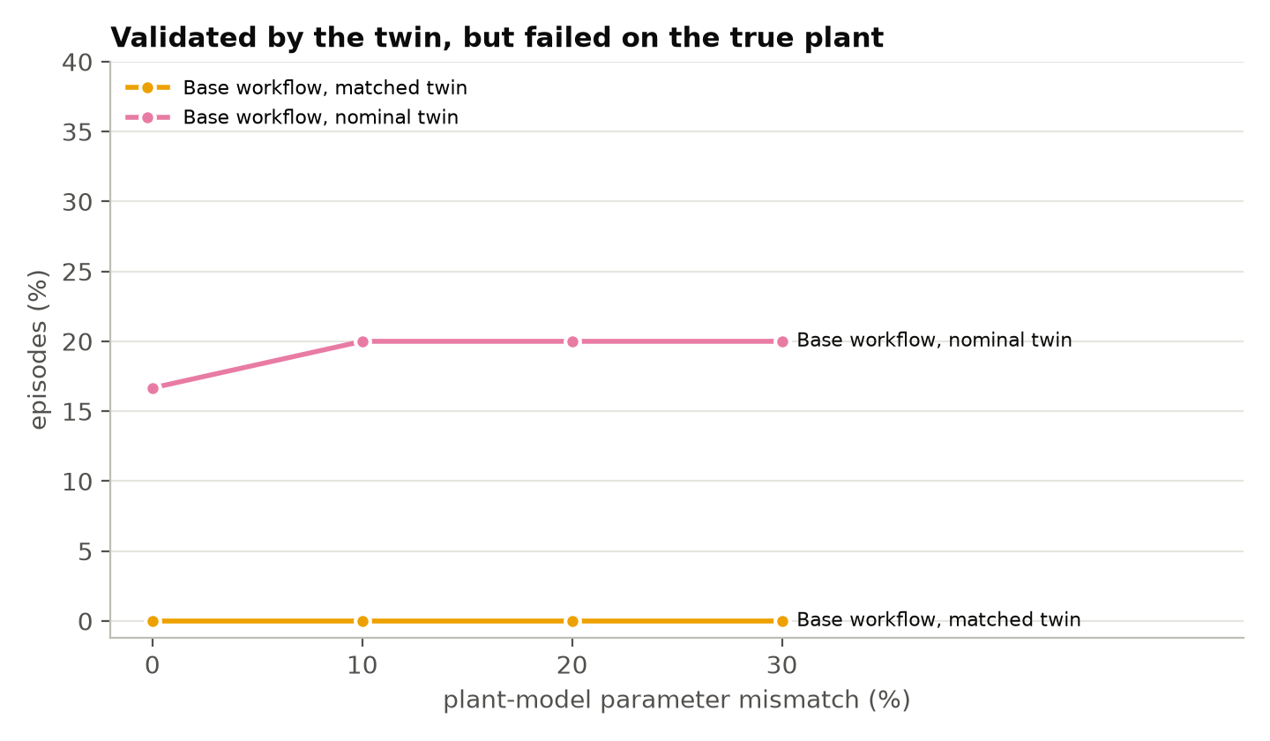
Figure 3. Share of episodes in which the base workflow's twin approved an action that then failed on the true plant, by plant–model mismatch (same scripted proposer for both twins; 30 episodes per point).
Table 14. Real-LLM results on the scenarios the LLM runs covered (two-zone plant: the 10-scenario core set, all five faults at 0% and 20% mismatch, plus two extra heater-degradation scenarios). All methods are scored on exactly these scenarios. n = episodes; Plant/Agent = plant/agent success; VbF = validated but failed; Unsafe = safety violation; Recovery = successful among reprompted episodes; Tokens and Time are per episode.
Method | n | Plant % | Agent % | VbF % | Unsafe % | Re-prompts | Recovery % | Calls | Tokens | Time (s)
B0 No recovery | 12 | 25.0 | – | – | 0.0 | – | – | – | – | –
B1 Rule table | 12 | 83.3 | – | – | 0.0 | – | – | – | – | –
B3 DE retune (nominal twin) | 12 | 91.7 | – | – | 0.0 | – | – | – | – | 104
B2 Single LLM call [gpt-oss-120b] | 12 | 41.7 | – | – | 0.0 | – | – | 1.0 | 1.8k | 11
B2 Single LLM call [gpt-oss-20b] | 11 | 27.3 | – | – | 18.2 | – | – | 1.0 | 1.8k | 7
B4 Base workflow, matched twin [gpt-oss-120b] | 11 | 100.0 | 63.6 | 0.0 | 0.0 | 2.36 | 33.3 | 4.4 | 11.2k | 113
B4 Base workflow, matched twin [gpt-oss-20b] | 11 | 100.0 | 63.6 | 0.0 | 0.0 | 3.00 | 42.9 | 5.0 | 12.3k | 128
B4 Base workflow, nominal twin [gpt-oss-120b] | 11 | 90.9 | 72.7 | 0.0 | 0.0 | 2.73 | 66.7 | 4.7 | 12.0k | 130
B4 Base workflow, nominal twin [gpt-oss-20b] | 10 | 90.0 | 60.0 | 0.0 | 0.0 | 2.90 | 42.9 | 4.9 | 11.5k | 122

A single unvalidated LLM call was unreliable and, for the smaller model, unsafe. gpt-oss-120b succeeded in 41.7% of episodes and gpt-oss-20b in 27.3%. Both mostly kept setpoints the faulted heater could no longer reach (0% on heat loss and insulation loss), and gpt-oss-20b caused a safety violation in 2 of 11 episodes. The validated base workflow kept the plant safe in every episode, with 100% plant success with the matched twin and 90–91% with the nominal twin. But the LLM itself found a validated action in only 60–73% of episodes; the deterministic fallback handled the rest. Episodes needed 2.4–3.0 reprompts on average, only 33–67% of reprompted episodes recovered, and each decision cost 11–12 thousand tokens and about two minutes. This mirrors the low recovery rates of GPT-4o-mini in the base paper [1] and is direct evidence for Gap 2.
Two further observations matter for the proposal. First, on these mostly feasibility-type faults the physics-based non-LLM baselines are strong (rule table 83.3%, DE 91.7%), because in these seed-0 scenarios the fault magnitudes happen to lie close to the nominal values those methods assume (for example a sensor bias of −9.66 °C against an assumed −10 °C, and heat loss ×3.15 against ×3.0). The LLM workflow is therefore not yet better than a well-tuned optimiser on plant success; its advantage lies in handling faults whose nature, not only size, must be inferred, and this is where G1–G3 aim. Second, the fallback is not always sufficient: in one of the two sensor-bias scenarios, both models exhausted the reprompt budget with the nominal twin, and the fallback's setpoint derate cannot correct a biased sensor, so the plant stayed off target. With roughly ten episodes per method, these LLM numbers are indicative; Phase 2 adds repeats and confidence intervals.
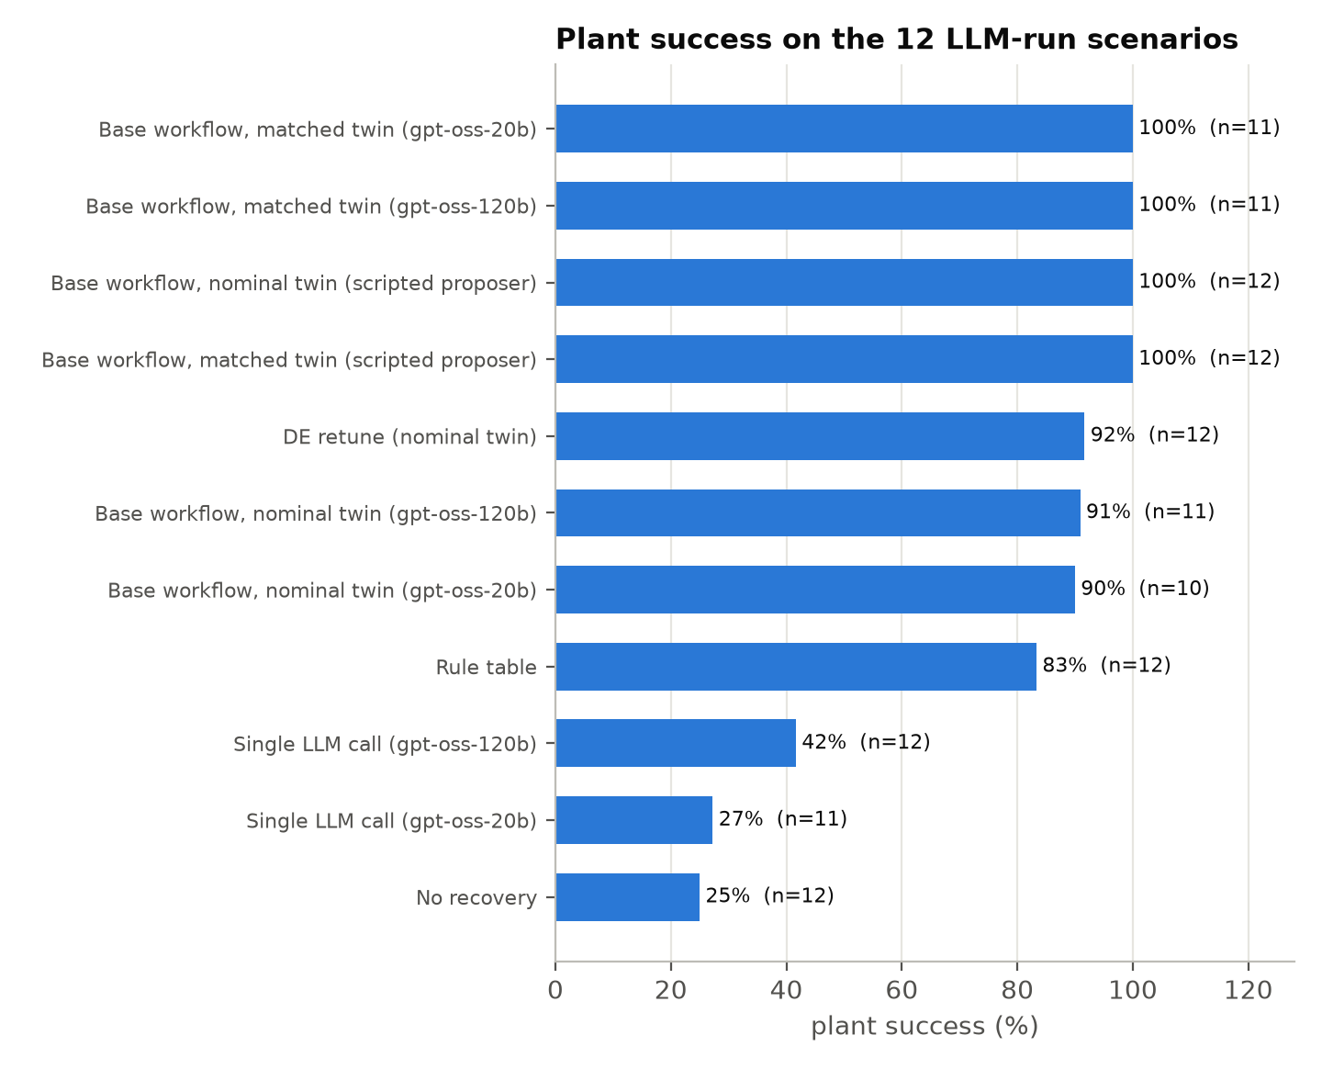
Figure 4. Plant success of all methods on the scenarios covered by the LLM runs (n per bar shown).
- Wrong sign that feedback cannot fix (Gap 2). In p1-z2-sensor_bias-mm00-s0 (true bias −9.66 °C), gpt-oss-20b proposed an offset of −9.65 °C, copying the sign of the residual, when +9.66 °C was needed. Used as a single unvalidated call, this offset drove the true heater temperature to 68.9 °C, 9 °C above the safety limit. In the validated workflow the same error was caught (twin prediction 68.9 °C), but the feedback named only the violated checks, so the model kept trying the same sign (−5, −15, −9 °C) until the fallback took over. With the matched twin, the same model proposed +9.65 °C at once and passed. An explicit counterexample such as "the corrected reading moves away from the true temperature; reverse the sign" is the kind of feedback G2 adds.
- Systematic mode error (Gap 2). In p1-z2-heater_degradation-mm00-s0 the planner chose RETUNE for a heater whose setpoint had become physically unreachable. The twin showed 100% heater output and a 2.4 °C shortfall. Because validator feedback goes to the Action Agent, which can only change gains, the agent raised Kc from 6 to 10 to 20 without effect until the budget ran out and the fallback derated the zone. A feasible-bound message such as "the highest reachable temperature is 47.6 °C" would have pointed to DERATE.
Together these results show that the platform works end to end with real LLMs. They show that the baseline reproduces the base paper's behaviour (high plant safety thanks to validation and fallback, but weak recovery by the LLM itself), and that each of the three selected gaps already shows up in the data. Phase 2 starts from this baseline, adds repeated runs, and implements the G1–G3 components.

References
[1] J. Vyas, M. S. Gill, A. Markaj, F. Gehlhoff, and M. Mercangöz, "From detection to action: Using LLM agents for fault-tolerant control," Journal of Process Control, vol. 167, Art. no. 103855, Nov. 2026, doi: 10.1016/j.jprocont.2026.103855.
[2] J. Vyas and M. Mercangöz, "Autonomous industrial control using an agentic framework with large language models," IFAC-PapersOnLine, vol. 59, no. 6, pp. 349–354, 2025, doi: 10.1016/j.ifacol.2025.07.170.
[3] Y. Wang, J. Vyas, T. Liu, and M. Mercangöz, "Closed-loop control with rule-aligned small language models and multi-agent self-correction," in Proc. IEEE Conf. Control Technology and Applications (CCTA), Aug. 2026, pp. 52–57, doi: 10.1109/CCTA62090.2026.11684321.
[4] T. M. Arif and M. A. Rahim, "Agentic AI for real-time adaptive PID control of a servo motor," Actuators, vol. 14, no. 9, Art. no. 459, Sep. 2025, doi: 10.3390/act14090459.
[5] N. S. M. Amin, Y.-W. Kim, and Y.-C. Byun, "Prompt-based PID tuning for adaptive AGV control via few-shot and MultiSpeed strategies," IEEE Access, vol. 13, pp. 190685–190700, 2025, doi: 10.1109/ACCESS.2025.3627967.
[6] C. Ren, S.-M. Hong, and R. Tang, "AgentiControl-MPC: Automated model predictive control for buildings using large language model-based multi-agent system," Advanced Engineering Informatics, vol. 76, Art. no. 105062, Nov. 2026, doi: 10.1016/j.aei.2026.105062.
[7] W. Xin, W. Liang, and A. Chong, "Causality-constrained hierarchical LLM agents for online rule adaptation in building HVAC control," Applied Energy, vol. 427, Art. no. 129012, Jan. 2027 (available online Oct. 2026), doi: 10.1016/j.apenergy.2026.129012.
[8] Z. Zhou et al., "LLM-guided adaptive compensator: Bringing adaptivity to robotic feedback control with large language model," IEEE Transactions on Automation Science and Engineering, vol. 23, pp. 10762–10774, 2026, doi: 10.1109/TASE.2026.3700674.
[9] C. Carr, M. Martínez-García, B. J. Marshall, M. Coombes, and Y. Zhang, "Automated UAV controller synthesis via LLM-generated control logic and particle swarm optimization," IEEE Transactions on Industrial Informatics, vol. 22, no. 7, pp. 6187–6197, Jul. 2026, doi: 10.1109/TII.2026.3675738.
[10] D. Schall, "Safe integration of large language models into industrial process control: A multi-agent architecture with P&ID-grounded validation," Autonomous Intelligent Systems, vol. 6, no. 1, Art. no. 14, Jun. 2026, doi: 10.1007/s43684-026-00136-1.
[11] B. A. Galitsky and A. Rybalov, "Neuro-symbolic verification for preventing LLM hallucinations in process control," Processes, vol. 14, no. 2, Art. no. 322, Jan. 2026, doi: 10.3390/pr14020322.
[12] J. Li, S. Li, C. Martin, Z. Chen, D. Chen, and W. Li, "An LLM-assisted multi-agent control framework for roll-to-roll manufacturing systems," Journal of Manufacturing Systems, vol. 86, pp. 569–578, Jun. 2026, doi: 10.1016/j.jmsy.2026.04.005.
[13] S. Yao, J. Zhao, D. Yu, N. Du, I. Shafran, K. Narasimhan, and Y. Cao, "ReAct: Synergizing reasoning and acting in language models," in Proc. Int. Conf. Learning Representations (ICLR), 2023.
[14] X. Guo, D. Keivan, U. Syed, L. Qin, H. Zhang, G. Dullerud, P. Seiler, and B. Hu, "ControlAgent: Automating control system design via novel integration of LLM agents and domain expertise," arXiv:2410.19811, 2024.
[15] J. Vyas and M. Mercangöz, "Autonomous control leveraging LLMs: An agentic framework for next-generation industrial automation," arXiv:2507.07115, 2025.
[16] J. Park, R. A. Martin, J. D. Kelly, and J. D. Hedengren, "Benchmark temperature microcontroller for process dynamics and control," Computers & Chemical Engineering, vol. 135, Art. no. 106736, Apr. 2020, doi: 10.1016/j.compchemeng.2020.106736.
[17] R. Storn and K. Price, "Differential evolution—A simple and efficient heuristic for global optimization over continuous spaces," Journal of Global Optimization, vol. 11, no. 4, pp. 341–359, 1997.
[18] AISL, Imperial College London, "ctrl-alt-recover: Code for LLM agents for fault-tolerant control," GitHub repository, 2026. [Online]. Available: https://github.com/AISL-at-Imperial-College-London/ctrl-alt-recover
[19] SCImago, "Journal of Process Control," SJR — SCImago Journal & Country Rank, 2025. [Online]. Available: https://www.scimagojr.com/journalsearch.php?q=14414&tip=sid

