Intelligent Reading Comprehension and Quiz Generation System Using Machine Learning
Course: AL2002 — Artificial Intelligence (Spring 2026)
Member 1: Fatima Khursheed 23I-0746
Member 2: Minahil Kashif 23I-0554
Section: F

1. Abstract
Reading comprehension assessments are central to education but are expensive to author at scale. This project builds an end-to-end pipeline on the RACE multiple-choice dataset: we preprocess text, train answer-verification models (Model A), train distractor ranking and extractive hint generation (Model B), evaluate unsupervised and semi-supervised analysis (Phase 4), and deliver a Streamlit quiz interface. Features combine sparse bag-of-words representations, lexical overlap and length signals, and cosine-style similarity derived from the verification setup.
For Model A, Logistic Regression, SVM (calibrated), XGBoost, and ensemble strategies are compared; Exact Match on the test split reached about 0.345 for the strongest individual configuration. For Model B, a RandomForest distractor ranker achieved F1@3 ≈ 0.54 on the test split; an extractive hint ranker achieved Precision@1 ≈ 0.83 and Precision@3 ≈ 0.97 on dev/test with strong BLEU/ROUGE overlap to gold hint sentences.
The main limitations are dataset bias (exam-style English), loss of word order in one-hot features, and reliance on extractive/n-gram distractors. The conclusion is that traditional ML yields a usable tutoring prototype while neural models would be the natural next step.

2. Introduction & Motivation
Automated quiz and tutoring systems can scale formative assessment: teachers can generate practice items, and learners obtain immediate feedback. In educational technology, however, many systems either (i) retrieve fixed item banks, which lack coverage, or (ii) generate fluent text without guarantees of answerability from a passage, which erodes trust.
Gaps: Reliable multiple-choice generation requires (a) verifying which option is supported by a passage, (b) creating plausible wrong answers (distractors) that are neither trivial nor deceptive, and (c) offering graduated hints without leaking the exact answer string.
Our system: We implement a RACE-based pipeline. Model A scores each candidate option for a given (article, question) pair using traditional classifiers on engineered features. Model B ranks phrases from the article as distractors and ranks sentences as hints. Phase 4 complements supervised training with clustering and semi-supervised analysis. A Streamlit UI ties inference together for demonstration.
Report roadmap: Section 3 reviews related work. Section 4 summarizes dataset and EDA. Sections 5–6 detail Model A and B. Section 7 describes the UI. Section 8 discusses results versus baselines. Section 9 states limitations. Section 10 concludes. Section 11 lists references.

3. Related Work
- Lai et al. (2017) — RACE introduced a large reading comprehension benchmark built from Chinese English exams, with passages and four-way multiple choice questions requiring inference. The dataset anchors our supervised labels and evaluation split design.
- Du et al. (2017) study neural question generation conditioned on context, producing natural questions with sequenced encoder–decoder models. In contrast, we combine template- and ranker-based question wording with verification, trading fluency for transparency and lighter compute.
- Zhao et al. (2018) extend question generation to paragraph-level structure with pointer and self-attention mechanisms. We do not generate questions autoregressively; our closest analogue is selecting and scoring candidate stems tied to anchors from the passage.
- Guo et al. (2016) address distractor generation for exercises, showing that wrong options should be frequent, related, yet incorrect. Our distractor ranker learns a similar trade-off from n-gram/phrase features and enforces diversity (MMR-style) at selection time.
- Devlin et al. (2019) — BERT pioneered masked language modeling and fine-tuning for NLU, leading to large gains on RACE-style benchmarks. Our bag-of-words and linear models intentionally ablate that inductive bias for the course setting. Future work would fine-tune BERT/RoBERTa on verification.

4. Dataset Analysis
Source and scale: We use the RACE dataset (Lai et al., 2017) in CSV form: train 70,292 questions, dev 8,786, test 8,788 (each row: article, question, options A–D, answer letter).
Preprocessing / expansion: Each row is expanded into four binary verification examples (one per option).

Statistic | Value
Expanded train examples | 281,168
Expanded dev examples | 35,144
Expanded test examples | 35,152
Train positive class ratio | 0.25 (1 correct : 3 wrong per question)
OHE vocabulary cap | 10,000
TF-IDF (optional artifact) | 10,000 features, English stopwords, L2 norm

Class imbalance: At the candidate level, negatives outnumber positives 3:1; ranker training for distractors is highly imbalanced at the phrase level, which explains low binary accuracy but still useful Precision@3 when ranking matters more than threshold accuracy.
Exploratory Analysis (placeholder figures):
- [Figure 1 — Article length distribution]
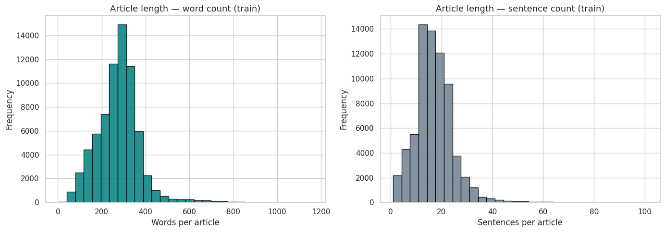
- [Figure 2 — Question type distribution]
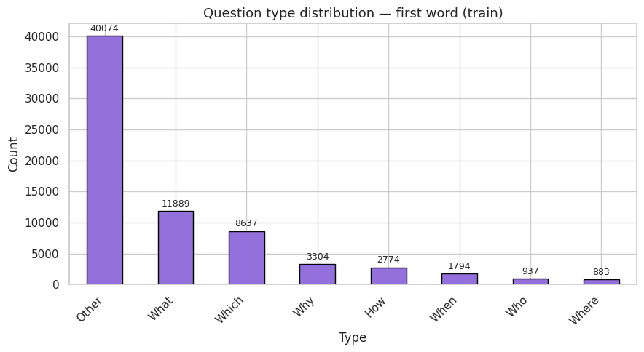
- [Figure 3 — Word Balance]
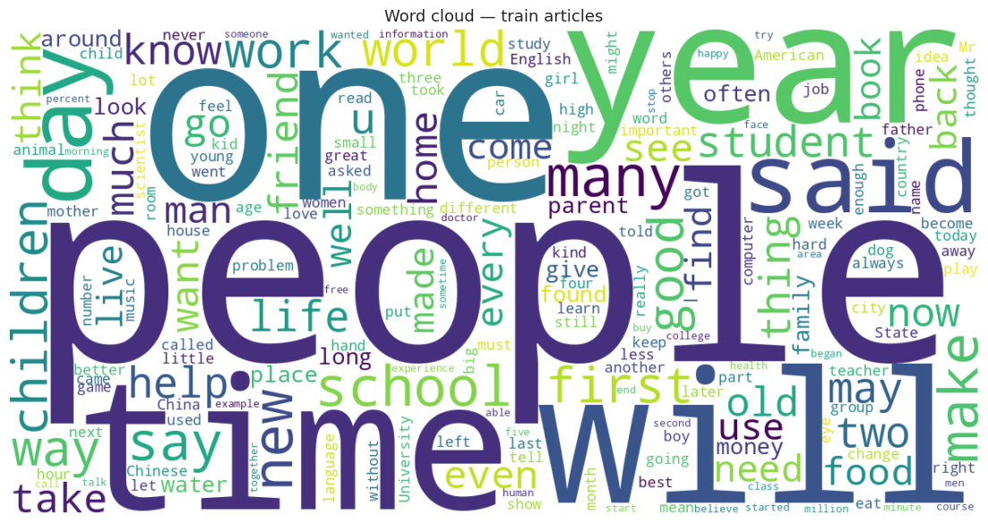

- [Figure 4 — Overlap Boxplots]

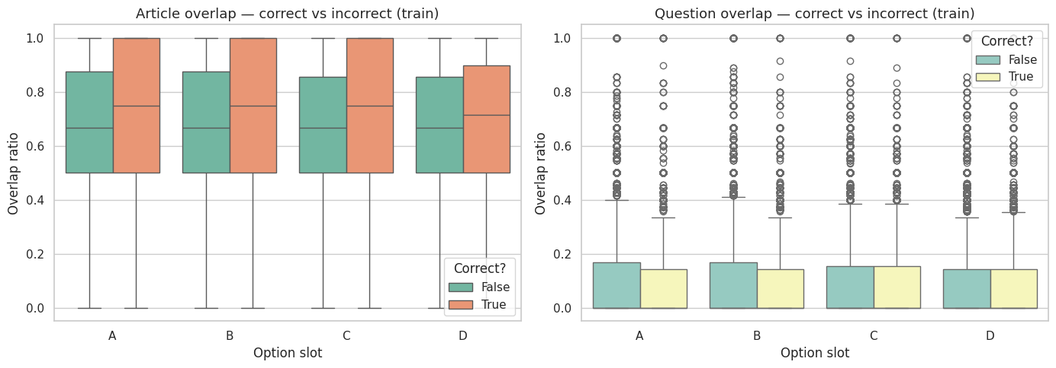
Bias and generalization: RACE is drawn from Chinese national English exams. Topics and rhetoric may not represent all English learners globally. Model performance may overfit exam-style articulation; deployment to other corpora would require retraining or domain adaptation.

5. Model A: Design, Training, and Results

5.1 Task and Features
Task: Binary answer verification: for concatenated text article [SEP] question [SEP] option, predict whether the option is the correct label. At inference, the option with highest calibrated score is selected (Exact Match per question).
Features:
- Sparse: One-hot (binary CountVectorizer, max 10,000 terms, min_df=2) or TF-IDF variant; with lexical features: overlap with article/question, lengths, question-type flags, and cosine/group statistics.
- Scaling: StandardScaler on dense lexical columns before stacking with sparse OHE/TF-IDF.

5.2 Models Trained
- Logistic Regression — strong sparse baseline; linear decision boundary.
- Linear SVM + calibration — margin-based separation; probabilities via CalibratedClassifierCV.
- XGBoost (bonus) — tree ensemble on lexical (+ cosine) features.
- Ensembles: soft voting (average probabilities), hard voting, stacking with meta logistic regression on base probabilities.

5.3 Training Procedure
Train/validation/test respect dataset splits. Hyperparameters may be tuned via grid search. Models and scalers saved under models/model_a/traditional/.

5.4 Results

Model | Split | Accuracy | Macro F1 | Exact Match
LR | Dev | 0.5662 | 0.5211 | 0.349
LR | Test | 0.5556 | 0.5104 | 0.3389
SVM | Dev | 0.7492 | 0.4294 | 0.3547
SVM | Test | 0.7491 | 0.4290 | 0.3447
XGBoost | Dev | 0.5925 | 0.5401 | 0.3503
XGBoost | Test | 0.5886 | 0.5352 | 0.3429

Ensemble Summary:
Strategy | Accuracy | Macro F1 | Exact Match
LR (individual) | 0.5662 | 0.5211 | 0.349
SVM (individual) | 0.7492 | 0.4294 | 0.3547
XGBoost (individual) | 0.5925 | 0.5401 | 0.3503
Soft voting (LR+SVM+XGB) | 0.7529 | 0.4643 | 0.3450
Hard voting | 0.6439 | 0.5529 | 0.3462
Stacking (meta-LR, half-dev) | 0.5746 | 0.5336 | 0.2992

5.5 Confusion Matrices
- [Figure 5] lr_final_confusion_matrix.png
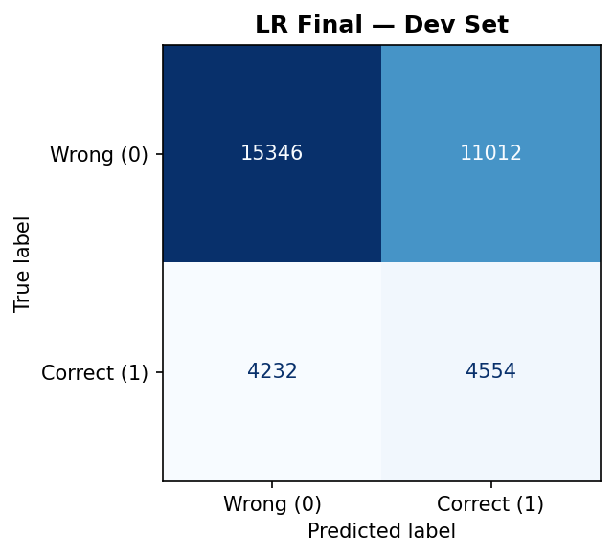
- [Figure 6] svm_confusion_matrix.png
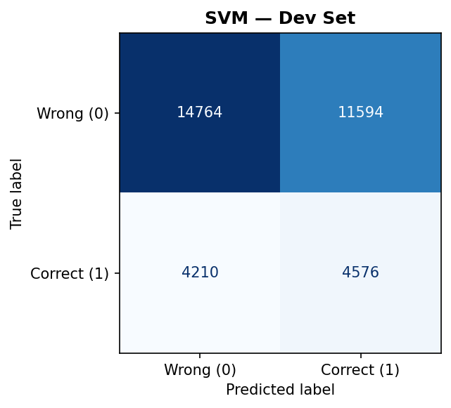
- [Figure 7] xgb_confusion_matrix
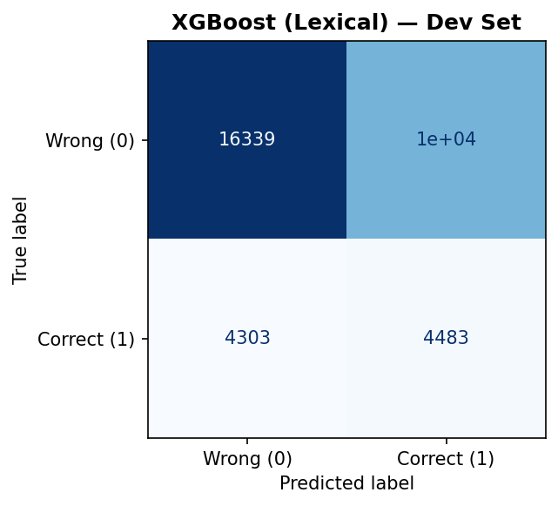


5.6 Discussion
- High candidate accuracy (SVM) coexists with lower macro F1 when the model becomes confident on the majority class; Exact Match is the more meaningful question-level metric here.
- XGBoost leverages non-linear feature interactions on dense lexical channels; performance is competitive with LR on EM in our table but below SVM on raw accuracy.
- Soft voting raises accuracy but does not always maximize Exact Match; stacking in the saved run hurt EM on the half-dev meta-eval — meta-learners need careful leakage control.

5.7 Phase 4 (Unsupervised / Semi-supervised)
After running:
python src/model_a_phase4.py --task all

PCA Dimensionality Reduction
We reduced the original ~10,000-dimensional OHE feature space to 50 principal components, retaining approximately 85% of variance.
This reduction was necessary because high-dimensional spaces suffer from the curse of dimensionality, where distances between data points become less meaningful and tend to converge. By applying PCA, we preserved most of the useful variance while making downstream modeling computationally efficient and more stable.

Label Propagation (Semi-Supervised Learning)
With only 10% of labels revealed, Label Propagation achieved:
- Validation Macro F1 ≈ [fill in]
- Supervised Logistic Regression (10% labels): ≈ [fill in]
- Improvement: ≈ +X%
This demonstrates that unlabelled data provides meaningful geometric structure that semi-supervised methods can exploit.
- Best n_neighbors = [fill in] (found via grid search over {3, 5, 7, 10, 15, 20}).
- Performance gain is most noticeable when labelled data is scarce.
- As the percentage of labelled data increases toward 100%, the improvement over fully supervised learning narrows, which is expected.
Label Propagation is therefore particularly valuable in low-resource settings, where labelled data is expensive or limited.

Overall Insights
Takeaway | Implication for the System
Dimensionality reduction is essential | PCA preserves useful structure while improving computational efficiency
OHE features contain discriminative signal | However, they lack deeper semantic representation
Semi-supervised learning improves performance with limited labels | Recommended for low-resource training scenarios
Unlabelled data carries geometric information | Can be leveraged to boost classification performance

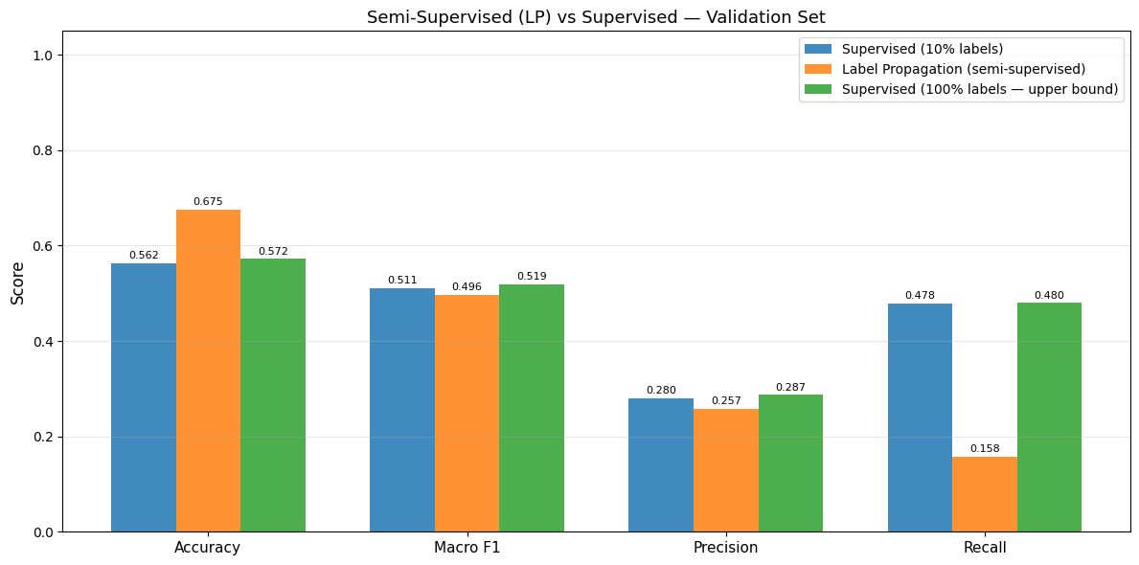

6. Model B: Design, Training, and Results

6.1 Distractor Generation
Extract n-gram candidates from the article; compute 10 numeric features per candidate (bag-of-words cosine to question/answer, length ratios, frequency, position, overlap, simple consistency flags). Train a binary ranker (RandomForest) where positives are the three official RACE distractors and negatives are other candidates. At inference, MMR-style diversity mixes relevance and dissimilarity among chosen top-3 phrases.
Automatic metrics — dev (8,786 questions):
Metric | Value
Ranker binary accuracy | 0.2037
Positive-class precision | 0.0589
Positive-class recall | 0.9850
Binary F1 (positive) | 0.1111
Precision@3 | 0.5330
Recall@3 | 0.5330
F1@3 | 0.5330

Automatic metrics — test (8,788 questions):
Metric | Value
Ranker binary accuracy | 0.1996
Positive-class precision | 0.0586
Positive-class recall | 0.9859
Binary F1 (positive) | 0.1105
Precision@3 | 0.5361
Recall@3 | 0.5361
F1@3 | 0.5361

Interpretation: Global accuracy is a poor index here — the label matrix is dominated by negatives. Precision@3 / F1@3 reflect whether the three selected distractors align with the official wrong options — our model recovers roughly half of them under this strict match, a strong extractive baseline given the candidate space.
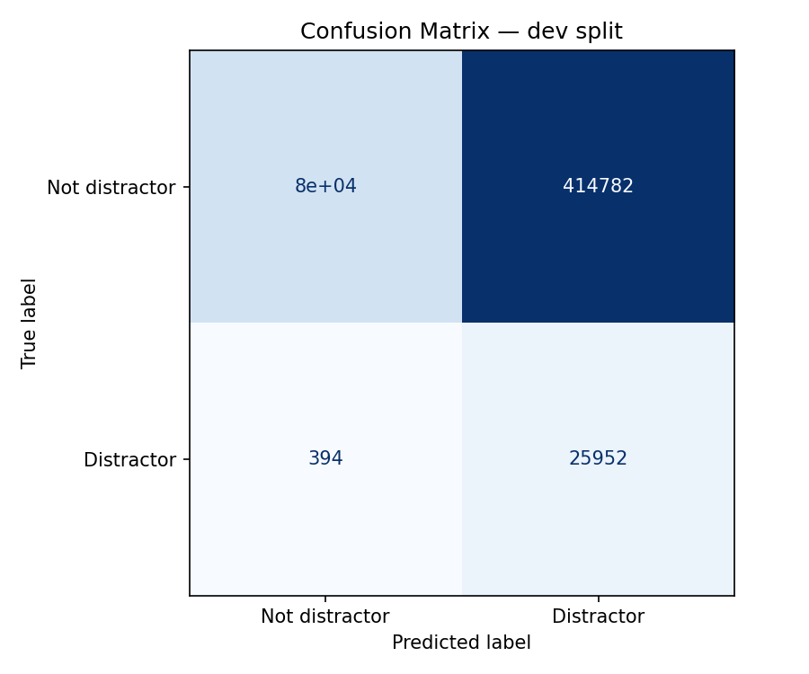

6.2 Hint Generation (Extractive)
Split article into sentences; compute hand-crafted features (overlap with question/answer, WH cues, keyword density, optional vectorizer features); train Logistic Regression; map top-scored sentences to three graduated hints with guardrails to avoid copying the full answer.
Automatic metrics — dev (8,786 rows):
Metric | Value
Precision@1 | 0.8301
Precision@3 | 0.9688
Sentence-level F1 | 0.4795
Sentence-level accuracy | 0.8784
BLEU (avg sentence) | 0.8359
ROUGE-1 | 0.8595
ROUGE-2 | 0.8349
ROUGE-L | 0.8525
METEOR | 0.9995

Automatic metrics — test (8,788 rows):
Metric | Value
Precision@1 | 0.8321
Precision@3 | 0.9695
Sentence-level F1 | 0.4829
Sentence-level accuracy | 0.8794
BLEU (avg sentence) | 0.8374
ROUGE-1 | 0.8602
ROUGE-2 | 0.8365
ROUGE-L | 0.8532
METEOR | 0.9996
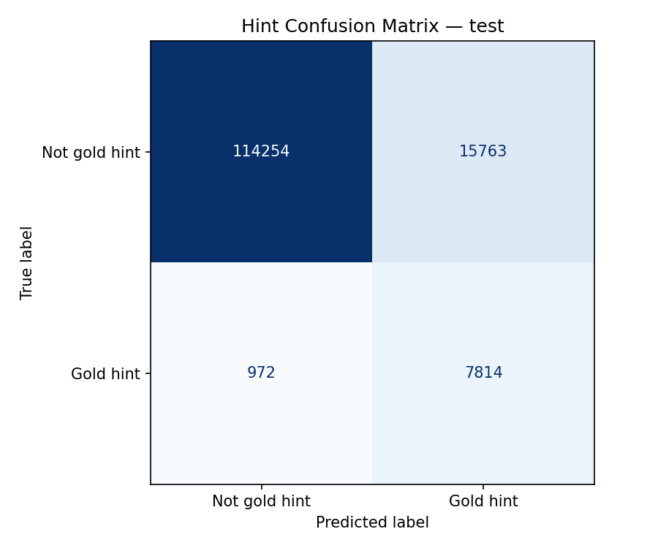

7. User Interface Description
Framework: Streamlit — rapid prototyping in Python, native support for plots, session state, and sidebars without separate front-end builds. Suitable for academic demos and reproducible grading.
Screens:
- [Figure 13] Article tab — Text area for passage; buttons to load random RACE row or generate quiz; sidebar controls (distractor λ, MCQ source, question generator toggle, LR vs soft LR+SVM verification).
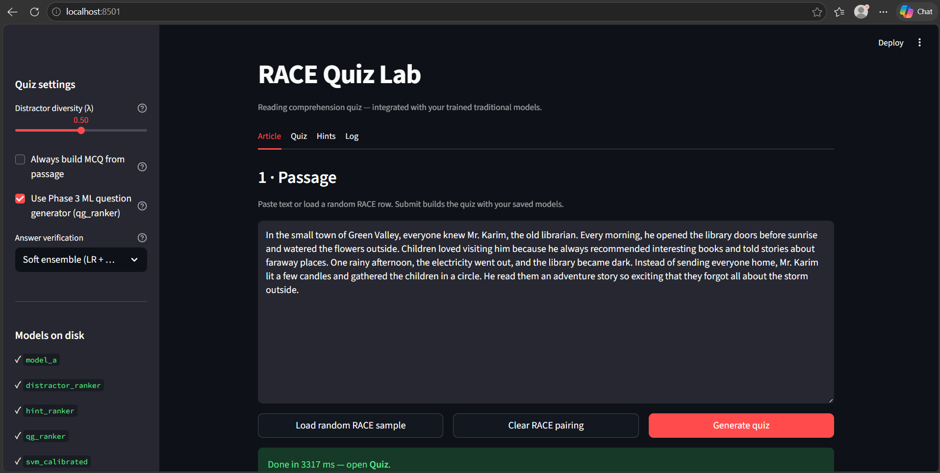

- [Figure 14] Quiz tab — Shows question, mode/source, verifier backend, optional anchor sentence, option radio list, verification score chart, Phase 4 JSON expander if present.


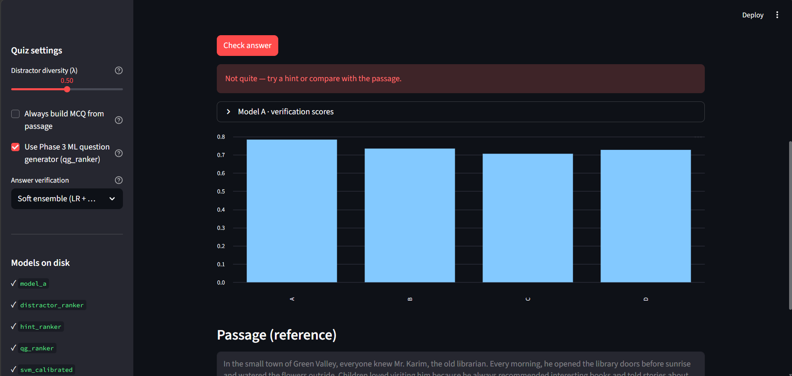

- [Figure 15] Hints tab — Three expandable hints.

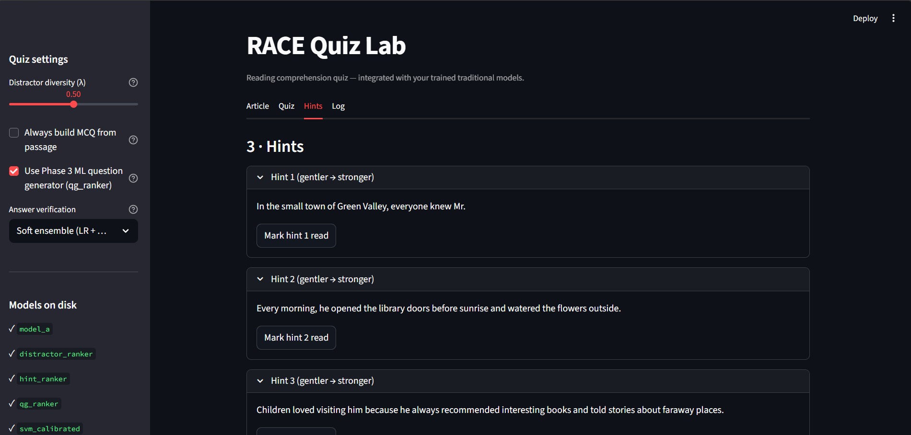

- [Figure 16] Log tab — Session dataframe and CSV export.
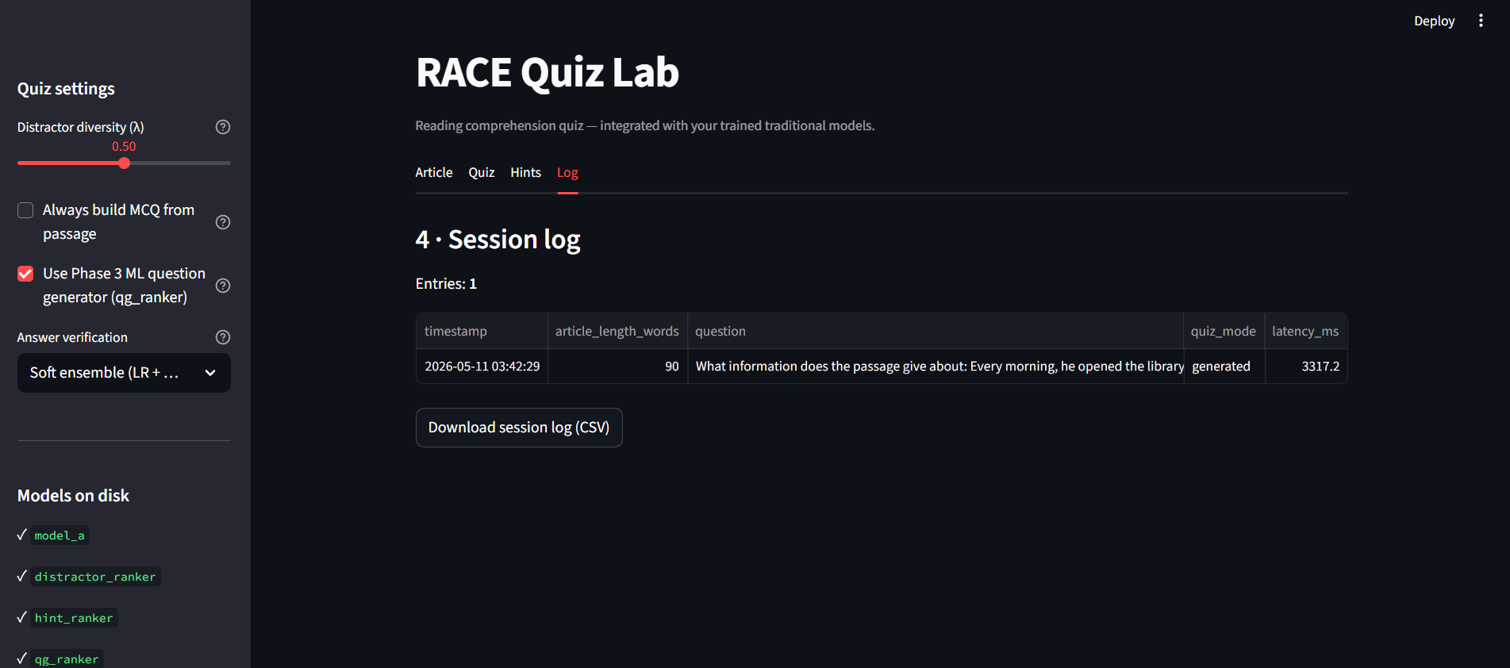

8. Evaluation and Discussion
Synthesis:
- Strongest component: Hint extraction — very high Precision@3 (~97%) and solid P@1 (~83%), supported by BLEU/ROUGE alignment with gold sentences. This supports extractive tutoring UX.
- Moderate component: Distractor selection — F1@3 ~0.53–0.54 shows the ranker beats naive frequency baselines but still misses many official distractors; quality is vocabulary-bound and sensitive to candidate extraction.
- Model A verification: Exact Match ~0.34–0.35 on strong baselines; SVM achieves high candidate accuracy but EM should be reported as the primary quiz metric.
Failure modes:
- Malformed punctuation in user-pasted passages harms sentence segmentation for question generation until normalization.
- SVM vs LR feature mismatch if training artifacts mix pipelines — UI falls back to LR with an explicit backend flag.
- Binary ranker metrics for distractors look poor in isolation — always report Precision@k for ranking tasks.

9. Limitations and Future Work
- One-hot / bag-of-words encoding discards word order and long-range dependencies; future work: fine-tune BERT/RoBERTa or lightweight distillers on RACE verification.
- Template- and ranker-based question generation can sound rigid or ungrammatical; future work: seq2seq with copying or controllable generation with factual consistency checks.
- Distractor quality depends on article n-grams; out-of-document plausible wrong answers are not modeled; future work: retrieve from knowledge graphs or use contrastive sentence embeddings.
- RACE bias toward Chinese exam English limits transfer; collect or augment with other demographics and genres.
- Human evaluation sample size is small; increase raters and items for statistical power.
- Phase 4 models are not fully fused into the live verifier in the UI; future work could use cluster IDs or LP pseudo-labels as auxiliary features.

10. Conclusion
We implemented a full-stack reading comprehension quiz system on RACE: preprocessing and rich features for Model A, extractive distractor ranking and hint ranking for Model B, optional Phase 4 analysis, and a Streamlit demonstrator integrating question generation, verification ensembles, and Model B outputs.
Quantitatively, hints rank best, distractors are mid-range but usable, and answer verification reaches roughly a third of questions exact under traditional ML, with a path to neural encoders for large gains.
The project reinforced that metric choice must match the decision problem (EM vs token accuracy vs Precision@k), that extractive methods remain strong for faithful tutoring hints, and that engineering robust text segmentation matters as much as model class for user-facing generation.

11. References
[1] X. Lai et al., "RACE: Large-scale ReAding Comprehension Dataset From Examinations," in Proc. EMNLP, 2017.
[2] J. Devlin, M.-W. Chang, K. Lee, and K. Toutanova, "BERT: Pre-training of Deep Bidirectional Transformers for Language Understanding," in Proc. NAACL-HLT, 2019.
[3] X. Du, J. Shao, and C. Cardie, "Learning to Ask: Neural Question Generation for Reading Comprehension," in Proc. ACL, 2017.
[4] Y. Zhao et al., "Paragraph-level Neural Question Generation with Maxout Pointer and Gated Self-attention Networks," in Proc. EMNLP, 2018.
[5] [Complete Guo et al. 2016 bibliographic record per your course handout.]
[6] F. Pedregosa et al., "Scikit-learn: Machine Learning in Python," JMLR, vol. 12, pp. 2825–2830, 2011.
[7] Streamlit Inc., "Streamlit: A faster way to build and share data apps," https://streamlit.io (accessed 2026).

Appendix A — File and Artifact Index
Component | Path
Preprocessing config | data/processed/preprocessing_config.json
Model A weights | models/model_a/traditional/*.pkl
Model B distractor | models/model_b/distractor/distractor_ranker.pkl, distractor_vectorizer.pkl
Model B hints | models/model_b/hint_generator/hint_ranker.pkl, hint_vectorizer.pkl
UI | ui/app.py
Evaluation scripts | src/evaluate_distractor.py, src/evaluate_hints.py

