Hotel Booking Cancellation Analysis | Python
Business Problem
In recent years, City Hotel and Resort Hotel have seen high cancellation rates. Each
hotel is now dealing with a number of issues as a result, including fewer revenues and
less than ideal hotel room use. Consequently, lowering cancellation rates is both hotels'
primary goal in order to increase their efficiency in generating revenue, and for us to
offer thorough business advice to address this problem.
The analysis of hotel booking cancellations as well as other factors that have no bearing
on their business and yearly revenue generation are the main topics of this report.

Assumptions

- No unusual occurrences between 2015 and 2017 will have a substantial impact on
- the data used.
- The information is still current and can be used to analyze a hotel's possible plans in
- an efficient manner.
- There are no unanticipated negatives to the hotel employing any advised technique.
- The hotels are not currently using any of the suggested solutions.
- The biggest factor affecting the effectiveness of earning income is booking
- cancellations.
- 6. Cancellations result in vacant rooms for the booked length of time.
- 7. Clients make hotel reservations the same year they make cancellations.

Research Question
- What are the key factors associated with hotel booking cancellations?
- How can hotels reduce booking cancellations and improve room occupancy and revenue?
- How can the findings help hotels make better pricing and promotional decisions?
- What is the overall cancellation rate, and how does it differ between City Hotel and Resort Hotel? ✅
- How does cancellation rate vary with lead time? ✅
- How does cancellation rate vary by deposit type?
- Which booking channels and market segments have the highest cancellation rates?
- What types of customers are most likely to cancel their reservations?

Hypothesis

- Higher ADR is associated with higher cancellation rates.
- Longer lead times are associated with higher cancellation rates.
- Cancellation rates differ by deposit type.
- Cancellation rates differ across booking channels and market segments.
- Cancellation rates differ between City Hotel and Resort Hotel.
- Customer characteristics and previous booking behavior are associated with cancellation rates.

Analysis and Findings
- Overall Cancellation Rate

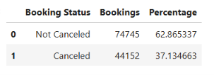
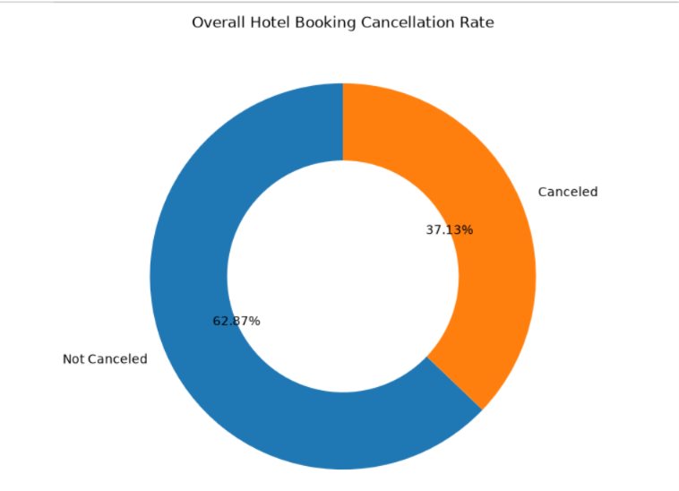
Finding
Finding: The overall cancellation rate is 37.04%, meaning approximately 37.13% of bookings in the dataset were cancelled, while 62.87% were not cancelled.
Business interpretation
Business Interpretation: A cancellation rate of approximately 37.13% represents a substantial proportion of bookings that may affect room occupancy and expected revenue. Therefore, identifying the characteristics associated with cancelled bookings is important for developing targeted cancellation-reduction strategies.
Next step
Next Step: To identify the key factors associated with cancellations, the analysis will examine cancellation rates across hotel type, ADR, lead time, deposit type, market segment, seasonality, and other booking characteristics.

- Cancellation Rate by Hotel Type
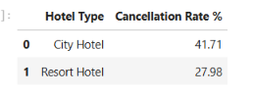
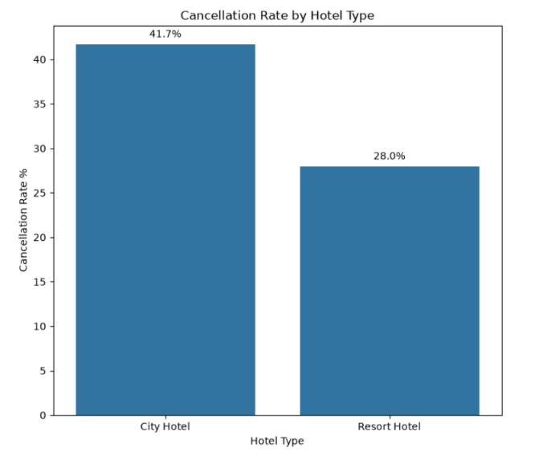
Finding
Finding: Cancellation rate differs by hotel type.
Business interpretation
Business Interpretation: Cancellation rates differ between the two hotel types. City hotel has a cancellation rate of 41.71%, compared with 27.98% for Resort hotel , a difference of 13.73 percentage points. This indicates that bookings at City hotel are more likely to be cancelled. Therefore, City hotels may require greater attention to cancellation-management strategies, such as reviewing pricing, deposit policies, and booking conditions.
Next step
Next Step: Cancellation Rate by Lead Time

- Cancellation Rate by Lead Time
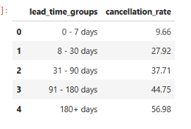
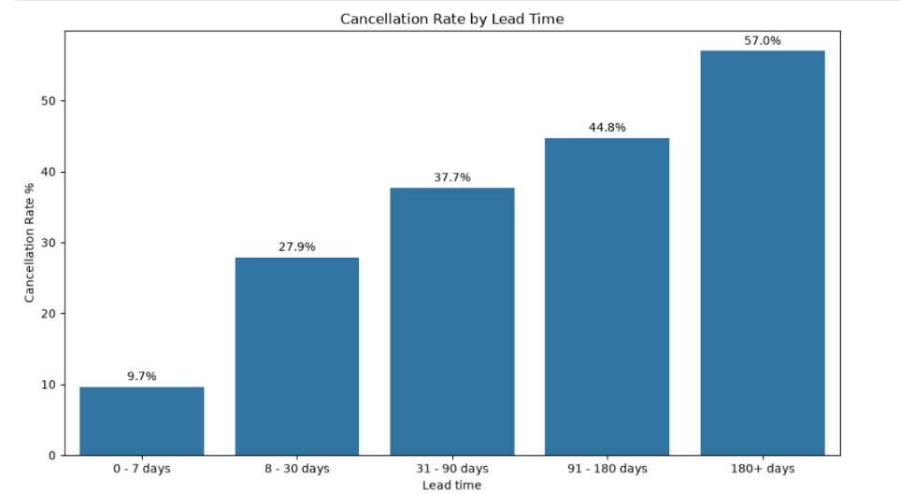

Finding
Finding: Cancellation risk increases substantially as the time between booking and arrival becomes longer, rising from 9.66% for bookings made 0–7 days in advance to 56.98% for bookings made 181+ days in advance.
Business interpretation
Business Interpretation: Cancellation rate increases consistently as lead time increases. Bookings made 0–7 days before arrival have a cancellation rate of 9.66%, while bookings made 181+ days in advance have a cancellation rate of 56.98%. This represents a difference of 47.31 percentage points.
The results indicate a strong positive association between longer lead times and booking cancellations. Customers who book significantly further in advance appear to have a higher likelihood of cancelling their reservations.
From a business perspective, hotels should pay particular attention to long-lead bookings because they represent a higher cancellation-risk segment. However, this analysis identifies an association rather than proving that longer lead time directly causes cancellations.
Business Recommendation from This Finding
This finding connects directly to your second business question:
How can hotels reduce booking cancellations and improve room occupancy and revenue?
A reasonable recommendation is:
Hotels should monitor long-lead bookings more closely and use appropriate cancellation-management strategies for these reservations.
For example, hotels could consider:
- stricter cancellation policies for high-risk booking segments
- deposits or partially non-refundable rates
- targeted confirmation/reminder communications
- maintaining a waitlist for high-risk periods
- forecasting expected cancellations when planning room inventory
Next step
Next Step: Cancellation Rate by Deposit Type

- Cancellation Rate by Deposit Type

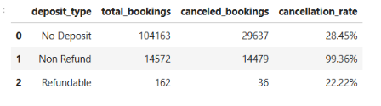
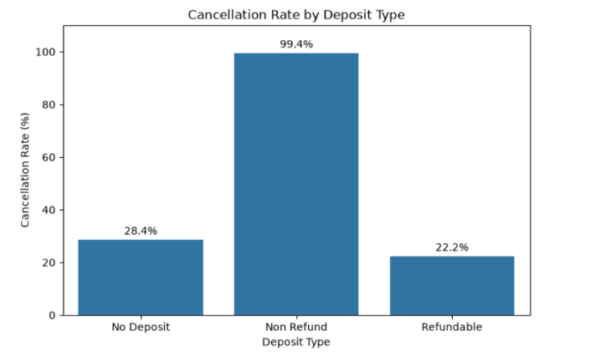

Finding
Cancellation rates vary substantially by deposit type. Non-refundable bookings have an exceptionally high cancellation rate of 99.36%, compared with 28.38% for No Deposit bookings and 22.22% for Refundable bookings. The Non Refund category therefore stands out as the deposit type most strongly associated with cancellations.
The Refundable category contains only 162 bookings, so its 22.22% cancellation rate should be interpreted with caution due to the small sample size.

Business interpretation
Deposit type appears to be an important factor associated with booking cancellations. The extremely high cancellation rate among Non Refund bookings suggests that this booking category requires further investigation.
Hotels should examine the characteristics of Non Refund bookings, such as market segment, customer type, booking channel, and lead time, before making changes to deposit policies. Understanding the underlying booking patterns can help hotels identify potential cancellation risks and design more effective deposit and booking strategies.
Next Step
Investigate the Non Refund booking category to understand why its cancellation rate is exceptionally high. Analyze its relationship with market segment, customer type, booking channel, and lead time.
After this investigation, proceed to Step 5: Cancellation Rate by Market Segment and Booking Channel to identify which customer segments and booking channels have the highest cancellation risk.

