UPDATED BUILDING REFERENCE
Floor Plans After Room Renaming
My Building
4 floors | 80 rooms | Rendered from src/data - the same validated data the deployed navigator serves
What changed: every room now carries the name and category from the completed naming worksheet. Room IDs, positions, doors and the navigation graph are unchanged, so any saved route or bookmark that refers to a room ID still resolves.

Rooms by floor and category
Floor | Administration | Canteen | Classroom | Female prayer room | Female washroom | Laboratory | Male washroom | Print shop | Unclassified | Total
Ground Floor | 1 | 1 | 4 |  | 2 | 6 | 2 | 1 |  | 17
First Floor | 1 |  | 10 |  | 2 | 5 | 2 | 1 |  | 21
Floor 2 | 1 | 1 | 9 | 1 | 2 | 4 | 2 |  | 1 | 21
Floor 3 | 1 | 1 | 9 |  | 2 | 6 | 2 |  |  | 21
All floors | 4 | 3 | 32 | 1 | 8 | 21 | 8 | 2 | 1 | 80

Ground Floor (GF)
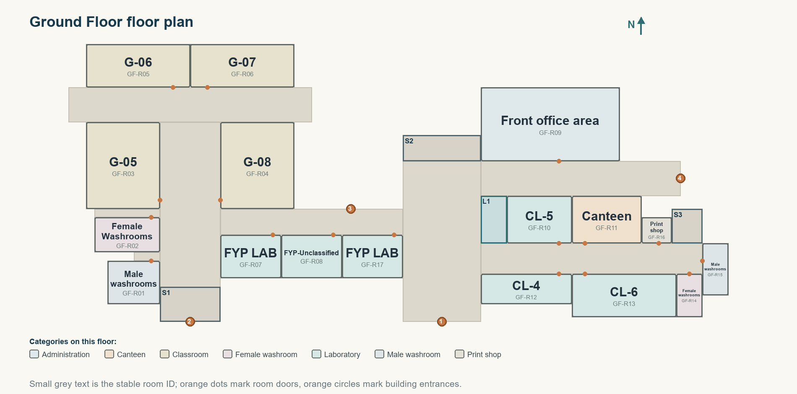
Figure: Ground Floor - updated room names, shaded by category

Ground Floor room list
Room ID | Name | Category | Room ID | Name | Category
GF-R01 | Male washrooms | Male washroom | GF-R10 | CL-5 | Laboratory
GF-R02 | Female Washrooms | Female washroom | GF-R11 | Canteen | Canteen
GF-R03 | G-05 | Classroom | GF-R12 | CL-4 | Laboratory
GF-R04 | G-08 | Classroom | GF-R13 | CL-6 | Laboratory
GF-R05 | G-06 | Classroom | GF-R14 | Female washrooms | Female washroom
GF-R06 | G-07 | Classroom | GF-R15 | Male washrooms | Male washroom
GF-R07 | FYP LAB | Laboratory | GF-R16 | Print shop | Print shop
GF-R08 | FYP-Unclassified | Laboratory | GF-R17 | FYP LAB | Laboratory
GF-R09 | Front office area | Administration

First Floor (F1)
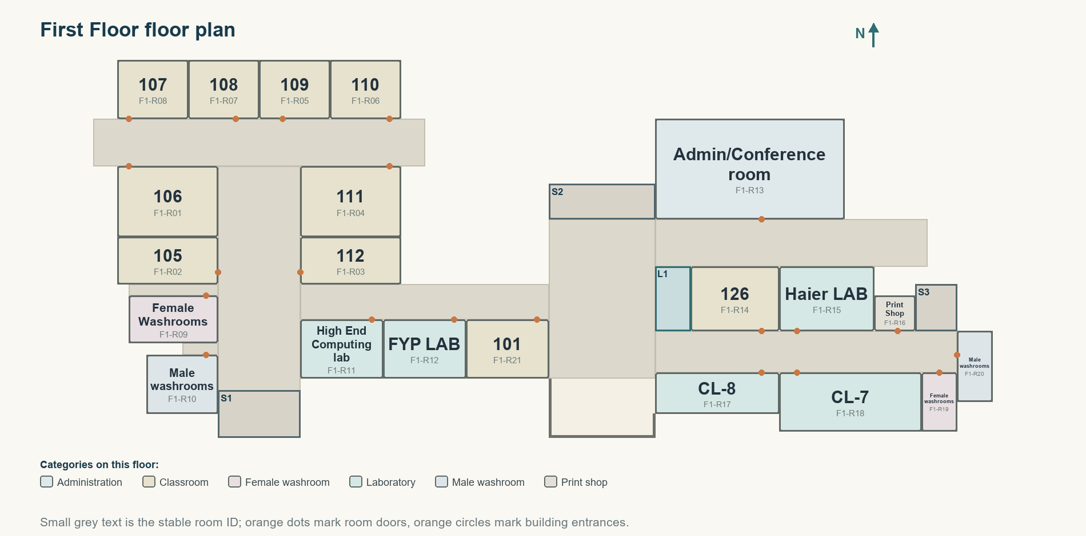
Figure: First Floor - updated room names, shaded by category

First Floor room list
Room ID | Name | Category | Room ID | Name | Category
F1-R01 | 106 | Classroom | F1-R12 | FYP LAB | Laboratory
F1-R02 | 105 | Classroom | F1-R13 | Admin/Conference room | Administration
F1-R03 | 112 | Classroom | F1-R14 | 126 | Classroom
F1-R04 | 111 | Classroom | F1-R15 | Haier LAB | Laboratory
F1-R05 | 109 | Classroom | F1-R16 | Print Shop | Print shop
F1-R06 | 110 | Classroom | F1-R17 | CL-8 | Laboratory
F1-R07 | 108 | Classroom | F1-R18 | CL-7 | Laboratory
F1-R08 | 107 | Classroom | F1-R19 | Female washrooms | Female washroom
F1-R09 | Female Washrooms | Female washroom | F1-R20 | Male washrooms | Male washroom
F1-R10 | Male washrooms | Male washroom | F1-R21 | 101 | Classroom
F1-R11 | High End Computing lab | Laboratory

Floor 2 (F2)
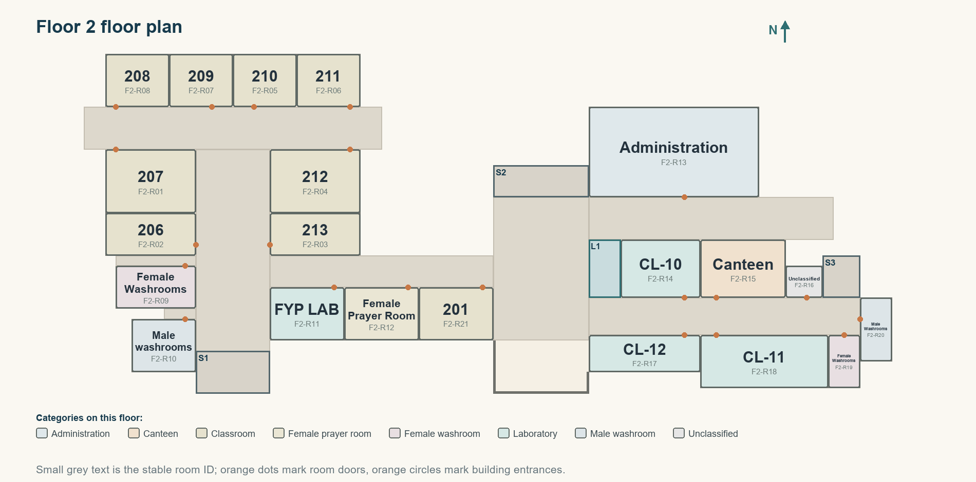
Figure: Floor 2 - updated room names, shaded by category

Floor 2 room list
Room ID | Name | Category | Room ID | Name | Category
F2-R01 | 207 | Classroom | F2-R12 | Female Prayer Room | Female prayer room
F2-R02 | 206 | Classroom | F2-R13 | Administration | Administration
F2-R03 | 213 | Classroom | F2-R14 | CL-10 | Laboratory
F2-R04 | 212 | Classroom | F2-R15 | Canteen | Canteen
F2-R05 | 210 | Classroom | F2-R16 | Unclassified | Unclassified
F2-R06 | 211 | Classroom | F2-R17 | CL-12 | Laboratory
F2-R07 | 209 | Classroom | F2-R18 | CL-11 | Laboratory
F2-R08 | 208 | Classroom | F2-R19 | Female Washrooms | Female washroom
F2-R09 | Female Washrooms | Female washroom | F2-R20 | Male Washrooms | Male washroom
F2-R10 | Male washrooms | Male washroom | F2-R21 | 201 | Classroom
F2-R11 | FYP LAB | Laboratory

Floor 3 (F3)
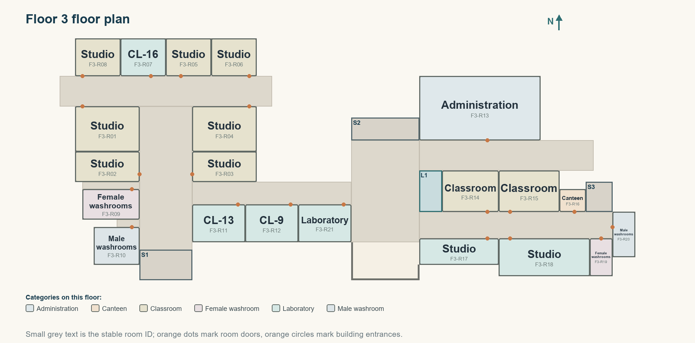
Figure: Floor 3 - updated room names, shaded by category

Floor 3 room list
Room ID | Name | Category | Room ID | Name | Category
F3-R01 | Studio | Classroom | F3-R12 | CL-9 | Laboratory
F3-R02 | Studio | Classroom | F3-R13 | Administration | Administration
F3-R03 | Studio | Classroom | F3-R14 | Classroom | Classroom
F3-R04 | Studio | Classroom | F3-R15 | Classroom | Classroom
F3-R05 | Studio | Classroom | F3-R16 | Canteen | Canteen
F3-R06 | Studio | Classroom | F3-R17 | Studio | Laboratory
F3-R07 | CL-16 | Laboratory | F3-R18 | Studio | Laboratory
F3-R08 | Studio | Classroom | F3-R19 | Female washrooms | Female washroom
F3-R09 | Female washrooms | Female washroom | F3-R20 | Male washrooms | Male washroom
F3-R10 | Male washrooms | Male washroom | F3-R21 | Laboratory | Laboratory
F3-R11 | CL-13 | Laboratory

