**Student's Name: Fatima Jameel**

**BSIT 4th Semester**

**Database Systems**

**Roll No: 110854**

**Govt Graduate College Civil Lines Sheikhupura**

**Submitted To: Mam Shehrish**

**Normalization**

**Question # 1:**

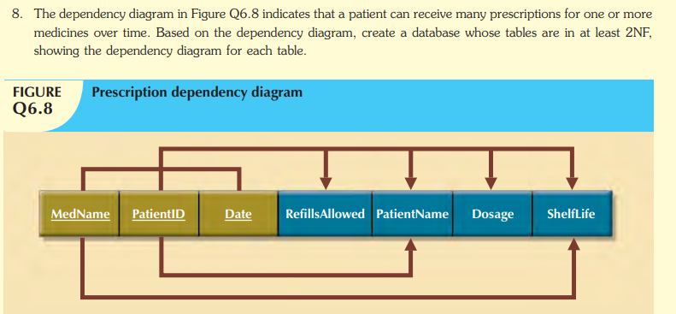

**Answer:**

**1NF:**

P.K = Patient-ID, Med-name, Date

**2NF:**

**“Partial dependencies”**

Patient ID (Patient Name)

Medicine (Med-Name, Date, Shelf life)

**“Functional dependencies”**

Prescription (Med-name, patient-ID, Date, Refills allowed, patient-name, Dosage, Shelf life)

**Question # 2:**

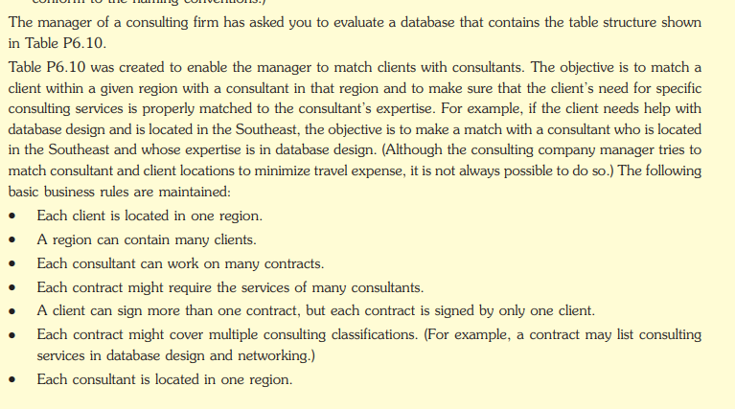

**ER Diagram:**

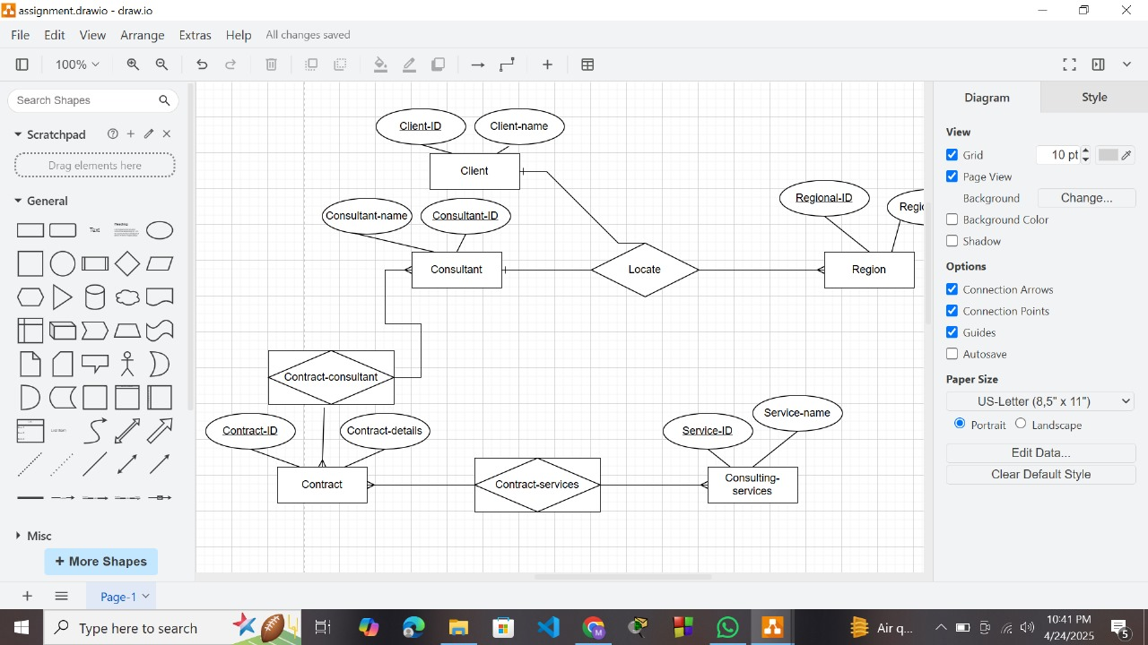

**Un Normalized form:**

|  |  |  |  |  |  |  |
| --- | --- | --- | --- | --- | --- | --- |
| **Contract-ID** | **Client-name** | **Client-Region** | **Consultant name** | **Consultant Region** | **Service 1** | **Service 2** |
| ……. | ……. | South-east | John Doe | Southeast | Database | Network |

**1NF:**

**Rule:** Eliminate repeating groups and multivalued attributes. Ensure each field contains atomic values.

We have to brake services into individual rows:

|  |  |  |  |  |  |
| --- | --- | --- | --- | --- | --- |
| **Contract-ID** | **Client-name** | **Client-Region** | **Consultant name** | **Consultant Region** | **Services** |
| ……. | ……. | South-east | John Doe | Southeast | Database |
| ……. | ……. | South-east | John Doe | Southeast | Network |

**Improvement:**

* Each columns contain atomic values.
* No repeating groups.

2NF:

Be in INF + eliminate partial dependencies (non-key attributes depending only on part of a composite primary key).

* Separate Clients, Consultant, Contracts and Services into their own tables.

1. Client (Client ID, Name, Region ID).

2. Consultant (Consultant ID, Name, Region ID).

3. Contract (Contract ID, Client ID).

4. Consulting Service (Service ID, Name).

5. Contract Service (Contract ID, Service ID).

6. Contract Consultant (Contract ID, Consultant ID).

No attribute is partially dependent on part of a composite key — all depend on the full key or are in separate tables.

3NF:

Be in 2NF + eliminate transitive dependencies (non-key attributes depending on other non-key attributes).

* In 2NF, if we had something like:
* Here, Region Name depends on Client Region, which depends on Client ID → transitive dependency.

So, we break Region into its own table:

|  |  |
| --- | --- |
| **Region** | |
| Region ID | Region-name |

Then reference Region ID in both Client and Consultant.

Final schema is in 3NF:

* No partial dependencies.
* No transitive dependencies.
* Each non-key field depends only on the primary key of its own table.

**Question # 3:**

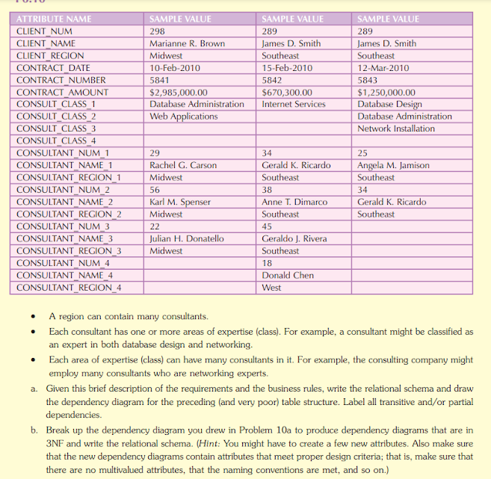

**1NF:**

Eliminate repeating groups. Each field should contain atomic values.

* Break each consultant and their class into individual rows per contract.

|  |  |  |  |  |  |
| --- | --- | --- | --- | --- | --- |
| **Contract-Num** | **Contract-Date** | **Consultant-Num** | **Consultant-Name** | **Consultant-Region** | **Class-Name** |
| 5841 | 10-Feb-2010 | 29 | Rachel G. Carson | Midwest | Database Admin |
| 5841 | 10-Feb-2010 | 56 | Karl M. Spenser | Midwest | Web Applications |
| 5841 | 15-Feb-2010 | 34 | Gerald K. Ricardo | Southeast | Internet Services |

**2NF:**

Eliminate Partial Dependencies.

* Consultant information depends only on Consultant-Num, not on Contract-Num.
* Class information depends only on Class-Name.

**Consultant-Table: Class-Table:**

|  |  |  |  |
| --- | --- | --- | --- |
| **Consultant-Num** | **Consultant-Name** | **Consultant-Region** | **Class-Name** |
| 29 | Rachel G. Carson | Midwest | Database Admin |
| 56 | Karl M. Spenser | Midwest | Web Applications |
| 34 | Gerald K. Ricardo | Southeast | Internet Services |

|  |  |
| --- | --- |
| **Class-ID** | **Class-Name** |
| 1 | Database Admin |
| 2 | Web Applications |
| 3 | Internet Services |

**Contract Table:**

|  |  |  |  |
| --- | --- | --- | --- |
| **Contract-Num** | **Contract-Date** | **Contract-Amount** | **Client-Num** |
| 5841 | 10-Feb-2010 | $2985,000.00 | 298 |

**Contract-Consultant Table:**

|  |  |  |
| --- | --- | --- |
| **Contract-Num** | **Consultant-Num** | **Class-ID** |
| 5841 | 29 | 1 |
| 5841 | 56 | 2 |

**3NF:**

Be in 2NF + eliminate transitive dependencies (non-key attributes depending on other non-key attributes).

* Client-Region should be moved to a separate Client table instead of repeating.

|  |  |  |
| --- | --- | --- |
| **Client-Num** | **Client-Name** | **Client-Region** |
| 298 | Marianne R. Brown | Midwest |
| 289 | James D. Smith | Southeast |

**Final Set of Tables (in 3NF):**

1. Client (Client-Num, Client-Name, Client-Region)

2. Contract (Contract-Num, Contract Date, Contract Amount, Client-Num)

3. Consultant (Consultant-Num, Consultant Name, Consultant Region).

4. Expertise Class (Class-ID, Class-Name)

5. Contract Consultant (Contract-Num, Consultant-Num, Class-ID)

**Question # 4:**

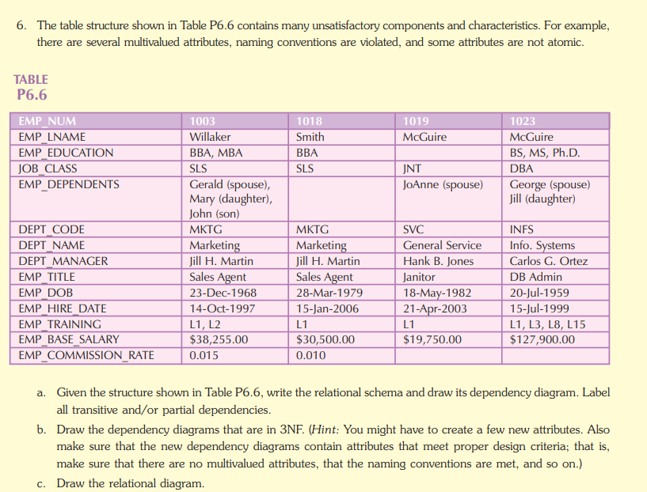

**1NF:**

Remove multivalued and non-atomic fields.

**2NF:**

Create separate rows/tables for multivalued attributes. Remove partial dependencies.

**Employee Table:**

|  |  |  |  |  |  |  |  |
| --- | --- | --- | --- | --- | --- | --- | --- |
| **Emp-Num** | **Emp-Name** | **Job-Class** | **Dept-Code** | **Emp-Title** | **Emp-DOB** | **Emp-Hire Date** | **Emp-Base Salary** |
| 1003 | Willaker | SLS | MKTG | Sales Agent | 23/12/1968 | 14/10/1997 | $38,255.00 |
| 1018 | Smith | SLS | MKTG | Sales Agent | 26/03/1979 | 15/06/2006 | $30,500.00 |
| 1019 | McGuire | JNT | SVC | Janitor | 18/05/1982 | 21/04/2003 | $19,750.00 |
| 1023 | McGuire | DBA | INFS | DB Admin | 20/07/1958 | 15/07/1999 | $127,900.00 |

**Emp-Education Table: Emp-Dependents:**

|  |  |
| --- | --- |
| **Emp-Num** | **Education** |
| 1003 | BBA |
| 1003 | MBA |
| 1018 | BBA |
| 1019 | BBA |
| 1023 | BS |
| 1023 | MS |
| 1023 | Ph.D. |

|  |  |  |
| --- | --- | --- |
| **Emp-Num** | **Dependent-Name** | **Relationship** |
| 1003 | Gerald | Spouse |
| 1003 | Mary | Daughter |
| 1003 | John | Son |
| 1019 | JoAnne | Spouse |
| 1023 | George | Spouse |
| 1023 | Jill | Daughter |

**Emp-Training:**

|  |  |
| --- | --- |
| **Emp-Num** | **Training-Code** |
| 1003 | L1 |
| 1003 | L2 |
| 1003 | L1 |
| 1019 | L1 |
| 1023 | L3 |
| 1023 | L8 |

**3NF:**

Remove data that does not depend on full key.

|  |  |  |
| --- | --- | --- |
| Client-Num | Client-Name | Client-region |
| 298 | Marianne R. Brown | Midwest |
| 289 | James D. Smith | Southeast |

**Final Set of Normalized Tables (3NF):**

1. EMPLOYEE (EMP-NUM, EMP-LNAME, JOB-CLASS, DEPT-CODE, EMP-TITLE, EMP-DOB, EMP-HIRE-DATE, EMP-BASE-SALARY)

2. EMP-EDUCATION (EMP-NUM, EDUCATION)

3. EMP-DEPENDENTS (EMP-NUM, DEPENDENT-NAME, RELATIONSHIP)

4. EMP-TRAINING (EMP-NUM, TRAINING-CODE)

5. DEPARTMENT (DEPT-CODE, DEPT-NAME, DEPT-MANAGER)

6. JOB-TITLE (EMP-TITLE, COMMISSION-RATE)

Question # 5:

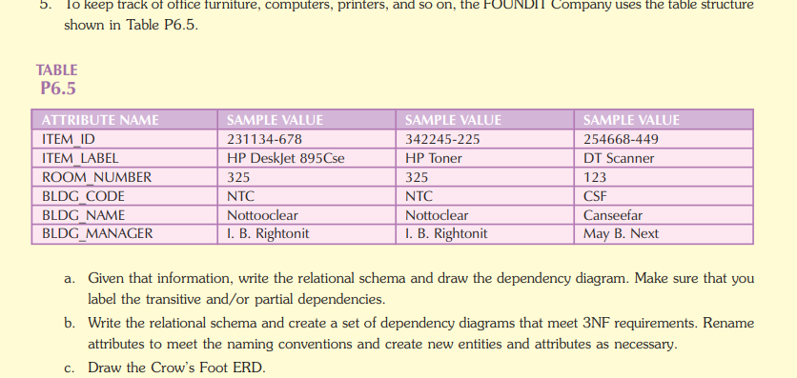

**ER Diagram:**

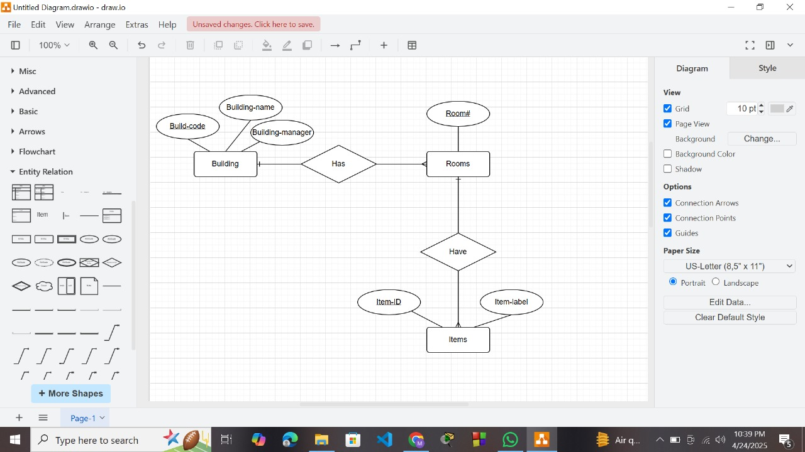

1NF:

Primary Key: Item-ID, BLDG-Code

2NF:

|  |  |  |  |
| --- | --- | --- | --- |
| **BLDG-Code** | **BLDG-Name** | **BLDG-Manager** | **Room-No** |
| NTC | Notto Clear | I.B. Rigto | 325 |
| NTC | Notto Clear | I.B. Rigto | 325 |
| CSF | Notto Clear | May B. Next | 123 |

Item-Id-----🡪 Item-label

BLDG ------🡪 BLDG-Name, BLDG-Manager, Room-No

|  |  |
| --- | --- |
| **Item-ID** | **Item-Label** |
| 2331-125 | HP Deskjet |
| 4372-152 | HP Toner |
| 1214-236 | DT-Scanner |

**3NF:**

|  |  |  |
| --- | --- | --- |
| **Item-ID** | **BLDG-Code** | **Room-No** |
| 2331-125 | NTC | 325 |
| 4372-152 | NTC | 325 |
| 1214-236 | CSF | 123 |