TABLE OF CONTENTS
- Problem Description
- Background
- Community Impact
- Proposed Solution and Objectives
- Computational Thinking
- Problem Decomposition
- Inputs, Processing and Outputs
- Variables, Constants and Data Types
- Decision Structures and Boolean Logic
- Repetition Structures
- Functional Modules
- Algorithm
- Pseudocode
- Flowchart
- Scenarios and Outputs
- SDG Alignment
- Open Source Software
- Digital Public Goods
- Community Impact and Sustainability
- References.

- PROBLEM DESCRIPTION
The problem addressed is that residents and local responders may not always receive organized, timely information about changing flood conditions in their community. Reports may be scattered across phone calls, messages or informal conversations, making it difficult to compare conditions between locations. If information is late, incomplete or inaccurate, residents may have less time to prepare and authorities may struggle to identify areas requiring attention.
Who is affected?
- Residents of low-lying or flood-prone communities.
- Children, older people and people with disabilities who may need additional assistance.
- Schools, health facilities, market vendors and local businesses.
- Drivers, transport operators and commuters using affected roads.
- Local councils, community leaders and emergency-response organizations.

Why does the problem exist?

- Heavy rainfall and rapidly changing water levels.
- Blocked or inadequate drainage and waste obstructing waterways in some locations.
- Homes and infrastructure located in areas exposed to flooding.
- Reports that may be incomplete, unverified or difficult to organize.
- Limited access to reliable warning information or communication channels in some communities.

- BACKGROUND
Flood risk is influenced by rainfall, terrain, drainage, water levels, land use and the location of people and infrastructure. The World Bank’s Freetown flood-risk assessment provides an example of the importance of mapping hazards and exposure when planning for flood risk. A community alert system could complement, but should never replace, official monitoring and emergency-management services. A real deployment would require local data, validated thresholds, trained operators and approval from relevant authorities.
- COMMUNITY IMPACT
Social impact
Flooding can displace families, interrupt schooling and affect community activities.
Economic impact
Floodwater may damage houses, shops, stock, equipment, crops and other property.
Transport and public services
Flooded roads can delay travel and limit access to workplaces, markets, schools and health facilities.
Health and sanitation
Flooding may contaminate water, damage sanitation facilities and create unhealthy conditions.
Emergency coordination
Structured reports can help authorized responders compare locations and prioritize follow-up.
- PROPOSED SOLUTION AND OBJECTIVES
The proposed Flood Early Warning and Community Alert System (FEWCAS) is a logical workflow for collecting flood-related information, checking it, assigning an indicative risk category and presenting a warning and action recommendation. Inputs may be entered by an authorized operator or received from validated monitoring sources.
Objectives
- Collect location and current rainfall and water-level information.
- Record community reports in a consistent format.
- Check that required inputs are present and plausible.
- Assess the combined indicators using transparent rules.
- Display a risk level, warning and recommended action.
- Store reports for later review and planning.
- Demonstrate a design that is modular, reusable and suitable for community adaptation.

- COMPUTATIONAL THINKING

5.1 Decomposition
Break the problem into data collection, validation, risk assessment, warning generation, action recommendation, report storage and monitoring.
5.2 Pattern recognition
Look for combinations such as high rainfall, rising water levels and multiple reports from the same location.
5.3 Abstraction
Use relevant information—location, rainfall status, water level, report count, time and risk category—while minimizing personal data.

5.4 Algorithm design
Define a repeatable sequence that converts validated inputs into a risk category and clear output.

- PROBLEM DECOMPOSITION
Data Collection: Collect location, rainfall status, water-level status, number of reports and time.
Data Validation: Check required values are supplied and are within allowed categories or ranges.
Risk Assessment: Apply the documented illustrative scoring rules to validated inputs.
Risk Classification: Map the score to LOW, MODERATE, HIGH or CRITICAL.
Warning Generation: Create a message that corresponds to the category.
Action Recommendation: Display a suitable preparedness or safety recommendation.
Report Storage: Save the assessment record for review.
Monitoring Control: Repeat the process while monitoring is enabled.

- SYSTEM INPUTS, PROCESSING AND OUTPUTS
- Inputs
- Community/location name
- Rainfall status
- Water-level status
- Number of community reports
- Date and time of assessment
- Processing
- Validate inputs.
- Initialize the risk score to zero.
- Add points for high rainfall, high water level and multiple reports.
- Classify the score using illustrative thresholds.
- Select a warning and recommended action.
- Save and display the report.
- Outputs
- Location and assessment time
- Risk score and category
- Warning message
- Recommended action
- Saved report status

- VARIABLES, CONSTANTS AND DATA TYPES

Name | Data type | Purpose
location | STRING | Community name or location
rainfall | STRING | LOW, HIGH or VERY HIGH
waterLevel | STRING | NORMAL, HIGH or VERY HIGH
reports | INTEGER | Number of community reports
riskScore | INTEGER | Total illustrative score
riskLevel | STRING | LOW, MODERATE, HIGH or CRITICAL
warning | STRING | Message displayed to the user
action | STRING | Recommended response
continueMonitoring | BOOLEAN | TRUE to repeat; FALSE to stop

9. DECISION STRUCTURES AND BOOLEAN LOGIC

The system uses IF, ELSE IF and ELSE to select a risk category. The Boolean operator OR checks whether rainfall is HIGH or VERY HIGH. The operator AND could be used in validation rules when two conditions must both be true.
IF rainfall = "HIGH" OR rainfall = "VERY HIGH" THEN\n riskScore = riskScore + 2\nEND IF

- REPETITION STRUCTURES

A WHILE loop allows repeated assessments. While continueMonitoring is TRUE, the system collects and processes another set of information. The user ends monitoring by setting the value to FALSE. In an operational system, monitoring would need safeguards, timestamps and a reliable way to receive new data.

- FUNCTIONAL MODULES

- GetLocation () Returns the community/location.
- GetRainfall () Returns the rainfall status.
- GetWaterLevel () Returns the water-level status.
- GetCommunityReports () Returns the number of reports.
- ValidateData () Checks that inputs are complete and acceptable.
- CalculateRisk () Computes the illustrative score.
- DetermineRiskLevel () Converts the score to a category.
- GenerateWarning () Creates a category-specific warning.
- RecommendAction () Selects the recommended action.
- SaveReport () Stores assessment record.
- MonitorFloodRisk () — Coordinates the monitoring loop.

- ALGORITHM

Step 1: Start the program.
Step 2: Enter the name of the community.
Step 3: Enter the drainage blockage code:
- 0 = No blockage
- 1 = Partial blockage
- 2 = Severe blockage
Step 4: Enter the standing-water code:
- 0 = No standing water
- 1 = Some standing water
- 2 = Severe standing water
Step 5: Enter the rainfall code:
- 0 = Low rainfall
- 1 = Moderate rainfall
- 2 = Heavy rainfall
Step 6: Enter the number of complaints received from community members.
Step 7: Validate the inputs. If any code is outside the allowed range or the number of complaints is negative, display an error message and request the information again.
Step 8: Initialize the maintenance priority score to zero.
Step 9: Add points to the score according to the following conditions:
- If blockage code = 2, add 4 points.
- If blockage code = 1, add 2 points.
- If standing-water code = 2, add 3 points.
- If standing-water code = 1, add 1 point.
- If rainfall code = 2, add 2 points.
- If rainfall code = 1, add 1 point.
- If complaints are 5 or more, add 2 points.
Otherwise, if complaints are 3 or more, add 1 point.
Step 10: Determine the maintenance priority:
- If the score is 9 or more, classify it as URGENT.
- Otherwise, if the score is 6 or more, classify it as HIGH.
- Otherwise, if the score is 3 or more, classify it as MEDIUM.
- Otherwise, classify it as LOW.
Step 11: Select the recommended action:
- URGENT: Notify the responsible local team and inspect the site as soon as safely possible.
- HIGH: Arrange a priority inspection and plan maintenance.
- MEDIUM: Schedule a drainage inspection and monitor the location.
- LOW: Continue routine drainage maintenance.
Step 12: Display the community name, priority score, priority level, and recommended action.
Step 13: Ask whether the user wants to assess another community.
Step 14: If YES, repeat the process from Step 2. If NO, continue to Step 15.
Step 15: Display a message indicating that the program has ended.
Step 16: Stop the program.

PSEUDOCODE
BEGIN DrainageWatch

DECLARE community AS STRING
DECLARE blockageCode AS INTEGER
DECLARE standingWaterCode AS INTEGER
DECLARE rainfallCode AS INTEGER
DECLARE complaints AS INTEGER
DECLARE priorityScore AS INTEGER
DECLARE priorityLevel AS STRING
DECLARE action AS STRING
DECLARE continueAssessment AS STRING

SET continueAssessment = "YES"

WHILE continueAssessment = "YES"

OUTPUT "DRAINAGEWATCH SYSTEM"

INPUT community
INPUT blockageCode
INPUT standingWaterCode
INPUT rainfallCode
INPUT complaints

IF community = "" OR
blockageCode < 0 OR blockageCode > 2 OR
standingWaterCode < 0 OR standingWaterCode > 2 OR
rainfallCode < 0 OR rainfallCode > 2 OR
complaints < 0 THEN

OUTPUT "Invalid input. Please enter the information again."

ELSE

SET priorityScore = 0

IF blockageCode = 2 THEN
SET priorityScore = priorityScore + 4
ELSE
IF blockageCode = 1 THEN
SET priorityScore = priorityScore + 2
END IF
END IF

IF standingWaterCode = 2 THEN
SET priorityScore = priorityScore + 3
ELSE
IF standingWaterCode = 1 THEN
SET priorityScore = priorityScore + 1
END IF
END IF

IF rainfallCode = 2 THEN
SET priorityScore = priorityScore + 2
ELSE
IF rainfallCode = 1 THEN
SET priorityScore = priorityScore + 1
END IF
END IF

IF complaints >= 5 THEN
SET priorityScore = priorityScore + 2
ELSE
IF complaints >= 3 THEN
SET priorityScore = priorityScore + 1
END IF
END IF

IF priorityScore >= 9 THEN
SET priorityLevel = "URGENT"
SET action = "Notify the responsible local team and inspect the site as soon as safely possible."

ELSE
IF priorityScore >= 6 THEN
SET priorityLevel = "HIGH"
SET action = "Arrange a priority inspection and plan maintenance."

ELSE
IF priorityScore >= 3 THEN
SET priorityLevel = "MEDIUM"
SET action = "Schedule a drainage inspection and monitor the location."

ELSE
SET priorityLevel = "LOW"
SET action = "Continue routine drainage maintenance."
END IF
END IF
END IF

OUTPUT "Community: " + community
OUTPUT "Maintenance Priority Score: " + priorityScore
OUTPUT "Priority Level: " + priorityLevel
OUTPUT "Recommended Action: " + action

END IF

OUTPUT "Assess another community? Enter YES or NO."
INPUT continueAssessment

SET continueAssessment = UPPERCASE(continueAssessment)

END WHILE

OUTPUT "DrainageWatch assessment has ended."

END DrainageWatch

- FLOWCHART

- SCENARIOS AND EXPECTED OUTPUTS

Scenario A — Low risk
Input: Location: Community A; Rainfall: LOW; Water level: NORMAL; Reports: 0.
Expected output: Score 0; Risk LOW. No immediate threat indicated by these inputs. Continue monitoring local conditions.

Scenario B — Moderate risk
Input: Location: Community B; Rainfall: HIGH; Water level: NORMAL; Reports: 1.
Expected output: Score 2; Risk MODERATE. Flooding may occur if conditions worsen. Remain alert and prepare.

Scenario C — High risk
Input: Location: Community C; Rainfall: HIGH; Water level: HIGH; Reports: 1.
Expected output: Score 5; Risk HIGH. Follow official guidance and prepare to move to safety if instructed.

Scenario D — Critical risk
Input: Location: Community D; Rainfall: VERY HIGH; Water level: VERY HIGH; Reports: 5.
Expected output: Score 7; Risk CRITICAL. Follow official emergency instructions immediately.
These scenarios demonstrate the algorithm only. They are not forecasts or real emergency assessments. A deployed system must use verified observations and official risk thresholds.

- SUSTAINABLE DEVELOPMENT GOAL ALIGNMENT
SDG 11: Sustainable Cities and Communities
This is the primary SDG supported. SDG 11 aims to make cities and human settlements inclusive, safe, resilient and sustainable. Target 11.5 focuses on reducing deaths, affected people and economic losses caused by disasters.
SDG 13: Climate Action
The project supports preparedness and resilience to climate-related hazards and natural disasters.
SDG 9: Industry, Innovation and Infrastructure
The project illustrates how accessible digital tools and resilient information systems can support community planning.

- OPEN-SOURCE SOFTWARE JUSTIFICATION

The proposed system could be released under a recognized open-source licence. Open Source Software allows people to inspect, use, modify and redistribute software according to licence terms.
Lower barriers to adoption for schools, NGOs and community organizations.
Local ICT students and developers can adapt the system to local needs.
Community contributions can improve documentation, translation and usability.
Public review can improve transparency and help identify design problems.
Shared maintenance can reduce dependence on a single developer.
Community contributions could include translating warnings into local languages, testing forms, improving accessibility, documenting local workflows and reviewing software security. Personal data and sensitive location information must not be published openly.

- DIGITAL PUBLIC GOODS JUSTIFICATION

Digital Public Goods (DPGs) include digital solutions such as open-source software, open data, open AI systems, open standards and open content that follow relevant safeguards and contribute to the Sustainable Development Goals. This student design is DPG-inspired; it should not be claimed to be an officially recognized DPG unless it passes the applicable review process.
Open licensing enables reuse and adaptation.
Open standards can help systems exchange data.
Clear documentation makes the design easier to understand and reproduce.
Privacy safeguards minimize personal data collection and control access to sensitive reports.
Accessibility and low-bandwidth options can help more communities benefit.
The system is connected to public benefit and SDG.

- COMMUNITY IMPACT AND LONG-TERM SUSTAINABILITY

Potential beneficiaries include residents, schools, market vendors, transport operators, local authorities and emergency responders. The system could improve the organization of reports, support earlier preparedness and provide structured information for planning. It cannot guarantee that flooding will be prevented or that every warning will be correct.
Sustainability measures
Train local students and community operators.
Review risk rules using verified local data and expert advice.
Maintain documentation and a clear contribution process.
Use open standards and a suitable open-source licence.
Protect data, maintain backups and restrict access appropriately.
Work with relevant authorities and community organizations.
Evaluate accuracy, usability and whether warnings reach intended users.

Github Evidence
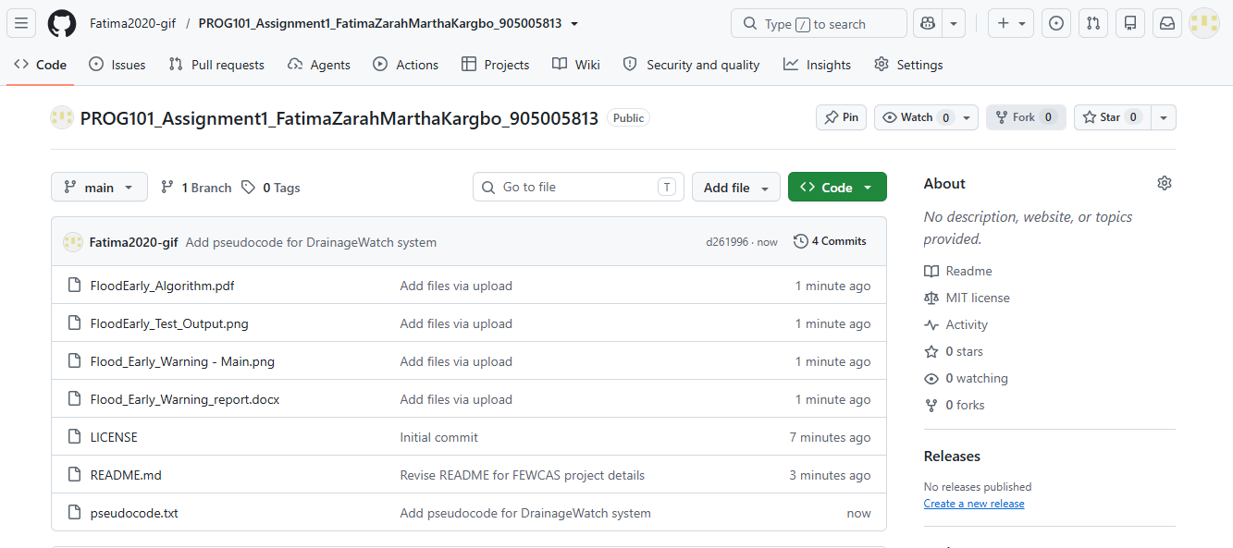
Commit History
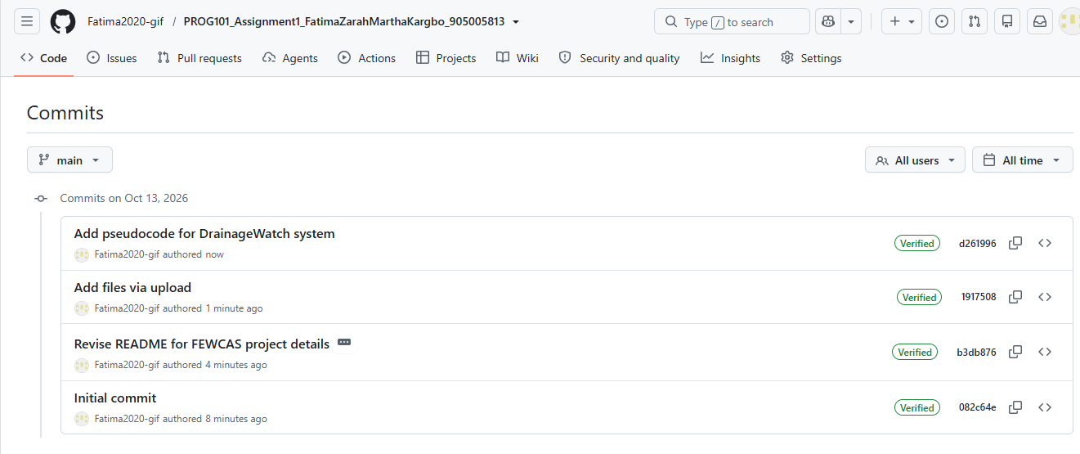

- REFERENCES
- World Bank. (n.d.). Freetown, Sierra Leone Flood Risk Assessment. World Bank Data Catalog. https://datacatalog.worldbank.org/search/dataset/0066934/freetown-sierra-leone-flood-risk-assessment
- World Bank. (2019). Sierra Leone Multi-City Hazard Review and Risk Assessment. https://www.worldbank.org/en/topic/disasterriskmanagement/brief/sierra-leone-multi-city-hazard-review-and-risk-assessment
- United Nations Department of Economic and Social Affairs. (n.d.). Goal 11: Sustainable Cities and Communities. https://sdgs.un.org/goals/goal11
- United Nations. (2015). Transforming our world: The 2030 Agenda for Sustainable Development. https://sdgs.un.org/2030agenda
- Digital Public Goods Alliance. (n.d.). Digital Public Goods Standard. https://www.digitalpublicgoods.net/standard
- Digital Public Goods Alliance. (n.d.). Digital Public Goods FAQs. https://www.digitalpublicgoods.net/digital-public-goods/faqs
- GitHub. (n.d.). About repositories. https://docs.github.com/en/repositories

