**WEB DEVELOPMENT:1**

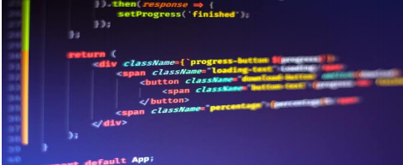

Website Name: **Nutrition**

Group Name : **Good Worker**

Batch code: **1605**

Centre name: **Pakistan Central Homeopathic**

**Medical College & Hospital**

Instructor: **Ma’am Sumbul**

Group leader : **Fatima Ismail**

Group members: **Fatima Ismail, Yusra Zain**

**& Tasbih e kainat**

Student I’d:

* **Yusra Zain(yusiii4566@gmail.com)**
* **Fatima Ismail(**[**fatimaismail123@gmail.com**](mailto:fatimaismail123@gmail.com)**)**
* **Tasbih e kainat (**[**tasbihekainat0905@gmail.com**](mailto:tasbihekainat0905@gmail.com) **)**

**Website : Nutrition**

**Description About Nutrition :**

Nutrition is the process of consuming, absorbing, and using nutrients needed by the body for growth, development, and maintenance of life. To receive adequate, appropriate nutrition, people need to consume a healthy diet, which consists of a variety of nutrients—the substances in foods that nourish the body.

To receive adequate, appropriate nutrition, people need to consume a healthy diet, which consists of a variety of nutrients—the substances in foods that nourish the body. A healthy diet enables people to maintain a desirable body weight and composition (the percentage of fat and muscle in the body), to do their daily physical and mental activities, and to minimize risk of disease and disability.

Body composition usually refers to how much of the body is fat and how much is muscle, typically expressed as the percentage of body fat.

Body composition can be estimated by measuring the amount of fat under the skin (skinfold thickness).

**About website**

 Included 11 pages

**Features**

* Home
* About
* Login
* Exercise
* Tips
* Diabetes
* BP
* Weak Bones
* Weight loss
* Weight Gain
* Contact Us

How to learn:

Html

* HTML stands for Hyper Text Markup Language
* HTML is the standard markup language for creating Web pages
* HTML describes the structure of a Web page
* HTML consists of a series of elements
* HTML elements tell the browser how to display the content
* HTML elements label pieces of content such as “this is a heading”, “this is a
* paragraph”, “this is a link”.
* HTML Element
* HTML Page Structure
* HTML Using Notepad or TextEdit
* View the HTML Page in Your Browser

CSS

* CSS stands for Cascading Style Sheets
* CSS describes how HTML elements are to be displayed on screen, paper, or
* in other media
* CSS saves a lot of work. It can control the layout of multiple web pages all
* at once
* External stylesheets are stored in CSS file
* Same Page Different Stylesheets
* CSS Saves a Lot of Work!
* CSS Syntax
* CSS element Selector