Freight Rate Prediction
Machine Learning Engineer Assessment | Fatima Alawneh

1. Summary
I built a model that predicts the posted rate of a freight load from its route, distance, equipment, weight and date. The final predictions are for loads that come after the training period, so I validated the model by training on the past and testing on the next month, not with a random split.
- Model: gradient boosting (scikit-learn HistGradientBoostingRegressor) trained on the log of the rate.
- Validation: rolling-origin (time-based) cross-validation over the last four months of the development data.
- Result: on clean rows the average error (MAPE) is 2.0% with quote_signal and 2.6% without it. If the 1.4% of corrupted prices are kept in the test months, the MAE is about $102 and cannot be reduced by any model.
- Main data finding: quote_signal is almost exactly the price per mile on about half of the days and wrong on the other days. The model detects which days are reliable.

2. Data and Cleaning

Development data: data/train_test.csv, 48,000 labeled loads from 2025-01-01 to 2025-10-31 (about 158 loads per day, 64 cities, three equipment types, target posted_rate). Final predictions: data/validation.csv (12,000 loads, no target).

The data was clean in most ways: no duplicate load_id, all dates parse, equipment has only three values (Dry Van, Reefer, Flatbed), and only weight (0.62%) and market_index (0.78%) have missing values. Because of this I kept the cleaning code short and only handled problems that I found.

Data-quality issues found
Issue | What I found | How it was handled
Negative weight | 292 rows (0.6%) have a negative weight, for example TR-000069 with -36,559 lb. Their prices are normal, so it is a sign error. | The absolute value is used.
Corrupted prices | 667 rows (1.4%) have a price per mile far from normal: some are about 2 to 6.6 times too high, others about 0.16 to 0.47 times too low (example TR-000051: $1,243 for 2,202 miles, $0.56 per mile, while the median is about $2.15). They are spread evenly over the months, so they are errors and not real price spikes. | Removed from training only. Rule: robust z-score (median and MAD) of log price per mile, drop |z| > 6. The count is almost the same for thresholds 4 to 6 (679 and 667), so the result does not depend on the exact threshold.
quote_signal works only on some days | On 150 of 304 days price is almost equal to quote_signal x distance (correlation 0.99, about 1% error). On the other days this is not true. | A per-day flag is computed from features only: the correlation between quote_signal and log(distance) inside each day is between -0.89 and -0.73 on reliable days and between -0.11 and +0.88 on the others, so the two groups separate completely.
Missing weight | 300 rows (0.62%). | Filled with the median weight of the same equipment type, learned from the training data.
Weight cap | 1,191 rows (2.5%) have exactly 47,500 lb, which looks like a cap in the data. | Kept as it is.

market_index (374 missing values) is not used. In my tests it did not improve the error once the date features were included.

3. Train/Test Split and Validation Approach

3.1 The principle
The final task is to predict loads that happen after the training data. So the validation has to answer this question: if the model is trained on the past, how well does it predict the next month? The file validation.csv is never used for training or tuning; it is only predicted once, at the end.

3.2 Rolling-origin cross-validation
I group the development data by month. For each of the last four months M (July to October), I train on all rows before M and test on the rows in M. The four test scores are averaged.
Fold | Training data | Test data
1 | January to June | July
2 | January to July | August
3 | January to August | September
4 | January to September | October

3.3 Why not a random split
- Loads from the same day have almost the same market conditions. A random split puts them in both train and test, so the model can "remember" the day and the score looks better than reality.
- The real task is to predict a later period from an earlier one. A time split measures exactly that.
- The behavior of quote_signal changes from month to month. A random split would hide this problem; the time split shows it.

3.4 Two ways to score
Because 1.4% of the prices are corrupted, I report two scores for every fold:
- Clean rows: test rows without the corrupted prices (MAE and MAPE). This shows how good the model is on normal loads.
- All rows: every test row (MAE and RMSE). This is closer to what a hidden test set with the same corruption would give. RMSE is about $625 mainly because of these rows.

3.5 Final model and leakage controls
- After validation, the final model is trained on all development data (without the corrupted rows) and predicts validation.csv. The result is merged with the provided template, so the IDs and the order match exactly.
- The target is never used to fill missing values or to build features. The corrupted-price rule uses the target only to remove training rows.
- Early stopping uses a random 10% slice of each training set. Each model is an average of three random seeds.
- Known limitation: in the cross-validation, the city codes and weight medians were learned from the whole development set. They use features only and the effect should be very small, but a stricter version would learn them inside each fold.

4. Model and Features
Gradient boosting trees fit this problem well: the data is a table, price depends on distance in a non-linear way (short trips cost more per mile), features interact, and the model handles missing values and categorical columns directly. Training on log(rate) makes the errors proportional.
Features: distance, weight, pickup city, delivery city, equipment, day of week, day of month, month and day of year. I tested holiday distances, coordinates, straight-line distance and lane frequency; none of them changed the error beyond the normal noise, so I removed them.

How quote_signal is used
The December file has only seven columns (no quote_signal and no market_index), because these values are unknown for a future load. So there are two ways to predict:
- December chart: model with the features above only.
- validation.csv: the same model plus three features (quote_signal, quote_signal x distance and the reliable-day flag). On reliable days the prediction is taken as quote_signal x distance times a calibration factor (the median of price divided by quote_signal x distance on reliable training days). On the other days the model prediction is used. If validation.csv has no quote_signal, the code falls back to the first model automatically.

5. Model Results
Rolling-origin cross-validation on the real development data. Each row is one test month; the last row is the mean.

Model without quote_signal
Test month | MAE clean ($) | MAPE clean (%) | MAE all rows ($) | RMSE all rows ($)
2025-07 | 100.68 | 4.30 | 153.73 | 630.66
2025-08 | 39.49 | 1.74 | 89.64 | 614.42
2025-09 | 52.47 | 2.15 | 101.98 | 615.46
2025-10 | 48.74 | 2.09 | 108.12 | 645.44
Mean | 60.34 | 2.57 | 113.37 | 626.49

Model with quote_signal and reliable-day rule
Test month | MAE clean ($) | MAPE clean (%) | MAE all rows ($) | RMSE all rows ($)
2025-07 | 59.86 | 2.16 | 113.69 | 628.79
2025-08 | 71.51 | 3.33 | 120.98 | 617.21
2025-09 | 21.87 | 0.83 | 71.75 | 609.40
2025-10 | 43.73 | 1.84 | 103.16 | 645.50
Mean | 49.24 | 2.04 | 102.39 | 625.22
Reading the results:
- September is a reliable-quote month, and the error drops to 0.83%. This is the gain that the rule gives.
- July and October are not reliable months. The model with quote_signal is better in both, but in August it is worse (71.5 against 39.5). So the gain on unreliable days is not guaranteed.
- These are single runs on four folds. Small differences (about 3 dollars of MAE) between feature sets are within the normal noise.
- RMSE on all rows is almost the same for both models because it is dominated by the corrupted prices.

6. December Prediction Chart
Chart produced by the provided score.py. The load is fixed (Lexington to Fort Wayne, 360 miles, Dry Van, 32,000 lb) and only the date changes, so every change in the line comes from the date.

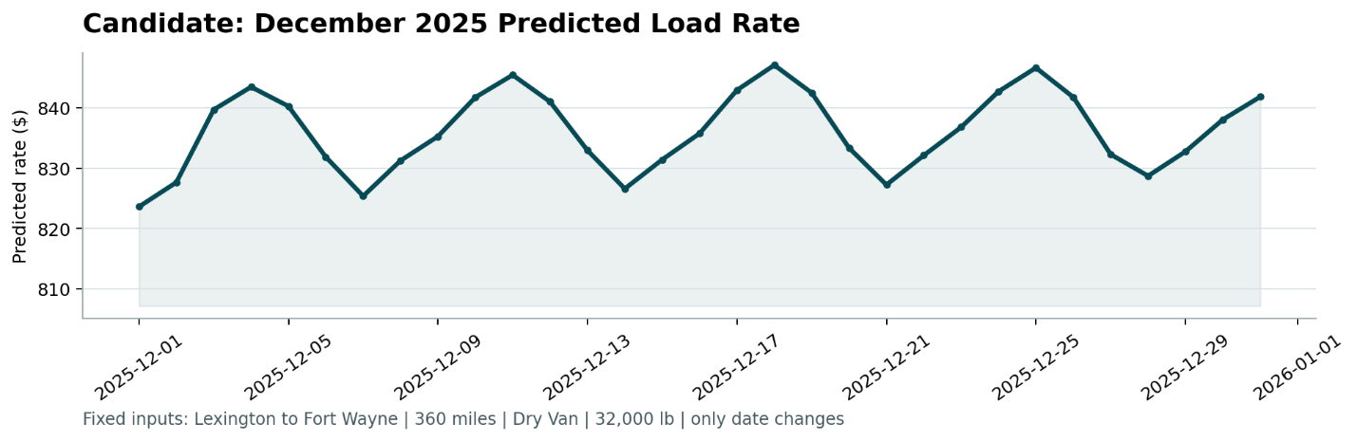

- The predicted rate stays between about $824 and $848, a range of about 3%.
- The line has a weekly cycle: peaks on Thursdays (Dec 4, 11, 18, 25) and lows on Sundays and at the start of the month.
- This agrees with the training data: after removing the effect of distance, Thursday is about 1.5% above the average and Sunday about 0.6% below.
- The level is inside the history: for Dry Van loads of 300 to 420 miles, the average price scaled to 360 miles was between $802 (January) and $876 (June) per month.
- December 25 looks like a normal Thursday peak, so I do not see a special holiday effect.

