1. **الشبكة**

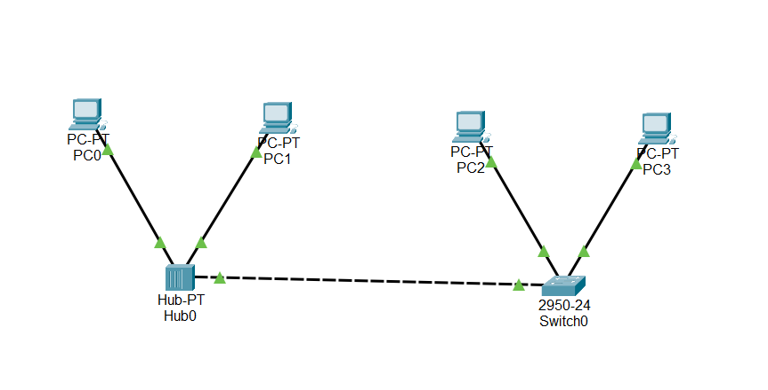

1. **the ping command**

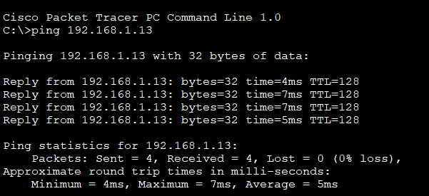

1. **the ipconfig command**

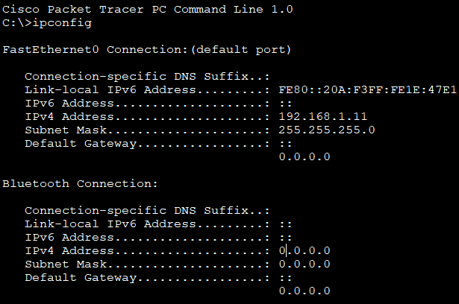

1. **the tracert command**

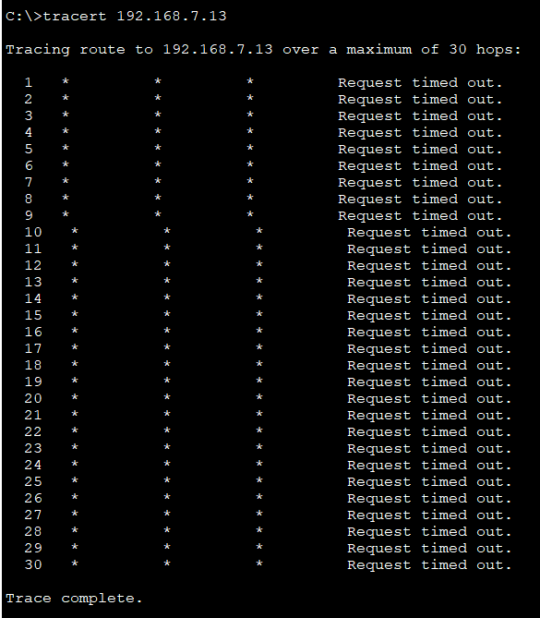

1. **the arp –a command**

