Which reference organisms exercise which rapid panel targets?
An open crosswalk of the CDC & FDA Antimicrobial Resistance Isolate Bank to FDA-cleared blood culture identification panels, with an external reference-method check of a U.S. benchmark
Fatima Abdulwahab  ^{1,*}
¹Independent Researcher, Dallas, Texas, USA
*abdulwahabfatima43@gmail.com · ORCID 0009-0008-2298-8386
Before a laboratory reports results from a new test, U.S. federal rules require it to verify the test's performance, and characterized reference organisms are the usual material. The CDC & FDA Antimicrobial Resistance (AR) Isolate Bank is the main free U.S. source of such organisms, but it is organized by panel rather than by test, so a laboratory introducing a rapid blood culture identification panel cannot easily see which isolates exercise which resistance target. We built an open, versioned crosswalk from the Bank's public pages. For all 1,087 isolates in 39 panels we recorded the CDC gene list, the BioSample accession (975 isolates) and CDC's reference broth microdilution results, mapped 578 distinct CDC gene names to targets through the NCBI AMRFinderPlus Reference Gene Hierarchy, and aligned them with the resistance targets of 7 FDA-cleared panels taken from 9 FDA decision summaries. Of 825 isolates in organisms these panels test, 529 (64.1%) carry at least one target; every reported target except OXA-143-like is represented, from CTX-M (168 isolates in 17 panels) to mecC (2). Every panel's targets can be covered by two to five Bank isolates. We flag 169 isolates whose gene and growth results part ways, among them 14 that carry a target while testing not resistant (KPC with meropenem MICs of 0.25–2 mg/L, mecA-positive S. aureus susceptible to oxacillin and cefoxitin, a vanA operon lacking its regulators), and 38 carbapenem-resistant Enterobacterales and Acinetobacter without any panel carbapenemase. We then used the Bank as an external yardstick for a published U.S. genotype–phenotype benchmark. NCBI AMRFinderPlus reproduced CDC's target calls (Cohen's κ = 1.00 for eight targets, 0.93 for OXA-48-like, 0.98 for CTX-M), the benchmark's breakpoint rules reproduced CDC's interpretations for 99.8% of 2,851 results, and in 538 independent isolates the benchmark's gene-level estimates held wherever both could be estimated: a panel target predicted resistance to at least one carbapenem with PPV 96.6% and CTX-M predicted ceftriaxone resistance with PPV 100.0%. The crosswalk, code, provenance log and quality-control report are openly released.
Keywords: test verification, CLIA, reference isolates, AR Isolate Bank, rapid diagnostics, blood culture identification panel, carbapenemase, mecA, AMRFinderPlus

I. INTRODUCTION
Multiplex blood culture identification panels report the organism and a small set of resistance genes within hours of a positive blood culture [1, 2]. The genes were chosen because each is tied to a treatment decision: mecA and its divergent homologue mecC [3] for methicillin resistance in S. aureus; vanA and vanB for vancomycin resistance in enterococci [4]; the carbapenemases KPC, NDM, OXA-48-like, VIM and IMP; CTX-M, the dominant extended-spectrum β-lactamase (ESBL) family [5, 6]; and, on newer panels, mcr, SME and the OXA-23, -24/40 and -58 carbapenemases of Acinetobacter. Molecular rapid diagnostics on positive blood cultures have been associated with lower mortality and shorter time to effective therapy, particularly with antimicrobial stewardship [7, 8].

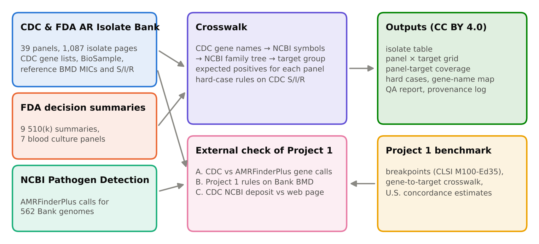
FIG. 1: Study design. Public CDC, FDA and NCBI sources feed two products: the crosswalk of Bank isolates to rapid panel targets, and an external check of the Project 1 benchmark. BMD, broth microdilution.

Before any of these results reaches a patient's chart, the laboratory must show the test works in its hands. Under the Clinical Laboratory Improvement Amendments, a laboratory that introduces an unmodified FDA-cleared test must, before reporting patient results, demonstrate performance comparable to the manufacturer's for accuracy, precision and reportable range [9]; CLSI has published guidance on verifying commercial microbial identification and susceptibility systems with characterized isolates [10]. For a resistance-gene target, accuracy can only be shown with organisms known to carry the target, organisms known not to, and, ideally, the difficult organisms in which the gene and the growth result disagree.
The CDC & FDA AR Isolate Bank was created in July 2015 to supply exactly such organisms [11]. Its isolates are characterized by reference broth microdilution and whole-genome sequencing and are offered free to approved institutions in curated panels [11, 12]. CDC reports that in its tenth year the Bank had grown from 3 to 34 panels and had shipped 500,000 isolates [13]. The Bank, however, is organized around resistance themes (carbapenemase diversity, borderline oxacillin susceptibility, new antibiotics) and around the drugs whose breakpoints the panels were built to test, not around diagnostic devices. A laboratory bringing up a BioFire BCID2 or a LIAISON PLEX panel has no list of which Bank isolates carry KPC, OXA-48-like or mecC, and no list of which ones will look discordant. It must open isolate pages one at a time.
The same isolates also serve a second purpose. The author's U.S. Rapid Panel Resistance Marker Concordance Benchmark (“Project 1”) measured how often each panel target predicts the susceptibility result reported for U.S. clinical isolates in NCBI Pathogen Detection [14]. Its phenotypes come from many submitting laboratories and platforms. The Bank's results come from one reference laboratory using the reference method, which makes the Bank a natural external check of that benchmark.
Here we describe the CDC & FDA AR Isolate Bank: Rapid Panel Target Crosswalk, version 1.0.0 [15]. It (i) captures every Bank isolate's gene list, BioSample accession and reference results exactly as CDC posts them; (ii) maps CDC's gene names to rapid panel targets through NCBI's gene family tree; (iii) states, for each of 7 FDA-cleared panels, which Bank isolates should be positive for each reported target; (iv) flags hard cases with explicit rules; and (v) uses the Bank to test the Project 1 benchmark. Section II describes the methods, Sec. III the results, Sec. IV their use and limits, and Sec. V our conclusions.

II. MATERIALS AND METHODS

A. Data sources
All inputs are public (Table I) and were downloaded on 24 October 2026. Every file was logged with its source URL, access date, size and SHA-256 fingerprint (1,188 provenance records).

1. Isolate Bank pages.
We downloaded the Bank's All Isolate Panels page, every panel page it lists, the 5 custom panel pages linked from panel descriptions, and every isolate page reached from them (1,087 isolates). The downloader made one request at a time with a pause between requests and stored each page unchanged. From each isolate page we read the AR Bank number, species, study identifier, BioSample accession, specimen source, MLST type, the free-text note CDC sometimes places above the MIC table (for example a cefoxitin disk diffusion result), the MIC table (drug, MIC, CDC's S/I/R and footnotes), the interpretive standard CDC names for that page, the “Molecular Mechanisms of Resistance” table (category and gene) and CDC's note on how the genes were called. Panel membership was taken from the panel pages themselves.
TABLE I: Data sources.
Source | Content used, version and terms
CDC & FDA AR Isolate Bank web site | All panel pages and 1,087 isolate pages (AR Bank number, species, BioSample, CDC gene list and calling method, reference broth microdilution MICs and S/I/R, page notes); accessed 24 Oct 2026; U.S. government work
FDA 510(k) decision summaries | 9 summaries for 7 cleared blood culture panels with resistance targets; U.S. government works
NCBI Pathogen Detection | AMRFinderPlus genotypes for Bank BioSamples (versions 4.2.5, 4.2.7), streamed from the latest analysis of each organism group; no restrictions on use
AMRFinderPlus Reference Gene Hierarchy | Database 2026-08-07.1; gene-to-family tree used to assign targets
Project 1 benchmark v1.0.0 | Breakpoint table (CLSI M100-Ed35, checked against FDA STIC), gene-to-target crosswalk, concordance table and isolate list

2. Rapid panel targets.
We took the resistance targets of each FDA-cleared blood culture panel from its 510(k) decision summary (Table II): BioFire BCID2 [16], ePlex BCID-GP and BCID-GN [17, 18], Verigene BC-GP and BC-GN [19, 20], and LIAISON PLEX Gram-Positive and Gram-Negative [21, 22]. Each reported target was translated into one or more target groups (for example, BCID2's “mecA/C” into mecA and mecC; ePlex BCID-GN's “OXA (OXA-23 and OXA-48 groups only)” into OXA-23-like and OXA-48-like). The Verigene BC-GN summary lists “OXA” without naming groups; we used the OXA-23 and OXA-48 groups used in its analytical studies, and the author confirmed this reading.

3. NCBI gene calls and gene hierarchy.
For the external check we streamed the NCBI Pathogen Detection isolate tables (latest_snps/AMR/*.amr.metadata.tsv) for every organism group matching a Bank genus and kept rows whose BioSample is a Bank BioSample [23]. These rows carry the AMRFinderPlus genotype NCBI computed for each genome (versions 4.2.5, 4.2.7) [24]. The AMRFinderPlus Reference Gene Hierarchy (database 2026-08-07.1) was used to place genes in families [24].
TABLE II: Resistance targets of the FDA-cleared blood culture identification panels included.
Panel | FDA 510(k) | Resistance targets reported
BioFire BCID2 | K193519 ; K243759 | mecA/C, mecA/C and MREJ (MRSA), vanA/B, CTX-M, KPC, NDM, OXA-48-like, VIM, IMP, mcr-1
ePlex BCID-GP | K181663 | mecA, mecC, vanA, vanB
ePlex BCID-GN | K182619 ; K213236 | CTX-M, IMP, KPC, NDM, OXA, VIM
Verigene BC-GP | K122514 | mecA, vanA, vanB
Verigene BC-GN | K132843 | CTX-M, KPC, NDM, VIM, IMP, OXA
LIAISON PLEX GP | K243490 | mecA/mecC, vanA, vanB
LIAISON PLEX GN | K243013 | CTX-M, IMP, KPC, MCR, NDM, OXA, SME, VIM

4. Project 1 artifacts.
From the Project 1 release we used, unchanged, its breakpoint table (CLSI M100, 35th edition [25], checked against the FDA Susceptibility Test Interpretive Criteria [26]), its AMRFinderPlus-symbol-to-target crosswalk, its concordance table and its list of benchmark BioSamples [14].

B. From CDC gene names to panel targets
CDC writes allele names without the bla prefix (“KPC-3”, “OXA-232”, “CTX-M-15”). Each of the 578 distinct names was matched to an NCBI symbol by trying, in order, the name itself, the name with bla added, NCBI synonyms and a case-insensitive match. When a name carried a one-letter bracket note (“OXA-48(c)”), the note was ignored after real gene names such as tet(A) had been tried. The NCBI symbol was then walked up the Reference Gene Hierarchy until it reached a node that defines a target group: blaKPC, blaNDM, blaVIM, blaIMP, blaCTX-M, the blaOXA-48, -23, -24, -58 and -143 families, blaSME, mcr-1, mcr-2, mcr-3, mecA, mecC, vanA and vanB. Three rulings were made by hand and recorded in the released gene map: “blaZ-mecC” (the blaZ carried on the mecC element), which CDC lists for the two isolates of its custom “S. aureus mecC+” panel, was counted as mecC; “vanHAX (lacks VanRS)”, which CDC describes on the isolate page as a vancomycin-variable enterococcus, was counted as vanA; and the generic entry “MBL” was left unmapped because no enzyme is named.

C. Expected positives
An isolate was marked as an expected positive for a panel's reported target when it carried any target group the target covers and its organism is one for which the panel reports that target: mecA/mecC in staphylococci, vanA/vanB in enterococci, and Gram-negative targets in Enterobacterales, Pseudomonas and Acinetobacter. BCID2's MRSA result additionally requires S. aureus; the SCCmec right-extremity junction (MREJ) it detects cannot be read from a gene list, so every mecA- or mecC-positive S. aureus was assumed to be an expected MRSA positive. Fungal, gonococcal, Clostridioides difficile and enteric-pathogen panels were listed but not mapped, because these panels do not report resistance genes for those organisms.

D. Hard cases
Hard cases were defined on CDC's own posted interpretation, treating intermediate (I) and susceptible-dose-dependent as not resistant, as in Project 1. Imipenem was not used for Proteus, Morganella and Providencia, whose imipenem MICs are intrinsically elevated [25]. The rules were: (1) a target gene is present and none of the matching drugs is resistant (carbapenems for carbapenemases; ceftriaxone, cefotaxime or ceftazidime for CTX-M; oxacillin, cefoxitin MIC or, where CDC posts one, cefoxitin disk for mecA/mecC; vancomycin for vanA/vanB; colistin for mcr); (2) an Enterobacterales or Acinetobacter isolate is resistant to a carbapenem without any panel carbapenemase; (3) an Enterobacterales isolate is resistant to a third-generation cephalosporin without CTX-M or a carbapenemase; (4) a staphylococcus is resistant to oxacillin or cefoxitin without mecA/mecC; and (5) an enterococcus is resistant to vancomycin without vanA/vanB. Two patterns in which a negative panel result is the correct answer were kept as separate categories: carbapenem-resistant P. aeruginosa without a carbapenemase, usually caused by loss of the OprD porin, efflux and chromosomal AmpC [27], and enterococci whose vancomycin resistance comes from intrinsic vanC [28]. For rule 2 we classified the other mechanisms CDC lists, using NCBI's drug subclass for each gene: a carbapenemase not reported by any panel; an intrinsic OXA-51-like enzyme in Acinetobacter; a truncated porin with an ESBL or AmpC; an ESBL or AmpC alone; a truncated porin alone; or nothing listed.

E. Illustrative verification sets
To show how the crosswalk can be queried, we computed for each panel the smallest set of Bank isolates whose expected positives cover all of the panel's reported targets, by a deterministic greedy rule: repeatedly take the isolate that covers the most uncovered targets, preferring isolates that are not hard cases and then the lowest AR Bank number, using only isolates in panels on the Bank's main list. This is an example of a query, not a recommended verification protocol.

F. External check of the Project 1 benchmark
The check used Bank isolates in Project 1's organisms (S. aureus, E. faecalis, E. faecium and Enterobacterales) that have a BioSample.

1. Check A, gene calls.
For Project 1's ten targets, we compared the targets in CDC's gene list with the targets in NCBI's AMRFinderPlus genotype for the same BioSample, mapped through the Project 1 crosswalk. Agreement is reported as counts and Cohen's κ [29]. Because some of CDC's gene calls used a database that includes NCBI's, the comparison was repeated in the isolates CDC called with ResFinder or ARG-ANNOT alone [30, 31].

2. Check B, gene versus reference result.
CDC's MICs were reinterpreted with Project 1's breakpoint table and censoring rules, and every Project 1 analysis (target, drug and pooled organism group, with intermediate as not resistant) was recomputed with AMRFinderPlus target calls as the gene result. Isolates that are also in the Project 1 benchmark were excluded, so the Bank estimates come from isolates Project 1 never saw. Positive predictive value (PPV), negative predictive value, sensitivity and specificity are reported with Wilson 95% intervals [32] next to Project 1's estimates. Check B used MICs only, as in Project 1; CDC's cefoxitin disk results enter the hard-case rules but not this comparison.

3. Check C, consistency of CDC's records.
For Bank isolates also in the Project 1 benchmark, Project 1's category for each drug (from the antibiogram deposited in NCBI) was compared with the reinterpreted category from CDC's web page.

G. Reproducibility and quality control
The pipeline is a set of numbered Python scripts (pandas [33]; figures with matplotlib and seaborn [34, 35]). Every number in this manuscript is read from files the pipeline writes. A quality-control report lists row counts, unmatched gene names, every interpretation difference and named spot checks. Before release, the saved pages were re-parsed with an independently written reader, which matched all 20,546 MIC rows and 8,298 gene rows; all saved pages matched their recorded fingerprints; spot checks were compared with the live CDC pages; and a clean rebuild from the archived inputs reproduced every released table byte for byte.

H. Ethics
The study used only public, de-identified data on bacterial and fungal isolates. No human subjects were involved and no isolates were handled.

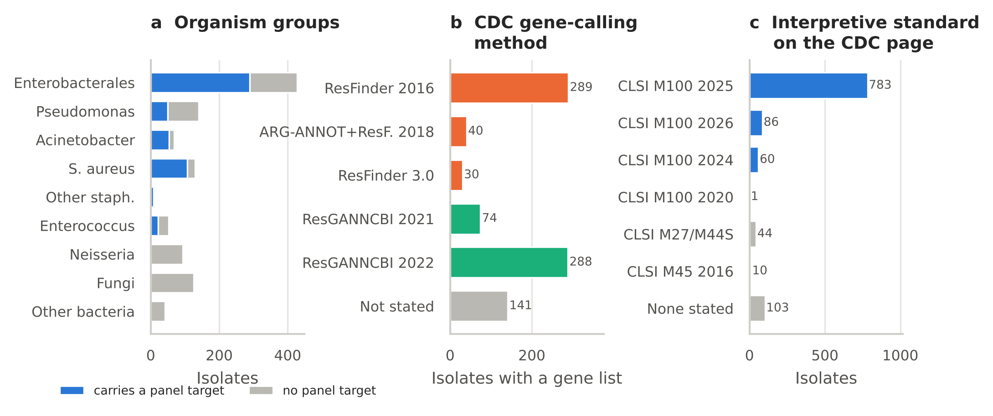
FIG. 2: The Isolate Bank collection. (a) Isolates by organism group and whether they carry a rapid panel target. (b) Method CDC states it used to call resistance genes; ResGANNCBI is CDC's combined ResFinder, ARG-ANNOT and NCBI database. (c) Interpretive standard named on the isolate page.

III. RESULTS

A. The collection
The Bank listed 34 panels on its main page, and 5 more custom panels were linked from their descriptions, for 39 panels and 1,087 unique isolates (Table III, Fig. 1). Of these, 975 list a BioSample accession and 862 list resistance genes. In all, 825 isolates belong to organisms that the cleared panels report resistance genes for: 427 Enterobacterales, 140 Pseudomonas, 129 S. aureus, 68 Acinetobacter, 52 enterococci and 9 other staphylococci. The rest are fungi (126), Neisseria (94) and other bacteria (42), mostly C. difficile and Campylobacter.
CDC's pages are not uniform (Fig. 2). Genes were called with ResFinder using its June 2016 database for 289 isolates, ARG-ANNOT and ResFinder in 2018 for 40, ResFinder 3.0 for 30, and a combined ResFinder, ARG-ANNOT and NCBI database accessed in 2021 or 2022 for 362; 141 gene lists name no method. Interpretations cite CLSI M100 2025 for 783 isolates, the 2026 edition for 86, 2024 for 60 and 2020 for 1; fungal and fastidious-organism pages cite their own standards, and 103 pages name none. In addition, 802 isolate–drug interpretations on 494 isolates are footnoted as based on FDA breakpoints. Of the 578 distinct gene names, 478 matched an NCBI symbol and 66 mapped to a panel target group; the 100 unmatched names are mostly point mutations, efflux genes, porins and fungal targets that no panel reports.
TABLE III: Isolate Bank collection by organism group. In scope: organisms for which a cleared panel reports resistance genes. Target: isolates carrying at least one rapid panel target. Hard case: isolates in any hard-case category, including the two expected-negative categories.
Organism group | Isolates | BioSample | Gene list | In scope | Target | Hard case
Enterobacterales | 427 | 422 | 408 | yes | 289 | 81
Pseudomonas | 140 | 137 | 131 | yes | 50 | 69
Acinetobacter | 68 | 68 | 67 | yes | 54 | 6
S. aureus | 129 | 128 | 126 | yes | 107 | 4
Other staphylococci | 9 | 9 | 9 | yes | 8 | 0
Enterococcus | 52 | 51 | 50 | yes | 21 | 9
Neisseria | 94 | 52 | 19 | no | 0 | 0
Fungi | 126 | 68 | 44 | no | 0 | 0
Other bacteria | 42 | 40 | 8 | no | 0 | 0
Total | 1,087 | 975 | 862 | 825 | 529 | 169

B. Target coverage
Of the 825 in-scope isolates, 529 (64.1%) carry at least one panel target, and 97 carry two or more (up to 4). Table IV gives the number of isolates, panels and species for each target group, and Fig. 3 shows where they sit. CTX-M is the most widely represented target (168 isolates in 17 panels), followed by mecA (113), KPC (95, 16 panels), NDM (77), OXA-48-like (38) and VIM (36). The Acinetobacter targets reported only by the newer Gram-negative panels are present (OXA-23-like 28, OXA-24/40-like 18, OXA-58-like 3), as are SME (9) and mcr genes (mcr-1 7, mcr-2 1, mcr-3 2). mecC is represented by two isolates (in the borderline-oxacillin panel and its “mecC+” custom panel), and OXA-143-like, which LIAISON PLEX Gram-Negative reports, by none.
The panels designed around carbapenemases cover the Gram-negative targets most densely: Gram Negative Carbapenemase Detection (CarbaNP) holds ten target groups, and Enterobacterales Carbapenemase Diversity (CRE) and the antibiotic verification panels for cefepime/zidebactam, plazomicin, imipenem/relebactam and meropenem/vaborbactam each hold four to seven. mecA sits mainly in the staphylococcal panels (borderline oxacillin susceptibility, difficult-to-detect mecA, oxazolidinone-resistant staphylococci and vancomycin-intermediate S. aureus), with further isolates in the delafloxacin and aminoglycoside/tetracycline panels; vanA and vanB sit mostly in the VRE panel; and mcr genes in the panel of isolates with new or novel resistance.

TABLE IV: Rapid panel target groups in the Isolate Bank. Species counts distinct genus–species names as CDC writes them.
Target group | Isolates | Bank panels | Species | Panels reporting itᵃ | CDC allele names (examples)
mecA | 113 | 6 | 3 | B2, eP, VP, LP | mecA
mecC | 2 | 2 | 1 | B2, eP, LP | blaZ-mecC
vanA | 11 | 3 | 3 | B2, eP, VP, LP | VanA, vanHAX(lacks VanRs)
vanB | 10 | 1 | 2 | B2, eP, VP, LP | VanB
KPC | 95 | 16 | 14 | B2, eN, VN, LN | KPC-11, KPC-2, KPC-3, KPC-4, KPC-45, KPC-5, +1 more
NDM | 77 | 15 | 12 | B2, eN, VN, LN | NDM, NDM-1, NDM-5, NDM-6, NDM-7
OXA-48-like | 38 | 12 | 7 | B2, eN, VN, LN | OXA-181, OXA-232, OXA-244, OXA-252, OXA-48, OXA-48(c)
VIM | 36 | 11 | 4 | B2, eN, VN, LN | VIM, VIM-1, VIM-11, VIM-2, VIM-27, VIM-4, +2 more
IMP | 26 | 8 | 7 | B2, eN, VN, LN | IMP-1, IMP-13, IMP-14, IMP-15, IMP-18, IMP-26, +7 more
CTX-M | 168 | 17 | 12 | B2, eN, VN, LN | CTX-M-1, CTX-M-124, CTX-M-14, CTX-M-14b, CTX-M-15, CTX-M-2, +6 more
OXA-23-like | 28 | 4 | 1 | eN, VN, LN | OXA-23
OXA-24/40-like | 18 | 3 | 1 | LN | OXA-24, OXA-72
OXA-58-like | 3 | 2 | 1 | LN | OXA-58
SME | 9 | 3 | 1 | LN | SME, SME-3, SME-4
mcr-1 | 7 | 1 | 3 | B2, LN | mcr-1
mcr-2 | 1 | 1 | 1 | LN | mcr-2
mcr-3 | 2 | 1 | 2 | LN | mcr-3

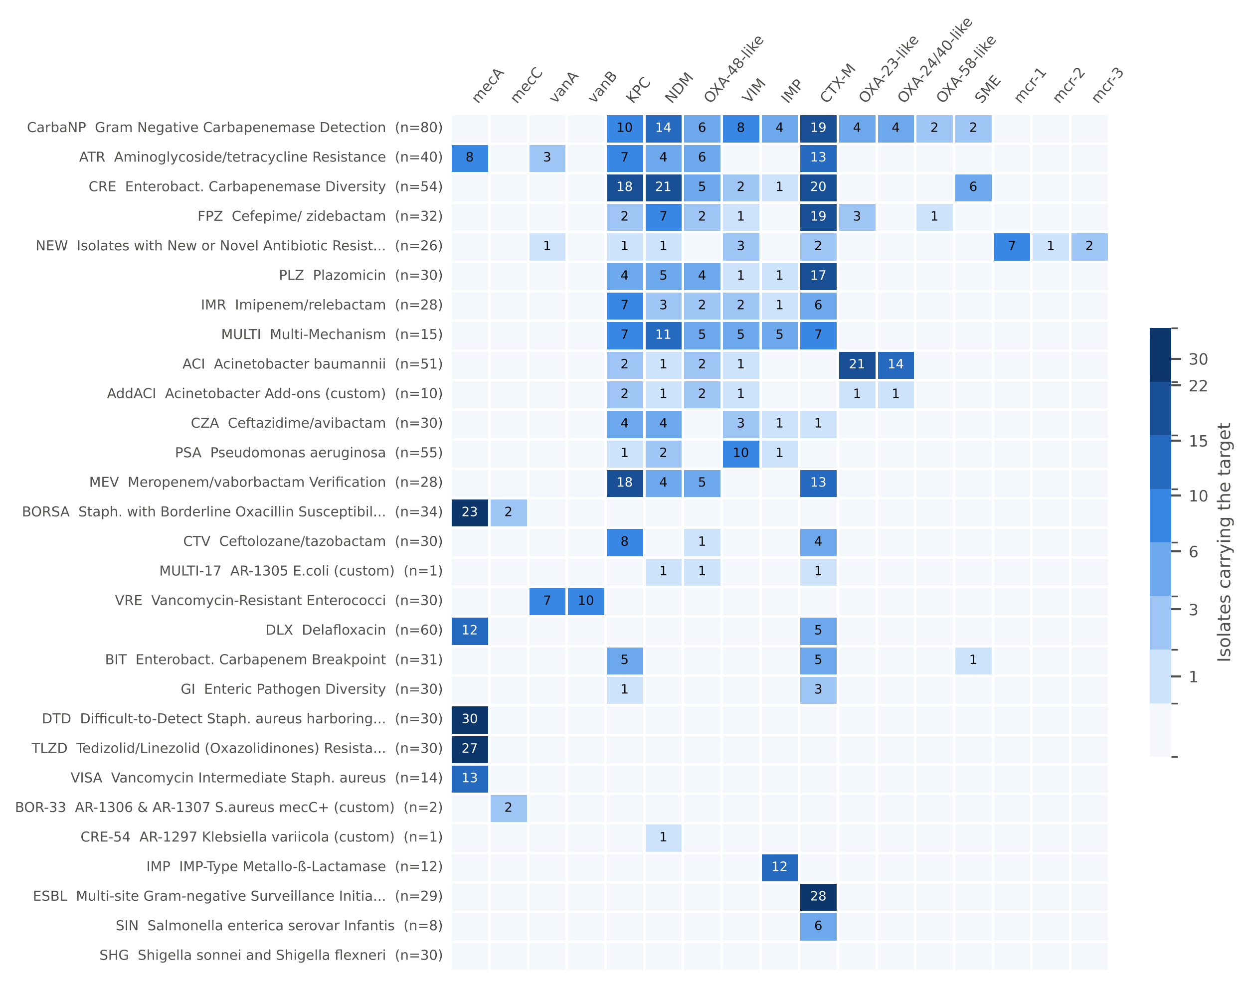
FIG. 3: Isolate Bank panels by rapid panel target. Each cell is the number of isolates in the panel whose CDC gene list includes the target; blank cells are zero. Panels without organisms that the cleared panels test are omitted. Panel codes are CDC's; “custom” panels are linked from other panels' descriptions. An isolate can belong to several panels.

Fig. 4 sets the target groups each cleared panel reports against the number of Bank isolates that carry them, and the released coverage table gives, for each reported target, the expected-positive isolates and their panels. Every reported target of every panel has at least one expected-positive Bank isolate except OXA-143-like within LIAISON PLEX's OXA result, which its OXA-23, OXA-24/40, OXA-48 and OXA-58 groups cover. The greedy query (Table V) found that 5 isolates cover all 10 BCID2 resistance targets and 4 cover all 8 LIAISON PLEX Gram-Negative targets; across the seven panels, between 2 and 5 isolates suffice. Table V also lists, for each panel, the expected positives that test not resistant, which a laboratory may want to include deliberately.

C. Hard cases
In total, 169 isolates fall into at least one hard-case category (Table VI, Fig. 5); 75 of them are in the two categories where a negative panel result is expected and 94 in the others.

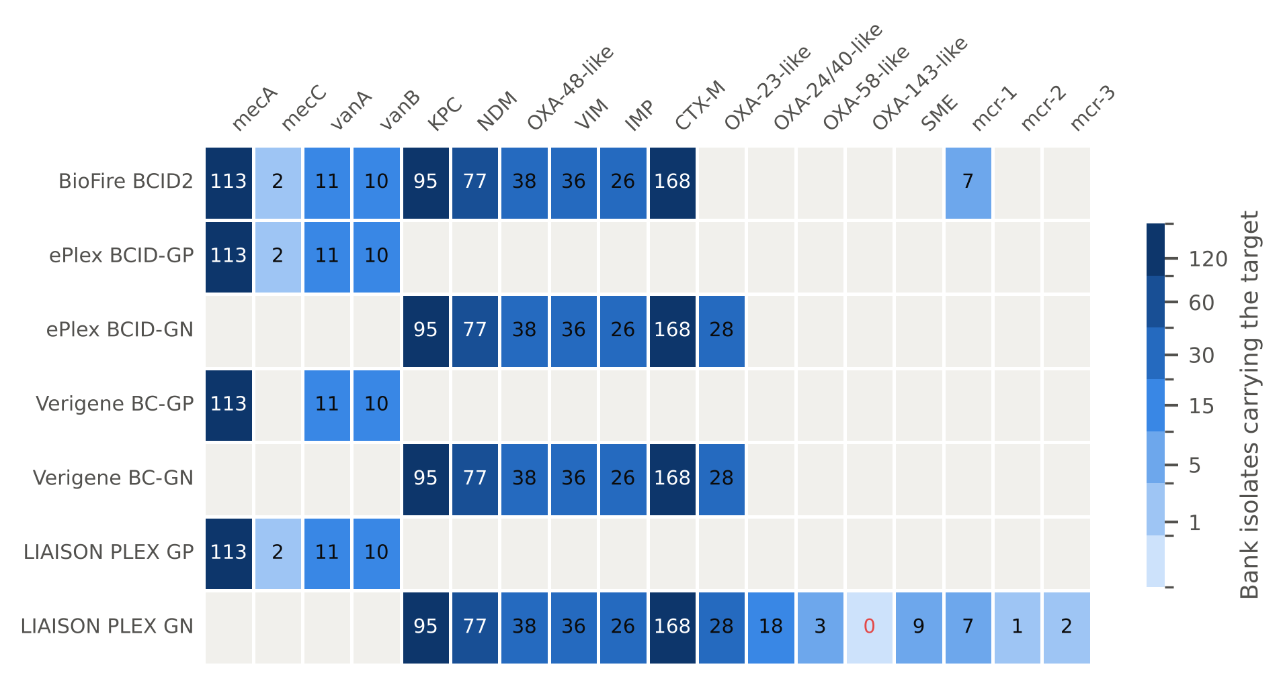
FIG. 4: Rapid panel target groups (columns) reported by each FDA-cleared panel (rows), with the number of Isolate Bank isolates whose CDC gene list includes the target group. Gray cells: the panel does not report that target group. Several groups are reported together as one result (for example BCID2's “mecA/C” and “vanA/B”, or ePlex BCID-GN's “OXA”). The red 0 marks OXA-143-like, reported by LIAISON PLEX Gram-Negative but carried by no Bank isolate.

TABLE V: Illustrative query: for each panel, the smallest set of Bank isolates (from panels on the Bank's main list) whose CDC gene lists cover every resistance target the panel reports, chosen by a deterministic greedy rule; and the expected-positive isolates whose matching drug tests not resistant. This shows how the crosswalk can be used; it is not a recommended verification protocol, and laboratories should follow the manufacturer's instructions and CLSI M52 [10].
Panel | Targets | Isolates | Smallest covering set: AR Bank number (targets exercised) | Target present, drug not resistant (AR Bank)
BioFire BCID2 | 10 | 5 | 1153 (CTX-M, KPC, NDM, OXA-48-like); 0215 (mecA/C, mecA/C and MREJ (MRSA)); 1159 (VIM, IMP); 0346 (mcr-1); 0571 (vanA/B) | 0032, 0050, 0147, 0156, 0451, 0464, 0500, 0541, +5
ePlex BCID-GP | 4 | 4 | 0215 (mecA); 0571 (vanA); 0782 (vanB); 1306 (mecC) | 0464, 0500, 0804, 0998, 1003
ePlex BCID-GN | 6 | 2 | 1153 (CTX-M, KPC, NDM, OXA); 1159 (IMP, VIM) | 0032, 0050, 0147, 0156, 0451, 0541, 0611, 0834
Verigene BC-GP | 3 | 3 | 0215 (mecA); 0571 (vanA); 0782 (vanB) | 0464, 0500, 0804, 0998, 1003
Verigene BC-GN | 6 | 2 | 1153 (CTX-M, KPC, NDM, OXA); 1159 (VIM, IMP) | 0032, 0050, 0147, 0156, 0451, 0541, 0611, 0834
LIAISON PLEX GP | 3 | 3 | 0215 (mecA/mecC); 0571 (vanA); 0782 (vanB) | 0464, 0500, 0804, 0998, 1003
LIAISON PLEX GN | 8 | 4 | 1153 (CTX-M, KPC, NDM, OXA); 1159 (IMP, VIM); 0091 (SME); 0346 (MCR) | 0027, 0032, 0050, 0147, 0156, 0451, 0541, 0611, +1

1. Target present, drug not resistant.
Table VII lists the 14 isolates that carry a panel target while testing not resistant to every matching drug. Six are KPC producers (KPC-2, -3 or -4) in E. cloacae, K. oxytoca, E. coli and P. mirabilis, with meropenem MICs of 0.25 to 2 mg/L and imipenem and ertapenem MICs mostly intermediate. Two carry VIM: VIM-1 in E. cloacae (meropenem 1 mg/L) and VIM-11 in P. aeruginosa (all carbapenems at 4 mg/L, intermediate). One Serratia marcescens carries SME with every carbapenem at the lowest dilution tested. Three S. aureus carry mecA with oxacillin MICs of 0.25 to 0.5 mg/L and cefoxitin MICs of 4 mg/L (susceptible); two of them were also susceptible by cefoxitin disk. These resemble oxacillin-susceptible MRSA [36]. CDC posts a cefoxitin disk result for 30 mecA-positive S. aureus, of which 28 are disk resistant; four of these (0977, 0981, 0991, 0992) are susceptible by oxacillin and cefoxitin MIC, so the disk detects their resistance and they are not counted as hard cases. Among enterococci, the vancomycin-variable E. faecium 0500 carries the vanA operon without its regulators and tests vancomycin susceptible (1 mg/L) [37, 38], and E. faecalis 0804 carries vanB with an intermediate vancomycin MIC of 16 mg/L.

TABLE VI: Hard cases, by category, on CDC's posted interpretation (intermediate counted as not resistant). An isolate can fall in more than one category.
Category | Isolates | Breakdown | What a laboratory sees
Target gene present, matching drug(s) not resistant | 14 | KPC 6, mecA 3, VIM 2, SME 1, vanA 1, vanB 1 | Panel positive, AST not resistant
Carbapenem resistant, no panel carbapenemase (Enterobacterales, Acinetobacter) | 38 | Porin truncation with ESBL or AmpC 16; ESBL or AmpC only 8; No mechanism listed by CDC 5; Carbapenemase not on any panel 4; Intrinsic OXA-51-like (Acinetobacter) 3; Porin truncation only 2 | Panel negative, AST resistant
Third-generation cephalosporin resistant, no CTX-M or carbapenemase | 58 | Other ESBL (SHV, TEM), plasmid or chromosomal AmpC | CTX-M negative, AST resistant
Oxacillin or cefoxitin resistant, no mecA/mecC | 1 | No mechanism listed | Panel negative, AST resistant
Carbapenem-resistant P. aeruginosa, no carbapenemase | 68 | Chromosomal (OprD, efflux, AmpC) | Expected negative
Vancomycin resistant by intrinsic vanC | 7 | E. gallinarum, E. casseliflavus | Expected negative

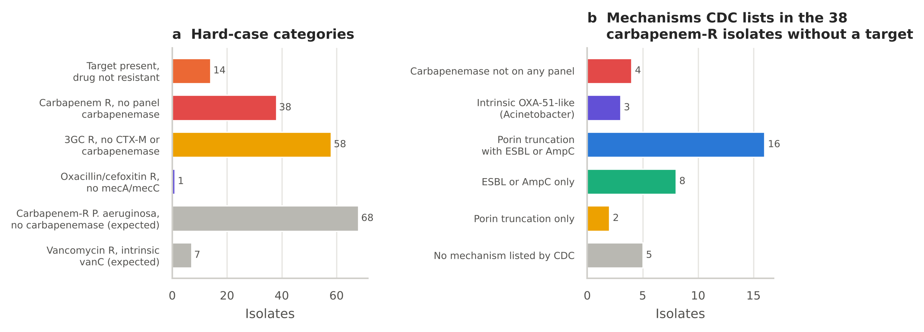
FIG. 5: Hard cases. (a) Isolates in each category; gray bars are the two categories in which a negative panel result is expected. (b) The mechanisms CDC lists for the 38 carbapenem-resistant Enterobacterales and Acinetobacter without a panel carbapenemase, classified by NCBI drug subclass.

2. Meropenem MICs of carbapenemase producers.
Among Enterobacterales with a meropenem result (Fig. 6), 1 of 49 NDM producers and 1 of 9 SME producers tested not resistant, compared with 12 of 79 KPC, 7 of 23 OXA-48-like, 4 of 7 VIM and 7 of 10 IMP producers. No OXA-48-like producer was meropenem susceptible; all 7 not-resistant OXA-48-like isolates sat at the intermediate MIC of 2 mg/L, consistent with the weak carbapenemase activity of this family [39]. Most of these isolates were resistant to another carbapenem; only the isolates in Table VII were not resistant to any.

TABLE VII: The 14 isolates that carry a rapid panel target while testing not resistant to every matching drug. Results are CDC's posted MICs (mg/L), disk diameters (mm) and interpretations.
AR Bank | Organism | Target | CDC gene | CDC reference results (MIC in mg/L or disk in mm, CDC S/I/R)
0032 | Enterobacter cloacae | KPC | KPC-3 | Meropenem=0.25 S; Imipenem=2 I; Ertapenem=1 I; Doripenem=0.5 S
0050 | Enterobacter cloacae | KPC | KPC-4 | Meropenem=2 I; Imipenem=2 I; Ertapenem=1 I; Doripenem=0.5 S
0147 | Klebsiella oxytoca | KPC | KPC-3 | Meropenem=0.5 S; Imipenem=2 I; Ertapenem=1 I; Doripenem=2 I
0156 | Proteus mirabilis | KPC | KPC-2 | Meropenem=0.25 S; Ertapenem=0.25 S; Doripenem=0.5 S
0451 | Escherichia coli | KPC | KPC-3 | Meropenem=0.5 S; Imipenem=2 I; Ertapenem=1 I; Doripenem=1 S
0541 | Escherichia coli | KPC | KPC-3 | Meropenem=1 S; Imipenem=2 I; Ertapenem=1 I; Doripenem=1 S
0027 | Serratia marcescens | SME | SME | Meropenem=≤0.12 S; Imipenem=≤0.5 S; Ertapenem=≤0.12 S; Doripenem=≤0.12 S
0611 | Pseudomonas aeruginosa | VIM | VIM-11 | Meropenem=4 I; Imipenem=4 I; Doripenem=4 I
0834 | Enterobacter cloacae | VIM | VIM-1 | Meropenem=1 S; Imipenem=2 I; Ertapenem=0.5 S; Doripenem=2 I
0464 | Staphylococcus aureus | mecA | mecA | Oxacillin=0.5 S; Cefoxitin=4 S
0998 | Staphylococcus aureus | mecA | mecA | Oxacillin=≤0.25 S; Cefoxitin=4 S; Cefoxitin disk=27 mm S
1003 | Staphylococcus aureus | mecA | mecA | Oxacillin=0.5 S; Cefoxitin=4 S; Cefoxitin disk=26 mm S
0500 | Enterococcus faecium | vanA | vanHAX(lacks VanRs) | Vancomycin=1 S
0804 | Enterococcus faecalis | vanB | VanB | Vancomycin=16 I

3. Resistant without a target.
Of the 38 carbapenem-resistant Enterobacterales and Acinetobacter without a panel carbapenemase, the largest group (16) carry a truncated porin together with an ESBL or AmpC, 8 an ESBL or AmpC alone and 2 a truncated porin alone (Fig. 5b). Another 4 carry a carbapenemase that no cleared panel reports (NMC-A, of the IMI family, in two Enterobacter; OXA-237, of the OXA-134 family, in two A. baumannii), 3 A. baumannii carry only their intrinsic OXA-51-like enzyme, and for 5 CDC lists no β-lactam mechanism. A further 58 Enterobacterales are resistant to a third-generation cephalosporin without CTX-M or a carbapenemase, typically with SHV or TEM ESBLs or plasmid or chromosomal AmpC enzymes [6, 40]. One S. aureus is resistant to oxacillin and cefoxitin without mecA or mecC. Of the 140 P. aeruginosa isolates, 50 carry a panel carbapenemase and 68 are carbapenem resistant without one; for these a negative panel result is the correct answer [27]. Seven E. gallinarum and E. casseliflavus are vancomycin resistant through intrinsic vanC [28].

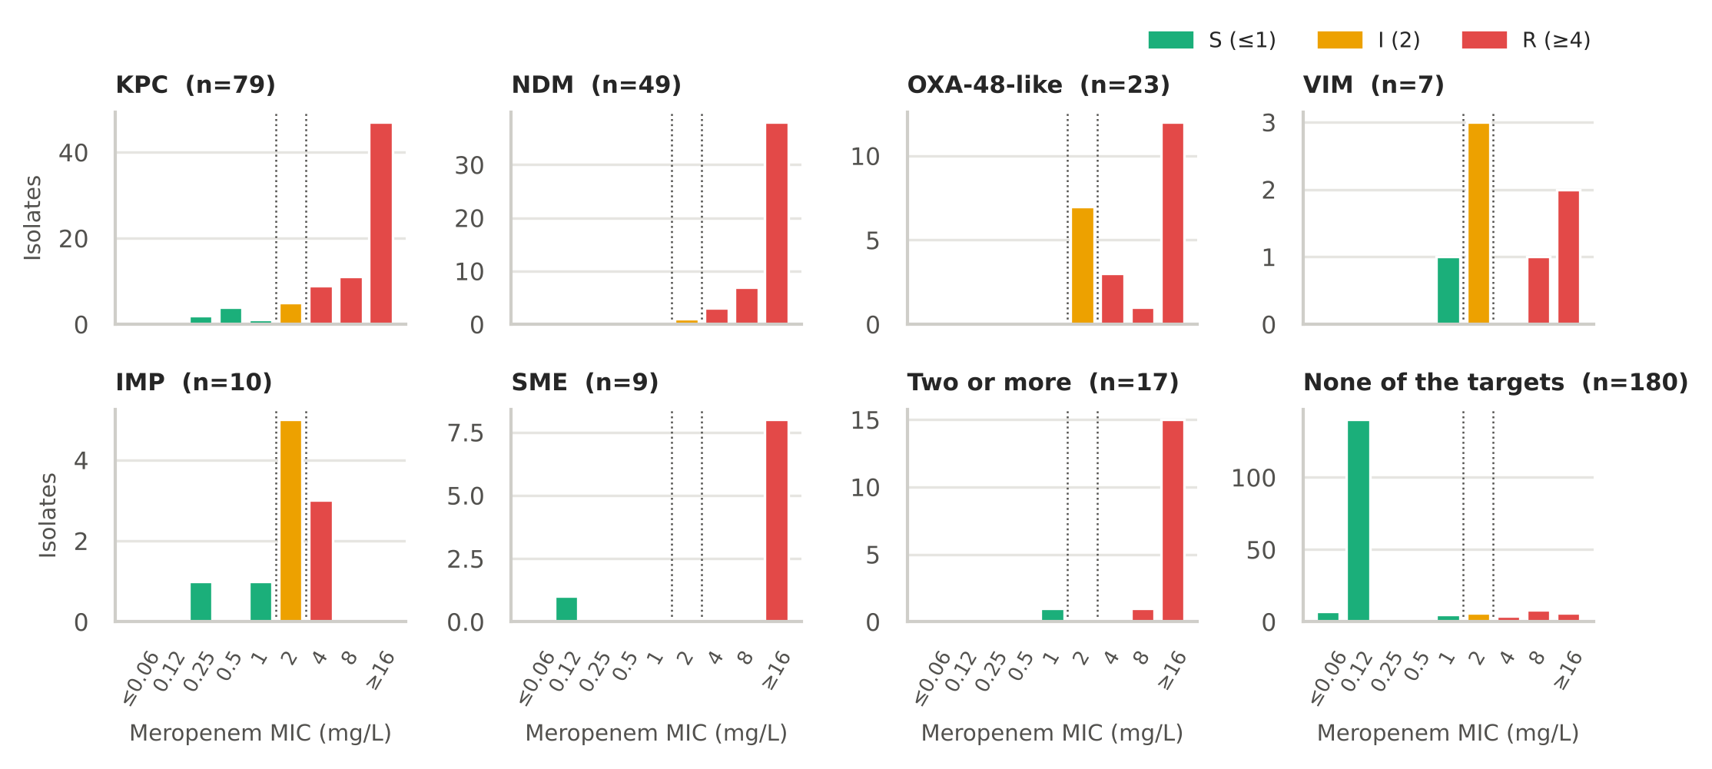
FIG. 6: CDC reference meropenem MICs for Enterobacterales, by the carbapenemase target the isolate carries. Colors give the CLSI category (susceptible ≤1, intermediate 2, resistant ≥4 mg/L); dotted lines mark the breakpoints. MICs recorded as ≤ or > a value are shown at that value.

D. External check of the Project 1 benchmark
Of 593 Bank isolates in Project 1's organisms with a BioSample, 562 had AMRFinderPlus results in NCBI Pathogen Detection and 31 did not. Of these, 24 were also in the Project 1 benchmark; all 24 had been deposited in NCBI by CDC itself. They were excluded from check B, leaving 538 independent isolates.

1. Check A.
CDC's gene lists and AMRFinderPlus agreed on every isolate for mecA, mecC, vanA, vanB, KPC, NDM, VIM and IMP (Table VIII, Fig. 7). OXA-48-like differed for 4 isolates, all K. pneumoniae with OXA-232 listed by CDC and absent from NCBI's analysis (κ = 0.93), and CTX-M for 2 in each direction (κ = 0.98). OXA-232 is carried on a small (6.1 kb) ColE-type plasmid [41], which may be missing from a public assembly while present in the sequencing reads; for three of the four isolates CDC states that its calls combined an assembly-based search with SRST2, which searches the reads directly. NCBI's analysis also confirmed mecC in both isolates CDC lists only as “blaZ-mecC”. Agreement did not depend on CDC's method: 3 of 198 positive calls differed among isolates CDC called without NCBI's database, and 5 of 199 among those called with it.

2. Check B.
Project 1's breakpoint rules reproduced CDC's posted category for 99.8% of 2,851 comparable isolate–drug results; the 6 differences (Table X) concern Morganellaceae meropenem and ceftazidime MICs at the breakpoint, an Enterobacter ceftazidime MIC of 8 mg/L, and one mecA-positive S. aureus with an oxacillin MIC of 2 mg/L that CDC reports as resistant, as CLSI directs for mecA-positive isolates [25].
TABLE VIII: Check A: rapid panel targets in CDC's gene lists and in NCBI AMRFinderPlus for the same BioSample. Right-hand columns restrict to isolates CDC called with ResFinder or ARG-ANNOT alone.
 | All isolates with both calls |  |  |  |  | CDC method without NCBI database
Target | n | Both | CDC only | NCBI only | κ | n | Both | Disagree
mecA | 124 | 103 | 0 | 0 | 1.00 | 61 | 51 | 0
mecC | 124 | 2 | 0 | 0 | 1.00 | 61 | 0 | 0
vanA | 39 | 10 | 0 | 0 | 1.00 | 18 | 2 | 0
vanB | 39 | 10 | 0 | 0 | 1.00 | 18 | 0 | 0
KPC | 377 | 74 | 0 | 0 | 1.00 | 161 | 29 | 0
NDM | 377 | 62 | 0 | 0 | 1.00 | 161 | 36 | 0
OXA-48-like | 377 | 30 | 4 | 0 | 0.93 | 161 | 14 | 1
VIM | 377 | 8 | 0 | 0 | 1.00 | 161 | 2 | 0
IMP | 377 | 10 | 0 | 0 | 1.00 | 161 | 1 | 0
CTX-M | 377 | 160 | 2 | 2 | 0.98 | 161 | 63 | 2

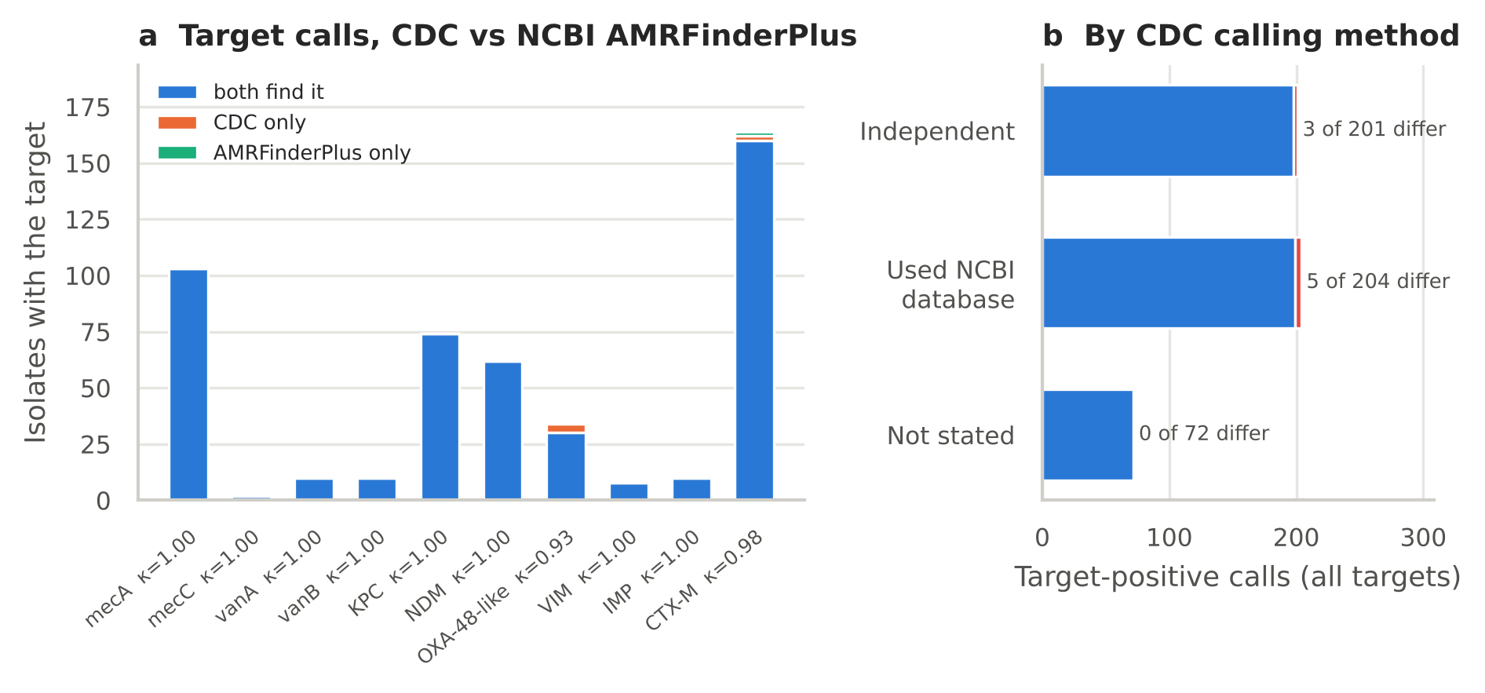
FIG. 7: Check A. (a) Isolates in which CDC, NCBI AMRFinderPlus, or both found each target, with Cohen's κ. (b) Disagreeing target-positive calls by CDC's gene-calling method; “independent” means CDC used ResFinder or ARG-ANNOT without NCBI's database.

Table IX and Fig. 8 set the Bank estimates beside Project 1's. When a target gene was present, the share of isolates testing resistant was similar to Project 1 for the high-PPV targets: KPC predicted resistance to any carbapenem in 60/64 (93.8%; Project 1 98.0%), OXA-48-like in 26/26 (100.0%), the five panel carbapenemases together in 142/147 (96.6%; Project 1 97.8%), and CTX-M predicted ceftriaxone resistance in 146/146 (100.0%; Project 1 97.7%). The drug-level pattern also held: carbapenemase producers were less often resistant to meropenem (PPV 84.4%) than to any carbapenem, and OXA-48-like producers least of all (19/26 meropenem resistant). For CTX-M and ceftazidime the Bank PPV was higher than Project 1's (87.6% versus 57.0%).
The measures that depend on what else is in the collection differed, as expected. Among S. aureus, mecA-positive isolates were often oxacillin susceptible by MIC (36 of them), so specificity for oxacillin was 39.0% against Project 1's 98.5%; with cefoxitin added, PPV was 94.2% and specificity 77.8%. These are the Bank's deliberately difficult staphylococci: its borderline oxacillin (BORSA) and difficult-to-detect mecA (DTD) panels. Sensitivity of each single carbapenemase was low because Bank isolates carry many different carbapenemases, but sensitivity of the five together for any-carbapenem resistance was 79.8% (Project 1 64.3%) and for meropenem 83.8% (Project 1 73.2%). CTX-M sensitivity for ceftriaxone resistance matched Project 1 (55.3% versus 56.5%), confirming that a negative CTX-M result is a weak predictor of ceftriaxone susceptibility.

3. Check C.
For the 120 isolate–drug results on the 24 overlapping isolates, the category from CDC's NCBI antibiogram matched the category from CDC's web page in 97.5%, with 0 major or very major differences; the 3 differences were susceptible versus intermediate at a carbapenem breakpoint. Because both records come from CDC, this is a consistency check of CDC's two postings, not a comparison between laboratories.

TABLE IX: Check B: Project 1 rules applied to independent Bank isolates (Bank) beside Project 1's U.S. estimates (P1). n is Bank isolates with an interpretable result; PPV and sensitivity also give Bank counts. Enterobacterales exclude Salmonella; enterococci are E. faecalis and E. faecium. – , not estimable.
 |  |  | PPV |  |  | Sensitivity |  |  | Specificity
Target | Drug | n | Bank | Bank | P1 | Bank | Bank | P1 | Bank | P1
mecA | oxacillin | 127 | 67/103 | 65.0% | 97.7% | 67/68 | 98.5% | 100.0% | 39.0% | 98.5%
mecA | cefoxitin | 127 | 97/103 | 94.2% | – | 97/100 | 97.0% | 0.0% | 77.8% | –
mecA | oxacillin or cefoxitin | 127 | 97/103 | 94.2% | 97.7% | 97/100 | 97.0% | 99.5% | 77.8% | 98.5%
vanA | vancomycin | 41 | 9/10 | 90.0% | 89.7% | 9/18 | 50.0% | 89.7% | 95.7% | 96.7%
vanB | vancomycin | 41 | 9/10 | 90.0% | – | 9/18 | 50.0% | 0.0% | 95.7% | 100.0%
KPC | meropenem | 312 | 54/64 | 84.4% | 90.5% | 54/148 | 36.5% | 55.3% | 93.9% | 99.5%
KPC | any carbapenem | 312 | 60/64 | 93.8% | 98.0% | 60/178 | 33.7% | 47.0% | 97.0% | 99.9%
NDM | meropenem | 312 | 52/53 | 98.1% | 97.6% | 52/148 | 35.1% | 12.2% | 99.4% | 100.0%
NDM | any carbapenem | 312 | 53/53 | 100.0% | 100.0% | 53/178 | 29.8% | 9.7% | 100.0% | 100.0%
OXA-48-like | meropenem | 312 | 19/26 | 73.1% | 76.3% | 19/148 | 12.8% | 8.8% | 95.7% | 99.7%
OXA-48-like | any carbapenem | 312 | 26/26 | 100.0% | 94.7% | 26/178 | 14.6% | 8.5% | 100.0% | 100.0%
VIM | meropenem | 312 | 3/6 | 50.0% | 75.0% | 3/148 | 2.0% | 0.9% | 98.2% | 100.0%
IMP | meropenem | 312 | 1/3 | 33.3% | 37.5% | 1/148 | 0.7% | 0.9% | 98.8% | 99.9%
CTX-M | ceftriaxone | 350 | 146/146 | 100.0% | 97.7% | 146/264 | 55.3% | 56.5% | 100.0% | 99.1%
CTX-M | ceftazidime | 312 | 127/145 | 87.6% | 57.0% | 127/235 | 54.0% | 42.7% | 76.6% | 86.7%
mecA or mecC | oxacillin or cefoxitin | 127 | 99/105 | 94.3% | 97.7% | 99/100 | 99.0% | 99.5% | 77.8% | 98.5%
vanA or vanB | vancomycin | 41 | 18/20 | 90.0% | 89.7% | 18/18 | 100.0% | 89.7% | 91.3% | 96.7%
Any of 5 carbapenemases | meropenem | 312 | 124/147 | 84.4% | 87.6% | 124/148 | 83.8% | 73.2% | 86.0% | 99.0%
Any of 5 carbapenemases | any carbapenem | 312 | 142/147 | 96.6% | 97.8% | 142/178 | 79.8% | 64.3% | 96.3% | 99.8%

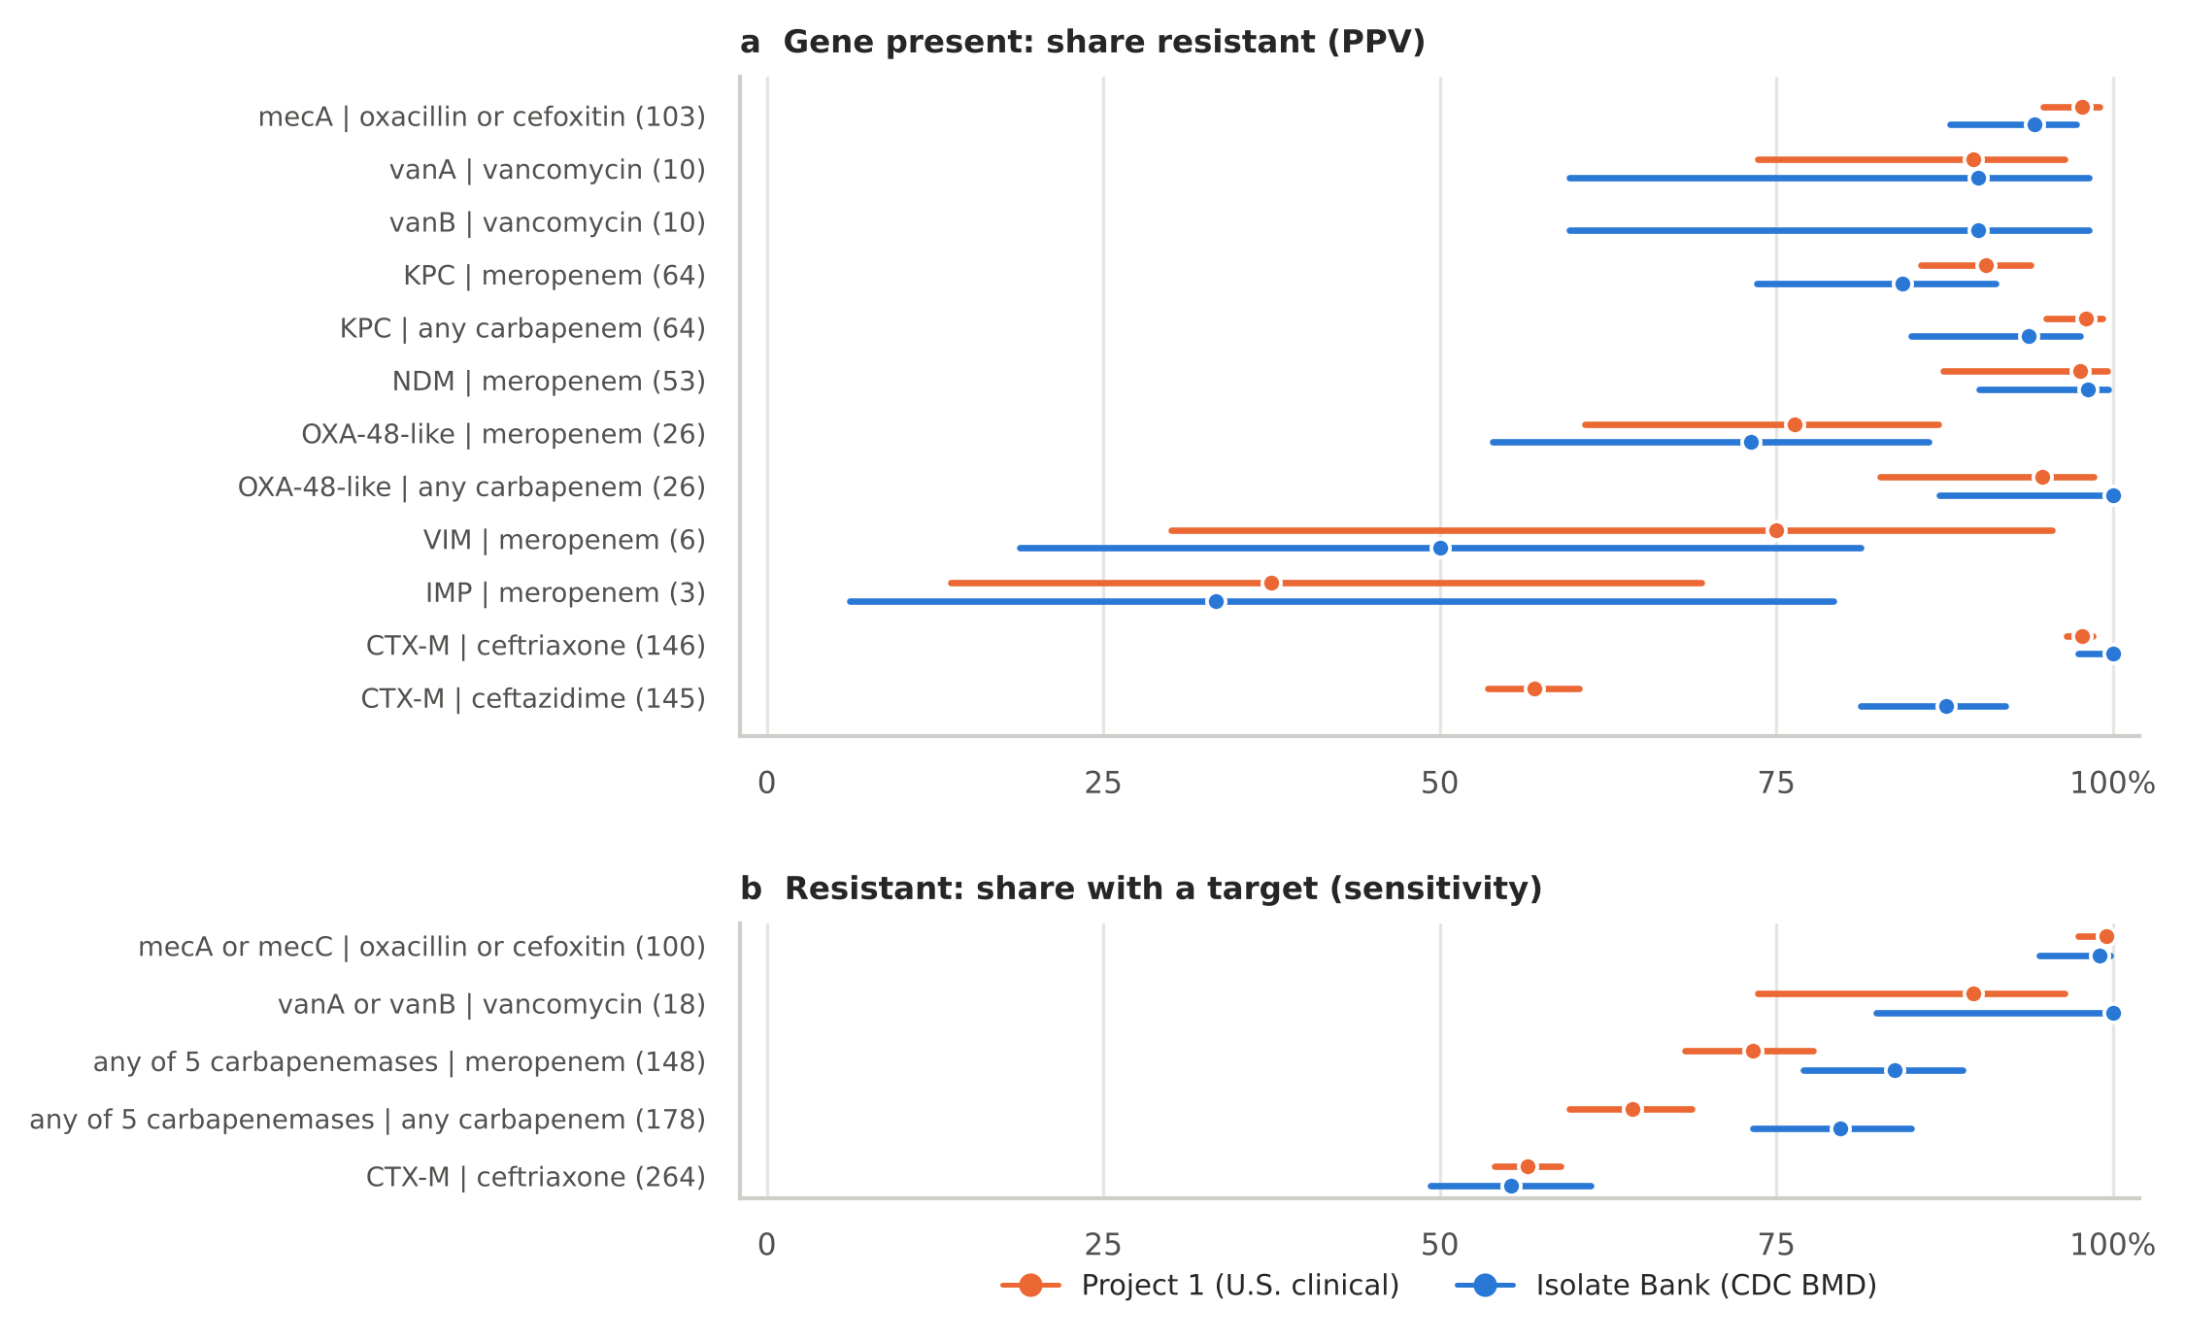
FIG. 8: Check B. (a) Share of gene-positive isolates that test resistant (PPV) and (b) share of resistant isolates that carry a target (sensitivity), Bank (blue) beside Project 1 (orange), with 95% Wilson intervals. Numbers in brackets are Bank denominators.

TABLE X: The 6 isolate–drug results where Project 1's breakpoint rules and CDC's posted category differ.
AR Bank | Organism group | Drug | MIC | CDC | Project 1 rules
0057 | Morganella / Providencia | meropenem | 2 | R | I
0082 | Morganella / Providencia | meropenem | 4 | I | R
0155 | Morganella / Providencia | ceftazidime | 8 | R | I
0216 | Staphylococcus aureus | oxacillin | 2 | R | S
1011 | Enterobacter cloacae complex | ceftazidime | 8 | R | I
1113 | Morganella / Providencia | meropenem | 2 | S | I

IV. DISCUSSION

A. Principal findings
The Isolate Bank already contains reference organisms for nearly every resistance target reported by the seven FDA-cleared blood culture panels with resistance targets, and for most of the ways those targets can mislead. What it lacked was an index by target and by device. The crosswalk supplies it: each isolate's targets, the panels that should call it positive, its reference results, and whether it is a hard case. Two to five isolates cover every target of any one panel, and the hard-case list offers a further set of organisms that tests what a panel cannot know.
Used as an external yardstick, the Bank supports the Project 1 benchmark where the benchmark is meant to be read. Gene calls by two different pipelines agreed almost perfectly. The benchmark's breakpoint rules reproduced CDC's reference interpretations. And the quantities that describe the gene itself (how often a gene-positive isolate is resistant, and to which carbapenem) behaved the same way in reference broth microdilution data from one laboratory as in submitted results from many.

B. Using the crosswalk for verification
A laboratory verifying a panel can filter the released isolate table by the panel's expected_positive column to see every candidate positive, by hard_case_types to find challenge organisms, and by organism to find negative controls of the right species. The covering sets in Table V show that coverage is cheap; the hard-case list is where the crosswalk adds most. A KPC-producing E. coli with a meropenem MIC of 0.5 mg/L, a mecA-positive S. aureus susceptible by oxacillin and cefoxitin MIC, or a vancomycin-susceptible E. faecium carrying vanA will each produce a positive panel result and a susceptible AST result. Including them in a verification shows the laboratory and its stewardship program what such a result looks like before it happens on a patient isolate, and tests whether the laboratory's reporting rules (for example, reporting mecA-positive S. aureus as oxacillin resistant [25]) are applied. Conversely, the carbapenem-resistant isolates without a panel carbapenemase, and especially the NMC-A, OXA-237 and porin-loss isolates, show the limits of a negative carbapenemase result [42, 43].

C. What the external check shows
The check separates measures that describe a gene from measures that describe a population. PPV for KPC, NDM and OXA-48-like against any carbapenem, and for CTX-M against ceftriaxone, had overlapping 95% ranges in the Bank and in Project 1, and the low meropenem PPV of OXA-48-like producers reappeared in reference broth microdilution data [39]. Specificity for mecA and single-gene sensitivities, in contrast, were lower in the Bank because the Bank was built to contain the exceptions: borderline and difficult-to-detect staphylococci, and carbapenem-resistant Enterobacterales with every mechanism CDC could collect. These differences are therefore not evidence against Project 1's estimates for U.S. clinical isolates; they show what those estimates look like in a challenge set. The higher CTX-M PPV for ceftazidime in the Bank than in Project 1 may reflect the Bank's many multi-mechanism isolates; we did not test this.

D. Limitations
The crosswalk records which targets an isolate carries, not whether a particular assay detects that allele; detection is defined by each manufacturer's instructions for use. The MRSA result of BCID2 depends on the MREJ junction, which a gene list cannot show, so its expected positives are an assumption. The Verigene BC-GN OXA groups are not named by FDA and were taken from its analytical studies. CDC's gene lists came from several methods between 2016 and 2022, and older calls can miss genes added to databases later; the gene-call comparison is only partly independent of NCBI, although agreement was as high in the independent subset. Hard cases rest on CDC's posted interpretations, which cite four CLSI M100 editions, while the external check uses a single breakpoint table. The Bank is not a patient population, so its prevalence-dependent measures should not be compared directly with clinical estimates. Some targets are represented by few isolates (mecC by two, OXA-58-like by three) and OXA-143-like by none. Thirty-one Bank isolates in Project 1's organisms had no NCBI AMRFinderPlus result and 112 isolates list no BioSample. The release reflects the Bank's pages on 24 October 2026; CDC adds isolates and revises MICs, so the crosswalk will need yearly refresh. No isolates were tested.

V. CONCLUSIONS
An open, versioned crosswalk turns the CDC & FDA AR Isolate Bank into a target-by-target, device-by-device catalog for verifying rapid blood culture panels: 529 isolates carry a panel target, every target but one is represented, a handful of isolates covers each panel, and 94 isolates are flagged as hard cases outside the expected-negative groups. Used as an external reference-method check, the Bank confirmed the gene calls, interpretation rules and gene-level estimates of a U.S. genotype–phenotype benchmark. Both resources are released for reuse and will be refreshed as the Bank grows.

DATA AND CODE AVAILABILITY
All data, code and documentation are available at https://github.com/FatimaAbdulwahab/ar-isolate-bank-panel-crosswalk [15]: the isolate-level crosswalk, the panel-by-target grid, panel target coverage, the hard-case list, the CDC gene-name map, the rapid panel target table with FDA sources, the external-check outputs, a codebook, a limitations file, the quality-control report and a provenance log with source URLs, access dates, sizes and SHA-256 fingerprints. The CDC pages, NCBI rows and FDA documents used are archived in the repository, and run_all.sh rebuilds every result from them. Data and documents are released under CC BY 4.0 and code under the MIT license. The Project 1 benchmark is at https://github.com/FatimaAbdulwahab/us-rapid-panel-amr-concordance [14].

AUTHOR CONTRIBUTIONS
F.A.: conceptualization, methodology, data curation, formal analysis, validation, visualization, writing (original draft, review and editing).

COMPETING INTERESTS
The author declares no competing interests and no relationship with CDC, FDA or any manufacturer of rapid diagnostic panels. This work is not affiliated with or endorsed by CDC or FDA.

FUNDING
This work received no specific funding.

USE OF AI TOOLS
Claude (Anthropic) assisted with code, data processing, figure generation and drafting of this manuscript. The author made the analytic decisions and rulings, verified the outputs against the CDC, FDA and NCBI records, and takes responsibility for the content.

ACKNOWLEDGMENTS
The author thanks CDC's Division of Healthcare Quality Promotion and FDA for building and maintaining the Antimicrobial Resistance Isolate Bank and publishing its characterization data, and the NCBI Pathogen Detection team for AMRFinderPlus and the Reference Gene Catalog.

REFERENCES
[1] Anna Maria Peri et al. Performance of BioFire Blood Culture Identification 2 Panel (BCID2) for the detection of bloodstream pathogens and their associated resistance markers: a systematic review and meta-analysis of diagnostic test accuracy studies. BMC Infect Dis, 22(1):794, 2022. doi:10.1186/s12879-022-07772-x
[2] Naoki Uno et al. Multicenter evaluation of the Verigene Gram-negative blood culture nucleic acid test for rapid detection of bacteria and resistance determinants in positive blood cultures. Diagnostic Microbiology and Infectious Disease, 83(4):344-348, 2015. doi:10.1016/j.diagmicrobio.2015.08.004
[3] Laura García-Álvarez et al. Meticillin-resistant Staphylococcus aureus with a novel mecA homologue in human and bovine populations in the UK and Denmark: a descriptive study. The Lancet Infectious Diseases, 11(8):595-603, 2011. doi:10.1016/s1473-3099(11)70126-8
[4] Patrice Courvalin. Vancomycin Resistance in Gram-Positive Cocci. Clinical Infectious Diseases, 42(Suppl. 1):S25-S34, 2006. doi:10.1086/491711
[5] Edward R. Bevan, Annie M. Jones, and Peter M. Hawkey. Global epidemiology of CTX-M β-lactamases: temporal and geographical shifts in genotype. Journal of Antimicrobial Chemotherapy, 72(8):2145-2155, 2017. doi:10.1093/jac/dkx146
[6] Karen Bush and Patricia A. Bradford. Epidemiology of β-Lactamase-Producing Pathogens. Clin Microbiol Rev, 33(2):e00047-19, 2020. doi:10.1128/cmr.00047-19
[7] Tristan T. Timbrook et al. The Effect of Molecular Rapid Diagnostic Testing on Clinical Outcomes in Bloodstream Infections: A Systematic Review and Meta-analysis. Clin Infect Dis., 64(1):15-23, 2017. doi:10.1093/cid/ciw649
[8] Ritu Banerjee and Romney Humphries. Rapid Antimicrobial Susceptibility Testing Methods for Blood Cultures and Their Clinical Impact. Front. Med., 8:635831, 2021. doi:10.3389/fmed.2021.635831
[9] Code of Federal Regulations. Title 42, § 493.1253, Standard: Establishment and verification of performance specifications. https://www.ecfr.gov/current/title-42/section-493.1253.
[10] Clinical and Laboratory Standards Institute. Verification of Commercial Microbial Identification and Antimicrobial Susceptibility Testing Systems. CLSI guideline M52, 1st edition. Clinical and Laboratory Standards Institute, Wayne, PA, 2015.
[11] Joseph D. Lutgring et al. FDA-CDC Antimicrobial Resistance Isolate Bank: a Publicly Available Resource To Support Research, Development, and Regulatory Requirements. J Clin Microbiol, 56(2):e01415-17, 2018. doi:10.1128/jcm.01415-17
[12] Centers for Disease Control and Prevention and U.S. Food and Drug Administration. CDC & FDA Antimicrobial Resistance Isolate Bank. https://wwwn.cdc.gov/ARIsolateBank/. Accessed 24 October 2026.
[13] Centers for Disease Control and Prevention. CDC & FDA Antimicrobial Resistance Isolate Bank: 10 Facts for 10 Years. CDC, Atlanta, GA, revised January 2026. https://www.cdc.gov/antimicrobial-resistance/media/pdfs/10-Facts-for-10-Years-508.pdf.
[14] Fatima Abdulwahab. U.S. Rapid Panel Resistance Marker Concordance Benchmark, version 1.0.0. https://github.com/FatimaAbdulwahab/us-rapid-panel-amr-concordance, 2026.
[15] Fatima Abdulwahab. CDC & FDA Antimicrobial Resistance Isolate Bank: Rapid Panel Target Crosswalk, version 1.0.0. https://github.com/FatimaAbdulwahab/ar-isolate-bank-panel-crosswalk, 2026. Archived on Zenodo.
[16] U.S. Food and Drug Administration. 510(k) decision summaries K193519 and K243759, BIOFIRE Blood Culture Identification 2 (BCID2) Panel. https://www.accessdata.fda.gov/cdrh_docs/reviews/K193519.pdf.
[17] U.S. Food and Drug Administration. 510(k) decision summary K181663, ePlex Blood Culture Identification Gram-Positive (BCID-GP) Panel. https://www.accessdata.fda.gov/cdrh_docs/reviews/K181663.pdf.
[18] U.S. Food and Drug Administration. 510(k) decision summaries K182619 and K213236, ePlex Blood Culture Identification Gram-Negative (BCID-GN) Panel. https://www.accessdata.fda.gov/cdrh_docs/reviews/K182619.pdf.
[19] U.S. Food and Drug Administration. 510(k) summary K122514, Verigene Gram-Positive Blood Culture Nucleic Acid Test (BC-GP). https://www.accessdata.fda.gov/cdrh_docs/pdf12/K122514.pdf.
[20] U.S. Food and Drug Administration. 510(k) decision summary K132843, Verigene Gram-Negative Blood Culture Nucleic Acid Test (BC-GN). https://www.accessdata.fda.gov/cdrh_docs/reviews/K132843.pdf.
[21] U.S. Food and Drug Administration. 510(k) decision summary K243490, LIAISON PLEX Gram-Positive Blood Culture Assay. https://www.accessdata.fda.gov/cdrh_docs/reviews/K243490.pdf.
[22] U.S. Food and Drug Administration. 510(k) decision summary K243013, LIAISON PLEX Gram-Negative Blood Culture Assay. https://www.accessdata.fda.gov/cdrh_docs/reviews/K243013.pdf.
[23] National Center for Biotechnology Information. Pathogen Detection. https://www.ncbi.nlm.nih.gov/pathogens/. Data accessed 24 October 2026.
[24] Michael Feldgarden et al. AMRFinderPlus and the Reference Gene Catalog facilitate examination of the genomic links among antimicrobial resistance, stress response, and virulence. Sci Rep, 11(1):12728, 2021. doi:10.1038/s41598-021-91456-0
[25] Clinical and Laboratory Standards Institute. Performance Standards for Antimicrobial Susceptibility Testing. CLSI supplement M100, 35th edition. Clinical and Laboratory Standards Institute, Wayne, PA, 2025.
[26] U.S. Food and Drug Administration. Antibacterial Susceptibility Test Interpretive Criteria. https://www.fda.gov/drugs/development-resources/antibacterial-susceptibility-test-interpretive-criteria. Accessed 24 October 2026.
[27] Philip D. Lister, Daniel J. Wolter, and Nancy D. Hanson. Antibacterial-Resistant Pseudomonas aeruginosa : Clinical Impact and Complex Regulation of Chromosomally Encoded Resistance Mechanisms. Clin Microbiol Rev, 22(4):582-610, 2009. doi:10.1128/cmr.00040-09
[28] Yesim Cetinkaya, Pamela Falk, and C. Glen Mayhall. Vancomycin-Resistant Enterococci. Clin Microbiol Rev, 13(4):686-707, 2000. doi:10.1128/cmr.13.4.686
[29] Jacob Cohen. A Coefficient of Agreement for Nominal Scales. Educational and Psychological Measurement, 20(1):37-46, 1960. doi:10.1177/001316446002000104
[30] E. Zankari et al. Identification of acquired antimicrobial resistance genes. Journal of Antimicrobial Chemotherapy, 67(11):2640-2644, 2012. doi:10.1093/jac/dks261
[31] Sushim Kumar Gupta et al. ARG-ANNOT, a New Bioinformatic Tool To Discover Antibiotic Resistance Genes in Bacterial Genomes. Antimicrob Agents Chemother, 58(1):212-220, 2014. doi:10.1128/aac.01310-13
[32] Edwin B. Wilson. Probable Inference, the Law of Succession, and Statistical Inference. Journal of the American Statistical Association, 22(158):209-212, 1927. doi:10.1080/01621459.1927.10502953
[33] Wes McKinney. Data Structures for Statistical Computing in Python. Proceedings of the Python in Science Conference, 56–61, 2010. doi:10.25080/majora-92bf1922-00a
[34] John D. Hunter. Matplotlib: A 2D Graphics Environment. Comput. Sci. Eng., 9(3):90-95, 2007. doi:10.1109/mcse.2007.55
[35] Michael Waskom. seaborn: statistical data visualization. JOSS, 6(60):3021, 2021. doi:10.21105/joss.03021
[36] E. Petinaki. Emergence of two oxacillin-susceptible mecA-positive Staphylococcus aureus clones in a Greek hospital. Journal of Antimicrobial Chemotherapy, 50(6):1090-1091, 2002. doi:10.1093/jac/dkf235
[37] Tom A. Szakacs et al. Outbreak of Vancomycin-Susceptible Enterococcus faecium Containing the Wild-Type vanA Gene. J Clin Microbiol, 52(5):1682-1686, 2014. doi:10.1128/jcm.03563-13
[38] Victoria Jordan and Hemalatha Varadhan. Detection of vanA genes in vancomycin-susceptible Enterococcus faecium isolates: implications for additional testing. Access Microbiology, 7(4), 2025. doi:10.1099/acmi.0.000959.v4
[39] L. Poirel, A. Potron, and P. Nordmann. OXA-48-like carbapenemases: the phantom menace. Journal of Antimicrobial Chemotherapy, 67(7):1597-1606, 2012. doi:10.1093/jac/dks121
[40] George A. Jacoby. AmpC β-Lactamases. Clin Microbiol Rev, 22(1):161-182, 2009. doi:10.1128/cmr.00036-08
[41] Anaïs Potron et al. Genetic and biochemical characterisation of OXA-232, a carbapenem-hydrolysing class D β-lactamase from Enterobacteriaceae. International Journal of Antimicrobial Agents, 41(4):325-329, 2013. doi:10.1016/j.ijantimicag.2012.11.007
[42] Pranita D. Tamma et al. Comparing the Outcomes of Patients With Carbapenemase-Producing and Non-Carbapenemase-Producing Carbapenem-Resistant Enterobacteriaceae Bacteremia. Clinical Infectious Diseases, 64(3):257-264, 2017. doi:10.1093/cid/ciw741
[43] Johann D. D. Pitout, Patrice Nordmann, and Laurent Poirel. Carbapenemase-Producing Klebsiella pneumoniae, a Key Pathogen Set for Global Nosocomial Dominance. Antimicrob Agents Chemother, 59(10):5873-5884, 2015. doi:10.1128/aac.01019-15

