How well do rapid blood culture panel resistance targets predict laboratory susceptibility?
An open, gene-by-gene concordance benchmark of U.S. clinical isolates in NCBI Pathogen Detection
Fatima Abdulwahab  ^{1,}*
¹Independent Researcher, Dallas, Texas, USA
Rapid blood culture identification panels report resistance genes (mecA/mecC, vanA/vanB, KPC, NDM, OXA-48-like, VIM, IMP and CTX-M) hours to days before growth-based antimicrobial susceptibility testing (AST) is complete, and laboratories and prescribers act on that early result. We built an open, versioned, isolate-level benchmark that measures how often each panel target predicts the AST result that follows, using public data only. From 26,886 NCBI BioSample records carrying a submitted antibiogram for Staphylococcus aureus, Enterococcus faecalis, Enterococcus faecium and the Enterobacterales, we joined AMRFinderPlus gene calls from NCBI Pathogen Detection, kept U.S. human clinical isolates, mapped genes to panel targets through NCBI’s Reference Gene Hierarchy, and reinterpreted 19,741 isolate-drug MICs and zone diameters against CLSI M100 (35th edition) breakpoints. The benchmark contains 5,168 isolates (731 from blood or other sterile sites). mecA predicted oxacillin or cefoxitin resistance in 215/220 S. aureus (positive predictive value, PPV, 97.7%; 95% CI 94.8%–99.0%), and its absence predicted susceptibility in 329/330 (NPV 99.7%). Any panel carbapenemase predicted resistance to at least one carbapenem in 272/278 Enterobacterales (PPV 97.8%) but to meropenem in only 241/275 (PPV 87.6%), with OXA-48-like and IMP enzymes most often leaving meropenem susceptible. CTX-M predicted ceftriaxone resistance with PPV 97.7% across Enterobacterales, but a CTX-M-negative result was a weak predictor of susceptibility outside E. coli (NPV 94.2% in E. coli, 37.3% in K. pneumoniae complex, and below 10% in chromosomal AmpC species). In a secondary analysis, CTX-M-1-group enzymes conferred ceftazidime resistance in 64.2% of E. coli versus 14.5% for CTX-M-9-group enzymes. vanA predicted vancomycin resistance in 26/29 enterococci; no vanB or mecC was present. All 970 discordant isolate-target pairs are released with a rule-based likely cause; most gene-negative resistant isolates carried a non-panel ESBL or AmpC, a panel carbapenemase, or belonged to a chromosomal AmpC species. The data, gene-to-target crosswalk, discordance collection, code and a public lookup page are openly released for reuse and annual update.
Keywords: antimicrobial resistance, rapid diagnostics, blood culture identification panel, AMRFinderPlus, genotype–phenotype concordance, carbapenemase, CTX-M, mecA, vanA

I. Introduction
Antimicrobial resistance (AMR) is a leading cause of preventable death. The U.S. Centers for Disease Control and Prevention (CDC) estimates more than 2.8 million antimicrobial-resistant infections and more than 35,000 deaths in the United States each year [1], and a global analysis attributed 1.14 million deaths in 2021 directly to bacterial AMR [2]. For bloodstream infection in particular, the interval between a positive blood culture and an optimized antimicrobial regimen matters: prescribers must choose therapy before the organism’s susceptibility is known. Rapid diagnostics are named as a goal of the U.S. National Action Plan for Combating Antibiotic-Resistant Bacteria, 2020–2025 [3], and molecular rapid diagnostic tests on positive blood cultures have been associated with lower mortality and shorter time to effective therapy, especially when paired with antimicrobial stewardship [4, 5].
Multiplex blood culture identification panels such as the BioFire FilmArray Blood Culture Identification 2 (BCID2) panel and the Verigene Gram-positive and Gram-negative blood culture tests identify the organism and a small set of resistance genes within hours of blood culture positivity [6, 7]. The genes they report were chosen because each is tightly linked to a treatment decision: mecA and mecC for methicillin resistance in S. aureus; vanA and vanB for vancomycin resistance in enterococci; the carbapenemases KPC, NDM, OXA-48-like, VIM and IMP for carbapenem resistance in Enterobacterales; and CTX-M, the dominant extended-spectrum β-lactamase (ESBL) family worldwide [8, 9], for resistance to third-generation cephalosporins. Laboratories translate these results into reports and comments, and stewardship programs translate them into escalation and de-escalation rules, before the AST result arrives.
That translation rests on an assumption that is rarely measured directly: that the presence of the gene predicts resistance, and its absence predicts susceptibility, for the organisms and drugs that matter. Panel evaluations have mostly asked whether the panel detects the gene that a reference molecular method detects, or whether the panel identifies the organism correctly [6, 7]. The question that a clinician faces is different. A positive KPC result is acted on as “carbapenem resistant”; a negative CTX-M result is often read as “no ESBL”. Both readings depend on biology the panel does not see: other β-lactamases, chromosomal AmpC enzymes [10], porin loss [11, 12], weakly hydrolyzing enzymes such as OXA-48 [13], or silent resistance genes [14, 15]. The answer also differs by organism, which panels report together with the resistance target.
Whole-genome sequencing offers a way to study this at scale. Genotype–phenotype concordance of genome-based resistance prediction has been studied extensively for individual species and collections [16, 17, 18, 19], and the EUCAST subcommittee on whole-genome sequencing reviewed the evidence and its limits [20]. NCBI Pathogen Detection now runs AMRFinderPlus [21] on every bacterial genome submitted to NCBI and links submitted laboratory antibiograms to the same isolates [22, 23]. Together these resources make it possible to ask the panel question directly, for U.S. isolates, without new laboratory work, and to repeat the measurement as new genomes are deposited. To our knowledge no openly maintained, U.S.-focused table currently reports this figure gene by gene, drug by drug and organism by organism.
Here we describe the U.S. Rapid Panel Resistance Marker Concordance Benchmark, version 1.0.0 [24]. The benchmark (i) pairs AMRFinderPlus calls with submitted susceptibility results for U.S. human clinical isolates; (ii) reinterprets every available MIC and zone diameter against one breakpoint edition; (iii) maps each gene to the panel target it represents through a released crosswalk; (iv) reports PPV, negative predictive value (NPV), sensitivity and specificity with confidence intervals for every target, drug and organism; and (v) releases every discordant isolate with a documented, rule-based likely cause. Section II describes the data and methods, Sec. III the results, Sec. IV their interpretation and limits, and Sec. V our conclusions.

II. Materials and methods

A. Data sources
All inputs are public NCBI resources released without restrictions on use. Files were downloaded on 2026-10-24; every file was logged with its source URL, access date, size and SHA-256 fingerprint, both for the full source stream and for the file as committed to the repository.
1. Susceptibility results. Laboratories that submit a bacterial genome to NCBI can attach an antibiogram to the BioSample record: one row per drug with the submitted resistance phenotype, a measurement sign (for example ≤, =, >), the measured value and units, the laboratory typing method and platform, and the testing standard. We retrieved every BioSample record matching antibiogram[filter] for Staphylococcus aureus, Enterococcus faecalis, Enterococcus faecium or the order Enterobacterales through the NCBI E-utilities [25], yielding 26,886 records. Records were parsed into one row per isolate and drug without interpretation.
2. Gene calls. NCBI Pathogen Detection publishes, for each organism group, an isolate table with the AMRFinderPlus genotype of every genome (latest_snps/AMR/*.amr.metadata.tsv) [23]. We streamed these tables for S. aureus, E. faecalis, E. faecium and every Enterobacterales group available (Escherichia coli/Shigella, Klebsiella, Klebsiella oxytoca, 16 Enterobacter groups, Citrobacter, Serratia, Morganella, Providencia, Kluyvera, Pluralibacter, Cronobacter and Salmonella), keeping rows whose BioSample carried an antibiogram. Isolates in this release were analyzed by NCBI with AMRFinderPlus versions 4.2.5, 4.2.7 and 5 database versions (2025-12-03.1, 2026-01-21.1, 2026-03-24.1, 2026-05-15.1, 2026-08-07.1).
3. Reference gene hierarchy. The AMRFinderPlus Reference Gene Hierarchy, Reference Gene Catalog and point-mutation table (database 2026-08-07.1) were downloaded to map genes to panel targets and to drug classes [21].

B. Cohort definition
Isolates were linked by BioSample accession; when a BioSample had more than one genome, the most recently created analysis target was kept. An isolate was classified as U.S. if its geo_loc_name began with “USA”. It was classified as human clinical if NCBI’s epidemiological type was “clinical” and the host was human, or the host was blank and the isolation source named a human specimen and no food, animal or environmental source. Submitted locations mixed state names, postal codes, cities and misspellings; these were resolved to states with a fixed table. Two laboratory reference strains submitted with clinical metadata (JE2 (SAMN06677988), LAC (SAMN08391108)) were removed by name. The benchmark contains isolates with at least one interpretable result for a drug paired with a panel target in their organism (Table II). Specimen categories (blood, other sterile site, urine, respiratory, wound/tissue, screening swab, stool, other) were assigned from the free-text isolation source by keyword rules.

C. Phenotype interpretation
Results were reinterpreted against CLSI M100, 35th edition (2025) [26], which the U.S. Food and Drug Administration (FDA) recognizes for these organism–drug pairs [27] (Table I); the breakpoint values were checked by the author against the published standard and the FDA Susceptibility Test Interpretive Criteria pages before release. A censored MIC was interpreted only when every value it allows falls in one category: ≤x allows (0, x], <x allows (0, x/2], ≥x allows [x, ∞) and >x allows [2x, ∞). Readings from gradient strips that fall between two-fold dilutions (for example 1.5 mg/L) were rounded up to the next two-fold dilution before interpretation, as CLSI directs. MIC values not on the two-fold or gradient series (for example “oxacillin 23 mg/L”, most likely a zone diameter filed with MIC units; 170 results) were not reinterpreted. When a value could not be interpreted, the submitter’s S/I/R call was used and flagged. When an isolate had several results for one drug, a reinterpreted MIC was preferred to a reinterpreted zone and both to a submitter call; ties kept the most resistant category. Imipenem was not used for Morganella or Providencia, whose imipenem MICs are intrinsically elevated.
For S. aureus, oxacillin resistance was judged from the oxacillin MIC or the cefoxitin screen, not from the submitter’s call. This keeps the phenotype independent of the genotype: laboratories may report oxacillin resistance on the basis of a mecA or PBP2a result, which would make the comparison partly circular. The alternative rule is reported as a sensitivity analysis.
TABLE I: Breakpoints applied (CLSI M100, 35th ed., 2025). “Between” gives the category assigned between the S and R breakpoints; “–” means none is defined.
Organism group | Agent | Method | S | R | Between
Enterobacterales | imipenem | MIC (mg/L) | ≤1 | ≥4 | I
Enterobacterales | meropenem | MIC (mg/L) | ≤1 | ≥4 | I
Enterobacterales | ertapenem | MIC (mg/L) | ≤0.5 | ≥2 | I
Enterobacterales | doripenem | MIC (mg/L) | ≤1 | ≥4 | I
Enterobacterales | ceftriaxone | MIC (mg/L) | ≤1 | ≥4 | I
Enterobacterales | cefotaxime | MIC (mg/L) | ≤1 | ≥4 | I
Enterobacterales | ceftazidime | MIC (mg/L) | ≤4 | ≥16 | I
Enterobacterales | imipenem | Disk (mm) | ≥23 | ≤19 | I
Enterobacterales | meropenem | Disk (mm) | ≥23 | ≤19 | I
Enterobacterales | ertapenem | Disk (mm) | ≥22 | ≤18 | I
Enterobacterales | doripenem | Disk (mm) | ≥23 | ≤19 | I
Enterobacterales | ceftriaxone | Disk (mm) | ≥23 | ≤19 | I
Enterobacterales | cefotaxime | Disk (mm) | ≥26 | ≤22 | I
Enterobacterales | ceftazidime | Disk (mm) | ≥21 | ≤17 | I
S. aureus | oxacillin | MIC (mg/L) | ≤2 | ≥4 | –
S. aureus | cefoxitin | MIC (mg/L) | ≤4 | ≥8 | –
S. aureus | cefoxitin | Disk (mm) | ≥22 | ≤21 | –
Enterococcus spp. | vancomycin | MIC (mg/L) | ≤4 | ≥32 | I
Enterococcus spp. | vancomycin | Disk (mm) | ≥17 | ≤14 | I

D. Gene-to-panel target crosswalk
Each AMRFinderPlus symbol was assigned to a panel target when the corresponding family node appeared among its ancestors in the Reference Gene Hierarchy (mecA, mecC, vanA, vanB, blaKPC, blaNDM, blaOXA-48_fam, blaVIM, blaIMP, blaCTX-M). The released crosswalk has 964 rows, each with a match flag: the target itself, a family member, an untyped family call, a functional variant (mecA-ceftaroline), or an OXA-48 family allele that NCBI does not catalogue as carbapenem-hydrolyzing (54 alleles, for example OXA-163 and OXA-405, versus 28 carbapenem-hydrolyzing alleles including OXA-48, -181, -232 and -244) [13]. A target was “detected” when any matching call was present, whether complete or partial, since a PCR target region can be detected in a gene that the assembly reports as partial. Whether a given commercial panel detects a given rare allele depends on the manufacturer’s instructions for use and is not asserted.
Non-panel mechanisms were tabulated for each isolate from the catalog’s drug-class annotation: other carbapenemase genes; porin and other point mutations annotated to carbapenems, including frameshift and truncation calls mapped by gene; non-CTX-M cephalosporinases, split into acquired ESBL or AmpC genes, chromosomal enzymes intrinsic to the organism (E. coli blaEC, Enterobacter blaACT/blaMIR, Citrobacter freundii blaCMY, Serratia blaSRT, K. oxytoca blaOXY and others) and narrow-spectrum OXA-1 and OXA-10 family enzymes; E. coli ampC promoter mutations [28]; and non-panel methicillin and glycopeptide genes.
TABLE II: Panel targets, drugs scored and analysis groups. Composite drugs count an isolate as resistant if it is resistant to any tested member, and as not resistant if at least one member was tested and none was resistant.
Panel target(s) | Organisms | Drugs scored individually | Composite
mecA, mecC | S. aureus | oxacillin (MIC), cefoxitin (screen) | oxacillin or cefoxitin
vanA, vanB | E. faecalis, E. faecium | vancomycin | –
KPC, NDM, OXA-48-like, VIM, IMP | Enterobacterales | meropenem, imipenem, ertapenem, doripenem | any carbapenem
CTX-M | Enterobacterales | ceftriaxone, cefotaxime, ceftazidime | any of the three
Note: Class-level targets: mecA or mecC; vanA or vanB; any panel carbapenemase (KPC, NDM, OXA-48-like, VIM or IMP).
Note: Enterobacterales are reported by organism group and pooled; Salmonella is reported separately and excluded from the pooled row.

E. Concordance measures
For each panel target t, drug (or composite) d and organism group o, isolates with a usable result for d form a 2×2 table of gene status (G⁺, G⁻) against phenotype (R, R̄). Resistant (R) means a final category of R; not resistant (R̄) means S, I or susceptible-dose dependent (SDD) in the main analysis. We report
 | $$PPV=\frac{n\left(G^{\text{+}}R\right)}{n\left(G^{\text{+}}\right)}, NPV=\frac{n\left(G^{−}\overset{‾}{R}\right)}{n\left(G^{−}\right)},$$ | (1)
 | $$Sens=\frac{n\left(G^{\text{+}}R\right)}{n\left(R\right)}, Spec=\frac{n\left(G^{−}\overset{‾}{R}\right)}{n\left(\overset{‾}{R}\right)},$$ | (2)
and categorical agreement [n(G⁺R) + n(G⁻R̄)]/n. PPV answers “when the panel reports this gene, how often is the isolate resistant?” and NPV answers “when the panel does not report it, how often is the isolate not resistant?”; these are the quantities a laboratory acts on. Confidence intervals are Wilson score intervals [29],
 | $$\frac{\hat{p}+\frac{z^{2}}{2n}±z\sqrt{\frac{\hat{p}\left(1−\hat{p}\right)}{n}+\frac{z^{2}}{4n^{2}}}}{1+\frac{z^{2}}{n}}, z=1.96,$$ | (3)
which behave well when proportions are near 0 or 1 and counts are small. For a single carbapenemase, isolates carrying a different carbapenemase count as gene-negative; the class-level “any panel carbapenemase” row describes what a fully negative carbapenemase result means. Predictive values depend on prevalence, and prevalence in this collection reflects what laboratories chose to sequence (Sec. IV, Limitations).

F. Discordance classification
Every discordant isolate was recorded once per target (gene detected, not resistant) or per drug class (gene not detected, resistant), using the composite drug where one exists. Causes were assigned by fixed rules in a fixed order, and all applicable causes were retained alongside the primary one. For gene-detected, not-resistant isolates the order was: partial or interrupted gene call; non-carbapenemase OXA-48 family allele; measured value at or within one two-fold dilution of the resistant breakpoint (or within 2 mm for zones); submitter interpretation differing from M100-Ed35; submitter call only; otherwise “unexplained by available data”. For gene-negative resistant isolates the order was class-specific: non-panel carbapenemase, ESBL or AmpC with a porin change, ESBL or AmpC without a called porin change, or porin change alone (carbapenems); panel carbapenemase present, acquired non-CTX-M ESBL or AmpC, chromosomal AmpC species, or ampC promoter mutation (third-generation cephalosporins); vanA operon genes without a ligase call, or a non-panel van gene (vancomycin); mec regulators without mecA, or a non-panel mec gene (methicillin); then the measurement and interpretation causes above. Cause labels identify likely mechanisms and do not prove them.

G. Sensitivity and secondary analyses
Pre-specified sensitivity analyses (i) excluded I and SDD results instead of counting them as not resistant, (ii) restricted the cohort to blood and other sterile-site isolates, the specimens panels are used on, and (iii) for S. aureus, accepted the submitting laboratory’s “resistant” call for oxacillin when it disagreed with the MIC. A secondary analysis, motivated by the CTX-M results, compared third-generation cephalosporin resistance between CTX-M-1-group (for example CTX-M-15, -55) and CTX-M-9-group (for example CTX-M-14, -27) enzymes [8] with a two-sided Fisher exact test.

H. Reproducibility, provenance and quality control
The pipeline is a set of numbered Python scripts (pandas [30]; figures with matplotlib and seaborn [31, 32]). Every number in this manuscript is read from files the pipeline writes; none was typed by hand. Rebuilding from the committed raw files reproduces all tables byte for byte. A quality-control report records row counts at each step, interpretation unit tests, sanity checks (every 2×2 table sums to n; every proportion lies in [0,1]; no duplicate BioSamples), and named spot checks. Before release the author compared 50 laboratory values with the live NCBI BioSample records and recomputed the headline estimates with independent code.

I. Ethics
The study used only publicly released, de-identified isolate metadata and genome-derived results. No human subjects were contacted and no identifiable private information was accessed.

III. Results

A. Cohort
Of the 26,886 BioSamples with an antibiogram, 26,109 had an AMRFinderPlus result and 19,587 were collected in the United States (Fig. 1). Most U.S. isolates with antibiograms came from food, animal or environmental surveillance (14,054), leaving 5,533 human clinical isolates, of which 5,168 had at least one interpretable result for a panel-paired drug. The benchmark comprises 3,176 E. coli, 790 K. pneumoniae complex, 550 S. aureus, 83 E. faecalis, 36 E. faecium, 109 Salmonella enterica and smaller numbers of other Enterobacterales (Table III, Fig. 2).
Urine was the commonest specimen (3,426 isolates, 66%), followed by blood (701), wound or tissue (276) and respiratory specimens (259); 731 isolates came from blood or another sterile site. Isolates were collected from 2003 to 2024 and submitted from 23 states and the District of Columbia; 397 gave no state. One project from the Walter Reed Army Institute of Research (PRJNA809394) contributed 2,076 isolates (40%); all District of Columbia isolates came from Walter Reed projects, so that location is the submitter’s rather than necessarily the patient’s.
Of 21,930 isolate-drug results, 21,813 were MICs and 117 zone diameters; 51% were from BD Phoenix and 33% from Vitek 2, and 96.6% cited CLSI as the testing standard. 19,741 results were reinterpreted, 281 used the submitter’s call, and 10 could not be categorized. Where both were available, the submitter’s S/I/R call agreed with our reinterpretation in 99.7% of results.
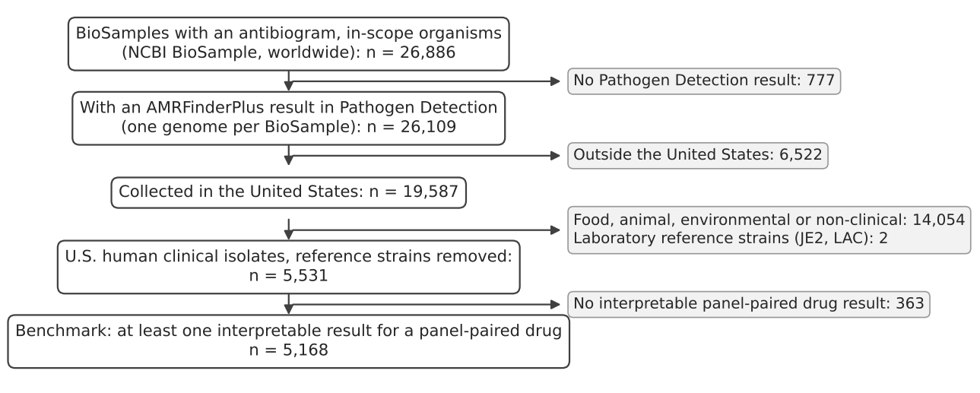
FIG. 1: Construction of the benchmark from NCBI BioSample antibiograms and NCBI Pathogen Detection AMRFinderPlus results. “Panel-paired drug”: a drug scored against a panel target for that organism (Table II).

TABLE III: Benchmark isolates by organism group.
Organism | Isolates | Blood/sterile | Urine | Years | Statesᵃ | BioProjects
E. coli | 3,176 | 314 | 2,636 | 2012–2024 | 7 | 39
K. pneumoniae cplx. | 790 | 83 | 494 | 2003–2024 | 22 | 72
S. aureus | 550 | 260 | 18 | 2011–2024 | 5 | 7
E. cloacae cplx. | 166 | 13 | 82 | 2012–2024 | 2 | 21
K. aerogenes | 115 | 11 | 64 | 2011–2024 | 5 | 17
Salmonella enterica | 109 | 9 | 8 | 2012–2017 | 2 | 4
E. faecalis | 83 | 7 | 55 | 2016–2023 | 2 | 2
C. freundii cplx. | 54 | 9 | 26 | 2012–2024 | 3 | 5
E. faecium | 36 | 12 | 13 | 2016–2024 | 3 | 3
Morganella/Providencia | 31 | 3 | 14 | 2014–2024 | 1 | 4
Serratia spp. | 30 | 4 | 4 | 2013–2024 | 1 | 3
K. oxytoca cplx. | 18 | 6 | 6 | 2017–2024 | 2 | 2
Other Enterobacterales | 7 | 0 | 3 | 2021–2023 | 1 | 1
Klebsiella, other | 3 | 0 | 3 | 2023–2024 | 1 | 1
Total | 5,168 | 731 | 3,426 | 2003–2024 | 24 | 152
Note: ᵃDistinct states named, District of Columbia included; isolates without a stated location are not counted.

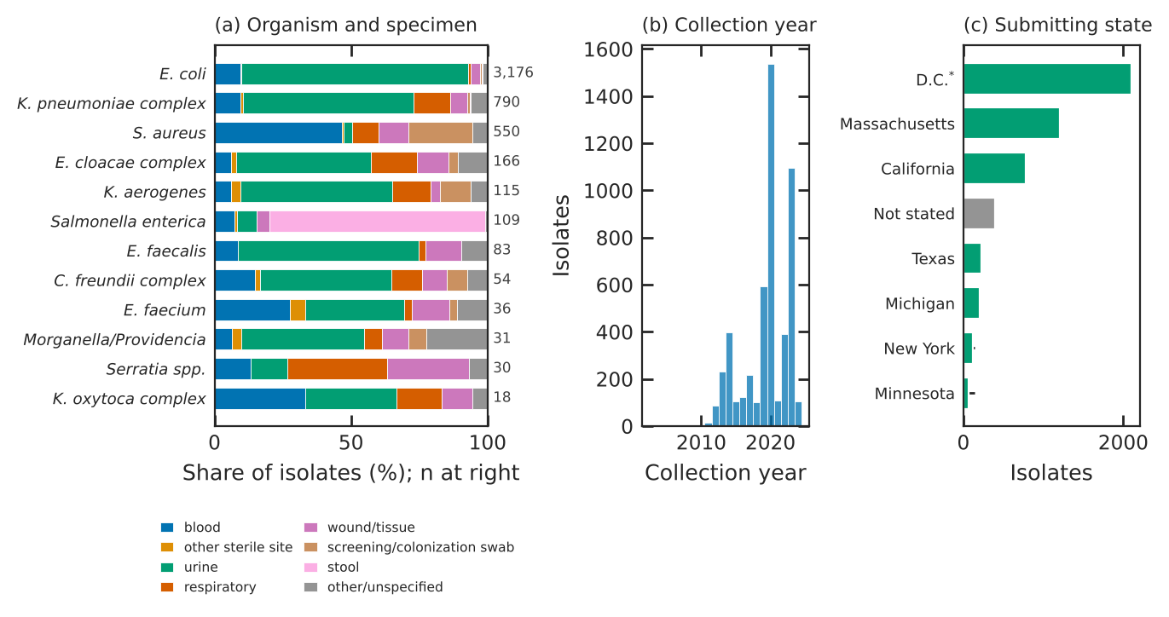
FIG. 2: Benchmark composition. (a) Specimen category by organism group (groups with at least 10 isolates; totals at right). (b) Collection year. (c) Submitting state, eight most frequent. †All District of Columbia isolates were submitted by the Walter Reed Army Institute of Research; the location is the submitter’s.

B. Panel targets detected
AMRFinderPlus detected mecA in 220 isolates, vanA in 29, KPC in 209, NDM in 41, OXA-48-like enzymes in 38, VIM in 5, IMP in 8 and CTX-M in 1,064; mecC and vanB were not found (Table IV). 284 isolates carried at least one panel carbapenemase, 191 of them K. pneumoniae complex, and 14 carried two or more. KPC-3 (130) and KPC-2 (60) dominated the KPC calls; NDM-1 (23) and NDM-5 (13) the NDM calls; and OXA-181 (17), OXA-232 (11) and OXA-48 (8) the OXA-48-like calls. CTX-M-15 (726), CTX-M-27 (182) and CTX-M-14 (64) were the commonest CTX-M alleles. Only 5 CTX-M calls, and no other panel target calls, were partial.
TABLE IV: Gene-to-panel target crosswalk (AMRFinderPlus Reference Gene Hierarchy, database 2026-08-07.1) and alleles observed in the benchmark. “Symbols”: crosswalk rows; “Isolates”: benchmark isolates with the target detected. An isolate carrying two alleles of one family counts once for each allele.
Target | Hierarchy node | Symbols | Non-carba.ᵃ | Isolates | Most frequent observed alleles (isolates)
mecA | mecA | 2 | – | 220 | mecA (220)
mecC | mecC | 1 | – | 0 | none
vanA | vanA | 1 | – | 29 | vanA (29)
vanB | vanB | 1 | – | 0 | none
KPC | blaKPC | 296 | – | 209 | KPC-3 (130), KPC-2 (60), KPC-4 (17), KPC-82 (1)
NDM | blaNDM | 99 | – | 41 | NDM-1 (23), NDM-5 (13), NDM-7 (3), NDM-4 (1)
OXA-48-like | blaOXA-48_fam | 83 | 54 | 38 | OXA-181 (17), OXA-232 (11), OXA-48 (8), OXA-244 (1)
VIM | blaVIM | 97 | – | 5 | VIM-1 (2), VIM-2 (2), VIM-4 (1)
IMP | blaIMP | 109 | – | 8 | IMP-13 (4), IMP-27 (2), IMP-18 (1), IMP-67 (1)
CTX-M | blaCTX-M | 275 | – | 1064 | CTX-M-15 (726), CTX-M-27 (182), CTX-M-14 (64), CTX-M-55 (54)
Note: ᵃOXA-48 family alleles that NCBI’s catalog does not list as carbapenem-hydrolyzing (flag FAMILY_MEMBER_NONCARBA).

C. Main concordance results
Table V and Fig. 3 give the headline estimates; the full table of 1,033 analysis rows is released with the data.
TABLE V: Concordance of panel targets with laboratory susceptibility, all U.S. human clinical isolates (main analysis: I and SDD counted as not resistant). G+R: gene detected, resistant; G+S: gene detected, not resistant; G−R: gene not detected, resistant; G−S: gene not detected, not resistant. OXA, oxacillin; FOX, cefoxitin; VAN, vancomycin; CBP, carbapenem; MEM, meropenem; CRO, ceftriaxone.
Target | Organism | Drug | n | G+R | G+S | G−R | G−S | PPV (95% CI) | NPV (95% CI) | Sens. | Spec.
mecA | S. aureus | OXA or FOX | 550 | 215 | 5 | 1 | 329 | 97.7% (94.8%–99.0%) | 99.7% (98.3%–99.9%) | 99.5% | 98.5%
mecA | S. aureus | OXA | 550 | 215 | 5 | 0 | 330 | 97.7% (94.8%–99.0%) | 100.0% (98.8%–100.0%) | 100.0% | 98.5%
vanA | E. faecium | VAN | 36 | 22 | 3 | 1 | 10 | 88.0% (70.0%–95.8%) | 90.9% (62.3%–98.4%) | 95.7% | 76.9%
vanA | E. faecalis | VAN | 83 | 4 | 0 | 2 | 77 | 100.0% (51.0%–100.0%) | 97.5% (91.2%–99.3%) | 66.7% | 100.0%
vanA/vanB | E. faecalis + E. faecium | VAN | 119 | 26 | 3 | 3 | 87 | 89.7% (73.6%–96.4%) | 96.7% (90.7%–98.9%) | 89.7% | 96.7%
KPC | Enterobacteralesᵃ | Any CBP | 4,147 | 199 | 4 | 224 | 3,720 | 98.0% (95.0%–99.2%) | 94.3% (93.6%–95.0%) | 47.0% | 99.9%
NDM | Enterobacteralesᵃ | Any CBP | 4,147 | 41 | 0 | 382 | 3,724 | 100.0% (91.4%–100.0%) | 90.7% (89.8%–91.5%) | 9.7% | 100.0%
OXA-48-like | Enterobacteralesᵃ | Any CBP | 4,147 | 36 | 2 | 387 | 3,722 | 94.7% (82.7%–98.5%) | 90.6% (89.7%–91.4%) | 8.5% | 99.95%
VIM | Enterobacteralesᵃ | Any CBP | 4,147 | 5 | 0 | 418 | 3,724 | 100.0% (56.6%–100.0%) | 89.9% (89.0%–90.8%) | 1.2% | 100.0%
IMP | Enterobacteralesᵃ | Any CBP | 4,147 | 8 | 0 | 415 | 3,724 | 100.0% (67.6%–100.0%) | 90.0% (89.0%–90.9%) | 1.9% | 100.0%
Any carbapenemaseᵇ | Enterobacteralesᵃ | Any CBP | 4,147 | 272 | 6 | 151 | 3,718 | 97.8% (95.4%–99.0%) | 96.1% (95.4%–96.7%) | 64.3% | 99.8%
Any carbapenemaseᵇ | Enterobacteralesᵃ | MEM | 3,834 | 241 | 34 | 88 | 3,471 | 87.6% (83.2%–91.0%) | 97.5% (97.0%–98.0%) | 73.2% | 99.0%
CTX-M | E. coli | CRO | 2,828 | 654 | 19 | 124 | 2,031 | 97.2% (95.6%–98.2%) | 94.2% (93.2%–95.2%) | 84.1% | 99.1%
CTX-M | K. pneumoniae cplx. | CRO | 636 | 216 | 2 | 262 | 156 | 99.1% (96.7%–99.7%) | 37.3% (32.8%–42.1%) | 45.2% | 98.7%
CTX-M | Enterobacteralesᵃ | CRO | 3,855 | 905 | 21 | 696 | 2,233 | 97.7% (96.6%–98.5%) | 76.2% (74.7%–77.7%) | 56.5% | 99.1%
CTX-M | Salmonella enterica | CRO | 108 | 1 | 0 | 14 | 93 | 100.0% (20.7%–100.0%) | 86.9% (79.2%–92.0%) | 6.7% | 100.0%
Note: ᵃPooled Enterobacterales excluding Salmonella. ᵇKPC, NDM, OXA-48-like, VIM or IMP.

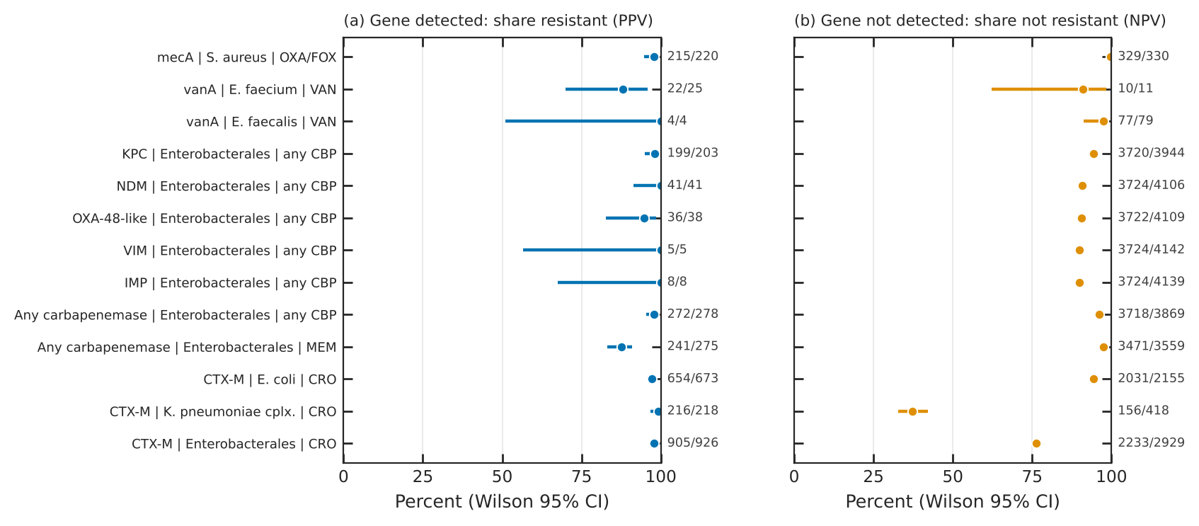
FIG. 3: Positive (a) and negative (b) predictive values with Wilson 95% confidence intervals for the principal target–organism–drug combinations. Fractions at right are the counts behind each estimate. “Enterobacterales” excludes Salmonella. CBP, carbapenem; MEM, meropenem; CRO, ceftriaxone; OXA/FOX, oxacillin or cefoxitin; VAN, vancomycin.

1. mecA and mecC in S. aureus. mecA was detected in 220 of 550 S. aureus with an oxacillin or cefoxitin result, and 215 of them were resistant (PPV 97.7%, 95% CI 94.8%–99.0%). Among isolates without mecA or mecC, 329/330 were not resistant (NPV 99.7%, 98.3%–99.9%); sensitivity was 99.5% and specificity 98.5%. The phenotype separated cleanly by genotype (Fig. 6a): almost every mecA-negative isolate had an oxacillin MIC ≤0.5 mg/L and almost every mecA-positive isolate an MIC ≥4 mg/L. The 5 mecA-positive isolates without resistance (SAMN12476193, SAMN38228831, SAMN38637651, SAMN38637652, SAMN48878967) had oxacillin MICs of 0.25 to 2 mg/L (Appendix Table AI); for 3 of them the submitting laboratory had nevertheless reported oxacillin resistance. One mecA-negative isolate (SAMN38228869) was cefoxitin-resistant (MIC ≥64 mg/L) with an oxacillin MIC of 0.5 mg/L and no other mec gene detected.
2. vanA and vanB in enterococci. The enterococcal arm is small. vanA was detected in 29 of 119 enterococci with a vancomycin result, and 26 were resistant (PPV 89.7%, 73.6%–96.4%); NPV was 96.7% (90.7%–98.9%). In E. faecium, PPV was 88.0% (22/25) and NPV 90.9% (10/11); in E. faecalis all 4 vanA-positive isolates were resistant. The 3 vanA-positive, vancomycin-susceptible isolates were all E. faecium (SAMN09728854, SAMN39956425, SAMN36892852) with vancomycin MICs of 1 to 2 mg/L, a pattern described as vancomycin-variable or silent vanA [14, 15] (Fig. 6b). Of the 3 vancomycin-resistant isolates without a panel van gene, one carried vanA operon accessory genes (vanY, vanZ) without a ligase call, suggesting an assembly break, and two E. faecalis had no explanation in the available data.
3. Carbapenemases in Enterobacterales. Any panel carbapenemase predicted resistance to at least one carbapenem in 272/278 isolates (PPV 97.8%, 95.4%–99.0%); its absence predicted no carbapenem resistance in 3718/3869 (NPV 96.1%, 95.4%–96.7%). Sensitivity was 64.3%: about a third of carbapenem-resistant Enterobacterales in this collection carried none of the five panel enzymes. KPC alone had PPV 98.0% (199/203), NDM 100.0% (41/41) and OXA-48-like 94.7% (36/38).
The predictive value of a carbapenemase depended on which carbapenem was asked about (Table VI, Fig. 4). Ertapenem resistance followed a carbapenemase in 96.0% of tested producers, but meropenem resistance did not: for any panel carbapenemase, PPV was 87.6% for meropenem (241/275) against 96.0% for ertapenem (213/222) and 89.8% for imipenem. By enzyme, meropenem PPV was 90.5% for KPC (182/201), 97.6% for NDM (40/41), 76.3% for OXA-48-like (29/38) and 37.5% for IMP (3/8). The meropenem MIC distribution of carbapenemase-positive isolates (Fig. 6c) had a long tail at and below the resistant breakpoint. Doripenem was tested in 305 isolates (median collection year 2014), mostly from one project, and is shown for completeness.
By organism, PPV for any carbapenem was high in K. pneumoniae complex (185/186) and E. cloacae complex (37/37), but NPV fell where non-carbapenemase mechanisms are common: 82.5% in E. cloacae complex and 57.6% in K. aerogenes (Table VII). In E. coli, carbapenemase-positive isolates were often meropenem-susceptible (meropenem PPV 58.6%, 17/29).
TABLE VI: PPV of each carbapenemase for resistance to each carbapenem, pooled Enterobacterales excluding Salmonella: resistant / gene-positive tested (percent).
Target | Meropenem | Imipenem | Ertapenem | Doripenem | Any carbapenem
KPC | 182/201 (91%) | 159/170 (94%) | 161/166 (97%) | 109/141 (77%) | 199/203 (98%)
NDM | 40/41 (98%) | 16/16 (100%) | 18/20 (90%) | 6/6 (100%) | 41/41 (100%)
OXA-48-like | 29/38 (76%) | 27/36 (75%) | 31/32 (97%) | 24/30 (80%) | 36/38 (95%)
VIM | 3/4 (75%) | 4/4 (100%) | 2/3 (67%) | 0/1 (0%) | 5/5 (100%)
IMP | 3/8 (38%) | 2/4 (50%) | 5/5 (100%) | – | 8/8 (100%)
Any panel enzyme | 241/275 (88%) | 193/215 (90%) | 213/222 (96%) | 135/174 (78%) | 272/278 (98%)

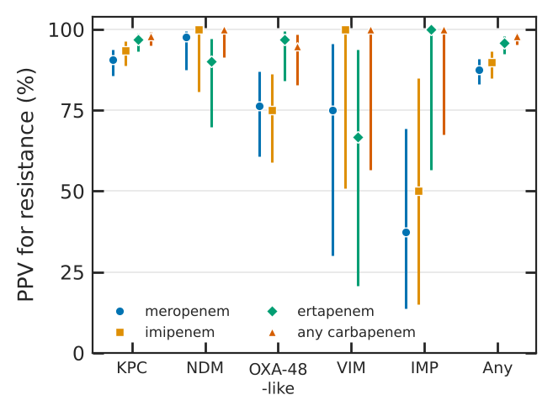
FIG. 4: PPV of each panel carbapenemase for resistance to meropenem, imipenem, ertapenem and any carbapenem, pooled Enterobacterales excluding Salmonella, with Wilson 95% CIs. “Any”: any of the five panel enzymes.
TABLE VII: Any panel carbapenemase by organism group. PPV and NPV as resistant/gene-positive and not resistant/gene-negative.
Organism | Any carbapenem: n | Any carbapenem: G+ | Any carbapenem: PPV | Any carbapenem: NPV | Any carbapenem: Sens. | Meropenem: PPV | Meropenem: NPV
E. coli | 3,168 | 29 | 26/29 | 3102/3139 | 41.3% | 17/29 | 2871/2889
K. pneumoniae cplx. | 564 | 186 | 185/186 | 339/378 | 82.6% | 177/185 | 289/320
E. cloacae cplx. | 163 | 37 | 37/37 | 104/126 | 62.7% | 29/36 | 116/124
K. aerogenes | 110 | 4 | 4/4 | 61/106 | 8.2% | 3/4 | 81/106
C. freundii cplx. | 54 | 7 | 6/7 | 46/47 | 85.7% | 5/7 | 46/47
Serratia spp. | 29 | 3 | 3/3 | 22/26 | 42.9% | 2/2 | 23/26
Morganella/Providencia | 31 | 5 | 4/5 | 24/26 | 66.7% | 2/5 | 24/26
Enterobacteralesᵃ | 4,147 | 278 | 272/278 | 3718/3869 | 64.3% | 241/275 | 3471/3559

4. CTX-M and third-generation cephalosporins. CTX-M predicted ceftriaxone resistance with PPV 97.7% (96.6%–98.5%) in pooled Enterobacterales, 97.2% in E. coli and 99.1% in K. pneumoniae complex (Table VIII). The value of a negative result depended strongly on organism (Fig. 5a). In E. coli, 2031/2155 CTX-M-negative isolates were not ceftriaxone-resistant (NPV 94.2%); in K. pneumoniae complex only 156/418 were (NPV 37.3%), because most CTX-M-negative, ceftriaxone-resistant K. pneumoniae carried another acquired ESBL or AmpC (140 of 296 as primary cause, mostly SHV-type) or a panel carbapenemase (135). In chromosomal AmpC species the NPV was below 10%: 4.4% in E. cloacae complex, 7.0% in K. aerogenes and 7.8% in C. freundii complex. For Salmonella, CTX-M was rare and the NPV was 86.9%.
CTX-M predicted ceftazidime resistance much less reliably than ceftriaxone resistance (PPV 47.4% in E. coli, 79.4% in K. pneumoniae complex). The secondary analysis attributes this to the CTX-M subgroup (Table IX, Fig. 5b). In E. coli, CTX-M-1-group enzymes conferred ceftriaxone resistance in 432/443 (97.5%) and ceftazidime resistance in 235/366 (64.2%); CTX-M-9-group enzymes conferred ceftriaxone resistance in 211/218 (96.8%) but ceftazidime resistance in only 26/179 (14.5%; Fisher exact p < 10⁻²⁹). In K. pneumoniae complex, CTX-M-1-group enzymes conferred ceftazidime resistance in 170/212 (80.2%); CTX-M-9-group enzymes were too few to compare.
TABLE VIII: CTX-M and ceftriaxone by organism group.
Organism | n | CTX-M+ | PPV (95% CI) | NPV (95% CI) | Sens. | Spec.
E. coli | 2,828 | 673 | 97.2% (95.6%–98.2%) | 94.2% (93.2%–95.2%) | 84.1% | 99.1%
K. pneumoniae cplx. | 636 | 218 | 99.1% (96.7%–99.7%) | 37.3% (32.8%–42.1%) | 45.2% | 98.7%
K. oxytoca cplx. | 18 | 7 | 100.0% (64.6%–100.0%) | 18.2% (5.1%–47.7%) | 43.8% | 100.0%
E. cloacae cplx. | 149 | 12 | 100.0% (75.8%–100.0%) | 4.4% (2.0%–9.2%) | 8.4% | 100.0%
K. aerogenes | 103 | 3 | 100.0% (43.9%–100.0%) | 7.0% (3.4%–13.7%) | 3.1% | 100.0%
C. freundii cplx. | 52 | 1 | 100.0% (20.7%–100.0%) | 7.8% (3.1%–18.5%) | 2.1% | 100.0%
Serratia spp. | 30 | 0 | – | 63.3% (45.5%–78.1%) | 0.0% | 100.0%
Morganella/Providencia | 29 | 4 | 100.0% (51.0%–100.0%) | 32.0% (17.2%–51.6%) | 19.1% | 100.0%
Salmonella enterica | 108 | 1 | 100.0% (20.7%–100.0%) | 86.9% (79.2%–92.0%) | 6.7% | 100.0%
Enterobacteralesᵃ | 3,855 | 926 | 97.7% (96.6%–98.5%) | 76.2% (74.7%–77.7%) | 56.5% | 99.1%
Note: ᵃExcluding Salmonella.

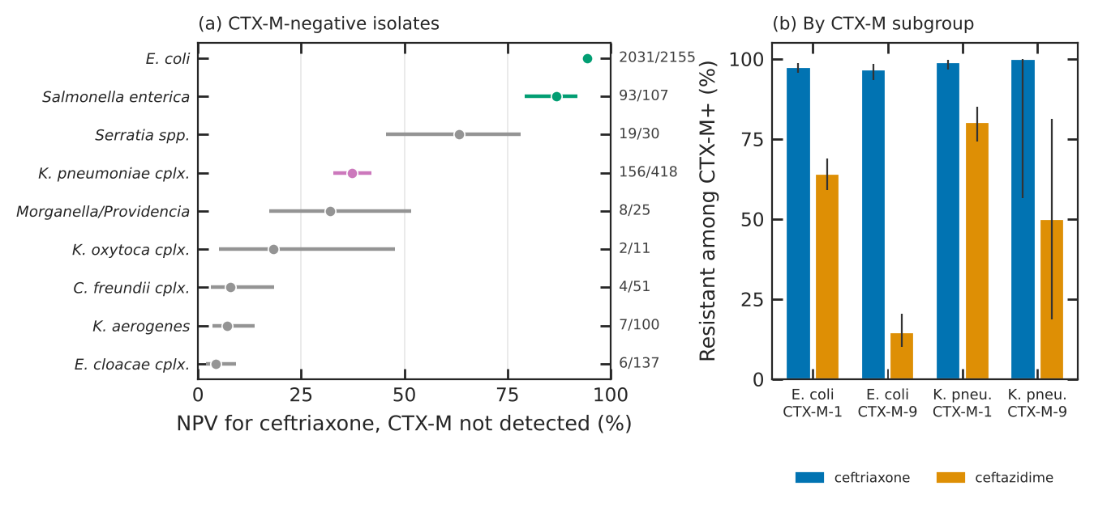
FIG. 5: CTX-M and third-generation cephalosporins. (a) NPV of a CTX-M-negative result for ceftriaxone by organism group (Wilson 95% CI; green, E. coli and Salmonella; purple, K. pneumoniae complex; gray, species with chromosomal AmpC or other intrinsic cephalosporinases). (b) Share resistant to ceftriaxone and ceftazidime among CTX-M-positive isolates, by CTX-M subgroup (CTX-M-1 group, e.g. CTX-M-15, -55; CTX-M-9 group, e.g. CTX-M-14, -27).

TABLE IX: Secondary analysis: third-generation cephalosporin resistance among CTX-M-positive isolates by CTX-M subgroup (resistant/tested, percent). Isolates carrying both subgroups or untyped CTX-M are not shown.
Organism | CTX-M subgroup | Ceftriaxone R | Cefotaxime R | Ceftazidime R
E. coli | CTX-M-1 group | 432/443 (98%) | 21/21 (100%) | 235/366 (64%)
E. coli | CTX-M-9 group | 211/218 (97%) | 5/5 (100%) | 26/179 (15%)
K. pneumoniae cplx. | CTX-M-1 group | 206/208 (99%) | 72/72 (100%) | 170/212 (80%)
K. pneumoniae cplx. | CTX-M-9 group | 5/5 (100%) | 4/4 (100%) | 3/6 (50%)

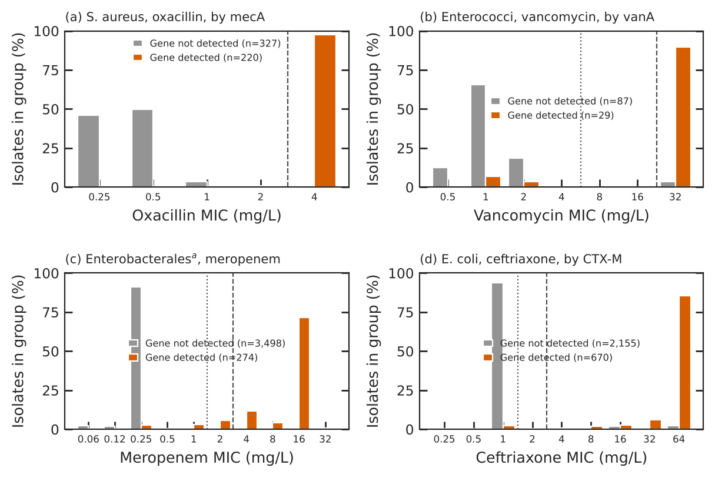
FIG. 6: MIC distributions by panel-target status. Bars show the share of isolates in each group at each MIC on the two-fold scale; censored readings are placed at their bound (≤x and ≥x at x, <x at x/2, >x at 2x) and gradient-strip half-steps are rounded up. Dotted line: susceptible breakpoint; dashed line: resistant breakpoint (CLSI M100-Ed35). (a) S. aureus, oxacillin, by mecA. (b) Enterococci, vancomycin, by vanA. (c) Enterobacterales excluding Salmonellaᵃ, meropenem, by any panel carbapenemase. (d) E. coli, ceftriaxone, by CTX-M.

D. Sensitivity analyses
The headline estimates were stable when I and SDD results were excluded instead of counted as not resistant (Table X, Fig. 7). Excluding them raised the meropenem PPV of any panel carbapenemase from 87.6% to 93.4%, because many carbapenemase producers have meropenem MICs in the intermediate range. Restricting to blood and sterile-site isolates left the mecA and carbapenemase estimates within the confidence intervals of the main analysis, with wider intervals; the NPV of CTX-M for ceftriaxone in E. coli was lower in blood isolates (80.5%, 103/128) than overall (94.2%). Accepting the submitting laboratory’s oxacillin call for S. aureus raised the mecA PPV from 97.7% to 99.1% (218/220).
TABLE X: Sensitivity analyses for the headline estimates.
Analysis | Main analysis: n | Main analysis: PPV | Main analysis: NPV | I/SDD excluded: n | I/SDD excluded: PPV | I/SDD excluded: NPV | Blood/sterile site: n | Blood/sterile site: PPV | Blood/sterile site: NPV
mecA, S. aureus, OXA/FOX | 550 | 97.7% | 99.7% | 550 | 97.7% | 99.7% | 260 | 98.7% | 100.0%
vanA/B, enterococci, VAN | 119 | 89.7% | 96.7% | 119 | 89.7% | 96.7% | 19 | 77.8% | 100.0%
KPC, Enterobacterales, any CBP | 4,147 | 98.0% | 94.3% | 4,101 | 99.5% | 94.3% | 420 | 100.0% | 93.6%
Any carbapenemase, any CBP | 4,147 | 97.8% | 96.1% | 4,101 | 98.9% | 96.0% | 420 | 97.3% | 95.0%
Any carbapenemase, MEM | 3,834 | 87.6% | 97.5% | 3,793 | 93.4% | 97.5% | 420 | 86.5% | 97.1%
CTX-M, E. coli, CRO | 2,828 | 97.2% | 94.2% | 2,825 | 97.5% | 94.2% | 262 | 98.5% | 80.5%
CTX-M, K. pneumoniae cplx., CRO | 636 | 99.1% | 37.3% | 601 | 99.1% | 31.6% | 63 | 94.4% | 28.9%

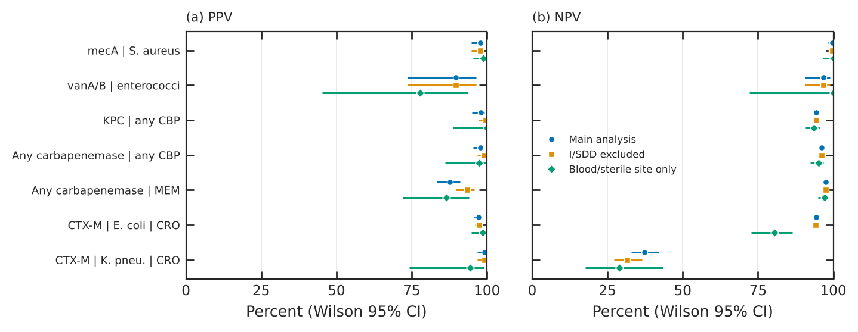
FIG. 7: Robustness of PPV (a) and NPV (b) to excluding intermediate and SDD results and to restricting to blood and sterile-site isolates, with Wilson 95% CIs. CBP, carbapenem; MEM, meropenem; CRO, ceftriaxone.

E. Discordant isolates
The discordance collection contains 970 isolate-target pairs from 872 isolates: 37 with the gene detected but no resistance, and 933 resistant without the panel target (Table XI, Fig. 8).
Gene-detected, not-resistant isolates were few. Of the 37, 7 had a measured value at or within one dilution of the resistant breakpoint, 2 had a submitter call that differed from our reinterpretation, and 28 had no explanation in the available data (Appendix Table AI). For S. aureus, in 3 of the 5 cases the submitting laboratory had reported oxacillin resistance despite the MIC. No gene-detected, not-resistant case involved a partial gene call.
Gene-negative resistant isolates were dominated by third-generation cephalosporin resistance without CTX-M (778 of 933). Of these, 268 carried an acquired non-CTX-M ESBL or AmpC, 254 belonged to a species with chromosomal AmpC, and 201 carried a panel carbapenemase, which itself confers cephalosporin resistance; 31 were unexplained. Among 151 carbapenem-resistant isolates without a panel carbapenemase, 14 carried an ESBL or AmpC with a porin change, 44 an ESBL or AmpC without a called porin change, and 31 a porin change alone, consistent with non-carbapenemase carbapenem resistance [11, 12]; 36 had a value within one dilution of the breakpoint, and 3 carried a non-panel carbapenemase (blaNMC-A, blaSME-2).
TABLE XI: Discordant isolate-target pairs by primary cause and drug class.
Primary cause | Methicillin | Vancomycin | Carbapenem | 3GCᵃ | Total
Gene detected, not resistant
Unexplained by available data | 1 | 3 | 3 | 21 | 28
MIC within one dilution of R breakpoint | 2 | – | 3 | 2 | 7
Submitter call differs from M100-Ed35 | 2 | – | – | – | 2
Subtotal | 5 | 3 | 6 | 23 | 37
Gene not detected, resistant
Acquired non-CTX-M ESBL or AmpC | – | – | – | 268 | 268
Chromosomal AmpC organism | – | – | – | 254 | 254
Panel carbapenemase present | – | – | – | 201 | 201
MIC within one dilution of R breakpoint | – | – | 36 | 23 | 59
Unexplained by available data | 1 | 2 | 23 | 31 | 57
ESBL/AmpC, no porin call | – | – | 44 | – | 44
Porin change only | – | – | 31 | – | 31
ESBL/AmpC plus porin change | – | – | 14 | – | 14
Non-panel carbapenemase | – | – | 3 | – | 3
Submitter call differs from M100-Ed35 | – | – | – | 1 | 1
vanA operon, no ligase call | – | 1 | – | – | 1
Subtotal | 1 | 3 | 151 | 778 | 933
Note: ᵃThird-generation cephalosporins.

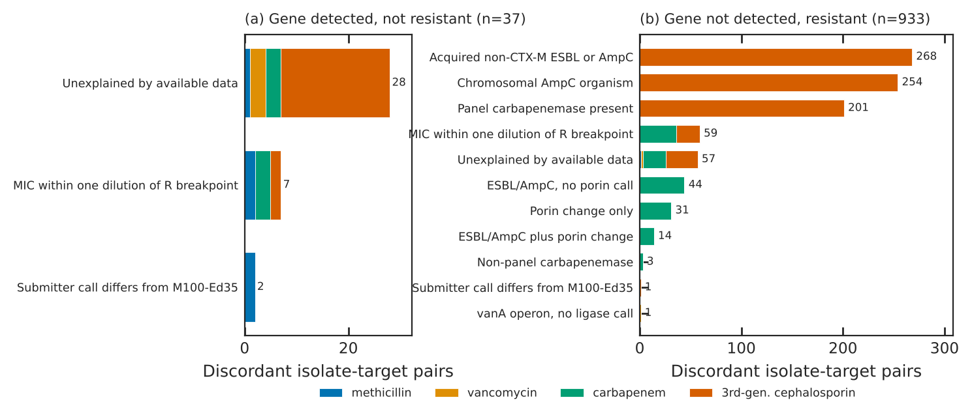
FIG. 8: Discordant isolate-target pairs by primary cause, colored by drug class. (a) Gene detected, not resistant. (b) Gene not detected, resistant. Causes are rule-based likely causes, not proven mechanisms.

IV. Discussion

A. Principal findings
Using public data alone, this benchmark measures how well the resistance targets on rapid blood culture panels predict the susceptibility result that follows, for 5,168 U.S. clinical isolates. Three patterns stand out. First, a detected target was a strong signal for most combinations: mecA for oxacillin or cefoxitin in S. aureus (97.7%), KPC and NDM for any carbapenem (98.0% and 100.0%), and CTX-M for ceftriaxone (97.7%) all had PPVs above 97%. Second, a negative result was organism-dependent: excellent for mecA in S. aureus and good for CTX-M in E. coli, but weak for CTX-M in K. pneumoniae and nearly uninformative in chromosomal AmpC species. Third, the drug matters as much as the gene: carbapenemase producers were almost always ertapenem-resistant but often meropenem-susceptible, and CTX-M-9-group producers were usually ceftazidime-susceptible.

B. Interpretation by target
1. mecA. The near-complete separation of oxacillin MICs by mecA status agrees with earlier genome-based studies of S. aureus [17]. The mecA-positive, oxacillin-susceptible isolates resemble oxacillin-susceptible MRSA, which can be missed by phenotypic testing [33]. Because CLSI directs that S. aureus positive for mecA or PBP2a be reported as oxacillin-resistant [26], the laboratory call and the MIC can legitimately differ; we kept the MIC to avoid circularity and report both.
2. vanA. The vanA-positive, vancomycin-susceptible E. faecium are consistent with vancomycin-variable enterococci, which can revert to resistance under glycopeptide exposure [14, 15]. For a panel result this means that a positive vanA should not be over-ruled by an early susceptible phenotype. The enterococcal sample is small, and the absence of vanB means this release cannot estimate vanB performance.
3. Carbapenemases. High PPV for “any carbapenem” coexisted with lower PPV for meropenem. OXA-48-like enzymes hydrolyze carbapenems weakly and often leave meropenem MICs below the resistant breakpoint [13]. The same pattern was common for IMP (only 3/8 meropenem-resistant) and less common for KPC (182/201). Treatment guidance distinguishes carbapenemase producers by enzyme class rather than by meropenem MIC [34], so a carbapenemase-positive, meropenem-susceptible isolate is not a panel error but a reason to report enzyme and MIC together. Conversely, about a third of carbapenem-resistant isolates had no panel carbapenemase, most with an ESBL or AmpC and porin change; non-carbapenemase carbapenem-resistant Enterobacterales differ clinically from carbapenemase producers [11]. A negative carbapenemase panel therefore rules out the five enzymes, not carbapenem resistance, particularly in Enterobacter and K. aerogenes.
4. CTX-M. The weak NPV of CTX-M outside E. coli reflects well-known biology: SHV- and TEM-type ESBLs and plasmid AmpC in K. pneumoniae [9], and chromosomal AmpC in Enterobacter, K. aerogenes and Citrobacter [10]. The subgroup analysis shows that CTX-M is not one phenotype: CTX-M-15 and related CTX-M-1-group enzymes commonly confer ceftazidime resistance, whereas CTX-M-14 and CTX-M-27 usually do not; together these two were the second and third commonest CTX-M alleles in this collection (CTX-M-27 in 182 isolates and CTX-M-14 in 64), consistent with the spread of CTX-M-27 described elsewhere [8]. Panels report “CTX-M” without the subgroup, so a CTX-M result predicts ceftriaxone resistance far better than ceftazidime resistance.

C. Implications
These estimates can inform how laboratories word panel reports and how stewardship programs write escalation and de-escalation rules, for example by pairing a negative CTX-M result in Enterobacter with a comment that cephalosporin resistance remains possible, or by reporting a carbapenemase result together with the eventual meropenem MIC. They are not a substitute for local validation; predictive values depend on local prevalence, and this collection is enriched for resistance. Because the benchmark is open and versioned, a laboratory can filter it to the organisms, specimens and years that resemble its own population, and the annual update will show whether estimates drift as new genomes are deposited.

D. Strengths
The benchmark uses only public data, so every number can be checked against NCBI records by anyone. All isolate-drug results were reinterpreted against one breakpoint edition rather than taken from submitters’ mixed interpretations. Genes were mapped through NCBI’s own hierarchy, and every discordant isolate is released with its genotype, its measured values and the rule that labeled it. The full pipeline rebuilds the release byte for byte.

E. Limitations
- Genome calls stand in for panel calls. AMRFinderPlus results from assembled genomes do not capture panel primer coverage, limits of detection, mixed cultures or specimen effects. The benchmark estimates how well the presence of the gene predicts the phenotype, not how a commercial panel performs.
- Selection. Isolates are those that laboratories and surveillance programs chose to sequence with susceptibility data. Resistant organisms and outbreak investigations are over-represented, which raises PPV and lowers NPV relative to an unselected population.
- Concentration. One submitter contributed 40% of isolates; its platform, drug panel and selection rules shape the results. All District of Columbia locations are the submitter’s.
- Sparse arms. Enterococci, VIM and IMP are few, and vanB and mecC are absent.
- Heterogeneous testing. Results come from many laboratories and methods without central re-testing; a small number of submitted values were not valid MICs.
- Cause labels are rule-based. Expression changes, porin loss not called by AMRFinderPlus, heteroresistance, mixed cultures and assembly errors cannot be distinguished with public data.
- Mixed AMRFinderPlus versions. NCBI analyzed isolates with several database versions; newer versions may call genes that older runs missed.
- Coverage. NCBI Pathogen Detection has no Proteus group, so Proteus is absent; specimen categories are inferred from free text.

V. Conclusions
Public genome and susceptibility data are now sufficient to measure, gene by gene and organism by organism, how well the resistance targets on rapid blood culture panels predict the susceptibility result that follows. In 5,168 U.S. clinical isolates, detected targets were strong predictors of resistance, while negative results were reliable only for some organisms; the drug, the enzyme and the CTX-M subgroup all changed the answer. The benchmark, crosswalk, discordance collection, code and lookup page are released openly and will be updated annually, so that laboratories can check these figures against their own populations and track how they change.

Data and code availability
All data, code and documentation are available at https://github.com/FatimaAbdulwahab/us-rapid-panel-amr-concordance [24], including the isolate-level benchmark, the full concordance table (1,033 rows), the discordance case collection, the gene-to-panel crosswalk, the breakpoint table, a codebook and a provenance log with source URLs, access dates, sizes and SHA-256 fingerprints. The public lookup page is at https://fatimaabdulwahab.github.io/us-rapid-panel-amr-concordance/. Zenodo archives: benchmark, DOI to be assigned on deposit; crosswalk, DOI to be assigned on deposit; discordance collection, DOI to be assigned on deposit. Data are released under CC BY 4.0 and code under the MIT license.

Author contributions
F.A.: conceptualization, methodology, data curation, formal analysis, validation, visualization, writing (original draft, review and editing).

Competing interests
The author declares no competing interests and no relationship with any manufacturer of rapid diagnostic panels.

Funding
This work received no specific funding.

Use of AI tools
Claude (Anthropic) assisted with code, data processing, figure generation and drafting of this manuscript. The author made the analytic decisions, verified the outputs against NCBI records and the published breakpoint standard, and takes responsibility for the content.

Acknowledgments
The author thanks the laboratories and public-health programs that deposited genomes and susceptibility results at NCBI, and the NCBI Pathogen Detection team for maintaining AMRFinderPlus and the Reference Gene Catalog.

References
[1] Centers for Disease Control and Prevention. Antibiotic Resistance Threats in the United States, 2019. U.S. Department of Health and Human Services, CDC, Atlanta, GA, 2019. doi:10.15620/cdc:82532.
[2] Mohsen Naghavi et al. Global burden of bacterial antimicrobial resistance 1990–2021: a systematic analysis with forecasts to 2050. The Lancet, 404(10459):1199-1226, 2024. doi:10.1016/s0140-6736(24)01867-1
[3] Federal Task Force on Combating Antibiotic-Resistant Bacteria. National Action Plan for Combating Antibiotic-Resistant Bacteria, 2020–2025. U.S. Department of Health and Human Services, Washington, DC, 2020. https://aspe.hhs.gov/reports/national-action-plan-combating-antibiotic-resistant-bacteria-2020-2025.
[4] Tristan T. Timbrook et al. The Effect of Molecular Rapid Diagnostic Testing on Clinical Outcomes in Bloodstream Infections: A Systematic Review and Meta-analysis. Clin Infect Dis., 64(1):15-23, 2017. doi:10.1093/cid/ciw649
[5] Ritu Banerjee and Romney Humphries. Rapid Antimicrobial Susceptibility Testing Methods for Blood Cultures and Their Clinical Impact. Front. Med., 8:635831, 2021. doi:10.3389/fmed.2021.635831
[6] Anna Maria Peri et al. Performance of BioFire Blood Culture Identification 2 Panel (BCID2) for the detection of bloodstream pathogens and their associated resistance markers: a systematic review and meta-analysis of diagnostic test accuracy studies. BMC Infect Dis, 22(1):794, 2022. doi:10.1186/s12879-022-07772-x
[7] Naoki Uno et al. Multicenter evaluation of the Verigene Gram-negative blood culture nucleic acid test for rapid detection of bacteria and resistance determinants in positive blood cultures. Diagnostic Microbiology and Infectious Disease, 83(4):344-348, 2015. doi:10.1016/j.diagmicrobio.2015.08.004
[8] Edward R. Bevan, Annie M. Jones, and Peter M. Hawkey. Global epidemiology of CTX-M β-lactamases: temporal and geographical shifts in genotype. Journal of Antimicrobial Chemotherapy, 72(8):2145-2155, 2017. doi:10.1093/jac/dkx146
[9] Karen Bush and Patricia A. Bradford. Epidemiology of β-Lactamase-Producing Pathogens. Clin Microbiol Rev, 33(2):e00047-19, 2020. doi:10.1128/cmr.00047-19
[10] George A. Jacoby. AmpC β-Lactamases. Clin Microbiol Rev, 22(1):161-182, 2009. doi:10.1128/cmr.00036-08
[11] Pranita D. Tamma et al. Comparing the Outcomes of Patients With Carbapenemase-Producing and Non-Carbapenemase-Producing Carbapenem-Resistant Enterobacteriaceae Bacteremia. Clinical Infectious Diseases, 64(3):257-264, 2017. doi:10.1093/cid/ciw741
[12] Johann D. D. Pitout, Patrice Nordmann, and Laurent Poirel. Carbapenemase-Producing Klebsiella pneumoniae, a Key Pathogen Set for Global Nosocomial Dominance. Antimicrob Agents Chemother, 59(10):5873-5884, 2015. doi:10.1128/aac.01019-15
[13] L. Poirel, A. Potron, and P. Nordmann. OXA-48-like carbapenemases: the phantom menace. Journal of Antimicrobial Chemotherapy, 67(7):1597-1606, 2012. doi:10.1093/jac/dks121
[14] Tom A. Szakacs et al. Outbreak of Vancomycin-Susceptible Enterococcus faecium Containing the Wild-Type vanA Gene. J Clin Microbiol, 52(5):1682-1686, 2014. doi:10.1128/jcm.03563-13
[15] Victoria Jordan and Hemalatha Varadhan. Detection of vanA genes in vancomycin-susceptible Enterococcus faecium isolates: implications for additional testing. Access Microbiology, 7(4), 2025. doi:10.1099/acmi.0.000959.v4
[16] N. Stoesser et al. Predicting antimicrobial susceptibilities for Escherichia coli and Klebsiella pneumoniae isolates using whole genomic sequence data. Journal of Antimicrobial Chemotherapy, 68(10):2234-2244, 2013. doi:10.1093/jac/dkt180
[17] N. C. Gordon et al. Prediction of Staphylococcus aureus Antimicrobial Resistance by Whole-Genome Sequencing. J Clin Microbiol, 52(4):1182-1191, 2014. doi:10.1128/jcm.03117-13
[18] Michael Feldgarden et al. Validating the AMRFinder Tool and Resistance Gene Database by Using Antimicrobial Resistance Genotype-Phenotype Correlations in a Collection of Isolates. Antimicrob Agents Chemother, 63(11):e00483-19, 2019. doi:10.1128/aac.00483-19
[19] Michelle Su, Sarah W. Satola, and Timothy D. Read. Genome-Based Prediction of Bacterial Antibiotic Resistance. J Clin Microbiol, 57(3):e01405-18, 2019. doi:10.1128/jcm.01405-18
[20] M.J. Ellington et al. The role of whole genome sequencing in antimicrobial susceptibility testing of bacteria: report from the EUCAST Subcommittee. Clinical Microbiology and Infection, 23(1):2-22, 2017. doi:10.1016/j.cmi.2016.11.012
[21] Michael Feldgarden et al. AMRFinderPlus and the Reference Gene Catalog facilitate examination of the genomic links among antimicrobial resistance, stress response, and virulence. Sci Rep, 11(1):12728, 2021. doi:10.1038/s41598-021-91456-0
[22] Eric W Sayers et al. Database resources of the National Center for Biotechnology Information in 2025. Nucleic Acids Research, 53(D1):D20-D29, 2025. doi:10.1093/nar/gkae979
[23] National Center for Biotechnology Information. Pathogen Detection. https://www.ncbi.nlm.nih.gov/pathogens/. Data accessed 24 October 2026.
[24] Fatima Abdulwahab. U.S. Rapid Panel Resistance Marker Concordance Benchmark, version 1.0.0. Code and data: https://github.com/FatimaAbdulwahab/us-rapid-panel-amr-concordance; lookup page: https://fatimaabdulwahab.github.io/us-rapid-panel-amr-concordance/; Zenodo archive DOI to be assigned on deposit.
[25] Eric Sayers. A General Introduction to the E-utilities. In Entrez Programming Utilities Help. National Center for Biotechnology Information, Bethesda, MD. https://www.ncbi.nlm.nih.gov/books/NBK25499/.
[26] Clinical and Laboratory Standards Institute. Performance Standards for Antimicrobial Susceptibility Testing. CLSI supplement M100, 35th edition. Clinical and Laboratory Standards Institute, Wayne, PA, 2025.
[27] U.S. Food and Drug Administration. Antibacterial Susceptibility Test Interpretive Criteria. https://www.fda.gov/drugs/development-resources/antibacterial-susceptibility-test-interpretive-criteria. Accessed 24 October 2026.
[28] N. Caroff et al. Analysis of the effects of -42 and -32 ampC promoter mutations in clinical isolates of Escherichia coli hyperproducing AmpC. Journal of Antimicrobial Chemotherapy, 45(6):783-788, 2000. doi:10.1093/jac/45.6.783
[29] Edwin B. Wilson. Probable Inference, the Law of Succession, and Statistical Inference. Journal of the American Statistical Association, 22(158):209-212, 1927. doi:10.1080/01621459.1927.10502953
[30] Wes McKinney. Data Structures for Statistical Computing in Python. Proceedings of the Python in Science Conference, 56–61, 2010. doi:10.25080/majora-92bf1922-00a
[31] John D. Hunter. Matplotlib: A 2D Graphics Environment. Comput. Sci. Eng., 9(3):90-95, 2007. doi:10.1109/mcse.2007.55
[32] Michael Waskom. seaborn: statistical data visualization. JOSS, 6(60):3021, 2021. doi:10.21105/joss.03021
[33] E. Petinaki. Emergence of two oxacillin-susceptible mecA-positive Staphylococcus aureus clones in a Greek hospital. Journal of Antimicrobial Chemotherapy, 50(6):1090-1091, 2002. doi:10.1093/jac/dkf235
[34] Pranita D Tamma et al. Infectious Diseases Society of America 2024 Guidance on the Treatment of Antimicrobial-Resistant Gram-Negative Infections. Clinical Infectious Diseases, ciae403, 2024. doi:10.1093/cid/ciae403

Appendix: gene-detected, not-resistant isolates (excluding CTX-M)
TABLE AI: Every isolate in which mecA, vanA or a panel carbapenemase was detected but the isolate was not resistant to the paired drug or composite. Phenotype gives each drug’s MIC (mg/L) or zone diameter (mm) and final category; “(sub.)” marks a submitter call. The 23 CTX-M cases are in the released discordance file.
BioSample | Organism | Allele | Phenotype (MIC mg/L or zone mm → category) | Primary cause
SAMN04393399 | K. pneumoniae cplx. | KPC-3 | meropenem 21 mm → I (disk); imipenem 21 mm → I (disk); ertapenem 20 mm → I (disk) | MIC within one dilution of R breakpoint
SAMN05170250 | E. coli | KPC-3 | meropenem ≤1 → S; imipenem 2 → I; ertapenem 1 → I; doripenem 2 → I | MIC within one dilution of R breakpoint
SAMN05170257 | E. coli | KPC-4 | meropenem <0.25 → S; imipenem ≤1 → S; ertapenem 1 → I; doripenem <0.25 → S | MIC within one dilution of R breakpoint
SAMN36729117 | C. freundii cplx. | KPC-4 | meropenem ≤0.25 → S | Unexplained by available data
SAMN03075590 | Morganella/Providencia | OXA-181 | meropenem 1 → S; ertapenem ≤0.5 → S | Unexplained by available data
SAMN48878816 | E. coli | OXA-244 | meropenem ≤0.25 → S; imipenem ≤0.25 → S | Unexplained by available data
SAMN12476193 | S. aureus | mecA | oxacillin 2 → S | MIC within one dilution of R breakpoint
SAMN38228831 | S. aureus | mecA | oxacillin 0.5 → S | Unexplained by available data
SAMN38637651 | S. aureus | mecA | oxacillin ≤0.25 → S | Submitter call differs from M100-Ed35
SAMN38637652 | S. aureus | mecA | oxacillin 1 → S | Submitter call differs from M100-Ed35
SAMN48878967 | S. aureus | mecA | oxacillin 2 → S | MIC within one dilution of R breakpoint
SAMN09728854 | E. faecium | vanA | vancomycin ≤2 → S | Unexplained by available data
SAMN36892852 | E. faecium | vanA | vancomycin 1 → S | Unexplained by available data
SAMN39956425 | E. faecium | vanA | vancomycin 1 → S | Unexplained by available data

* abdulwahabfatima43@gmail.com

