Prompt Log: Dhaba Menu Website
Name: Fatima Ajmal Abbasi | Roll No: i263093 | Section: B | AI tool: Gemini

Prompt 1: in front of the “prompts.docx :”
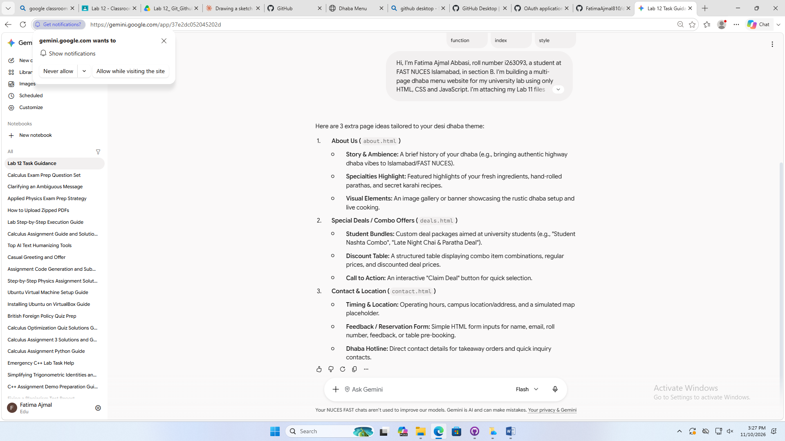
prompts.docx :
Prompt: Hi, I’m Fatima Ajmal Abbasi, roll number i263093, a student at FAST NUCES Islamabad, in section B. I’m building a multi-page dhaba menu website for my university lab using only HTML, CSS and JavaScript. I’m attaching my Lab 11 files. The theme is a desi dhaba, with a cream background, brown text, orange buttons and the Arial font. Please suggest 3 extra pages that suit this theme, and what each could contain. Don’t write any code yet.
Results:
Gemini suggested three pages: About Us, Special Deals and Contact & Location. I will use these pages along with my existing home page.

Prompt 2: About page and navigation bar
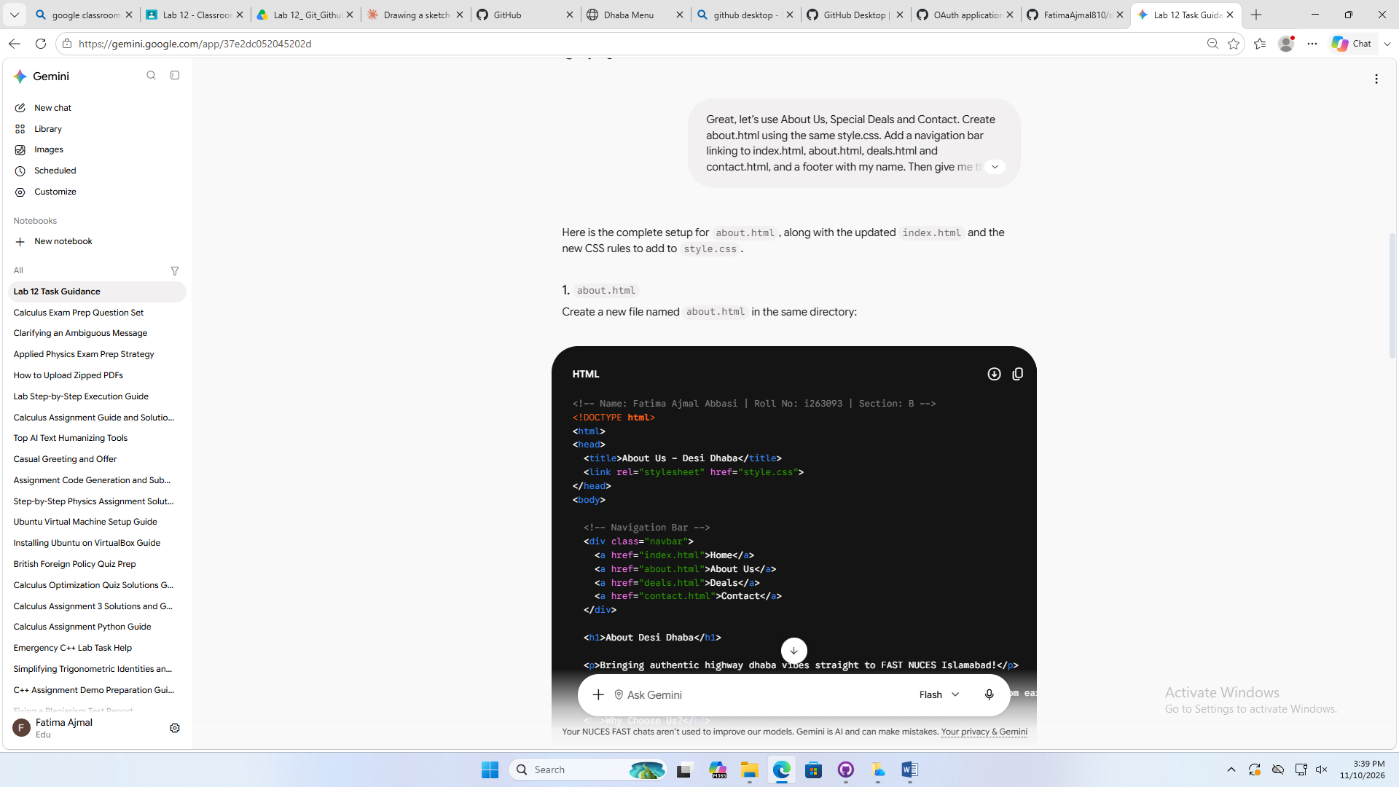
Prompt:
Great, let’s use About Us, Special Deals and Contact. Create about.html using the same style.css. Add a navigation bar linking to index.html, about.html, deals.html and contact.html, and a footer with my name. Then give me the updated index.html with the same navigation bar and footer, and any new CSS to add to style.css. Use lowercase file names only.
Result :
The pages worked. I tested the links and the Order button.

Prompt 3: Deals page
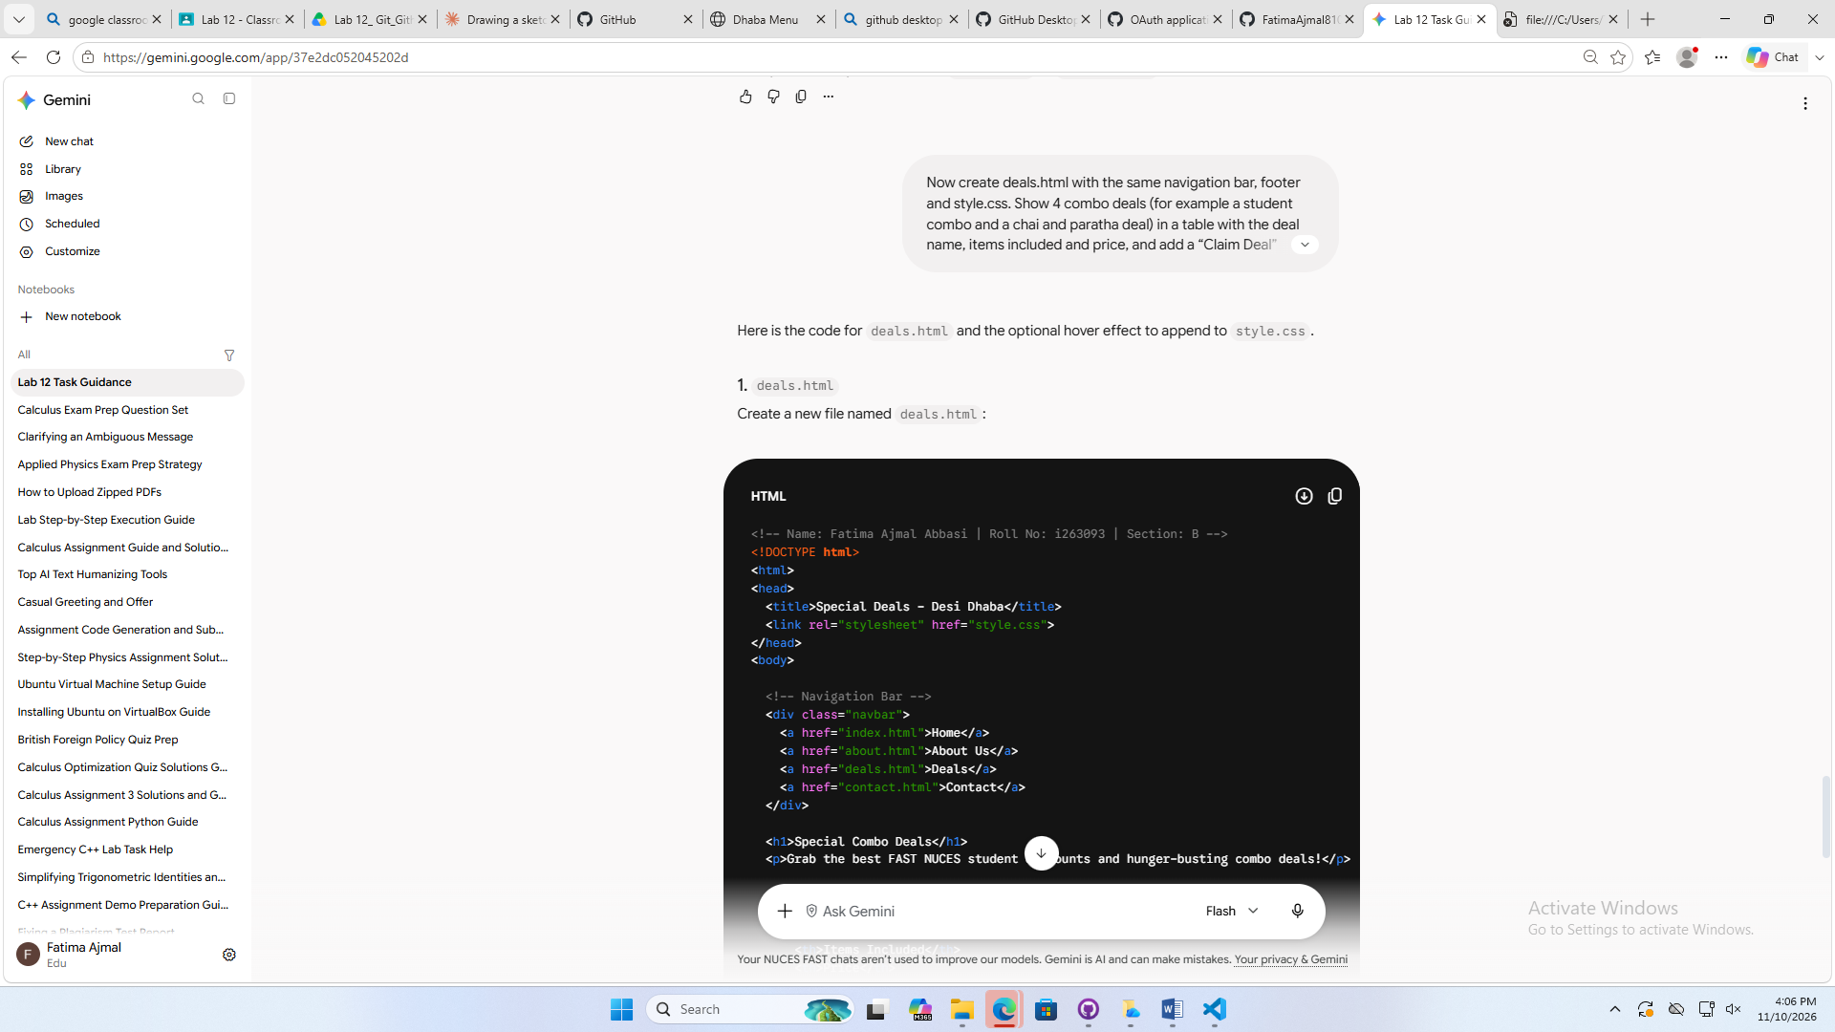
Prompt:
Now create deals.html with the same navigation bar, footer and style.css. Show 4 combo deals (for example a student combo and a chai and paratha deal) in a table with the deal name, items included and price, and add a “Claim Deal” button that shows window.alert(“Deal claimed!”). Give me only deals.html and any new CSS to add to the bottom of style.css.
Results :
Gemini gave me three parts: a new about.html, an updated index.html with a navigation bar and footer, and new CSS for style.css. I created about.html, replaced index.html, and added the CSS. I tested the links and the Order button, and they worked.

Prompt 4: Contact page
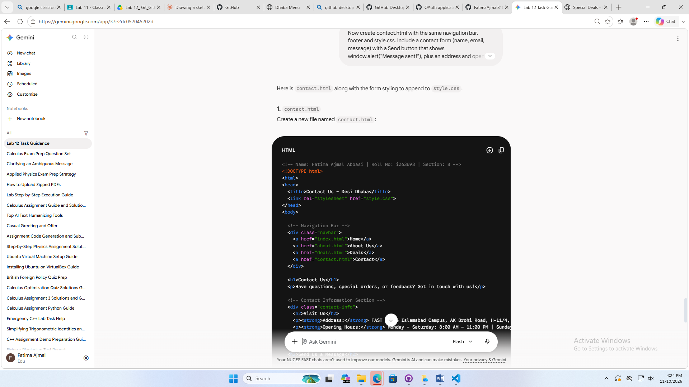
Prompt:
Now create contact.html with the same navigation bar, footer and style.css. Include a contact form (name, email, message) with a Send button that shows window.alert(“Message sent!”), plus an address and opening hours. Give me only contact.html and any new CSS to add to the bottom of style.css.
Result:
Gemini gave me contact.html with a contact form, an address and opening hours, plus CSS for style.css. I created the file, added the CSS and tested that the Send button shows an alert.

