Yarmouk University


DA450 : DEEP LEARNING AND NEURAL NETWORKS
Violence Classification
Students' name:
- فاطمه الحجة
- غادة أبو فضالة
- تقى الغزلان
- عبير عليمات
- مجد العمري
Supervisor: Dr. Zeyad Hailat

FIRST TERM 2024

Introduction
In recent years, the proliferation of video content across various platforms has raised significant concerns regarding the presence of violent material. Detecting such content efficiently is crucial for ensuring user safety and compliance with community guidelines. This project aims to develop an automated model for detecting violent and non-violent content in videos using a 3D Convolutional Neural Network (CNN).
3D CNNs are particularly suited for video analysis as they can capture spatial and temporal features simultaneously, unlike traditional 2D CNNs, which only analyze spatial information. By considering both the spatial dimensions of each video frame and the temporal sequence of frames, the model can learn complex patterns associated with violence.
The project utilizes TensorFlow and Keras as the primary frameworks, which provide robust functionality for building and training deep learning models. Several techniques have been employed throughout the project, including data preprocessing, model training, and evaluation strategies, all aimed at achieving accurate classification of video content.
The overall goal is to create a reliable and efficient system that can assist in automatic content moderation, thereby enhancing the safety and user experience on digital platforms.
Dataset
The dataset used for this project consists of video samples categorized into two distinct classes: Violence and Non-Violence (1000 sample for each class).
To ensure a robust evaluation of the model's performance, the dataset was divided into three subsets:
- Training Set (70%)
- Validation Set (15%)
- Testing Set (15%)

Data Preparation
Video Processing
In this project, frame extraction was performed using a technique known as uniform sampling. This approach ensures that frames are evenly sampled throughout the video, providing a consistent representation of the content without bias towards any particular segment.

Each extracted frame underwent several preprocessing steps:
- Grayscale Conversion: Each frame was converted to grayscale to reduce computational complexity and focus on structural features rather than color information.
- Resizing: The frames were resized to a standard dimension of 224x224 pixels. This standardization is crucial for ensuring that all input data is compatible with the model's architecture.
- Normalization: The pixel values of each frame were normalized by dividing by 255.0. This scaling transforms the pixel values into a range between 0 and 1, which is beneficial for the training process as it helps in faster convergence.
The load_data function was then utilized to compile all video frames and their associated labels into NumPy arrays. The resulting arrays were subsequently expanded to accommodate the channel dimension, transforming each video into a format suitable for input into the 3D CNN model.

Model Architecture
The core of the project is a 3D Convolutional Neural Network (CNN) constructed using Keras. This architecture is specifically designed to handle the spatiotemporal nature of video data. The model consists of the following layers:
- Convolutional Layers: The model includes three 3D convolutional layers, each designed to extract spatial and temporal features from the video frames. The first layer employs 64 filters, the second layer uses 128 filters, and the third layer comprises 256 filters. Each convolutional layer is followed by MaxPooling and BatchNormalization layers, which help reduce dimensionality, enhance training stability, and mitigate overfitting.
- Flatten Layer: After the final convolutional layer, a Flatten layer is employed to transform the 3D output into a 1D vector. This conversion is necessary for connecting the convolutional portion of the network with the fully connected layers.
- Dense Layers: The model features a fully connected layer with 512 neurons, which allows for the aggregation of features learned in the previous layers. To combat overfitting, a Dropout layer is included before the output layer. The final layer uses a sigmoid activation function to produce a binary classification output, determining whether the content is violent or non-violent.
Model’s Architecture:
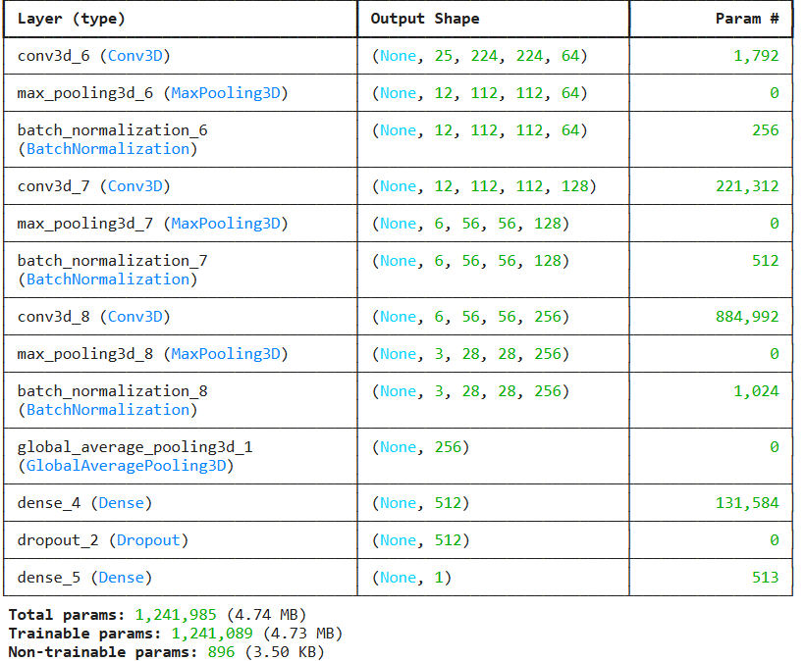
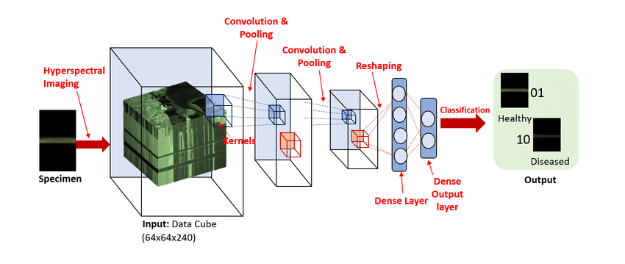
Reference: ResearchGate “ 3D Convolutional Neural Network Architecture for Classification. | Download Scientific Diagram”

Training Process
The training of the model was a critical phase in the project, utilizing the Adam optimizer due to its efficiency and effectiveness in handling sparse gradients and adapting the learning rate. The binary cross-entropy loss function was employed, which is standard for binary classification tasks, as it quantifies the difference between the predicted probabilities and the actual binary labels.
Training involved 15 epochs, during which the model iteratively adjusted its weights based on the training data. After each epoch, the model's performance was evaluated on the validation set, allowing for real-time feedback on its learning progress. This evaluation helped in identifying potential overfitting and in fine-tuning hyperparameters to optimize performance.
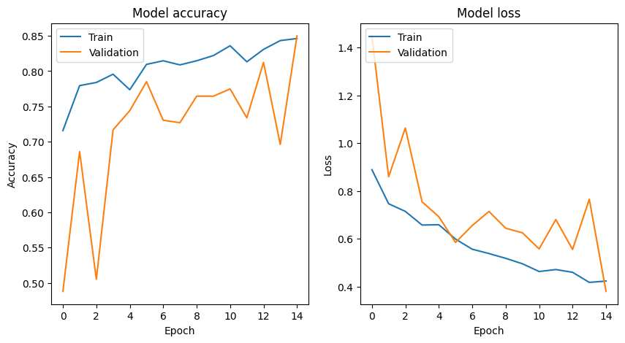
Performance Metrics
To thoroughly assess the model's performance, several key metrics were calculated:
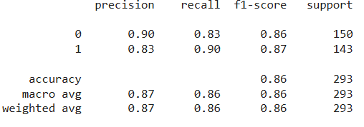
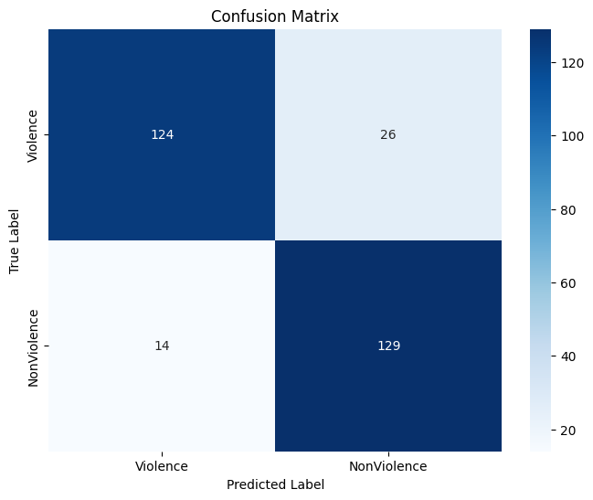
classification results. This matrix provided a clear breakdown of true positives, true negatives, false positives, and false negatives, allowing for a better understanding of the model's classification capabilities.

Ensemble Learning
To further enhance the model's performance, an ensemble approach was utilized. This method involved combining predictions from two different models that were trained on the same dataset. The rationale behind this approach is that by leveraging the strengths of multiple models, the overall classification accuracy can be improved.
Initially, we developed a second model that incorporated regularization techniques, which aimed to reduce overfitting. While this model achieved an accuracy of approximately 81%, the first model without regularization demonstrated a higher accuracy of 86%. However, upon examining the confusion matrices for both models, we noticed some discrepancies in their classifications. This observation prompted us to explore an ensemble method.
The ensemble model averaged the predictions of both individual models, taking into account the probability outputs. By applying a threshold of 0.45 to these averaged probabilities, the ensemble approach was able to synergize the strengths of both models. This cooperative learning strategy resulted in a more robust and generalized model, ultimately increasing the accuracy to around 90%. The confusion matrix for the ensemble model indicated effective differentiation between violent and non-violent classes, showcasing high precision and recall rates, which reflects the model's reliability in real-world applications.
Results
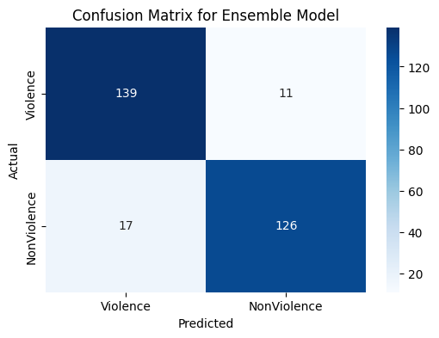
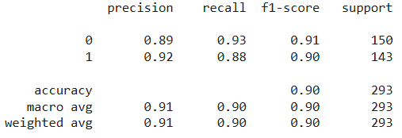
These metrics underscore the model's capability to accurately identify violent content while minimizing false classifications, which is crucial for applications in content moderation.
Conclusion
The project successfully established a comprehensive dataset and developed a robust model for recognizing violence in videos. The Real Life Violence Situations Dataset serves as a valuable resource for future research and development in video analysis and violence recognition. The findings highlight the effectiveness of deep learning techniques in this domain, and continued advancements in these methodologies can further enhance the models' capabilities. This work paves the way for real-time applications in surveillance, safety monitoring, and content moderation, ultimately contributing to safer online environments.

