

THE UNIVERSITY OF AZAD JAMMU & KASHMIR, MUZAFFARABAD
Name | Fatima Arshad
COURSE TILE | Computer Networks
Lab. | 06
ROLL NUMBER | 2024-SE-24
INSTRUCTOR NAME | ENGR. DR. ASMA JAVED

Star Topology

Introduction

A star topology is a network configuration in which all devices (computers, printers, etc.) are connected to a central device called a switch. The switch manages communication between devices, making the network efficient, reliable, and easy to troubleshoot.

To design and configure a star topology using a switch and assign IP addresses to ensure communication between devices.

Procedure
1: Open Simulation Software
Open Cisco Packet Tracer and prepare a blank workspace for network design.

2: Add Devices
Place one switch at the center and add multiple PCs around it to form a star topology.

3: Connect Devices to Switch
Connect each PC to the switch using straight-through cables (all links should turn green).

4: Configure IP Addresses
Assign unique IP addresses to each PC within the same network (e.g., 192.168.1.x with subnet mask 255.255.255.0).

5: Verify Connectivity
Use the ping command between PCs and also test using simulation mode to observe packet flow through the switch.
Step 1 & 2: Adding Switch and PCs (Star Layout)
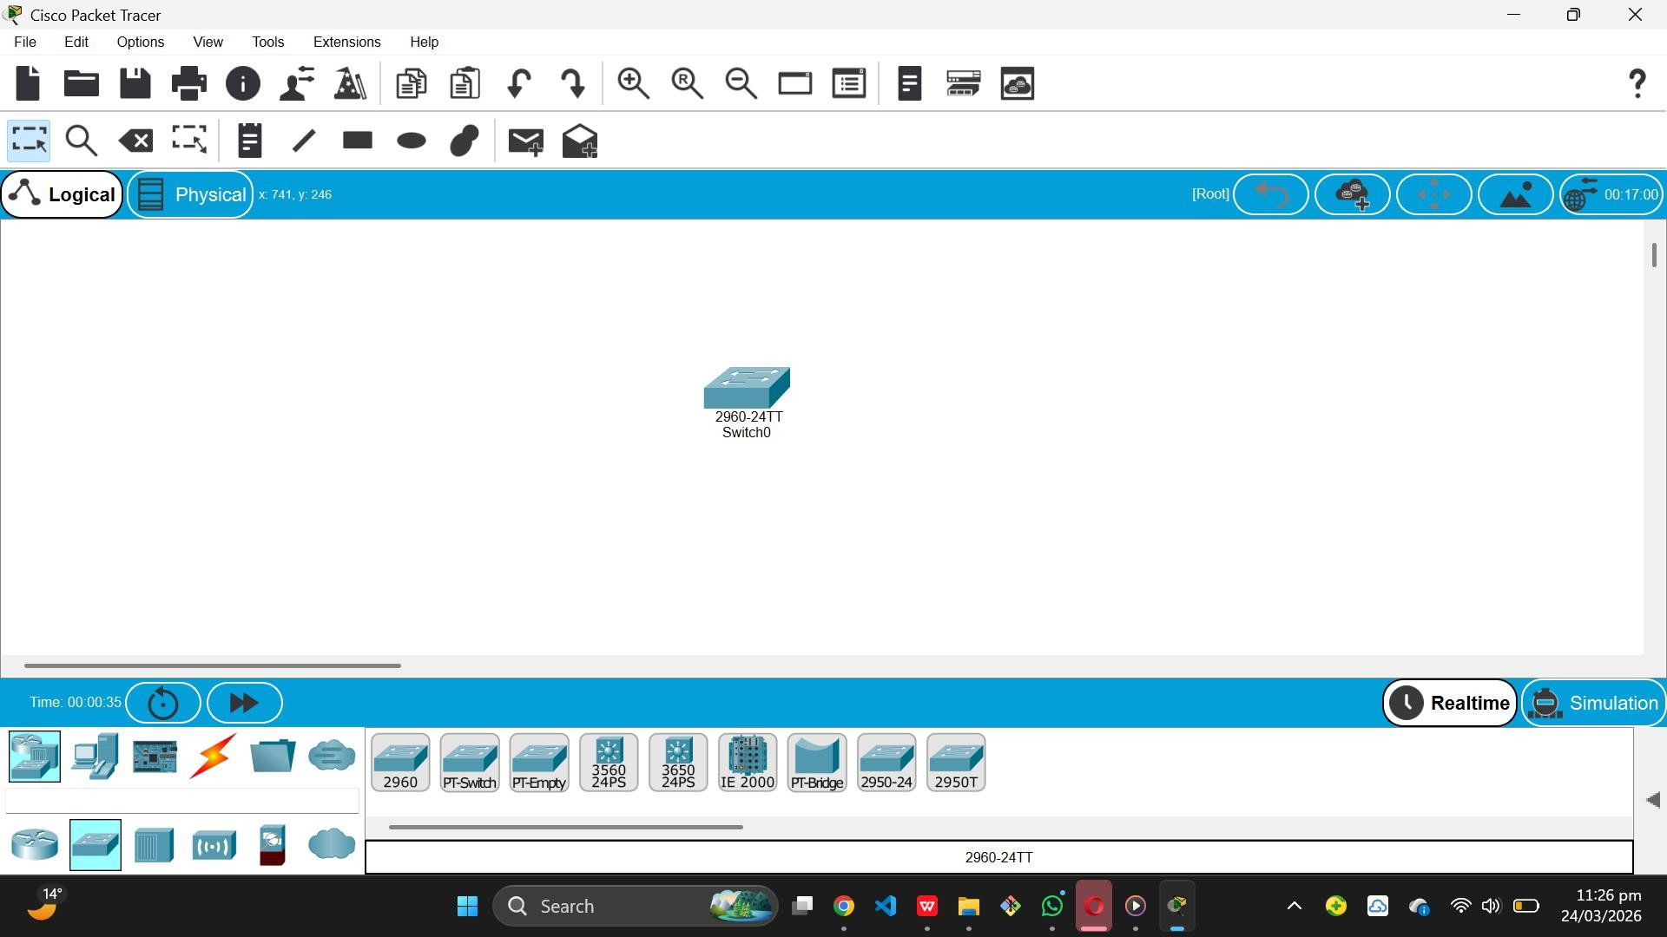

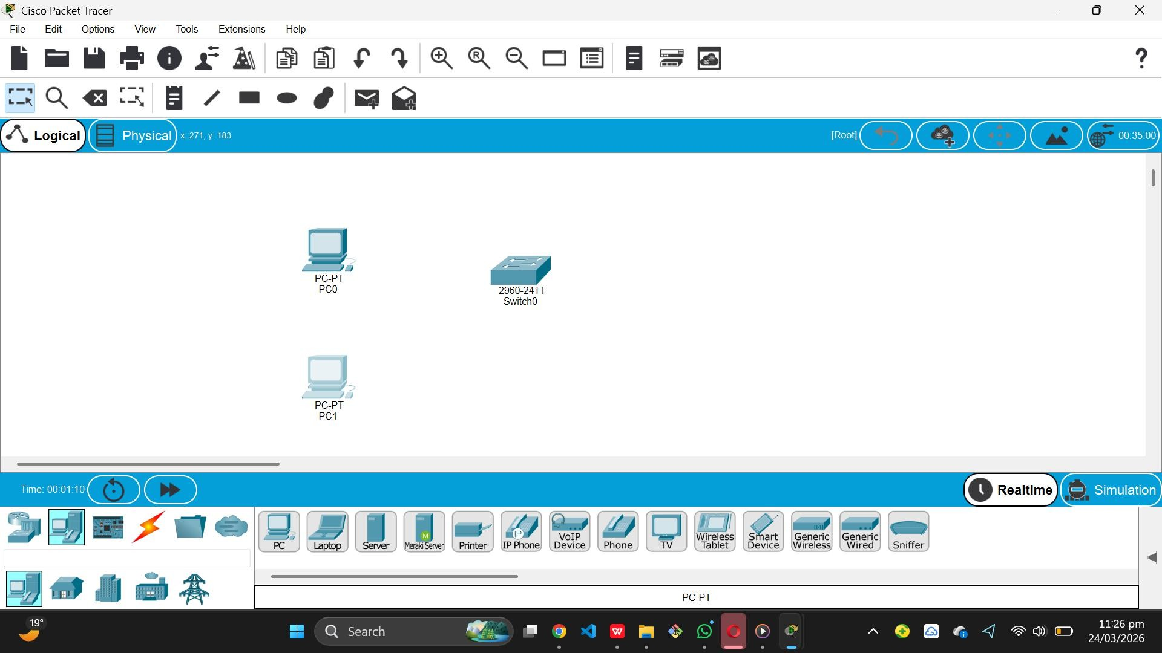

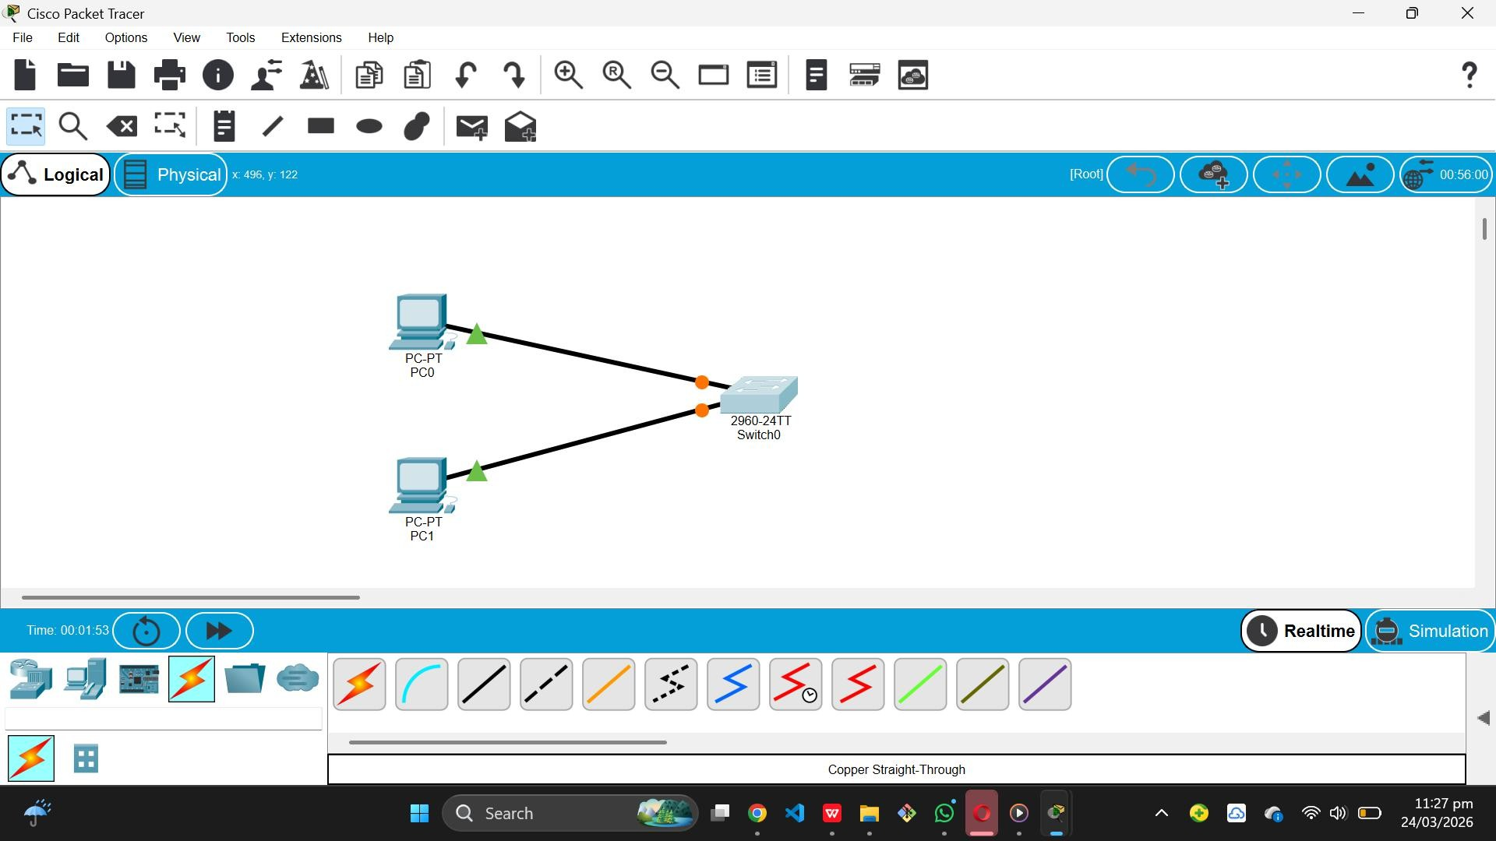
Step 3: Connecting Devices to Switch

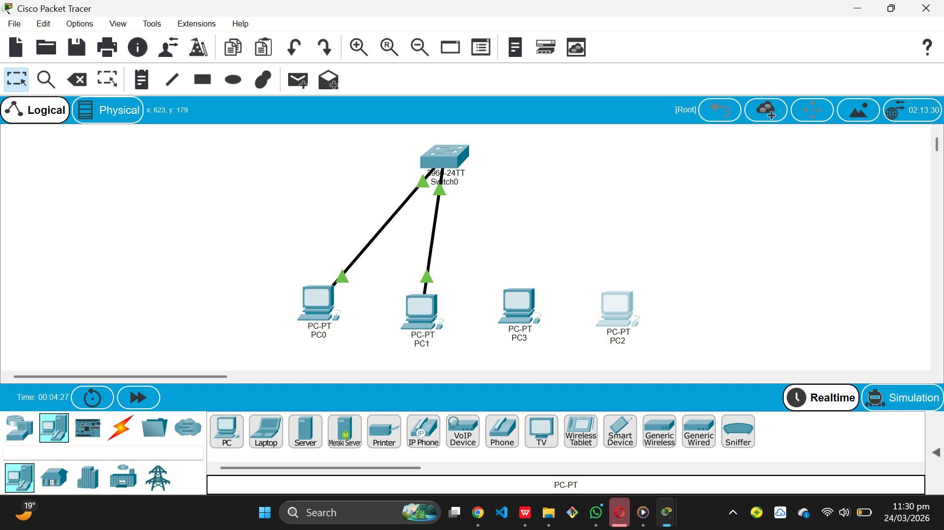

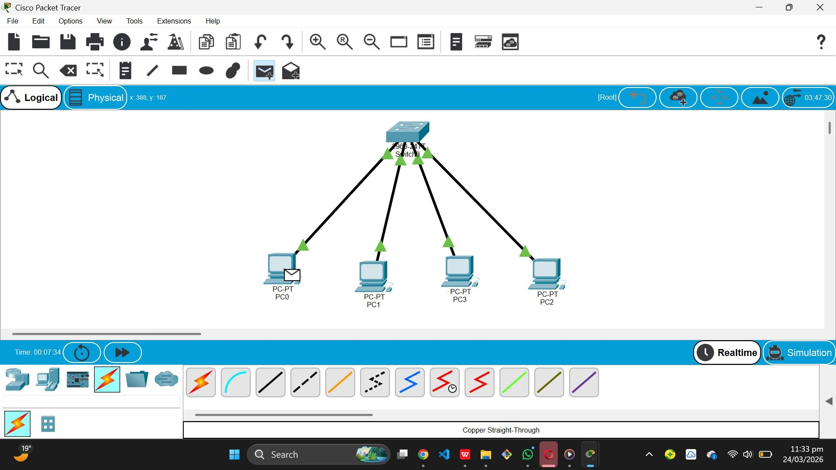

- Step 4: Configuring IP Addresses (Multiple PCs)
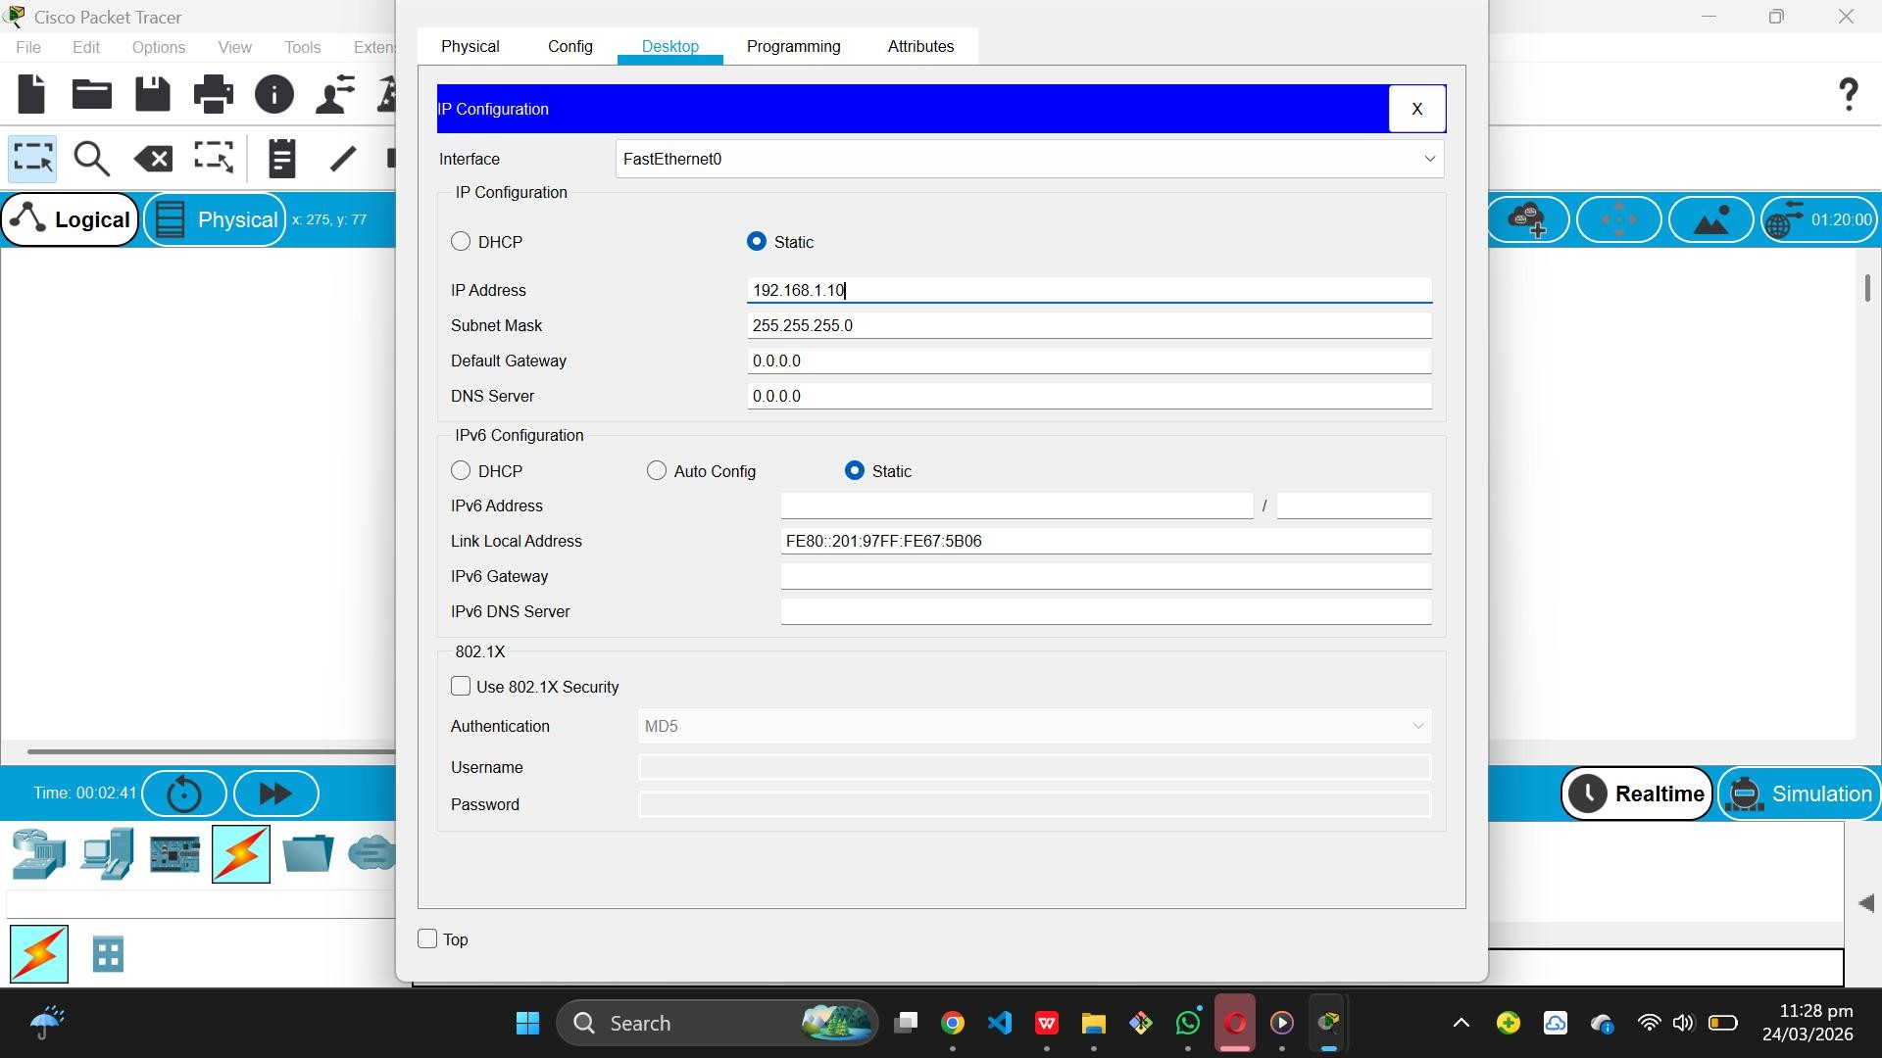
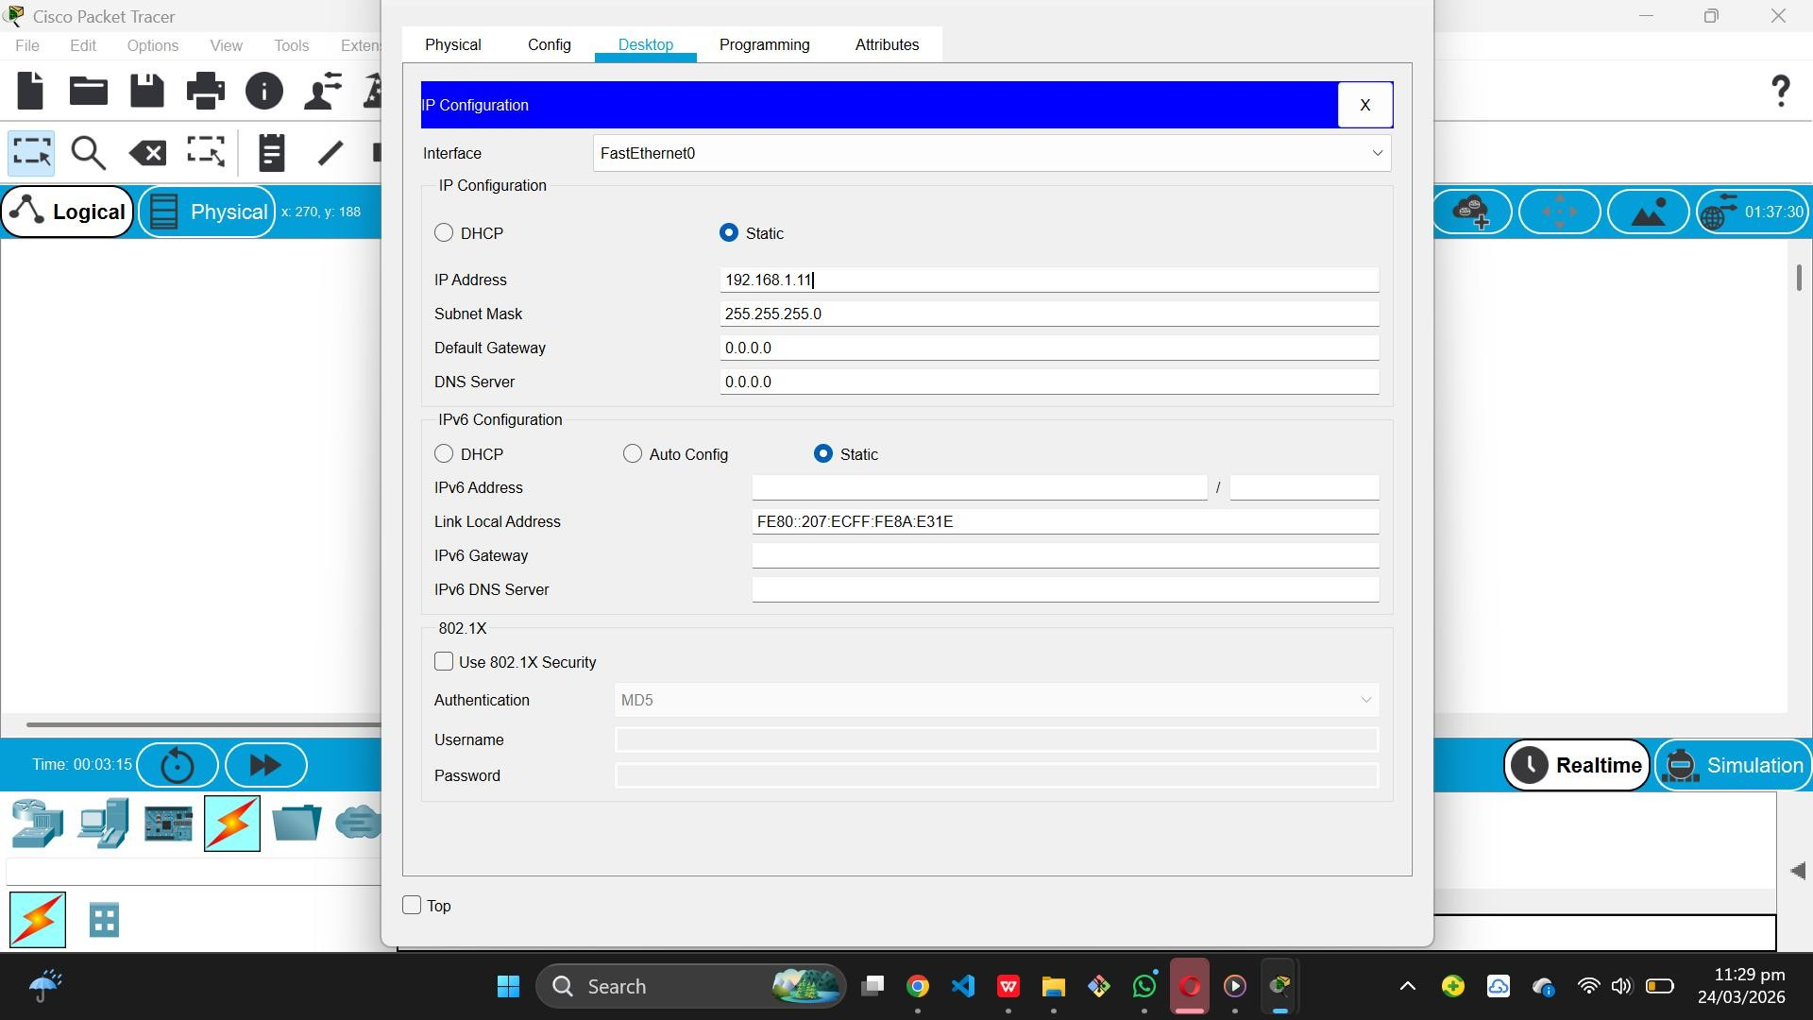

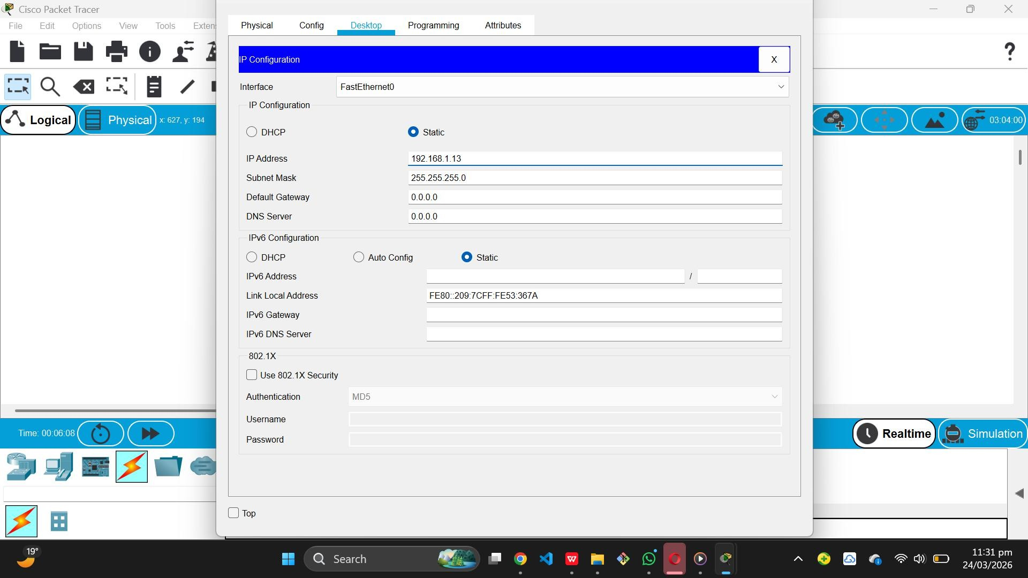

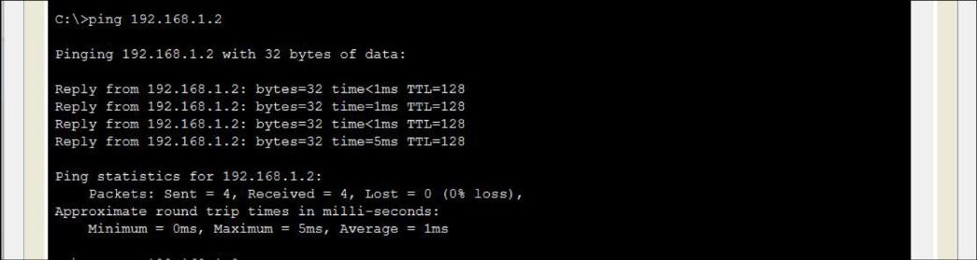
- Step 5: Ping Results and Packet Simulation

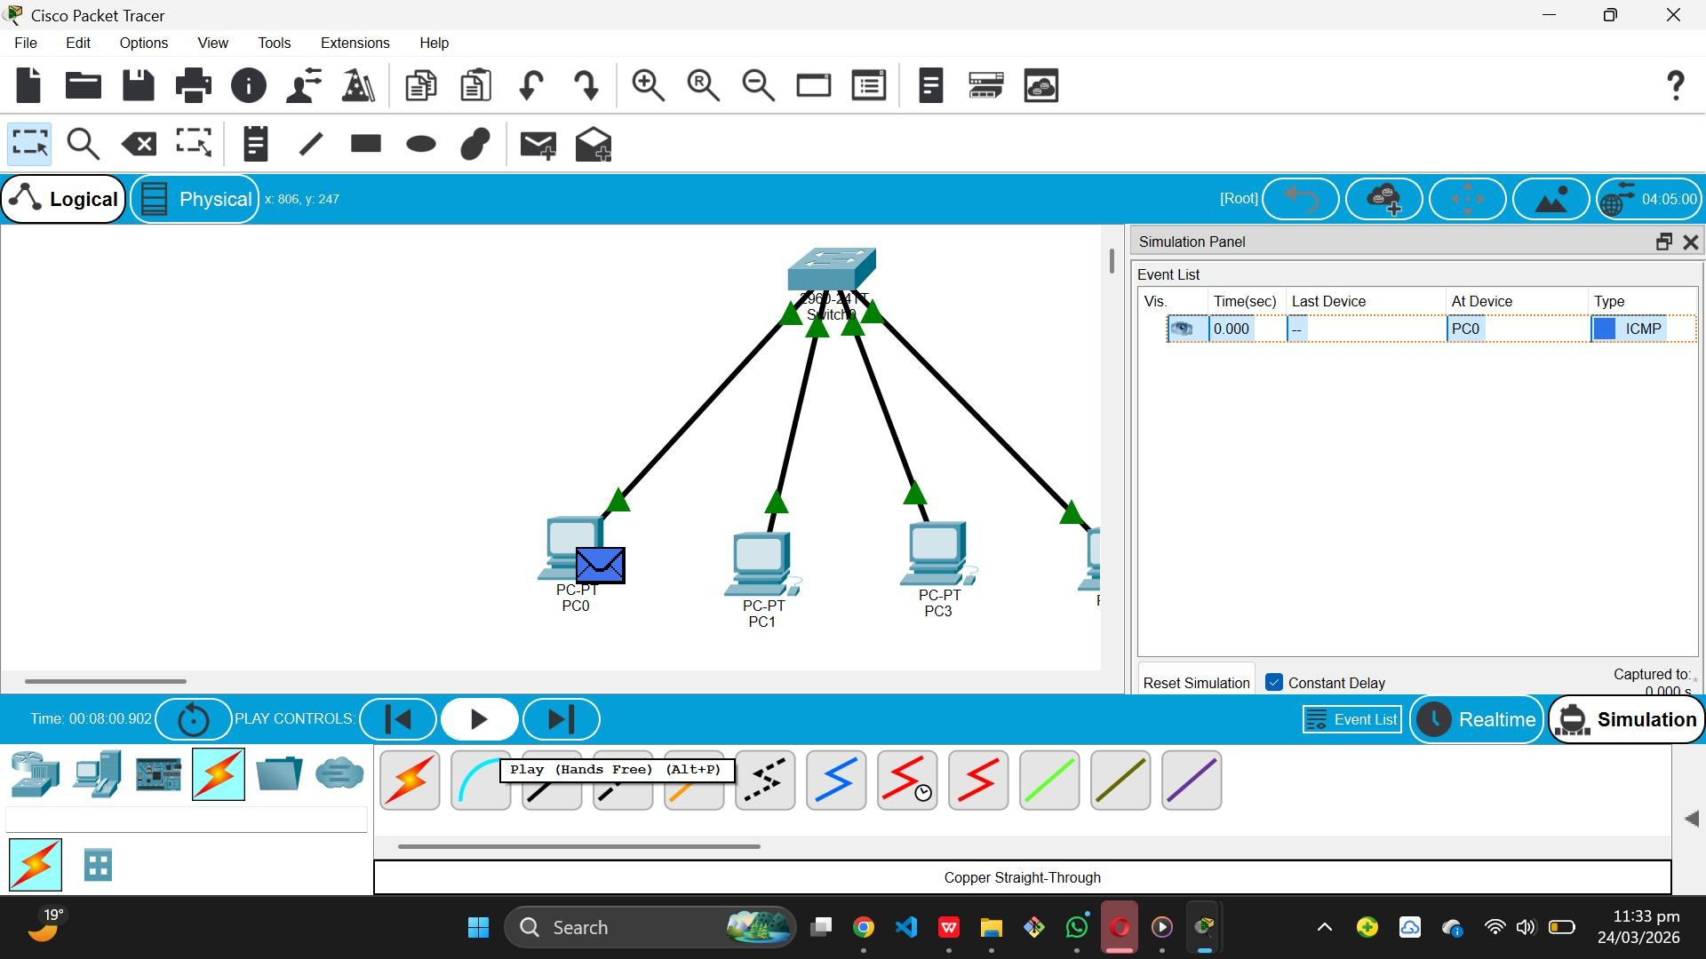

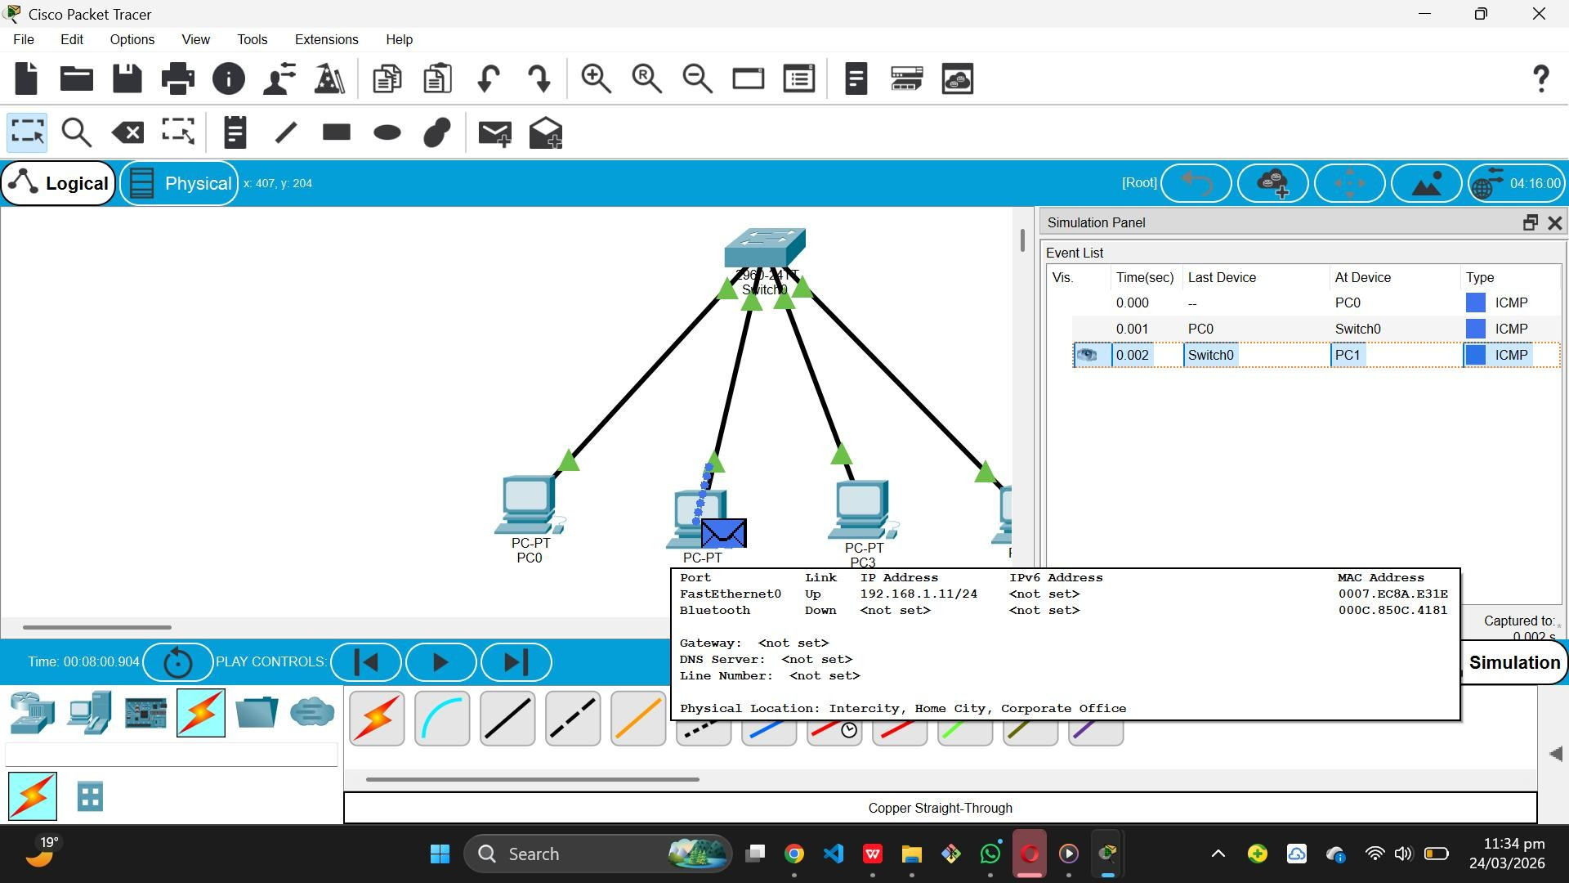

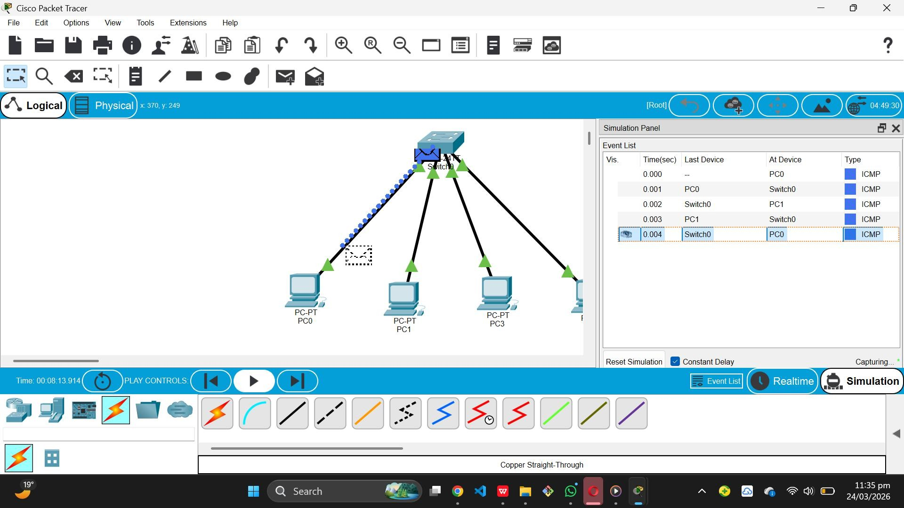

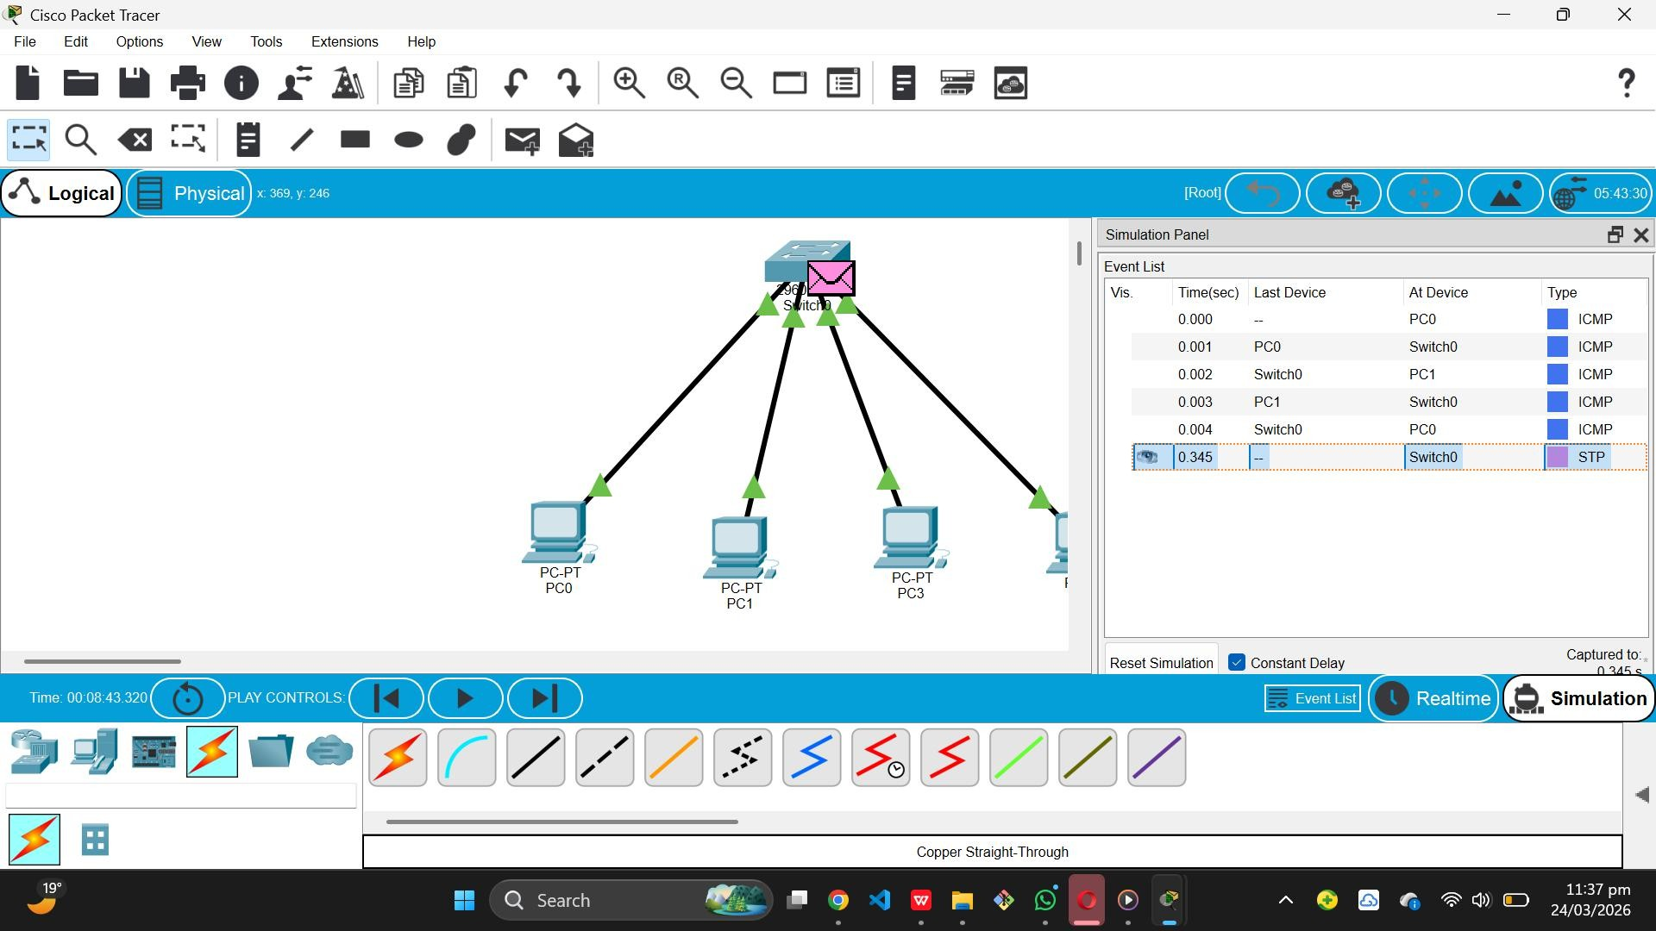
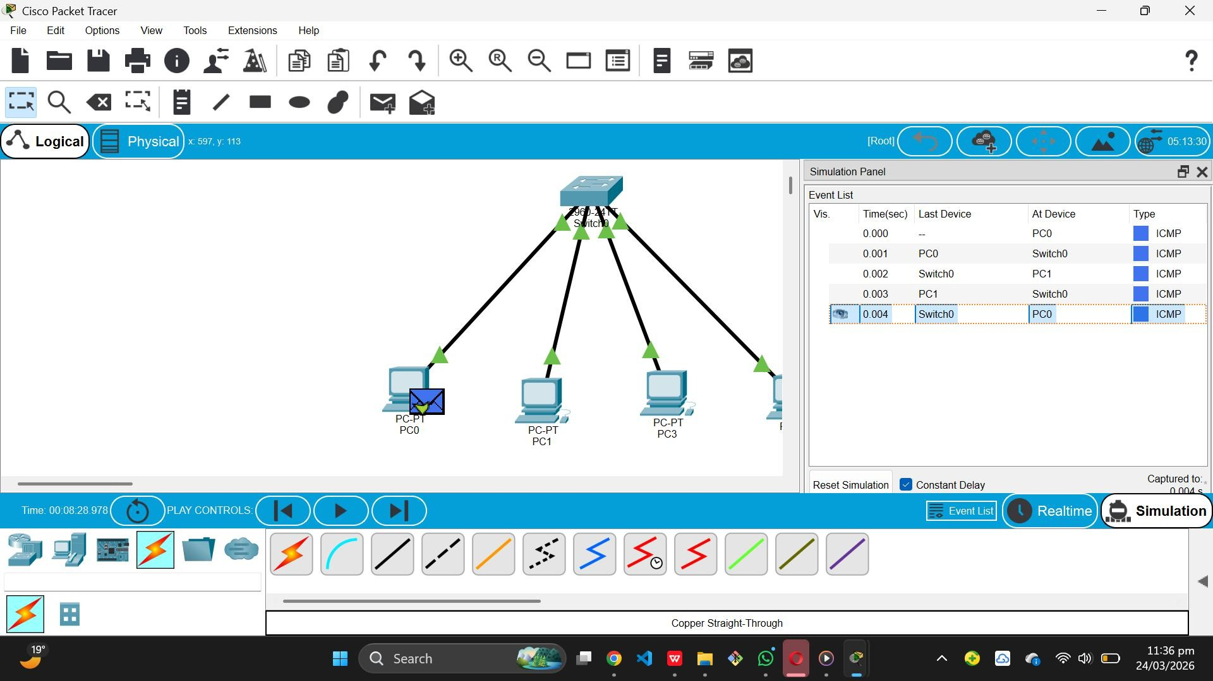

Conclusion

The star topology using a switch provides efficient communication and centralized control. It is easy to manage and troubleshoot, making it one of the most commonly used network topologies.

