

THE UNIVERSITY OF AZAD JAMMU & KASHMIR, MUZAFFARABAD
Name | Fatima Arshad
COURSE TILE | Computer Networks
Lab. | 08
ROLL NUMBER | 2024-SE-24
INSTRUCTOR NAME | ENGR. DR. ASMA JAVED

COMPUTER NETWORKS Lab 8

MAC ADDRESS TABLE AND SWITCH LEARNING

1. Objective
To observe how a switch learns MAC addresses by checking the MAC address table before and after communication between PCs, and to clear the learned MAC-address entries.

2. Network Setup
We create a simple switched network in Cisco Packet Tracer with a switch and two PCs. Assign IPv4 addresses to both PCs in the same network so that they can communicate.
Device | Example IPv4 Address | Subnet Mask
PC1 | 192.168.1.10 | 255.255.255.0
PC2 | 192.168.1.11 | 255.255.255.0

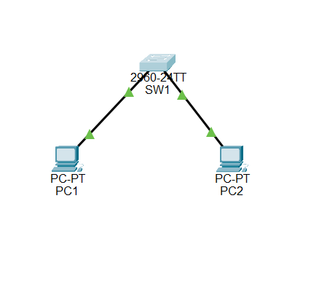

3. Procedure

Part A — Create and Configure the Network
- Place one switch and two PCs in the Packet Tracer workspace.
- Connect each PC to the switch using copper straight-through Ethernet cables.
- Configure the two PCs with the IPv4 addresses shown above and subnet mask 255.255.255.0.

Part B — Check the MAC Address Table Before Ping
Open the switch CLI and enter:
- Switch> enable
Switch# show mac address-table

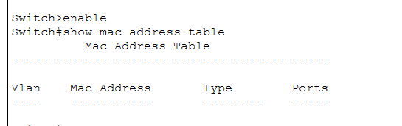
Depending on the Packet Tracer state and traffic already generated, the table is empty.

Part C — Ping Between PCs
On PC1, open Desktop → Command Prompt and enter:
ping 192.168.1.11

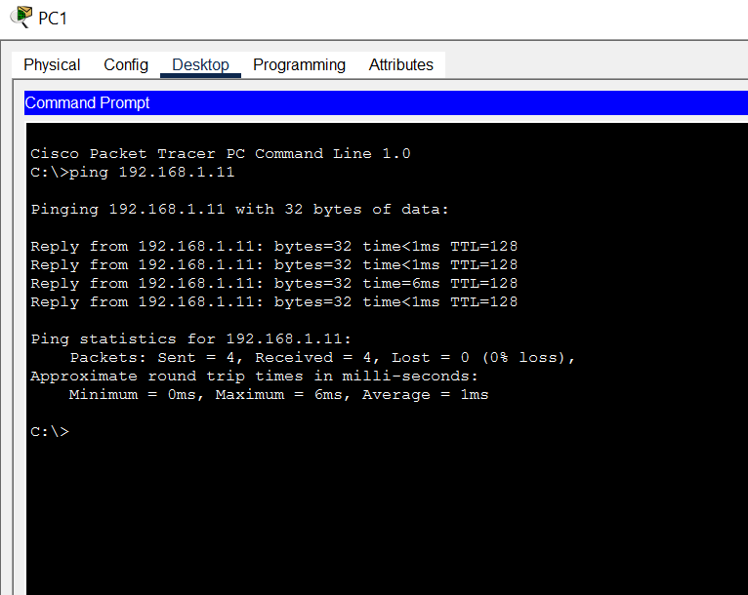
Successful replies confirm connectivity between the two PCs and generate Ethernet traffic that allows the switch to learn source MAC addresses.

Part D — Check the MAC Address Table After Ping
Return to the switch CLI and enter:
show mac address-table
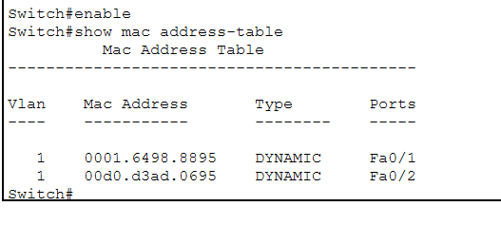
Compare the table with the earlier observation. The switch should have learned dynamic MAC addresses associated with the active switch ports.

Part E — Clear the MAC Address Table
On the switch, use:
clear mac address-table dynamic
Then verify with:
show mac address-table
The dynamic entries should be cleared, although new entries can appear again when traffic is generated.

5. Result
The MAC address table of the switch was examined before and after communication between the two PCs. Initially, no dynamic MAC addresses were present in the table. When PC1 successfully communicated with PC2 through a ping, the switch automatically learned the MAC addresses of both devices. These addresses were recorded on Fa0/1 and Fa0/2 and appeared as DYNAMIC entries.
The learned entries were then removed by executing the clear mac address-table dynamic command. After clearing the table, the dynamic MAC address entries were no longer displayed. This experiment demonstrated how a switch learns and stores MAC addresses based on incoming network traffic.

6. Conclusion
This lab demonstrated the basic MAC-learning behavior of a Layer 2 switch. Checking the table before and after a ping showed how communication causes the switch to associate source MAC addresses with switch ports.

********************************

