

THE UNIVERSITY OF AZAD JAMMU & KASHMIR, MUZAFFARABAD
Name | Fatima Arshad
COURSE TILE | Computer Networks
Lab. | 04
ROLL NUMBER | 2024-SE-24
INSTRUCTOR NAME | ENGR. DR. ASMA JAVED

Department of SE

Router – CLI accession & configuration

Introduction
This lab introduces the basic method of accessing and configuring a Cisco router using the Command Line Interface. In computer networks, routers and switches must be configured before they can properly operate in a network. I used to simulate a real networking environment and practice router configuration commands.

- After opening Cisco Packet Tracer, I selected a router (1941).
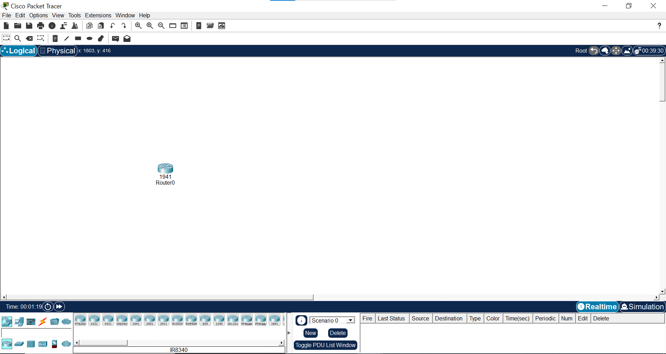

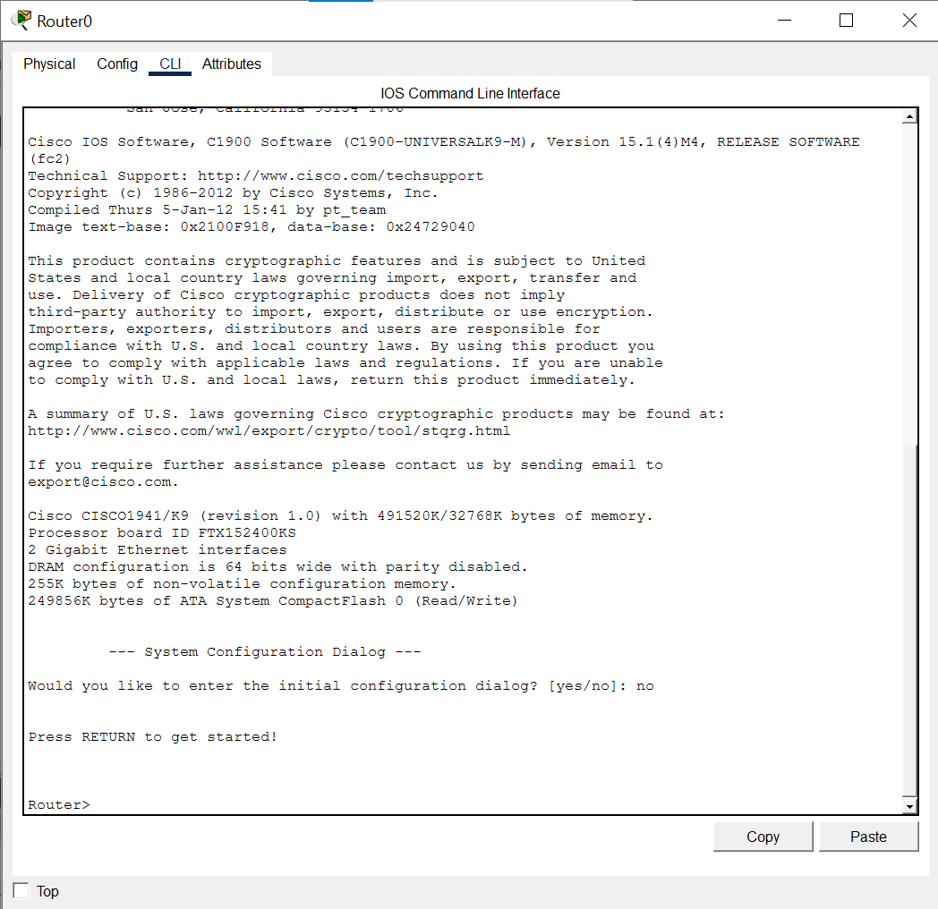
This shows that the router CLI was opened successfully in Cisco Packet Tracer.
The Router> prompt indicates User EXEC Mode, which is the basic access mode.

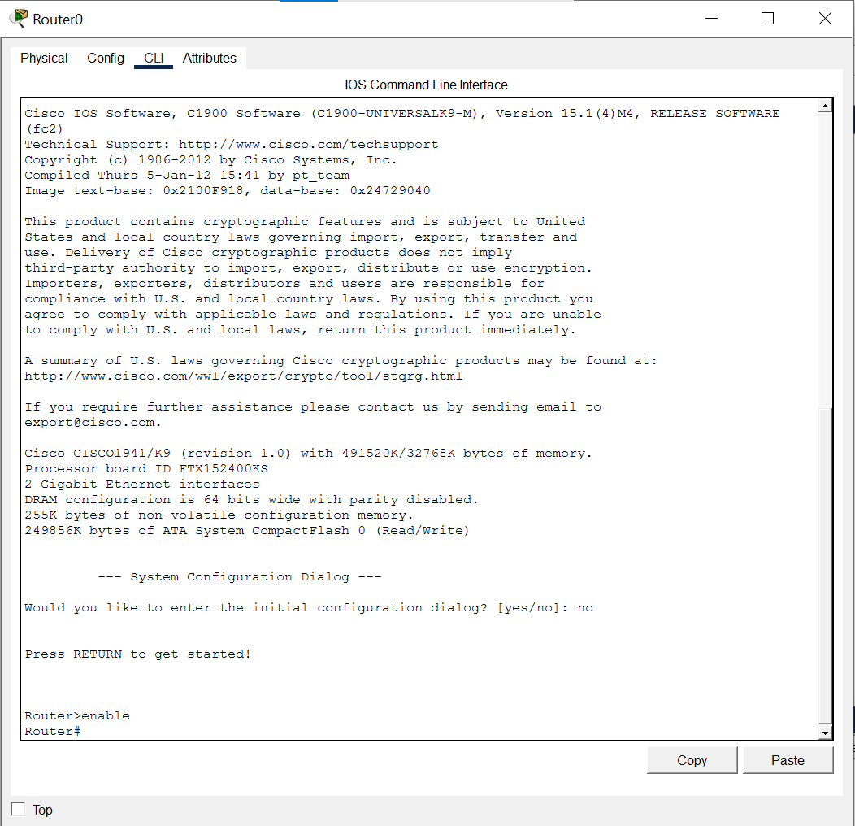
This screenshot shows that the enable command was used to move from User EXEC Mode to Privileged EXEC Mode. The Router# prompt confirms that privileged mode was entered successfully.

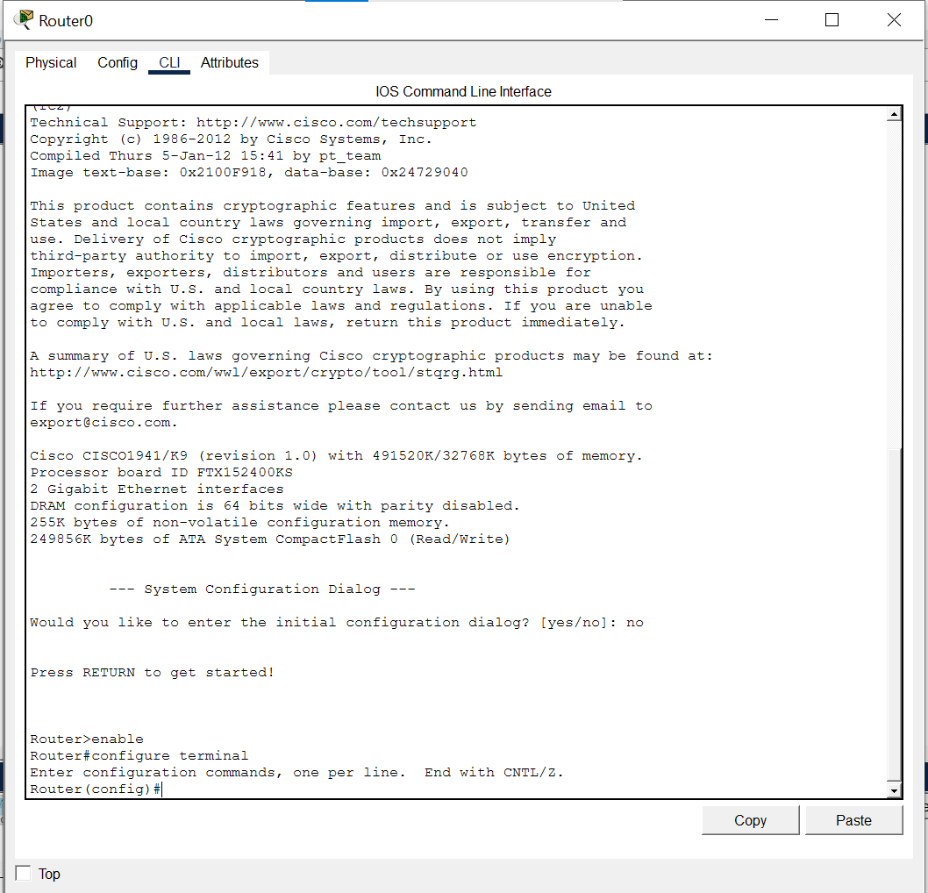
This screenshot shows that the router entered Global Configuration Mode. This mode is used to configure router settings such as passwords and security commands.

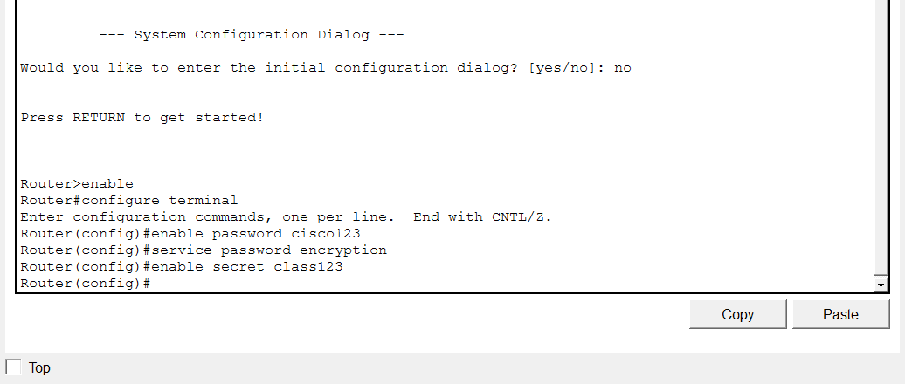
This SS shows the basic security configuration of the router. An enable password was set, password encryption was enabled, and an enable secret password was configured for stronger security

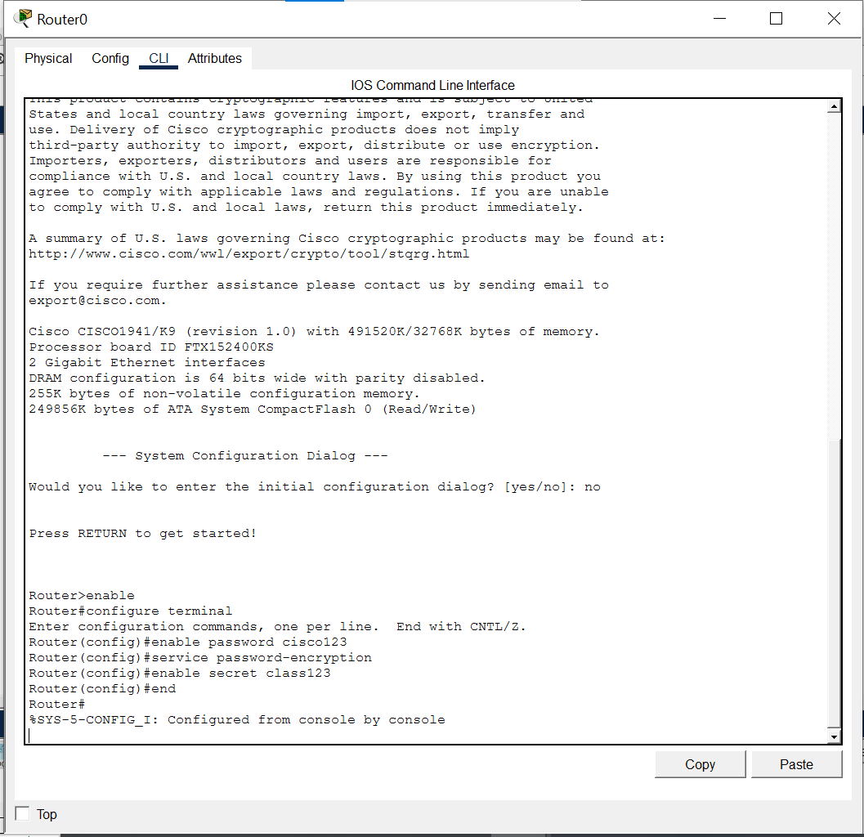
This screenshot shows that the end command was used to exit Global Configuration Mode and return to Privileged EXEC Mode.

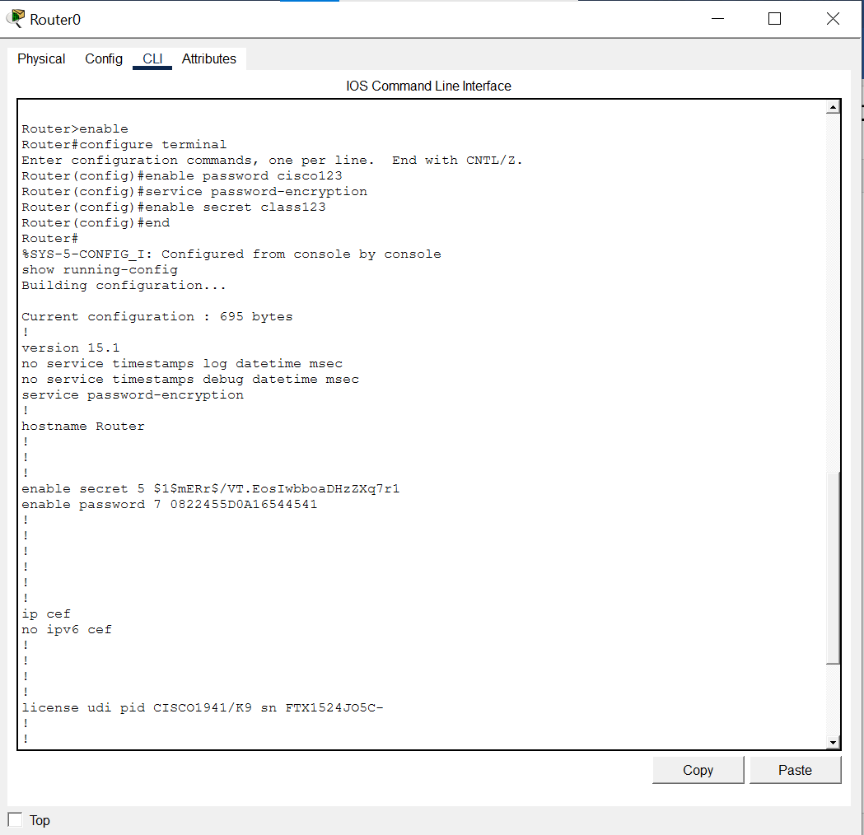
This screenshot shows the running configuration of the router. The running configuration is stored in RAM and contains the active password and encryption settings.

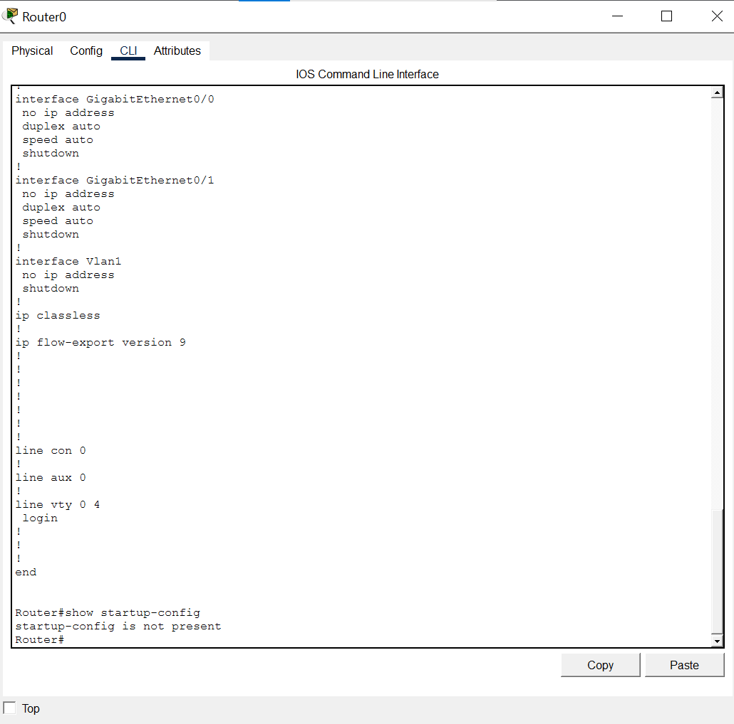
This screenshot shows the startup configuration before saving. As the startup-config is not present, it means the current router settings have not yet been saved to NVRAM.

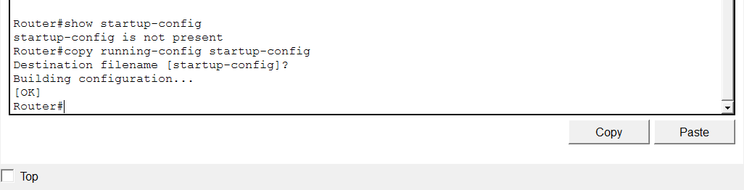
This screenshot shows that the running configuration was saved to the startup configuration. This ensures the router keeps the configured settings after restart.

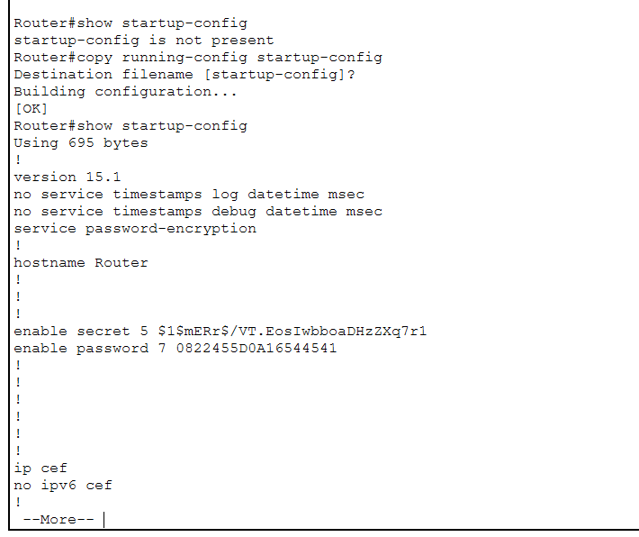
This screenshot shows the startup configuration after saving. The saved configuration is stored in NVRAM and will be loaded when the router restarts.

Conclusion
I learned how to access a router CLI in Cisco Packet Tracer and navigate between User EXEC, Privileged EXEC, and Global Configuration modes. I configured basic router passwords, enabled password encryption, viewed running and startup configurations, and saved the configuration to NVRAM.

