

THE UNIVERSITY OF AZAD JAMMU & KASHMIR,
MUZAFFARABAD

COURSE TITLE | COMPUTER NETWORKS
LAB | 01
NAME | Fatima Arshad
ROLL NUMBER | 2024-SE-24
INSTRUCTOR NAME | Engr. Asma Javed
DATE OF SUBMISSION | 3rd March, 2026

CISCO PACKET TRACKER INSTALLATION

Run the setup. Read the terms, select the radio button corresponding to "I accept the agreement", and click Next to proceed.

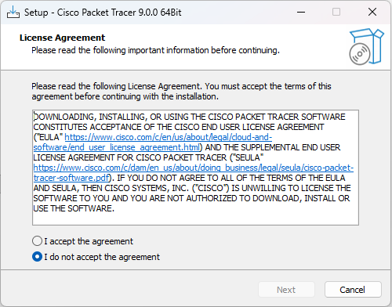

Location
Leave it as default or click Browse to choose a different location, then click Next.
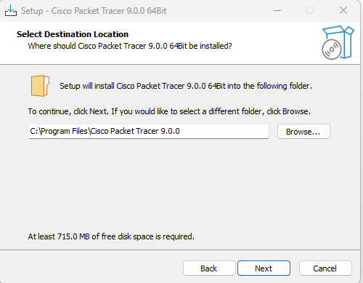

Installation Process
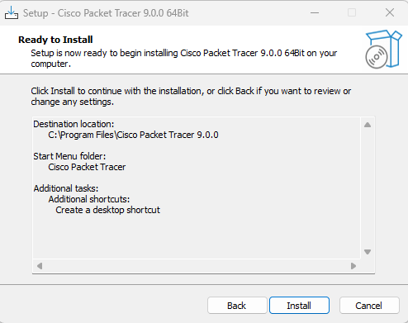

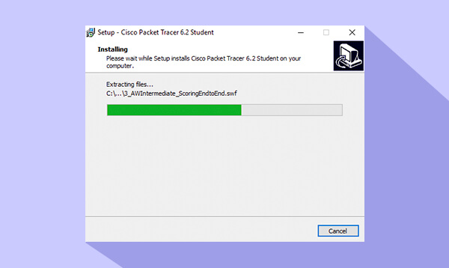

Finish the Setup
To immediately verify the installation, ensure the "Launch Cisco Packet Tracer" checkbox is selected, and click Finish.
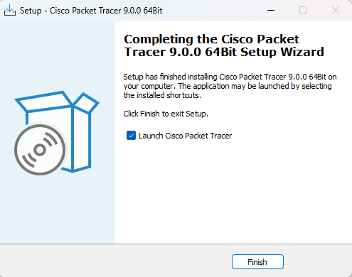

Verification and Launch The Cisco Packet Tracer application will execute and open to its default workspace. The presence of the logical/physical workspace tabs and the network component library at the bottom confirms that the software has been installed successfully and is ready for use.

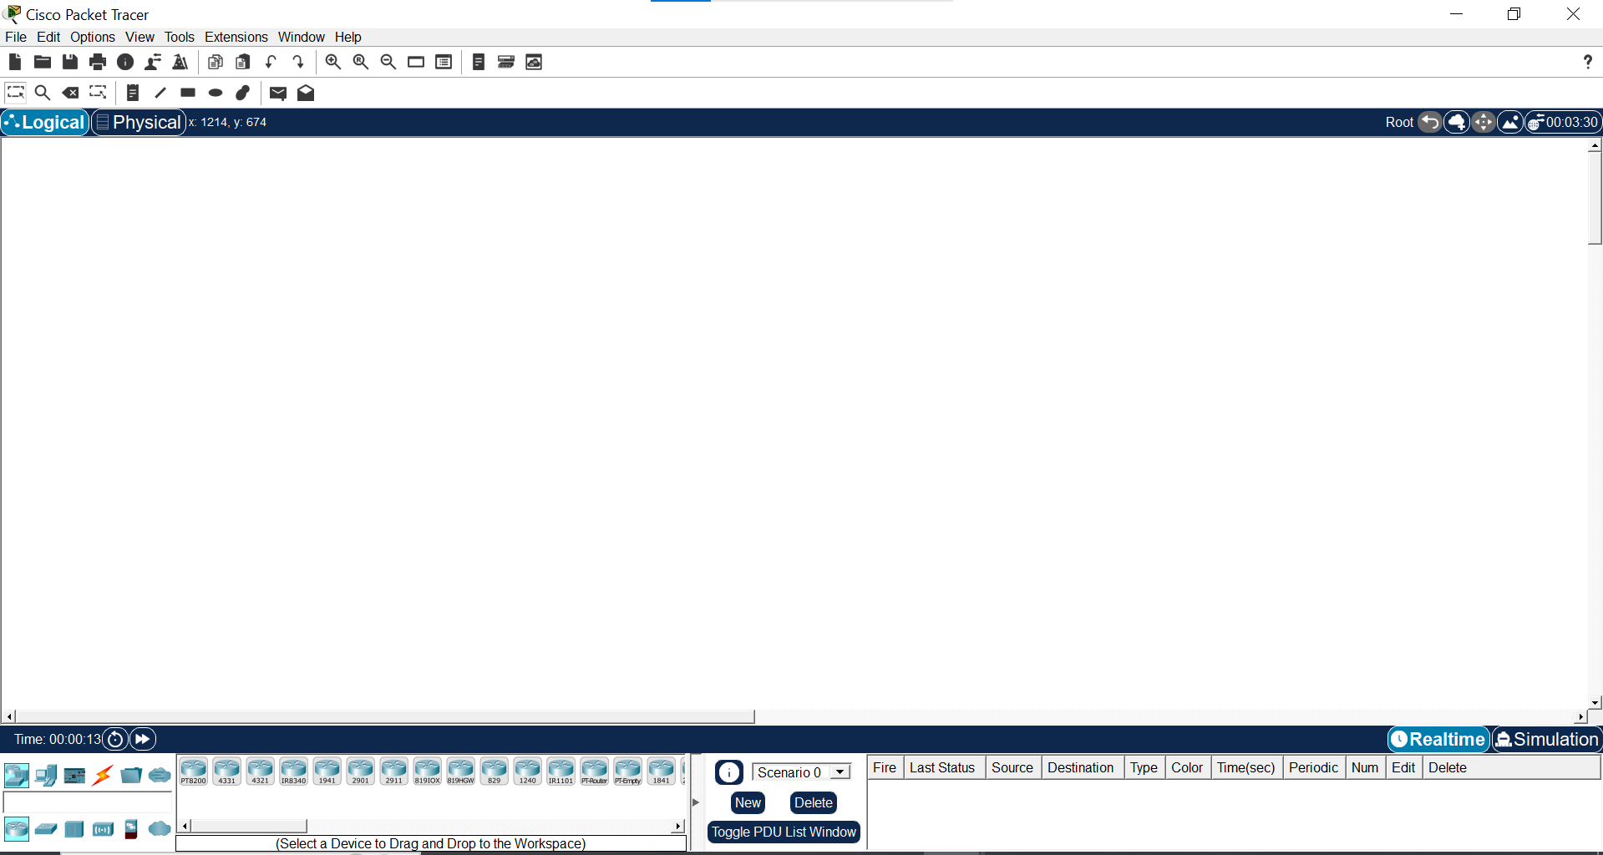

Conclusion
Installation of Cisco Packet Tracer 9.0.0 64-bit completed successfully with no errors encountered. The application launched correctly, demonstrating that the environment is fully prepared for subsequent network simulation tasks.

