

THE UNIVERSITY OF AZAD JAMMU & KASHMIR,
MUZAFFARABAD

COURSE TITLE | COMPUTER NETWORKS
LAB | 02
NAME | FATIMA ARSHAD
ROLL NUMBER | 2024-SE-24
INSTRUCTOR NAME | ENGR. ASMA JAVED
DATE OF SUBMISSION | 3RD March, 2026

Network Topology

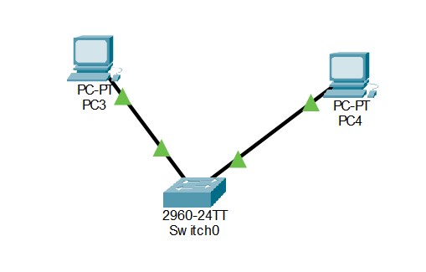

I created a simple Local Area Network (LAN) topology using Cisco Packet Tracer. I added two end devices (PCs) to the workspace and connected them to a central node, a switch, using copper straight-through cables. The green link lights indicate that the physical connections are active and the devices are ready to communicate within the same network.

IP Configuration

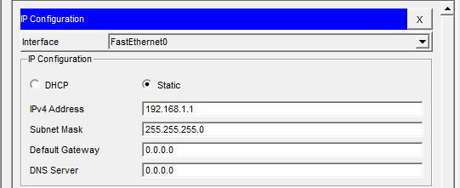

To enable communication, a unique logical IP address was manually assigned to each PC. PC3 was configured with the static IP 192.168.1.1 and PC4 with 192.168.1.2 on the 192.168.1.0 network using a 255.255.255.0 subnet mask. A default gateway was not required because the devices are on the same local network, and no router is used to route traffic externally.

CLI Testing – PC 3
Ipconfig command for ip
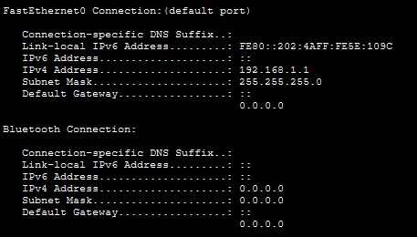

Ping command to show response
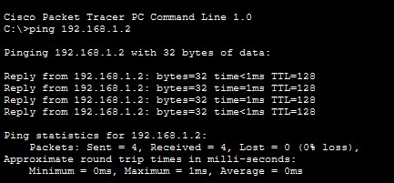

"Reply from..." messages confirms that data packets are successfully being exchanged between the two nodes across the switch without any packet loss.

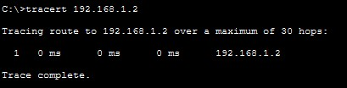
Tracert command used

The tracert command was run to display the specific path the packets took to reach the destination IP address. The output displays only a single hop because both PCs are directly connected to the same local switch, meaning the data does not need to traverse multiple routers to reach its target.

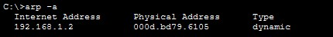
Commands: arp -a, netstat

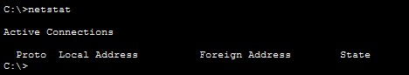

The arp -a command successfully displayed the device's Address Resolution Protocol (ARP) table, which maps the known logical IP addresses to their corresponding physical MAC addresses. Additionally, the netstat command was executed to display active network connections and statistics for the system.

CLI Testing – PC 4
ipconfig
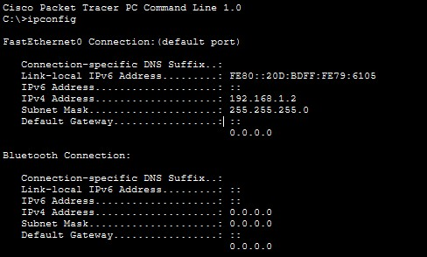

The output successfully verified that the static IP address and subnet mask entered in the graphical interface were properly applied to the PC's network adapter.

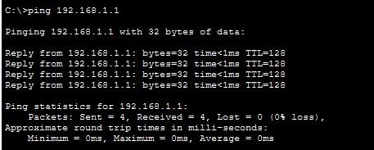
Ping

The ping command was used to test network connectivity between PC3 and PC4. Receiving four consecutive "Reply from..." messages confirms that data packets are successfully being exchanged between the two nodes across the switch without any packet loss.

Tracert

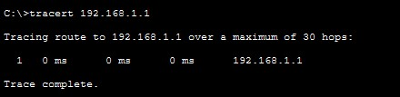

The tracert command was run to display the specific path the packets took to reach the destination IP address. The output displays only a single hop because both PCs are directly connected to the same local switch, meaning the data does not need to traverse multiple routers to reach its target.

arp -a, netstat
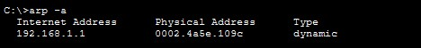
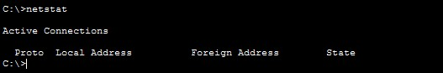

The arp -a command successfully displayed the device's Address Resolution Protocol (ARP) table, which maps the known logical IP addresses to their corresponding physical MAC addresses. Additionally, the netstat command was executed to display active network connections and statistics for the system.

