

The University of Azad Jammu & Kashmir, Muzaffarabad

Name | Fatima Arshad
COURSE TILE | Computer Networks
Task no. | 09
ROLL NUMBER | 2024-SE-24
INSTRUCTOR NAME | ENGR. DR. ASMA JAVED

Inter-VLAN Routing Using Router-on-a-Stick

This lab demonstrates Inter-VLAN Routing using the Router-on-a-Stick method. The lab manual specifies a company with two departments: Development (DEV) and Human Resources (HR). DEV uses VLAN 10 and HR uses VLAN 20; each department has two PCs connected to one switch, and a router provides communication between the VLANs.
Objective list:
- Create the required topology in Cisco Packet Tracer.
- Create VLAN 10 for DEV and VLAN 20 for HR.
- Assign the appropriate PCs to their VLANs.
- Configure the switch-router connection as a trunk.
- Configure router subinterfaces for VLAN 10 and VLAN 20.
- Assign IP addresses and default gateways.
- Test communication between the VLANs using ping.

Requirements and Network Design
The required hardware is:
Device | Quantity | Purpose
Router | 1 | Inter-VLAN routing
Switch | 1 | VLAN creation and trunk/access connectivity
PC | 4 | Two DEV hosts and two HR hosts

VLAN and IP Addressing Plan

Department | VLAN | Network | Default Gateway
Development (DEV) | 10 | 192.168.10.0/24 | 192.168.10.1
Human Resources (HR) | 20 | 192.168.20.0/24 | 192.168.20.1

Topology

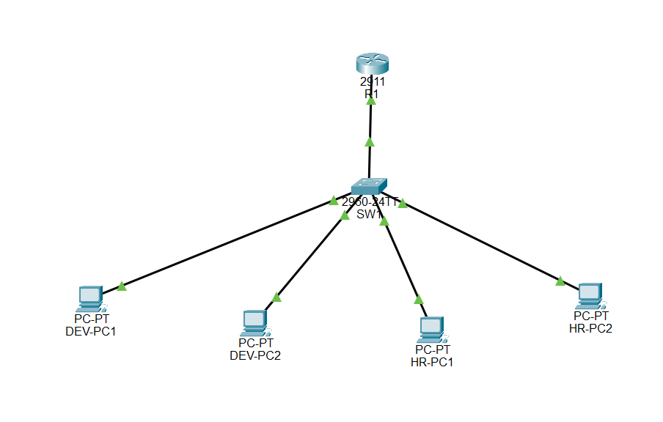

Physical and Logical Connections
Using copper straight-through Ethernet connections for PC-to-switch links and the switch-to-router link. The switch-router link will later operate as an 802.1Q trunk so that traffic for both VLAN 10 and VLAN 20 can cross the single physical link.

VLAN Creation and Port Assignment
VLAN 10 is named DEV and VLAN 20 is named HR. The two DEV PCs are placed in VLAN 10, while the two HR PCs are placed in VLAN 20. The port connected to the router is configured as a trunk.

Example Switch Configuration

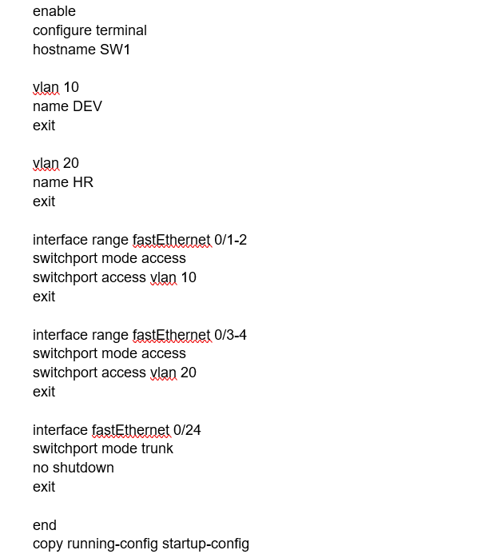

VLAN and Switch Configuration

- show vlan brief
- show interfaces trunk

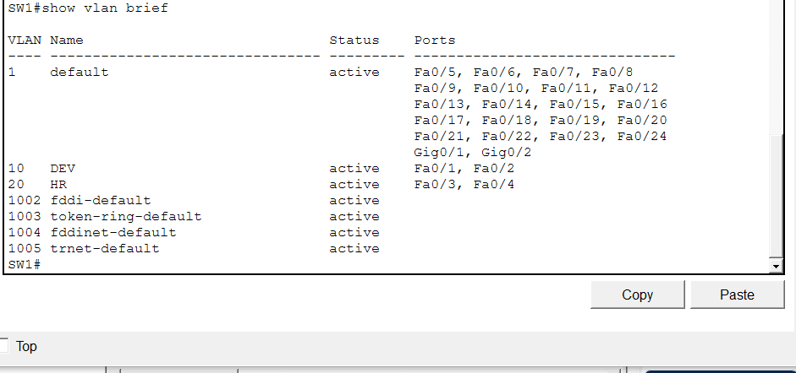

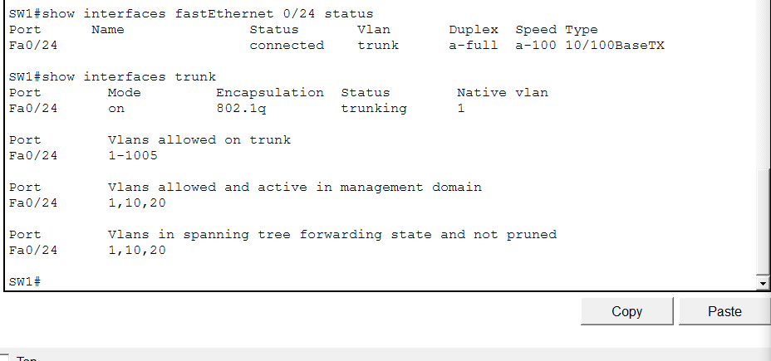

5. Router-on-a-Stick Configuration
Router-on-a-Stick uses one physical router interface divided into logical subinterfaces. Each subinterface is associated with one VLAN using 802.

Router Configuration
enable
configure terminal
hostname R1
interface gigabitEthernet 0/0
no shutdown
exit
interface gigabitEthernet 0/0.10
encapsulation dot1Q 10
ip address 192.168.10.1 255.255.255.0
exit
interface gigabitEthernet 0/0.20
encapsulation dot1Q 20
ip address 192.168.20.1 255.255.255.0
exit
end
copy running-config startup-config

Router Configuration

Configuring the router using the interface connected to the switch. If your router uses a different interface name, use the interface actually connected to SW1. Verify the subinterfaces with show ip interface brief.

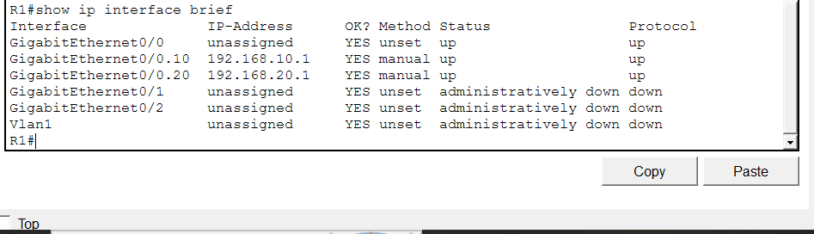

6. End-Device IP Addressing
Device | VLAN | IP Address | Subnet Mask | Default Gateway
DEV-PC1 | 10 | 192.168.10.10 | 255.255.255.0 | 192.168.10.1
DEV-PC2 | 10 | 192.168.10.11 | 255.255.255.0 | 192.168.10.1
HR-PC1 | 20 | 192.168.20.10 | 255.255.255.0 | 192.168.20.1
HR-PC2 | 20 | 192.168.20.11 | 255.255.255.0 | 192.168.20.1

Configuring PC IP Addresses

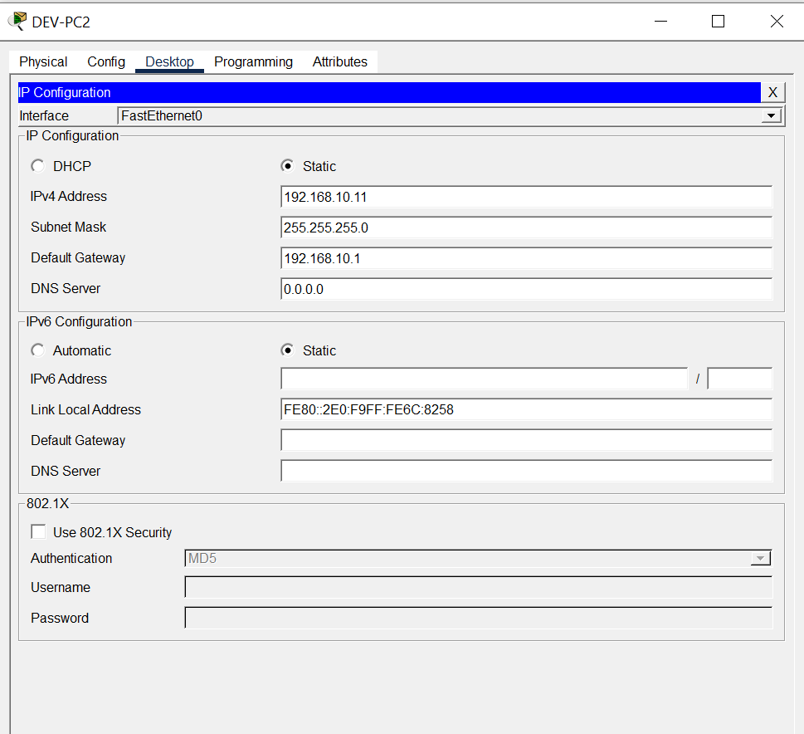

7. Connectivity Testing
The expected result is successful communication between VLAN 10 and VLAN 20 through the router. Ping tests should be performed after both VLANs, the trunk, router subinterfaces, and PC addressing have been configured.
From DEV-PC1, test the local gateway and an HR host:
ping 192.168.10.1
ping 192.168.20.10
From HR-PC1, test the local gateway and a DEV host:
ping 192.168.20.1
ping 192.168.10.10

Source | Destination | Command | Actual Result
DEV-PC1 | 192.168.10.1 | ping | SUCCESSFUL
DEV-PC1 | 192.168.20.10 | ping | SUCCESSFUL
HR-PC1 | 192.168.20.1 | ping | SUCCESSFUL
HR-PC1 | 192.168.10.10 | ping | SUCCESSFUL

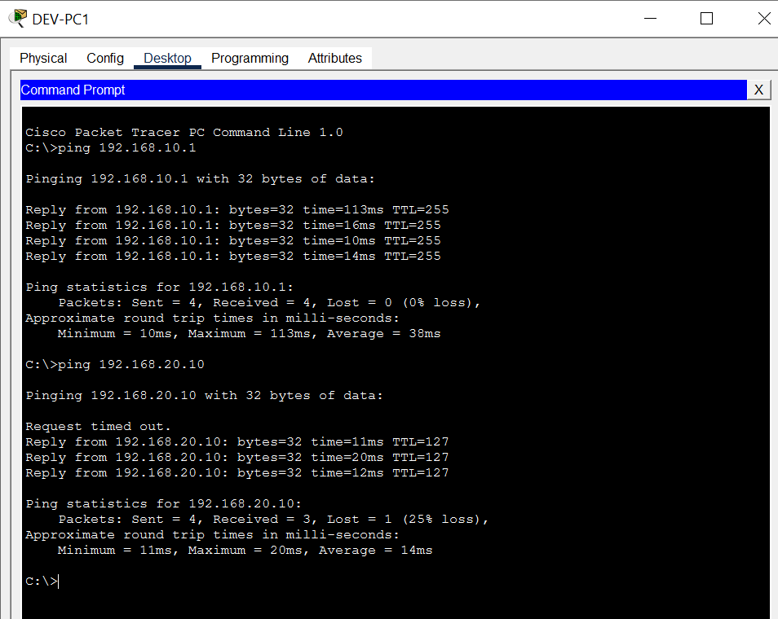

8. Verification Commands
SW1:
show vlan brief
show interfaces trunk
R1:
show ip interface brief
PCs:
ping <destination-IP>

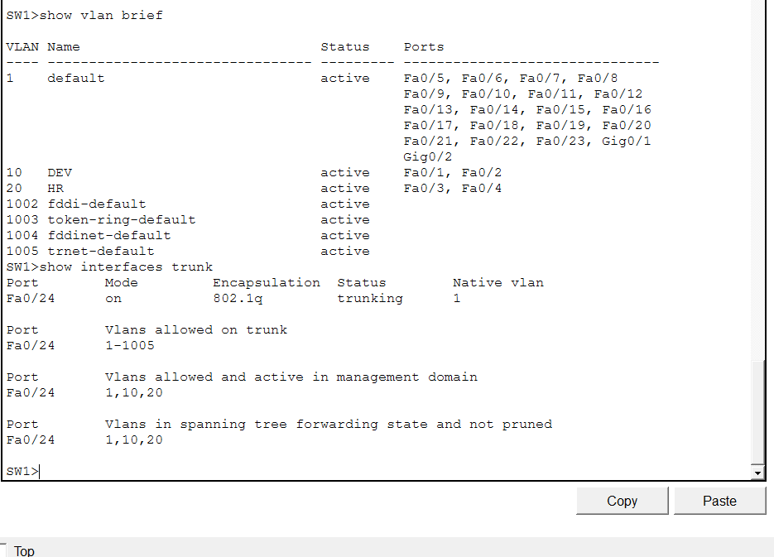

10. Conclusion
This laboratory demonstrated Inter-VLAN Routing using the Router-on-a-Stick approach. VLAN 10 was used for Development and VLAN 20 for Human Resources. The switch was configured with access ports for the respective departments and a trunk toward the router. Router subinterfaces provided the default gateways for both networks. After assigning appropriate IP addresses and gateways to the PCs, connectivity between the two VLANs was verified using ping tests.

