

The University of Azad Jammu & Kashmir

SCECARIO BASED OPEN ENDED LAB

Student Name | Fatima Arshad
Roll No. | 2024-SE-24
Instructor | Engr. Asma Javed
Department | Software Engineer
Course | Computer Networks

Introduction
The lab manual asks for the design of a reliable and scalable network for a newly established educational institute serving administration and academic departments. The required deliverables are requirements analysis, topology justification, cabling plan, switch configuration, router configuration, IP addressing table, network diagram, and future recommendations.

Network Requirements Analysis
The network should provide reliable communication, logical separation of departments, straightforward management, and sufficient capacity for future expansion.

Estimation

Department / Area | PCs | Other Devices | Total Estimated
Administration | 8 | 1 network printer | 9
Faculty / Academic | 12 | 1 network printer | 13
IT | 20 | 1 server | 21
Network Infrastructure | — | 3 switches + 1 router | 4

TASK 1 : Network Requirements Verification

For the packet tracer implementation, the network is designed as:
Switches corresponding to the departments.
- Administration
- Academic
- IT/Lab
Each with 3 PCs initially.

This allows departments to communicate through the router while keeping their networks logically separated. It’s a scaled implementation of the proposed institute network. 13 devices included.

Topology

Each department connects its end devices to an access switch, and the departmental switches connect toward a central Layer-3 routing point. This arrangement is suitable for a small institute because individual links can be isolated for troubleshooting, expansion can be made by adding ports or switches, and the logical departmental networks can be separated using different IP subnets.
The design uses three access switches: one for Administration, one for Faculty/Academic users, and one for the IT/Lab area. A router provides inter-network routing between the departmental subnets.

TASK 2 : Topology Evidence
Star-based topology connecting the three departmental networks:
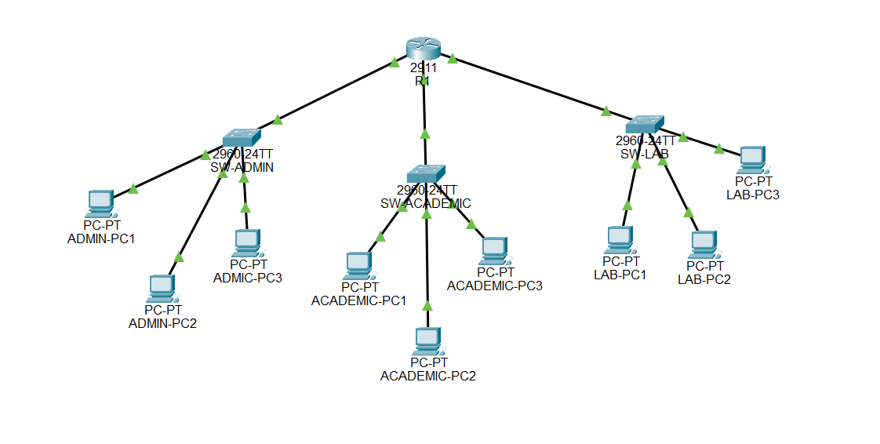

Network Cabling Plan

Connection | Recommended Cable | Reason | Typical Use
PC ↔ Switch | Copper straight-through, Cat6 | Reliable Ethernet connection and good bandwidth | End devices
Printer/Server ↔ Switch | Copper straight-through, Cat6 | Standard Ethernet connection | Network resources
Switch ↔ Router | Copper straight-through, Cat6 | Ethernet uplink to routing device | Inter-network connectivity

4. Switch Design and Configuration
Three access switches are used. Each switch serves one logical department.

ASwitch | Department | Example Access Ports | Uplink
SW-ADMIN | Administration | Fa0/1–Fa0/8 | Fa0/24 → Router
SW-ACADEMIC | Faculty / Academic | Fa0/1–Fa0/12 | Fa0/24 → Router
SW-LAB | IT / Lab | Fa0/1–Fa0/20 | Fa0/24 → Router

Basic Switch Configuration Template
Use the following commands as a starting point. Device names and interface numbers should match your Packet Tracer topology.
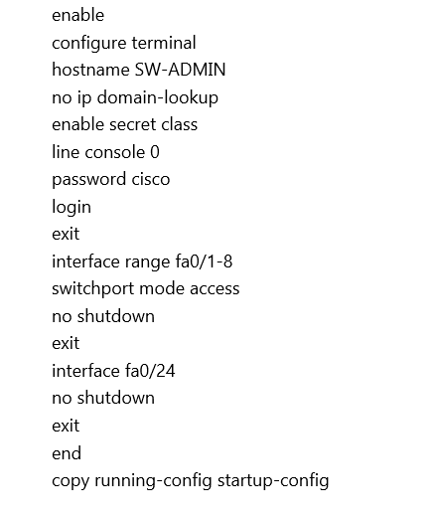

TASK 4 — Switch Configuration and Verification
SW-ADMIN
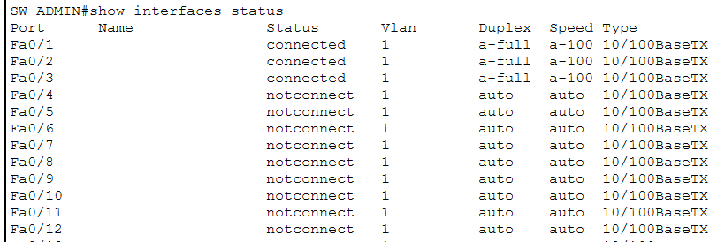

SW-ACADEMIC
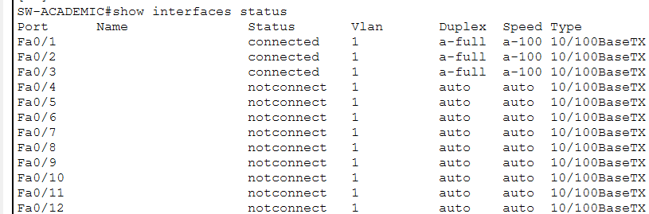
SW-LAB
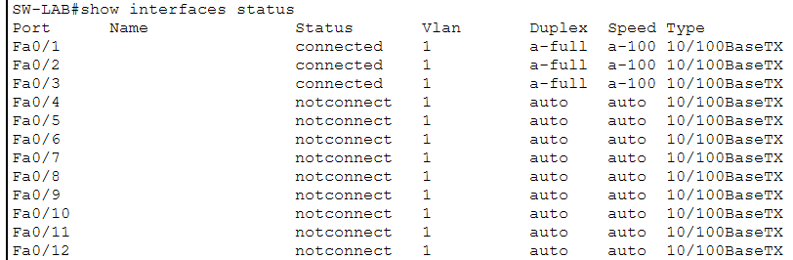

5. Router Configuration and IP Addressing
The /24 networks are simple to understand and leave substantial room for future devices.
Device/Interface | IP Address | Mask | Purpose
R1 G0/0 | 192.168.10.1 | 255.255.255.0 | Administration gateway
R1 G0/1 | 192.168.20.1 | 255.255.255.0 | Academic gateway
R1 G0/2 | 192.168.30.1 | 255.255.255.0 | Lab gateway

Device | IP | Mask | Gateway
ADMIN-PC1 | 192.168.10.10 | 255.255.255.0 | 192.168.10.1
ADMIN-PC2 | 192.168.10.11 | 255.255.255.0 | 192.168.10.1
ADMIN-PC3 | 192.168.10.12 | 255.255.255.0 | 192.168.10.1
ACADEMIC-PC1 | 192.168.20.10 | 255.255.255.0 | 192.168.20.1
ACADEMIC-PC2 | 192.168.20.11 | 255.255.255.0 | 192.168.20.1
ACADEMIC-PC3 | 192.168.20.12 | 255.255.255.0 | 192.168.20.1
LAB-PC1 | 192.168.30.10 | 255.255.255.0 | 192.168.30.1
LAB-PC2 | 192.168.30.11 | 255.255.255.0 | 192.168.30.1
LAB-PC3 | 192.168.30.12 | 255.255.255.0 | 192.168.30.1
Segment | Network | Gateway | Usable Host Range | Broadcast
Administration | 192.168.10.0/24 | 192.168.10.1 | 192.168.10.2–192.168.10.254 | 192.168.10.255
Academic | 192.168.20.0/24 | 192.168.20.1 | 192.168.20.2–192.168.20.254 | 192.168.20.255
IT / Lab | 192.168.30.0/24 | 192.168.30.1 | 192.168.30.2–192.168.30.254 | 192.168.30.255

Router-on-a-Stick Example Configuration
If one physical router interface is connected to a switch trunk, router subinterfaces can represent the three departmental networks. This example assumes the router interface connected to the switching infrastructure is GigabitEthernet0/0. Because this configuration uses 802.1Q subinterfaces, the switch uplink connected to the router must be configured appropriately as a trunk, and the relevant VLANs must exist. If your lab topology instead uses separate physical router interfaces, configure each interface directly with the corresponding gateway address.

STUDENT TASK 5 — Router Configuration and Connectivity

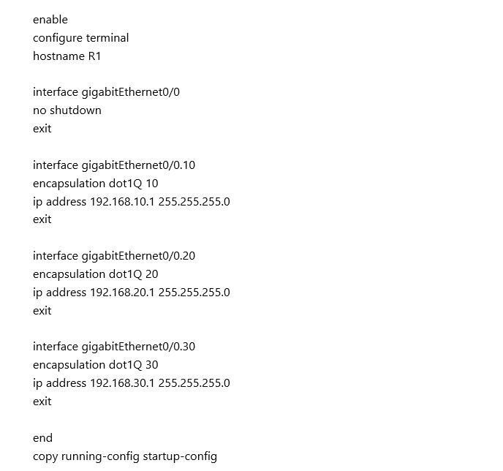
R1 interface configuration and status:
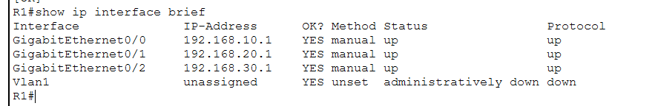

Connectivity Testing between departmental networks

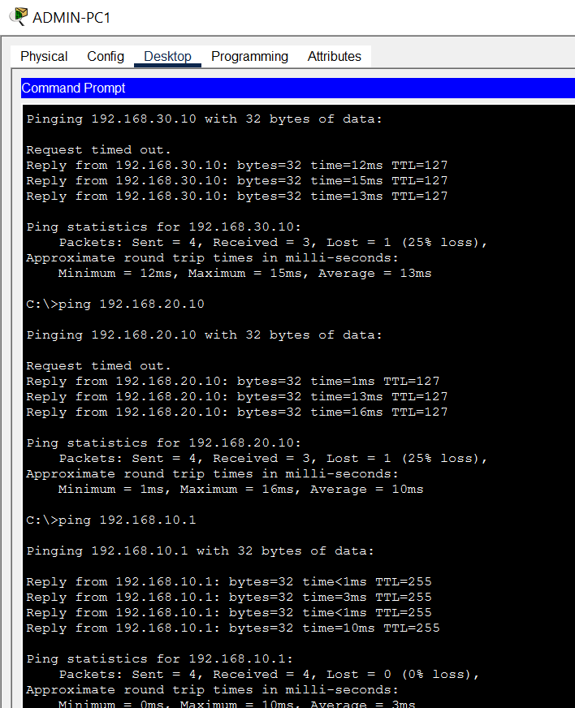

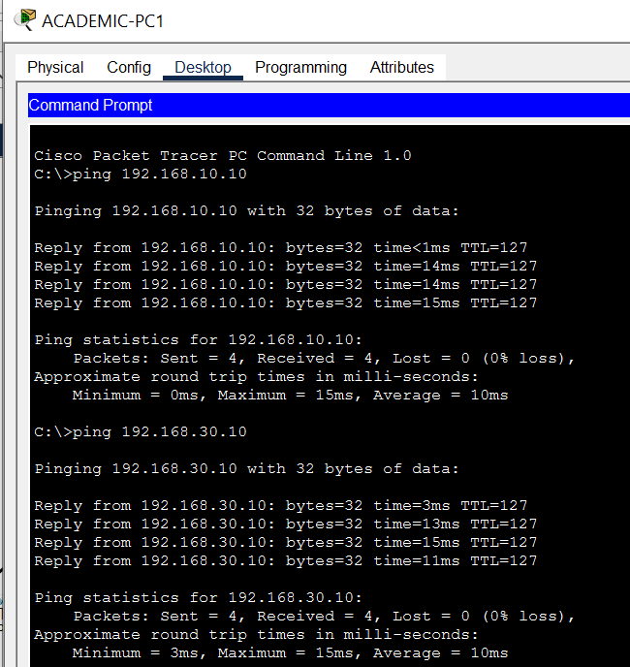

TASK 6 : Complete Logical Network Diagram
Final Network Diagram

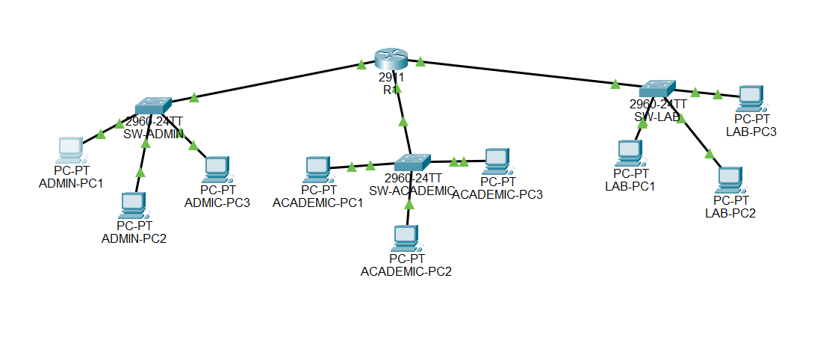

Potential Improvements
- A firewall or dedicated security appliance can be introduced between the internal network and the Internet to improve perimeter security.
- Redundant switches, links, or routing equipment can be considered to improve availability as the institute grows.
- Centralized services such as DHCP, DNS, directory services, monitoring, and backup can be deployed for easier administration.
- Fiber-optic uplinks can be introduced for longer distances or higher-capacity backbone connections.

8. Testing and Verification
After implementation, verify that all intended links are operational and that hosts can communicate with their default gateway. Then verify communication between at least two different departmental networks. Useful Cisco IOS commands include:
- show ip interface brief
show running-config
show vlan brief
show interfaces trunk
ping <destination-IP>

TASK 8 — Test Results

Source Device | Destination | Test / Command | Result
ADMIN-PC1 | 192.168.10.1 | Ping | Successful
ADMIN-PC1 | 192.168.20.10 | Ping | Successful
ADMIN-PC1 | 192.168.30.10 | Ping | Successful
ACADEMIC-PC1 | 192.168.10.10 | Ping | Successful
ACADEMIC-PC1 | 192.168.30.10 | Ping | Successful
LAB-PC1 | 192.168.10.10 | Ping | Successful
LAB-PC1 | 192.168.20.10 | Ping | Successful

The Packet Tracer implementation successfully demonstrated communication between the Administration, Academic, and IT/Lab networks using the configured router interfaces and IPv4 addressing scheme.
The star-based physical arrangement also allows an individual endpoint or access link to be serviced without redesigning the whole network. The practical configuration must, however, be verified in the chosen simulator or hardware environment, especially interface names, VLAN/trunk requirements, and successful end-to-end connectivity.

Conclusion
The report covers requirements estimation, topology selection, cabling, switch planning, IP addressing, router configuration, network diagram requirements, testing, and future expansion. Packet Tracer implementation and observations ensure that the final submission contains authentic configuration evidence and verified connectivity results.

******************************************

