Course Name: Database Systems Lab (CL-2005)

Project Title: CampusRide –
University Carpooling & Ride-Sharing System

Batch: Spring 2026
Group Members:
- Aliza Vahidy 24L-3033
- Fatima Asif 24L-3075
- Hassan Ashraf 24L-3073
- Zunaira Tahir 24L-3038

Lab Instructor: Muhammad Nouman Hanif
University: FAST NUCES LAHORE CAMPUS

LIST OF TABLE NAMES WITH ATTRIBUTES

1. USERS TABLE
Stores all user account information
Attribute | Data Type | Constraints | Description
UserID | INT | PRIMARY KEY, IDENTITY(1,1) | Unique user identifier
Name | VARCHAR(50) | NOT NULL | User's full name
Email | VARCHAR(50) | NOT NULL, UNIQUE | User's email address
PasswordHash | VARCHAR(255) | NOT NULL | Encrypted password
Phone | VARCHAR(20) | NOT NULL | Contact number
Role | VARCHAR(20) | NOT NULL, CHECK IN ('Driver', 'Passenger', 'Both') | User role in system
Gender | CHAR(1) | CHECK IN ('M', 'F', 'O') | Gender (Optional)
Rating | DECIMAL(3,2) | DEFAULT 0.00, CHECK (0-5) | Average user rating
IsVerified | BIT | DEFAULT 0 | Email/University verification status
CreatedAt | DATETIME | DEFAULT GETDATE() | Account creation timestamp

2. VEHICLES TABLE
Stores vehicle information for drivers

Attribute | Data Type | Constraints | Description
VehicleID | INT | PRIMARY KEY, IDENTITY(1,1) | Unique vehicle identifier
OwnerID | INT | NOT NULL, FOREIGN KEY → Users(UserID) | Vehicle owner
Make | NVARCHAR(50) | NOT NULL | Vehicle manufacturer
Model | NVARCHAR(50) | NOT NULL | Vehicle model
Year | INT | CHECK (1990 to current year+1) | Manufacturing year
Color | NVARCHAR(30) |  | Vehicle color
LicensePlate | NVARCHAR(20) | NOT NULL, UNIQUE | Registration number
Capacity | INT | CHECK (>0) | Total seats including driver
AC_Available | BIT | DEFAULT 1 | Air conditioning availability
InsuranceExpiry | DATETIME |  | Insurance expiry date
CreatedAt | DATETIME | DEFAULT GETDATE() | Record creation timestamp

3. RIDES TABLE
Stores ride offerings from drivers

Attribute | Data Type | Constraints | Description
RideID | INT | PRIMARY KEY, IDENTITY(1,1) | Unique ride identifier
DriverID | INT | NOT NULL, FOREIGN KEY → Users(UserID) | Driver offering the ride
VehicleID | INT | NOT NULL, FOREIGN KEY → Vehicles(VehicleID) | Vehicle used
Source | VARCHAR(200) | NOT NULL | Pickup location
Destination | VARCHAR(200) | NOT NULL | Dropoff location
DepartureTime | DATETIME | NOT NULL, CHECK (> GETDATE()) | Scheduled departure
AvailableSeats | INT | NOT NULL, CHECK (>=0) | Empty seats available
PricePerSeat | DECIMAL(10,2) | NOT NULL, CHECK (>=0) | Fare per passenger
Status | VARCHAR(20) | DEFAULT 'Active', CHECK IN ('Active', 'Completed', 'Cancelled', 'In Progress') | Current ride status
CreatedAt | DATETIME | DEFAULT GETDATE() | Ride creation timestamp

4. BOOKINGS TABLE
Stores passenger ride bookings

Attribute | Data Type | Constraints | Description
BookingID | INT | PRIMARY KEY, IDENTITY(1,1) | Unique booking identifier
RideID | INT | NOT NULL, FOREIGN KEY → Rides(RideID) | Ride being booked
PassengerID | INT | NOT NULL, FOREIGN KEY → Users(UserID) | Passenger making booking
SeatsBooked | INT | NOT NULL, CHECK (>0) | Number of seats booked
TotalFare | DECIMAL(10,2) | NOT NULL, CHECK (>=0) | Total amount to pay
BookingTime | DATETIME | DEFAULT GETDATE() | Time of booking
Status | VARCHAR(20) | DEFAULT 'Confirmed', CHECK IN ('Confirmed', 'Cancelled', 'Completed', 'No Show') | Booking status

5. PAYMENTS TABLE
Stores payment transactions

Attribute | Data Type | Constraints | Description
PaymentID | INT | PRIMARY KEY, IDENTITY(1,1) | Unique payment identifier
BookingID | INT | NOT NULL, FOREIGN KEY → Bookings(BookingID) | Associated booking
Amount | DECIMAL(10,2) | NOT NULL, CHECK (>0) | Payment amount
PaymentMethod | VARCHAR(50) | NOT NULL, CHECK IN ('Cash', 'Credit Card', 'Debit Card', 'JazzCash', 'EasyPaisa', 'In-App Wallet') | Payment method
TransactionStatus | VARCHAR(20) | NOT NULL, DEFAULT 'Pending', CHECK IN ('Pending', 'Completed', 'Failed', 'Refunded', 'Cancelled') | Payment status
TransactionID | VARCHAR(100) | UNIQUE | External transaction reference
Timestamp | DATETIME | DEFAULT GETDATE() | Payment time

6. REVIEWS TABLE
Stores user ratings and feedback after rides

Attribute | Data Type | Constraints | Description
ReviewID | INT | PRIMARY KEY, IDENTITY(1,1) | Unique review identifier
ReviewerID | INT | NOT NULL, FOREIGN KEY → Users(UserID) | User writing the review
RevieweeID | INT | NOT NULL, FOREIGN KEY → Users(UserID) | User being reviewed
RideID | INT | NOT NULL, FOREIGN KEY → Rides(RideID) | Associated ride
Rating | DECIMAL(2,1) | CHECK (1.0 to 5.0) | Numerical rating
Comment | NVARCHAR(MAX) |  | Text feedback
Timestamp | DATETIME | DEFAULT GETDATE() | Review submission time

7. ROUTES TABLE
Stores waypoints for rides

Attribute | Data Type | Constraints | Description
RouteID | INT | PRIMARY KEY, IDENTITY(1,1) | Unique route identifier
RideID | INT | NOT NULL, FOREIGN KEY → Rides(RideID) ON DELETE CASCADE | Associated ride
WaypointOrder | INT | NOT NULL | Sequence number (1 = start)
Location | NVARCHAR(255) | NOT NULL | Stop location
EstimatedArrival | DATETIME |  | Expected arrival time

8. PREFERENCES TABLE
Stores user travel preferences (1-to-1 with Users)

Attribute | Data Type | Constraints | Description
PreferenceID | INT | PRIMARY KEY, IDENTITY(1,1) | Unique preference identifier
UserID | INT | NOT NULL, UNIQUE, FOREIGN KEY → Users(UserID) ON DELETE CASCADE | Associated user
PrefersSameGender | BIT | DEFAULT 0 | Prefer same gender companions
MusicPreference | NVARCHAR(50) | CHECK IN ('Any', 'Pop', 'Rock', 'Classical', 'Silence') | Music preference
ConversationPreference | NVARCHAR(50) | CHECK IN ('Chatty', 'Quiet', 'Professional') | Chat preference
SmokingAllowed | BIT | DEFAULT 0 | Allow smoking in car
PetFriendly | BIT | DEFAULT 0 | Allow pets in car

9. NOTIFICATIONS TABLE
Stores system notifications for users

Attribute | Data Type | Constraints | Description
NotificationID | INT | PRIMARY KEY, IDENTITY(1,1) | Unique notification identifier
UserID | INT | NOT NULL, FOREIGN KEY → Users(UserID) ON DELETE CASCADE | Recipient user
Type | NVARCHAR(50) | CHECK IN ('Booking', 'Payment', 'RideUpdate', 'System') | Notification type
Message | NVARCHAR(255) | NOT NULL | Notification content
IsRead | BIT | DEFAULT 0 | Read status (0=Unread, 1=Read)
CreatedAt | DATETIME | DEFAULT GETDATE() | Notification time

10. EMERGENCY CONTACTS TABLE
Stores user emergency contacts

Attribute | Data Type | Constraints | Description
ContactID | INT | PRIMARY KEY, IDENTITY(1,1) | Unique contact identifier
UserID | INT | NOT NULL, FOREIGN KEY → Users(UserID) ON DELETE CASCADE | Associated user
Name | NVARCHAR(100) | NOT NULL | Contact person name
Phone | NVARCHAR(20) | NOT NULL | Contact phone number
Relationship | NVARCHAR(50) |  | Relationship to user
IsPrimary | BIT | DEFAULT 0 | Primary emergency contact flag

11. CARPOOL GROUPS TABLE
Stores persistent carpool groups

Attribute | Data Type | Constraints | Description
GroupID | INT | PRIMARY KEY, IDENTITY(1,1) | Unique group identifier
Name | NVARCHAR(100) | NOT NULL | Group name
Description | NVARCHAR(MAX) |  | Group description
CreatedBy | INT | NOT NULL, FOREIGN KEY → Users(UserID) | Group creator
CreatedAt | DATETIME | DEFAULT GETDATE() | Creation timestamp
SchedulePattern | NVARCHAR(50) |  | Recurring schedule (e.g., 'Mon-Fri')
IsActive | BIT | DEFAULT 1 | Group active status

12. GROUP MEMBERSHIPS TABLE
Stores user-group relationships (junction table)

Attribute | Data Type | Constraints | Description
MembershipID | INT | PRIMARY KEY, IDENTITY(1,1) | Unique membership identifier
GroupID | INT | NOT NULL, FOREIGN KEY → CarpoolGroups(GroupID) | Associated group
UserID | INT | NOT NULL, FOREIGN KEY → Users(UserID) | Associated user
JoinedAt | DATETIME | DEFAULT GETDATE() | Join timestamp
Role | NVARCHAR(20) | DEFAULT 'Member', CHECK IN ('Member', 'Admin', 'Moderator') | Role in group
 |  | CONSTRAINT UQ_GroupUser UNIQUE (GroupID, UserID) | Prevent duplicate members

13. REPORTS TABLE
Stores user reports and complaints
Attribute | Data Type | Constraints | Description
ReportID | INT | PRIMARY KEY, IDENTITY(1,1) | Unique report identifier
ReporterID | INT | NOT NULL, FOREIGN KEY → Users(UserID) | User filing report
ReportedUserID | INT | NOT NULL, FOREIGN KEY → Users(UserID) | User being reported
RideID | INT | FOREIGN KEY → Rides(RideID) ON DELETE SET NULL | Associated ride (optional)
Reason | NVARCHAR(MAX) | NOT NULL | Report details
Status | NVARCHAR(20) | DEFAULT 'Pending', CHECK IN ('Pending', 'Reviewed', 'Resolved', 'Dismissed') | Report status
ResolvedBy | INT | FOREIGN KEY → Users(UserID) | Admin who resolved
ResolvedAt | DATETIME |  | Resolution timestamp
CreatedAt | DATETIME | DEFAULT GETDATE() | Report submission time
 |  | CHECK (ReporterID != ReportedUserID) | Cannot self-report

14. FARE CALCULATIONS TABLE
Stores detailed fare breakdown for rides

Attribute | Data Type | Constraints | Description
FareID | INT | PRIMARY KEY, IDENTITY(1,1) | Unique fare identifier
RideID | INT | NOT NULL, UNIQUE, FOREIGN KEY → Rides(RideID) ON DELETE CASCADE | Associated ride
BaseFare | DECIMAL(10,2) | NOT NULL, CHECK (>=0) | Base fare amount
DistanceCharge | DECIMAL(10,2) | CHECK (>=0) | Distance-based charges
TimeCharge | DECIMAL(10,2) | CHECK (>=0) | Time-based charges
SurgeMultiplier | DECIMAL(3,2) | DEFAULT 1.0, CHECK (>=1.0) | Surge pricing multiplier
TotalFare | DECIMAL(10,2) | NOT NULL, CHECK (>=0) | Final calculated fare
CalculatedAt | DATETIME | DEFAULT GETDATE() | Calculation timestamp

ROUGH DIAGRAM OF DATABASE SCHEMA
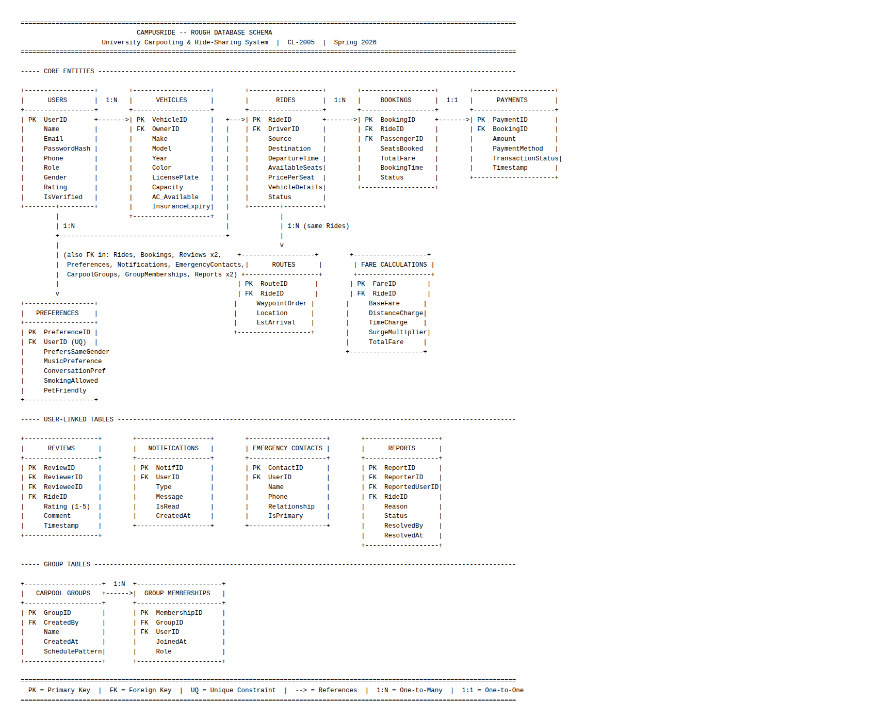

RELEVANT SCREENSHOTS OF DDL QUERIES

1 Users
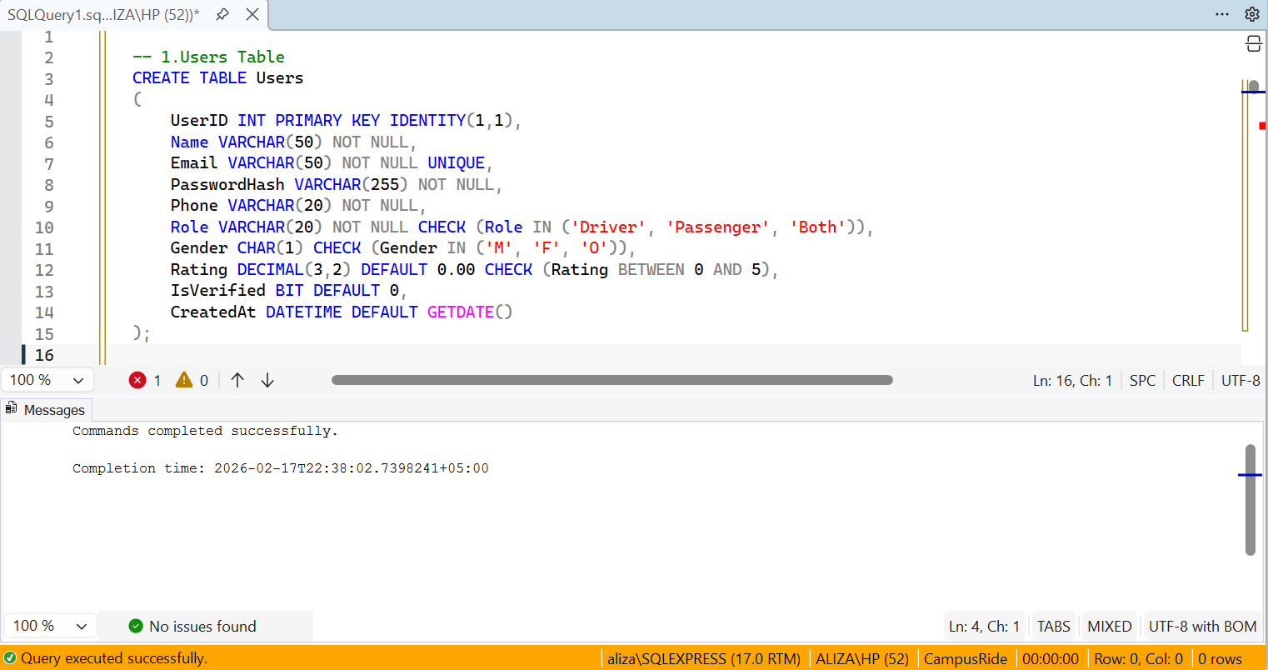
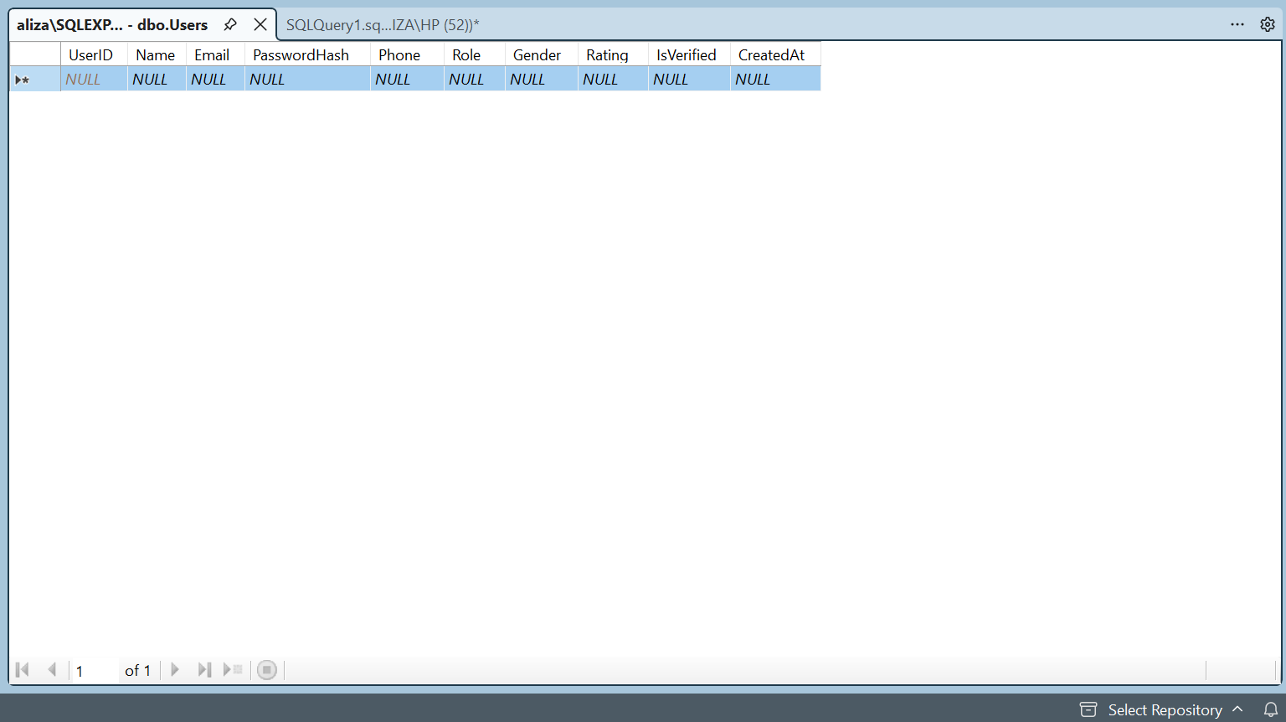

2 Vehicles
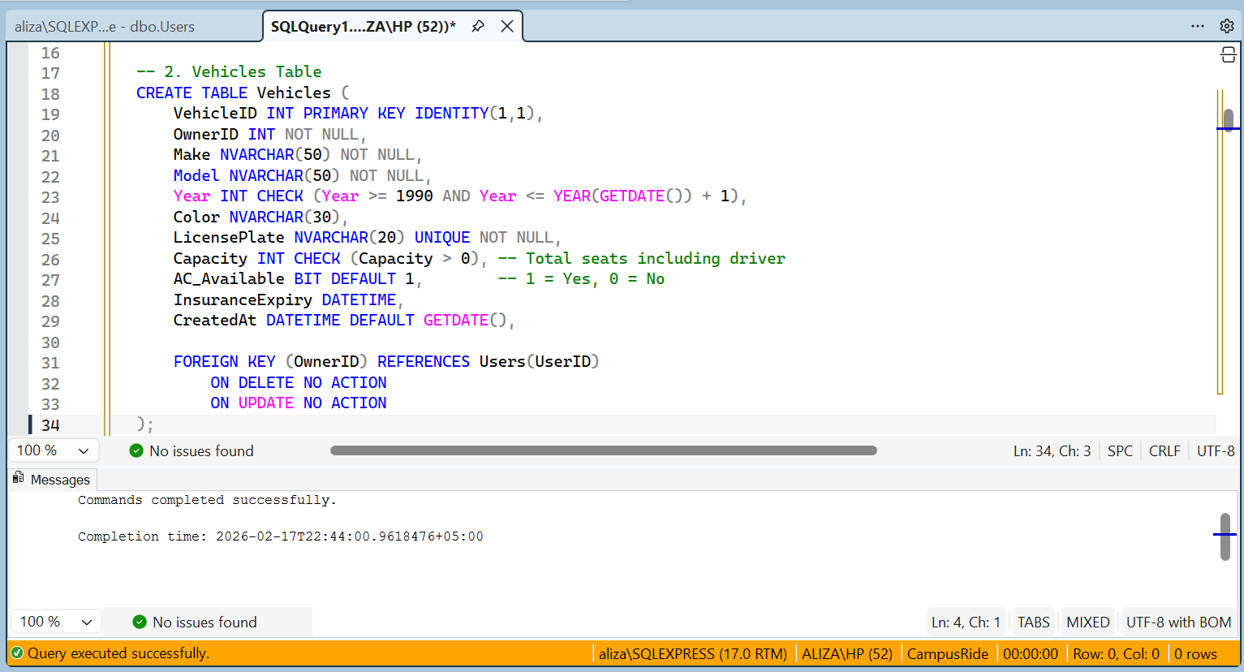
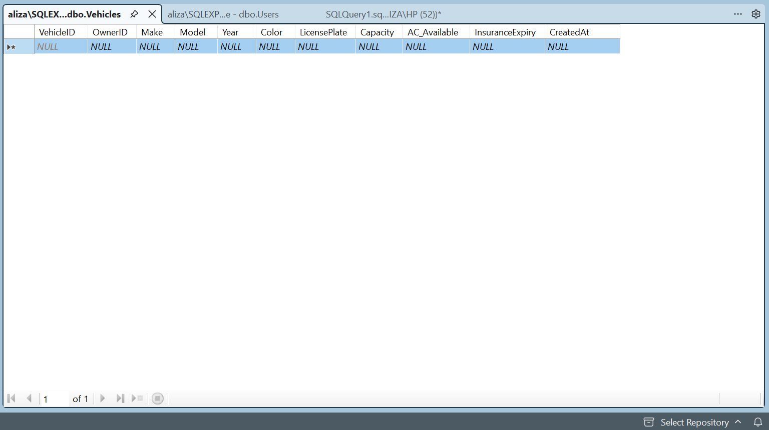

3. Rides
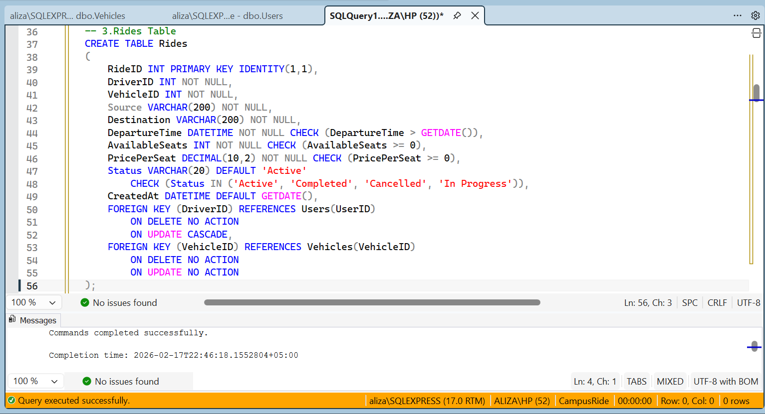

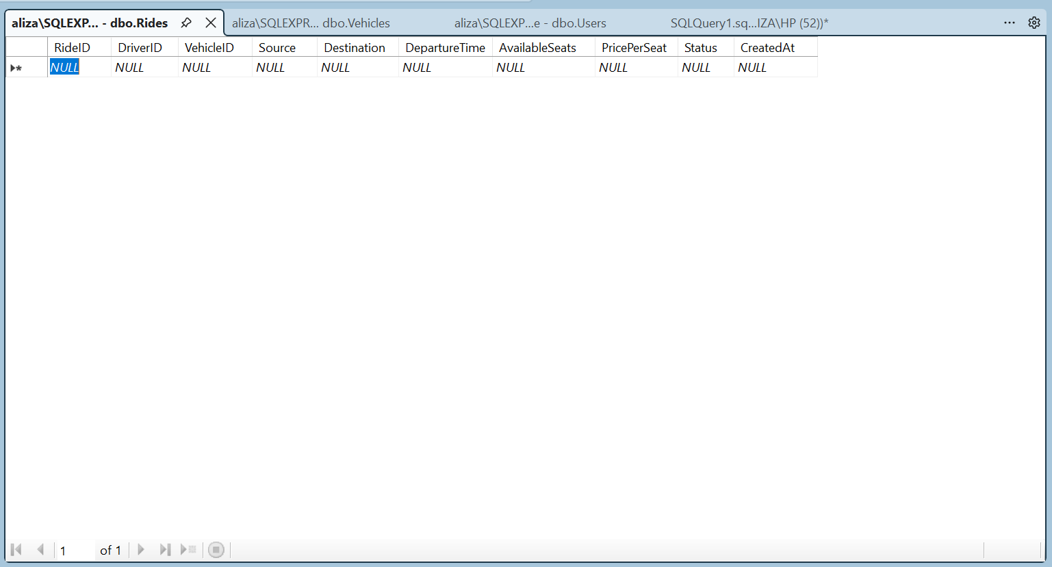

4 Bookings
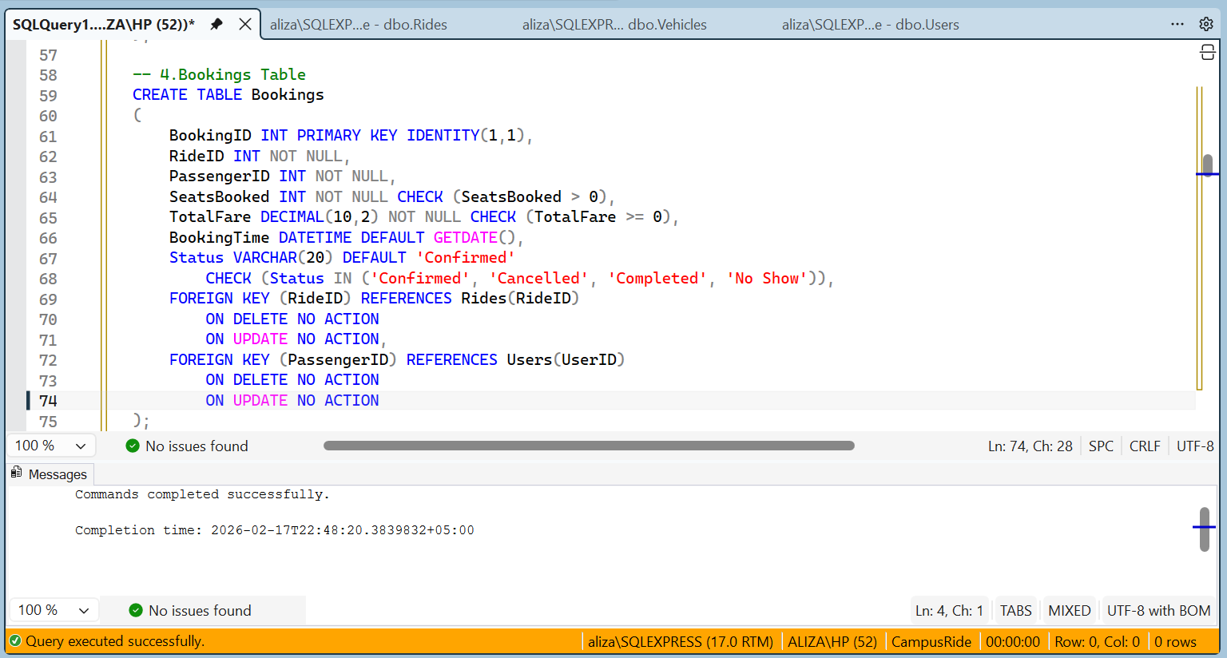

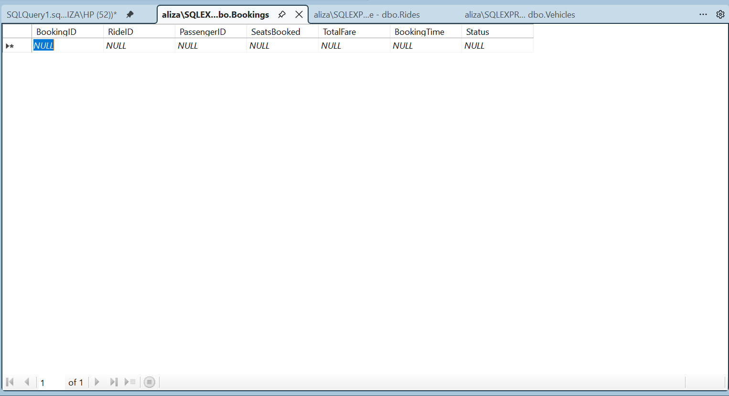
5.Payments
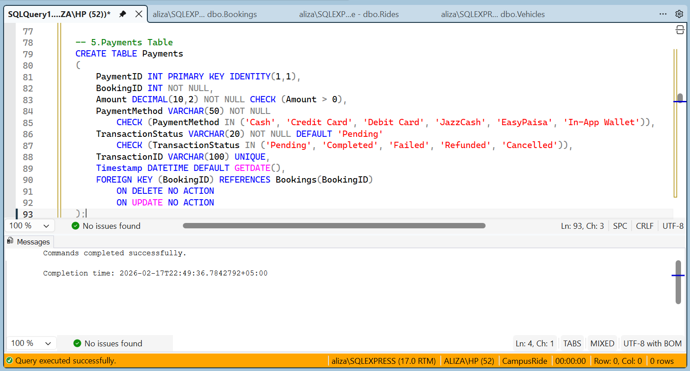

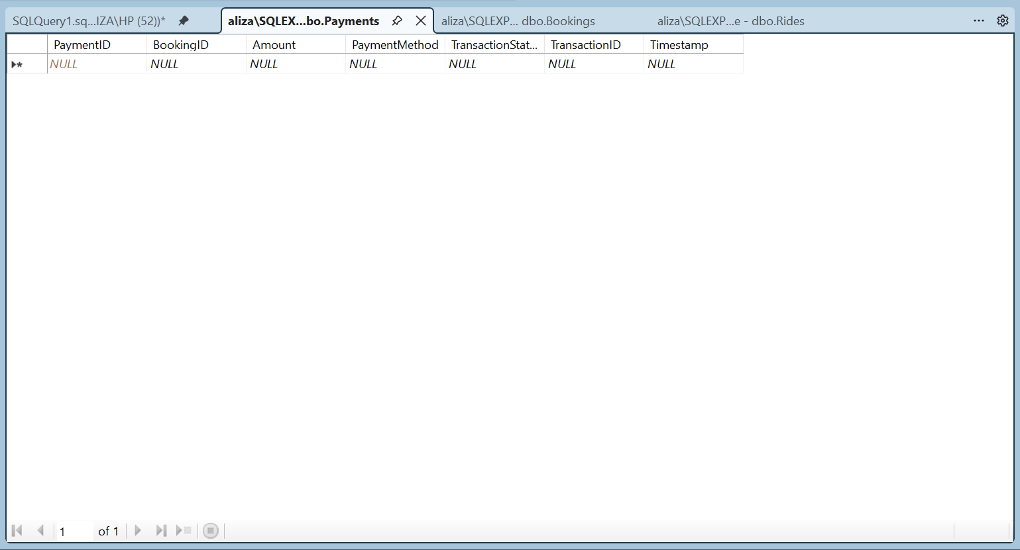

6.Reviews

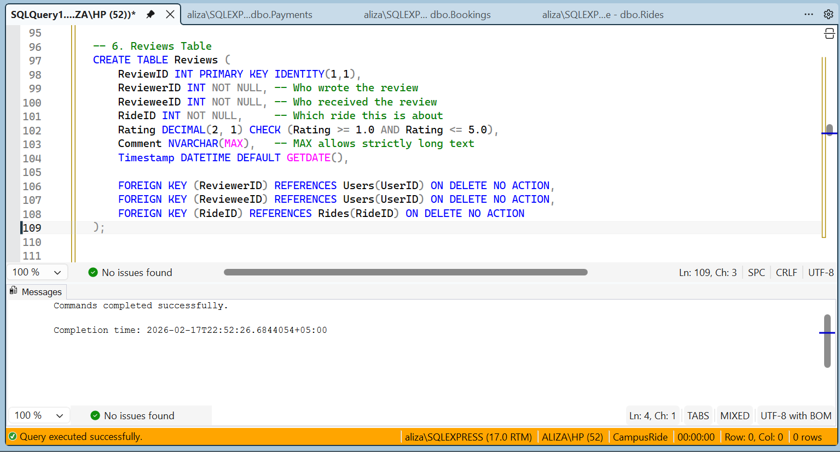
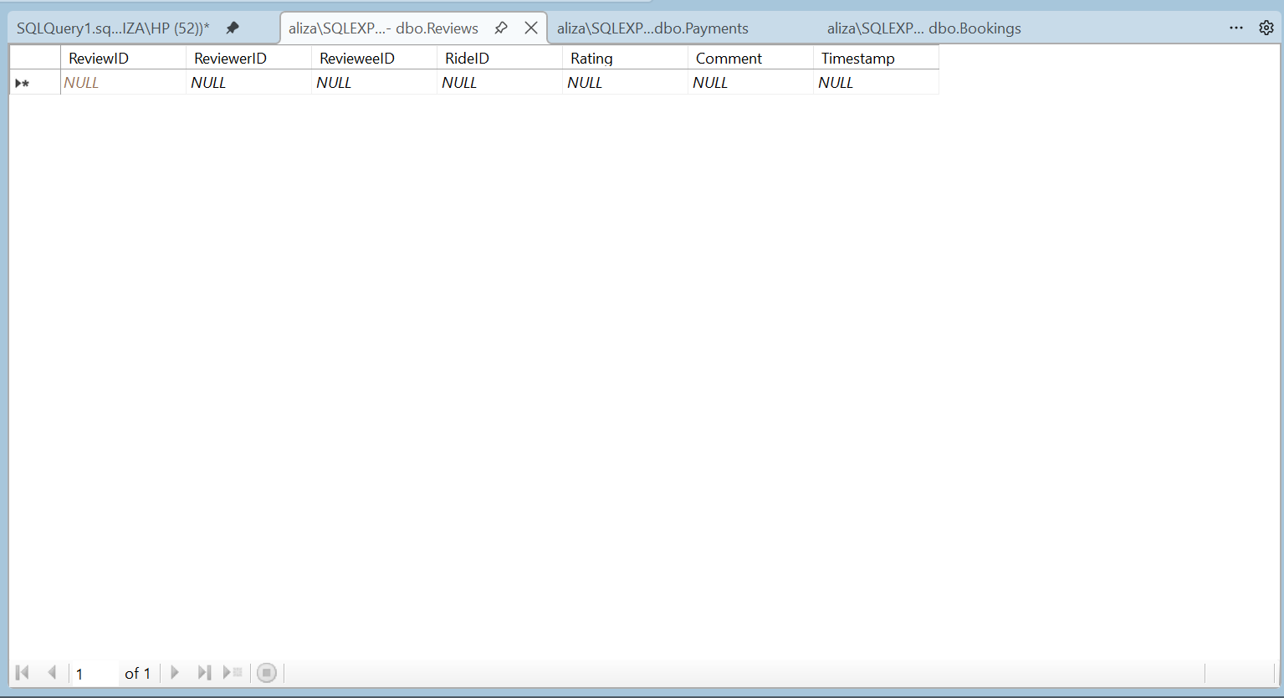

7.Routes

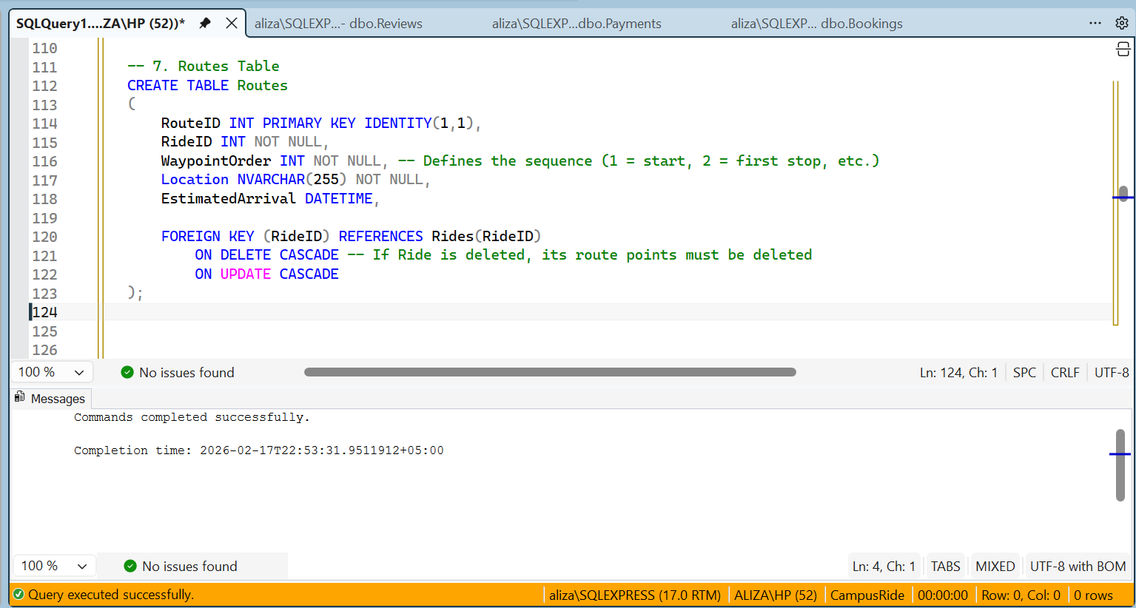

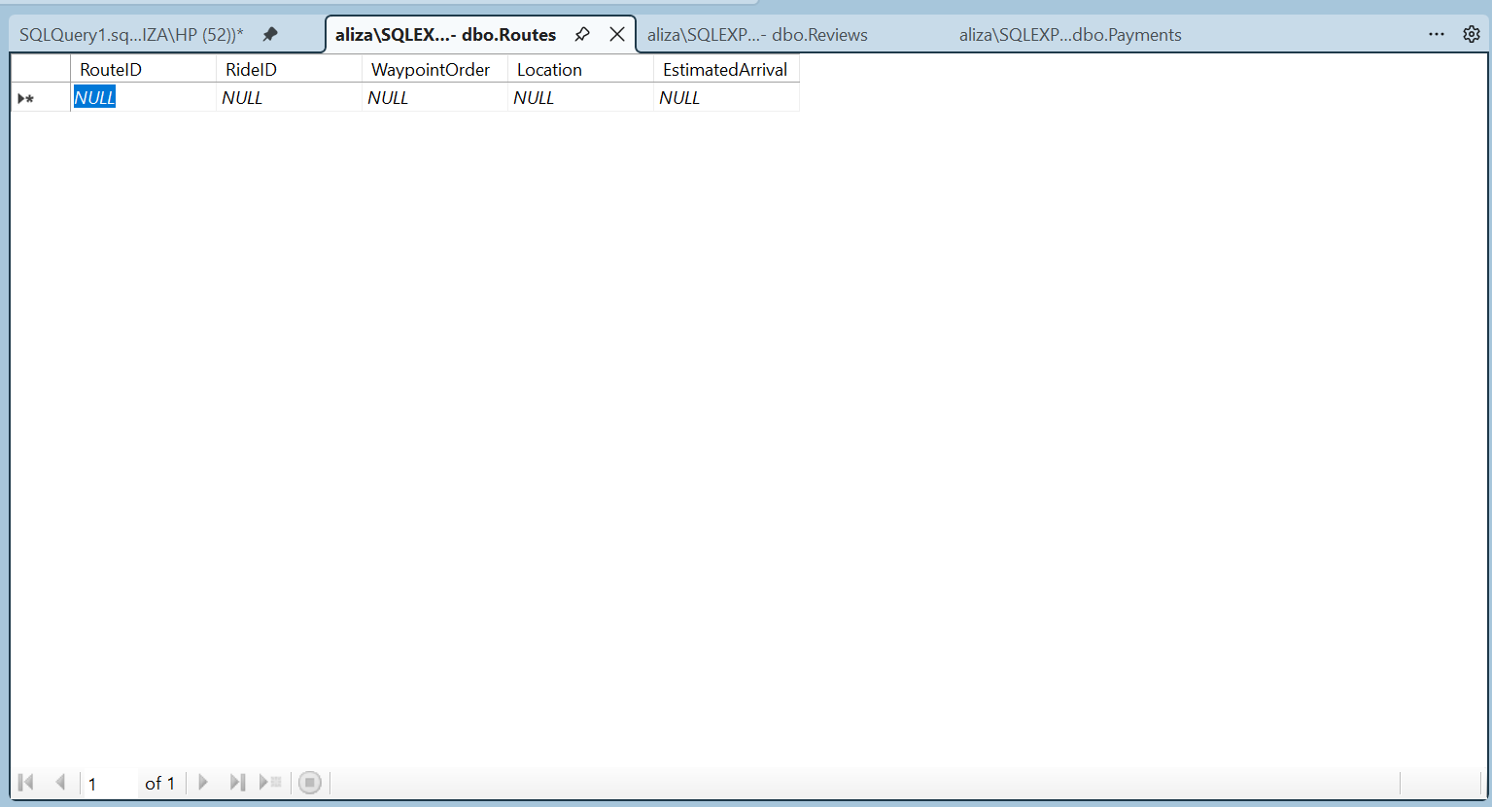

8.Prefrences
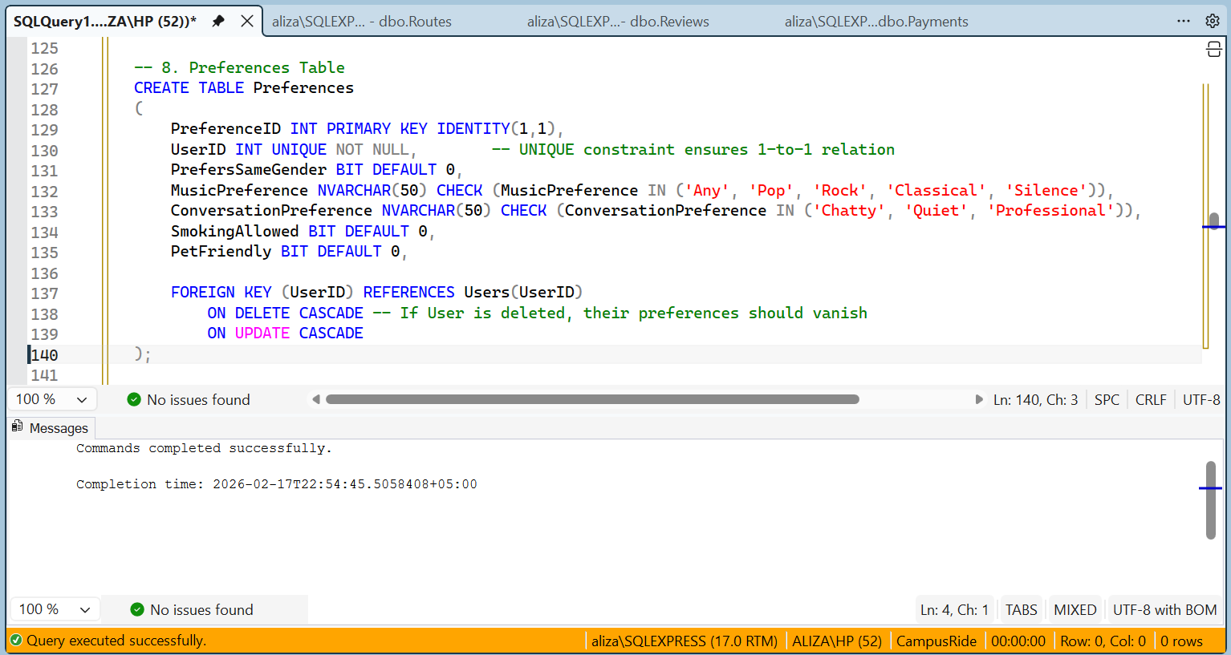

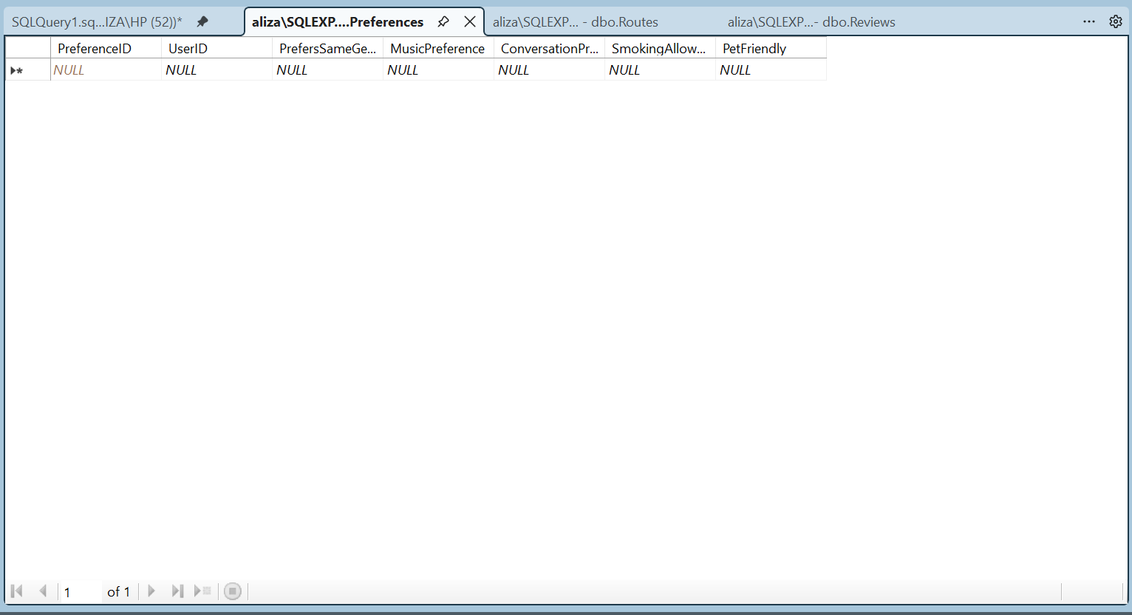

9.Notifications
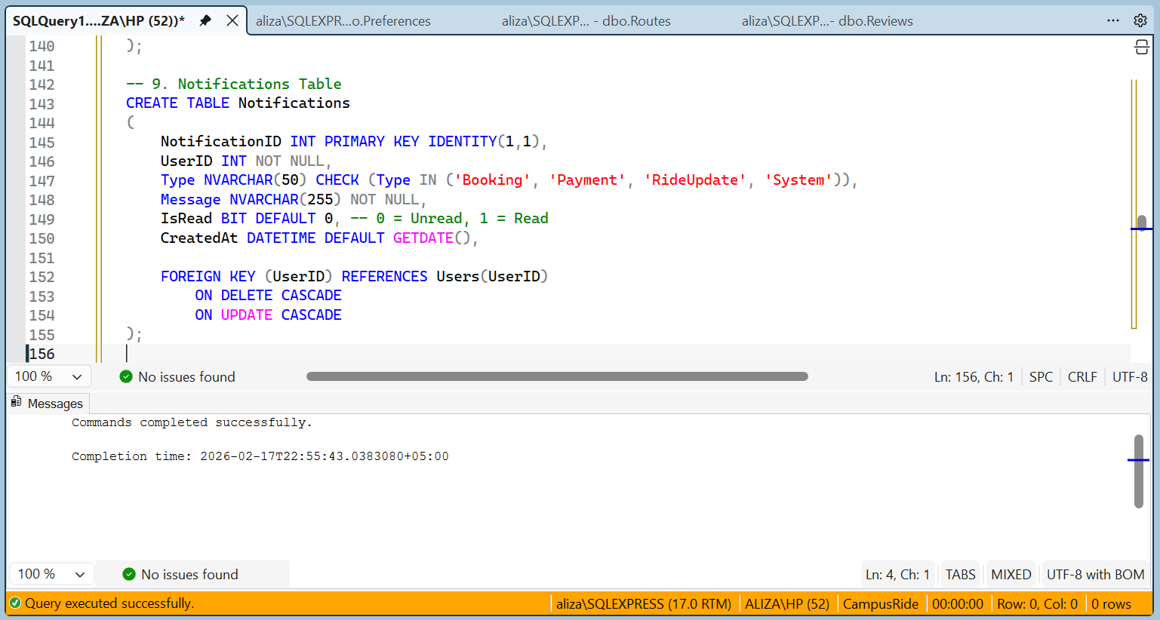

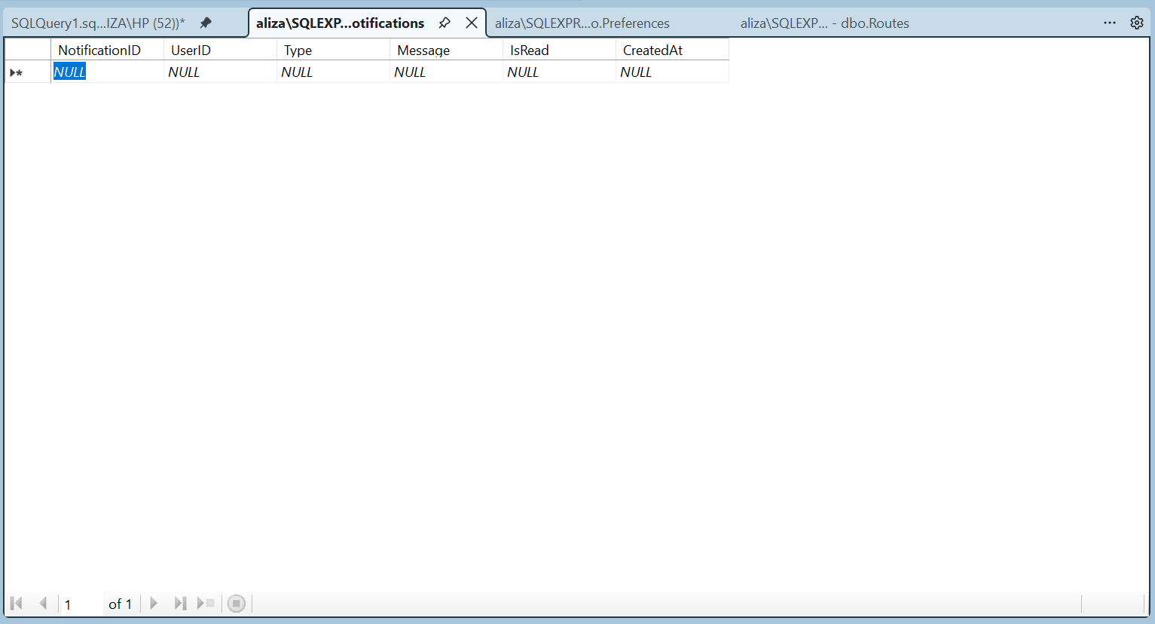

10.EmergencyContacts
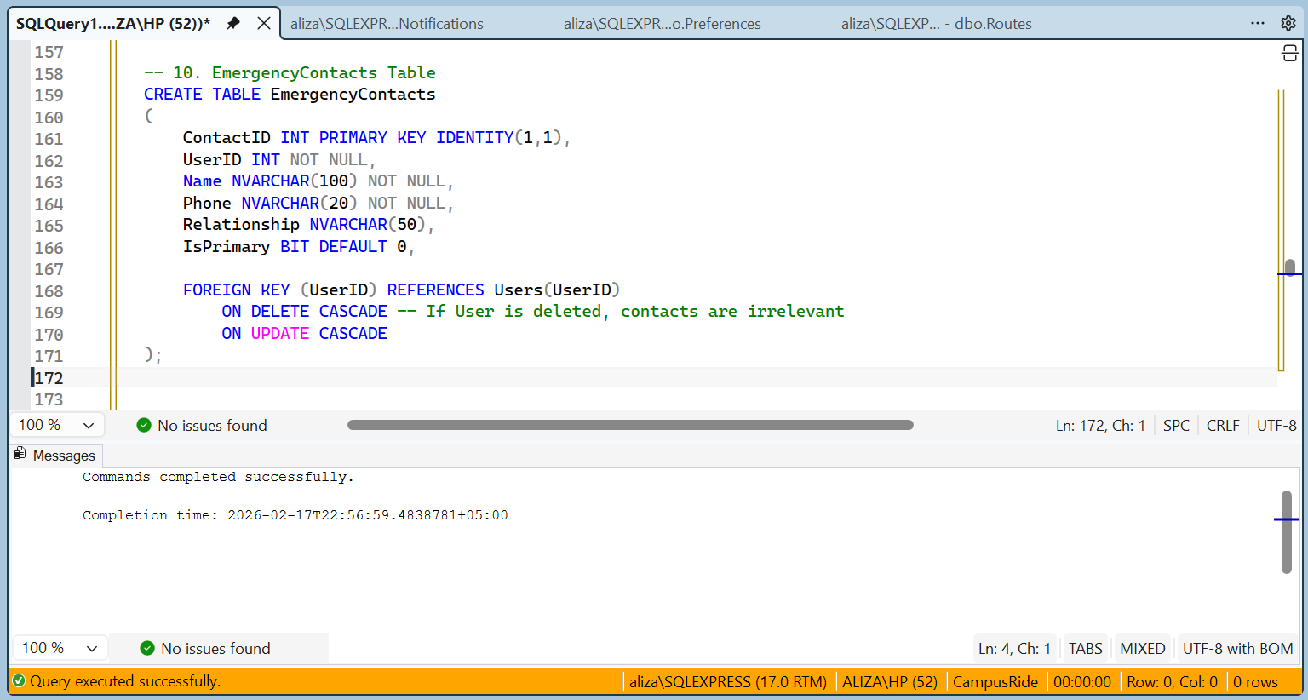

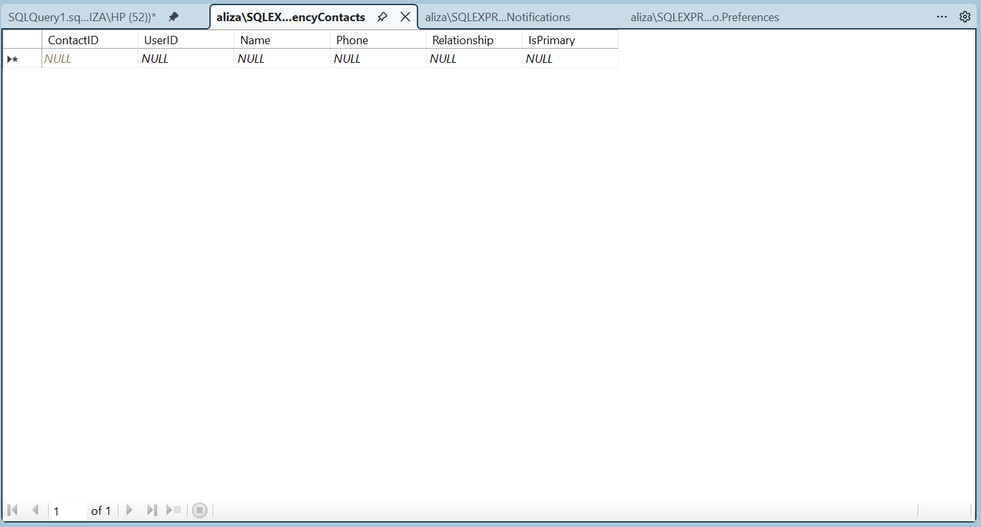

11.CarpoolGroups
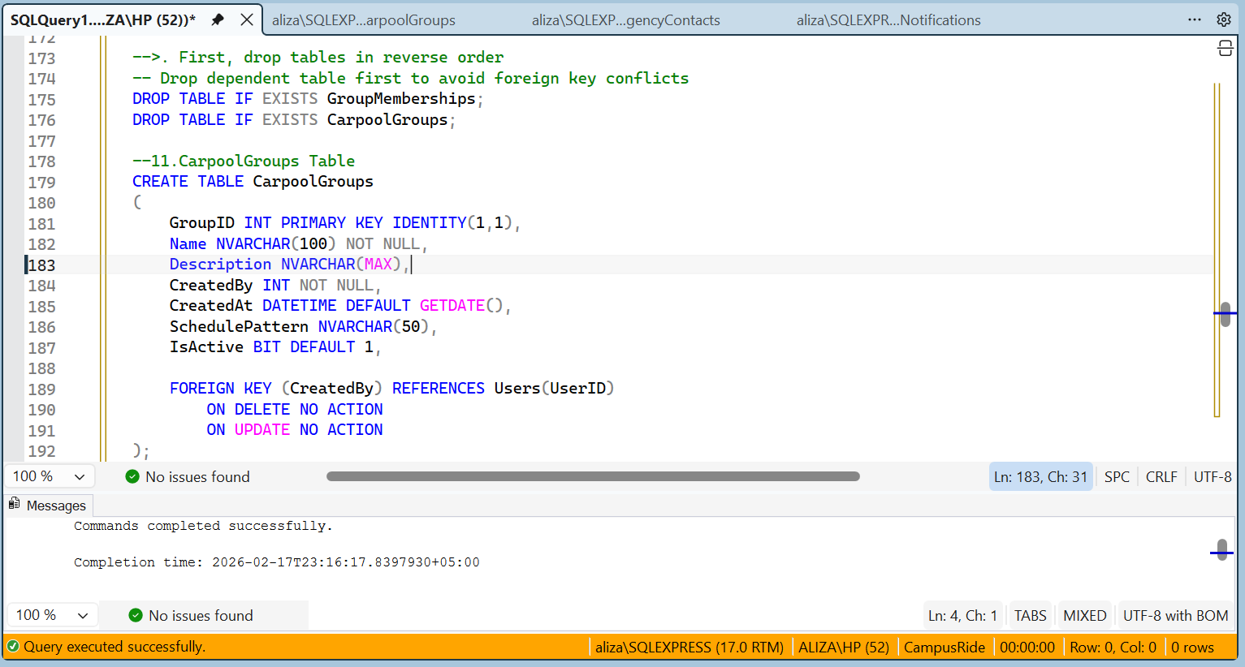

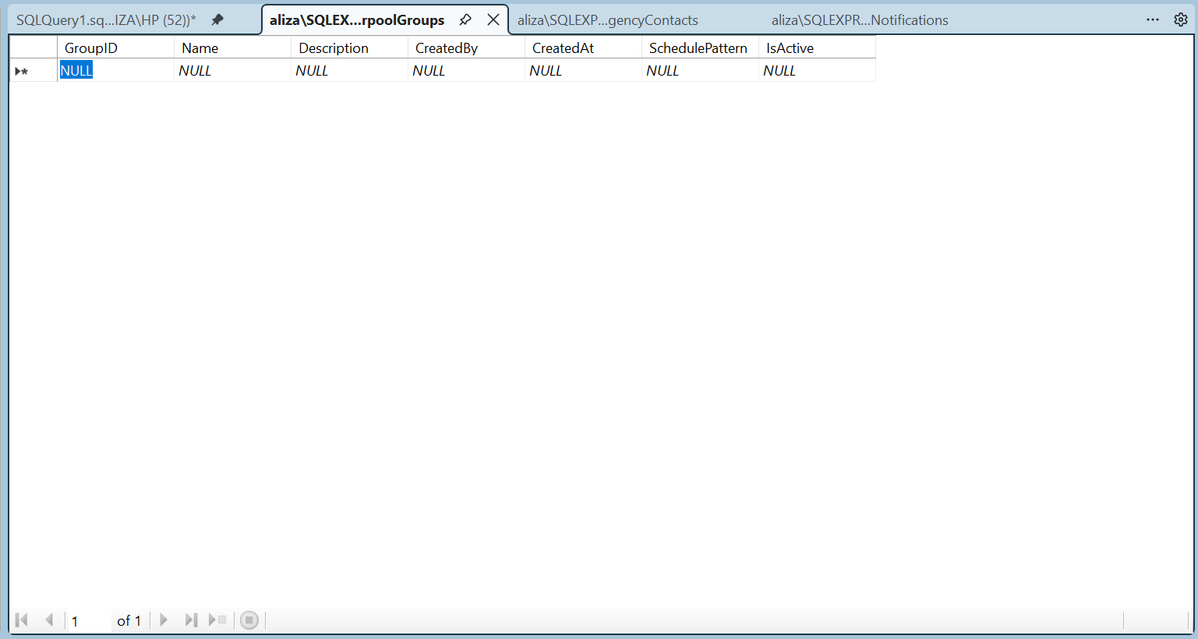

12 . GroupMemberships

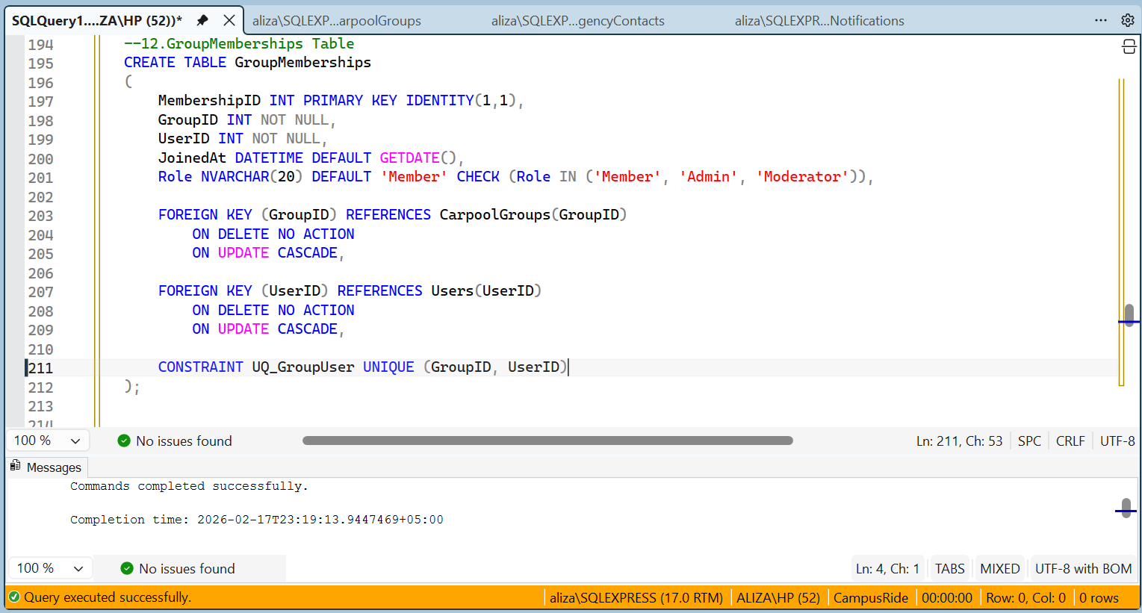

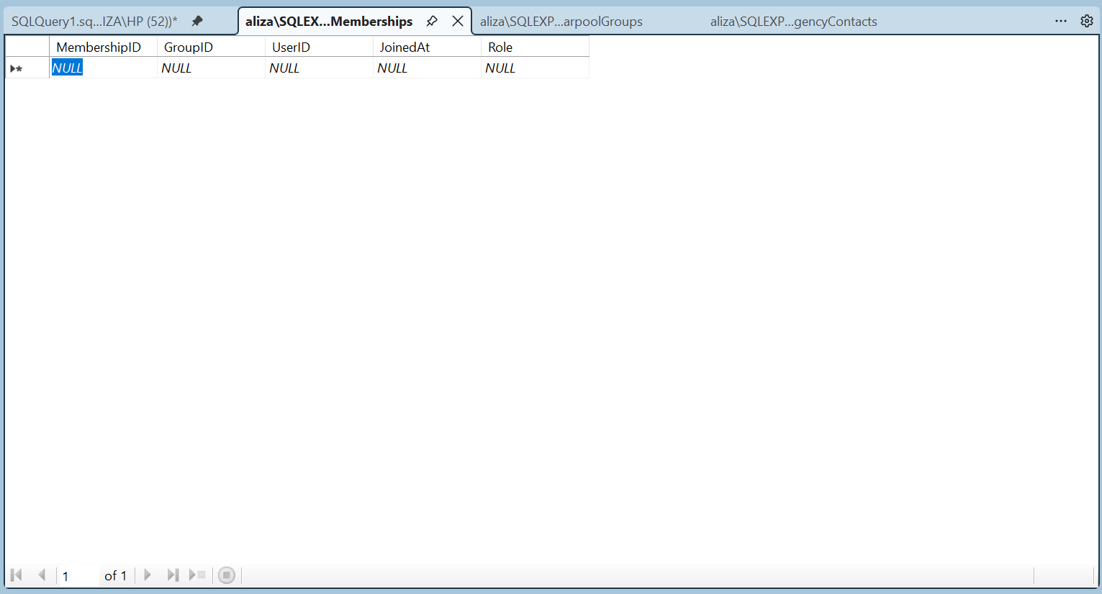

13 . Reports
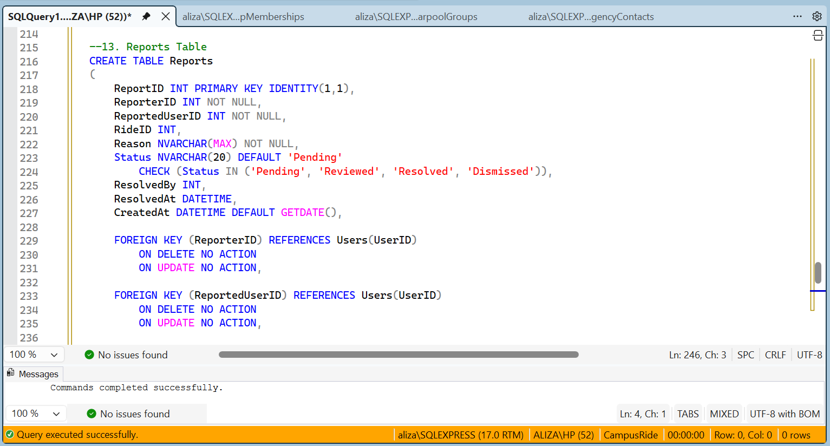

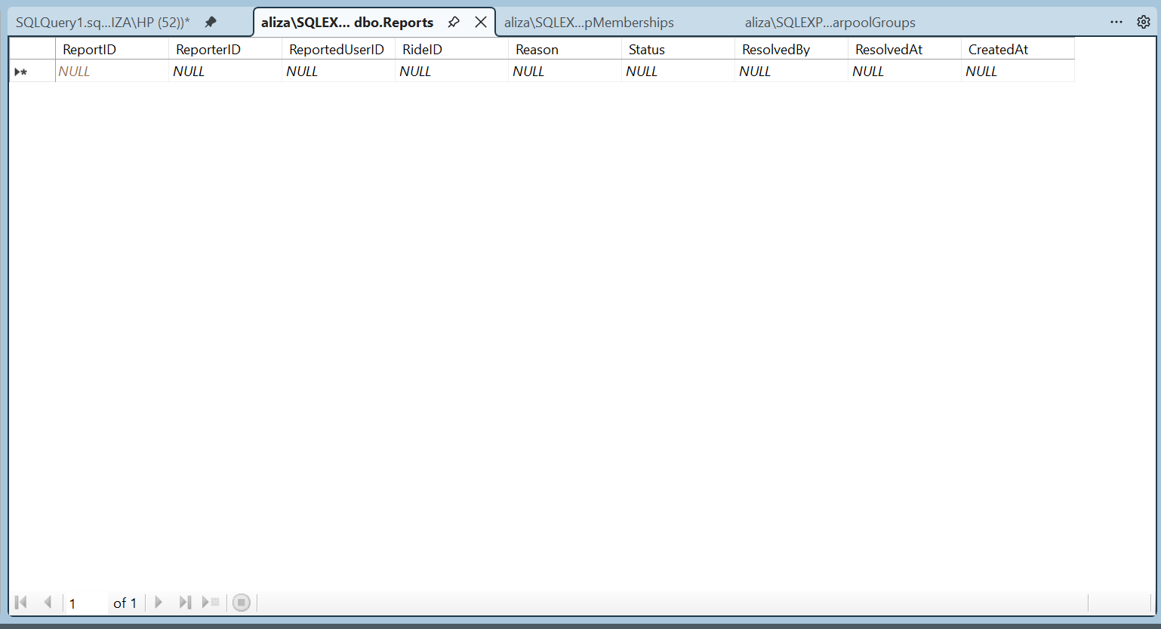

14 . FareCalculations

