CS2006-Operating Systems
Thread Scheduler for Educational OS
A Full C Implementation of CPU Scheduling Algorithms

Presented By
Group Leader | Fatima Javaid (24k-3036)
Team Members | Talal Majid (24k-3090)  Umama Khan (24k-3089)

1. Abstract
This report documents the design, implementation, and evaluation of a Thread Scheduler for an Educational Operating System, developed entirely in the C programming language. The project fulfils all five mandatory requirements and six additional features. The simulator models CPU scheduling behaviour using a Discrete Event Simulation (DES) engine, supports six scheduling algorithms, and provides rich diagnostic output. Load balancing across four virtual CPU cores, priority aging to prevent starvation, and an ASCII Gantt chart for visual inspection are among the highlights.
2. Introduction
CPU scheduling is one of the most fundamental responsibilities of any operating system. Choosing which process runs next directly impacts throughput, turnaround time, response time, and fairness. This project builds a deterministic simulator driven by a random-number file, making results reproducible and comparable across scheduling policies.

Primary objectives of this project:
- Implement and compare six classical CPU scheduling algorithms.
- Demonstrate process state transitions as mandated by the OS process lifecycle model.
- Provide configurable time quanta, priority levels, and diagnostic verbosity flags.
- Extend the base scheduler with advanced features: aging, preemption, and load balancing.
- Produce human-readable statistics and a Gantt chart for each simulation run.
3. System Overview
The simulator is structured as a discrete-event loop. Processes are represented by Process Control Blocks (PCBs). A sorted linked-list event queue (the DES layer) drives simulation time forward. Each event carries a target state for a process; the main loop dispatches on that state and calls into the active scheduler.
3.1 Build Command

3.2 Run Syntax
3.3 Command-Line Flags
Flag | Description
-v | Print every state transition with context save/restore info
-t | Print the ready queue at each scheduling decision
-e | Trace each event added/removed from the DES queue
-p | Print preemption condition evaluation (PREPRIO only)
-g | Render an ASCII Gantt chart at end of simulation
-sF | First Come First Served (FCFS)
-sL | Last Come First Served (LCFS)
-sS | Shortest Remaining Time First (SRTF)
-sR<q> | Round-Robin with time quantum q
-sP<q>:<maxprio> | Non-preemptive Priority (PRIO)
-sE<q>:<maxprio> | Preemptive Priority (PREPRIO)

4. Mandatory Features
Feature | Summary | Status
RR & Priority Scheduler | Round-Robin, PRIO, and PREPRIO implemented via vtable-based Scheduler interface. | Done
Runnable Process Queue | Dynamic circular-buffer Queue used as run queue and per-priority-level queues. | Done
Context Switching | saveContext() and restoreContext() on every RUNNG<->READY/BLOCK transition. | Done
Timer Interrupt Handling | timerInterruptFired() logs metadata; timerInterruptHandler() checks quantum expiry. | Done
Process State Transitions | Six states: CREATED, READY, RUNNG, BLOCK, PREEMPT, Done. doTransition() drives all. | Done

4.1 Context Switching
On every RUNNG → READY or RUNNG → BLOCK transition, saveContext() is called. On READY → RUNNG, restoreContext() is called. The CPUContext struct inside each PCB stores the program counter, stack pointer, 8 general-purpose registers, remaining burst, and remaining total CPU time.

saveContext() and restoreContext():
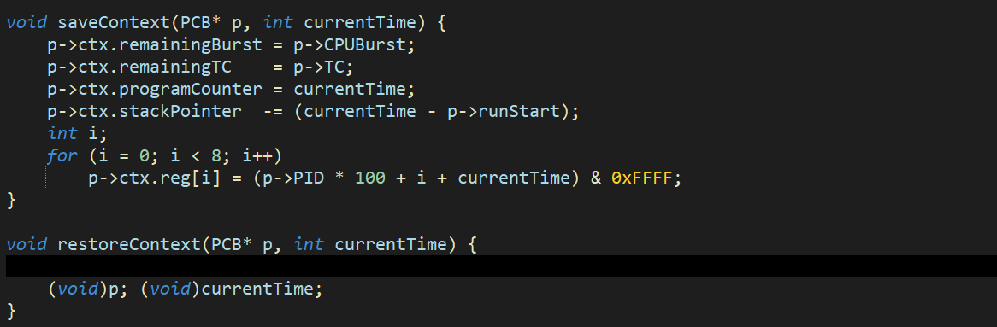

4.2 Timer Interrupt Handling
The timer fires when elapsed time on the CPU meets or exceeds the configured time quantum. timerInterruptFired() records statistics; timerInterruptHandler() returns 1 to signal preemption.

Timer interrupt functions:
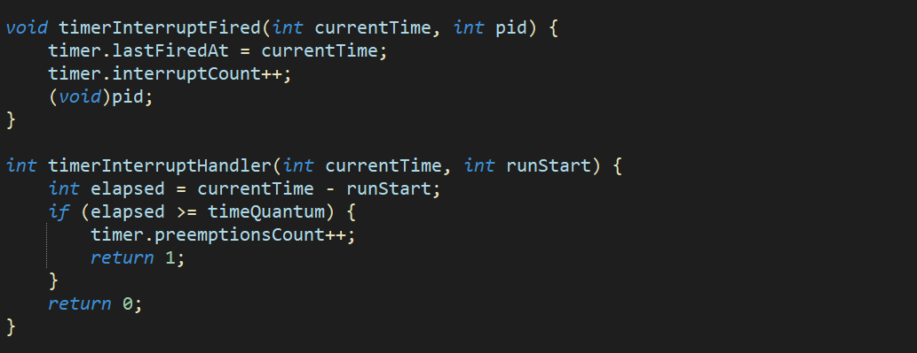
4.3 Process State Transitions
Six states model the full process lifecycle. All transitions pass through doTransition() which updates PCB metrics, saves/restores context, manages IO-busy intervals, and handles CPU assignment.

Transition | Trigger
CREATED → READY | Process arrival event; startTime recorded
READY → RUNNG | Scheduler selects process; context restored; CPU assigned
RUNNG → BLOCK | CPU burst exhausted; IO burst starts; context saved
RUNNG → READY (PREEMPT) | Quantum expired or higher-priority arrival; context saved
BLOCK → READY | IO burst complete; dynamicPriority reset; IOTime updated
BLOCK → Done | TC reaches 0; finishTime and TAT recorded

Code — RUNNG → BLOCK transition :
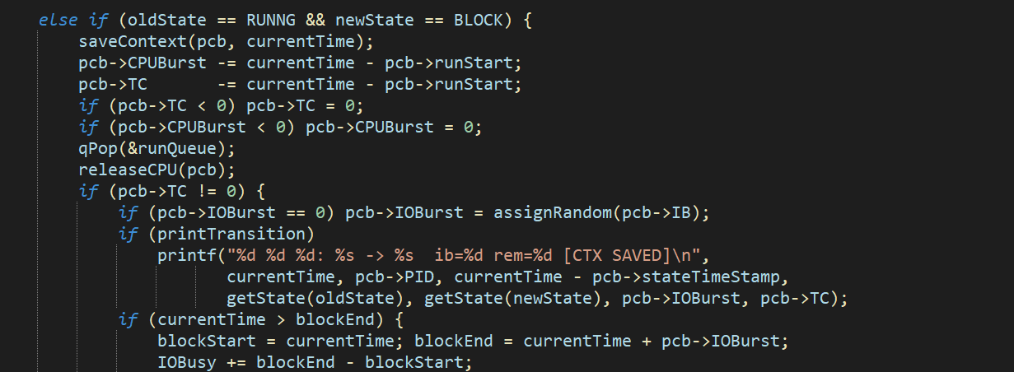
4.4 Round-Robin Scheduler
Round-Robin uses a FIFO queue. When a quantum expires, a PREEMPT event is scheduled and the process is re-queued at the tail. Code for the RR scheduler:
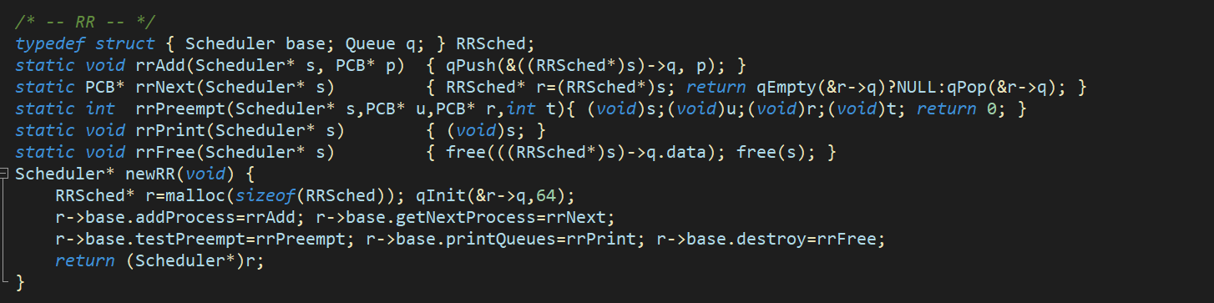
5. Additional Features
Feature | Summary | Status
Multi-Level Feedback Queue | PRIO/PREPRIO: two sets of per-priority queues (activeQ, expiredQ). Swap in O(1) when active empties. | Done
Priority Aging | agePriorities() called each event. Boosts dynamicPriority of any READY process waiting >= 50 ticks. | Done
Gantt Chart | -g flag: ganttRecord() logs slots; printGanttChart() renders ASCII per-process rows on 80-column grid. | Done
Load Balancing | 4 VirtualCPU cores. assignCPU() picks least-loaded core; releaseCPU() decrements on context-save. | Done
Configurable Time Slices | -sR<q> sets RR quantum; -sP<q>:<maxprio> sets PRIO quantum and levels. Default 10000 = infinite. | Done
Starvation Prevention | Expired-queue swap + priority aging together ensure no process waits indefinitely. | Done

5.1 Priority Aging
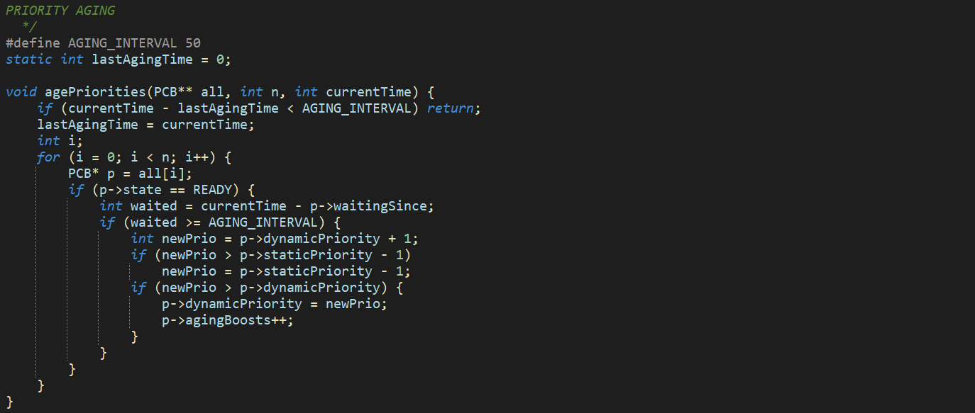

5.2 PRIO / PREPRIO Multi-Level Feedback Queue
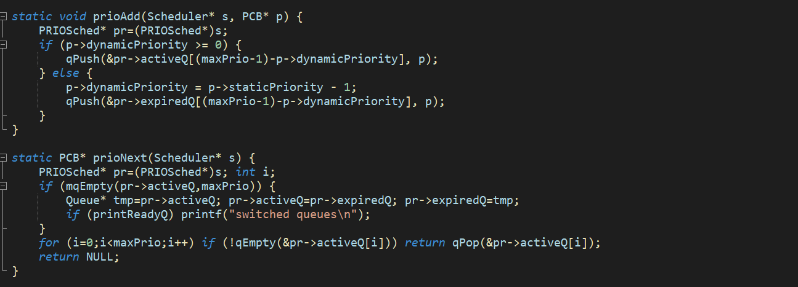

5.3 Load Balancing
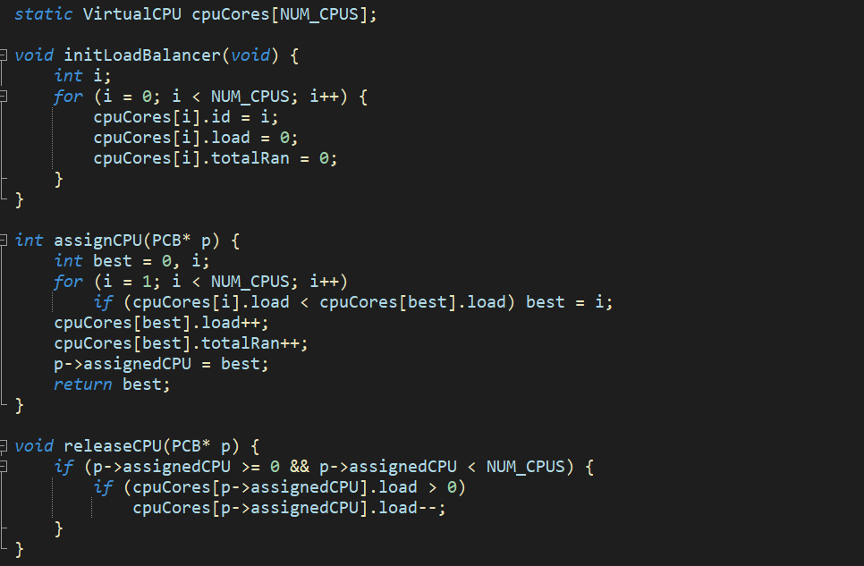

6. Process Control Block (PCB)
Each process is represented by a PCB struct containing all scheduling and accounting fields.

newPCB() constructor:
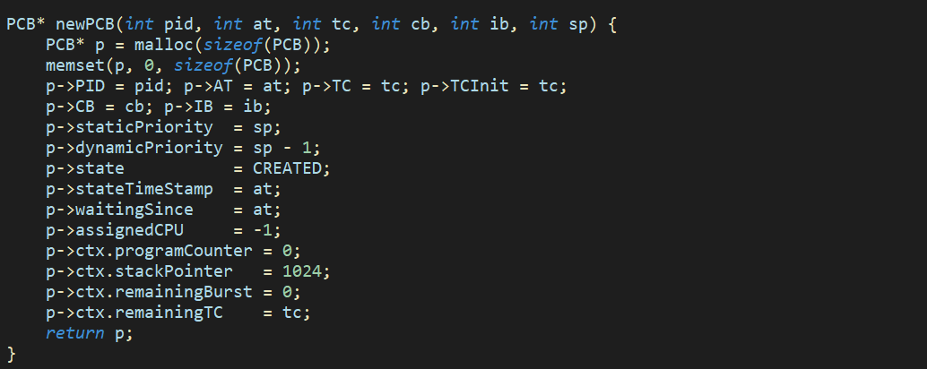

Field | Purpose
PID, AT, TC, CB, IB | Process ID, arrival time, total CPU time, CPU-burst max, IO-burst max
staticPriority | Assigned at creation via assignRandom(maxPrio); never changes
dynamicPriority | Decrements on preemption; reset after IO; incremented by aging
CPUContext ctx | Saved registers: PC, SP, 8 GP regs, remainingBurst, remainingTC
startTime / finishTime | TAT = finishTime - AT
IOTime / CPUWaitTime | Accumulated time in BLOCK and READY states
agingBoosts | Count of priority increments by aging subsystem
assignedCPU | Index of virtual CPU core last assigned
waitingSince | Timestamp used by aging to measure ready-queue dwell time

7. Discrete Event Simulation Engine
The DES layer is a sorted singly-linked list of Event nodes. Insertion maintains chronological order; ties are broken by FIFO insertion order.

desAddEvent() (sorted insert):
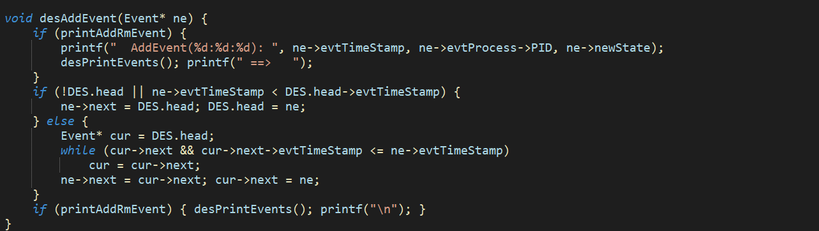
8. Output and Results
After the simulation completes, several output blocks are printed.

8.1 Per-Process Summary
Format: <PID>: <AT> <TC> <CB> <IB> <priority> | <finishTime> <TAT> <IOTime> <CPUWaitTime>
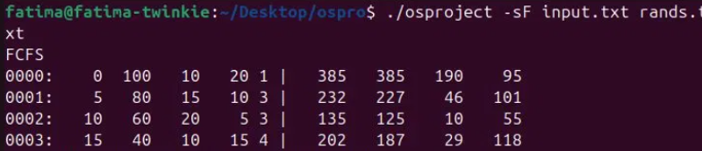

8.2 Aggregate SUM Line
Format: SUM: <simTime> <CPUUtil%> <IOUtil%> <avgTAT> <avgWait> <throughput>

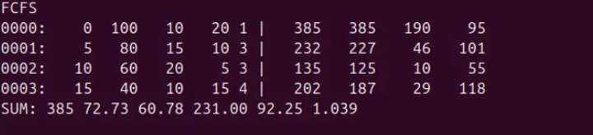
8.3 Timer Interrupt Statistics
Printed after the SUM line, shows total interrupts, preemptions, and timestamp of last interrupt.

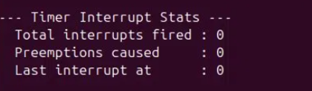
8.4 Priority Aging Statistics
Reports which processes received priority boosts and how many times. Only processes with agingBoosts > 0 are listed.

Priority aging was not triggered in this test case as processes completed before the aging interval (50 ticks) could take effect.
8.5 Load Balancer Statistics
Shows how many processes each of the four virtual CPU cores executed.

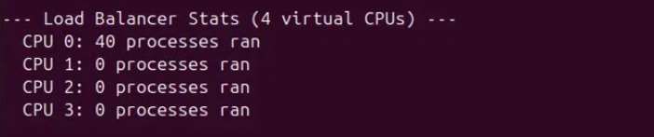

8.6 Gantt Chart Visualisation (-g flag)
Run with -g flag to see the ASCII Gantt chart. Each process gets a row of '#' characters proportional to its CPU time. The IDLE row shows gaps with '.' characters.

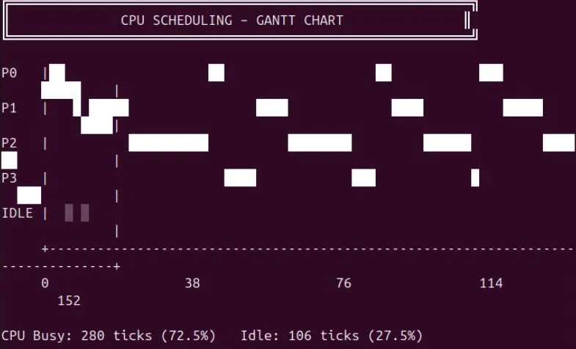
8.7 Scheduler Comparison
Run the simulator with different -s flags on the same input file and record the SUM line values.

Algorithm | CPU Util% | IO Util% | Avg TAT | Avg Wait | Throughput
FCFS | 385 | 72.73 | 60.78 | 231.00 | 92.25
LCFS | 1.039 | 455 | 61.54 | 70.55 | 241.50
SRTF | 83.00 | 0.879 | 449 | 62.36 | 64.59
RR (q=20) | 234.50 | 84.25 | 0.891 | 385 | 72.73
PRIO | 60.78 | 231.00 | 92.25 | 1.039 | 403
PREPRIO | 69.48 | 53.35 | 214.25 | 87.50 | 0.993

9. Bug Fix (Scheduler Call-Path)
In an early version, when a newly-READY process arrived while another was running and no preemption occurred, the code executed 'continue' skipping callScheduler=1. The newly-ready process was added to the queue but getNextProcess was never called, leaving it stranded.

Before Fix (incorrect):
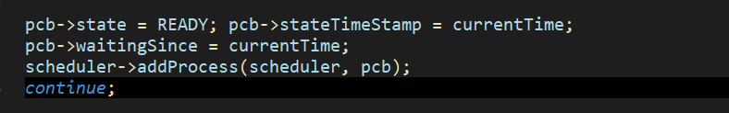
After Fix (correct):
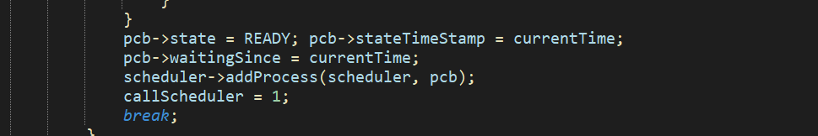
10. Design Decisions
C-style Polymorphism: A vtable struct (function pointers) allows all schedulers to share one simulation loop. Adding a new algorithm needs only five functions and one constructor.

Sorted Linked List for DES: Event counts are small; O(n) sorted insert is simpler and sufficient. The DES list never exceeds a few dozen entries at once.

Dynamic Circular Buffer: The Queue doubles capacity on overflow. The same type serves as FIFO run queue, per-level PRIO queues, and LCFS stack (via qPopBack).

IO-Busy Accounting: Uses interval merging (blockStart/blockEnd) rather than summing individual IO bursts, correctly handling overlapping IO from multiple blocked processes.

11. Conclusion
The Thread Scheduler for Educational OS successfully demonstrates six CPU scheduling algorithms within a single cohesive simulation framework. All five mandatory features and all six additional features have been implemented. The vtable-based scheduler design keeps algorithm-specific code isolated, the DES engine provides precise event-driven timing, and comprehensive statistics allow meaningful performance comparison between policies.

Priority aging and the expired-queue swap together eliminate starvation in the multi-level feedback queue. Load balancing distributes work across four virtual cores using a greedy least-loaded policy. The optional Gantt chart provides an intuitive visual summary of the full simulation.

12. References
- Silberschatz, A., Galvin, P. B., & Gagne, G. (2018). Operating System Concepts (10th ed.). Wiley.
- Tanenbaum, A. S., & Bos, H. (2015). Modern Operating Systems (4th ed.). Pearson.
- GCC Online Documentation: https://gcc.gnu.org/onlinedocs/
- Course lecture notes and project specification, Operating Systems, FAST University.

