Lebanese International University
School of Arts and Sciences - Department of Computer Science

CSCI441 – Machine Learning


Title: Spam Email Classifier using
Naive Bayes

Author(s): Fatima Hussien Dahwi
ID:42230649

1. Introduction:

- Spam email detection is a common problem in machine learning. The goal of this project is to build supervised models to classify emails as Ham or Spam.
- Three different models were trained and evaluated: Multinomial Naive Bayes, K-Nearest Neighbors (KNN), and Logistic Regression.
- The project demonstrates the impact of algorithm choice and dataset balance on model performance.

2. Machine Learning Type & Model:

ML Type:
Classification (predicting discrete labels: Ham or Spam)
Models Used:
- Multinomial Naive Bayes:
suitable for text classification with discrete features like word counts or TF-IDF.
- K-Nearest Neighbors (KNN):
Predicts class based on closest training samples in feature space.
- Logistic Regression:
Outputs probability of a class and works well for balanced datasets.

3. Dataset Description:
- Dataset: ~9,989 emails, 2 classes: Ham (5,294) and Spam (4,695) – fairly balanced.
- Columns: label (target), text (email content)
- Preprocessing steps:
- Remove missing values
- Convert text to TF-IDF features
- Split into training and testing sets

Class distribution:
Figure 1: Distribution of Ham vs Spam emails in the balanced dataset.
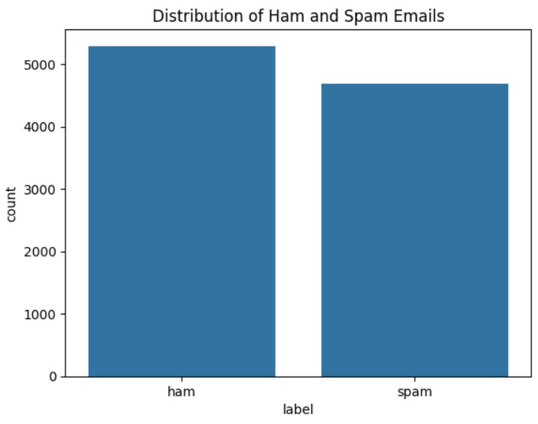
The balanced dataset contains almost equal numbers of Ham and Spam emails (~5294 Ham, ~4695 Spam), which helps the model learn to detect both classes more reliably.

Note: Dataset balance plays a crucial role in model performance. Unbalanced datasets can bias models toward the majority class, leading to misleading accuracy metrics.

4. Data Preprocessing:
- Removed missing values.
- TF-IDF vectorization for text → numerical features.
- Removed stop words.
- Train/Test split (80% train / 20% test).

5. Algorithm Explanation:
1️-Naive Bayes
- Assumes feature independence.
- Calculates probability of each class based on word frequencies.
- Fast and effective for text classification.

2️-K-Nearest Neighbors (KNN)
- Instance-based algorithm: predicts the class of a sample based on the majority class among its k closest neighbors in feature space.
- Distance metric (e.g., Euclidean) determines “closeness”.
- Simple, but computationally expensive on large datasets.
- Performance can be sensitive to feature scaling.
3️-Logistic Regression
- Linear classifier for binary classification.
- Estimates probability of class membership using the logistic (sigmoid) function.
- Works well on balanced datasets and outputs interpretable probabilities.
- Efficient, robust, and widely used for text classification with TF-IDF features.

6. Training and Evaluation

- Same preprocessing and train/test split for all models.
- Evaluation metrics: Accuracy, Precision, Recall, F1-score
- Confusion matrices plotted for all models.

7. Results
- 7.1. Accuracy Comparison:
Model | Logistic Regression | Naïve Bayes | KNN
Accuracy | 0.981 | 0.967 | 0.667

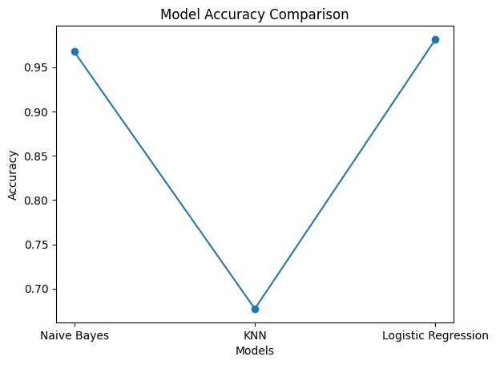
Figure 2: Line Plot of Accuracy for KNN, Naïve Bayes and Logistic Regression

- 7.2. Precision / Recall / F1-score (Spam Class)

Model | Precision | Recall | F1-Score
Logistic Regression | 0.99 | 0.97 | 0.98
Naïve Bayes | 0.95 | 0.98 | 0.97
KNN | 0.97 | 0.32 | 0.49

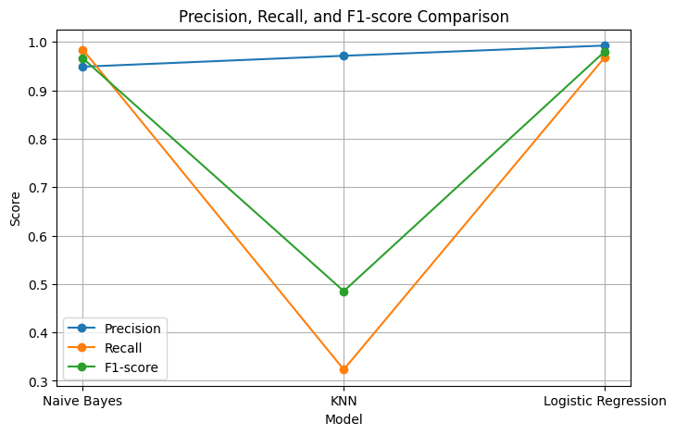

Figure 3: Line Plot of Precision, Recall, F1-score for each model

- 7.3. Confusion Matrices

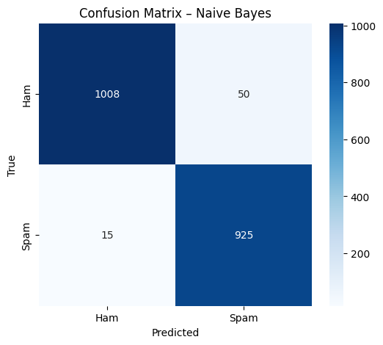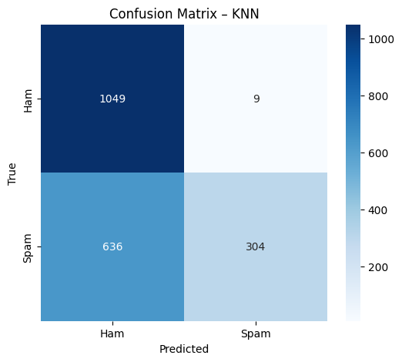

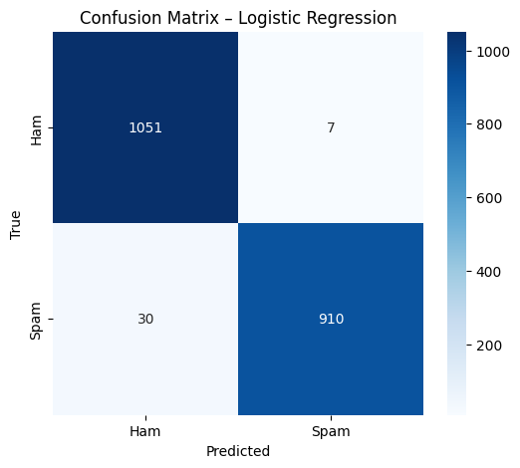
Figures 4,5,6: Confusion Matrix for Models

8. Recommendations
- Use Logistic Regression for production due to high accuracy and balanced performance.
- Naive Bayes: good for fast training and simple implementation; effective for text classification.
- KNN: not recommended for this dataset as it misclassifies many spam emails, resulting in low recall.
- Future work: explore more advanced models (SVM, ensemble methods) or feature engineering (e.g., n-grams, bigrams, TF-IDF tuning).
- Consider hyperparameter tuning to further optimize model performance.
- Test models on larger and more diverse datasets to ensure generalization.
- Continuously monitor dataset balance to prevent model bias toward majority classes.

9. Real-world Applications
- Email filtering systems (Gmail, Outlook)
- SMS spam detection
- Phishing detection

10. Self-learning Outcomes
- Learned preprocessing and vectorizing text data (TF-IDF, train/test split).
- Applied Naive Bayes classifier and understood its assumptions and limitations.
- Applied K-Nearest Neighbors (KNN) and observed its sensitivity to dataset size and feature scaling.
- Applied Logistic Regression and analyzed its probability outputs and performance.
- Interpreted metrics beyond accuracy: Precision, Recall, F1-score, and Confusion Matrix.
- Gained experience handling imbalanced datasets and understanding their effect on model performance.
- Learned how dataset balance affects model bias and evaluation.
- Gained hands-on experience comparing multiple models on the same dataset.
- Learned to visualize results effectively (line plots, confusion matrix heatmaps).

11. Conclusion
- Project shows model selection and dataset balance significantly impact performance.
- Logistic Regression achieves the best results in terms of both accuracy and spam detection reliability.
- Future work: more complex algorithms, feature engineering, and real-world deployment considerations.

