
Lebanese International University
School of Arts and Sciences - Department of Computer Science
CSCI380 – Software Engineering Project
Medical Center
Done by:
Fatima Dahwi
Sarah Shbeeb
Shatha Hashem
Mariam Ghazala
Malak Farran

Instructor:
Dr. Amin Fahes

Date:
21 May 2024

Phase 1: Requirements Analysis
Functional Requirements:
Stakeholder | Functional Requirements
Patient | 1. Book an appointment where:  - View available appointment slots for different doctors and specialties.  - Select the preferred appointment date and time.  - Specify the reason for appointment (e.g., routine check-up, specific health concern).  - Receive confirmation of appointment via email or SMS  - Cancel an appointment.  2. Access Medical History where he can:  - View personal medical history, including past diagnoses, treatments, and prescriptions  - Update personal information such as contact details and insurance information.  3. Request prescriptions as he:  - View current prescriptions and medication instructions.  - Request prescription refills or new prescriptions for ongoing health conditions.  - Receive notifications when prescriptions are ready for pickup.  4. Pay bills where he:  - View itemized bills for services rendered.  - Make payments securely online or in person.  - Receive receipts and statements for payments made.
Scheduler | 1. Schedule appointments as she:  - View doctor schedules and availability.  - Book appointments on behalf of patients.  - Manage appointment slots, including rescheduling or canceling appointments as needed.  2. Manage resources where she:  - Allocate rooms, equipment, and staff for appointments.  - Ensure availability of required resources for scheduled appointments.  3. Notify people where she:  - Send appointment reminders to patients via email or SMS.  - Notify doctors and patients about any changes or cancellations to appointments.  - Confirm appointments with patients.
Doctor | 1. Access the patient’s history where he:  - Access patient medical records, including past diagnoses, treatments, and prescriptions.  - Update patient records with new information after consultations.  - Record notes and observations during patient appointments.  2. Access appointments where he:  - View scheduled appointments, including patient details and appointment reasons.  - Accept, reschedule, or cancel appointments as needed.  - Block off time for administrative tasks or breaks.  3. Prescribing suitable treatment as he:  - Prescribes medications for patients.  - Request a lab test for patients.  - Review prescription history and refill requests from patients.
Head Doctor | - Supervise and oversee the work of other doctors.  - Make strategic decisions regarding clinic operations, resource allocations, and staff management.  - Represent the clinic in external meetings and conferences.  - Serve as the primary point of contact for managing medical emergencies within the clinic.
Lab Specialist | 1. Receive test requests from doctors, including necessary details such as patient information and test type.  2. Schedule sample collection appointments with patients.  3. Track Samples as she:  - Analyze and report stages of the sample.  - Record any deviations or issues encountered during sample processing.  4. Notify doctors and patients about completed test results and any abnormal findings.
Security Guard | 1. Monitor entrances and exits to the clinic premises.  2. Respond to any security incidents or emergencies promptly.  3. Patrol clinic facilities to deter unauthorized access or suspicious activity.  4. Assist with crowd control during peak times.

Non-Functional Requirements:
Non-Functional Requirement | Description
Performance | The system should respond to requests from users (patients, doctors, administrators) within an acceptable time frame, such as 3 seconds, under normal load conditions to ensure efficient management of appointments, medical records, and other functions critical to healthcare delivery.
Security | Access to sensitive patient health information and administrative functions must be restricted to authorized personnel only, enforced through robust authentication mechanisms such as role-based access control, two-factor authentication, and encryption of data both in transit and at rest. Compliance with healthcare data privacy regulations should be emphasized.
Reliability | The system should maintain a high level of uptime, with a minimum target of 99.9%, to ensure continuous availability for critical healthcare operations, including appointment scheduling, medical record access, and prescription management. Scheduled maintenance windows should be communicated in advance to minimize disruption to services.
Scalability | The system architecture should be designed to accommodate growth in user load and data volume over time, with a target capacity to handle a certain percentage increase annually (e.g., 20%) without experiencing degradation in performance. This ensures that the system can scale alongside the medical center's patient base and operational needs.
Language Support | The system must support user interfaces and content in both English and Arabic languages.

Phase 2: Use-Case Diagram

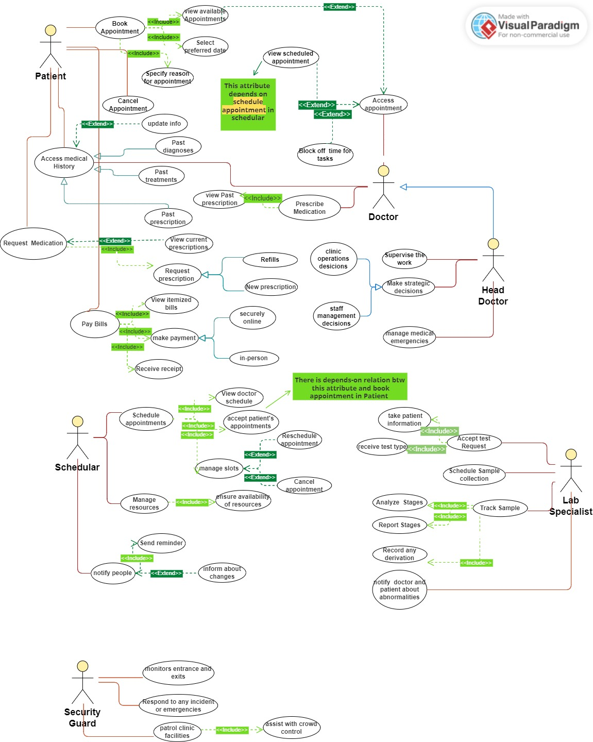

Use-Case Narrative:
Use case name: Book Appointment

Priority: high
Primary actor: Patient
Description: this use case describes the event where the patient is booking an appointment after viewing the available appointments selecting the preferred date and specifying the reason for the appointment
Precondition: the patient is logged into the system

A typical course of events:
1. The patient selects the "Book Appointment" option.
2. System displays available appointments.
3. Patient views available appointments.
4. Patient selects preferred date and time.
5. The patient specifies the reason for the appointment.
6. The system schedules the appointment

Conclusion: the use case concludes that the patient has booked an appointment
Postconditions: Appointment is booked and confirmation is sent to the patient.

Use Case Name: Cancel Appointment

Priority: High
Primary Actor: Patient
Description: This use case describes the event where the patient cancels a previously booked appointment.
Precondition: The patient is logged into the system and has an existing appointment.

Typical Course of Events:
1. The patient selects the "Cancel Appointment" option.
2. The system displays a list of the patient's scheduled appointments.
3. The patient views the list of scheduled appointments.
4. The patient selects the appointment they wish to cancel.
5. The system prompts the patient to confirm the cancellation.
6. The patient confirms the cancellation.
7. System cancels the appointment and updates the schedule.
Conclusion: The use case concludes that the patient has canceled their appointment.
Postconditions: The appointment is canceled, the slot is freed, and a cancellation confirmation is sent to the patient.

Use Case Name: Request Medication

Priority: High
Primary Actor: Patient, Doctor
Description: This use case describes the event where either the patient or the doctor requests a medication refill or a new prescription.
Precondition:
For Patient: The patient is logged into the system and has an existing prescription.
For Doctor: The Doctor is logged into the system and has the necessary permissions to request medication for a patient.

Typical Course of Events:
1. Patient/Doctor selects the "Request Medication" option.
2. If Doctor: The system prompts the doctor to enter the patient's identification (e.g., patient Name).
enters the patient's identification.
3. The system displays the patient's current prescriptions
4. Patient/Doctor views the current prescriptions.
5. The patient/Doctor selects the prescription to refill or requests a new prescription.
6. System prompts for confirmation of the request.
7. The patient/Doctor confirms the medication request.
8. The system sends the request to the doctor for approval (if the request was made by the patient) or processes it directly (if the request was made by the doctor)
Conclusion: The use case concludes that a medication refill or a new prescription has been requested.
Postconditions:
- For Patient: A medication request is sent to the doctor for approval, and the patient is notified when the request is processed.
- For Doctor: The medication request is processed, and the patient is notified of the update.

Use Case Name: Access Medical History

Priority: High
Primary Actor: Patient, Doctor
Description: This use case describes the event where either the patient or the doctor accesses the patient's medical history, including past diagnoses, treatments, and prescriptions.
Precondition:
For Patient: The patient is logged into the system.
For Doctor: The Doctor is logged into the system and has the necessary permissions to access patient records.

Typical Course of Events:
1. Patient/Doctor selects the "Access Medical History" option.
2. If Doctor: The system prompts the doctor to enter the patient's identification (e.g., patient Name).
The doctor enters the patient's identification.
3. The system retrieves the patient's medical records from the database.
4. The system displays the patient's past diagnoses, treatments, and prescriptions.
5. Patient/Doctor views the patient's medical history.
Conclusion: The use case concludes that the patient's medical history has been accessed and reviewed.
Postconditions: The patient's medical history is displayed, and the user (patient or doctor) can review past medical records.

Use Case Name: Pay Bills

Priority: High
Primary Actor: Patient
Description: This use case describes the event where the patient pays their medical bills online or in person.
Precondition: The patient is logged into the system and has outstanding bills.

Typical Course of Events:
1. The patient selects the "Pay Bills" option.
2. The system displays the patient's itemized bills.
3. Patient views their itemized bills.
4. Patient selects the bill(s) they want to pay.
5. The patient chooses the payment method (online or in person).
6. If paying online, the patient enters payment details and confirms payment.
7. The system processes the payment and updates the billing status.
8. The system generates a receipt for the payment.
9. The patient receives the receipt.
Conclusion: The use case concludes that the patient has successfully paid their bills.
Postconditions: The Bill is marked as paid in the system, and a receipt is sent to the patient.

Use Case Name: View Available Appointments

Priority: High
Primary Actor: Patient
Description: This use case describes the event where the patient views the available appointments to choose a suitable date and time.
Precondition: The patient is logged into the system

Typical Course of Events:
1: Patient selects the "View Available Appointments" option
2. The system displays a list of available appointments.
3. The patient views the list of available appointments.
4. The patient selects a preferred date and time from the list.
Conclusion: The use case concludes that the patient has viewed the available appointments.
Postconditions: The available appointment slots are displayed to the patient, and the selected slot can be used for booking an appointment.

Use Case Name: Select Preferred Date

Priority: High
Primary Actor: Patient
Description: This use case describes the event where the patient selects a preferred date for an appointment from the available options.
Precondition: The patient is logged into the system and has accessed the list of available appointments.

Typical Course of Events:
1. The patient selects the "Select Preferred Date" option.
2. The system displays a calendar with available dates for appointments.
3. The patient views the available dates.
4. The patient selects their preferred date.
5. The system confirms the date selection and shows available time slots for that date.
Conclusion: The use case concludes that the patient has selected a preferred date for their appointment.
Postconditions: The preferred date is reserved for the patient, and available time slots for that date are displayed for further selection.

Use Case Name: Specify Reason for Appointment

Priority: High
Primary Actor: Patient
Description: This use case describes the event where the patient specifies the reason for their appointment after selecting a preferred date and time.
Precondition: The patient is logged into the system and has selected a preferred date and time for the appointment.

Typical Course of Events:
1. The patient selects the "Specify Reason for Appointment" option.
2. The system prompts the patient to enter the reason for the appointment.
3. The patient enters the reason for the appointment.
4. The system confirms and records the reason for the appointment.
Conclusion: The use case concludes that the patient has specified the reason for their appointment.
Postconditions: The reason for the appointment is recorded in the system and associated with the scheduled appointment.

Use Case Name: Update Info

Priority: High
Primary Actor: Patient
Description: This use case describes the event where the patient updates their personal information in the system.
Precondition: The patient is logged into the system.

Typical Course of Events:
1. The patient selects the "Update Info" option.
2. The system displays the patient's current personal information.
3. Patient reviews their current information.
4. Patient makes necessary changes to their personal information.
5. The patient submits the updated information.
6. The system validates the changes and updates the patient's record.
Conclusion: The use case concludes that the patient's personal information has been updated.
Postconditions: The patient's updated personal information is saved in the system.

Use Case Name: View Itemized Bill

Priority: Medium Primary
Actor: Patient
Description: This use case describes the process where a patient accesses and reviews the detailed breakdown of charges for a specific medical bill.
Precondition: The patient is logged into the system and has a medical bill available for viewing.
Typical Course of Events:
- The patient selects the "Billing" or "Statements" option from the main menu.
- The system displays a list of the patient's medical bills, including the bill date, amount due, and associated doctor or department.
- The patient selects the specific bill they want to view in detail.
- The system retrieves and displays the full itemized bill for the selected encounter.
- The itemized bill details each service, medication, or product provided, along with the corresponding cost.
- The bill may also display additional information such as insurance coverage details and remaining patient responsibility.
- The patient can navigate and review the different sections of the bill
Conclusion: The use case concludes after the patient has reviewed the itemized breakdown of charges for their medical bill.
Postconditions:
No changes are made to the patient's bill or account balance.
The patient has a clearer understanding of the specific charges associated with their medical care.

Use Case Name: Pay Bill After Viewing Details (Extension of Pay Bills)
Priority: High (inherited from Pay Bills)
Primary Actor: Patient (inherited from Pay Bills)
Description: This use case extends the "Pay Bills" scenario by allowing the patient to review the itemized breakdown of a bill before proceeding with the payment.
Precondition:
● Patient is logged into the system and has a medical bill available to be viewed and paid (same as Pay Bills).
● Patient has sufficient funds in their chosen payment method to cover the bill amount (same as Pay Bills).
Typical Course of Events:
- Patient follows steps 1 and 2 from "View Itemized Bill" (select "Billing" and choose the specific bill).
- The system displays the selected bill details in full, including the itemized breakdown of charges.
- The patient has the option to review the itemized charges before proceeding.
- The patient can then choose to:
(a) Proceed to payment in person
(b) Proceed to payment securely online
Conclusion: The use case concludes after the patient successfully pays their medical bill and receives a digital receipt.
Postconditions: This use case inherits the same postconditions as both "Pay Bills" and "View Itemized Bill".

Use Case Name: Pay Bills Online
Priority: High
Primary Actor: Patient
Description: This use case describes the process for a patient to pay their medical bill electronically and receive a digital receipt.
Precondition:
- The patient is logged into the system and has a medical bill available to be paid.
- The patient has sufficient funds in their chosen payment method to cover the bill amount.
Typical Course of Events:
- The patient selects "Pay Bills" from the main menu.
- The system displays a list of outstanding bills.
- The patient chooses the specific bill to pay.
- The system displays the selected bill details (optional: includes a breakdown of charges).
- The patient confirms payment details and submits payment.
- The system processes the payment and transmits funds for successful payment
- The system generates a digital receipt for the patient.
Conclusion: The use case concludes after the patient successfully pays their bill and receives a digital receipt.
Postconditions:
- The outstanding medical bill is marked as paid.
- The payment amount is reflected in the patient's account history.
- A digital receipt is available for the patient to access

