AI Lead Qualification System

1. Architecture Diagram
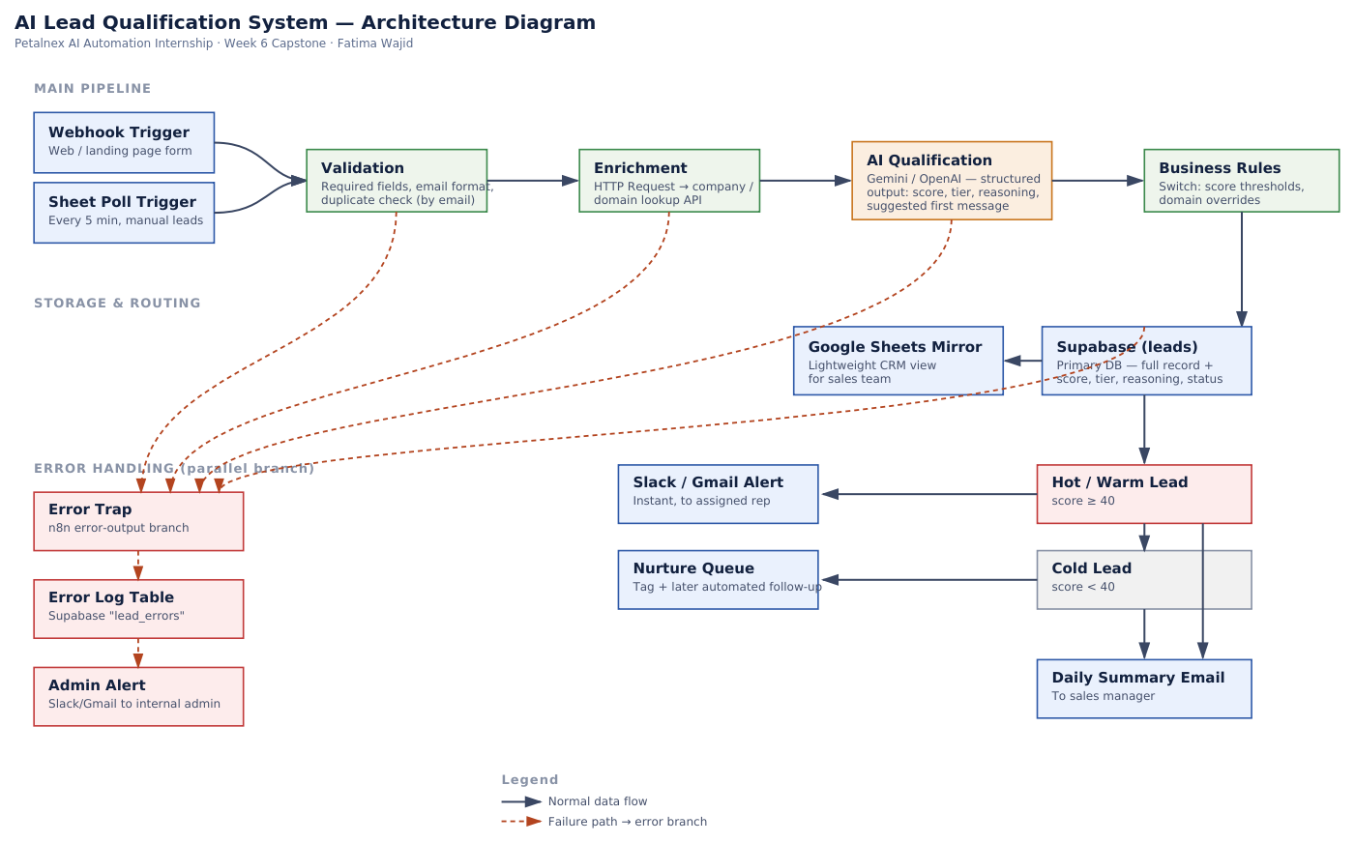
Solid arrows = normal data flow · Dashed red arrows = failure path into the error-handling branch

2. Node Group / Component List
# | Node Group | Type | Purpose
1 | Webhook Trigger | Trigger | Receives new lead submissions in real time from the web/landing-page form.
2 | Sheet Poll Trigger | Trigger | Polls a shared Google Sheet every 5 minutes for leads added manually by marketing.
3 | Validation | IF / Switch | Checks required fields, email format, and looks up existing email to flag duplicates.
4 | Enrichment | HTTP Request | Calls a company/domain lookup API to confirm the lead's company is real and pull basic firmographic data.
5 | AI Qualification | AI Agent (LLM) | Gemini/OpenAI call with a structured-output prompt returning ICP fit score, tier, reasoning, and a suggested first message.
6 | Output Parser / Validator | Code / Set | Parses the AI's JSON output and validates it against the expected schema before it is trusted downstream.
7 | Business Rules | Switch | Applies deterministic score thresholds and domain overrides on top of the AI's tier.
8 | Database Write | Supabase node | Writes the full lead record (fields + AI score/tier/reasoning) to the leads table.
9 | Sheet Mirror Write | Google Sheets node | Mirrors the same record into a spreadsheet view for the sales team.
10 | Sales Alert | Slack / Gmail node | Sends an instant notification to the assigned rep for Hot/Warm leads.
11 | Nurture Tagging | Set / Supabase update | Tags Cold and lower Warm leads for a later automated follow-up sequence.
12 | Daily Summary | Schedule Trigger + Gmail | Once-daily digest to the sales manager summarizing all leads processed and their tiers.
13 | Error Trap | Error Trigger / error output | Catches failures from any node in the main pipeline (validation, enrichment, AI, DB write).
14 | Error Log Table | Supabase node | Records failed leads with the error reason into a separate lead_errors table — nothing is silently dropped.
15 | Admin Alert | Slack / Gmail node | Notifies the internal admin/dev when a failure is logged so it can be manually resolved.

3. Integrations, Models & Data Stores
Category | Component | Notes
Automation Platform | n8n (self-hosted / n8n.cloud) | Orchestrates the full workflow; reused from Weeks 1–5 environment.
AI Model | Google Gemini (primary) / OpenAI (fallback) | Structured-output qualification and message drafting; same provider family used in the Day 20 RAG pipeline.
Primary Database | Supabase (Postgres) | Tables: leads, lead_errors. Chosen for consistency with the pgvector experience from Week 4.
Secondary Store | Google Sheets | Human-friendly mirror for sales reps who prefer a spreadsheet view.
Enrichment API | Company/domain lookup service | Confirms company legitimacy and basic firmographic data before the AI step (saves AI cost on junk leads).
Notifications | Slack + Gmail | Slack for instant rep alerts and admin error alerts; Gmail for the daily manager digest.
Vector DB | Not used in this capstone | No RAG/document retrieval is required for lead qualification, so pgvector is not part of this specific workflow.

4. Credentials List
All credentials are stored in n8n's built-in credential manager only. No API key, token, or password is ever hard-coded into a node's parameters or logged in plain text.
Credential | Used By | Storage | Notes
Webhook auth token | Webhook Trigger | n8n credential store | Validates that inbound form POSTs come from the real form, not a random caller.
Google Sheets OAuth2 | Sheet Poll Trigger, Sheet Mirror Write | n8n credential store | Scoped to the specific lead-tracking spreadsheet only.
Enrichment API key | Enrichment (HTTP Request) | n8n credential store / HTTP header auth | Rotated periodically; never appears in node parameters.
Gemini / OpenAI API key | AI Qualification | n8n credential store | Usage capped via provider dashboard to guard against runaway cost on malformed loops.
Supabase service role key | Database Write, Error Log Table | n8n credential store | Same key type debugged in the Day 20 RAG pipeline; restricted to the leads/lead_errors tables via row-level policy.
Slack Bot Token | Sales Alert, Admin Alert | n8n credential store | Scoped to the sales and internal-alerts channels only.
Gmail OAuth2 | Daily Summary | n8n credential store | Send-only scope; no inbox read access required.

5. Failure Handling
Failure Scenario | Handling
Missing/malformed lead fields | Validation node rejects before the AI step; error branch logs the raw payload for review.
Duplicate lead | Existing record is updated instead of creating a second row; no re-scoring cost incurred.
Enrichment API timeout/down | Workflow continues without enrichment data rather than blocking the whole pipeline; flagged in the record.
AI call fails or returns invalid JSON | Output Parser catches the schema mismatch; lead is stored with tier “Needs Manual Review” instead of being lost or mis-scored.
Database write failure | Error Trap catches it, retries once, then logs to lead_errors and alerts the admin.
Notification (Slack/Gmail) failure | Lead record is already safely stored in the DB before notification fires, so a failed alert never means a lost lead — it is simply re-sent or caught in the daily digest.

6. Security Considerations
- All secrets live only in n8n's credential store — never in node parameters, code nodes, or exported workflow JSON.
- Supabase access uses row-level security scoped to the lead tables; the service role key is restricted to this workflow's use case.
- Webhook endpoint validates a shared token/signature so it cannot be spammed or spoofed by arbitrary requests.
- Personally identifiable information (name, email, phone) is stored only in Supabase/Sheets — never passed to third-party enrichment or AI calls beyond what is strictly needed for qualification.
- Exported workflow JSON and documentation are checked before sharing/publishing to confirm no credentials or tokens are embedded.

