Security Audit Report
Day 27 — Security & Secret Management
AI Automation Internship • Petalnex Pvt. Ltd.

Objective
The objective of this task was to improve the security of an existing n8n AI automation workflow by protecting credentials, preventing unauthorized webhook requests, reviewing sensitive data handling, and following least-privilege and secret-management practices.

Workflow Audited
The Week 3 AI Customer Support Triage workflow was used as the security-audit target. The existing customer-support flow receives a request through a webhook and then performs AI analysis and downstream ticket-processing actions. A security layer was added before AI processing.
Updated security flow:
Customer Request → Webhook → Validate Webhook Secret → Valid: Existing AI Workflow / Invalid: Reject with HTTP 401

Security Changes Implemented
Area | Change | Status
Webhook authentication | Added an IF node to validate the X-Webhook-Secret header. | Implemented
Unauthorized requests | Invalid or missing secret is routed to Respond to Webhook. | Implemented
HTTP response | Unauthorized branch is configured to return an HTTP 401 response. | Implemented / verify
Workflow protection | AI processing is reached only through the valid-secret branch. | Implemented
Sensitive screenshots | Actual secrets should not be displayed in screenshots or document | implemented
GitHub protection | Workflow JSON should be checked for keys, tokens, passwords

Webhook Security Configuration
The webhook now checks the incoming HTTP header X-Webhook-Secret. The IF node reads the header value and compares it with the configured test secret. A matching value follows the TRUE branch and continues to the existing AI workflow. A missing or incorrect value follows the FALSE branch and is handled by Respond to Webhook.
Important: The test secret used during development is only a demonstration value. A real production secret must be stored securely and must not be hard-coded, committed to GitHub, or shown in screenshots.

Test Results
Test | Input | Expected | Current result
Test 1 | No X-Webhook-Secret header | 401 / unauthorized branch | PASS
Test 2 | Incorrect secret | 401 / unauthorized branch | PASS
Test 3 | Correct test secret | TRUE branch → existing workflow | PASS

Security Checklist
- No API keys, passwords, bearer tokens, database passwords, or webhook secrets should be hard-coded in Code nodes.
- n8n Credentials should be used for supported external services instead of placing credentials directly in workflow logic.
- Workflow JSON should be inspected before uploading to GitHub.
- Real customer names, emails, messages, or other PII should not be used in public test files.
- Secrets must not appear in screenshots, README files, PDFs, presentations, or public repositories.
- Webhook endpoints should not accept unauthenticated requests when the workflow is intended to be protected.
- If a real secret has ever been exposed publicly, it should be revoked/rotated rather than merely deleted from the visible file.

Findings and Fixes
Finding: The original webhook did not verify a caller-provided secret before allowing the request to proceed into the workflow.
Risk: An exposed webhook endpoint could potentially be called by unauthorized clients.
Fix: Added a secret-header validation step before AI processing and routed failed validation to an HTTP 401 response.

Conclusion
The Week 3 customer-support automation was strengthened with a webhook authentication check. Testing confirmed that a request without the required secret is rejected and that a request containing the correct test secret can continue through the existing workflow.
WRONG SECRET:
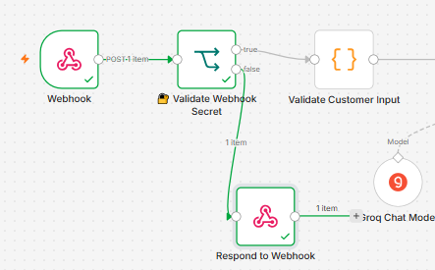

CORRECT SECRET:
