**Designing Blocks**

What is my App name ?

Little Muslim

What is app logo ?

My app logo :



What will be the application of my app?

My Application help little Muslim to memories first surah of holy Quran , dua and five pillars of Islam.

How many screen will I use ?

5

|  |  |  |  |
| --- | --- | --- | --- |
| Number of Screen | Visible components | Non Visible components | Rename all components |
| Screen 1 | 3 buttons | Sound 1 | Screen 1 : not changed  Button 1:Stop  Button 2:Start  Button 3:play  Sound 1: little Muslim |
| Screen 2 | 1 lable  3 buttons | none | Screen 1 : not changed  Button1:Quran  Button 2:Dua  Button3: Five pillars of Islam  Lable 1 : not changed |
| Screen 3 | 4 buttons | Sound 1  Sound 2 | Screen 3 : Al fatiha  Button 1:back  Button 2:urdu Audio  Button 3:play  Button 4:Stop  Sound 1: Al FAtiha  Sound 2 : urdu translation |
| Screen 4 | 1 lable  4 buttons | Sound 1  Sound 2 | Screen 4 : Dua  Button 1:back  Button 2:urdu Audio  Button 3:play  Button 4:Stop  Lable 1 : Dua  Sound 1: dua  Sound 2 :dua translation |
| Screen 5 | 3 buttons | Sound 1 | Screen 5 : pillars of Islam  Button 1:back  Button 2:play  Button 3:Stop  Sound 1: pillar of Islam |

Selection of media(images, mp3)

**Screen 1 :-**

Background image :

Start background : Green colour

Play background image :



Stop background image :



**Screen 2 :-**

Background image :



Lable 1 background : none

Quran background :



Dua background :



Five pillars of Islam :



Screen 3 : Al fatiha

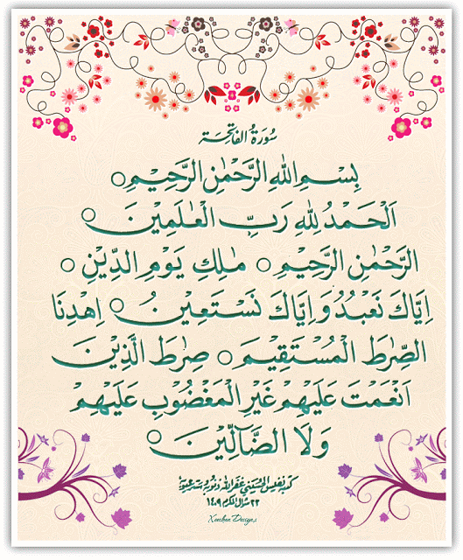Al fatiha background image :

Back button background : Pink

Button 2:urdu Audio



Button 3:play



Button 4:Stop



Sound 1: Al FAtiha mp3

Sound 2 : urdu translation mp3

Screen 4 : Dua

Dua background image :

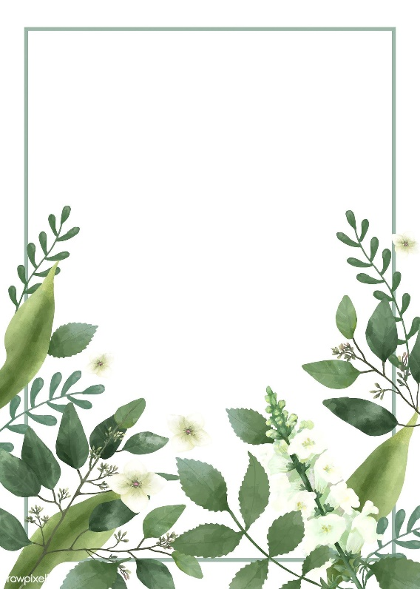

Button 1:back

Back ground color Green

Button 2:urdu Audio



Button 3:play



Button 4:Stop



Lable 1 : Dua

No background color

Sound 1: dua mp3

Sound 2 :dua translation mp3

**Screen 5 : pillars of Islam**

Pillar of Islam background image :

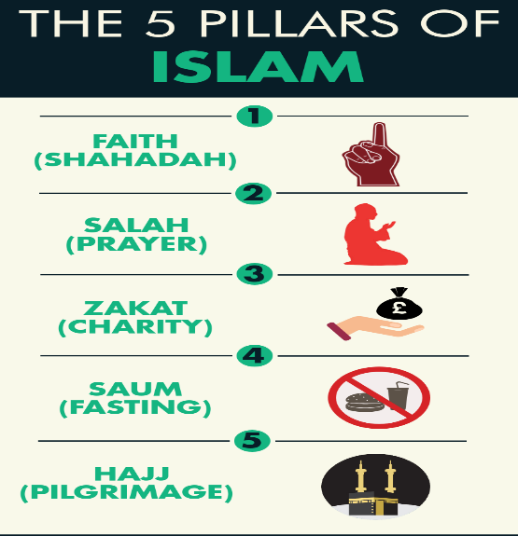

Button 1:back

Back button background color is Black

Button 2:play



Button 3:Stop



Sound 1: pillar of Islam mp3

**Programming Blocks:**

1. Working of my components:

**Screen 1:**

When user click on play button the sound play .

When user click on stop button the sound stop.

When user click on start the screen 2 open.

**Screen 2:**

When user click on Al fatiha button the Dua screen opened.

When user click on Dua button the pillars of Islam screen opened.

**Al fatiha :**

When user click on Urdu audio button the sound play .

When user click on play button the sound play .

When user click on stop button the all sounds stop.

When user click on back the screen 2 open.

**Dua :**

When user click on Urdu audio button the sound play .

When user click on play button the sound play .

When user click on stop button the all sounds stop.

When user click on back the screen 2 open.

**Pillars of Islam:**

When user click on play button the sound play .

When user click on stop button the sound stop.

When user click on back the screen 2 open.

2- Conditional statements(control) used: None