TCP connection

Screen shot of the TCP client

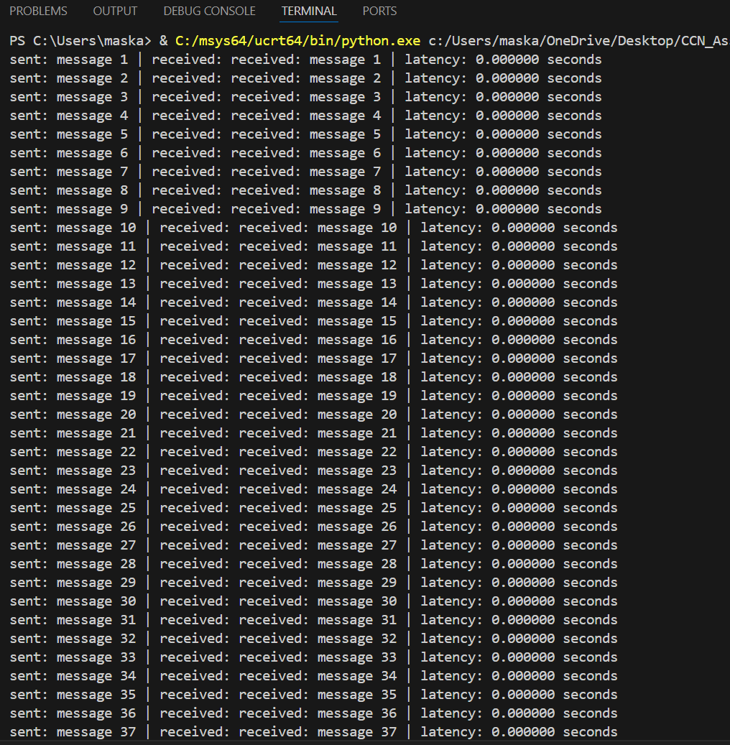

The output shown above ensures that server listens for incoming TCP connections. When the client connects, it responds with "Received: <message>". It measures the time taken for each message to be sent and acknowledged. The client sends 100 messages sequentially and records the time taken for each round trip. It then calculates the average latency and throughput.