rAIn_check — AI-assisted ensemble rainfall verification
Prototype implementation plan, v0.0.2 (supersedes v0.0.1) · 11 August 2026
Working title rAIn_check; repository folder rAIn_check.

0. Purpose and design philosophy
This plan specifies a prototype of a locally run, AI-assisted verification system for ensemble rainfall forecasts, designed with and for operational meteorologists who know their regional climatology thoroughly but have had little reason to use Python or ensemble verification. It closes a specific collaboration gap: national hydro-meteorological services (NHMSs) often cannot, by policy, send station observations abroad, while partners cannot usefully send code without spending many hours helping install the (Python) code that runs the verification analysis. rAIn_check therefore moves the code, the environment and the teaching to where the observations legally live: verification happens on the data owner's machine so no raw observation data leave the NHMSs.
Four principles govern every technical choice below. First, the deterministic engine owns every number: the large language model (LLM) proposes, explains and teaches, but no score, plot value or statistic is ever generated by the LLM. Second, the assistant is a permanent colleague, not a feature: it is always present in the interface. Third, declarative before generative: users extend the system through approved, saved, human-readable specifications that the engine executes, rather than through freshly generated code. Fourth, the design targets the computers institutions actually run — standard office machines, older browsers, no administrator rights, intermittent connectivity — because software that assumes more quietly excludes the colleagues it is meant to serve.

1. Objective
Build a demonstrable prototype of a locally run, AI-assisted ensemble rainfall verification system that guides the user through verification; it never runs the analysis end-to-end on its own. The assistant is always available to advise and assist; the user always decides. After a single download, the prototype runs fully offline on the reference machine; one optional, explicitly user-approved online step exists solely for fetching forecast data (§4.6).

2. Reference machine and hard constraints
The reference machine defines the floor, chosen to match computers observed at partner institutions; anything faster is a bonus, and nothing in the design assumes it.
Constraint | In plain terms | Why it is set this way
Windows 10–11 64-bit, 4 GB RAM, ~100 GB free disk, CPU only, no administrator rights. | Installs into the user's own folder; never asks for an administrator password or a graphics card. | Institutional machines are centrally managed; needing privileges or a GPU stops most installations.
Older browser (Chrome-109 era): server-rendered HTML only, no modern JavaScript frameworks, no build step. | Pages are ordinary web forms produced by the local program; the browser only displays them. | Old browsers cannot run current JavaScript frameworks; plain pages work everywhere and are simple to maintain.
All data and all AI inference stay on the machine; no network calls at runtime (single opt-in exception, §4.6). | Observations, forecasts and every AI answer are processed on this computer only. | Respects national data policy; works where the internet is slow or absent.
Installed footprint ≤ 8 GB total: environment ≈ 2.5 GB, model ≈ 2 GB, sample data ≤ 1 GB. | One zip file, unpacked once; movable on a USB stick. | Must fit beside the user's data on a ~100 GB disk and install without a fast connection.
RAM budgets, enforced by psutil tests: engine peak ≤ 1.2 GB; web app steady ≤ 300 MB; LLM ≤ 1.8 GB at 2k context; the model and heavy computation never run simultaneously. | The program measures its own memory and pauses the assistant during large calculations, resuming it automatically (Figure 4). | 4 GB is shared with Windows itself; without sequencing the machine would freeze mid-analysis.
Lazy processing (xarray chunking); never load a full ensemble cube into memory. | Forecast files are read one slice at a time. | A month of ensemble data is far larger than the memory available. So, it is not possible to save the actual raw forecasts. They need to be pre-processed (e.g., selecting only the forecasts closest to the observations, and saved as csv files instead of grib or netCDF).

3. Architecture — three layers

3.1 Verification engine (deterministic; owns every number)
Pure NumPy/Pandas score functions with xarray I/O and a command-line interface. New capability enters the engine only through reviewed code: shipped releases, or signed extension packs prepared by the coordinating team in response to capability requests (§8.2). The local model never writes score code into the running system.
{AI: This is the one place I have overruled v0.0.1, which asked the system to notice a missing score and "create it with scientific rigour, checking with the scientist". A 2 GB local model can draft plausible-looking verification code, but neither it nor a user who is still learning verification can validate it, and a wrong CRPS that looks right is more damaging than a missing one. The redesign in §8.2 keeps the experience you wanted — ask in plain language, capability appears — while routing correctness through your team. This is reversible if you disagree, but I would not ship model-written mathematics in version 1.}
{AUTHOR: Perhaps, when a user wants to create a new score, the system open a GitHub issue automatically to review the code, so we can check the content and see if it is correct.}

3.2 Guided GUI
A fixed five-step rail — Data → Checks → Scores → Maps & case studies → Report — plus a permanently visible assistant dock (Figures 1–6). The assistant is never switched off. Static "What am I looking at?" panels complement it on every page, so a written explanation survives the brief pauses imposed by the memory guard.

3.3 Local assistant
A small GGUF model behind a model-agnostic adapter; a fixed tool registry; JSON-only tool calls enforced by a llama.cpp GBNF grammar; verification answers retrieved from local knowledge cards. Interaction loop: propose → user approves → engine executes → assistant explains. The model never generates numeric results or formulas from memory; it calls tools and quotes cards.
In plain terms. GGUF is a single-file format that stores a language model so it can run on an ordinary laptop or desktop CPU: one file on disk is the whole "AI", loaded by the free llama.cpp software. A GBNF grammar restricts, character by character, what the model may type when calling a tool — like a form that only accepts valid entries — so a call is either well-formed JSON the engine can execute or it is rejected; the model cannot improvise an action.

4. Data handling

4.1 One canonical internal schema
Every input, whatever its native format, is converted on read into one internal representation; everything downstream — quality control, scores, plots, report — sees only this schema. Forecasts: an xarray Dataset with dimensions (forecast_reference_time, lead_day, member, lat, lon), variable tp = 24-hour precipitation accumulation in mm (float32), and attributes accumulation_hours: 24 and accumulation_end_utc. Observations: a tidy table with columns station_id, name, lat, lon, elevation_m, date, accum_hours, precip_mm, qc_flag (example row: TZ0042, Moshi, -3.35, 37.33, 890, 2026-03-14, 24, 31.2, 0).

4.2 Readers: NetCDF and GRIB are both first-class
The system detects the format from the file's content (magic bytes, not the filename) and routes to the matching reader: h5netcdf for NetCDF, cfgrib/eccodes for GRIB. Both converge on the §4.1 schema; no other component knows which format arrived.

4.3 Ingestion recipes — the flagship AI capability
Real observation files will arrive in many shapes, and organising input data is the dominant cost of any verification study. When a file matches no known recipe, the assistant reads a small sample of it — plus any documentation the user points to — and proposes a mapping to the canonical schema: column meanings, units, date formats, and aggregations such as four 6-hour totals into one 24-hour accumulation. The proposal appears in full as an editable table (Figure 2), with items requiring human judgement marked explicitly. On approval, the mapping is saved as a JSON recipe in the workspace and executed by the deterministic engine, now and for every future file of that kind. The division of labour is fixed — the model reads and guesses, the human decides, the engine executes — so ingestion becomes a supervised five-minute task instead of a day of scripting, with no unreproducible step.

4.4 Golden dataset: what it does and does not test
data/golden/ holds a tiny analytic case already in canonical form (5 stations × 20 days × 10 members drawn from known distributions) with hand-computable expected values in expected.json; scripts/make_golden.py regenerates it deterministically from a fixed seed, and the first-run self-test recomputes all scores against it. Its purpose is narrow and untouched by input variety: it proves the score mathematics on this installation. Ingestion correctness is tested separately by a fixture suite — one small sample per supported format or recipe pattern, each paired with the canonical table it must produce (§6).

4.5 Demo pack: repurposed, and kept deliberately raw
data/samples/ ships ECMWF open-data ensemble 24-hour precipitation over roughly a 10° × 10° East Africa window at 0.25°, around 60–90 daily runs at leads 1–5 days, plus about 30 pseudo-stations sampled from a held-out perturbed member with added noise, gaps and outliers — so quality control has something honest to catch and no real partner observation exists anywhere in the prototype. The pack is shipped raw-ish (GRIB as downloaded; stations in a slightly awkward spreadsheet) so the demo exercises the same recipe flow as real data. Purposes: day-one training before partner data is ready; an end-to-end smoke test on the partner's machine; a self-contained demonstration for management. It does not claim to represent the variety of partner data — recipes (§4.3) carry that load. Size ≤ 300 MB.

4.6 Optional online acquisition (the only network path)
Where a machine has connectivity and the user has credentials — ECMWF open data, or MARS through the user's own API key — a single tool, fetch_forecasts(spec), turns a plain-language request into a download the user approves explicitly before anything is transferred. It is off by default and is the only code path permitted to touch the network; the default distribution route remains team-prepared forecast files, because ensemble retrievals over poor connections are slower than a courier.
{AI: On your MCP question: I recommend deferring it. MCP earns its complexity when several independent clients and servers must interoperate; the prototype is one application on one offline-first machine, and an MCP layer would add a protocol, a transport and a failure mode without adding capability. The cheap future-proofing is already in the design: every tool in the registry is defined by a JSON schema (§9), which is exactly the shape MCP expects, so exposing the engine as an MCP server — or consuming a MARS MCP server on connected machines — later becomes an adapter, not a redesign.}

5. Tech stack (pin exact versions in requirements.txt)
- Python 3.11. numpy, pandas, xarray, h5netcdf, cfgrib + eccodes (binary wheels), matplotlib, seaborn, cartopy (binary wheels).
- Maps: try earthkit-plots first; timebox half a day in Step 1. If Windows installation misbehaves, fall back to cartopy + matplotlib. Do not use earthkit-data in the prototype.
- Web: fastapi, uvicorn, jinja2, htmx (vendor the single htmx.min.js file). If htmx misbehaves on the oldest target browsers, plain full-page forms are the accepted floor — the design must survive without any client-side script.
- LLM: llama-cpp-python, prebuilt CPU wheel.
- Tests: pytest. Dev-only, never shipped: xskillscore or the BoM scores package for cross-validation.
- Packaging: conda-pack portable zip + run.bat (per-user, no registry writes; launches the server and opens the default browser at http://127.0.0.1:8501).

6. Repository layout
rainverify/
engine/ # scores, qc, bootstrap, station–grid matching, manifest
ingest/ # format detection, readers (netcdf, grib, tabular), recipe executor, canonical schema
app/ # fastapi routes, templates/, static/
assistant/ # adapter.py, tools.py, grammar.gbnf, triage_rules.py
cards/ # one .md knowledge card per score/topic
data/
golden/ # canonical-form analytic case + expected.json
fixtures/ # tiny samples of each supported input format + the canonical output each must produce
samples/ # demo pack (raw-ish; exercised through recipes)
scripts/ # make_golden.py, make_demo_pack.py, benchmark_model.py
tests/ # test_engine/, test_ingest/, test_app/, test_assistant/
run.bat README.md requirements.txt config.toml
User-created material never lives in the repository: recipes, run logs, reports and the user's own data go to a workspace/ directory created beside the installation on first run.
{AI: Direct answer to your layout question: v0.0.1 was close to right, and I would resist adding structure beyond two changes. (i) Ingestion is promoted to its own package so the messy-inputs boundary is explicit — everything left of ingest/ may be heterogeneous, everything to its right is canonical. (ii) data/ is split by role: golden/ is mathematical truth, fixtures/ is format truth, samples/ is training and demonstration. "Data of any type" then stops being a testing problem: engine tests never see a raw format, and each newly supported format costs exactly one fixture pair. Tests mirror the packages one-to-one, which keeps navigation trivial for both the coding agent and humans.}

7. Verification engine
Implement as small, readable, individually documented functions — the assistant will teach from this code.
- Scores v1: ensemble CRPS with the Hersbach (2000) decomposition; rank histogram with a chi-square flatness test; Brier score and BSS at thresholds 1, 5, 20, 50 mm/24 h; reliability diagram data (10 bins, with sharpness counts); ROC curve and AUC; spread–error ratio; ensemble-mean bias and MAE.
- Reference forecast for skill scores: sample climatology built from the observation series itself.
- Uncertainty: moving-block bootstrap (block length 5 days, 1,000 resamples) for confidence intervals on CRPS and BSS; emit a warning whenever any stratum has fewer than 30 forecast–observation pairs.
- Matching: nearest grid point, with the chosen point recorded per station. Hard-fail with a plain message if forecast and observation accumulation windows disagree.
- Validation: agreement with the dev reference package within 1e-6 relative tolerance on golden and demo data; unit tests per score including degenerate cases (all-zero rainfall, single member, ties).

7.1 The manifest, in plain terms
Every run writes manifest.json: SHA-256 fingerprints of the exact input files, the code version, all parameters, and timestamps. Months later it answers the questions that decide whether a result can be trusted — which files, which settings, which code — and it makes the report reproducible: the same inputs regenerate the same report to the digit (§12 tests this). It is also the collaboration instrument this project needs: a partner emails a report with its manifest, the observations never leave their machine, and anyone can later verify precisely what was computed. Cost: one small text file per run.

8. Guided GUI

8.1 The five-step rail
One route per rail step; large primary buttons; later steps greyed out until prerequisites are met; every page has a collapsible "What am I looking at?" panel with static explanatory text; the assistant dock is permanently visible on every page (Figures 1–6).
- Data: pick forecast and observation files; format auto-detected; unknown formats route through recipe approval (Figure 2); summary table of period, stations, members, leads.
- Checks: QC results (physical range 0–500 mm/24 h, spikes, duplicates, gap counts) and the accumulation-window check, each with pass/warn/fail badges (Figure 3).
- Scores: tick-box selection of scores, thresholds and lead times; results as Seaborn figures with confidence intervals; one-click PNG download per figure (Figure 4).
- Maps & case studies: pick a date; ensemble mean, probability of exceedance for a chosen threshold, and a postage-stamp grid of members, with station observations overlaid (Figure 5).
- Report: a single self-contained HTML file with embedded PNGs, the score tables, the user's typed interpretation and the manifest; PDF via the browser's Print (Figure 6).

8.2 Changing the system in plain language
Requests for modifications and new capability arrive through the chat, at three levels. Level 1, configuration: anything expressible in the existing specification space — scores, thresholds, leads, stratifications, plot styling, map domains — is composed by the assistant as a spec, approved by the user and executed by the engine; this covers most realistic requests. Level 2, composition: new combinations of existing engine primitives, such as a derived table or a multi-panel figure, are saved as declarative specs and reused like recipes. Level 3, new capability: a genuinely new score or method becomes a capability request — the assistant drafts a one-page specification with the user (definition, reference, worked example, test values) for the coordinating team, who implement, review and return it as a signed extension pack installed after showing the user what it adds. The user experiences one continuous conversation; correctness never rests on an unreviewed model.

8.3 Interface mockups
The six mockups below show the intended interface with the §2 constraints made visible rather than hidden; they are wireframes for layout and behaviour, not visual design.
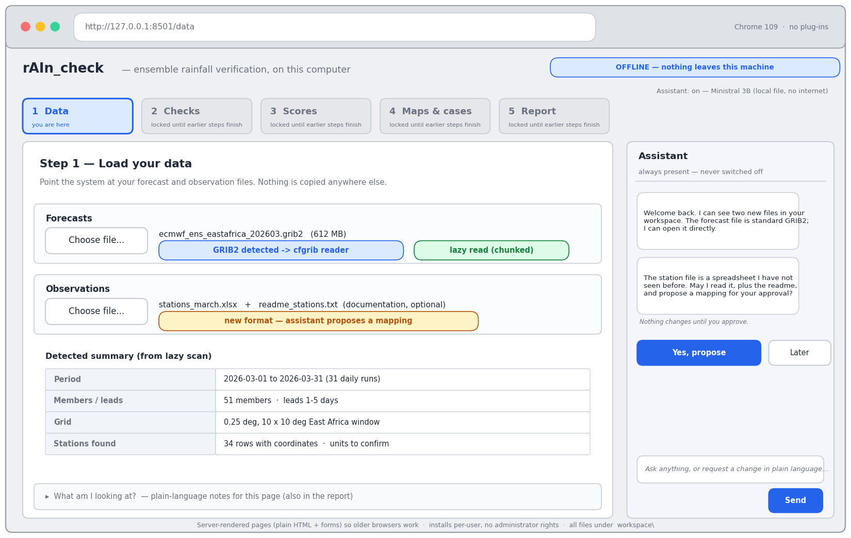
Figure 1 — Data step. Encoded constraints and behaviours: permanently present assistant dock; offline banner; plain server-rendered layout appropriate to a Chrome-109-era browser; GRIB auto-detection with lazy (chunked) reading; the assistant proposes and waits — nothing happens without approval.
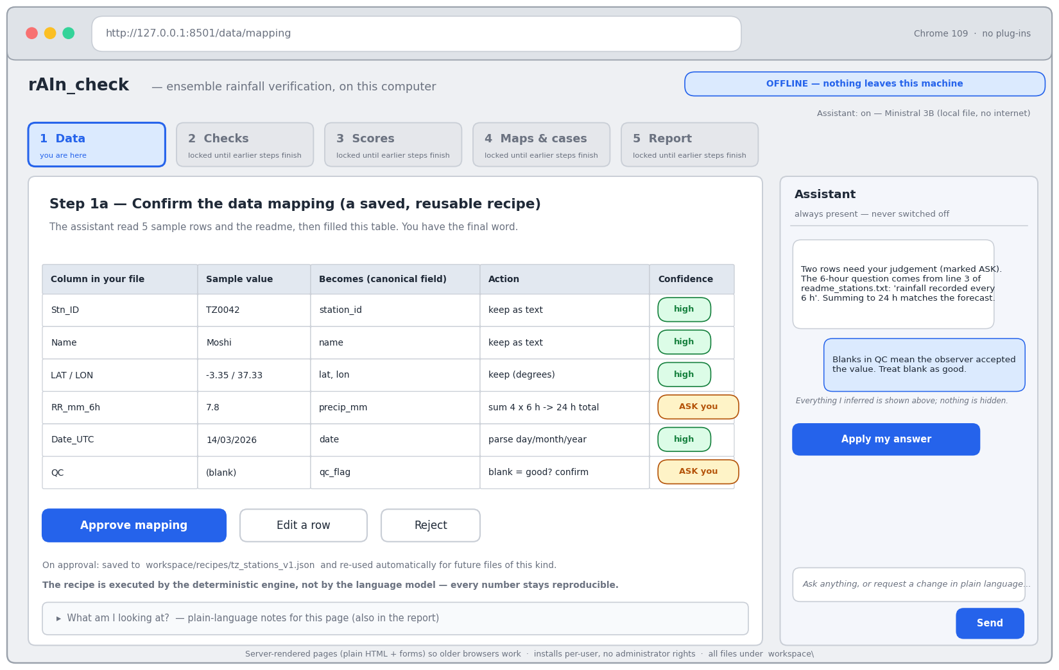
Figure 2 — Recipe approval, the ingestion flagship (§4.3). Every inference the model made is shown as an editable table; items needing human judgement are marked ASK; the provenance of what the model read (sample rows, the readme) is stated; execution is deterministic and the recipe is saved for reuse.
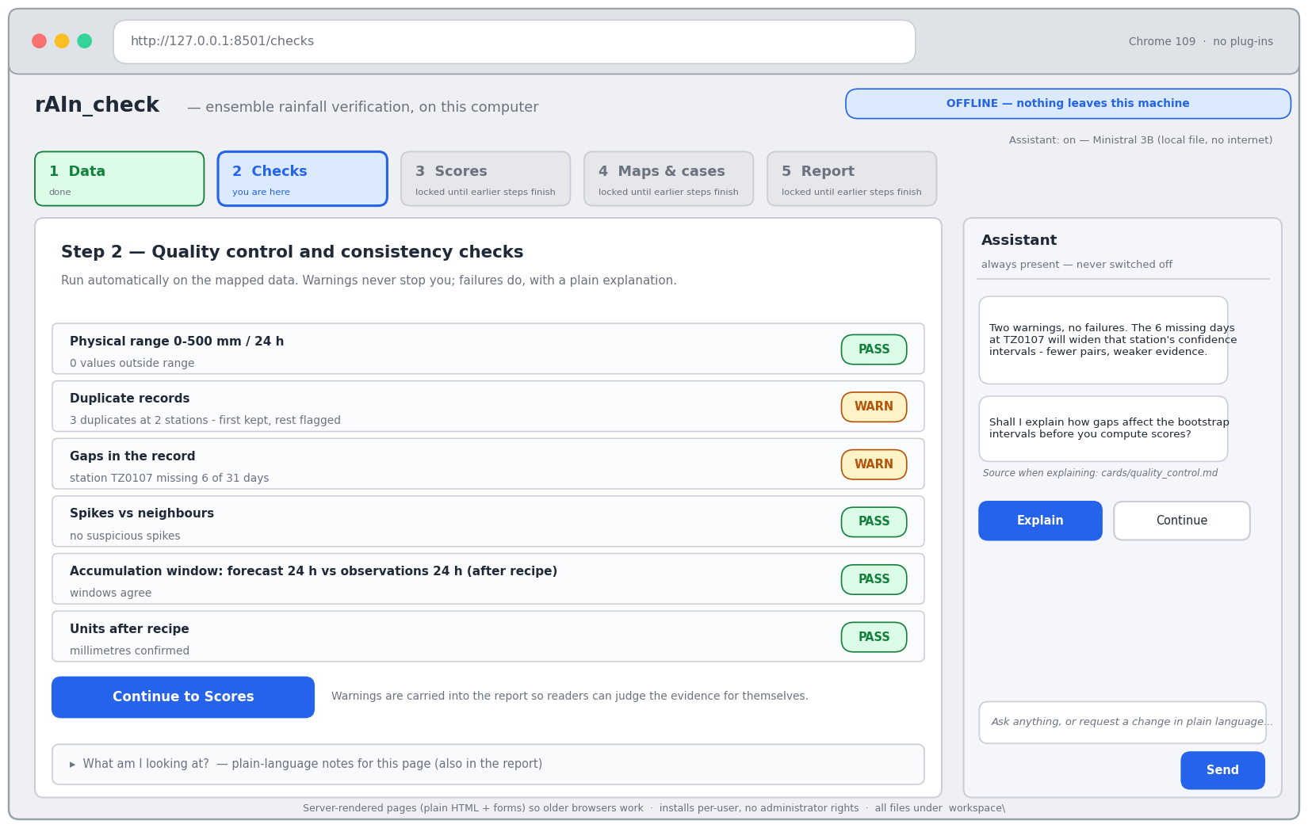
Figure 3 — Checks step. Pass/warn/fail badges; warnings inform but never block, and are carried into the report; the assistant offers an explanation sourced from a named knowledge card rather than improvising.
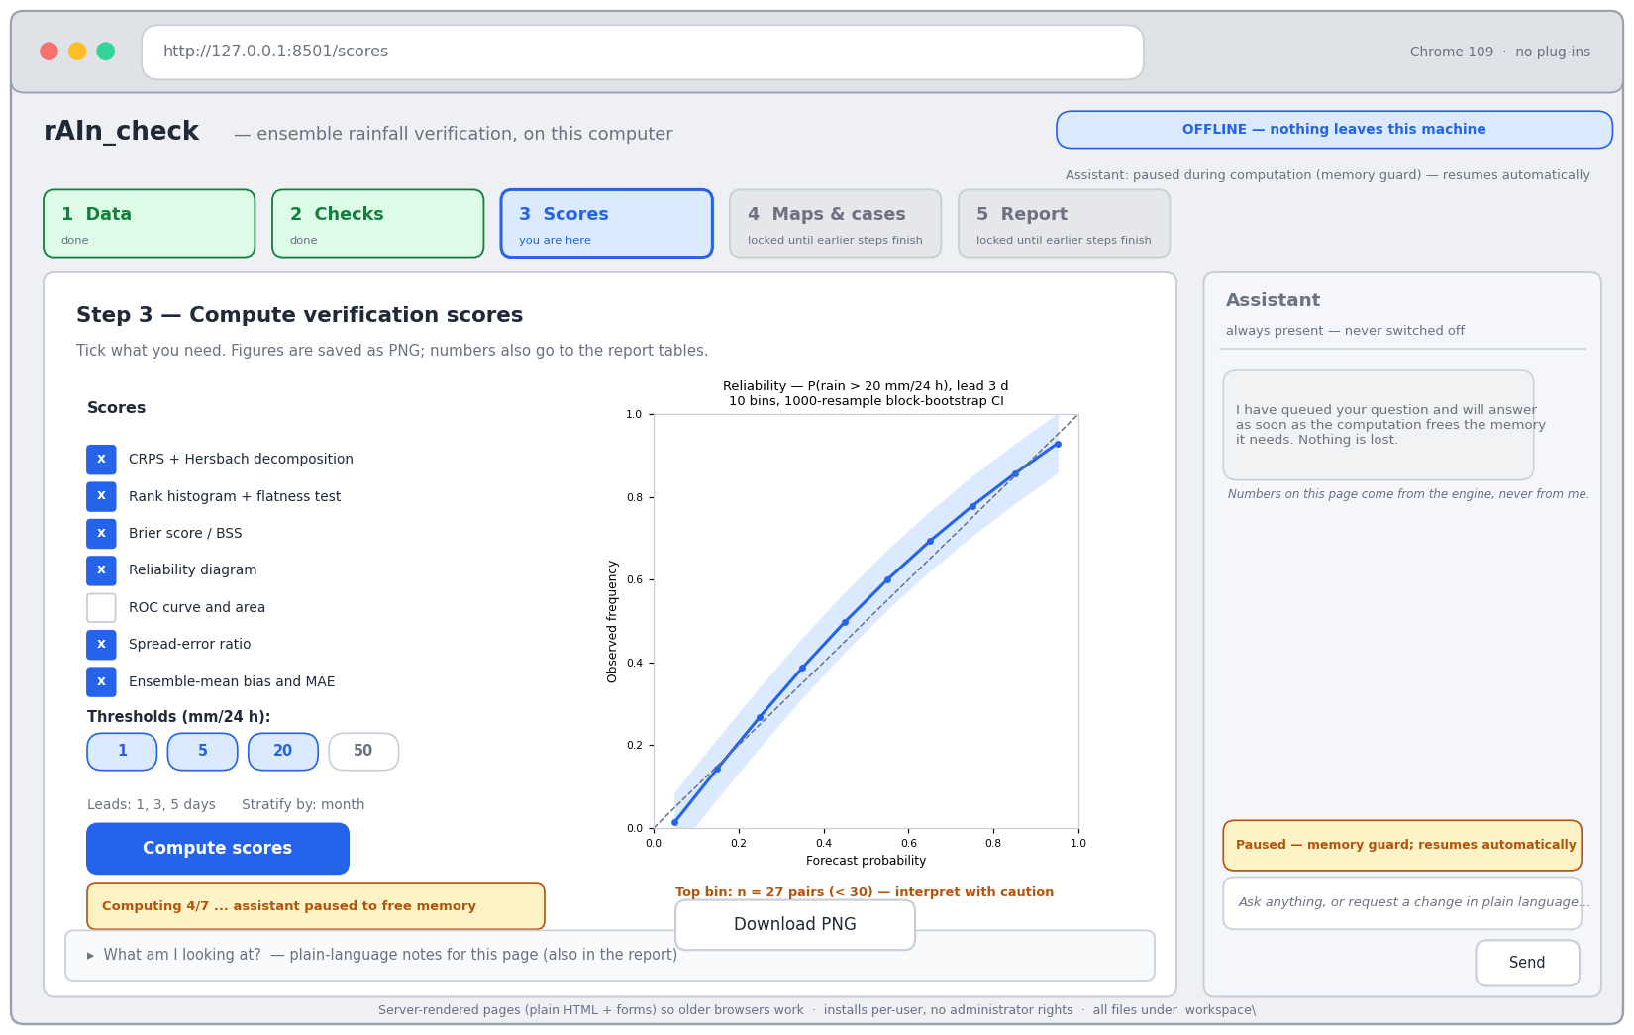
Figure 4 — Scores step during computation. The memory guard has paused the model (status chip top right, amber notice in the dock), but the assistant dock remains: paused is not absent, and the user's question is queued, not lost. The small-sample caution (n < 30 in the top bin) is surfaced beside the figure.
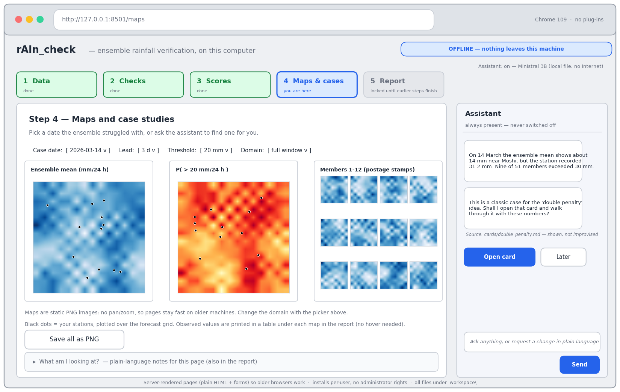
Figure 5 — Maps and case studies. Maps are static PNGs — an explicit old-browser and memory choice, with the domain picker replacing pan/zoom; the assistant proposes a case study from the numbers and names the card it will teach from.
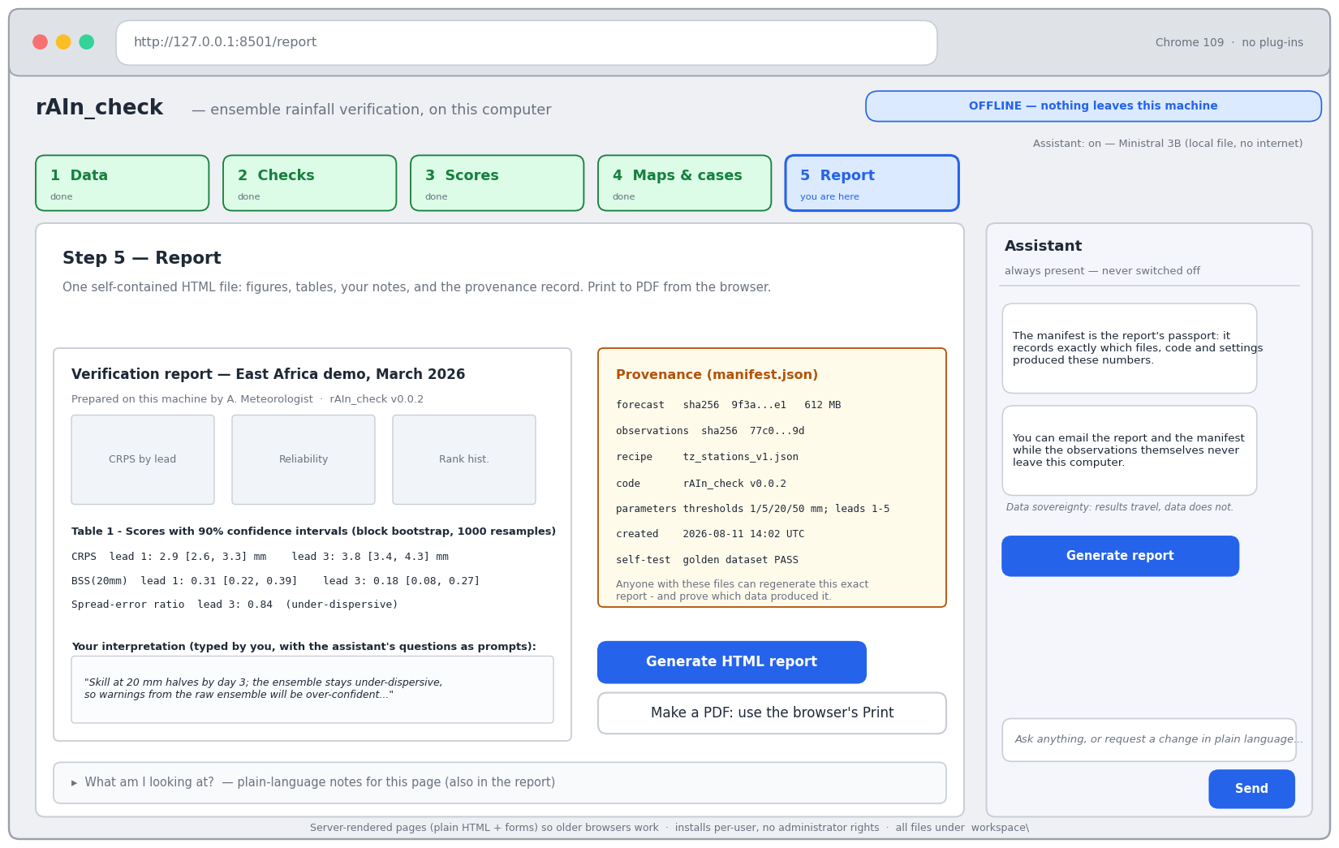
Figure 6 — Report step. One self-contained HTML report, printed to PDF from the browser; the manifest is displayed as the provenance record. The dock states the project's data-sovereignty principle: results travel, data does not.

9. Assistant
- Adapter: generate(messages, grammar=None) → ToolCall | Text over llama-cpp-python; model path and context length from config.toml.
- Models and gate: candidates are Ministral 3 3B Instruct (Apache 2.0; preferred — the project narrative favours a European model) and Gemma 4 E2B (smaller footprint; verify licence). Gate at the start of Step 5 on the reference machine via scripts/benchmark_model.py: peak RAM ≤ 1.8 GB, ≥ 4 tokens/s, ≥ 95% valid-JSON on 30 canned tool-call prompts. The gate sets each machine's default capability level; its report is committed.
- Capability ladder: L3, full assistant — the gated model as configured. L2, reduced — a smaller model or tighter quantisation: shorter context, terser replies, same tools and behaviour. L1, deterministic — the same dock driven by triage rules, cards and per-step scripted guidance, with no free-form generation. Dock, propose/approve pattern and teaching material are identical at every level; only fluency degrades. A LAN inference-server alternative is documented in the README only — not built.
- Tool registry (read-only except plots, reports and recipes, which write to the workspace): list_data, inspect_file(path), propose_recipe(path, docs), run_qc(), compute_scores(spec), make_plot(spec), fetch_forecasts(spec) (opt-in, §4.6), get_card(topic), quiz(topic), explain_last_error(). Every tool is defined by a JSON schema (MCP-shaped; §4.6). Example call: {"tool": "compute_scores", "args": {"scores": ["crps", "bss"], "thresholds_mm": [20], "leads": [1, 3]}}.
- Conversation policy: one proposed action per turn with a one-sentence reason; the UI renders Approve / Modify / Skip; after execution the engine's summary is shown verbatim, then the assistant explains it in ≤ 120 words and asks one interpretation question back.
- Error triage, rules first: a table of ≥ 15 regex-classified failure modes (file not found, encoding, date parse, unit mismatch, memory, malformed NetCDF or GRIB, …), each mapping to a fixed diagnosis and fix; the LLM only narrates the matched diagnosis. No match: pass only the last 15 traceback lines, clearly labelled as unverified.
- Knowledge cards (cards/*.md): plain-language definition; a worked example with about five numbers; common misreadings; what good and bad look like for rainfall. Score questions are answered solely by summarising a card, with the card title shown as source; if no card matches, the assistant says so and does not improvise.
- Guardrails: refuse to state formulas from memory; log every tool call and outcome to runlog.jsonl; no file writes outside the workspace.

10. Build steps and acceptance criteria
The steps are ordered and the order is binding; calendar time is not. Each step ends at its acceptance test, not at a date.
- S1 Foundations. Repo scaffold; pinned environment builds on Windows; canonical schema plus NetCDF and GRIB readers pass the fixture suite; make_golden.py and make_demo_pack.py work. Accept: golden regenerates deterministically; demo pack loads lazily within budget; GRIB reads on the reference machine or the fallback decision is recorded.
- S2 Engine. Scores, bootstrap, manifest. Accept: all tolerance tests pass against the dev reference package.
- S3 Figures. Seaborn figures and map plots (earthkit-plots or fallback decided). Accept: every v1 score has a publication-quality figure from demo data.
- S4 GUI end-to-end with the L1 deterministic assistant in place; Demo 1 script written (10-minute walkthrough: load → recipe approval → QC → CRPS/BSS with CIs → exceedance map → report). Accept: a non-developer completes the flow on the reference machine with only the mouse, dock present throughout.
- S5 LLM adapter; model gate run and capability level decided; tool registry callable from chat. Accept: gate report committed; ≥ 95% valid JSON on the 30-prompt suite at the chosen level.
- S6 Propose/approve loop, recipe proposals, triage rules, and 8–10 knowledge cards (CRPS, rank histogram, Brier/BSS, reliability, ROC, spread–error, climatology reference, double penalty). Accept: three scripted tutoring dialogues and one recipe approval run end-to-end.
- S7 Polish and budgets. Case-study page, report generator, RAM tuning and model load/unload sequencing. Accept: the full assisted flow stays within RAM budgets on the reference machine — measured, not estimated.
- S8 Packaging. conda-pack portable zip, run.bat, README (install, capability levels, LAN note, licences), Demo 2 script; buffer. Accept: the definition of done (§12) passes on a fresh Windows 10 VM.

11. Descoping ladder (apply in order if behind)
1. Drop the quiz tool. 2. Drop ROC figures, keeping the numbers in the report tables. 3. Reduce cards to the five core scores. 4. Ship with default capability level L1 — dock, guidance, cards and buttons all present, no free-form generation. 5. Ship Demo-1 scope with the L1 assistant. The assistant dock is never removed at any rung.

12. Definition of done
On a fresh Windows 10 VM with 4 GB RAM: unzip, double-click run.bat, the browser opens; a first-time user completes Data → Report on the demo pack — including one recipe approval — with assistant guidance in ≤ 20 minutes without touching a console; the golden self-test passes; peak RAM stays within the §2 budgets; and the report regenerates identically from its manifest.

13. Verify before build
Ministral 3 3B licence text as shipped on Hugging Face; Gemma 4 licence terms; eccodes/cfgrib binary wheels install and read a demo GRIB on the reference Windows machine; earthkit-plots installability on Windows; ECMWF open-data terms and required attribution; llama-cpp-python CPU wheel runs on the reference CPU; conda-pack output unzips and runs without administrator rights.

