CS-4032: Web Programming
Assignment #02
2D Cricket Web Application
Name | Fatima Farrukh Rana
Roll Number | 23i-0773
Section | E
Course | CS-4032: Web Programming
Assignment | #02 — 2D Cricket Web Application
Date | 26 March 2026

Technologies Used: React 18 | HTML5 Canvas | CSS3 | JavaScript

1. Game Logic and Working Mechanism
Cricket Blitz is a single-player 2D cricket batting game built with React 18, HTML5 Canvas, CSS3, and JavaScript. The player acts as a batsman and faces 2 overs (12 balls total) with a maximum of 2 wickets. On each ball the player selects a batting style and interacts with a probability-based power bar to determine the shot outcome. No random number generation is used — the result depends entirely on where the slider is when the player clicks.

1.1 Game Flow
Step 1 — Select Style: Before each ball, the player chooses Aggressive (high risk/reward) or Defensive (low risk/reward). The style can only be changed between balls.
Step 2 — Click BOWL!: The bowling animation starts. The ball travels from the bowler's end (right side) toward the batsman (left side) over 900ms using requestAnimationFrame on an HTML5 Canvas.
Step 3 — Power Bar Activates: Once the ball arrives, the power bar slider begins moving continuously back and forth across the coloured probability segments. Speed varies slightly per ball.
Step 4 — Click to Play Shot: The player clicks the power bar canvas. The slider position at that exact moment determines the outcome — it maps directly to whichever probability segment the slider is inside.
Step 5 — Result Displayed: The batting animation triggers (bat swings, ball flies), commentary is shown, and the scoreboard updates immediately.
Step 6 — Repeat / Game Over: The game ends when 12 balls are bowled or 2 wickets are lost, showing a full innings summary with rating.

1.2 Game Rules
- Total overs: 2 (12 balls)
- Total wickets: 2
- Each ball = one batting attempt
- Game ends when all overs are complete OR all wickets are lost
- Restart option resets: Runs, Wickets, Overs, Balls, and Batting Style

1.3 React State Management
All game state is managed in a custom React hook (useGameState.js) using useState and useCallback. The game phases are: idle → bowling → batting → result → gameover. Each transition is controlled by the hook's action functions (startBowling, startBatting, playShot, nextBall, restartGame). No state mutation happens outside the hook, ensuring a clean separation of concerns.

2. Mapping of Probabilities to the Power Bar
Each batting style defines a discrete probability distribution over 7 outcomes. All probabilities in each style sum exactly to 1.00. The power bar is divided into proportional colour-coded segments matching these probabilities. The outcome is determined by which segment the slider occupies at click time — no random number generation is involved.

2.1 Probability Distributions
Outcome | Aggressive | Bar Segment | Defensive | Bar Segment
Wicket | 30% | 0.00 – 0.30 | 12% | 0.00 – 0.12
0 Runs | 8% | 0.30 – 0.38 | 25% | 0.12 – 0.37
1 Run | 10% | 0.38 – 0.48 | 30% | 0.37 – 0.67
2 Runs | 12% | 0.48 – 0.60 | 18% | 0.67 – 0.85
3 Runs | 5% | 0.60 – 0.65 | 8% | 0.85 – 0.93
4 Runs | 15% | 0.65 – 0.80 | 5% | 0.93 – 0.98
6 Runs | 20% | 0.80 – 1.00 | 2% | 0.98 – 1.00
TOTAL | 100% |  | 100%

2.2 How Segments Map to the Bar
The buildSegments() function in gameConfig.js iterates through the probability array for the selected style and accumulates a running cumulative total. Each segment is assigned a start and end value. These values directly control the pixel width of each colour region on the Canvas-rendered power bar.

Example (Aggressive style): If the slider stops at position 0.72, it falls inside the 4 Runs segment (0.65–0.80), so the result is FOUR. If it stops at 0.15, it is in the Wicket region (0.00–0.30), so the result is OUT.

2.3 Style Comparison
- Aggressive — Wicket risk: 30% vs Defensive: 12%. Boundary (4+6) chance: 35% vs 7%.
- Defensive — Lower wicket risk, higher singles/dots. Suited to preserving wickets.
- Both styles sum exactly to 1.00 — verified in gameConfig.js with cumulative accumulation.

3. Implementation of Animations

3.1 Bowling Animation (CricketField.jsx)
When gamePhase transitions to "bowling", a requestAnimationFrame loop starts inside a useEffect. The ball's (x, y) coordinates are linearly interpolated from the bowler's stump position (450, 90) to the batsman position (240, 180) over 900ms. Progress is calculated as elapsed / 900, clamped to 1. A bowlingDoneFired boolean ref ensures the onBowlingDone callback fires exactly once when progress reaches 1.0, preventing double-triggers and phase bugs.

3.2 Batting Animation (CricketField.jsx)
When gamePhase becomes "result", the bat rotation angle is animated from -0.3 radians to +1.7 radians over 300ms using ctx.save() / ctx.rotate() / ctx.restore() on the Canvas 2D context. Simultaneously the ball's position is offset in the +X and -Y direction scaled by elapsed time, simulating it flying toward the boundary. The animation continues running until the next phase begins.

3.3 Power Bar Slider (PowerBar.jsx)
PowerBar.jsx runs two nested requestAnimationFrame loops. The outer loop updates sliderRef.current at a speed of 0.007–0.013 per frame, bouncing the value between 0 and 1 by flipping a direction ref. Speed is randomised per ball for progressive difficulty. The inner loop (in PowerBarVisual) re-renders the Canvas every frame, reading sliderRef.current directly via a ref (not state) to achieve zero-lag rendering without triggering React re-renders.

3.4 Result Badge & Commentary Animations (CSS)
The result badge uses a CSS @keyframes animation (badge-pop) with a cubic-bezier spring curve for a satisfying pop effect. Wicket outcomes add a shake animation. Boundary results (4 or 6) trigger a golden glow pulse. Commentary lines are stored as arrays of 4-5 strings per outcome in gameConfig.js, with a random index selected at shot time for variety.

3.5 Ball Tracker (Scoreboard.jsx)
Each bowled ball lights up a dot in the scoreboard ball tracker row using a CSS transition and a pulse keyframe (pulse-dot). This gives live visual feedback of innings progress without any additional state management overhead.

4. Gameplay Screenshots
Each screenshot below must include a visible sticky note showing: Name, Roll Number, and Section.

Screenshot 1 — Aggressive Batting in Action
Aggressive Batting Style Selected
Shows power bar active with Aggressive style — high-risk segments visible
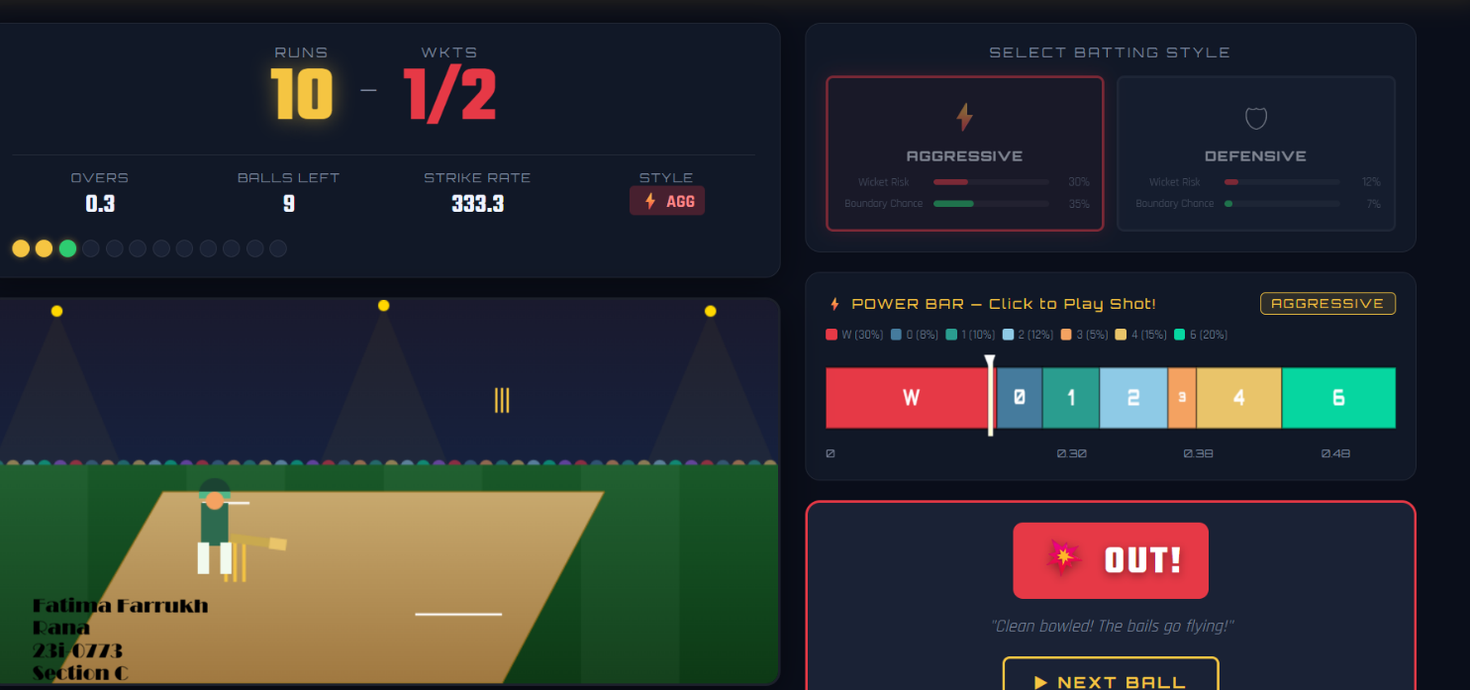r screenshot here ]
Sticky note must show: Name | Roll Number | Section

Screenshot 2 — Defensive Batting in Action
Defensive Batting Style Selected
Shows power bar active with Defensive style — larger 0/1 run segments visible
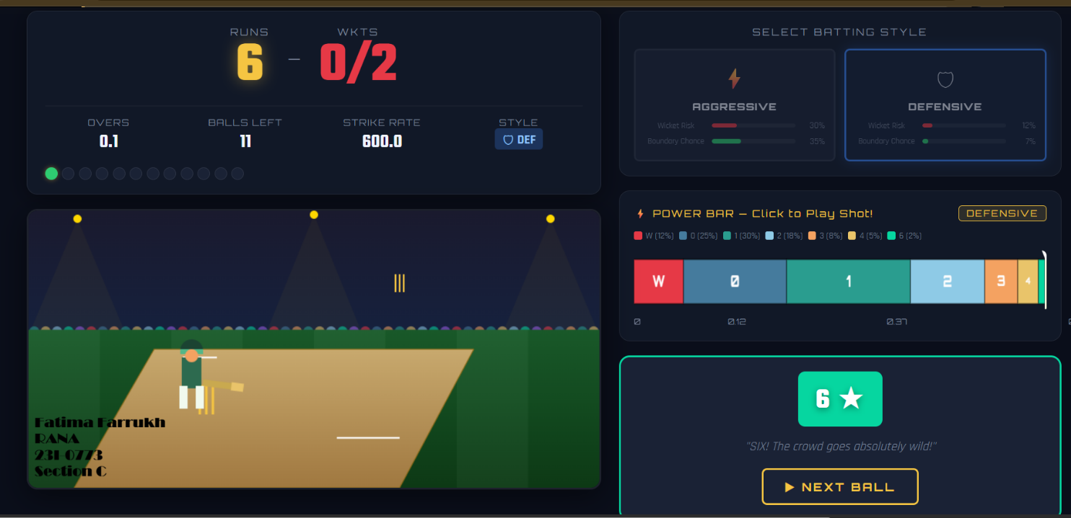 [ Paste your screenshot here ]
Sticky note must show: Name | Roll Number | Section

Screenshot 3 — Power Bar During Gameplay
Power Bar Visible with Moving Slider
A Clear view of all coloured probability segments and the white slider in motion
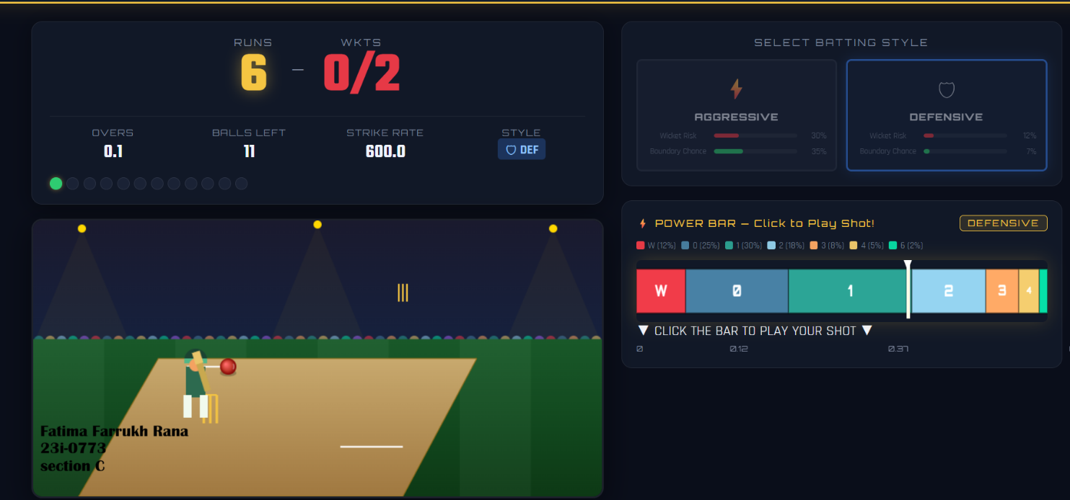
Sticky note must show: Name | Roll Number | Section

Screenshot 4 — Scoreboard Updates
Scoreboard After Multiple Balls
Shows updated runs, wickets, overs, strike rate, and ball tracker dots filled in
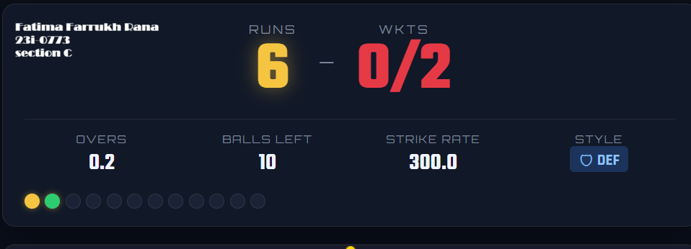

Screenshot 5 — Game Over Screen
Final Game Over / Innings Complete Screen
Shows total score, wickets, overs, strike rate, and innings rating
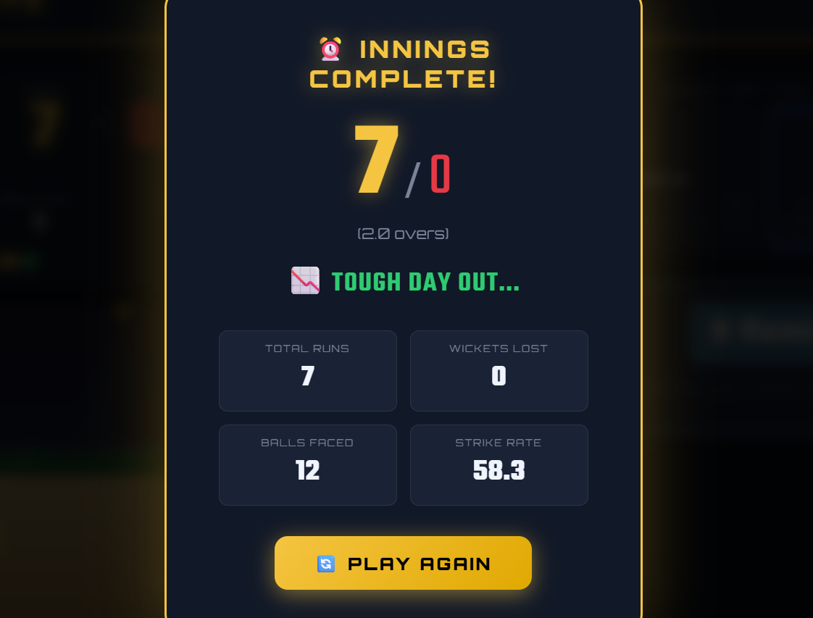 [ Paste your screenshot here ]
Sticky note must show: Name | Roll Number | Section

5. Project Structure & Technologies

5.1 File Structure
File | Purpose
src/gameConfig.js | Probability distributions, commentary, constants, helper functions
src/hooks/useGameState.js | Custom React hook — all game state, phase transitions, scoring logic
src/App.jsx | Root component — game flow controller, layout, phase routing
src/App.css | All styles — dark stadium theme, animations, responsive layout
src/components/CricketField.jsx | Canvas 2D field, bowling animation, batting animation
src/components/Scoreboard.jsx | Live scoreboard with runs, wickets, overs, ball tracker
src/components/PowerBar.jsx | Canvas probability bar, animated slider, click detection
src/components/BattingStyleSelector.jsx | Aggressive / Defensive toggle with stat previews
src/components/ResultDisplay.jsx | Shot outcome badge with commentary and animations
src/components/GameOverScreen.jsx | End-of-innings summary with rating system

5.2 Technologies Used
- React 18 — Component-based UI, useState, useEffect, useCallback, useRef hooks
- HTML5 Canvas API — 2D field rendering, ball/batsman/bat sprites, animations
- CSS3 — Animations, keyframes, CSS variables, dark theme, responsive layout
- JavaScript ES6+ — Game logic, probability engine, requestAnimationFrame loops
- Vite — Development server and build tool

5.3 Key Design Decisions
- Refs over State for animation — sliderRef.current is used instead of useState to avoid React re-renders during 60fps animation loops.
- Phase-based game flow — A string phase variable (idle/bowling/batting/result/gameover) drives all conditional rendering, keeping logic predictable.
- Zero randomness in outcomes — The getOutcome() function does a simple range check against cumulative segment boundaries. No Math.random() for shot results.
- Modular components — Each UI concern is isolated in its own file with clear props interface, satisfying the separation of concerns requirement.

CS-4032: Web Programming | Assignment #02 | All work is original and completed individually.

