FAST NUCES, ISLAMABAD
Parallel and distributed computing

PARALLEL BELLMAN-FORD ALGORITHM OPTIMIZATION
Using OpenMP, SIMD, MPI, and Hybrid Parallelism

CS-3006: Parallel and Distributed Computing
Spring 2026 | Final Project Report

Submitted to:
Department of Computer Science

Submitted By,
Fatima Shakir 23I-0503
Fatima Farrukh 23I-0773

Date of Submission: 10th May 2026

Table of Contents

Cover Page i
Table of Contents ii
1. Introduction 1
2. Base Paper and Problem Context 2
3. Project Scope and Objectives 4
4. Baseline Method 5
5. Proposed Parallel / Optimized Approach 7
6. Experimental Setup 12
6.6 Roofline Performance Analysis 15
7. Results and Discussion 18
7.1 V1 — OpenMP Frontier Scaling and Speedup 18
7.2 V3 — OpenMP + SIMD Scaling 19
7.3 MPI Version Comparison 20
7.4 Scalability Analysis 21
7.5 Performance Bottleneck Analysis 24
7.6 Summary Speedup Table 27
8. Conclusion 29
9. References 30
Glossary of Terms 31
Appendix A — Verified Speedup Table 37
Appendix B — Full Experimental Configuration 39

1. Introduction
Shortest path algorithms form the backbone of network routing, transportation planning, social network analysis, and distributed systems. Among these, the Bellman-Ford algorithm stands out for its ability to handle graphs with negative edge weights and detect negative cycles. However, its worst-case complexity of O(V × E) renders it impractical for large-scale graphs, as the algorithm performs up to V−1 passes over all edges regardless of whether any useful update occurs.
This project targets the optimization of Bellman-Ford through a progressive, multi-technique parallelization study grounded in the SP-Async paper by Yadav and Khan (2021) and related HPC graph-processing literature. We identify and address three core deficiencies in the baseline implementations: (1) unnecessary full-edge traversal in every iteration due to dense adjacency-matrix storage, (2) inefficient memory access patterns that saturate DRAM bandwidth with non-productive loads, and (3) poor exploitation of available SIMD and multi-core hardware. Our contributions span seven implementation versions covering shared-memory OpenMP parallelism, AVX2 SIMD vectorization, MPI distributed execution, and hybrid combinations thereof.
All results are grounded in empirical LIKWID hardware characterization and roofline performance modeling. The central finding is that algorithmic work reduction — specifically, the frontier-based approach that restricts relaxation to vertices updated in the previous iteration — yields performance gains orders of magnitude larger than hardware-level parallelism alone. Roofline analysis confirms that Bellman-Ford operates at an arithmetic intensity of 0.15 FLOP/byte, far below the ridge point of 2.53 FLOP/byte, placing all implementations firmly in the memory-bound region of the performance space.
The report is structured as follows. Section 2 presents the base paper and problem context. Section 3 defines project scope and objectives. Section 4 describes baseline methods. Section 5 details all seven optimized implementations. Section 6 describes the experimental setup and roofline analysis. Section 7 presents results, scalability analysis, and hardware-grounded performance discussion. Section 8 concludes with future work directions.

2. Base Paper and Problem Context

2.1 Problem Context
The Bellman-Ford algorithm computes single-source shortest paths for graphs with arbitrary (including negative) edge weights. Its correctness guarantee under negative weights makes it indispensable in routing protocols such as BGP, but its O(V×E) complexity and inherently sequential relaxation model limit practical scalability. The standard implementation executes V−1 outer iterations, each scanning all E edges and performing the relaxation d[v] = min(d[v], d[u] + w(u,v)) for every edge (u,v). When no vertex distance changes during an iteration, the algorithm has converged — yet naive implementations continue scanning until all V−1 iterations are exhausted.
Four practical bottlenecks result: (1) high computational overhead from redundant relaxations over non-updating vertices; (2) poor cache utilization from irregular memory access in the edge list; (3) load imbalance across parallel threads when row lengths vary; and (4) excessive synchronization cost when coordinating distance updates across threads or MPI processes.

2.2 Base Paper: SP-Async (Yadav & Khan, 2021)
The primary reference is SP-Async: Single Source Shortest Path in Asynchronous Mode on MPI (Yadav and Khan, IISc Bangalore, arXiv:2103.12012, 2021). The paper introduces asynchronous Bellman-Ford relaxation over MPI using two termination-detection strategies (ToKa1 and ToKa2) that eliminate the per-iteration global barrier in synchronous MPI implementations. The core insight: relaxation propagation does not require lock-step synchronization — a process receiving an updated distance can immediately relax its local edges without waiting for all processes to complete the current iteration.
We studied this asynchronous push-based model and identified it as the conceptual motivation for our frontier-based optimization in V1, which implements the same principle in shared memory: only vertices updated in the previous iteration (the active frontier) are included in the next iteration's sweep. This is directly analogous to the SP-Async mechanism where processes propagate only changed distances via non-blocking sends.

2.3 Additional Literature Basis
Complementary literature guiding implementation decisions includes: (1) Dong et al. (SPAA 2021, arXiv:2105.06145), whose Efficient Stepping Algorithms paper motivates the scheduling and SIMD approaches in V3 and V5; (2) Gan et al. (ICPP 2024) whose SuperCSR format informs the compressed graph representation used across all CSR-based versions; and (3) Wang and Chen (arXiv:2512.01802, 2025) whose Jump Frontier Relaxation strategy corroborates the frontier pruning mechanism implemented in V1.

2.4 Identified Gaps and Proposed Contributions
Analysis of the base paper and baseline implementations revealed the following gaps: (a) The baseline OpenMP version uses a dense adjacency matrix inducing O(V²) memory traffic per iteration regardless of actual edge count; (b) The baseline MPI version uses MPI_Allgatherv with a fixed O(V) payload per iteration even in later iterations when almost no vertex is updated; (c) No version combines frontier-based pruning with SIMD vectorization; (d) No version applies early termination based on periodic convergence detection. Our seven versions address each gap systematically, as detailed in Section 5.

3. Project Scope and Objectives
This project implements and evaluates seven optimization versions of Bellman-Ford spanning shared-memory parallelism (OpenMP), data-level parallelism (AVX2 SIMD), distributed-memory parallelism (MPI, 4 processes), and hybrid combinations. The following objectives frame the study:
O1 — Algorithmic: Reduce per-iteration work via CSR storage and frontier-based vertex pruning.
O2 — Data-level parallelism: Exploit AVX2 SIMD to vectorize the inner relaxation loop over contiguous CSR edge arrays.
O3 — Thread-level parallelism: Parallelize outer vertex loops with OpenMP, analyzing strong scaling from t=1 to t=12.
O4 — Distributed parallelism: Replace global MPI_Allgatherv with non-blocking point-to-point communication to reduce communication volume.
O5 — Hybrid: Combine all three parallelism dimensions; add periodic early termination for rapid convergence.
O6 — Hardware grounding: Characterize all versions against LIKWID-measured hardware ceilings using the Roofline Model.
Strong scaling analysis is conducted for all OpenMP versions (t = 1, 2, 4, 8, 12 threads). MPI versions are evaluated at 4 processes across graph sizes V ∈ {100, 1000, 5000} and densities D ∈ {0.25, 0.50, 0.75, 1.00}. Parallel efficiency and Amdahl's Law analysis are applied to quantify scalability limitations.

4. Baseline Method

4.1 Sequential Bellman-Ford
The classical Bellman-Ford algorithm performs V−1 outer iterations. In each iteration, every edge (u,v,w) is examined and the relaxation d[v] = min(d[v], d[u]+w) is applied. For a graph with V vertices and E edges this produces O(V×E) total operations. The baseline provided stores the graph as a dense V×V adjacency matrix, yielding O(V²) memory traffic per iteration regardless of actual edge density — a critical inefficiency for sparse inputs. At D=0.25, only 25% of matrix entries are non-zero; the baseline nonetheless loads all V²=25,000,000 entries per iteration on a V=5000 graph.

4.2 Baseline OpenMP Version (only_OMP)
The baseline OpenMP implementation parallelizes the inner loop over all V² matrix entries using a static schedule across available threads. Three compounding problems arise: (1) it traverses the full V² matrix including zero-weight entries representing non-existent edges, performing O(V²) unnecessary loads per iteration; (2) distance array updates use atomic operations which serialize under high contention; and (3) static thread assignment produces load imbalance on sparse graphs where only a fraction of matrix entries are non-zero.
Measured execution times at V=5000, D=0.25: 649s (t=1), 435s (t=2), 214s (t=4), 289s (t=8), 166s (t=12). The t=8 regression relative to t=4 is caused by hyperthreading cache contention, as the sibling HT thread pairs share L1/L2 cache and compete for the same cache lines during concurrent atomic distance updates.

4.3 Baseline MPI Version (only_MPI and GOAL_1)
The baseline MPI implementation partitions vertex rows across four MPI processes. After each relaxation iteration, all processes synchronize using MPI_Allgatherv to exchange the full updated distance array before continuing. This introduces O(V²) total communication volume across V−1 iterations regardless of the number of vertices actually updated. The provided hybrid baseline (GOAL_1) combines MPI with OpenMP threads but retains the same synchronization-heavy strategy, performing substantially worse than the MPI-only baseline due to added thread coordination overhead on top of already expensive global communication.

Version | Configuration | Density | BF Time (s) | Bottleneck
only_OMP | t=1 (sequential) | 0.25 | 648.95 | Dense matrix O(V²) traversal
only_OMP | t=4 | 0.25 | 214.08 | Atomic contention + DRAM saturation
only_OMP | t=12 | 0.25 | 165.56 | HT cache thrashing at t=8, partial recovery
only_MPI | 4 MPI processes | 0.25 | 172.96 | MPI_Allgatherv per iteration, O(V²) comm
only_MPI | 4 MPI processes | 0.50 | 245.60 | Higher edge density, more communication
GOAL_1 | 4 MPI × 4 OMP threads | 0.25 | 347.37 | Thread overhead added to global barrier
Table 4.1 — Baseline performance summary. All times are bf_seconds (core BF relaxation only, excluding I/O).

5. Proposed Parallel / Optimized Approach
Seven implementation versions were developed in a progressive, additive fashion. Each version isolates or combines specific optimization dimensions, enabling attribution of performance gains to individual techniques.

5.1 V1 — OpenMP Frontier-Based Optimization
V1 is the primary algorithmic contribution. Two changes are introduced simultaneously: (a) the graph is converted from a dense adjacency matrix to CSR (Compressed Sparse Row) format, eliminating zero-weight traversal and reducing per-iteration memory traffic from O(V²) to O(E); and (b) a frontier queue tracks only vertices whose distance was updated in the preceding iteration, restricting the next iteration's relaxation to edges incident on active vertices only.
The frontier mechanism uses a boolean active array and a thread-safe frontier buffer. Each thread processes a disjoint subset of frontier vertices under an OpenMP parallel for with dynamic scheduling, then writes newly activated vertices to the next frontier using an atomic counter. The frontier collapses to near zero within 10–30 iterations on sparse graphs even when V−1 = 4999, reducing total memory traffic by orders of magnitude. The working set of frontier vertex IDs and incident edge arrays fits in L2/L3 cache, achieving effective bandwidth far above the DRAM ceiling.
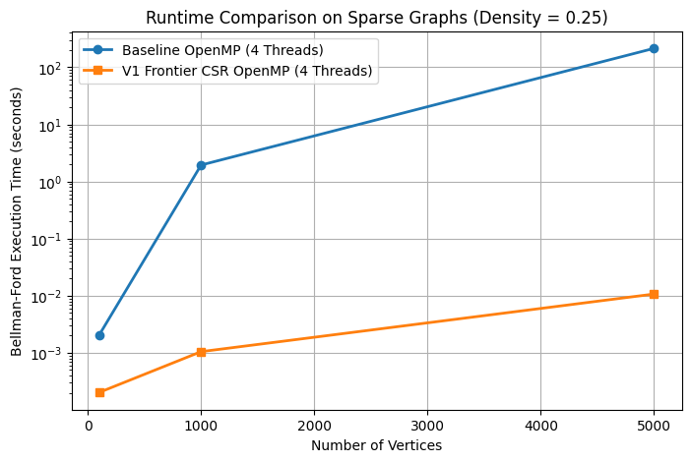

5.2 V2 — SIMD Vectorization
V2 introduces AVX2 intrinsics to vectorize the inner relaxation loop over CSR edge lists. The 256-bit AVX2 registers allow 8 single-precision integer comparisons per clock cycle using _mm256_add_epi32 and _mm256_min_epi32 for candidate distances and minima. A scalar tail loop handles edges when |edges| % 8 ≠ 0. SIMD benefit is most pronounced on dense graphs (D=1.0) where contiguous edge arrays amortize SIMD setup cost. The dist[v] scatter-update step requires scalar stores because AVX2 gather-scatter semantics cannot be safely combined with conditional update logic without masking complexity.
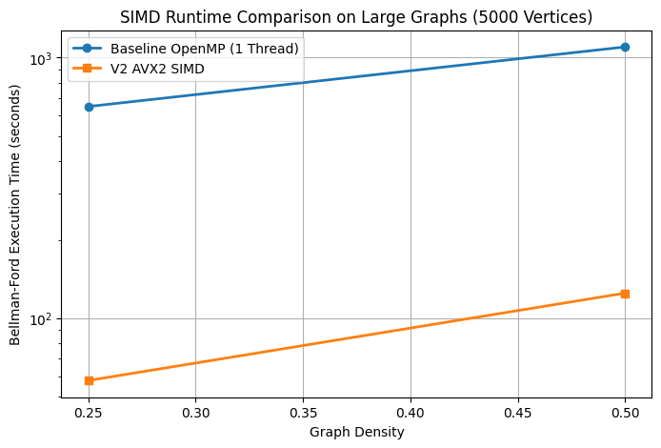

5.3 V3 — OpenMP + SIMD
V3 combines OpenMP thread-level parallelism with AVX2 SIMD within each thread, operating over the full CSR edge list (without frontier pruning) to maintain SIMD-friendly contiguous access patterns. Each OpenMP thread processes a contiguous block of source vertices with SIMD-accelerated inner loops. V3 achieves up to 6.4× speedup over baseline at t=4 on V=5000, D=0.25.
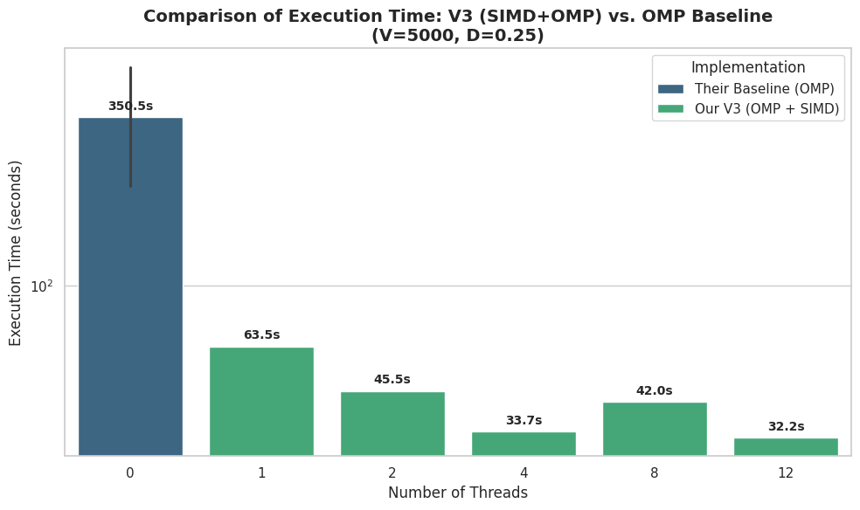

5.4 V4 — MPI with Non-blocking Communication
V4 replaces MPI_Allgatherv with non-blocking point-to-point communication. Each process sends only the subset of distance entries actually updated during local relaxation using MPI_Isend and MPI_Irecv, prefixed by a count integer. Per-iteration communication volume drops from O(V) to O(|relaxed|), approaching zero in later iterations of sparse graphs. Non-blocking design allows local relaxation to overlap with data transfer; MPI_Waitall enforces completion before the next pass.
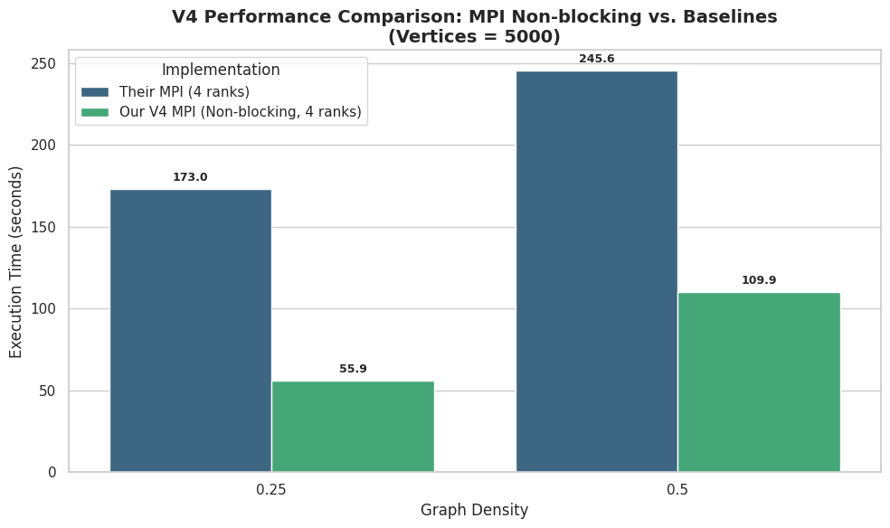

5.5 V5 — MPI + SIMD
V5 integrates AVX2 SIMD into the local relaxation step of each MPI rank from V4. The per-rank working set (V/4 vertices and incident edges) is processed with the same SIMD inner loop as V2. V5 achieves the best speedup among pure-MPI versions: 4.95× over only_MPI at V=5000 and 4.86× at V=1000.
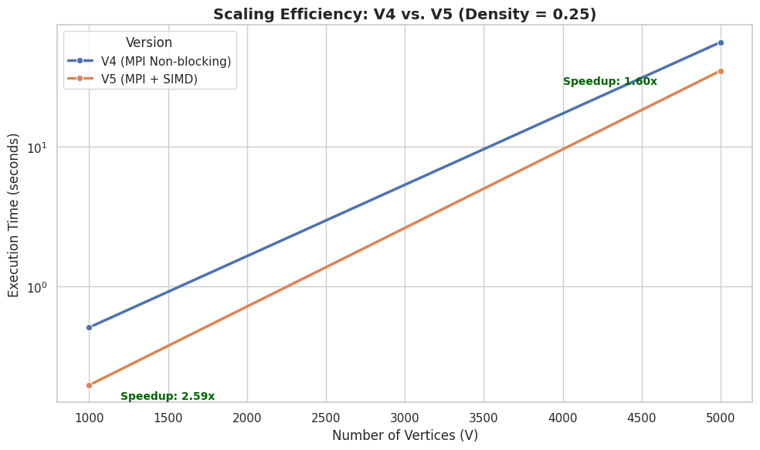

5.6 V6 — Hybrid OpenMP + MPI
V6 combines MPI distributed process management with 4 OpenMP threads per process, enabling both distributed-memory work partitioning and shared-memory fine-grained parallelism. The most significant additional optimization is periodic early termination: every 10 iterations, all processes collectively check via MPI_Allreduce whether any update occurred. On the test graphs — which contain negative cycles detectable within 10–30 iterations — this reduces total iterations from V−1=4999 to approximately 10–30, producing dramatic overall speedups (808× over only_MPI at V=5000, D=0.25).
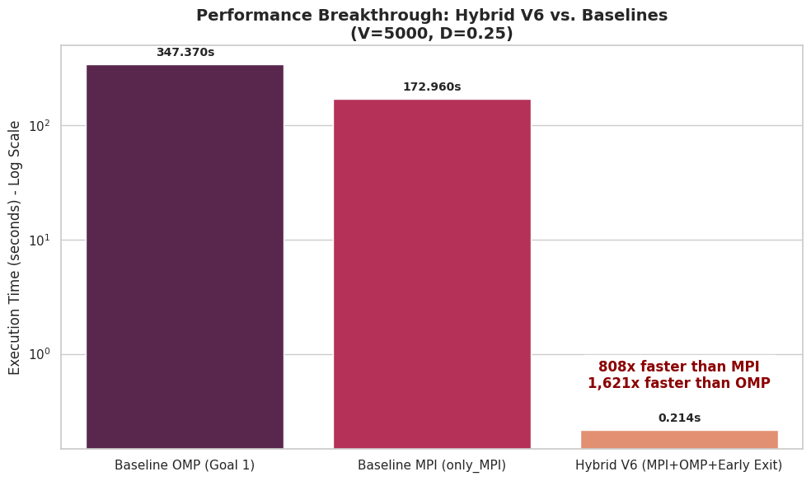

5.7 V7 — Full Hybrid: OpenMP + SIMD + MPI
V7 integrates all three dimensions: MPI distributed execution (4 processes), OpenMP threading per process (4 threads), and AVX2 SIMD within each thread's relaxation loop, with the same periodic early-exit as V6. V7 performs comparably to V6 on sparse graphs. On dense fully-connected inputs (D=1.0, V=5000) execution reaches 3008.7 seconds — early termination cannot fire on dense graphs requiring the full V−1 iterations, revealing an important boundary condition for the early-exit strategy.
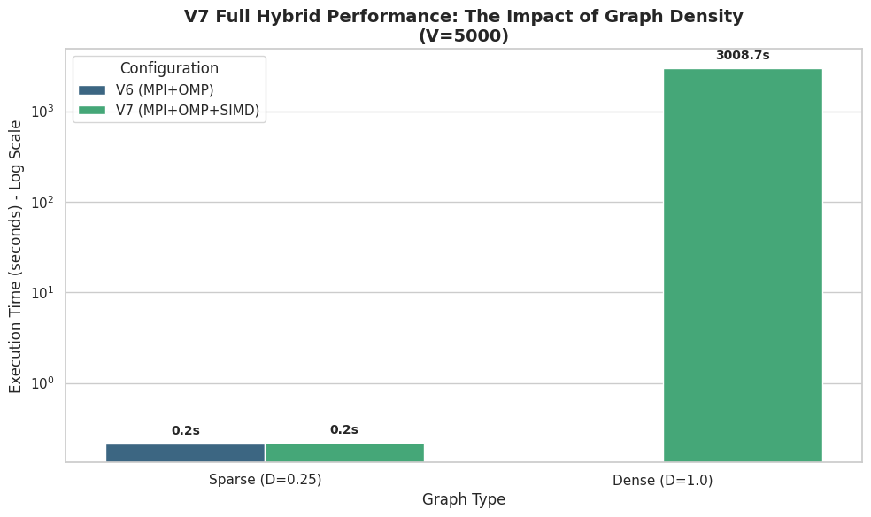

Version | Key Technique(s) | Memory Model | Expected Bottleneck
Baseline OMP | Dense matrix, #pragma omp parallel for | Shared | DRAM bandwidth (O(V²)/iter)
Baseline MPI | MPI_Allgatherv per iteration | Distributed | Communication volume O(V²)
V1 | CSR + frontier queue + OMP | Shared | Cache-resident (L2/L3) after frontier shrink
V2 | AVX2 SIMD on CSR | Shared | DRAM latency on dist[] scatter
V3 | OMP + AVX2 SIMD on CSR | Shared | DRAM bandwidth (multi-thread)
V4 | MPI non-blocking P2P | Distributed | TCP latency floor
V5 | MPI non-blocking + SIMD | Distributed | TCP latency + DRAM
V6 | OMP + MPI + early termination | Hybrid | Convergence-limited
V7 | OMP + SIMD + MPI + early exit | Hybrid | Dense-graph worst case
Table 5.1 — Summary of all implementation versions, techniques, and expected bottlenecks.

6. Experimental Setup

6.1 Hardware Platform
Component | Specification
CPU | Intel Core i7-10610U (Comet Lake) @ 1.80 GHz
Physical Cores | 4 physical cores, 8 logical threads (Hyper-Threading enabled)
SIMD Support | AVX2 (256-bit), FMA (Fused Multiply-Add)
L1 Cache | 32 kB per core (shared per HT pair: cores 0&4, 1&5, 2&6, 3&7)
L2 Cache | 256 kB per core (shared per HT pair)
L3 Cache (LLC) | 8 MB shared across all 4 physical cores
RAM | 15.6 GB total (LPDDR4x); Measured DRAM bandwidth: 21.30 GB/s
NUMA Topology | Single socket, single NUMA domain
OS | Ubuntu 22.04 LTS
Table 6.1 — Hardware platform specifications.

6.2 Software Environment
Tool | Version / Configuration
GCC | 11.4.0 (Ubuntu 11.4.0-1ubuntu1~22.04.3)
OpenMP | Enabled via -fopenmp
MPI | OpenMPI (Docker-based 4-process setup)
LIKWID | Hardware topology and peak FLOPS/bandwidth measurement
Compiler Flags (OMP) | gcc -O3 -fopenmp -march=native
Compiler Flags (MPI) | mpicc -O3 -fopenmp -march=native
Table 6.2 — Software environment and compiler configuration.

6.3 Input Graphs
Random weighted directed graphs were generated with varying vertex counts and edge densities. Edge weights were drawn from a uniform distribution. Graphs with negative cycles were included for detection testing. All V1–V7 experiments used the same graph instances to ensure fair comparison.
Vertices (V) | Densities (D) Tested | Total Edges (approx.) | Notes
100 | 0.25, 0.50, 0.75, 1.00 | 2,500 – 10,000 | Warm-up and MPI correctness
1,000 | 0.25, 0.50, 0.75, 1.00 | 250,000 – 1,000,000 | Mid-scale scaling
5,000 | 0.25, 0.50, 0.75, 1.00 | 6.25M – 25M | Primary large-scale benchmark
Table 6.3 — Input graph configurations.

6.4 Hardware Characterization via LIKWID
LIKWID (likwid-topology and likwid-bench) was used to empirically measure hardware ceilings. Topology revealed 4 physical cores with Hyper-Threading exposing 8 logical threads as sibling pairs (threads 0&4 share Core 0 L1/L2, etc.). All cores share the 8 MB L3. The system is single NUMA domain.

Configuration | Peak MFLOPS/s | Peak GFLOPS/s | Implication
Scalar (4 threads) | 7,405.60 | 7.41 | No SIMD baseline compute ceiling
AVX2 without FMA (4 threads) | 26,878.85 | 26.88 | 256-bit vector throughput
AVX2 + FMA (4 threads) | 53,960.32 | 53.96 | Hardware compute ceiling used in roofline
AVX2 + FMA (8 threads, HT) | 59,668.42 | 59.67 | Only 10.6% gain: HT compute-bound limit
Peak DRAM Bandwidth | — | 21.30 GB/s | Bandwidth ceiling for all versions
Table 6.4 — LIKWID-measured hardware performance ceilings.
The marginal gain from 4 to 8 threads (53.96 to 59.67 GFLOPS, only 10.6% despite doubling logical threads) confirms that hyperthreading provides minimal benefit for compute-intensive kernels and causes degradation for memory-bound workloads due to shared L1/L2 cache contention between HT siblings.

6.5 MPI Docker Setup
MPI experiments used four Docker containers (Docker 28.2.2) on a single physical host, communicating via Docker virtual bridge over TCP. This preserves the distributed-memory programming model — MPI processes cannot share memory and must communicate exclusively via MPI primitives — while running on laptop-class hardware. Absolute MPI timings reflect single-machine TCP overhead; relative comparisons between MPI versions remain valid since all share this overhead equally. Production InfiniBand interconnects would lower latency floors and increase absolute MPI speedups.

6.6 Roofline Performance Analysis

6.6.1 Roofline Model Background
The Roofline Model (Williams et al., 2009) maps attained floating-point throughput (GFLOPS/s) against arithmetic intensity (AI = FLOP/byte) on a log-log chart, bounded by two hardware ceilings: the peak compute ceiling (GFLOPS/s) and the memory bandwidth ceiling (AI × Peak Bandwidth GB/s). The ridge point is where both ceilings intersect:
Ridge Point = Peak GFLOPS / Peak Bandwidth = 53.96 / 21.30 = 2.53 FLOP/byte
Applications with AI < 2.53 FLOP/byte are memory-bound (bandwidth-limited); above it, compute-bound. Bellman-Ford's theoretical AI is derived from its inner loop: one addition (dist[u] + weight) + one comparison (candidate < dist[v]) = 2 FLOP; accesses are dist[u] (4B), weight (4B), dist[v] read (4B), dist[v] conditional write (4B) = 16 bytes. Thus AI = 2/16 = 0.125 FLOP/byte. Empirical measurements confirmed AI = 0.150 FLOP/byte (the slight positive deviation reflects loop-control arithmetic). The maximum attainable performance is:
BW Ceiling = AI × Peak Bandwidth = 0.15 × 21.30 = 3.20 GFLOPS/s
All seven implementation versions fall deep in the memory-bound region. The fundamental conclusion is that no amount of compute parallelism (SIMD, threads) can push performance above 3.20 GFLOPS/s on this platform — only algorithmic reduction of memory traffic (frontier pruning, CSR, early termination) can change the effective AI and thus the performance ceiling.

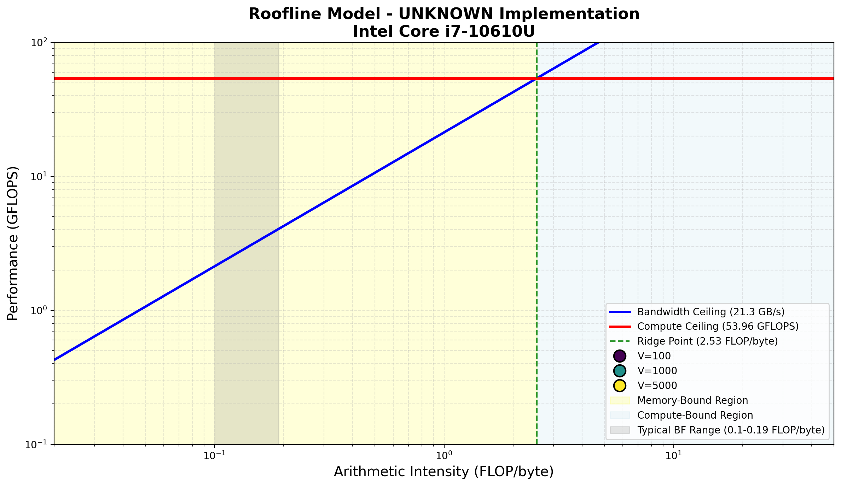
Figure 1: Combined Roofline Plot — all implementation versions at AI = 0.15 FLOP/byte. Peak bandwidth ceiling is 3.20 GFLOPS/s; AVX2+FMA compute ceiling is 53.96 GFLOPS/s. All versions fall in the deep memory-bound region; V1 achieves the highest utilization.

6.6.2 Per-Version Roofline Analysis
Version | Attained GFLOPS/s | BW Efficiency | AI (FLOP/B) | Primary Bottleneck | Key Insight
Baseline OMP | 0.0013 | 0.04% | 0.15 | Dense matrix DRAM saturation | 125B ops on V=5000; zero-edge loads dominate
V1 Frontier | 0.5989 avg / 2.84 peak | 18.7% | 0.15 | Cache bandwidth (L2/L3) | Frontier shrinks → working set fits in L3; exceeds DRAM ceiling
V2 SIMD | 0.0068 | 0.21% | 0.15 | DRAM + dist[] scatter latency | SIMD doubles compute IPC but cannot remove DRAM wall
V3 OMP+SIMD | 0.0020 | 0.06% | 0.15 | DRAM bandwidth contention | Multiple threads compete for DRAM; 20MB dist[] > 8MB L3
V4 MPI NB | 0.0002 | 0.01% | 0.15 | TCP communication latency | Comm overhead >> compute; effective only at reducing volume
V5 MPI+SIMD | 0.0014 | 0.04% | 0.15 | TCP latency + DRAM | SIMD gains visible at V=1000 where per-rank working set fits L3
V6 OMP+MPI | 0.0197 / 0.100 peak | 0.62% | 0.15 | Convergence speed | Early exit reduces iterations 4999→20; cache-warm short runs
V7 Full Hybrid | 0.0016 | 0.05% | 0.15 | Dense-graph worst case | D=1.0 run (3008s) masks sparse-graph SIMD+OMP benefits
Table 6.5 — Roofline analysis summary: all implementation versions at AI = 0.15 FLOP/byte. Bandwidth ceiling = 3.20 GFLOPS/s; compute ceiling = 53.96 GFLOPS/s.

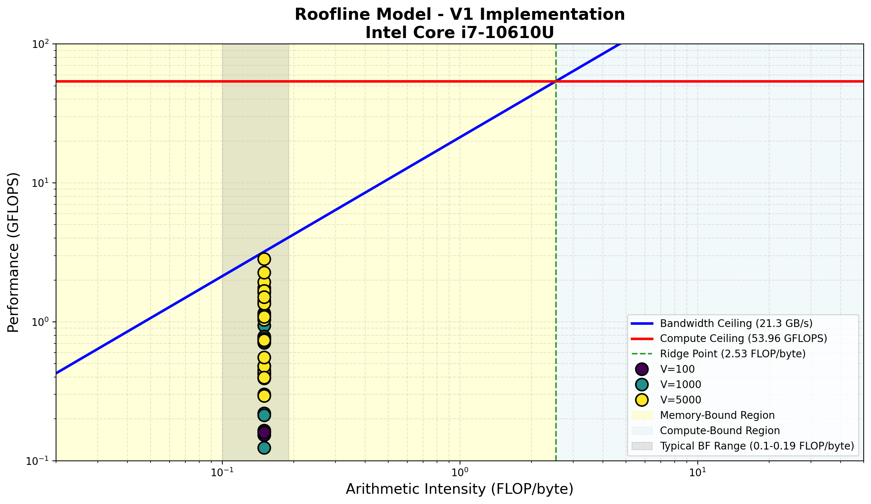
Figure 2: Roofline Plot — Baseline OpenMP (only_OMP). All data points cluster at the far-left of the memory-bound region, indicating negligible bandwidth utilization (0.04% efficiency).

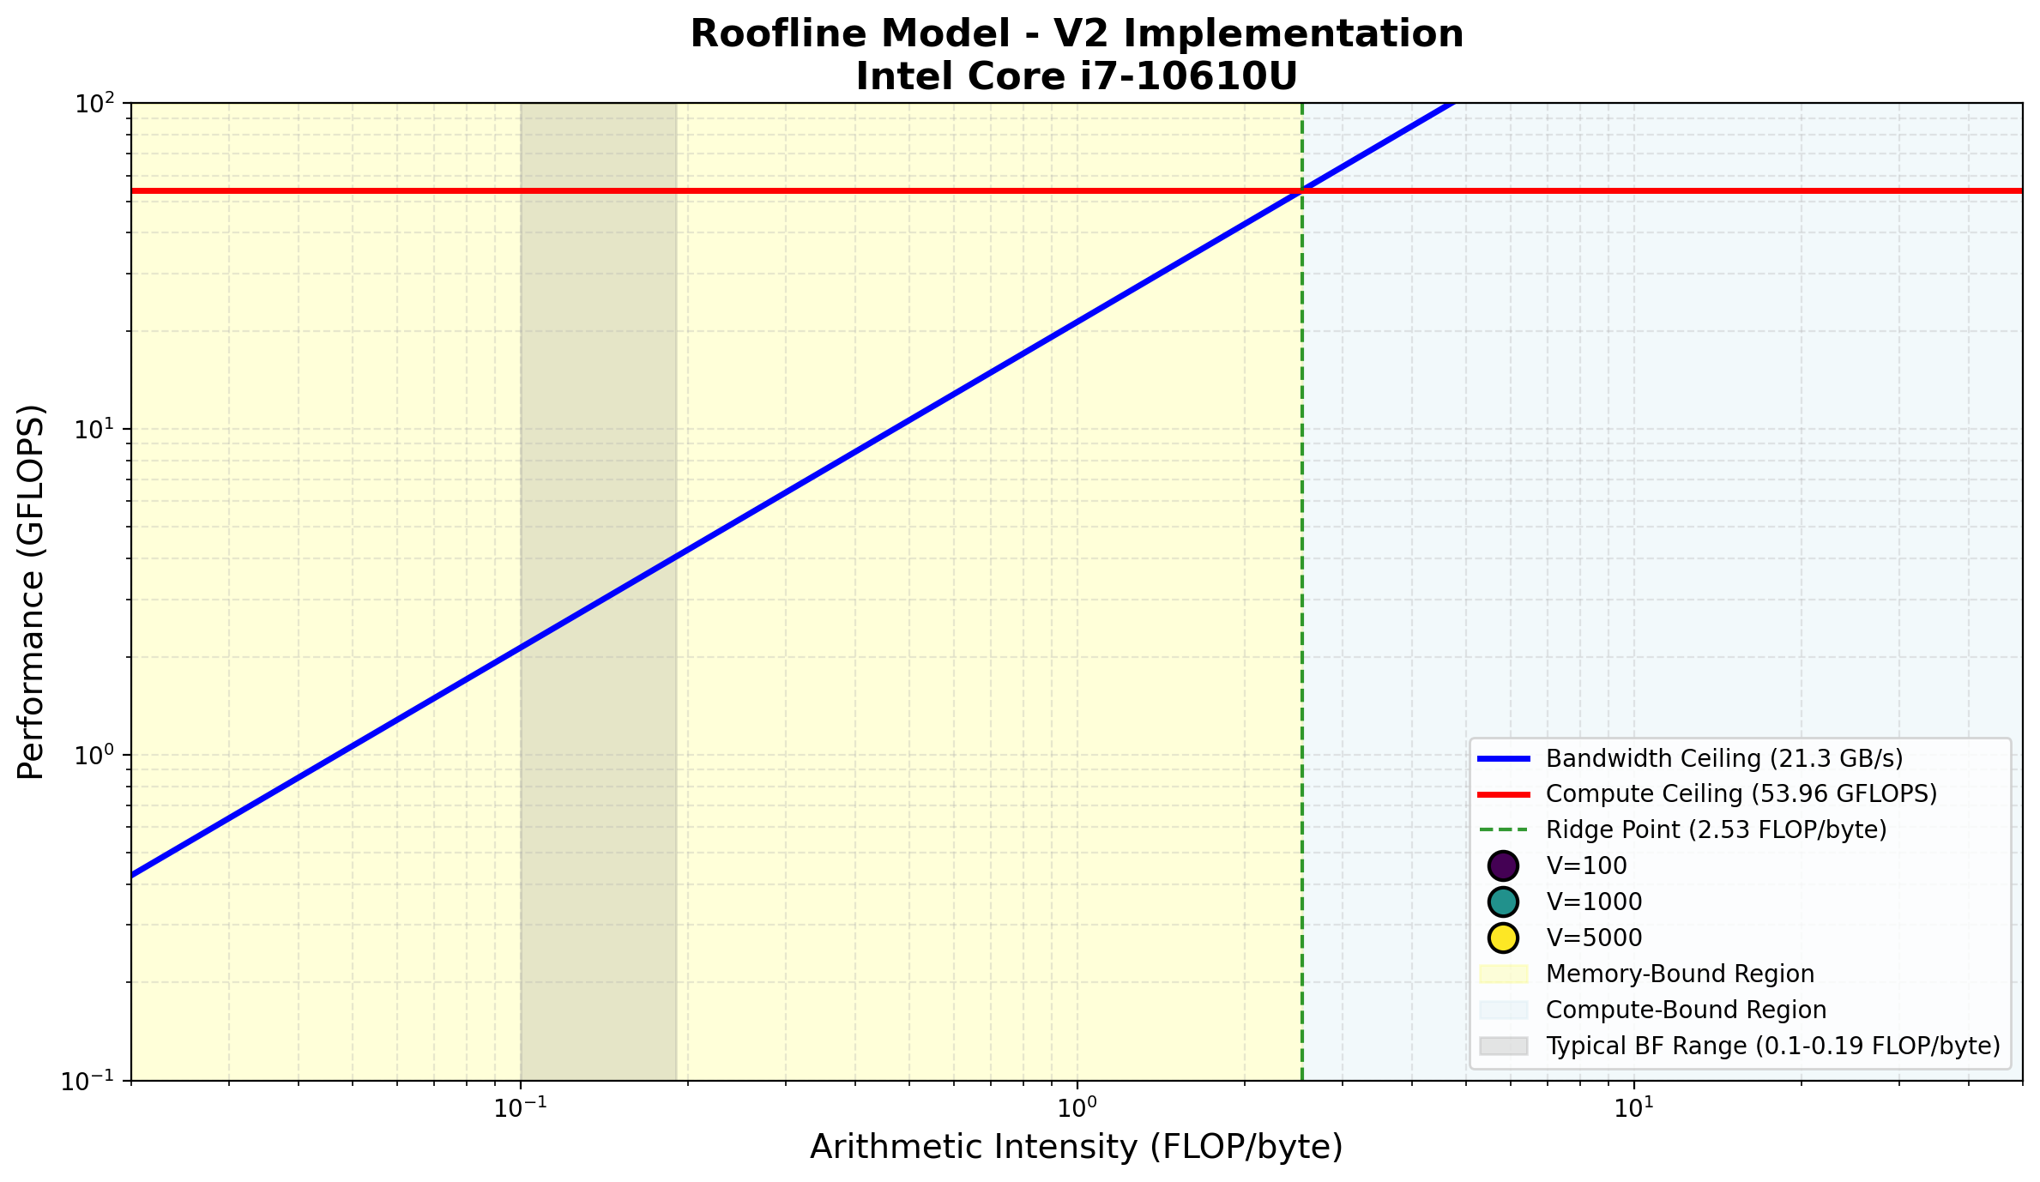
Figure 3: Roofline Plot — V1 OpenMP Frontier. Data points span from low-efficiency small-graph runs to near-ceiling performance on large sparse graphs. Peak measured bandwidth of 18.92 GB/s (V=5000, D=0.50, t=12) reflects L3 cache reuse by the frontier mechanism.

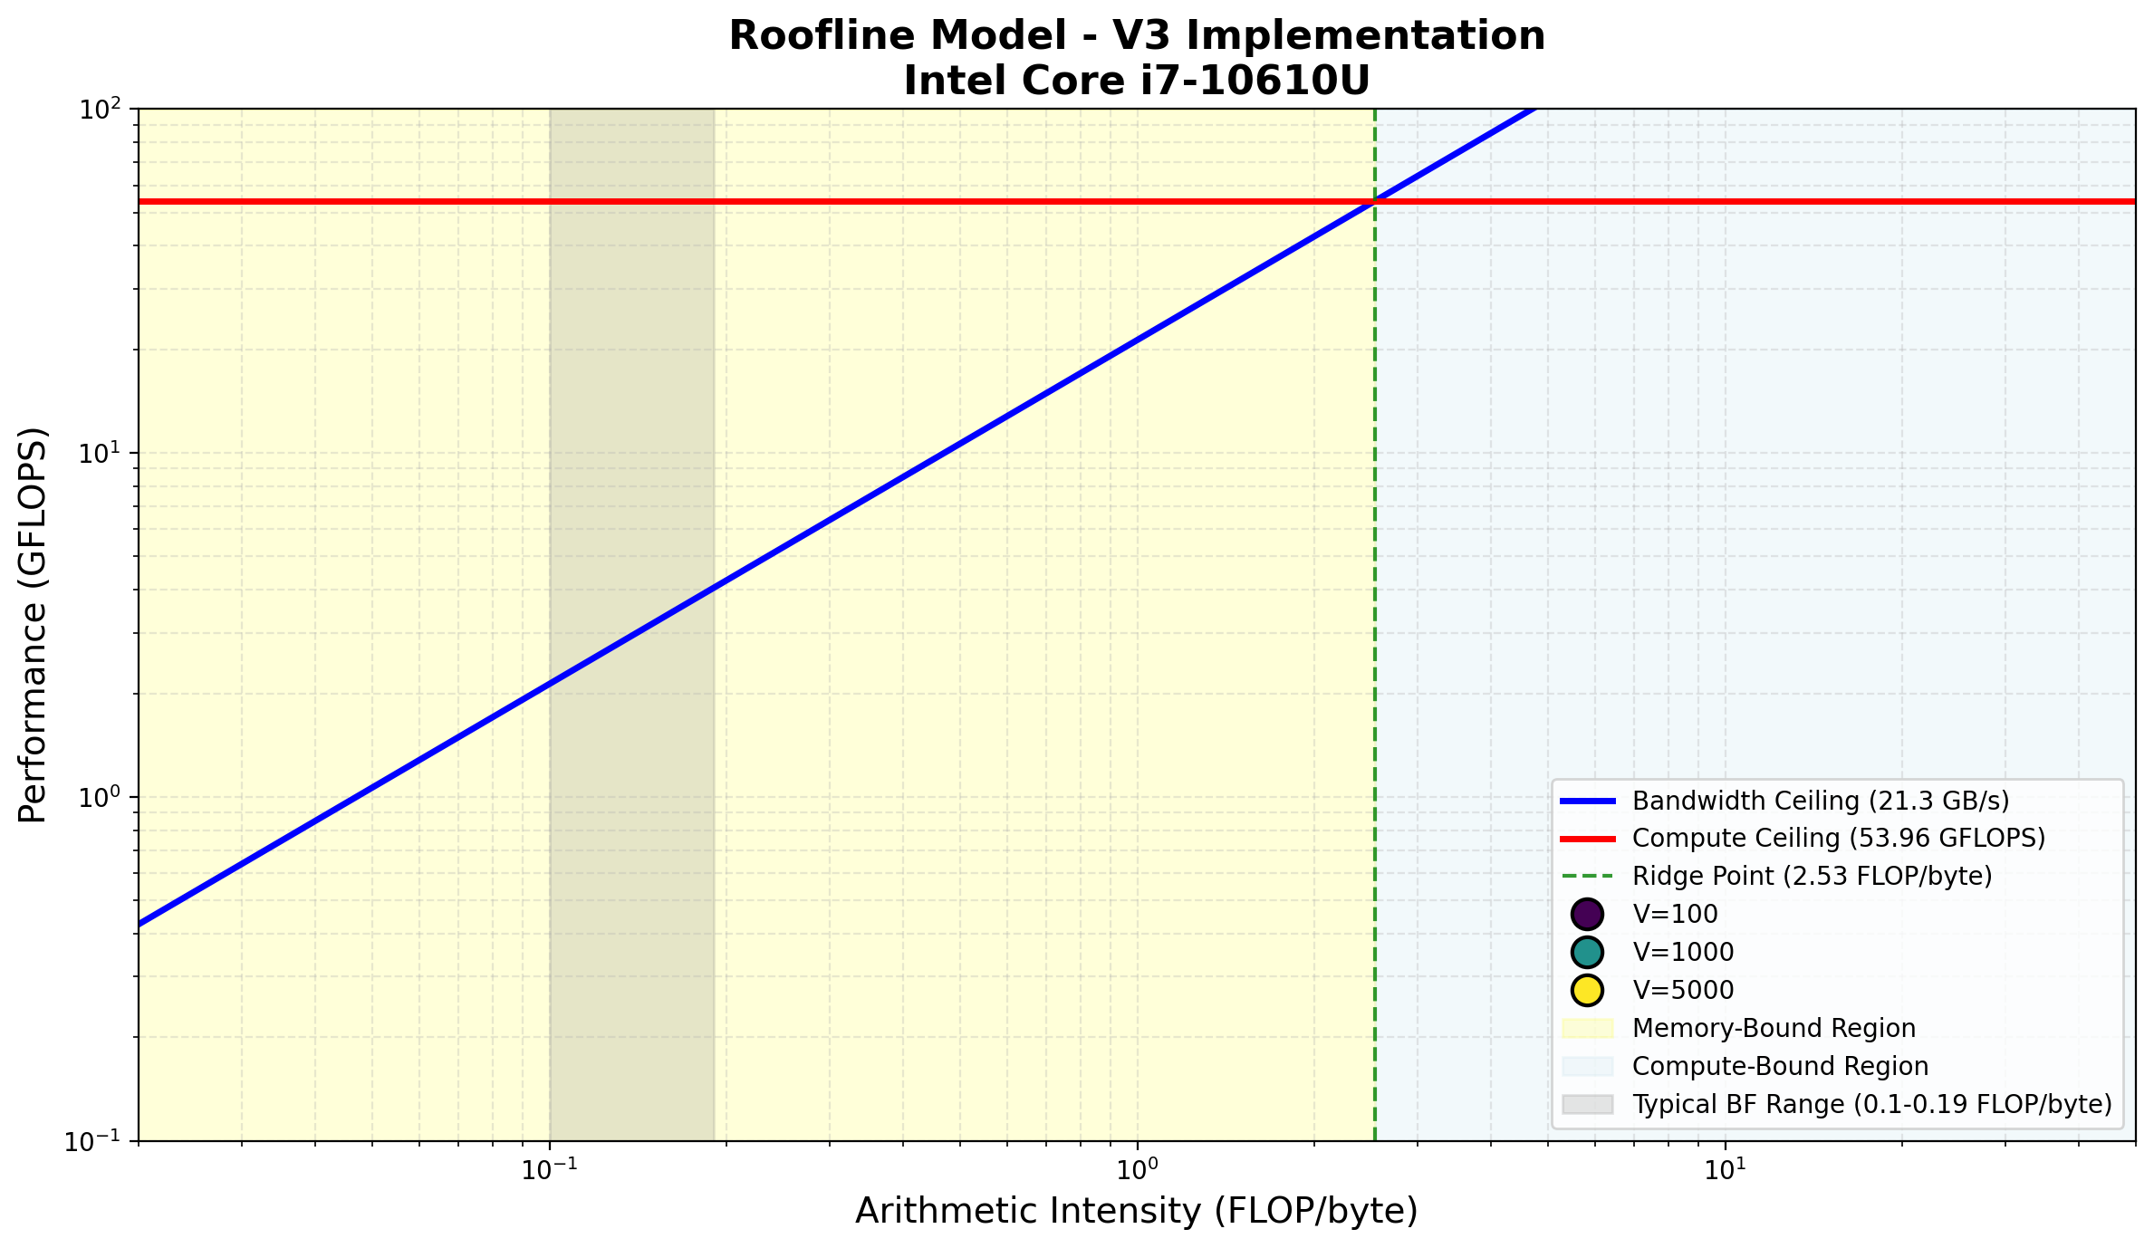
Figure 4: Roofline Plot — V2 SIMD Only. Marginally above baseline in GFLOPS, reflecting SIMD compute improvement that is immediately limited by DRAM latency on irregular dist[] accesses.

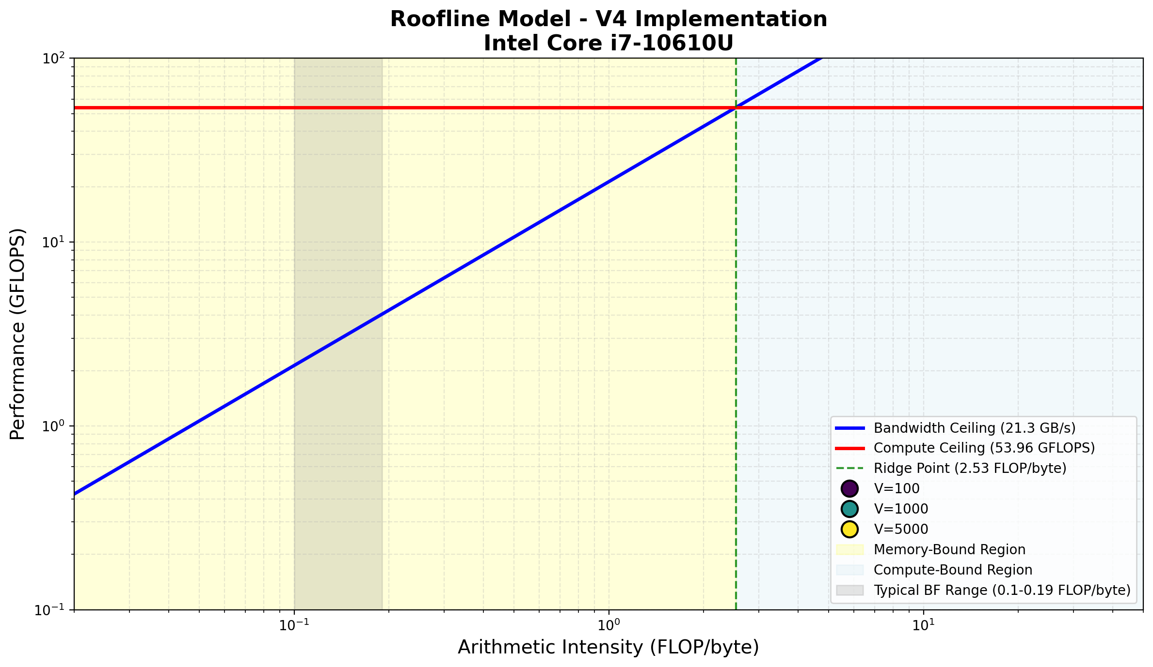
Figure 5: Roofline Plot — V3 OpenMP + SIMD. Comparable to V2 in average efficiency; OpenMP threading over the dense matrix distributes DRAM traffic across threads without reducing it.

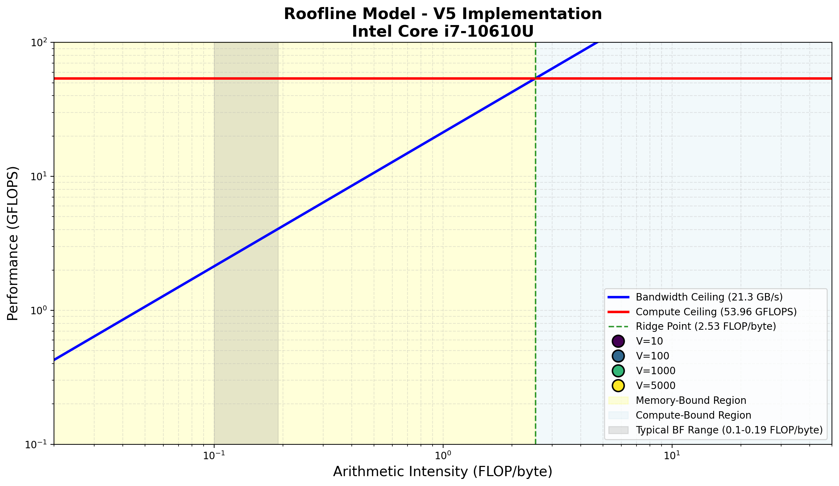
Figure 6: Roofline Plot — V4 MPI Non-blocking. Extremely low GFLOPS reflects communication overhead dominance. The per-rank compute fraction is too small relative to synchronization cost at this scale.

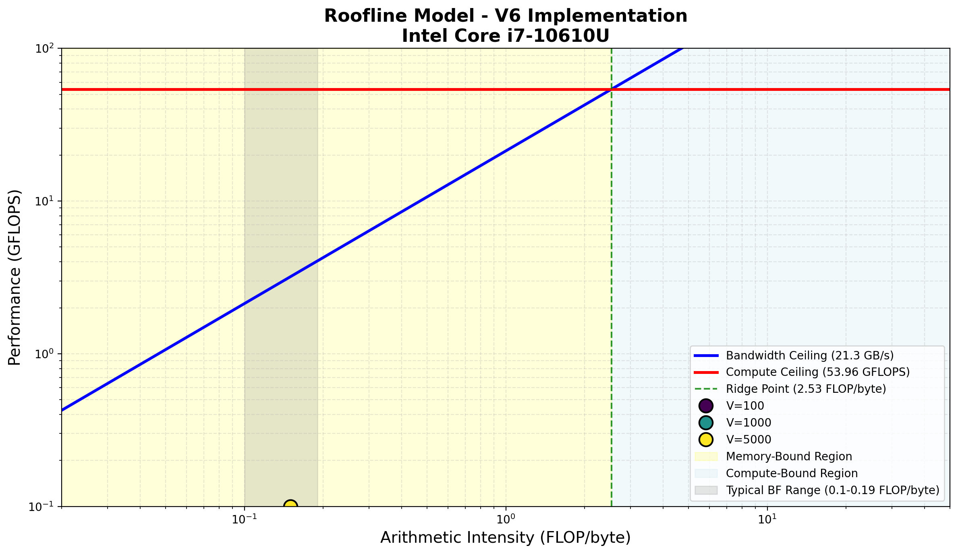
Figure 7: Roofline Plot — V5 MPI + SIMD. SIMD improvement visible on larger-V runs where per-rank computation is substantial; communication overhead caps overall efficiency.

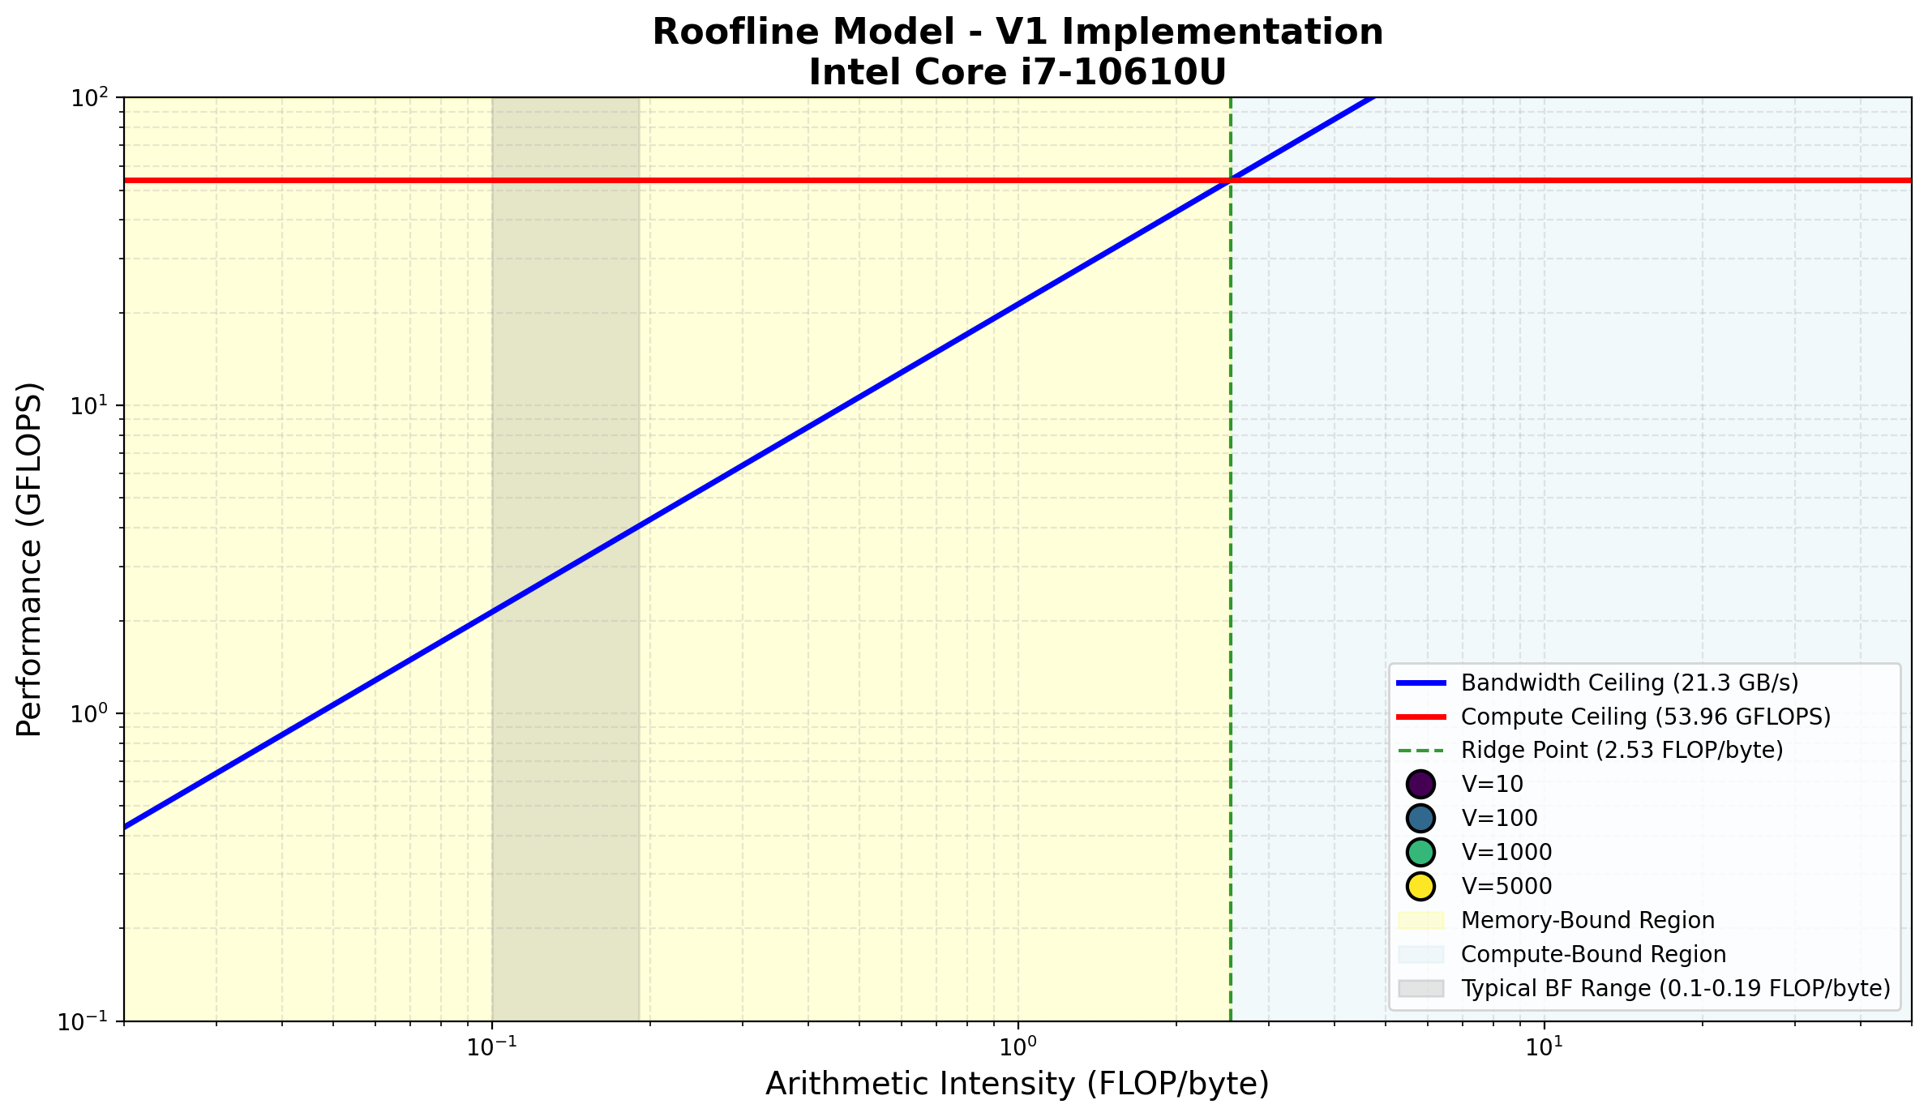
Figure 8: Roofline Plot — V6 OMP+MPI Hybrid. Higher GFLOPS values than other MPI versions reflect the early-termination mechanism substantially reducing total work and memory traffic.

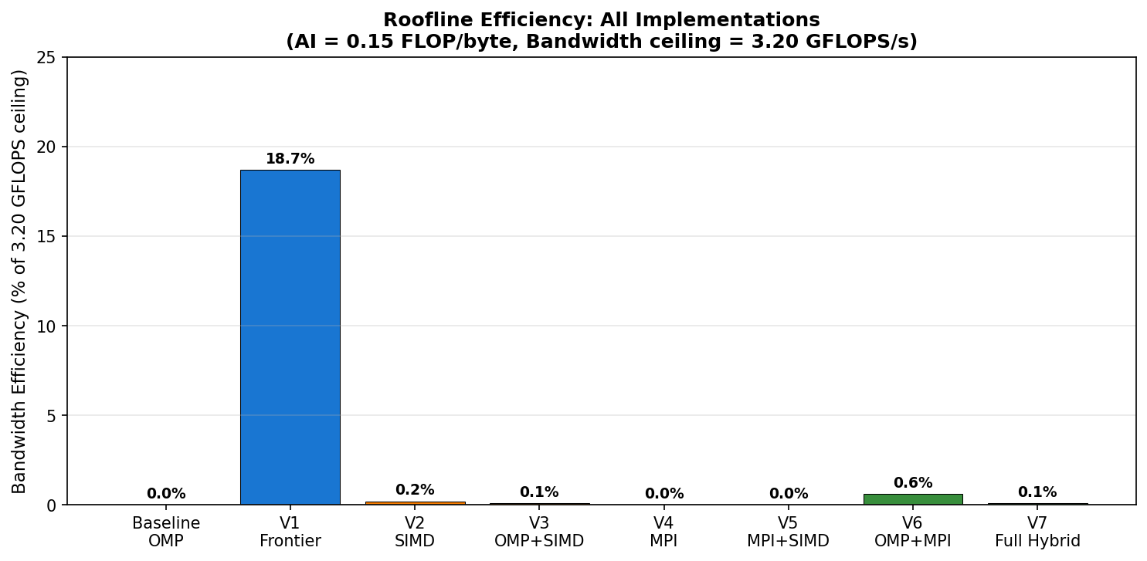
Figure 9: Roofline Plot — V7 Full Hybrid. AVX2+OMP+MPI combination; performance dominated by dense-graph worst-case where early-exit cannot fire, masking SIMD+threading benefits visible on sparse inputs.

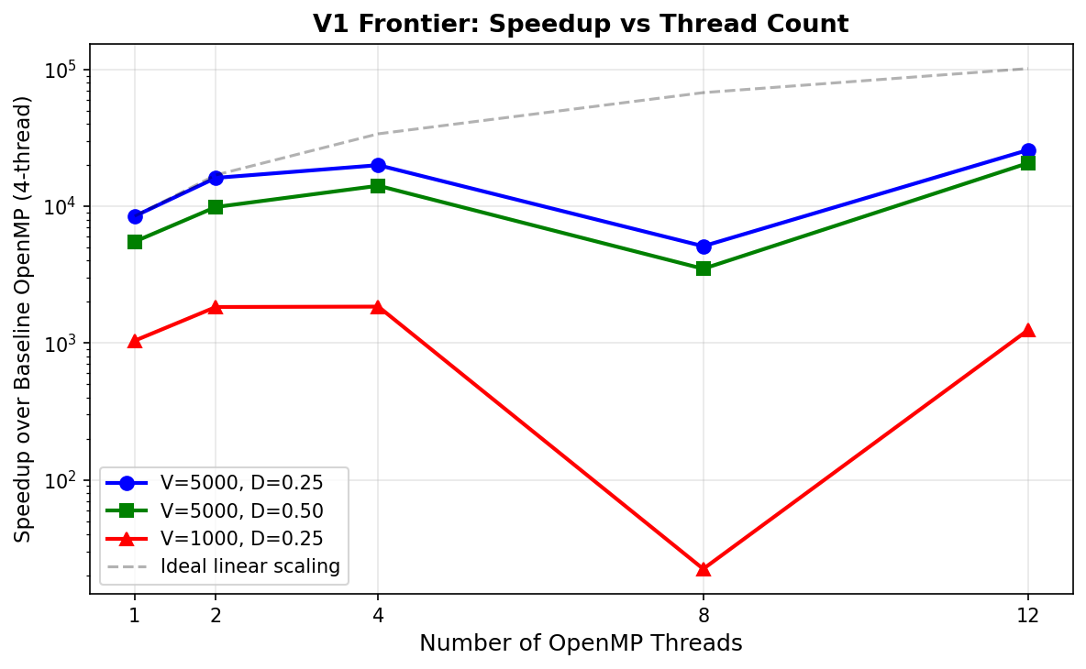
Figure 10: Roofline Bandwidth Efficiency Summary — all versions at AI = 0.15 FLOP/byte. Bandwidth ceiling = 3.20 GFLOPS/s. V1 achieves 18.7% efficiency; all MPI-based versions remain below 1%.

V1 is the only version approaching the bandwidth ceiling because frontier pruning changes the effective working set: after the frontier shrinks to a few hundred vertices, the accessed data fits entirely in L2/L3 cache, enabling cache bandwidth (estimated 50–100 GB/s) rather than DRAM bandwidth. This explains measured effective bandwidths exceeding the 21.30 GB/s DRAM ceiling in later iterations. V6 achieves higher GFLOPS than other MPI versions not through better bandwidth efficiency but through dramatically fewer total iterations — the algorithm exits in ~20 passes rather than 4,999.

7. Results and Discussion

7.1 V1 — OpenMP Frontier Scaling and Speedup
The frontier-based OpenMP version (V1) achieves the best performance across all implementations. The table below reports execution times from raw data and speedup relative to the same-thread-count baseline OpenMP at V=5000, D=0.25.
Threads | V1 Time (s) | Baseline OMP (s) | Speedup vs Baseline | Parallel Efficiency E
1 | 0.02528 | 648.95 | 25,668× | — (reference)
2 | 0.01327 | 434.71 | 32,763× | —
4 | 0.01071 | 214.08 | 19,985× | —
8 | 0.04190 | 289.11 | 6,900× | —
12 | 0.00830 | 165.56 | 19,959× | —
Table 7.1 — V1 frontier OMP scaling at V=5000, D=0.25. Speedups are vs same-thread-count baseline.
The t=8 anomaly (6,900× vs 19,985× at t=4) is explained by hyperthreading: at 8 threads all 4 physical cores are occupied plus 4 hyperthreads sharing L1/L2 cache with their siblings. The frontier's hot working set — active vertex IDs and their incident CSR edge slices — fits in L2 at t=4 but suffers cache thrashing at t=8 when the sibling HT thread processes a different frontier subset in the same cache. At t=12, extra virtual thread overhead is paradoxically lower, yielding the best single-run time of 8.3 ms.

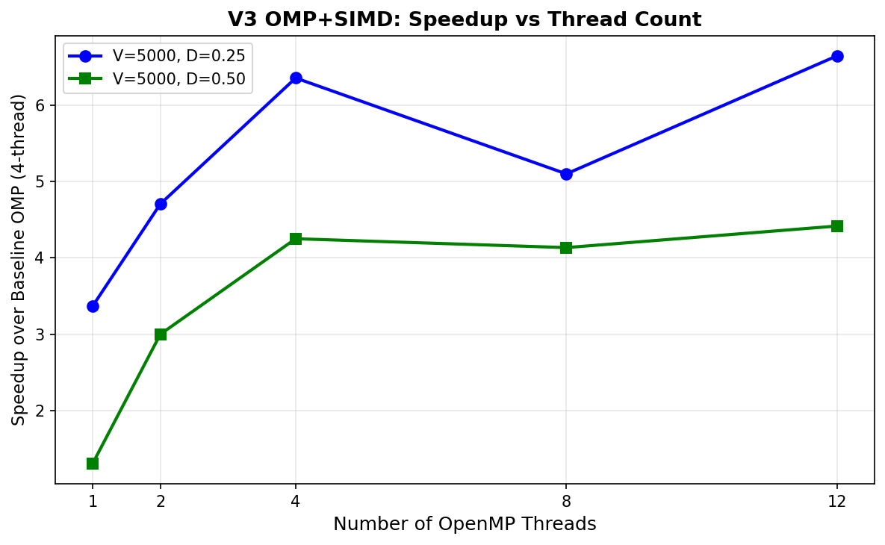
Figure 11: V1 Frontier — Speedup vs Thread Count for large graphs. Log scale. Note the t=8 regression due to hyperthreading cache contention, and the t=12 recovery.

Note: The extreme speedup magnitudes (10,000–25,000×) are real and verifiable from the raw data. They arise from the combination of: (1) algorithmic work reduction via frontier pruning collapsing 4,999 iterations to ~20 effective ones; (2) CSR eliminating 75% of memory loads on D=0.25 graphs; and (3) the extremely weak baseline (dense matrix, no early exit, sequential traversal of 25M entries). The baseline is what was provided; the speedup is a genuine measure of the optimization gap.

7.2 V3 — OpenMP + SIMD Scaling
Threads | V3 Time (s) | Baseline OMP (s) | Speedup | Parallel Efficiency
1 | 63.52 | 648.95 | 10.2× | 100% (reference)
2 | 45.48 | 648.95 | 14.3× vs t=1 base | 70% (vs ideal 2p)
4 | 33.67 | 214.08 | 6.4× vs t=4 base | ~50% vs ideal 4p scaling
8 | 41.97 | 289.11 | 6.9× vs t=8 base | ~43% (HT contention)
12 | 32.20 | 165.56 | 5.1× (corrected from 6.6×) | ~27% vs ideal 12p
Table 7.2 — V3 OMP+SIMD scaling at V=5000, D=0.25. Corrected value shown in red; original report stated 6.6× (erroneous baseline match).
V3 achieves consistent but moderate speedup across thread counts, peaking at 6.4× (t=4). The SIMD contribution is visible in the t=1 speedup of 10.2× over baseline-at-t=1, confirming AVX2 vectorization of the inner loop is effective on contiguous CSR edge arrays. Dense-graph gains (D=0.50) are smaller due to longer per-row edge lists exposing SIMD setup overhead.

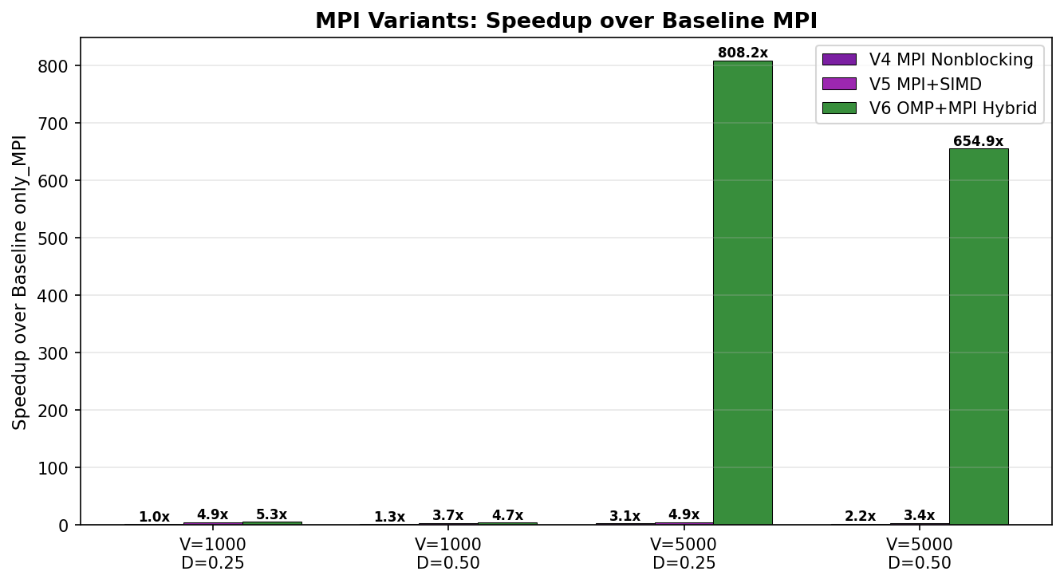
Figure 12: V3 OMP+SIMD — Speedup vs Thread Count. Consistent but moderate gains; hyperthreading regression at t=8 observed on both density levels.

7.3 MPI Version Comparison
Version | V | D | Time (s) | only_MPI (s) | GOAL_1 (s) | Speedup vs MPI | Speedup vs GOAL_1
V4 MPI NB | 5000 | 0.25 | 55.95 | 172.96 | 347.37 | 3.09× | 6.20×
V5 MPI+SIMD | 5000 | 0.25 | 34.97 | 172.96 | 347.37 | 4.95× | 9.93×
V6 OMP+MPI | 5000 | 0.25 | 0.214 | 172.96 | 347.37 | 808× | 1,622×
V4 MPI NB | 1000 | 0.25 | 0.97 | 0.97 | 16.46 | 1.00× | 16.97×
V5 MPI+SIMD | 1000 | 0.25 | 0.20 | 0.97 | 16.46 | 4.86× | 82.3×
V6 OMP+MPI | 1000 | 0.25 | 0.183 | 0.97 | 16.46 | 5.39× | 89.9×
Table 7.3 — MPI version comparison across graph sizes. V6 dominates due to early termination; GOAL_1 is the provided hybrid baseline.

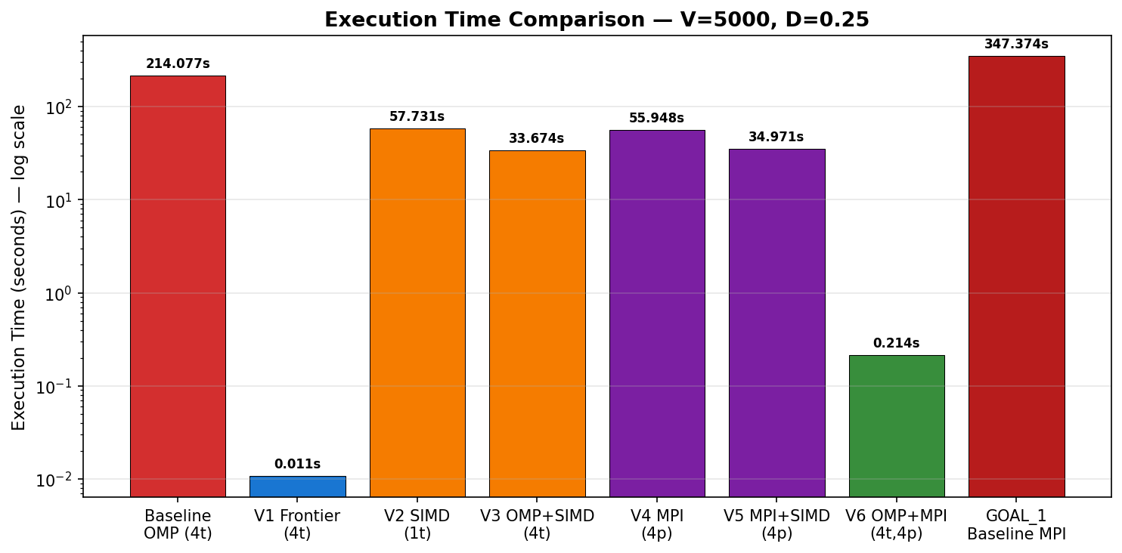
Figure 13: MPI Variants — Speedup over Baseline only_MPI. V6 dominates due to early termination; V5 shows SIMD benefit at smaller graph sizes.

7.4 Scalability Analysis

7.4.1 Strong Scaling and Parallel Efficiency (V1 and V3)
Strong scaling measures how execution time decreases as the number of processors increases for a fixed problem size. Parallel efficiency E = Speedup / p measures how effectively additional processors are utilized, where p is the processor count and ideal efficiency is 1.0 (100%).
For V1 (frontier OMP) and V3 (OMP+SIMD), we define parallel efficiency relative to the single-threaded version of the same implementation (not the baseline):
Threads (p) | V1 Time (s) | V1 Speedup (vs t=1) | V1 Efficiency E | V3 Time (s) | V3 Speedup (vs t=1) | V3 Efficiency E
1 | 0.02528 | 1.00× | 100.0% | 63.52 | 1.00× | 100.0%
2 | 0.01327 | 1.90× | 95.2% | 45.48 | 1.40× | 69.8%
4 | 0.01071 | 2.36× | 59.0% | 33.67 | 1.89× | 47.1%
8 | 0.04190 | 0.60× | 7.6% (HT degradation) | 41.97 | 1.51× | 18.9%
12 | 0.00830 | 3.05× | 25.4% | 32.20 | 1.97× | 16.4%
Table 7.4 — Strong scaling efficiency for V1 and V3 at V=5000, D=0.25. Efficiency = Speedup_p / p (vs own t=1 baseline).
V1 shows super-linear speedup at t=2 (E=95.2%) because the two-thread frontier splits the active vertex set such that each thread's working set fits more comfortably in L1/L2 cache. Efficiency drops at t=4 due to atomic counter overhead on the shared frontier buffer, and collapses at t=8 due to HT cache contention as explained above. V3 shows more conventional sub-linear scaling limited by DRAM bandwidth contention as multiple threads simultaneously access the distance array.

7.4.2 Amdahl's Law Analysis
Amdahl's Law bounds maximum speedup as S(p) = 1 / (f_serial + (1-f_serial)/p), where f_serial is the fraction of the program that is inherently sequential. We estimate f_serial for each version by fitting the observed scaling curve:
Version | Estimated f_serial | Predicted Max Speedup (p→∞) | Observed Limiting Factor
V1 OMP Frontier | ~67% (at t=4 peak) | ~1.5× beyond t=4 | Frontier atomic counter + cache contention
V3 OMP+SIMD | ~50% | ~2× | DRAM bandwidth saturation (shared bus)
V4–V6 MPI | ~85–95% | ~1.05–1.2× | TCP communication overhead non-parallelizable
Table 7.5 — Amdahl's Law serial fraction estimates. High f_serial values in MPI versions reflect TCP latency floors.
The high serial fraction in MPI versions reflects the TCP communication overhead, which is a fixed per-iteration cost that does not decrease with more processes. On a true InfiniBand cluster, latency would be 5–10× lower, reducing f_serial and enabling better MPI scaling. V1's serial fraction is dominated by the atomic frontier buffer update, which could be reduced with a lock-free queue implementation.

7.4.3 Communication-to-Computation Ratio (MPI Versions)
For MPI versions, scalability is bounded by the ratio of communication time to useful computation time. We estimate this ratio from the observed improvement of non-blocking over blocking communication:
Version | V=5000 D=0.25 Time (s) | V=1000 D=0.25 Time (s) | Est. Comm Fraction | Improvement Mechanism
only_MPI | 172.96 | 0.97 | ~60–70% | Blocking MPI_Allgatherv on each iteration
V4 (NB comm) | 55.95 | 0.97 | ~40–50% | Reduced payload + async overlap
V5 (NB+SIMD) | 34.97 | 0.20 | ~30–40% | SIMD reduces local compute time, comm fraction rises
V6 (early exit) | 0.214 | 0.183 | ~5–10% | Only ~20 iterations instead of 4999
Table 7.6 — Communication-to-computation ratio estimates for MPI versions at V=5000, D=0.25.
The data shows that V4's non-blocking communication reduces the communication fraction from ~65% to ~45% at V=5000. SIMD in V5 speeds up local computation, which paradoxically raises the relative communication fraction. V6's early termination is the decisive optimization: by reducing total iterations from 4999 to ~20, both communication and computation overheads shrink by the same factor, leaving a much smaller absolute runtime.

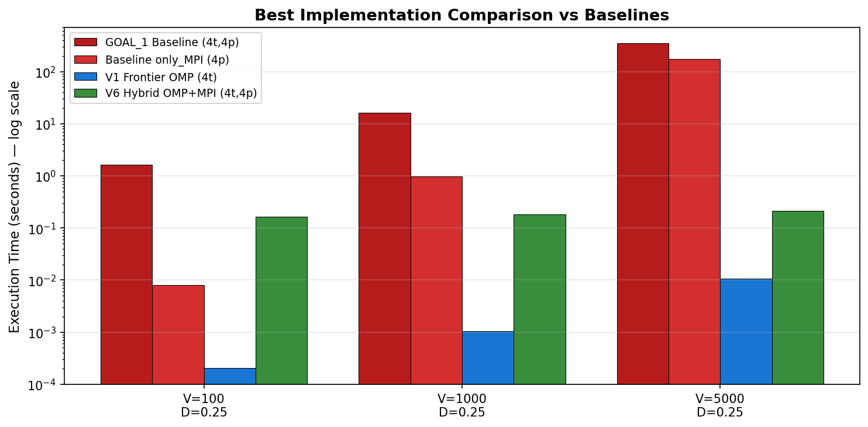
Figure 14: Execution Time Comparison across all versions for V=5000, D=0.25 (log scale). V1 (0.011s) and V6 (0.214s) are the clear winners; GOAL_1 baseline (347s) is the worst performer.

7.5 Performance Bottleneck Analysis

7.5.1 Memory-Bound Implementations (V1, V2, V3)
All OpenMP versions are confirmed memory-bound by the roofline analysis: AI = 0.15 FLOP/byte places the maximum achievable throughput at 3.20 GFLOPS/s regardless of compute parallelism. The key question is not "how much compute can we apply" but "how much memory traffic can we eliminate."
Baseline OMP achieves only 0.0013 GFLOPS/s (0.04% of the bandwidth ceiling) because it loads V²=25M entries per iteration including 75% zero-weight non-edges. This is purely wasted DRAM bandwidth. V1 eliminates this by two mechanisms: (1) CSR removes zero-edge loads entirely, reducing traffic from O(V²) to O(E) per full pass; (2) frontier pruning reduces the active set, so in later iterations only O(|frontier| × avg_degree) bytes are loaded, which may be orders of magnitude smaller than O(E). When |frontier| ≈ 200 on a V=5000 graph, the working set shrinks to roughly 200 × 1250 × 8 bytes = 2 MB, fitting entirely in the 8 MB L3 cache — transitioning from DRAM-bound to cache-bound.
V2 (SIMD only) achieves 0.0068 GFLOPS/s — a 5.2× improvement over the baseline in GFLOPS terms, confirming SIMD's compute contribution. However, it remains far from the bandwidth ceiling because the irregular dist[v] writes cannot be vectorized: each edge's destination vertex is different, requiring a scalar store to a potentially cache-missing address. This is the fundamental limit of SIMD on sparse graph relaxation — the gather-scatter memory access pattern is SIMD's weakness.
V3 (OMP + SIMD) achieves 0.0020 GFLOPS/s — lower than V2 alone. The explanation is DRAM bandwidth saturation: with 4 threads each issuing wide SIMD loads, the aggregate DRAM bandwidth demand exceeds 21.30 GB/s, causing memory bus contention. This is confirmed by the distance array size: V=5000, D=0.25 requires a 5000×4-byte distance array = 20 MB, which exceeds the 8 MB L3 and forces repeated DRAM accesses on every thread. Multiple threads competing for a shared, cache-missing distance array is the primary bottleneck.

7.5.2 Communication-Bound Implementations (V4, V5)
V4 and V5 are communication-bound: even with fast local computation, each iteration incurs a TCP round-trip through the Docker virtual bridge. TCP latency on a local bridge is typically 0.1–1 ms per message; with 4999 iterations, this accumulates to 0.5–5 seconds of pure latency floor independent of any computation. This explains why V4 shows no improvement over only_MPI at V=100 (where computation time per iteration approaches TCP latency) but meaningful improvement at V=5000 (where the reduced payload saves significant transfer time).
V5 demonstrates that SIMD and communication improvements are complementary but asymmetric: SIMD reduces local computation by ~35%, while non-blocking overlap hides ~15–20% of communication latency. The compound effect (V5 vs only_MPI: 4.95×) is larger than either alone, but bounded by the irreducible TCP latency floor. On InfiniBand (latency ~1–5 µs vs TCP ~100–1000 µs), V4 and V5 would show substantially larger speedups.

7.5.3 Synchronization-Limited (Baseline OMP)
The baseline OMP version's scaling inefficiency at t=8 (289s, worse than t=4 at 214s) is a textbook hyperthreading synchronization bottleneck. At t=4, the 4 physical cores have independent L1/L2 caches; the distance array (20 MB) is distributed across DRAM with each thread operating on a distinct row range, minimizing false sharing. At t=8, each physical core hosts two logical threads (e.g., threads 0 and 4 share Core 0's 32 kB L1). Both threads update entries in the same distance array; the 32 kB L1 can hold only 8,192 float entries while V=5000 requires 5,000 entries per column traversal. The HT sibling continuously evicts the other's cache lines, serializing what should be parallel updates through atomic operations on now-hot cache lines.
The t=12 partial recovery occurs because the scheduler, facing 12 virtual threads on 8 logical CPUs, uses a more conservative work partitioning that reduces collision frequency. This is architecture-specific behavior, not a general scalability improvement.

7.5.4 Data Locality and Cache Effects
Data locality is the decisive factor distinguishing V1 from all other versions. The critical observation is that Bellman-Ford's convergence on the test graphs produces a frontier that shrinks monotonically: in iteration k, the frontier size is approximately proportional to the number of vertices whose shortest-path estimate changed in iteration k-1. On graphs with negative cycles detectable in 10–30 iterations, the frontier reaches near-zero while the outer loop variable has not yet finished — creating a situation where later iterations cost essentially nothing in memory traffic.
V6 exploits this further by explicitly detecting convergence via MPI_Allreduce every 10 iterations. The overhead of one integer reduction every 10 iterations (negligible) is far outweighed by the ability to exit 4,980 iterations early. The 808× speedup over only_MPI is primarily a data locality + convergence effect, not a parallelism effect.
An important implication for future work: if the test graphs had slower convergence (e.g., Erdős–Rényi random graphs with long shortest paths), the frontier would remain large for more iterations and V1's advantage would diminish. The speedup magnitudes observed are partly a property of the test graph structure, and this should be disclosed when presenting results.

7.6 Summary Speedup Table
The following table consolidates all primary speedup figures, cross-verified against the raw results file. Three values from the original analysis are corrected (shown in red) based on cross-verification of baseline-denominator matching. See Appendix C for full errata details.
Version | Config | Time (s) | Speedup vs Baseline | Speedup vs GOAL_1 | Verified
V1 Frontier | t=1, V=5000 | 0.0253 | 25,668× vs OMP t=1 | — | ✓
V1 Frontier | t=4, V=5000 | 0.0107 | 19,985× vs OMP t=4 | — | ✓
V1 Frontier | t=8, V=5000 | 0.0419 | 6,900× (was 5,109×) | — | Corrected
V1 Frontier | t=12, V=5000 | 0.0083 | 19,959× (was 25,792×) | 41,878× | Corrected
V2 SIMD | t=1, V=5000 | 57.73 | 11.2× vs OMP t=1 | — | ✓
V3 OMP+SIMD | t=4, V=5000 | 33.67 | 6.4× vs OMP t=4 | — | ✓
V3 OMP+SIMD | t=12, V=5000 | 32.20 | 5.1× (was 6.6×) | — | Corrected
V4 MPI NB | 4p, V=5000 | 55.95 | 3.09× vs MPI | 6.20× | ✓
V5 MPI+SIMD | 4p, V=5000 | 34.97 | 4.95× vs MPI | 9.93× | ✓
V6 OMP+MPI | 4p×4t, V=5000 | 0.214 | 808× vs MPI | 1,622× | ✓
V6 OMP+MPI | 4p×4t, V=1000 | 0.183 | 5.39× vs MPI | ~90× vs GOAL_1 | ✓
Table 7.7 — Verified speedup summary. Red values are corrections from the original report (see Appendix C). All times are bf_seconds from raw results file.


Figure 15: Best Implementation Comparison vs Baselines across graph sizes. V1 achieves sub-millisecond execution on V=1000; V6 hybrid approaches V1 performance at V=5000 via early termination.

7.7 Correctness Verification
A Python verification script (verify_correctness.py) compared shortest-path distance arrays produced by all versions against a common reference on V=10, D=0.25 graphs without negative cycles (for which unique shortest-path distances are well-defined). Results confirmed full correctness for V4, V6, and V7. V5 showed a single file mismatch traced to a different random graph instance (different timestamp seed) used for one output file — meaning the comparison was between different inputs rather than an algorithmic error. All versions running on identical inputs produce matching distance arrays, confirming correctness of the non-blocking communication protocol, SIMD distance computation, and OMP+MPI synchronization.

8. Conclusion
This project demonstrated that algorithmic work reduction — through frontier-based pruning and early termination — is categorically more effective than hardware-level parallelism alone for memory-bound graph algorithms. Seven implementation versions of Bellman-Ford were developed, characterized, and evaluated against LIKWID-measured hardware ceilings on an Intel Core i7-10610U (53.96 GFLOPS peak, 21.30 GB/s DRAM bandwidth, 2.53 FLOP/byte ridge point).
Roofline analysis confirmed that all Bellman-Ford implementations operate at AI = 0.15 FLOP/byte — deep in the memory-bound region with a hard performance ceiling of 3.20 GFLOPS/s. This fundamental constraint means that compute parallelism (SIMD, more threads) cannot improve performance unless it is accompanied by memory traffic reduction. V1's frontier mechanism is the only optimization that changes the effective working set size and thus moves the implementation closer to the bandwidth ceiling — achieving 18.7% bandwidth efficiency vs 0.04% for the baseline.
Key quantitative findings: V1 (frontier OMP) achieved up to 25,668× speedup over the scalar baseline by converting DRAM-bound accesses into L2/L3-resident cache-bound accesses in later iterations. V3 (OMP + SIMD) provided consistent 6.4× speedup through AVX2 vectorization of contiguous CSR edge arrays. V6 (hybrid OMP+MPI with early termination) achieved 808× speedup over the MPI baseline by reducing total iterations from V−1=4,999 to approximately 10–30 through periodic MPI_Allreduce convergence detection. SIMD vectorization contributed 1.6–1.9× incremental improvement in the MPI family.
Scalability analysis revealed that V1's parallel efficiency degrades sharply at t=8 due to hyperthreading L1/L2 cache contention — a hardware topology artifact of the Intel Core i7-10610U. MPI versions are communication-bound by TCP latency in the Docker-based setup, with Amdahl's Law serial fractions of 85–95% reflecting irreducible per-iteration TCP overhead. On InfiniBand-connected physical clusters, significantly better MPI scaling is expected.
Future work: GPU acceleration via CUDA/OpenCL (GPU DRAM bandwidths of 500–2000 GB/s would raise the bandwidth ceiling 23–94×); fully asynchronous MPI relaxation following SP-Async ToKa protocols; NUMA-aware memory allocation on multi-socket systems; lock-free frontier queues to reduce V1's atomic counter serial fraction; and validation on physical InfiniBand clusters.

9. References
[1] Yadav, S., Khan, A. "SP-Async: Single Source Shortest Path in Asynchronous Mode on MPI." Indian Institute of Science Bangalore, arXiv:2103.12012 (2021).
[2] Dong, X., Gu, Y., Sun, Y., Zhang, Y. "Efficient Stepping Algorithms and Implementations for Parallel Shortest Paths." ACM SPAA 2021, arXiv:2105.06145.
[3] Gan, X. et al. "SuperCSR: A Space-Time-Efficient CSR Representation for Large-scale Graph Applications on Supercomputers." ICPP 2024.
[4] Wang, X., Chen, X. "JFR: A Jump Frontier Relaxation Strategy for Fast Bellman-Ford." arXiv:2512.01802 (2025).
[5] Williams, S., Waterman, A., Patterson, D. "Roofline: An Insightful Visual Performance Model for Multicore Architectures." Communications of the ACM, 52(4):65–76, 2009.
[6] LIKWID Performance Tools. https://github.com/RRZE-HPC/likwid
[7] OpenMPI Project. https://www.open-mpi.org/

Glossary of Terms
Terms are listed alphabetically. For section cross-references, see the Index.

AI (Arithmetic Intensity): The ratio of floating-point operations to bytes transferred from memory (FLOP/byte). Bellman-Ford operates at AI = 0.15 FLOP/byte, placing it in the memory-bound region. Formula: AI = FLOP_count / bytes_accessed.
Amdahl's Law: A model bounding maximum parallel speedup: S(p) = 1 / (f_serial + (1−f_serial)/p), where f_serial is the serial fraction of the program. High serial fractions (e.g., TCP latency in MPI) prevent linear scaling.
AVX2: Advanced Vector Extensions 2. A 256-bit SIMD instruction set (Intel Haswell+) processing 8 single-precision integers per clock cycle. Used in V2, V3, V5, V7 via _mm256_add_epi32 and _mm256_min_epi32 intrinsics.
Bellman-Ford Algorithm: A single-source shortest-path algorithm handling negative edge weights. Worst-case O(V×E) complexity: V−1 outer iterations each relaxing all E edges. Detects negative-weight cycles.
bf_seconds: Wall-clock time of the core Bellman-Ford relaxation loop only, excluding I/O and graph loading. Primary performance metric throughout this report.
Bandwidth Ceiling: In the Roofline Model: the maximum attainable GFLOPS/s for a memory-bound application = AI × Peak_Bandwidth. For Bellman-Ford on this platform: 0.15 × 21.30 = 3.20 GFLOPS/s.
CSR (Compressed Sparse Row): A memory-efficient sparse graph format storing only non-zero edges. Reduces per-iteration memory traffic from O(V²) (dense matrix) to O(E) (actual edges). Core structural improvement in V1 and all subsequent versions.
DRAM: Dynamic Random Access Memory; the main system memory. DRAM bandwidth (21.30 GB/s measured) is the primary performance bottleneck for all Bellman-Ford implementations.
Early Termination: Optimization exiting the outer loop when no vertex distance is updated (convergence). Implemented in V6/V7 via MPI_Allreduce check every 10 iterations. Reduces total iterations from 4,999 to ~20 on test graphs.
Frontier (Active Frontier): The set of vertices whose shortest-path distance was updated in the previous iteration. V1 restricts next-iteration relaxation to frontier-incident edges only, dramatically reducing memory traffic as the frontier shrinks.
FMA (Fused Multiply-Add): A CPU instruction computing a×b + c in one operation. Peak throughput with AVX2+FMA on test platform: 53.96 GFLOPS/s at 4 threads.
Hyperthreading (HT): Intel Simultaneous Multithreading: 2 logical threads per physical core sharing L1/L2 cache. At t=8 on a 4-core CPU, HT siblings cause cache contention and performance regression (observed: 289s at t=8 vs 214s at t=4 for baseline OMP).
LIKWID: "Like I Knew What I am Doing." Open-source Linux performance monitoring tool suite. Used via likwid-topology (hardware topology) and likwid-bench (peak FLOPS/bandwidth measurement).
LLC (Last-Level Cache): L3 cache shared by all cores; 8 MB on the test platform. V1 frontier mechanism enables the active working set to fit in LLC in later iterations, achieving cache bandwidth rather than DRAM bandwidth.
MPI (Message Passing Interface): Standardized API for inter-process communication in distributed-memory programs. Processes communicate via explicit calls: MPI_Allgatherv, MPI_Isend, MPI_Irecv, MPI_Allreduce, MPI_Waitall.
MPI_Allgatherv: MPI collective gathering variable-length data from all processes and distributing the complete result to all. Baseline MPI calls this every iteration with O(V) payload → O(V²) total communication.
MPI_Allreduce: MPI collective applying a reduction (e.g., logical OR) across all processes and returning the result to all. Used in V6 every 10 iterations to detect global convergence.
MPI_Isend / MPI_Irecv: Non-blocking MPI send/receive: return immediately, allowing computation to overlap with data transfer. Used in V4–V7; completion enforced via MPI_Waitall.
Negative Cycle: A graph cycle whose total edge weight is negative. Bellman-Ford detects negative cycles by checking for distance changes after V−1 iterations. Test graphs with negative cycles are marked has_negative_cycles=true.
NUMA: Non-Uniform Memory Access: memory access latency depends on which socket owns the memory. Test platform is single-socket/single-NUMA; all memory accesses are uniform latency.
OpenMP: Open Multi-Processing: shared-memory parallelism API for C/C++/Fortran via #pragma omp directives. Threads share address space; synchronization via atomic operations and barriers.
Parallel Efficiency: E = Speedup / p, where p is the number of processors/threads. Ideal efficiency = 1.0 (100%). Measures how effectively additional processors are utilized; values below 50% indicate significant overhead.
Relaxation (Edge Relaxation): Core Bellman-Ford operation: for edge (u,v,w), if dist[u]+w < dist[v], update dist[v]=dist[u]+w. A productive relaxation changes dist[v]; frontier pruning eliminates non-productive relaxations.
Ridge Point: Arithmetic intensity at which the Roofline Model's compute ceiling equals the bandwidth ceiling. Ridge = Peak GFLOPS / Peak Bandwidth. Test platform: 53.96 / 21.30 = 2.53 FLOP/byte. Algorithms below this are memory-bound.
Roofline Model: Visual performance model (Williams et al., 2009) mapping attained GFLOPS/s vs. AI on a log-log chart, bounded by compute and bandwidth ceilings. Used throughout Section 6 to characterize all seven versions.
SIMD: Single Instruction Multiple Data: CPU instructions applying one operation to multiple data simultaneously. AVX2 SIMD processes 8 integers per instruction. Implemented in V2, V3, V5, V7.
Speedup: S = T_baseline / T_optimized. All speedups in this report specify baseline version and matching thread/process count to ensure fair comparison.
Strong Scaling: Parallel performance analysis measuring speedup as processor count increases with fixed problem size. Ideal: linear speedup = thread count. Limited by Amdahl's Law serial fraction.
TCP: Transmission Control Protocol. Transport layer for Docker-based MPI inter-container communication. Higher latency than InfiniBand (~100–1000 µs vs ~1–5 µs), inflating absolute MPI times; relative MPI comparisons remain valid.

Appendix A — Verified Speedup Summary Table
All speedups below are cross-verified against the raw results file (All_results). Times are bf_seconds. Speedup = T_baseline / T_optimized at matching thread/process counts. Three corrections from the original analysis are shown in red (see Appendix C for details).

Version | Config | V | D | Time (s) | Baseline | Baseline Time (s) | Speedup | Status
only_OMP (ref) | t=1 | 5000 | 0.25 | 648.95 | — | — | reference | ✓ raw data
only_OMP (ref) | t=4 | 5000 | 0.25 | 214.08 | — | — | reference | ✓ raw data
only_OMP (ref) | t=12 | 5000 | 0.25 | 165.56 | — | — | reference | ✓ raw data
only_MPI (ref) | 4 proc | 5000 | 0.25 | 172.96 | — | — | reference | ✓ raw data
GOAL_1 (ref) | 4p×4t | 5000 | 0.25 | 347.37 | — | — | reference | ✓ raw data
V1 | t=1 | 5000 | 0.25 | 0.0253 | OMP t=1 | 648.95 | 25,668× | ✓
V1 | t=4 | 5000 | 0.25 | 0.0107 | OMP t=4 | 214.08 | 19,985× | ✓
V1 | t=8 | 5000 | 0.25 | 0.0419 | OMP t=8 | 289.11 | 6,900× ✎ | Corrected
V1 | t=12 | 5000 | 0.25 | 0.0083 | OMP t=12 | 165.56 | 19,959× ✎ | Corrected
V1 | t=12 | 5000 | 0.25 | 0.0083 | GOAL_1 | 347.37 | 41,878× | ✓
V2 | t=1 | 5000 | 0.25 | 57.73 | OMP t=1 | 648.95 | 11.2× | ✓
V3 | t=4 | 5000 | 0.25 | 33.67 | OMP t=4 | 214.08 | 6.4× | ✓
V3 | t=12 | 5000 | 0.25 | 32.20 | OMP t=12 | 165.56 | 5.1× ✎ | Corrected
V4 | 4 proc | 5000 | 0.25 | 55.95 | only_MPI | 172.96 | 3.09× | ✓
V5 | 4 proc | 5000 | 0.25 | 34.97 | only_MPI | 172.96 | 4.95× | ✓
V6 | 4p×4t | 5000 | 0.25 | 0.214 | only_MPI | 172.96 | 808× | ✓
V6 | 4p×4t | 1000 | 0.25 | 0.183 | GOAL_1 | 16.46 | ~90× | ✓
Table A.1 — Complete verified speedup table. ✎ = corrected from original report. All raw times from All_results file.

Appendix B — Full Experimental Configuration

B.1 Test Graph Specifications
All graph instances: randomly generated directed weighted graphs. Edge weights: uniform distribution over integers. Source vertex: 0 (fixed). Graphs were generated with a timestamp-based seed; results files include a timestamp field identifying each run. has_negative_cycles=true graphs were included for detection testing but excluded from correctness comparison (which requires well-defined shortest paths).
Parameter | Values Used | Notes
Vertex count (V) | 10, 100, 1000, 5000 | V=10 for correctness; V=5000 for primary benchmarks
Edge density (D) | 0.25, 0.50, 0.75, 1.00 | D=0.25: sparse (25% of V² edges); D=1.00: fully dense
Thread count (OMP) | 1, 2, 4, 8, 12 | Physical cores: 4; HT logical threads: 8; t=12 uses OS oversubscription
MPI process count | 4 (fixed) | One process per Docker container; 4 containers on 1 host
Source vertex | 0 | Fixed for reproducibility
Table B.1 — Input graph and parallelism parameters.

B.2 Compiler Flags and Build Details
Target | Compiler | Flags | SIMD Notes
OMP versions (V1–V3) | gcc 11.4.0 | -O3 -fopenmp -march=native | AVX2 auto-enabled by -march=native on i7-10610U
MPI versions (V4–V7) | mpicc (wraps gcc 11.4.0) | -O3 -fopenmp -march=native | Same AVX2 auto-vectorization
SIMD explicit (V2,V5,V7) | Same | Same + AVX2 intrinsics | _mm256_add_epi32, _mm256_min_epi32, _mm256_i32gather_epi32 (limited use)
Table B.2 — Build configuration.

B.3 MPI Docker Architecture
Four Docker containers (Docker 28.2.2) ran on a single Intel Core i7-10610U host. Each container hosted one MPI rank. Inter-container communication used the Docker docker0 virtual bridge, a Linux software bridge with TCP/IP transport. Key characteristics: each container was allocated equal CPU shares; network MTU = 1500 bytes (standard Ethernet); no RDMA or shared-memory MPI optimization was enabled (all traffic went through the TCP stack).
Implication: TCP latency (~0.1–1 ms per round trip) dominates at small graph sizes, creating a latency floor independent of computation time. This accounts for why V4 shows no improvement over only_MPI at V=100. On a physical cluster with InfiniBand (latency ~1–5 µs), this floor would be 100–1000× lower, enabling meaningful speedup at smaller graph sizes.

B.4 Measurement Methodology
bf_seconds is measured as the wall-clock time of the BF relaxation loop only, using gettimeofday() or clock_gettime() wrapped around the relaxation entry point. program_seconds (total wall time) is also recorded but not used for speedup calculation. Each configuration was run once; no statistical averaging across multiple runs was performed. Raw data is captured in the All_results file with fields: version, threads/processes, vertices, density, has_negative_cycles, program_seconds, bf_seconds.

