Web Development Task1 Analysis

Exact AI prompt used
Create a modern, responsive, single-page Art Gallery website using ONLY:
• one HTML file (index.html)
• one external CSS file (style.css)

IMPORTANT RULES:
- Do NOT use JavaScript
- Do NOT use frameworks (no Bootstrap, no Tailwind)
- Use ONLY HTML5 + CSS3
- Use semantic HTML elements properly (header, nav, main, section, article, footer)
- Keep the code clean, readable, and well-structured
- The design should look professional and creative

WEBSITE REQUIREMENTS:

1) Navigation Bar
- Fixed or sticky navigation bar
- Smooth section linking using anchor tags
- Hover effects using CSS pseudo-classes
- Sections: Home, Gallery, Artists, About, Sign Up, Feedback, Contact

2) Home Section
- Large hero section with heading and subheading
- Background image or gradient
- Short welcome message describing a modern art gallery

3) Gallery Section
- Responsive image grid using CSS Flexbox or Grid
- Hover effects on images
- Image captions
- Placeholder image names (art1.jpg, art2.jpg, etc.)

4) Artists Section
- Cards for 3–4 artists
- Each card includes image, name, short description, and icon
- Use Font Awesome icons

5) About Section
- Description of the gallery’s mission and vision
- Simple layout with good typography

6) Sign Up / Login Section
- Clean and modern form design
- Inputs: Name, Email, Password
- Styled form with focus and hover effects
- No backend or JS

7) Feedback Section
- Feedback form with icons
- Fields: Name, Email, Message, Rating (select dropdown)
- Clean card-style layout

8) Contact Section
- Contact details with icons (email, phone, location)

DESIGN & CSS REQUIREMENTS:

- Use an external CSS file only
- Use:
• type selectors
• class selectors
• ID selectors
- Use Google Fonts for typography
- Use Font Awesome icons
- Use consistent color palette
- Use spacing, borders, shadows, and rounded corners
- Add hover and focus effects
- Change background colors and fonts across sections

RESPONSIVE DESIGN:
- Use media queries
- Layout must adapt for mobile screens
- Navigation and gallery should stack vertically on small screens

OUTPUT REQUIREMENTS:
- Provide complete HTML code in one block
- Provide complete CSS code in a second block
- Do not include explanations
- Do not include extra files
- Do not include JavaScript

The final website should look like a high-quality AI-generated art gallery suitable for academic comparison with a manual HTML/CSS website.
Comparison between AI website and my website
Screenshots
AI website
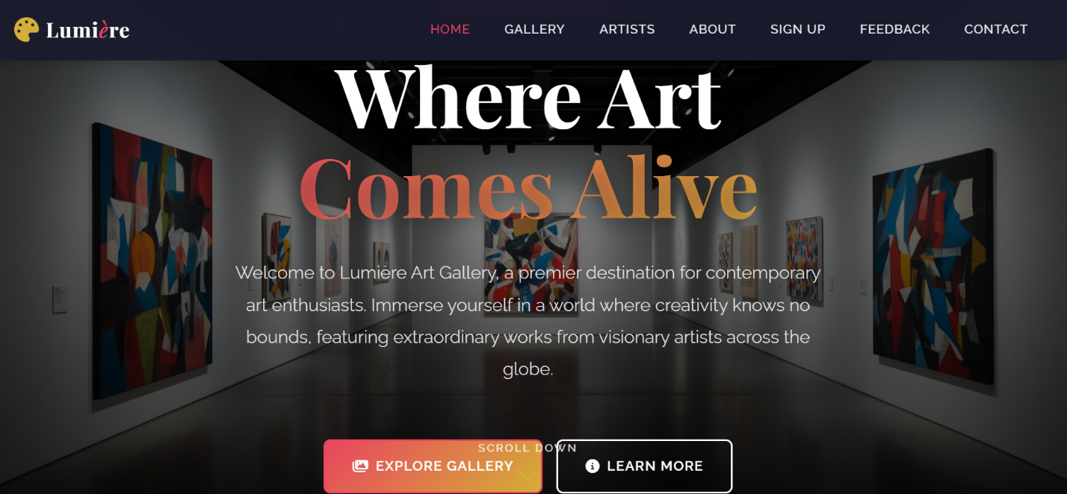

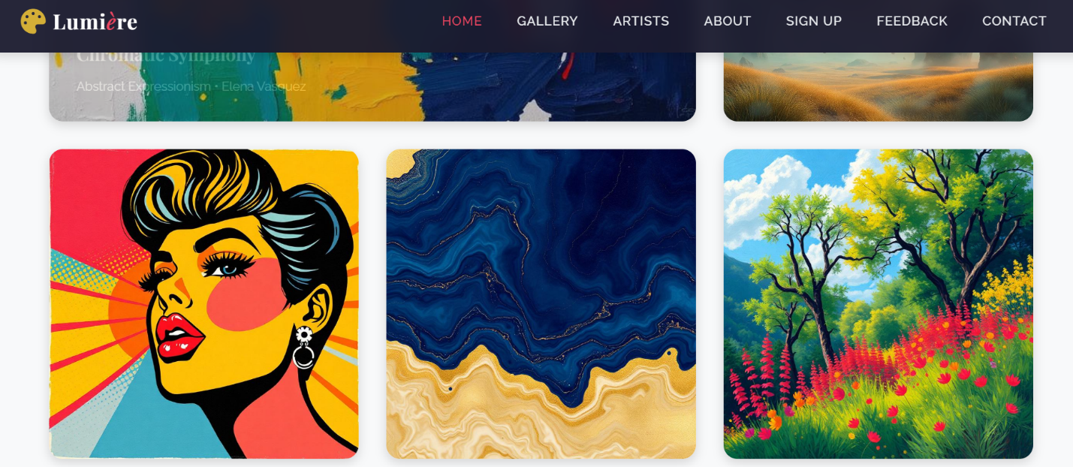

My website
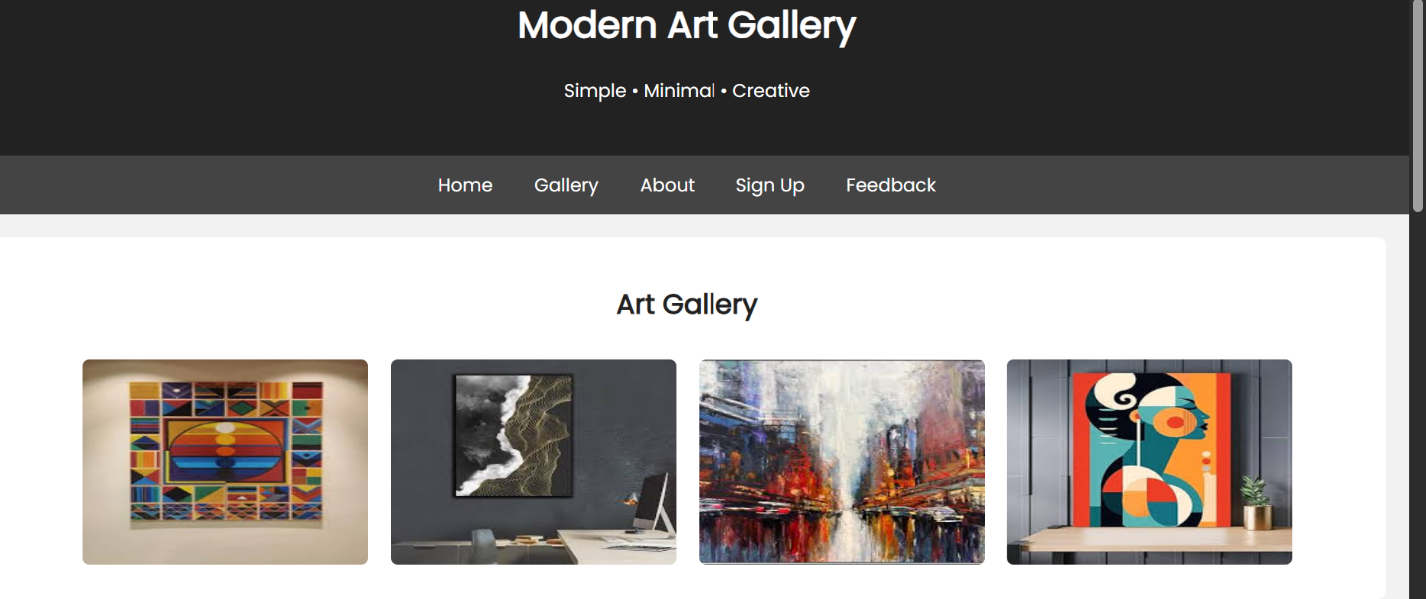
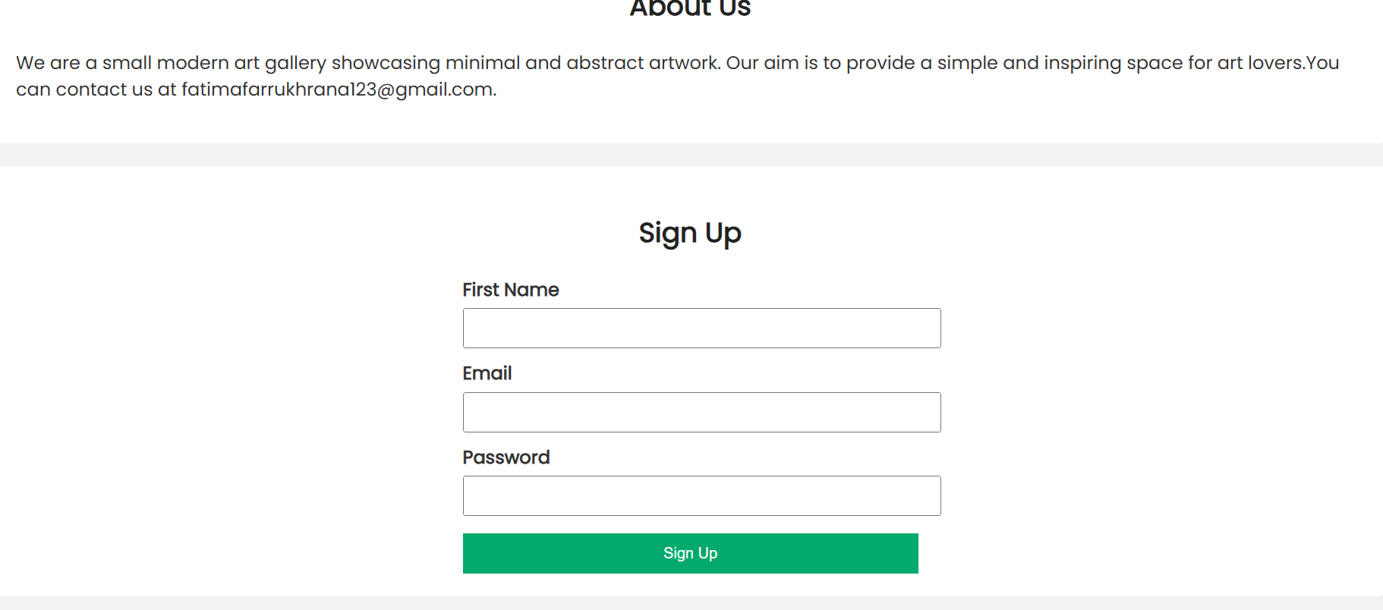

Analysis and Comparison
My code has a simple gallery with basic styling and responsiveness while the AI-generated version shows professional completeness with semantic structure, accessibility features (ARIA labels, alt text), modern CSS (custom properties, grid layouts), sophisticated interactivity (hover effects, animations), and comprehensive responsive handling. Key differences include the AI's mobile-first navigation, enhanced visual hierarchy through typography and spacing, and systematic organization using CSS variables which shows production-ready web development patterns beyond basic functionality.

