**Department of Computing**

**Course Code: CS332**

**Class: BSCS-9ABC**

**Lab 06: Understanding the Network Time Protocol**

**CLO1: Design Distributed Protocols**

**Date: 14th March 2022**

**Time: 9:00-11:50am, 02:00-04:50pm**

**Instructors: Dr. Farzana Jabeen, Shah Khalid**

|  |
| --- |
| **Submitted By:**  **Fatima Seemab**  **291310**  **Lab 6** |

# Lab 06: Understanding the Network Time Protocol

**Introduction**

This lab focuses on the giving overview of network time protocol. An implementation will be required to demonstrate network time protocol.

**Objectives**

To understand the concept of network time protocol.

**Tools/Software Requirement**

MS Visual Studio 2013

**Description**

**Network Time Protocol** (NTP) is a protocol that helps the computers clock times to be synchronized in a network. This protocol is an application protocol that is responsible for the synchronization of hosts on a TCP/IP network. NTP was developed by David Mills in 1981 at the University of Delaware. This is required in a communication mechanism so that a seamless connection is present between the computers.

**Features of NTP :**   
Some features of NTP are –

* NTP servers have access to highly precise atomic clocks and GPU clocks
* It uses Coordinated Universal Time (UTC) to synchronize CPU clock time.
* Avoids even having a fraction of vulnerabilities in information exchange communication.
* Provides consistent timekeeping for file servers

**Working of NTP :**   
NTP is a protocol that works over the application layer, it uses a hierarchical system of time resources and provides synchronization within the stratum servers. First, at the topmost level, there is highly accurate time resources’ ex. atomic or GPS clocks. These clock resources are called stratum 0 servers, and they are linked to the below NTP server called Stratum 2 or 3 and so on. These servers then provide the accurate date and time so that communicating hosts are synced to each other.

**Architecture of Network Time Protocol :**

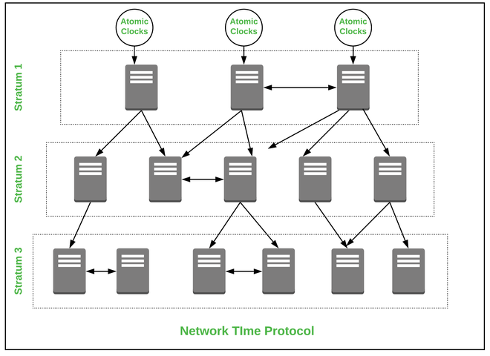

**Applications of NTP :**

* Used in a production system where the live sound is recorded.
* Used in the development of Broadcasting infrastructures.

**Advantages of NTP :**

* It provides internet synchronization between the devices.
* It provides enhanced security within the premises.
* It is used in the authentication systems like Kerberos.
* It provides network acceleration which helps in troubleshooting problems.
* Used in file systems that are difficult in network synchronization.

**Disadvantages of NTP :**

* When the servers are down the sync time is affected across a running communication.
* Servers are prone to error due to various time zones and conflict may occur.
* Minimal reduction of time accuracy.
* When NTP packets are increased synchronization is conflicted.
* Manipulation can be done in synchronization.

**Lab Tasks**

1. Run the code (uploaded on LMS) to get the time & date from the time server.

2. Edit the code to get the time from ten servers and display, also calculate the time difference with multiple time servers.

**Deliverables**

Submit the project files and screenshots of your output on LMS.

**Task 1:**

**time.nist.gov.pk**

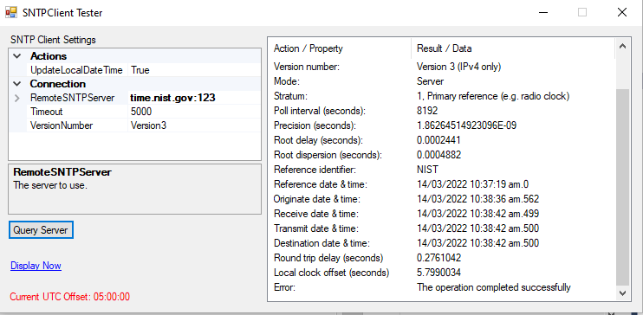

**Output:**

**Local Offset:** 5.7990034

**Task 2**

**Server 1:**

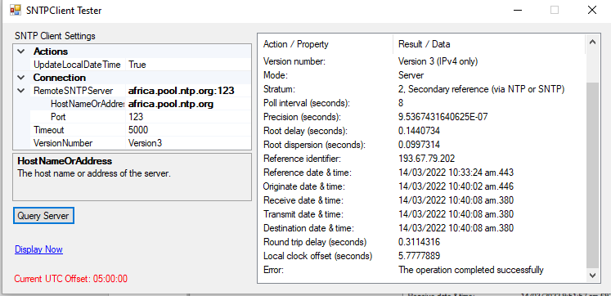

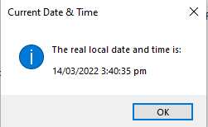

**Time Difference:** 5.7777889

**Server 2**

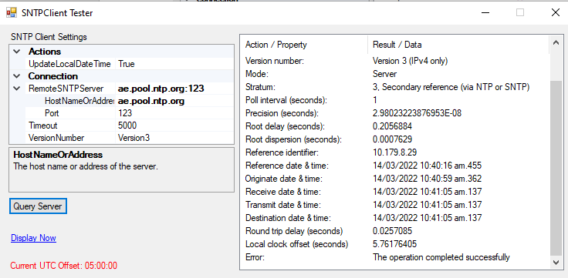

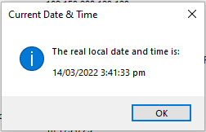

**Time Difference:** 5.l76176405

**Server 3**

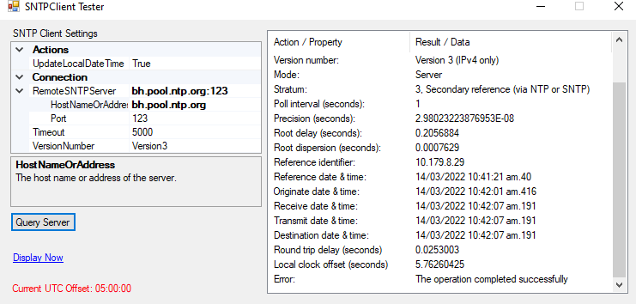

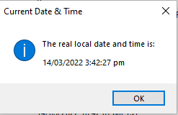

**Time Difference:** 5.76260425

**Server 4**

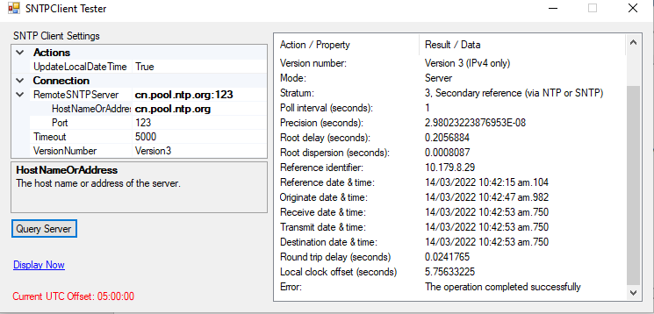

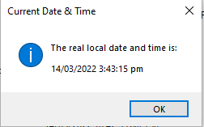

**Time Difference**:5.75633225

**Server 5**

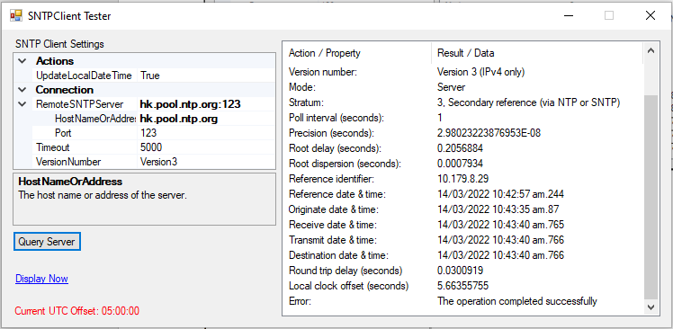

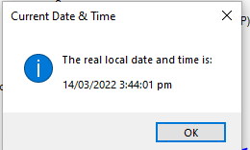

**Time Difference:**5.66355755

**Server 6**

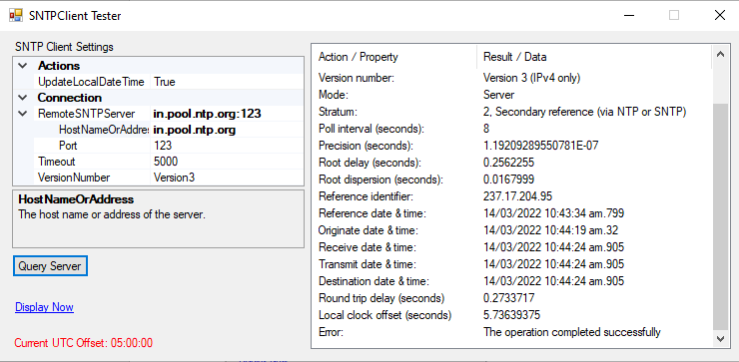

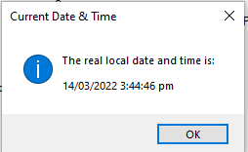

**Time Difference:**5.7639375

**Server 7**

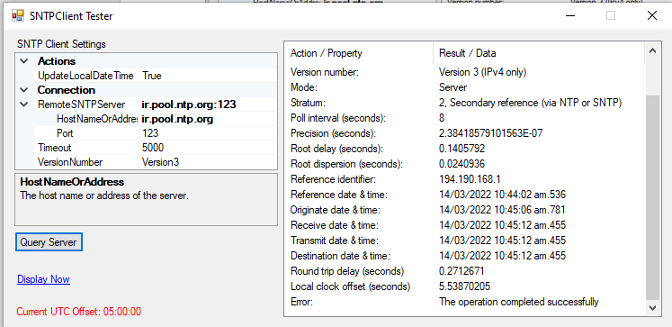

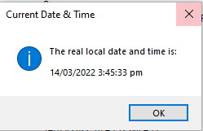

**Time Difference**: 5.53870205

**Server 8**

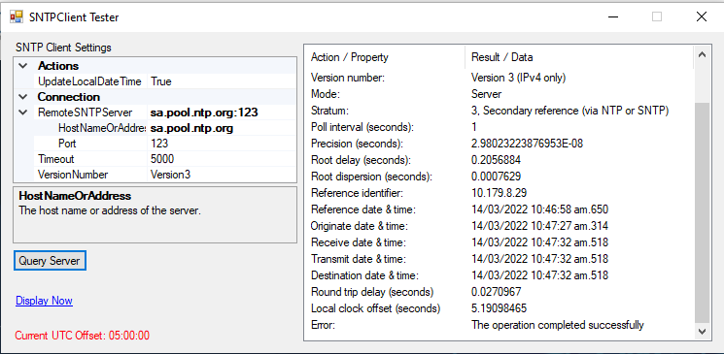

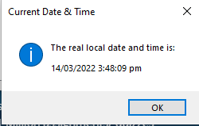

**Time Difference**: 5.19098465

**Server 9**

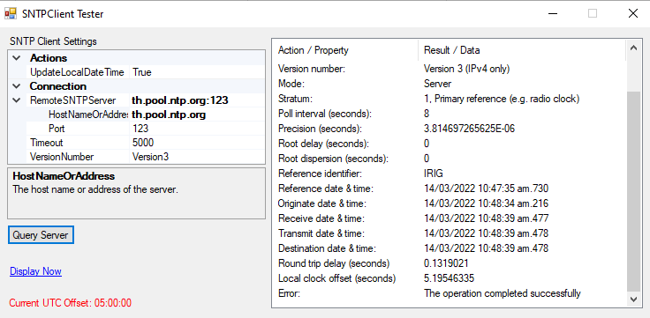

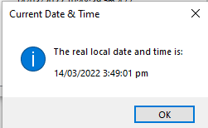

**Time Difference**: 5.19546335

**Server 10**

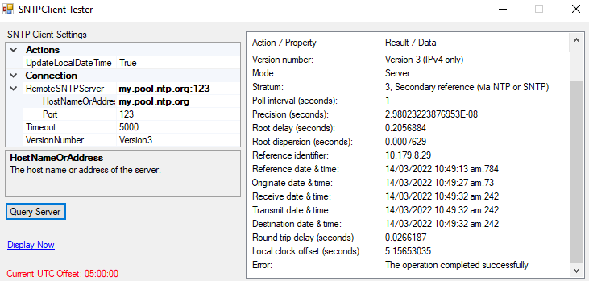

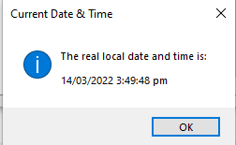

**Time Difference**: 5.15653035