# 

# Department of Software Engineering

**CS 250: Data Structures and Algorithms**

**Class: BSCS-9AB**

**Lab 12: Binary Search Trees – Part B**

**Date: December 29, 2020**

**Time: 10:00 am -1:00pm, 2:00pm – 5:00pm**

# Instructor: Dr. Yasir Faheem

# Lab 12: Implementation of Binary Search Tree – Part B

**Introduction**

This lab is based on the implementation of Binary Search tree and its functions.

**Objectives**

The objectives of this lab are the following:

* Become familiar with implementation of binary search trees
* Study some statistics of binary search trees
* Write simple applications using binary search tree

**Tools/Software Requirement**

Visual Studio 2012 or gcc or g++

**Description**

In computer science, a binary search tree (BST), which may sometimes also be called an ordered or sorted binary tree, is a node-based binary tree data structure which has the following properties:

* The left sub-tree of a node contains only nodes with keys less than the node's key.
* The right sub-tree of a node contains only nodes with keys greater than the node's key.
* Both the left and right sub-trees must also be binary search trees.
* There must be no duplicate nodes.

In this lab, you will expand implement binary search tree, study some statistical properties of BST and write a simple application using the BST.

Here is a template of how your class/structure looks like.

class BST_Node{

Template data;

BST_Node *LeftChild;

BST_Node *RightChild;

};

**Lab Task**

You are required to upload the lab tasks on LMS and the name of that tasks must be in this format

FullName_reg#_task#.cpp

Remember to comment your code properly. Inappropriate or no comment will result in the deduction of marks.

**Tasks**

**Previous Week’s Tasks:** In the previous lab you implemented the following operation of a binary search tree:

* bool IsEmpty();
* void Search(template value)
* Void InsertWithoutDuplication(template value)
* Void InsertWithDuplication(template value)
* Traversing a binary tree in pre-order, in-order and post-order.
* Implement a function that prints the smallest value of a BST.
* Implement a function that prints the largest value of a BST.
* Implement a function to calculate the height of a BST.
* Implement a function that calculates the depth of a BST.

**In today’s lab**, your task is to implement the following operations of a binary search tree:

1. Deleting a node. You may call your search(value) function. You should implement all the three cases:
   1. **Deleting a leaf node.**

Include the case in which the node being deleted is a root node.

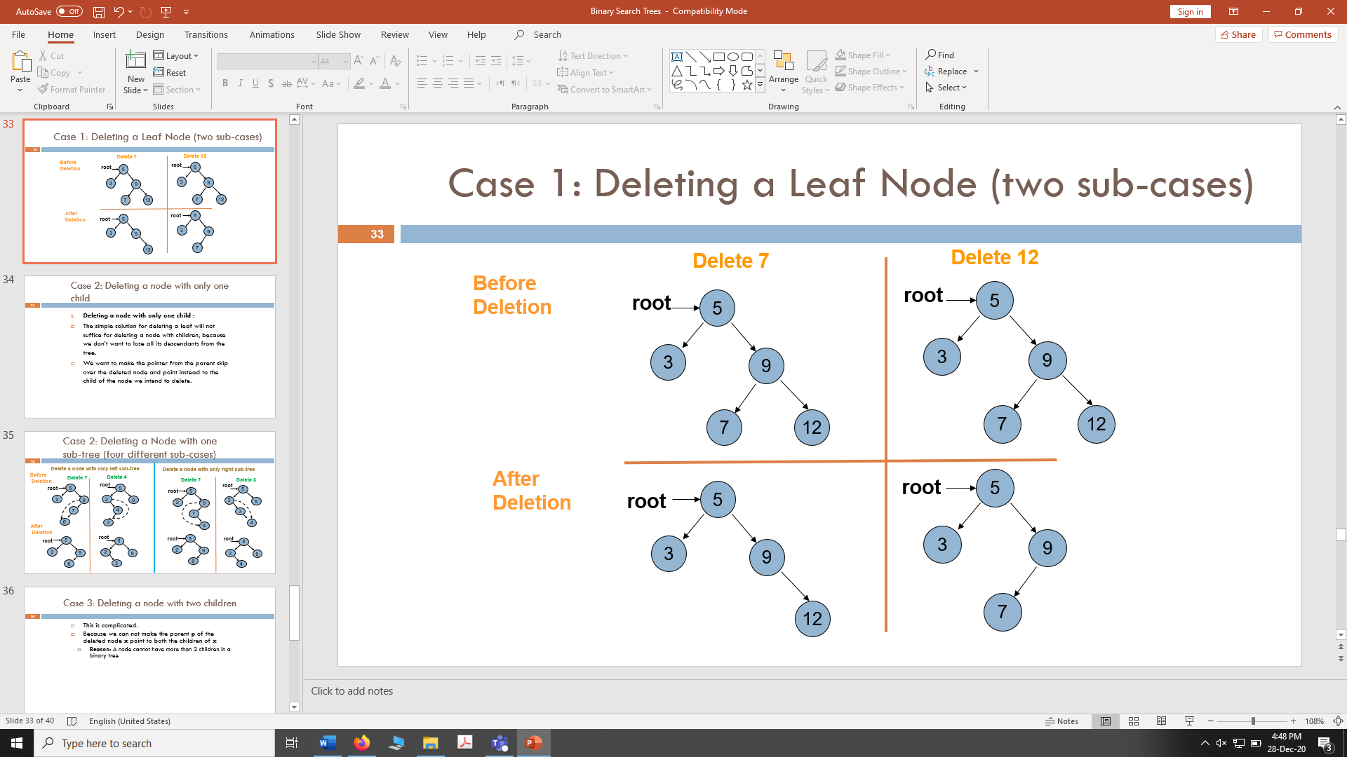

* 1. **Deleting a node with only one sub-tree.**

Include the case in which the node being deleted is a root node.

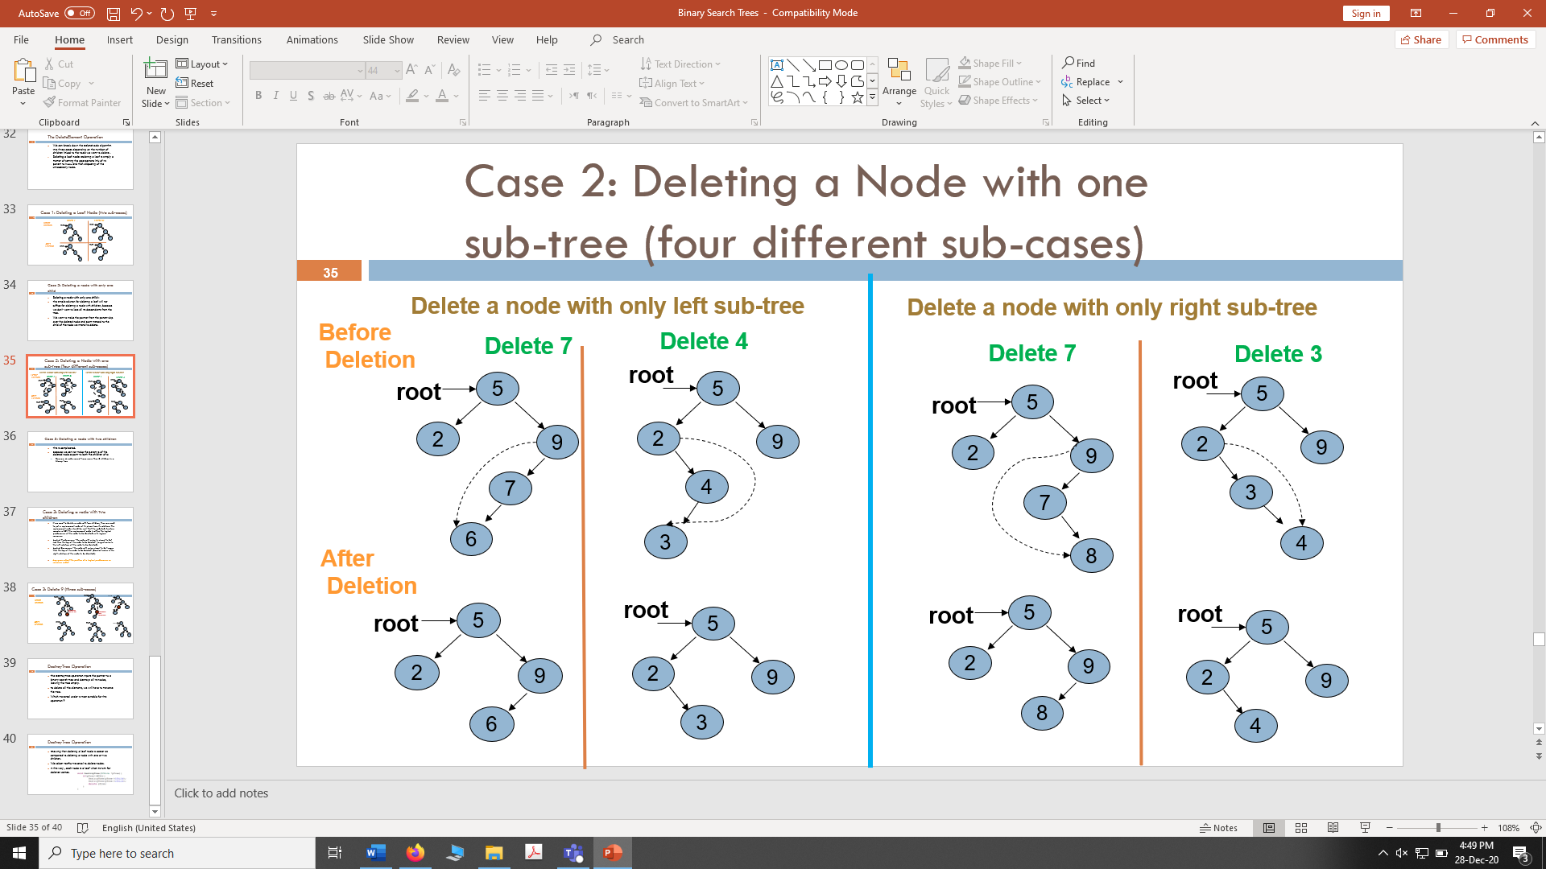



* 1. **Deleting a node with two children**: If we want to delete a node with two children, then we need to put a replacement node at its place from its sub-tree. The replacement node should be such that the updated structure remains a BST. The replacement node is either the logical predecessor of the node to be deleted or its logical successor.

**Logical Predecessor:** ”*the node with value to closest to but less than the key of the node to be deleted*” (largest value in the left sub-tree of the node to be deleted).

**Logical Successor:** ”*the node with value closest to but larger than the key of the node to be deleted*” (Smallest value in the right sub-tree of the node to be deleted).

In the below example, the node containing value 9 is deleted using its logical predecessor as replacement node. Include the case in which the node being deleted is a root node.

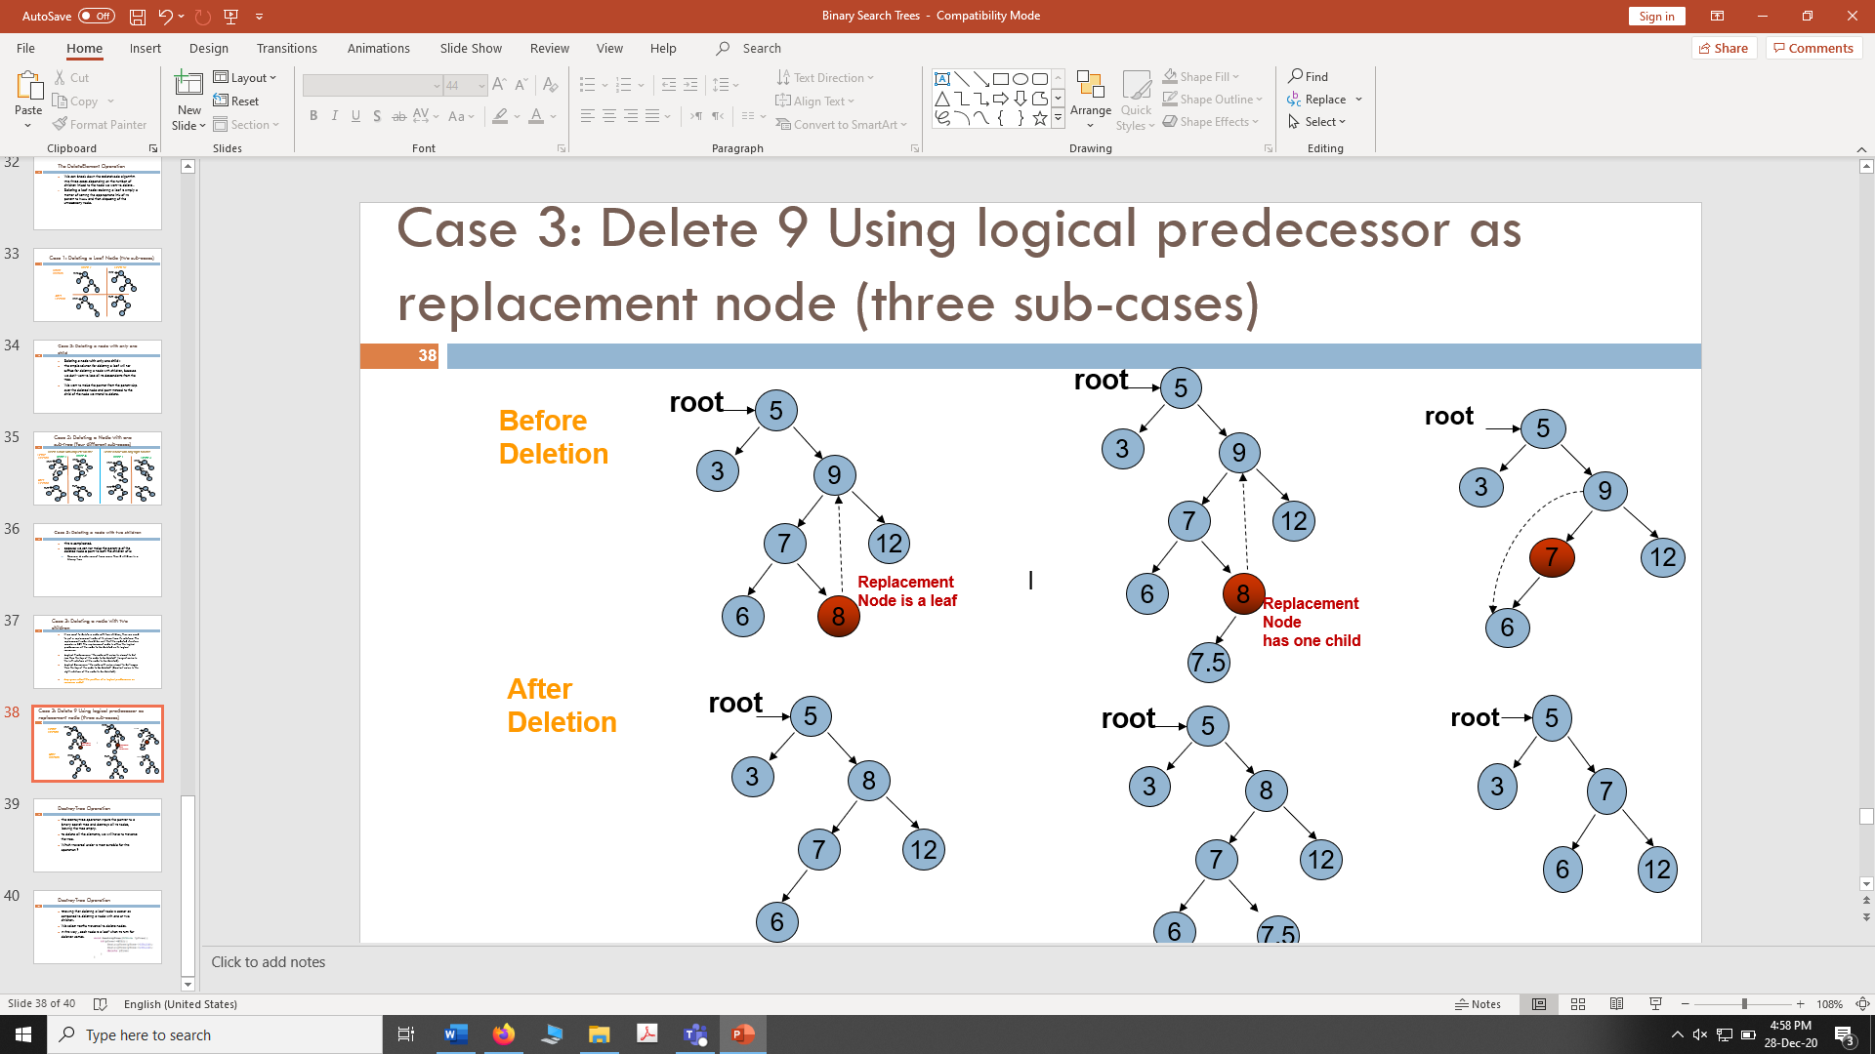

1. **Destroy tree:** Implement a function that destroys all nodes of a binary tree leaving the tree empty.
2. Implement a function that traverses a BST and **prints** only its **leaf nodes.**
3. Implement a function that traverses all nodes of a BST once, and counts the number of leaves, nodes with only left child, nodes with only right child and nodes with two children in it. You should maintain a separate counter variable for each of the four types of nodes.
4. Implement a function that **deletes** all **leaf** nodes of a **given BST only.**
5. Implement a function that **deletes** only those nodes from a **given** **BST** that have only **left sub-tree.** Only those nodes should be deleted that have left branch in the original tree.

**Task 1**

**CODE:**

void DeleteSubTree(int pointer)

{

Search(pointer);

**CASE:1**

if (loc!= NULL)

{//Case1: Delete Leaf Node

if (loc->leftchild == NULL && loc->rightchild == NULL)

{//leaf is also the root means tree has only one node

if (ploc==NULL)

{

root = NULL;

}

//leaf is right child of parent

else {

if (ploc->rightchild == loc)

{

ploc->rightchild = NULL;

}

//leaf is leftchild of parent

else { ploc->leftchild = NULL; }

}

//delete loc;

}

**CASE 2:**

//Case2: Delete Node with only left subtree

if (loc->leftchild!= NULL && loc->rightchild == NULL)

{

if (ploc == NULL)

{

root = loc->leftchild;

}

else

{

if (ploc->rightchild == loc)

{

ploc->rightchild = loc->leftchild;

}

if (ploc->leftchild == loc)

{

ploc->leftchild = loc->leftchild;

}

}

}

**CASE 3:**

//Case2: Delete Node with only right subtree

if (loc->rightchild != NULL && loc->leftchild == NULL)

{

if (ploc == NULL)

{

root = loc->rightchild;

}

else

{

if (ploc->rightchild == loc)

{

ploc->rightchild = loc->rightchild;

}

if (ploc->leftchild == loc)

{

ploc->leftchild = loc->leftchild;

}

}

}

**CASE 4:**

//Case4: Delete Node with both subtree

else

{

Node* ptemp = NULL;

Node* temp = root;

while (temp != NULL)

{

ptemp = temp;

temp = temp->rightchild;

}

ptemp = root;

if (ploc->leftchild == loc)

{

ploc->leftchild = ptemp;

ploc->leftchild->rightchild =loc->rightchild;

}

if (ploc->rightchild == loc)

{

ploc->rightchild = ptemp;

ploc->rightchild->leftchild =loc->leftchild;

}

}

}

delete loc;

}

else { cout << "Node is not in the tree"; }

}

**OUTPUT:**

**CASE 1:**

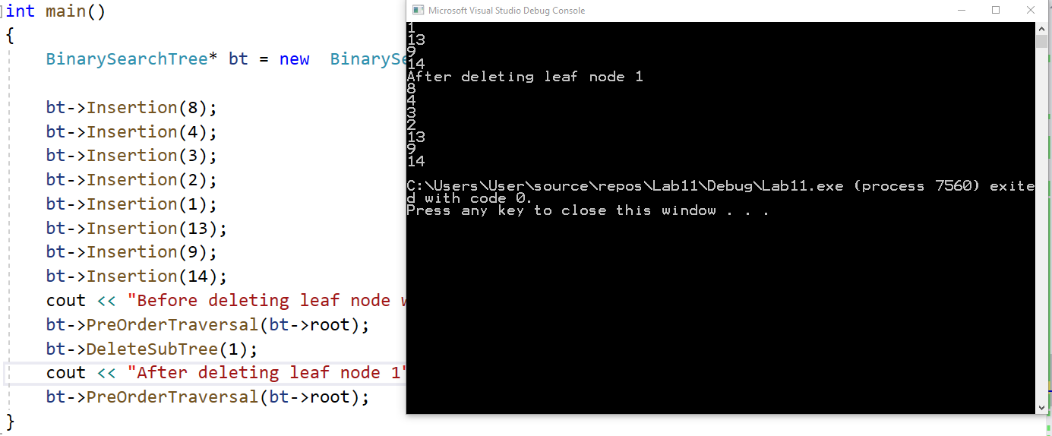

**CASE 2:**

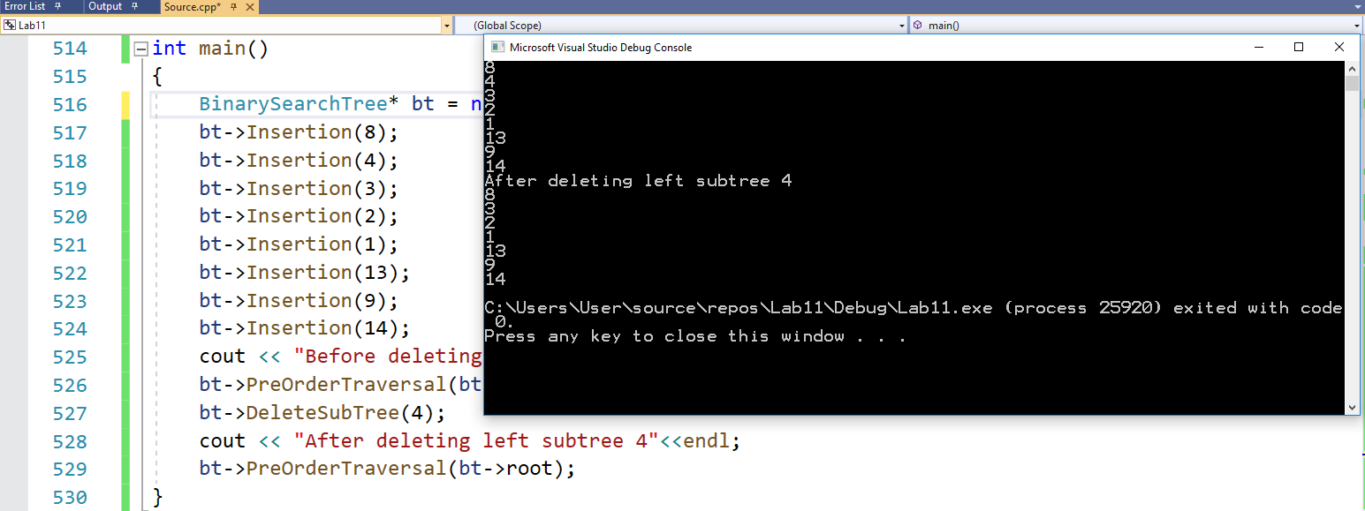

**CASE 3:**

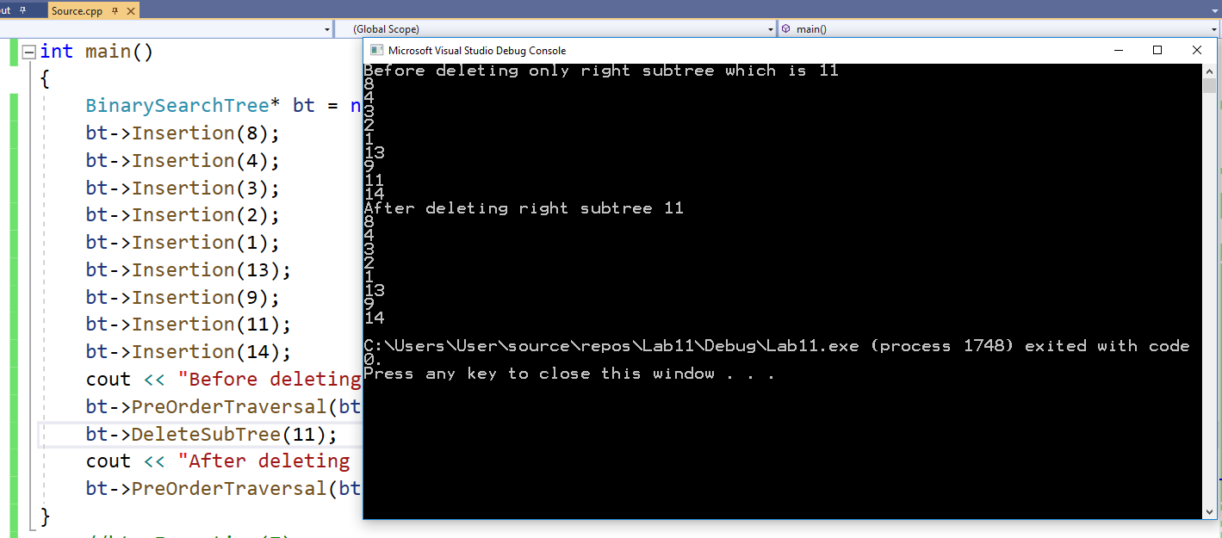

**CASE 4:**

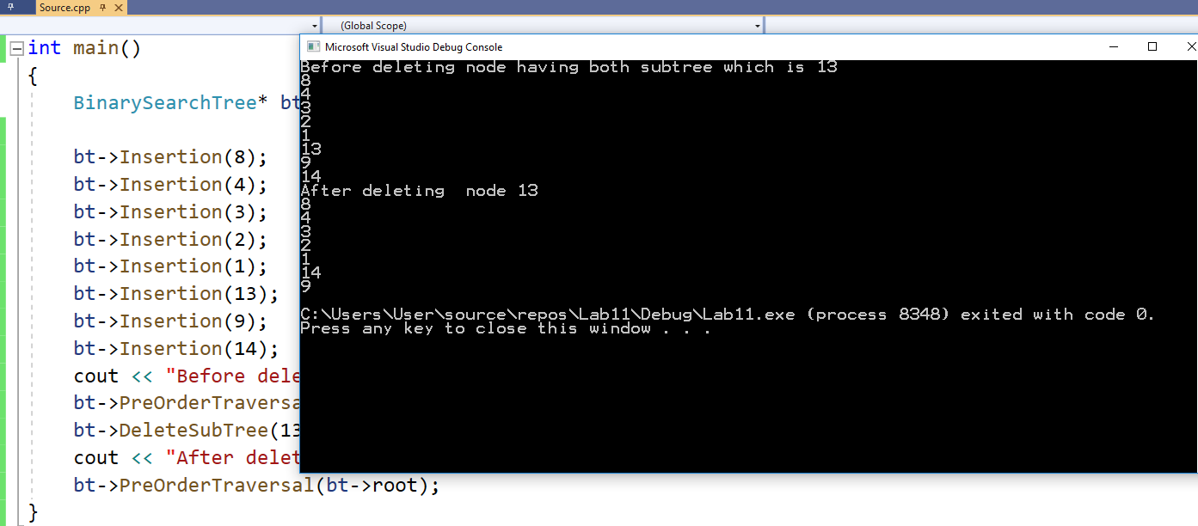

**TASK 2:**

**Destroy tree:** Implement a function that destroys all nodes of a binary tree leaving the tree empty.

**CODE:**

void DestroyTree(Node* root)

{

if (root == NULL)

{return;}

else

{

DestroyTree(root->leftchild);

DestroyTree(root->rightchild);

delete root;

}

}

**TASK 3:**

Implement a function that traverses a BST and **prints** only its **leaf nodes.**

**CODE:**

void PrintOnlyLeaf(Node* root)

{

if (root == NULL) { return; }

if (root->leftchild == NULL && root->rightchild == NULL)

{

if (ptemp != NULL)

{

if (ptemp->rightchild == root)

{

cout<<ptemp->rightchild->data;

}

else { cout<<ptemp->leftchild->data; }

}

return;

}

else

{

ptemp = root;

PrintOnlyLeaf(root->leftchild);

PrintOnlyLeaf(root->rightchild);

}

}

**OUTPUT**

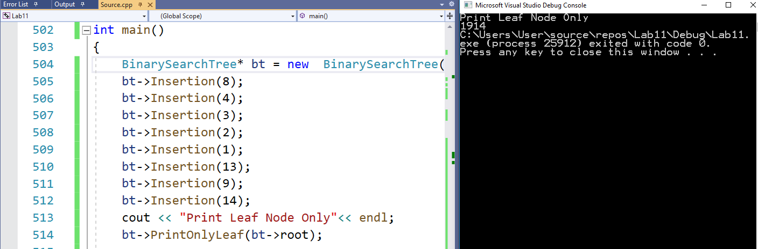

**TASK 4**

Implement a function that traverses all nodes of a BST once, and counts the number of leaves, nodes with only left child, nodes with only right child and nodes with two children in it. You should maintain a separate counter variable for each of the four types of nodes.

**CODE:**

void Count(Node* root)

{

if (root== NULL)

{

return;

}

if (root->leftchild == NULL && root->rightchild ==NULL)

{

leaf++;

}

if(root->leftchild == NULL && root->rightchild != NULL)

{

Noderight++;

}

if (root->leftchild != NULL && root->rightchild == NULL)

{

Nodeleft++;

}

if (root->leftchild != NULL && root->rightchild != NULL)

{

BothNode++;

}

Count(root->leftchild);

Count(root->rightchild);

}

**OUTPUT:**

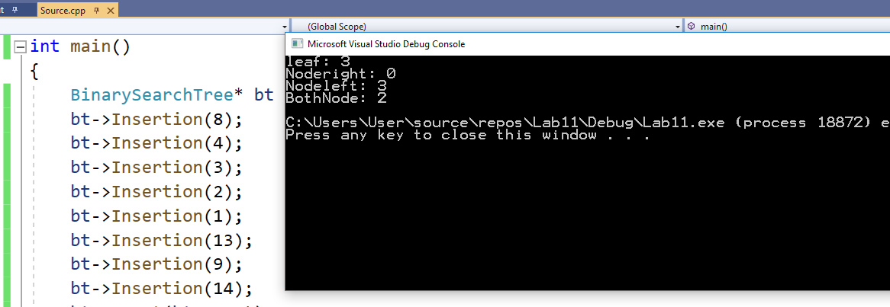

**TASK 5**

Implement a function that **deletes** all **leaf** nodes of a **given BST only.**

**CODE:**

void DeleteLeaf(Node* root)

{

if (root == NULL) { return; }

if (root->leftchild == NULL && root->rightchild == NULL)

{

if (ptemp != NULL)

{

if (ptemp->rightchild== root)

{

ptemp->rightchild = NULL;

}

else { ptemp->leftchild = NULL; }

}

delete root;

return;

}

else

{

ptemp = root;

DeleteLeaf(root->leftchild);

DeleteLeaf(root->rightchild);

}

}

**OUTPUT:**

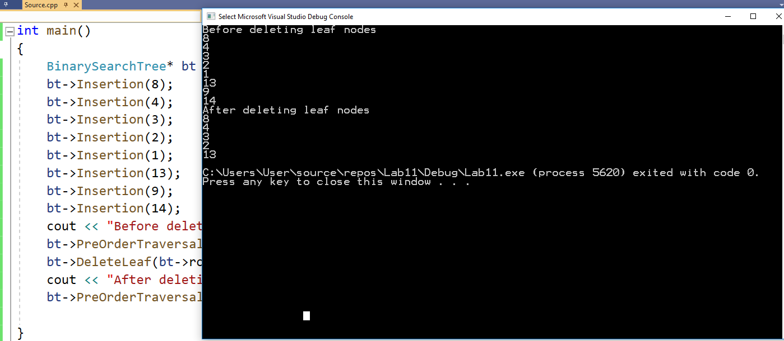

**TASK 6**

Implement a function that **deletes** only those nodes from a **given** **BST** that have only **left sub-tree.** Only those nodes should be deleted that have left branch in the original tree.

**CODE:**

void OnlyLeftNode(Node* root)

{

Node* temp =root;

if (root == NULL)

{

return;

}

if (root->rightchild == NULL && root->leftchild!=NULL)

{

if (ptemp->leftchild == root)

{

ptemp->leftchild = root->leftchild;

delete root;

OnlyLeftNode(ptemp->leftchild);

OnlyLeftNode(ptemp->leftchild);

}

else { ptemp->rightchild = root->leftchild;

delete root;

OnlyLeftNode(ptemp->leftchild);

}

return;

}

else {

ptemp = root;

OnlyLeftNode(ptemp->leftchild);

OnlyLeftNode(ptemp->rightchild);

}

}

**OUTPUT:**

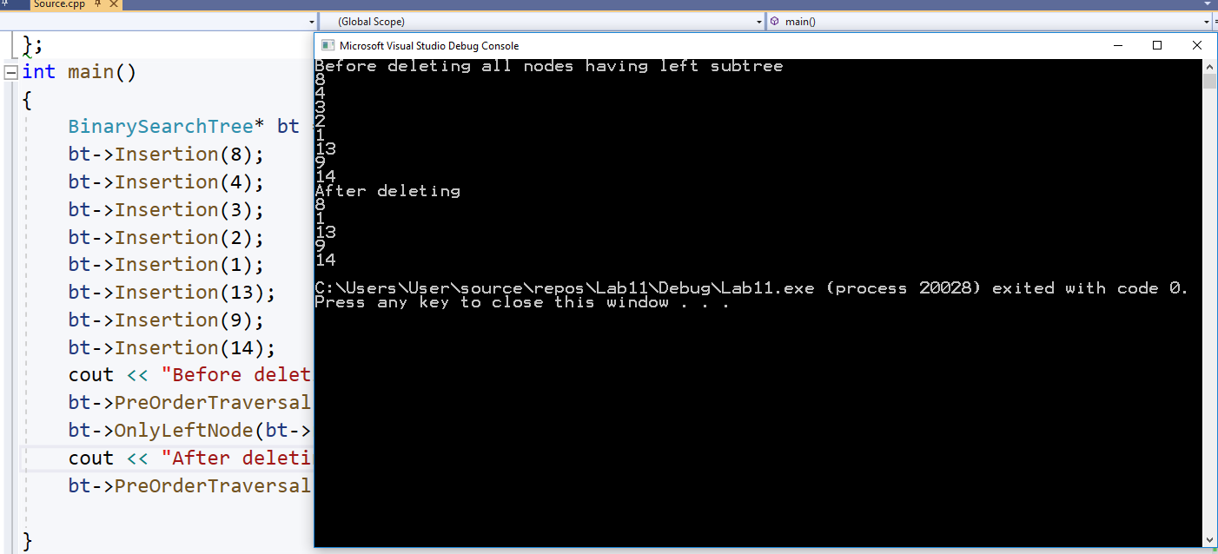

**Deliverable**

Students are required to upload the lab task on LMS before the deadline.