# Department of Computing

**CS220: Database Systems**

**Class: BSCS-9AB**

**Lab 06: Join Queries of SQL**

# Instructor: Dr. Shams

**Lab Engineer: Ms. Sadia Amir**

# 

# Introduction

* SQL DDL (Data Definition Language) commands are used to create and modify the databases. Data Manipulation Language (DML) commands are used to query the databases.

# Objectives

After performing this lab students should be able to:

1. Create tables in SQL using DDL commands.

2. Perform DML operations on created tables.

# Tools/Software Requirement

* MySQL Community Server 5.6
* MySQL Workbench 6.1

# Description

**Join Queries**

Given the following **database schema**:

Student (snum: integer, sname: char(30), major: char(25), level: char(2), age: integer)

Faculty (fid: integer, fname: char(30), deptid: integer)

Class (cname: char(40), meets_at: char(20), room: char(10), fid: integer | fid REFS Faculty.fid)

Enrolled (snum: integer, cname: char(40) | snum REFS student.snum, cname REFS class.name)

1. Find the names of all juniors (Level = JR) who are enrolled in a class taught by Ivana Teach.

select sname from student s, class c, enrolled e, faculty f

where s.snum = e.snum and e.cname = c.cname

and c.fid = f.fid and s.level = 'JR' and fname = 'Ivana Teach'

select sname

from student s

Join enrolled e on s.snum = e.snum

Join class c on e.cname = c.cname

join faculty f on c.fid = f.fid

where s.level = 'JR' and fname = 'Ivana Teach'

select sname

from student s

Join enrolled e using (snum )

Join class c using (cname)

join faculty f using (fid)

where s.level = 'JR' and fname = 'Ivana Teach'

select sname

from student s

inner Join enrolled e on s.snum = e.snum

inner Join class c on e.cname = c.cname

inner join faculty f on c.fid = f.fid

where s.level = 'JR' and fname = 'Ivana Teach'

# Lab Task

**Write SQL expressions using Join Operator for each of the following queries and execute them:**

**1.Find the names of faculty members that has taught classes only in room R128.**

**QUERY**

**Select * from faculty f join class c using (fid) having c.room='R128';**

**OUTPUT**

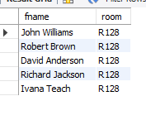

**2.Find the names of classes taught by ‘Richard Jackson’ and their times when a class meet there.**

**QUERY**

select cname ,meets_at from faculty join class c using (fid) where fname="Richard Jackson";

**OUTPUT**

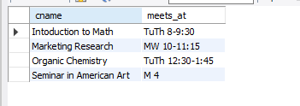

**3.Find the names of classes taught by ‘John Williams’ in dept # 68.**

**QUERY**

Select distinct c1.cname,f.fname from faculty F,

class C join class c1 using(fid) where

f.deptid="68" and f.fname="John Williams";

**OUTPUT**

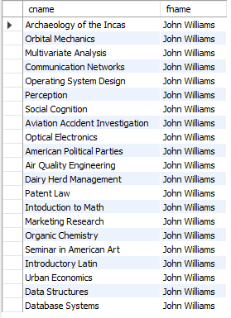

**4.For each class taught by ‘John Williams’, retrieve the name and age for students**.

**QUERY**

select sname, age from student s

join enrollment e using(snum)

join class c using(cname) join faculty f using (fid)

where f.fname="John Williams";

**OUTPUT**

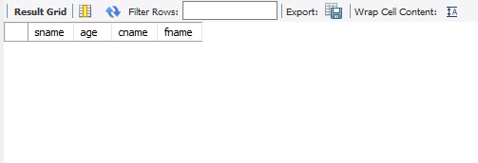

**5.Find the names of faculty that teach ‘Database Systems’ class in descending deptid-wise.**

**QUERY**

select fname from faculty f

join class c using(fid)

where cname="Database Systems"

order by deptid DESC

**OUTPUT**

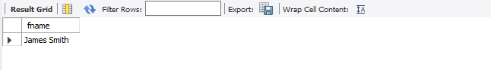

**6.Find distinct student ages in ‘Database Systems’ class in descending order.**

**QUERY**

select distinct age from student s

join enrollment e using(snum)

where cname="Database Systems" order by age DESC

**OUTPUT**

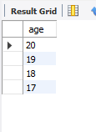

**7**. List the name of ‘Christopher Garcia’s teachers.

**QUERY**

select f.fname,c.cname,s.sname from faculty f

join class c using(fid)

join enrollment e using(cname)

join student s using (snum)

where s.sname="Christopher Garcia";

**OUTPUT**

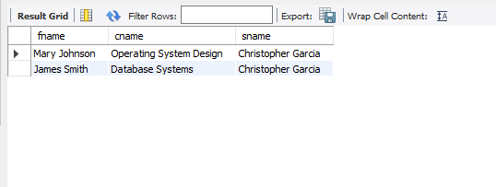

**8. Find the name and age of student in ‘Database Systems’ class.**

**QUERY**

select s.sname,s.age from student s

join enrollment e using(snum)

where e.cname="Database Systems";

**OUTPUT**

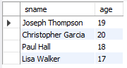

**9.Find the class names, strength of faculty members for each class.**

**QUERY**

select c.cname,count(fid) from class c

join faculty f using(fid)

group by fid;

**OUTPUT**

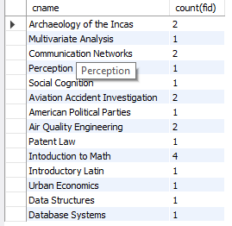

# Deliverables

1. Complete your lab tasks in SQL workbench and submit a word file in with queries along with the screenshots of the results to all the questions attempted. Upload it on LMS. The marking will be based on viva/lab task submitted.