**Department of Computing**

**CS220: Database Systems Class: BSCS-5C**

**Lab 07: Nested Queries of SQL Date: Nov. 25, 2020**

**Time: 0900-1200**

**Instructor: Mr. Mujtaba Haider**

**Lab Engineer: Mr. Nadeem Nawaz**

**Lab 07: Nested Queries of SQL**

# Introduction

* SQL DDL (Data Definition Language) commands are used to create and modify the databases. Data Manipulation Language (DML) commands are used to query the databases.

# Objectives

After performing this lab students should be able to:

* 1. Create tables in SQL using DDL commands.
  2. Perform DML operations on created tables.

# Tools/Software Requirement

* MySQL Community Server 5.6
* MySQL Workbench 6.1

# Description

## Nested Queries/Subqueries

A nestested/subquery is a SQL query nested inside a larger query, such inner-outer queries are called nested queries

A subquery may occur in:

* A SELECT clause
* A FROM clause
* A WHERE clause

**Rule of thumb**: avoid writing nested queries when possible; keep in mind that sometimes it’s impossible

**Nested queries**

* can return a single constant and this constant can be compared with another value in a WHERE clause

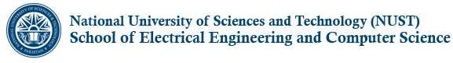

* Can return relations that can be used in various ways in WHERE clauses
* Can appear in FROM clauses, followed by a tuple variable that represents the tuples in the result of the subquery
* Can appear as computed values in a SELECT clause Given the following **database schema**:

Student (snum: integer, sname: char(30), major: char(25), level: char(2), age: integer) Faculty (fid: integer, fname: char(30), deptid: integer)

Class (cname: char(40), meets_at: char(20), room: char(10), fid: integer | fid REFS Faculty.fid) Enrolled (snum: integer, cname: char(40) | snum REFS student.snum, cname REFS class.name)

1. **Find the name of faculty members who do not teach any course**. select distinct f.fname

from faculty f where f.fid not in

(select c.fid from class c);

## Find the names of students who are enrolled in a course taught by I. Teach. Select s. snames

From student s where S.snum in (Select E.snum

From class C, enrolled E, faculty F

Where E.cname = C. cname and C.fid = F.fid and f.fname = 'I. Teach')

## Find the names of all students who are enrolled in two classes that meet at the same time.

select distinct S.sname from student S

Where S.snum in (select E1.snum

from enrolled E1, enrolled E2, class C1, class C2 where E1.snum = E2.snum and E1.cname <> E2.cname and E1.cname = C1.cname

and E2.cname = C2.cname and C1.meets_at = C2.meets_at)



# Lab Task

**Write SQL expressions for each of the following queries and execute them:**

* 1. Find the names of all juniors (Level = JR) who are enrolled in a class taught by ‘Ivana Teach’.

**Query**

select sname from student where snum in

(select snum from enrollment where cname in

(select cname from class where fid in

(select fid from faculty where fname='Ivana Teach' and level='JR')));

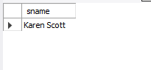**Output**

* 1. Find the names of faculty members that has taught classes only in room R128.

**Query**

select fname from faculty where fid in

(select fid from class c where room='R128'

and fid not in (select fid from class c where room!='R128'));

**Output**

* 1. Find the names of classes taught by ‘Richard Jackson’ and their times when a class meet there.

**Query**

select cname,meets_at from class where fid =

(select fid from faculty where fname='Richard Jackson');

**Output**

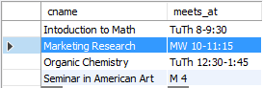

* 1. Find the names of students majoring in ‘Computer Science’.

**Query**

select sname from student where sname in

(select sname from student where major='Computer Science');

**Output**

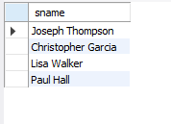

* 1. Find the names of classes taught by ‘John Williams’ in dept # 68..

**Query**

select cname from class where fid in

(select fid from faculty where fname='John Williams' and deptid=68);

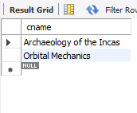**Output**

* 1. Find the names of students in ‘Computer Science’ major in descending age-wise.

**Query**

select sname from student where major='computer science' order by age desc;

**Output**

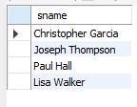

* 1. Find distinct student ages in ‘Database Systems’ class in descending order.

**Query**

select distinct age from student where snum in

(select snum from enrollment where cname='Database Systems')

order by age desc;

**Output**

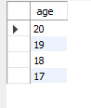

* 1. List the name of ‘Christopher Garcia’s teachers.

**Query**

select fname from faculty where fid in

(select fid from class where cname in

(select cname from enrollment where snum in

(select snum from student where sname='Christopher Garcia')));

**Output**



# Deliverables

1. Complete your lab tasks in SQL workbench and submit a word file in with queries along with the screenshots of the results to all the questions attempted. Upload it on LMS. The marking will be based on viva/lab task submitted.