# Department of Computing

**CS220: Database Systems**

**Lab 10**

**Relational Model and Normalization**

|  |  |
| --- | --- |
| **Name** | **CMS ID** |
| Fatima Seemab | 291310 |
| Maryam Fatima | 290479 |

**Class: BSCS-9B**

# Instructor: Dr. Shams

**Lab Engineer: Ms. Sadia Amir**

**Date: January 12, 2021**

**ER Diagram**

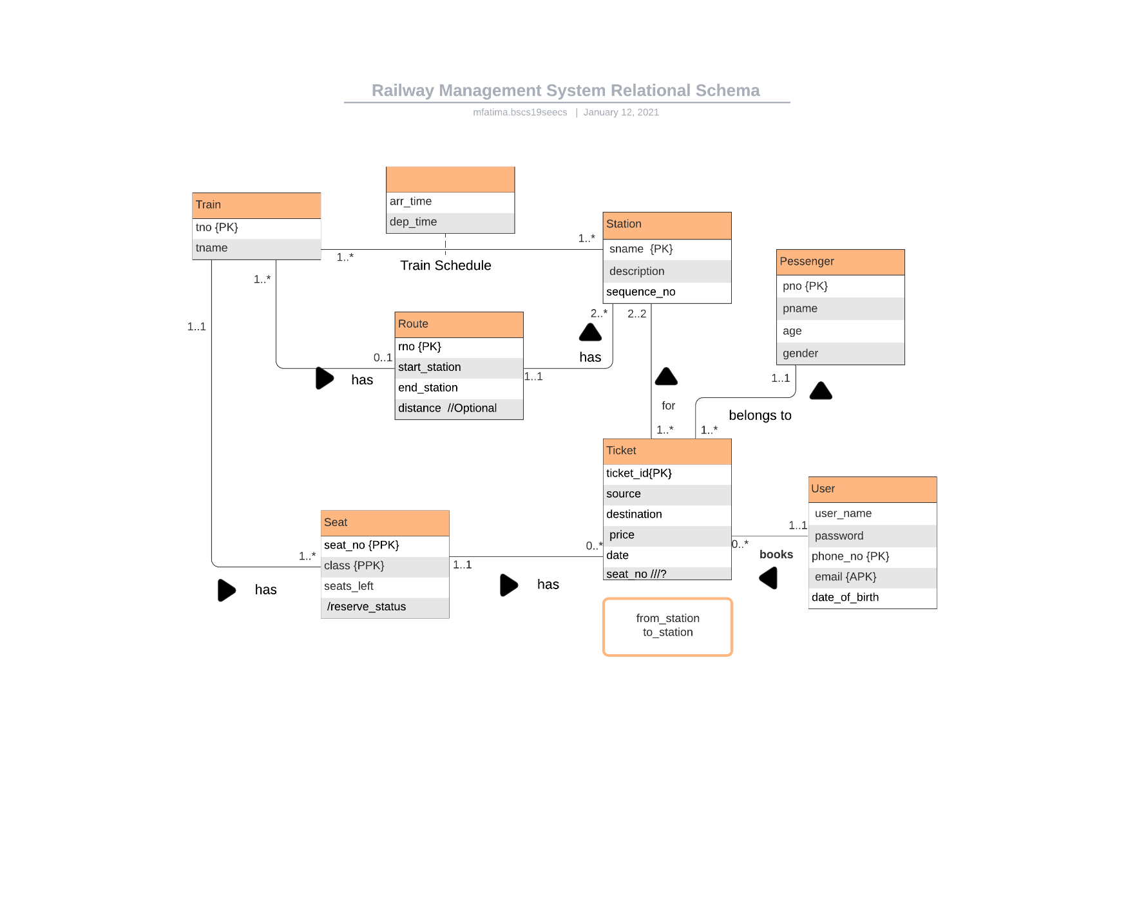

**Explanation**

User can book multiple tickets and for multiple passengers.

A ticket belongs to only one passenger and is booked by a single user. It is booked for train seat and has data of two stations, one is source and other is destination.

A train has a route, which consists of 2 or more stations, each specified with a sequence number.

Multiple trains can travel on a route.

A station belongs to only one route.

Train Schedule is a relationship between Train and Station, contains arrival and departure time of train for each station.

# Relational Mapping

Train( tno, tname, **rno**)

Route(rno, **start_station**, **end_station**, distance)

Seat(tno, class, seat_no, seats_left)

Station(sname, description, **rno**, sequence_no)

Schedule(tno, sname, arr_time, dep_time)

User(phone_no, email, user_name, password, date_of_birth)

Passenger(pno, pname, age, gender)

Ticket(ticket_id, **pno, phone_no, source, destination, tno, seat_no, class,** date, price, status)

**Normalized Schema**

Relational schema is already normalized, since there is no multi-valued attribute (1NF) also all non-prime attributes are fully functionally dependent on primary keys (2NF). Moreover, no transitive dependency exists (3NF).

**Train:** tno **->** tname, rno

**Route:** rno **->** start_station, end_station, distance

**Seat:** tno, class, seat_no **->** seats_left

**Station:** sname **->** description, rno, sequence_no

**Schedule:** tno, sname **->** arr_time, dep_time

**User:** phone_no **->** email, user_name, password, date_of_birth

**Passenger:** pno **->** pname,age,gender

**Ticket:** ticket_id **->** pno, phone_no, source, destination, tno, seat_no, class, date, price, status